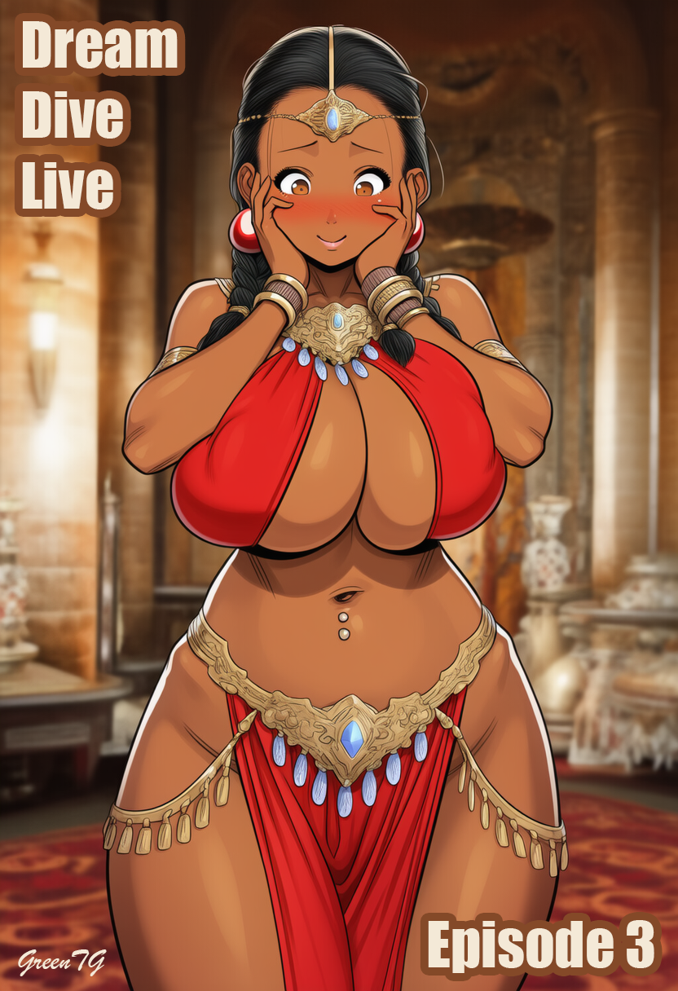

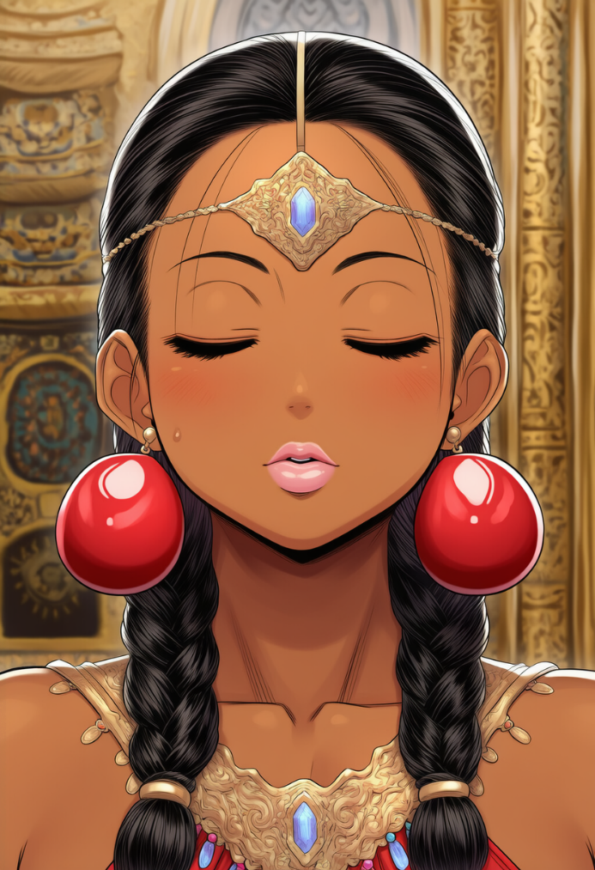
Palaces, marble floors, all this wealth. Damn it, how realistic can a game be? Though really, who am I asking — the people who even programmed the suffering from death, not to mention how the body hurts every damn month when it decides to give me yet another “little gift” of female physiology. Yes, yes, periods — with pain, with cramps, with that very feeling like someone inside is wringing your guts out, and on top of that you still have to dance, smile, and look “seductive.” Well, thank you so much, Big Evil Corporation. Stunning realism.
And what an idiot I was in the first week, when I, still barely breathing after the Red Gates, thought that here it was — a chance. Everything is more expensive, quieter, cleaner… But the moment I started “working” in the huge dining hall where they put me to dance, I understood right away that it was the same shit, just wrapped in gold. And why the hell did I think it would be any different?
Probably because I’m an idiot. Because somewhere deep under this skin — under this soft belly, under these impossible hips and heavy breasts that live their own life — I still believed in logic, ordinary male logic. And it said that if they called you from a sewage ditch into a palace, that’s a promotion. That if there’s marble around you, magical lanterns, and scents of expensive oils, then their attitude toward you would at least become a tiny bit… more human.
Yeah. Right.
A palace is basically the same filthy platforms at the Red Gates, only here the planks are marble, and the contempt is served in elegant glasses.
The same looks, only colder and much scarier.
The same conversations, only spoken in whispers and with sweet smiles.
The same judgments, only now everyone knows my price except me, as if it’s stuck to my forehead.
Even the music, which should be beautiful, precise, magical — still sounded the same as back there: demanding. Harsh. Poking me into the rhythm like it was teasing me: “Come on, bitch, dance pretty, that’s why you’re here, you’re nobody, just a part of the decor.”
And I danced. Because what else could I do?... God, even that sounds just like the Red Gates. Though unlike them, here I had more chances, because I could, even if it was risky, try to talk to the princess… to my Stephanie, damn her, who forgot about me and didn’t even try to look for me.
Yeah.
That cut deeper than the heat of the stage at the Red Gates, deeper than the endless pain in my back from my heavy breasts, deeper than the cramps that made me nearly moan into my pillow at night. She didn’t even try to look for me.
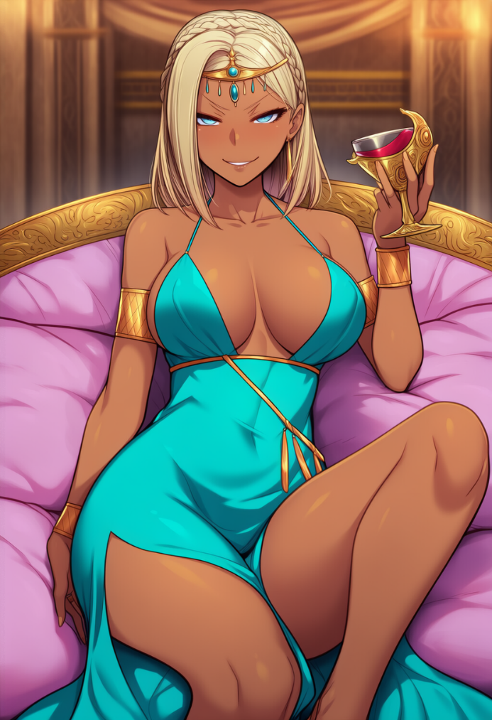
To hell with the hundreds of courtiers around me. To hell with the strict rules here. To hell with the roles, the masks, with this whole royal show. If she were Stephanie… something would’ve hinted it. A look. A gesture. Some strange phrase. Anything at all.
But no, damn it, no. She did absolutely nothing, and now I’m more and more convinced of it.
Just look at how she’s sitting right now, as if that throne was made out of her own whims. As if the celebration was held not in honor of the prince’s return but in honor of her mood.
The princess, Stephanie… doesn’t even pretend to listen to the guests’ speeches. Her elbow rests on the throne’s armrest, her wrist hangs in the air, fingers lazily tapping on a thin glass filled with golden wine. One leg crossed over the other so that the slit of her dress opens her knee almost up to her thigh, and she, damn her, can’t be bothered to cover it even though the hall is full of nobles. A strand of her long blond hair slowly slides across her collarbone, and she, as if on purpose, tilts her head back so her perfectly styled hair looks even more impressive.
She isn’t listening. She’s watching. Watching how the servants rush around. How the advisors lean toward the prince. How some silly dancer — me — makes a wave with her hips in the middle of the hall. Her eyes — cold, lazy — glide across the room as if every person here exists only for her amusement.
— Hands higher, Arissa, — one of the senior dancers hisses quietly at me from the side, and I force my body to arch more.
My shoulder stretches, my breasts lift and then immediately pull downward in a heavy curve, my stomach muscles tremble. I raise my arms, feeling how the soft weight rises with them — like my tits have their own rules of gravity — and I try not to wince. The music shimmers, steady and ceremonial, built on long smooth movements you have to “breathe out” with your body instead of doing in jerks. But in this hall, on the marble, under these eyes, dancing is much harder than on the dirty planks of the Red Gates.
The crowd at the long tables is loud: half the guests are already drunk, servants rush around with dishes, the smells of roasted meat, spicy sauce, and wine mix with the warm scent of oils they rubbed into my shoulders and legs before the performance. The prince — tall, tanned, broad-shouldered — sits at the head of the table beside his sister. Unlike her, he behaves calmly: speaks little, listens a lot. His hands folded on the tabletop, his movements restrained. All evening he looks as if he’s doing nothing but comparing the atmosphere of this hall with the places he saw in his travels.
And then his gaze — calm, heavy — slides for a second over my hips, the curve of my waist, my breasts catching the light in the slit of the fabric, before it goes back to the advisor. I don’t know what’s worse: the fact that he looks at me like an object… or the fact that I’m used to it.
But the princess… she’s something else entirely.
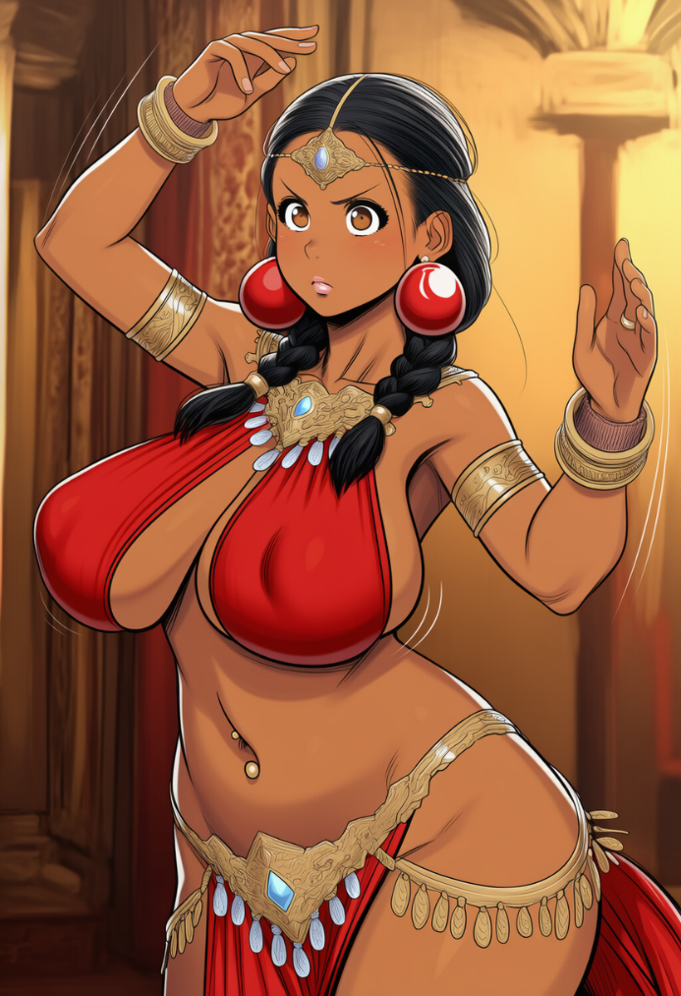
While I’m dancing, her lips stretch again into that small, predatory smirk. She tilts her head a little, as if comparing me to yesterday’s dancer, or to the next one who’ll come out after me. She doesn’t even try to hide her boredom. Her elbow still hangs off to the side, her wrist plays with the glass, and when her gaze hooks mine again — cold runs along my skin down my spine. Am I… scared of her?
Stephanie… what happened to you? Why don’t you look at me like you recognize me? Why are you like this? Arrogant, spoiled, as if the whole world should serve you? Is it the program? A role? Or are you just enjoying yourself?
"— The princess has been going wild these past months," — I once heard in the women’s bath from the other dancers.
"— How many lovers does she even have now?" — one whispered.
"— Three? Four?" — another answered.
"— Oh please, — the third snorted, — you mean the courtiers? And then there are the mages. And the bodyguards. And that singer from the southern coast…"
Of course, rumors aren’t easy to trust. But damn, how well they fit what I was seeing now. Stephanie — the princess — lazily runs her finger along the stem of her glass, her eyes narrowed, her gaze drifting over the men at the tables — as if choosing whom to pay attention to later.
God. My fiancée?
My quiet Stephanie, who used to blush from the lightest kisses?
Who used to tremble when I touched her waist?
Why is she acting like she never knew me?
Did she always want to be like this and finally got her chance?
I make another turn, a bit too sharp even though it still looks smooth. My hips slide to the side, pulling the skin along my ribs, my breasts shimmer over the edge of the fabric, and I have to hold my breath a little so I don’t fall out of rhythm.
When the music makes a pause, I lift my gaze.
The princess is kissing some guy with a French kiss right there by the throne — simple, easy, as if she’s doing it out of boredom, for fun, to fill the pauses between glasses of wine and lazy sighs. Judging by his look, he’s either one of the young mages or a singer — the kind they’ve been delivering to her in batches these past months like new toys.
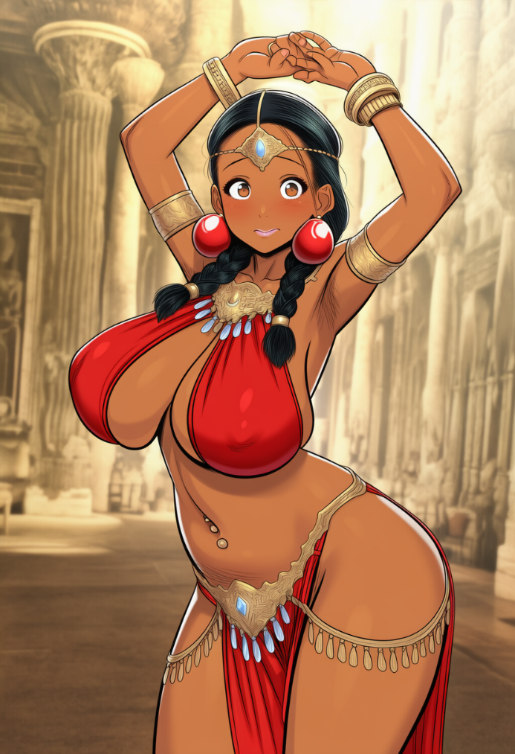
And from that sight alone I feel my legs go weak, the ground slipping from under me, while she — or rather her lips — slowly pull away from his, and she lightly bites her lower lip, exhales into his mouth, and then lazily, sensually runs her finger along his chin. She does it so naturally, so confidently, as if etiquette doesn’t exist, nor the guests, nor the wedding we once planned. As if I don’t exist and never did.
I catch myself freezing for a second and immediately feel Madame Halarina’s stare — and from that stare alone I straighten instantly, as if a whole team of medics just restarted my stopped heart. My back arches on its own, my breasts jerk upward in heavy curves, and my hips somehow find the rhythm I lost for a moment. Even the air around me seems to shiver with me.
The music keeps going, but now I hear it only as marks, as sharp beats I must move to, otherwise… otherwise I don’t want to think. I’m afraid that this time I won’t get off with just the Red Gates.
On the next measure, right in the middle of a long movement stretched out into a painful exhale… the music dies. As if someone cut a thin thread with scissors.
My arms freeze above my head, my breasts pull downward with their familiar weight, my hips stop halfway through a motion. I stay in the pose — as required. Like a statue. Like part of the decor.
— ATTENTION, — came the voice of the master of ceremonies, thin and solemn. — His Highness Prince Dahren wishes to address the gathered.
Something shifted softly through the hall: whispers, rustling fabric, the clink of glasses. But all of it melted instantly into an even hum when He rose.
The prince.
And the moment he stood, the princess sitting beside him burst into a ringing giggle and leaned her head back against the throne as lazily as if everything happening already bored her. She waved her fingers at a servant without even looking so he would refill her wine. I could feel her careless luxury even on my skin — she warmed the air around her somehow.
The prince, though… moved completely differently, like someone trying to be the ideal, the one everyone loves. Like someone who carries his own inner map he doesn’t have to show to anyone. Smooth, refined, in a way even graceful — gracefully in a man’s way, of course.
He raises his glass, tilts his head slightly. The crowd quiets down.
And I remain there, holding the pose. Arms above my head, back arched, hips shifted, my breasts — those damn heavy breasts — lifting and then sinking again with a weight that strains me harder every second. Breathing hurts. But I can’t move. I even have to force a smile, because Madame Halarina is already watching me closely.
— Dear guests, — he began in a low, confident voice, without even a hint of pretended grandeur. — I am grateful to each of you for coming to celebrate my return.
The princess snorted, loud and sharp. As if he’d already repeated this speech three times tonight.
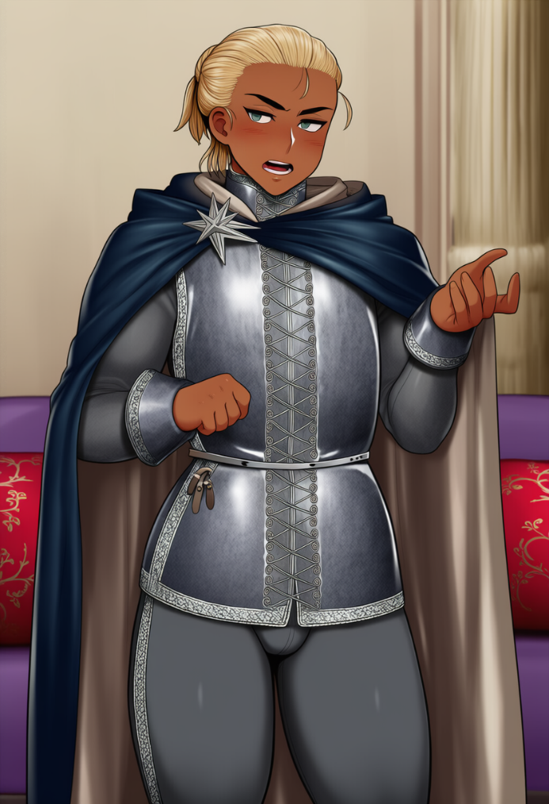
— The journey lasted longer than planned, — he continued, not looking toward his sister. — I… searched and traveled to places that exist on no map, seeking… the truth.
I felt a chill run along my spine.
"Seeking the truth"…
The tone. The phrasing. He clearly meant something else entirely, and it definitely wasn’t about geography.
The princess yawned, completely indecently, and stretched her leg forward so the slit of her turquoise dress opened all the way up to her thigh. Several advisors turned their eyes away. She, however, smiled straight at them, almost defiantly.
A stab hit my chest. God, Stephanie, I don’t recognize you at all. Not one bit.
— And yet, — the prince said, — the most important part of my journey… is not the new lands. And not the negotiations. And not the wandering.
He paused. Just for a fraction of a second he fell silent, looking over the spacious hall, and I closed my eyes, feeling my legs about to go numb and praying he would finish faster. And as if it actually worked, he continued again.
— …the most important part of the journey — is what I was seeking… — he paused again, and I bit my lip, feeling my breasts grow heavy like they’d been filled with lead, pulling downward with such force they felt ready to slap onto the marble separately from me. The skin beneath them stretched with a painful burning, my shoulders started trembling — I could no longer feel my fingers in my extended arms, and even breathing came hard. But I couldn’t lower my arms. Couldn’t move.
The princess snorted loudly, tilting her glass so far the wine nearly spilled.
— Here he goes again… — she muttered with a lazy smirk. — Someone bring him something stronger to drink before he starts telling us how he saved the world.
This time the prince turned toward her — slow, heavy, without a trace of a smile. Not irritated, no… more like the kind of look he gives people whose words ruin an important moment, but whom he, unfortunately, cannot throw out without causing diplomatic consequences.
The princess met his gaze with a lazy half-smile, lips stretched as if she’d just heard a filthy joke.
I saw the corner of her mouth twitch — and that was it. She tilted her head, took a light sip of wine… and then burst out laughing across the entire hall, loud and genuine, enough to make the glasses ring.
— Oh gods, Dahren, really? — she drawled, leaning back on the throne, her leg sliding even higher, the slit of her dress revealing her thigh. — You just got back — and already these speeches… Can’t you see people are drinking, eating, relaxing! It’s a celebration, dear brother. A celebration! Don’t turn all of this into some philosophical lecture.
Her laugh was ringing, bright. The kind of laugh Stephanie… my Stephanie… never had.
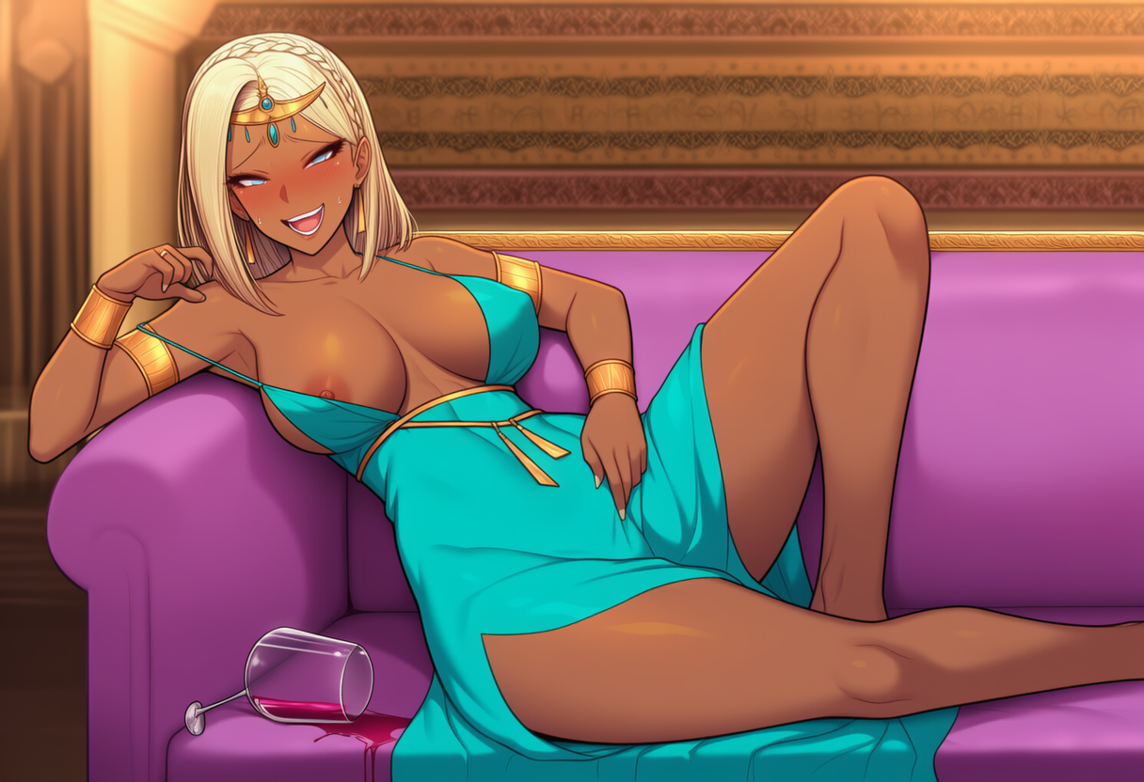She seemed so carried away she didn’t even notice the strap of her dress slipping so low her nipple became visible. Hell, she didn’t even seem to notice she had spilled her wine.
And even though my arms — still raised above my head — were turning into stone, my fingers going numb, my breasts aching from the weight, I couldn’t look away. Was that really her? There was something familiar in her face… but in her behavior — nothing. Not a trace of the woman whose knees trembled when I proposed to her. How did she become like this? Was it all the freedom she has now, or was she always like that?
The hall picked up her laughter with relief — so obvious, so transparent, that even an idiot would’ve sensed the unspoken truth: everyone here had been terrified the prince might drag his speech out for another half hour. A few courtiers snickered, one advisor muttered something, probably approving.
The prince slowly lowered his glass and, surprisingly, didn’t even glance at his sister again. He just ignored her, as if this kind of outburst was normal and arguing would be pointless.
— As I was saying, — he continued evenly, as though her laughter had never happened, — the most important thing… is what I managed to find. And I hope that in the coming weeks I will have a chance to share it with you, honored guests.
But the moment he said “weeks,” the princess rolled her eyes so dramatically that several men in the front rows nearly burst out laughing.
— Music! — she shouted in a voice ringing with impatience, snapping her fingers. — Faster, come on! Let everyone keep celebrating instead of listening to my boring brother.
The orchestra, as if terrified to be late by even a heartbeat, raised their instruments immediately, and I… I never thought I would say this, but I exhaled in pure relief when the first uneven notes sounded.
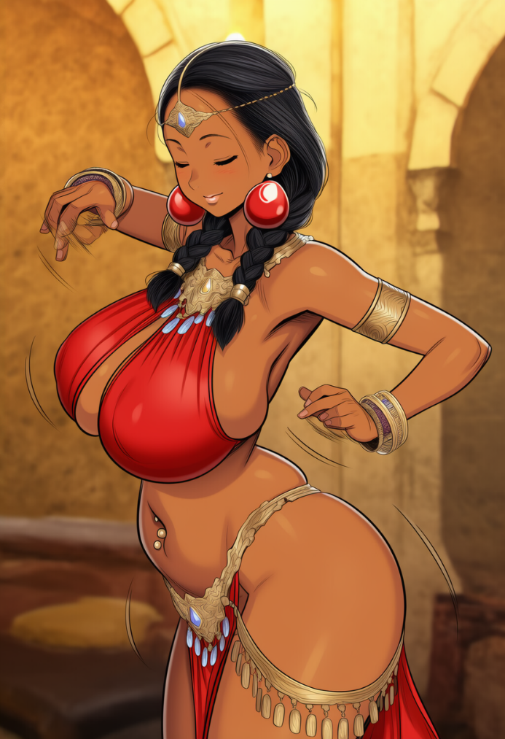
The music returned — and with it returned at least some ground beneath my feet. Standing still had been far harder than moving: my arms ached, my shoulders throbbed, and my breasts… my breasts felt like they were about to drag me straight to the floor, every heavy, round centimeter of them. It seemed that if I stood another second with my arms raised, my muscles would finally give out and I’d collapse onto the marble in front of the entire hall.
But the dance… humiliating as it was to admit, the dance made sense to me. I knew the rhythm. I knew how the marble slid under my foot. I knew where the body’s weight shifted when the hips drew a soft arc. And when my breasts — heavy and alive — tried to swing forward too sharply, I already knew how to restrain that movement so I wouldn’t lose the beat. As much as this anatomy pissed me off, I had learned to work with it.
The music caught me, wrapped around me, and I took my first step forward.
Slow.
Then the second.
My fingers found their airy path again, my elbows opened, and I could already feel the muscles of my back pulling in and spreading, my stomach muscles taking on the main work. I closed my eyes, because I didn’t want to see any of it anymore. It was easier to dance. Easier than standing still. Easier than breathing under the eyes of fifty half-drunk men. Easier than looking at Stephanie. Movement at least gave the illusion of clarity, of something, anything in this world making sense.
And still… it was only an illusion.
Reality was in the way the sweat slid down my spine, tickled my waist, got trapped in the bends of my body. In how my heavy breasts swung my torso as if I were carrying two tight, warm, sloshing water-bags strapped to me. In how these wide, soft, too-expressive hips moved smoothly, and every roll of them seemed to shout to the hall: here I am, Jake, look at me, look at what I’ve become! And fuck, that made me want to sink through the marble right now. Especially when I realized that the dance was no longer just a dance for me — it had become something that I… that I, damn it, somehow… liked?
No, no, it’s just the program. Yes, it’s probably just some stupid software influence. I’m in a dancer’s body, so that would be logical, right?
…right?
I try to cling to that explanation like a life raft, but it disintegrates in my hands immediately. Because the same moment I make another slow turn, and my knee slides gently to the side, my hip arcs out, my stomach pulls in on its own, my arms rise to exactly the right line, I understand: No… this isn’t the program or some template. This is me.
Me. I learned this myself, remembered this myself, spent months, days, sleepless nights on it. Studying the movements in the heat, on those reeking, hateful planks.
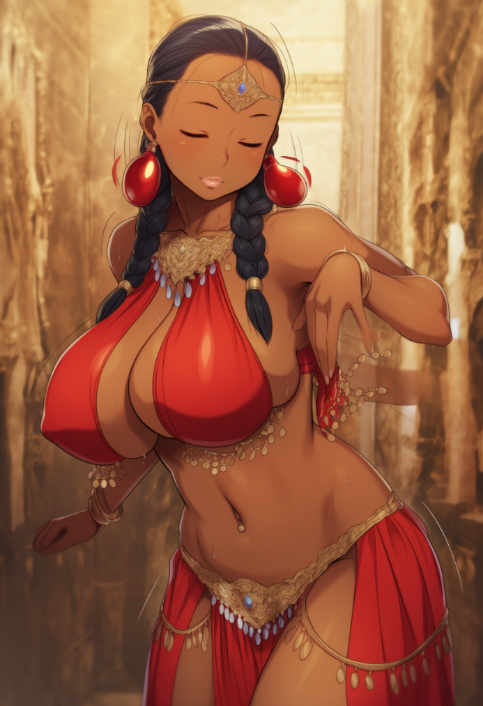
But I had to do it, right? Had to, to survive, because in those first days I danced so horribly that even the boards themselves seemed to groan under my clumsiness. At the Red Gates no one expected perfection from me — they needed something else entirely: a show. They wanted me to roll my hips, move softly, make every step look like an invitation. Simple. And if I tried to resist, or if I simply didn’t move the way they wanted… there were worse options, and I lived through them. More than once.
So yes — I learned. Clenching my teeth, forcing this body to obey. Arching my back when I just wanted to hunch in on myself. Stretching my fingers when my hands shook with exhaustion. Taking steps when my knees buckled from pain. I learned because a woman’s body is not just a set of motions. It lives differently. The weight shifts differently. The breathing breaks differently. And, God, these breasts…
How many times did I silently, soundlessly curse this whole damn curse while it swung too hard, hit, pulled my skin, made it hard to breathe. How many times did I stop the dance, clutching my ribs because the pain shot somewhere under my shoulder blade and cut there like a dull knife. How many times did I think: that’s it, enough, let the devils drag me out of here, I can’t do this anymore.
But then… I pulled myself together. In these damn female hands. And kept going.
Because if I didn’t learn, I wouldn’t be able to get back into the palace. That was my truth, the truth I had always believed in. And yet. Now, after hearing and seeing the princess, after the music wrapped around me again following that whole spectacle, after the marble slid under my foot as if greeting me, after my hips found the arc they had traced a hundred times before… suddenly I caught myself thinking something that made me hotter than all the lamps in that huge hall:
I… like this? No, I shouldn’t and I can’t. I have no right to. But… I do.
Not because my body is programmed this way. Not because someone planted an algorithm of smoothness into me. No.
I genuinely liked feeling my hands stretch upward and the air slip between my fingers. Feeling my back arch and the muscles respond. Feeling my heavy breasts react to the motion — not from pain now, but from the way I’d learned to move them so it looked beautiful. Feeling my hips roll — soft, smooth, natural. God, if only you knew how much effort I spent on this.
Am I actually proud of it? No. No-no-no.
But somewhere inside, at the very bottom, in the place I hide even from myself — something reached for that feeling. As if there, beneath all the layers of anger, fear, and humiliation, sat a small, stubborn spark whispering: “But you did this yourself. You made it. You got better. You… dance beautifully.”
No. No! I almost barked it inside my head. As if yelling at my own thoughts could help.
I was not going to be proud of this.
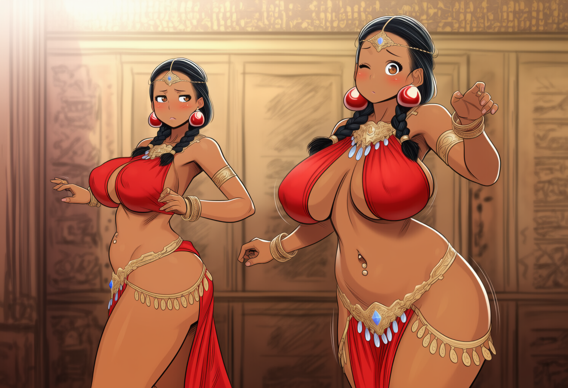I didn’t learn any of it to enjoy it. Not to “polish technique.” Not to witness, once again, soldiers or these courtiers stretching their necks to get a better look at me.
And there were many of those looks now. In this huge hall they followed me, clung to my movements, slid along the lines of my body. Men leaned forward to see better. Someone froze with a glass in hand. Someone turned away from conversations. Even those pretending to be noble still watched from the corner of their eye as my arms rose… and how the heavy curve of my breasts rose with them, barely covered by the fabric.
“God…” — I nearly exhaled out loud during another smooth turn. — “Don’t tell me I really… can love this?”
The music shifted rhythm softly — and I lifted my gaze to the crowd again, saw those looks again, and then my eyes moved to the prince. He was still sitting beside the princess. Not arrogant or condescending, no, more like… calm. Quiet. As if it wasn’t this hall that revolved around him, but he — just a part of the picture, not standing out, yet somehow standing out more than anyone else here.
I didn’t even realize at first that I’d lingered on him too long. As if the music itself slowed me, bent my movement to the right angle so I would have time to take him in.
Broad, strong, confident shoulders — but not shown off, more like… natural, as if that was simply how they were meant to be. A clean line of the neck, sharp but not harsh cheekbones. His hair neat but without fussiness. Everything in its place. And when he leaned slightly forward, resting an elbow on his knee, I saw something… alive in him. Real. Not like the courtiers who either act like peacocks or freeze in stiff postures.
"Well yes… of course. Handsome. A typical handsome guy whose life is perfect," — I tried to scoff inside my head with sarcasm… but the mental laugh came out strained, weak.
Because the longer I looked at him… the more something strange and pulling warmed inside me.
Not desire, no! God, no! I’m not like that!
…but that pulling warmth didn’t go away. It clung somewhere under my ribs and tugged downward, slowly filling me like warm water I didn’t ask for, but which kept rising anyway.
"Not like that…" — I repeated to myself, almost begging. — "I’m a man. I like girls. I like…"
And right at that moment, as if on cue from somewhere outside, I remembered Stephanie. Her smile, her shy laugh, the way she pressed her hand to her cheek when she thought I wasn’t looking. I turned my gaze to her… to how she was sitting now on the throne, shamelessly touching lips with some singer, lazily crossing one leg over the other, playing with the whole hall using only her eyes.
And my next thought — the obvious one after that — twisted something inside me so sharply I nearly staggered.
"See? That’s what you’re supposed to like. Girls. Slim. Graceful. Bold…"
Yes, damn it, exactly. I answered myself while my hips moved in a smooth arc. Those are the ones I like. Not this pulling, confusing, hot feeling under my ribs. Not this… strange, unfamiliar, and definitely not manly thing. No.
I even pushed the movement with my hips harder, making a wider arc, but it only seemed to underline something inside me and whisper: you know who you are.
And right at that moment the prince lifted his eyes to me, and our gazes collided so sharply it felt like I’d been hit with electricity.
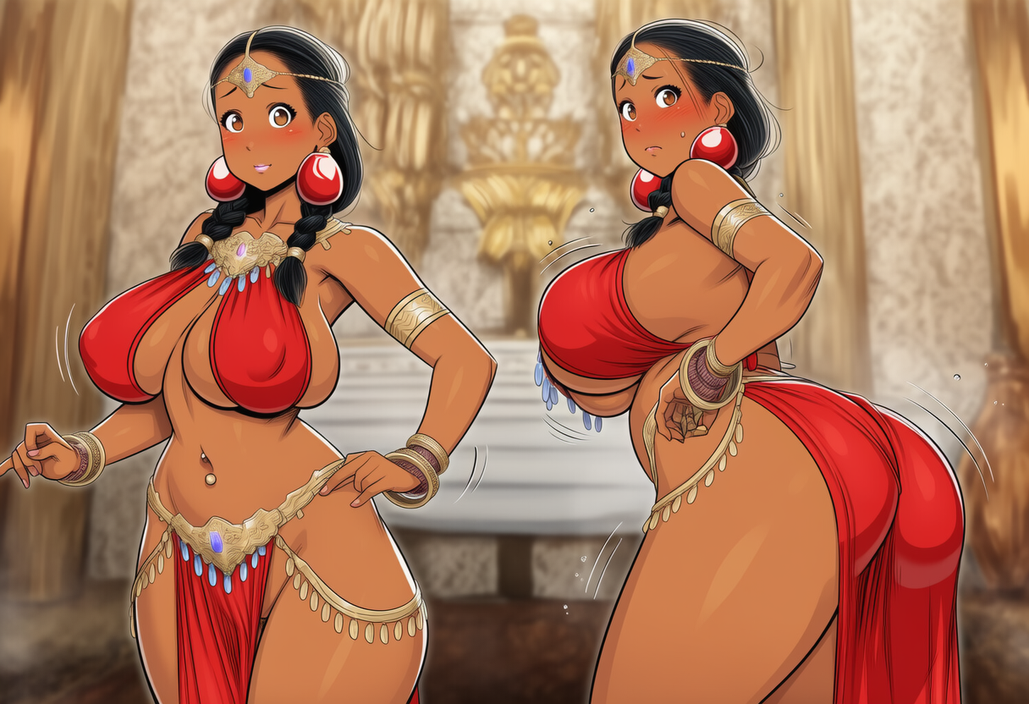
I actually felt a short hot jolt run down my spine, making my breasts twitch and sink heavily downward, my breath breaking on a half-inhale. He wasn’t just looking in my direction — he was looking into me, as if he knew who I was better than I did.
For a second I forgot how my legs moved — no, I forgot I was moving at all. My body kept going on autopilot: hips tracing the arc on their own, stomach pulling in on its own, arms rising on their own… and inside everything narrowed down to one thing — his gaze.
I had never understood before what “a look that steals your breath” meant. I always assumed it was some bullshit from women’s novels, melodramatic crap to trick a chick into sex.
But now… I felt my throat tighten, like I’d inhaled too sharply and couldn’t draw the next breath.
“No… no, stop it! It’s just… just a coincidence! He looks at everyone like that! The hall is big, I just ended up in the line of his sight!”
I tried to look away, but I couldn’t. He held my attention so firmly it felt like he’d reached out, taken me by the chin, and gently turned my face toward him. Inside everything fluttered, tangled up, tightened into some strange knot I couldn’t pull apart. It felt like that gaze meant something, something that could give me more grounding than these damn dances ever did.
And it wasn’t desire. It wasn’t manly or womanly — it was something… stirring. Something that made my knees tremble traitorously and my lips grow a little softer.
He furrowed his brows slightly as he looked at me — and I instantly tore my gaze away, like some embarrassed schoolgirl, and felt my cheeks ignite. And it wasn’t just a mild blush. It was heat — real, deep heat, as if my blood had flared right under my skin.
“No! NO! Stop it! I’m a man! I like girls! Girls, damn it!”
Yes, girls.
But then why did my heart, at his look…
thud.
…make that strange, stumbling beat?
“This body… the body is to blame. It’s programmed to react like that. It’s not me. It’s not me! It can’t be me!”
