Venuses in Furs  A Vignette  By Maryanne Peters  We always get the invitations. It was that way when we started doing it just for fun, but now it has become a lifestyle. You might say that it has gone way to far, but I have learned lately that too far isn’t far enough for me.  We decided to throw our own “Fur Party” because that is how it started, for me anyway.  I had always nursed masochistic fantasies, but never put a name to it. I did not even know where the name came from, or what he wrote, but in time I learned. | 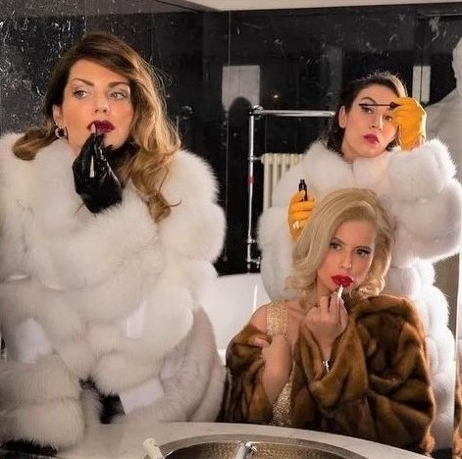

I asked my wife to abuse me, but she always refused. It was her nature to be nice – she could never be cruel – not even in the slightest. The good die young, they say, and she did. She left me with two young sons, and it was not until the oldest was ready to graduate high school that I felt ready to go out and find my “Wanda” – the woman Masoch wrote about in “Venus in Furs”.

I found Ellie online. She told me that I was worthless, and barely a man. I loved the way she talked to me. The feminization thing was her idea. I was happy to be just submissive, but she told me that no real man would ever accept what she handed out.

“Deep down inside you are a woman,” she said. “Admit it. Bend over and scream it out – say ‘I want to be a woman’. Say ‘crush my balls. Cut my cock off’. Say it!”

I said it. I was shaking all over, but it was not from fear. I wish it was – perhaps that would be even better?

She made me shave my body, and moisturize it. She said that I should be smooth and soft. She wanted to see the welts. I adored her.

She said that I should wear a chastity cage on my cock. Because she drove me crazy with desire the pain from that device seemed worse than any whip.

“You have to wear it during the day,” she said. “I will keep the key. You must be locked away when we are not together. Remember that you are mine. Nobody goes near that pathetic thing you call a cock, except me. That belongs to me. You belong to me!”

I could still ooze through the cage even if I was not fully erect.

She said that I should grow my hair longer. She wanted to hold my head by my girly hair while she thrust dildos into my mouth and demanded that I suck the color off them. I did what I was told.

I was in way to deep. It became hard to explain my hair and my injuries, let alone something in my pants that did not belong. But somehow that made it all the more exciting – I was pretending to be a man while in fact I was just a thing – a toy for Ellie to play with.

Just like in Masoch’s story, my very own Wanda became bored with me. Sometimes I wonder that it was because I had become so broken and impotent that she was no longer excited by me, but there was nothing I could do about it. I could not fight her even when she discarded me. She owned me and she could chose to throw her toy on the trash heap.

But that is not exactly what she did. She gave me to Patrick.

I was open to being abused by a man. I told him that I had given up being a man because I did not deserve to be one, or so I had been told. Ellie had penetrated me with all manner of dildoes and such, and I suppose that I assumed he would do the same. Except, of course, he did not need plastic.

I suppose that the first time I felt the flesh of another human being inside me, and his seed flowing into me, I discovered that I had been seeking gratification in the wrong place.

“I only punish women,” he said. “But then, as you have pointed out, you are a woman, just an incomplete one.”

I missed Ellie terribly and I so much wanted to be Patrick’s victim, especially after I had tasted the joys of receiving a man. He liked me to keep my cock cage on so that he did not see “The Problem” in my crotch, but he said that he would make it more manageable..

He used suppositories shoved up my butt hole before sex – female hormones.

It was when they started to have effect that I told him that I had a job and a family to deal with. Even though I was completely subservient to him, just as I wanted to be, there were still responsibilities that even in my sex-addled mind I knew must come before pleasure.

“Nonsense, you work for me,” he said. He had his own business and he was to hire me as an office girl, on the condition that I should be occasionally naughty and ridden by guilt because of it.

“As for your family, I want to meet them,” he said.

I took him home for dinner and he simply announced how things were going to be. He said – “Your father is going to become a woman, and she will work for me and be my mistress.”

I have to say that I swooned just to hear him say that. He was so powerful I knew that we could all feel it. It was as if nobody could speak without asking him first.

But then my oldest sone spoke up. He said – “Is it true Dad? Are you going to transition. I am so happy because I am transgender too!”

I never knew. Perhaps I should have known. It was just that since there mother died I had buried my head in sexual things so perhaps I had missed the signs. All I could do was to hold my son (who would soon be my daughter) close and assure her that my love and support was total.

“This is fantastic,” said Patrick. Then turning to my younger son, he said – “What about you. Don’t tell me that I have another man in this household to deal with. It strikes me that you could be the prettiest in the family.”

Pretty soon she was. She just followed her father and her brother, I guess – or rather she followed her mother and sister.

Patrick moved in with us. We became his women. He calls us his “Venuses in Furs”. Perhaps you know what I am talking about? Anyway, like I said, the “Fur Party” is something we throw every year, around the anniversary of Patrick moving in, because that is how it started.

As for our love life, I should only talk about mine. Patrick doesn’t punish me anymore. He says that even when I am naughty – and sometimes I try to be – I am simply perfect, so there is nothing to punish me for. Strangely, I don’t miss it. It was a man thing, you see, and I am not a man anymore.

The End

1210

© Maryanne Peters 2023

