Pretty Little Pothead  Inspired by a Captioned Image from PJ’s Caption Corner  By Maryanne Peters  They say that too much pot affects your hormones too. It started to show with gynecomastia. Do you know what that is? It is like growing a pair of little tits on your chest. Mum said it was all down to playing with drugs, but now I am wondering if she put something in my food.  I suppose that I now realize that she was just trying to look after me. That is what mothers do – right? She was right, the guys I hung with were just interested in getting high.  The other thing that Mum said she noticed about “my friends” is that they were always putting down women and calling guys who didn’t do as they did, sissies. I guess Mum figured that this was the way to get them out of my life.  She found my stash and said that she was going to burn it all in the garden, or, if that is what I wanted to do, I could smoke it all. | 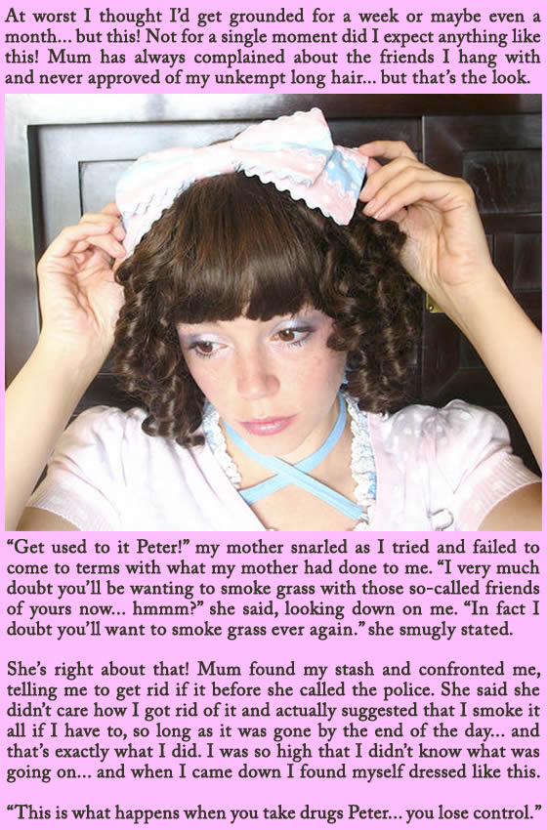

She told me later that if I had let her destroy it then she probably would not have gone ahead with her plan, but when she saw me almost unconscious have taken the bad option. I was in so much of stupor that I never even noticed every hair being stripped from my body and my hair being styled in bangs and ringlets, plus plucked eyebrows and lip stain.

When I finally came to she told me – “This is what happens when you take drugs, Peter … you lose control.” She told me that she had the bonfire she promised, and all my clothes were on it. All I had to wear were these ridiculous ultra-feminine outfits.

When I looked in the mirror I was supposed to see somebody totally humiliated – a true sissy that could never associate with the guys that she blamed for introducing me to a life driven by pot-smoking. But instead, I saw something that captivated me beyond all understanding. I saw a girl – a pretty girl.

I had lost control. But perhaps not in the way that she might have thought. I found myself surrendering to the thoughts in my head. Maybe it was the last of the influence of all that weed I had smoked, or whatever hormones were floating around inside me, but I don’t think so now. It seems now that my mind was clear, as if illuminated by a bright pink light.

I am Petunia now. Not a pretty little pothead at all. I am just high on being a girl.

The End

Master Coach  Inspired by a TG Alice Captioned Image  By Maryanne Peters  It was not quite like that. It was just that Coach always talked about understanding every play of the team, and digging deep to find their true psyche. Every player was interviewed, and some of the results were surprising.  Bobbi was first. That’s her on the right. Whatever the coach said in that private session it resulted in her revealing that she had always suffered from gender dysphoria, and football was a way of fighting it.  The coach said that was all wrong. He said that in addition to performance enhancing stuff he had access to the drugs that she would need to achieve her full potential, and that would not be on the field.  “You can be part of my personal team,” he said to her. That was last years. She has grown her hair and those tits and all natural.  Then at the start of the season he interviewed Jamie – that is her on the left. Once they were in private Jamie broke down and told Coach that he had fallen for him big time and could not sleep for imagining being fucked by such a strong masculine guy.  “My personal team are all women,” said Coach. “But I can help you qualify”. | 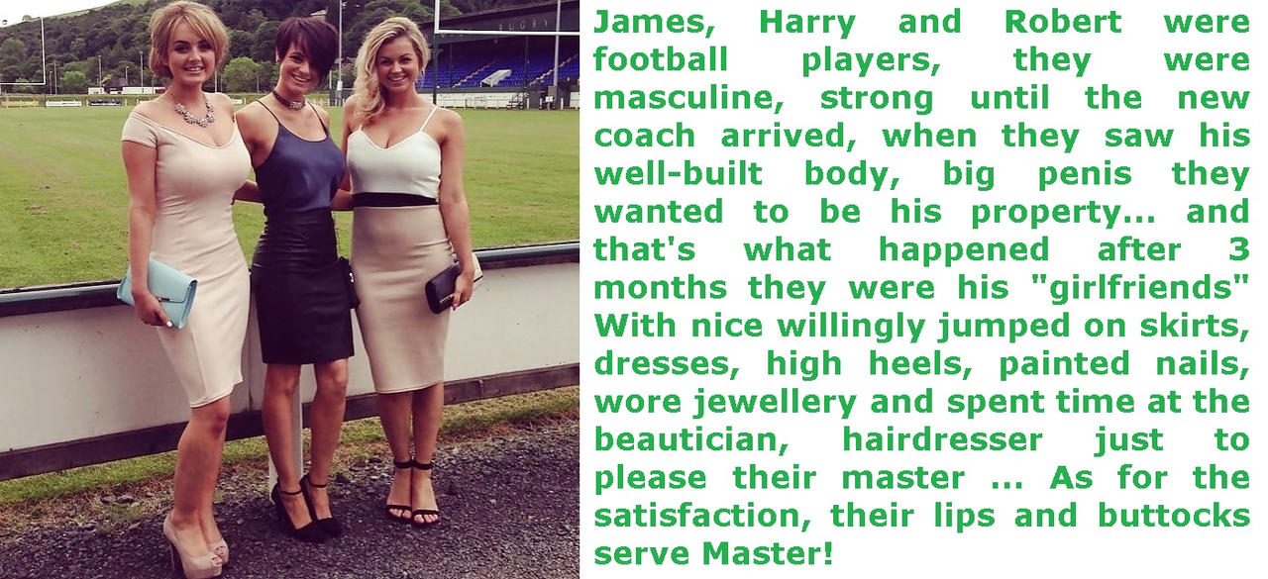

That is me in the middle. I am the last one to join the Coach’s personal team. I guess that I just saw Bobbi and Jamie carrying the coaches stuff and looking so gorgeous and so happy to be dominated completely, that I wanted a piece of that too. I had worked hard on being a better player, but somehow it just seemed easier to be pretty and looked after.

I am working on growing my hair and my breasts, so (like Jamie) I need a little concealed support under that top. I have some catching up to do, but Coach treats us all equally. He is so big and strong and full of male juices that he seems to be able to keep all of his personal team as happy as we look.

As he says, it also serves to remind the boys on the field that if you can’t perform then maybe you belong on the Coach’s personal team?

But for now, the three of us are happy to serve or Coach and Master.

The End

The Captioner
Inspired by a Captioned Image from NRAEcaps
By Maryanne Peters

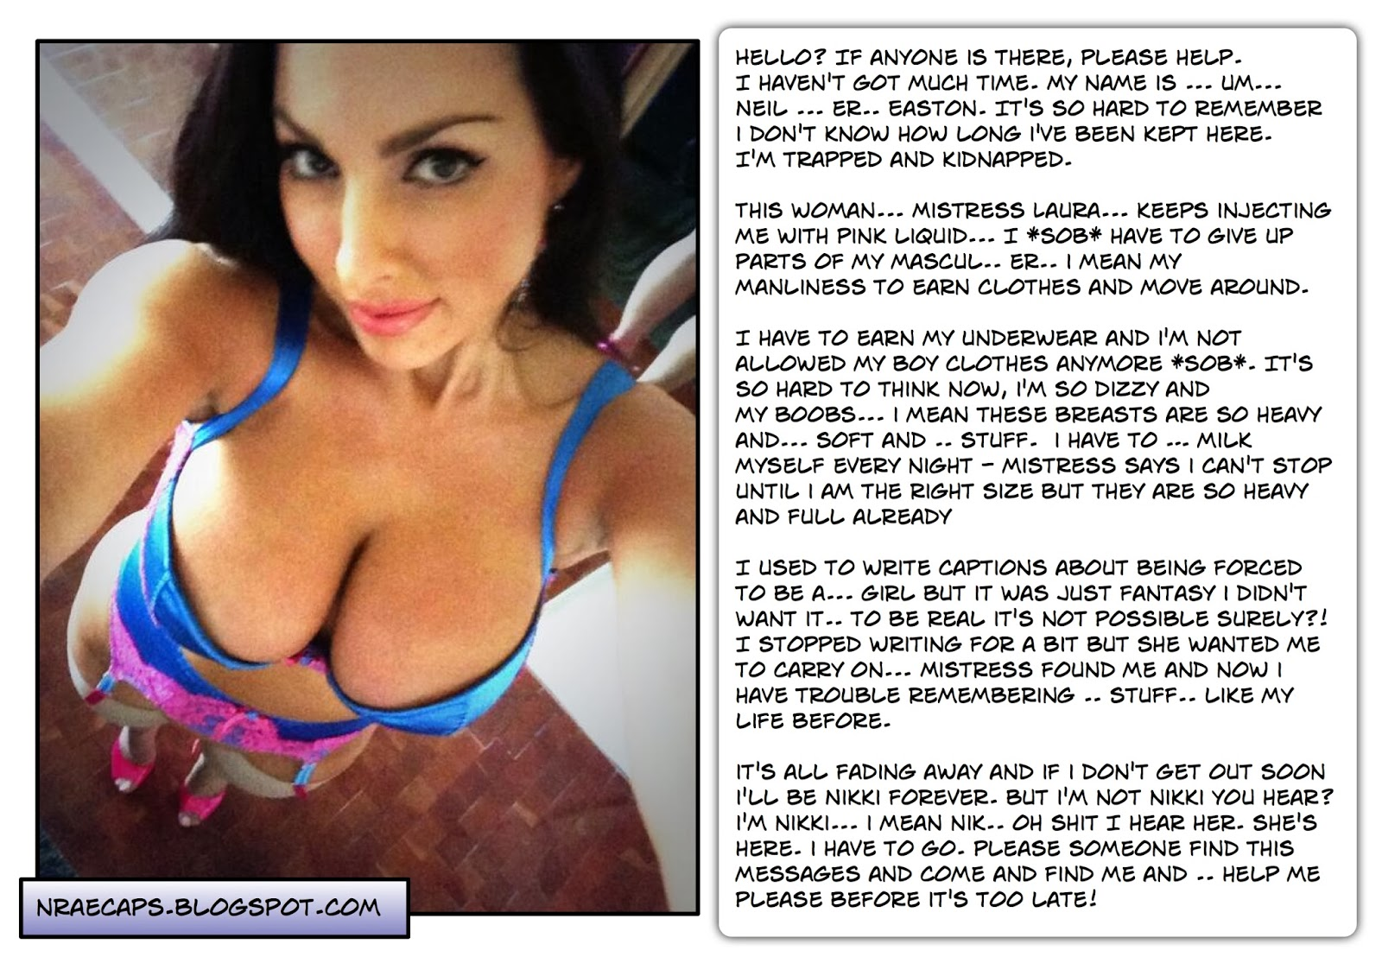

I used to write captions. I remember that much. I used to find images of sexy girls and imagine that they were once guys. OK, so it was kinky I guess. It was always about the guy being forced to be a woman. It was pretty harmless. I would just jack off at the thought that she was once a guy and was now forced to be female. Who doesn’t have a fetish? I liked the idea of guys who ended up as fuckable babes, and fucking them. Is it that weird? Maybe it is. You just have to keep it in your head.

But I had to push it. I went online searching to see whether this was real. I checked out a few sites under the tag “forced feminization”. I had to find out whether guys out there were really being forced to change sex and submit to men – men like me, I guess. I was prepared to seek them out and try to live my fantasy.

That was when Laura replied. She said that I should call her Mistress Laura like all her subs. I explained that I was not that. I was searching for one of those post-transformation and I was prepared to pay to meet and fuck the “woman” of my dreams.

“It is real,” she said. “Send me the deposit and I will send you an address. Keep it confidential and tell tell nobody. These subs are being changed against their will, so this is a crime. You understand that don’t you? You will be participating in physical abuse.”

Of course I knew that! I was ready. No, I was crazy ready.

The address that I was given was just a front. It lead to another address and then another. But I understood. I was now a long way from home. I met Laura and she sat me down and gave me a drink.

From that point everything went fuzzy, and I mean everything. I cannot even remember where I used to live and I can barely remember my name. I have just worked back to remember how it all started. Ok, so Laura has filled in some of the gaps there by showing me some of the captions I wrote and how I craved to see men forced to become women.

Laura tells me that I am now getting what I want. I am living the fantasy.

It is just that I get fucked every night, and I am pretty sure that was not part of the plan. But maybe it was? As I say, it is all pretty fuzzy.

Hi, my name is Nikki.

The End

Parisian Spa  Inspired by a Cap by Iwannabeclaire  By Maryanne Peter  I had always battled with my weight, ever since I was a small boy. I was too chubby to play sport without looking like a total failure. I guess I became a bit introverted and just stayed at home gaming, and letting my hair a my waistline grow.  But the thing is that I am not a naturally shy person. Online I was able to project myself as an interesting person. It was just that it was all a lie.  For some reason I got interested in French stuff. I think it was somebody I started gaming with who suggested that I learn French, so I did. The resources to learn a language on line are pretty good, and I got the hand of the pronunciation. I dreamed about going to France. But I was a blob sitting in my room in Philly.  Then I saw this thing about the La Tresse Spa (it should have an E at the end because it is feminine) offering patented herbal treatments “no deprivation guaranteed and satisfaction guaranteed”. I sounded great, but what sounded even better was that it was in Paris, France – the place I dreamed of visiting.  All I had to do was sign up and play the deposit. That was the easy part – then I had to get out of the house and squeeze into an airplane seat with the help of one of those belt extenders. I figured that I should at least try, and nobody knew me in France so what did it matter?  La Tresse was right in the middle of town. It was through one of those giant gates with a smaller do in it, opening to a courtyard and a large house – but it was all the spa, except for the gran banquet hall at the back. | 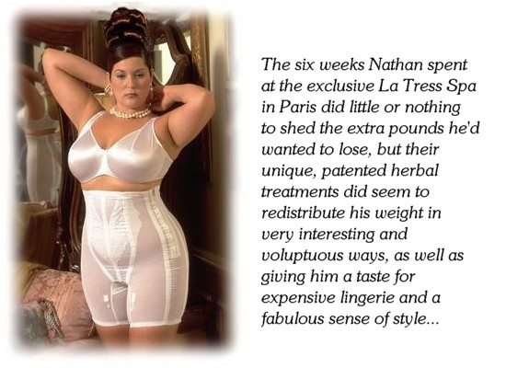

As they explained to me, insofar as I could understand them, they spent my first hour there trying to understand me and formulating a spa treatment specific to me. I told them (in the best French I could put together) that I hated my life and that I wanted to be attractive and sociable. I said that I would take any treatment they recommended.

They talked to me about “a totally new life” and that sounded great. I was nobody back home. I was ready to put everything behind me and start afresh. They said that they knew how to do that.

« Êtes-vous prêt à vous remettre entièrement entre nos mains ? » - “Are you prepared to put yourself entirely in our hands?” My answer was a definite « Oui!» - yes!

I could feel my body changing within a few days, and then they introduced me to a special underwear that could help me to lose weight. The initial garments were not white lace but black and almost rigid fabric, but it was effective. I was losing weight but the weight I had seemed to be pushed up to my chest and down onto my butt. Still, it seemed to be working.

I suppose that I started to think that things were not going the way I expected when they started to style my hair. They had washed my hair and “polished” my body on my first arrival, but now after a few days of conditioning my hair the stylist started to play around with putting my hair up in a variety of styles.

My first thought was that they were just playing around. I was enjoying being pampered and having somebody play with your hair seemed like part of that. I sat back and enjoyed it. It was just that the styles became increasingly more ornate.

By the time that they announced that I would be attending a formal reception and dinner at the grand banquet hall, I was wearing my hair high with pinned curls. The reception was to be “the start of my new life”. They presented me with the underwear I would need to fit what I would be wearing, and some “accessories”.

It would be naïve for me to say that I suddenly discovered that I would be going to the ball as Cinderella – a woman. I was being slowly pushed in that direction and had already acquired a shape that was less than masculine. It was just that I had promised to place myself in their hands, and I was curious to see whether they could deliver. Would I be satisfied with the treatment? Would there be a fairy tale ending?

The image catches the moment. My hair looked fabulous and my body looked better than I could ever remember. It seemed like all that flab had been placed exactly where it belonged, and that I looked desirable, perhaps for the first time in my entire life. All I needed was to put on the dress and shoes, and add a little makeup. But even without that, there was no mistake that I was somebody else. My life could start anew. It was my decision.

You’ll never see a happy ending unless you say the word - « Oui!» - yes!

Whether they had been arranged or not I do not care. At the reception it seemed like every man wanted to meet me and every woman nodded in my direction in quiet admiration. No only had I stepped into society, but I was more alive in it than I ever could have imagined.

It is too early to tell whether love is in my future, but now I am an American woman in a Paris full of French men who truly appreciate a woman with a voluptuous figure. It is the City of Love after all. How would you rate my chances?

The End

Working for my Father
Inspired by a Captioned Image
This by Dontshunitfunit on DeviantArt

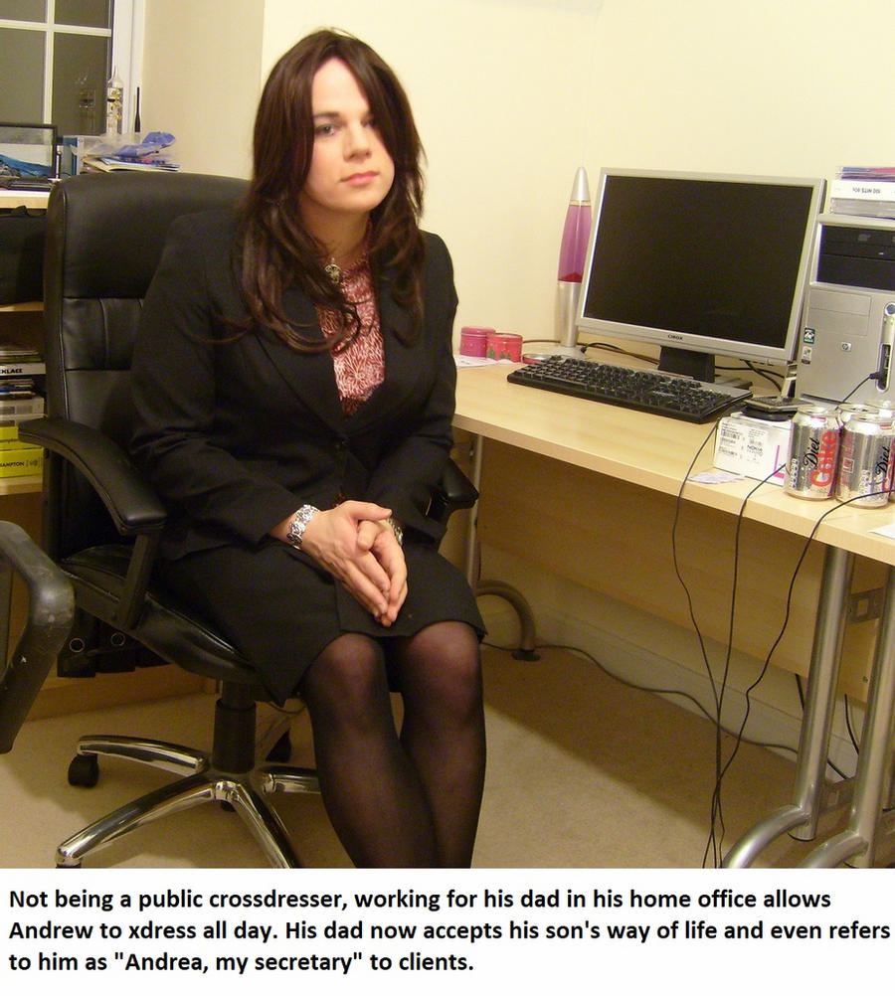

Daddy likes me to be organized as you as you can see. I have face and breast creams next to my lava lamp and my boxes of hormones next to my cans of Diet-Coke. Daddy says that being organized is the secret to being appreciated. He appreciates me. I know he does.

He never liked Andrew. Mothers love all their children but fathers pick and choose. Boys that can’t be what their fathers want them to be must find their place elsewhere. I never wanted to leave, but I always feared that if my father found out that I was a crossdresser he would throw me out.

But in these days of greater understanding on gender issues I was ready to discuss things with my father. I expected that he might be mad. I just explained that I had a thing – I like to dress in women’s clothing from time to time.

To my surprise his only question was – “How often are we talking?” He then started to talk about things transgender, which seemed like he had totally missed the point. “You can’t do things by half, Andrew. I would not have been as successful as I am today by doing just a little bit. It seems to me that you have to be all in.”

“I am not sure that I am ready for that Dad,” I said. “I would not be ready to start wearing a dress to work.”

“You have a shit job, Son. I know your skills. You are too good for them. Come and work for me. I will pay you twice what you are getting and you can dress as a woman full time.”

I guess that was not sure that this is what I wanted, but it seemed like for the first time I could get closer to my father than I ever had been. So I accepted the job and now I work as his secretary.

All of this happened during Covid lockdown which is when he took this photo. Because if Dad’s “acceptance of my way of life” I had been living and working as a woman 24/7 for months at that point. And he got me the hormones … and I took them happily.

I guess that he was right all along. I thought I was just an occasional crossdresser but it turns out that I am a true transwoman, and since I am back in the workplace I have discovered that I am a heterosexual woman too.

The End

© Maryanne Peters 2023

