The Lois Einhorn Story
A Short Story inspired by an old Movie
By Maryanne Peters

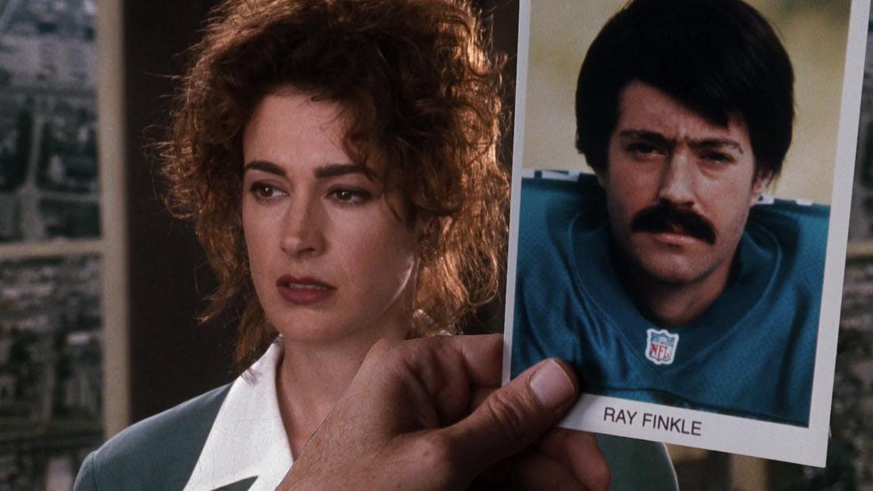

I don’t think that anybody can understand the true power of shame until you are drowning in it. Everything depended on that kick, and when my boot hit those laces, I knew that I would miss. How many times did I tell Marino – “Laces out!” The hero of the Miami Dolphins is an asshole – he cannot get such a simple thing right. The contact with the boot needs a smooth surface. I just stood and watched it go wide. Just 26 yards and it missed. The whole stadium gasped, and then the abuse started. The game was lost. The Dolphins were out – Superbowl losers – the very worst kind of losers. And Ray Finkle was to blame.

I know what football fans are. Fans never forgive something like that. History lasts forever, and my small moment of fame in football history was that kick. It was just so easy, if only the laces had faced away from me. Instead of the San Francisco 49ers rejoicing, it would have been us. Their fans pointed at me and laughed. The Dolphins fans wanted blood – my blood.

People can talk about sticking it out and standing tall, but nobody can understand it without experiencing it. A whole state hated me – my home state. I hated myself – I had failed everybody who had expectations of me. Football was everything to me, and that career was over. Nobody hires a kicker who misses shots like that. I had always believed that football would take me places, and a super bowl ring counts for a lot. Instead, I had a halo of shame following me.

I ran. I am not proud of that, but pride meant nothing to me. That was dead and buried as far as I was concerned. The only place to go was back to Collier County and my mom’s house. Even then I hid in my old room with the curtains drawn, and told her to tell nobody. She was the local beautician in our town and had a lot of friends who didn’t follow football. Still, she said nothing and I stayed in hiding.

She ran her salon out of the back of the garage. She had all kinds of equipment and products. It was her idea that I venture out in a disguise, dressed as a woman. The idea seemed crazy at first, but she showed me some before and after photos of her “miracle makeovers” and I started to believe that it could be done. The fact is that I was spiraling down in isolation, and I would go crazy if I didn’t venture outside. I agreed to submit to the makeover.

I spent a few weeks living as my mom’s niece Daphne, helping her out in the salon and going outside to enjoy that sun in increasingly skimpy clothes. I started to take hormones. I was starting to think that the best way to live with myself was to accept that Ray Kinkel was dead and that I was now Daphne, the complete opposite of everything Ray was. I had swapped the ball for curlers and combs – I was nothing like him – not him at all.

But inside I was still seething. Shame had turned to anger. I was not really to blame – it was Dan Marino. “Laces out!” How hard is that to get right? Dan Marino had to die.

The problem was that I could not share these thoughts with my mom. I needed to vent, and the only other person in the room was Ray. He was still there, hiding behind Daphne, so weak and pathetic. He had to die too, but what future could there be for Daphne. She had nothing – she was not even a real woman. It was all very confusing and highly emotional.

I don’t blame my mom for calling in the white coats. It had been a bad night with Ray shouting at Daphne and Daphne crying and screaming back at Ray. God knows what they thought when they entered the room and were meet with the sight of me literally wrestling with myself. Later I heard them refer to it as schizoaffective transference, but at the time I can only remember being held down and sedated and waking up in a mental institution.

Even there, the shame of that game followed me. All the male staff knew who I was, even if the longer hair and the lack of Ray’s moustache made me look different. Because it was known that I could find no peace in company, after a while I was allowed to spend more time on my own walking the grounds, which gave me that opportunity to escape.

I have heard it said since, that I should have taken the treatment and things would not have got as bad as they did, but I can’t accept that. The fact is that mental disease remains, and all that can be asked of a patient is that they be able to ignore the stimuli that cause breakdown. But in Florida that was never going to happen. Escape and disappearance was the only option, preferably putting an end to the existence of Ray Finkel

I had never intended to kill the real Lois Einhorn – I suppose that you could say that she was in the wrong place at the wrong time. I had jumped in the back of a truck to get out of state, and I met her hitching the other way, headed down to Miami for a job. She said that she could afford the bus but that she liked hitchhiking for the company. She was outgoing and confident – nothing like I had become. Why did she have to start talking about the Superbowl that had happened months before? She just went on an on. I bashed her head in with a rock and slid her body into a pond full of alligators to disappear forever.

If it had not been for the experience of being Daphne for a while, I never would have been able to assume her identity, but when I opened up her backpack it was all there. There were her clothes and all her personal papers, including her certificate from the Central Missouri Police Academy and the letter from Miami Police offering employment. Imagine that – I could be a police officer. I could return to Miami as somebody else, and I could bide my time and plan my revenge on Dan Marino, and being in the police I had the advantage of finding a way to do that and get away with it.

I had not known Lois for long, maybe less than an hour, but I had a clear idea of who she was, and I decided that I would do more than take her identity, I would be her. She was everything that I used to be, and nothing like the person I had become, and that I needed to leave behind. She was forward and sassy, and that was the Lois that the Chief of the Miami Police Department met the day I arrived back in my home city.

I told him that I had never been to Miami before, but I was a quick learner. I would need to ask many questions that I already knew the answer to, and to pretend ignorance of local facts. My weakness was that I had never been to any police academy, so what I really needed to learn was the local manual, back to front. By being a rookie who knew the rules and was seeming to learn the neighborhood faster than anybody, I looked like a star.

I was self-taught when it came to questioning, but I learned that some special abilities that countered for something, and two of them had been growing on my chest from the moment I started back om estrogen. I learned that female cops pretending to be hardasses like the males, could never win, but when it comes to questioning men, a pretty girl who can look at a man in a certain way can just open him up and the words flood out.

The fact is that the Lois in the belly of some crocodile down in the swamp was not nearly as pretty as I was. I had her sass and assurance, but with added sexuality. I suppose it was only a matter of time before I learned that a pretended attraction to men could become real.

There was a time when I would have been disgusted by the thought of being kissed by a man. The first time was after a long date when he paid for everything. It just felt like the fair thing to do. It was not supposed to be wet and probing, but when it became that, I felt good. He was getting pleasure and so was I. I put it down to the fact that I was becoming more Lois and less Ray, with each passing day.

I confess that I even park my thirst for revenge so that I could do my job better. There were moments when the crimes of Dan Marino and the other offenders against Ray Finkle, dropped out of my mind completely. They were the days when I got up in the morning and saw only Lois in the mirror, looking good and ready to get working in a job that she loved, and which was helping people. But then there were days not like that at all.

The worst of it started when the Miami Dolphins brought in their new mascot – Snowflake, a live dolphin. There was a huge fuss made about it, and there was Dan Marino crowing about his success. We could have won that game if only he had placed the ball the way I asked, but no – he didn’t, we didn’t – it was all his fault and nobody knows. Something snapped.

I suppose the rest is history, if history even records such things. I was caught and exposed to the world. I was accused of being Ray Finkel, because in that moment of madness, I was Ray Finkel with all his insecurities and need for revenge. I could have lived as Lois Einhorn, and been a quiet success as her, but with my crotch exposed for all to see, it seemed like she was finished, and not just her career.

I had committed multiple crimes – kidnapping, stealing the dolphin, and other crimes. I would have gone to jail had it not been for the psychologist.

Dr. Mark Pfenning was a sincere man, and I could see immediately that he was struck by Lois. After almost ten years living as a woman, and using feminine charms with the police force and throughout my work, I knew the power of my appearance. Somehow, while the presence of male genitals disgusted so many when confront by them, I knew that Mark would understand what transgender means, so that was the card I played.

Yes, Ray Finkel was driven insane by revenge, but deep inside he was wracked by gender dysphoria. Becoming Lois was his way out of madness. Of course, I said nothing about the real Lois except that I had found her bag by the swamp and taken advantage of the identity it presented. She was the person that Ray had always wanted to be. She was not crazy – he was. Then, in a moment of crisis, the personality of Ray Finkel had risen up and taken over.

Mark diagnosed that I was suffering from a multiple personality disorder, and that I was unfit to stand trial for the crimes I was charged with. I was to be returned to a psychiatric institution, a place I was familiar with, but this time as Lois Einhorn, not Ray Finkel.

I cried as much as I could make myself. I pleaded with Mark that I was ready to put Crazy Ray behind me forever. I could be Lois again and forever. I used my big, mist, feminine eyes to the best of my ability, and I knew that it was working. Of course, I would need to spend sometime in the care of the State, but I was working on a way out of this.

It was just that what Mark was proposing was difficult to accept, even while there was logic to it. In order to ensure that Ray never returned, Mark was proposing that I undergo sex reassignment surgery – removal of my male genitals and creation of female bits in their place. It was something that I had avoided, but as Mark pointed out, this could be the ticket to my discharge from care.

I suppose you could say that I had created this problem myself, but it seemed that I had no other way out. I was already Lois Enhorn, then a self-declared pre-operative transwoman, very feminine in appearance, but with male parts. Thanks to Mark’s recommendation, the State would pay for the surgery as treatment for my disorder. There was no way that I could refuse treatment and be able to leave that institution.

There are people who will say that there is no justice where somebody like me should be able to go free after all that I had done, but my answer to that is simple – this is the Lois Einhorn story, not the Ray Finkel story. He was a madman, weak and insecure, driven to crimes by shame to great for him to overcome. Lois was the person he should always have been – strong, driven, feminine and sexy. Her only crime was allowing him to return in that moment that so many have heard about. Now he can never return – his parts went to the hospital furnace.

Mark Pfenning was the first to make use of Lois’s new parts. It is entirely unprofessional and improper that he did, but I knew that in order to escape that institution I would need to use all the charms I had developed over the years, and the new body that treatment had delivered to me. I now live with him, but discreetly.

I avoid football like the plague. I am concerned that it might trigger some kind of relapse.

I would like to leave Florida completely. If Mark can find work in another place then we may even be able to live as a couple. But to be honest he is really not my type. He is weak and insecure and a little too easily led. He reminds me a little of Ray Finkel.

The End
2424

© Maryanne Peters 2026

Author’s Note: On Fictionmania Message Board, Diana Prince asked : “I'm trying to gauge and see if anyone would be interested in co-writing this story about Lois Einhorn from Ace Ventura.” The Jim Carrey led movie “Ace Ventura, Pet Detective” included the character Lois Einhorn who was later discovered to have been a shamed placekicker for the Miami Dolphins, as well as the villain of the story. I agreed to write my own story about her.

