Nice
A Vignette
By Maryanne Peters

Dad and I were nice guys. The kind of men who just want to please the people they love. What is wrong with that?

Mom and older my sisters were strong women. Mom always said that she knew what she wanted and that was to marry a man who adored her and would do anything for her. That would be Dad. She said that I was a chip off the old block and just like Dad, but I think that disappointed her. She wanted me to be more like her.

Even nice guys can be led astray. April was Mom’s beauty therapist and best friend and so she expected Dad to care for her as he did. That meant that she wanted Dad to please her, but she never would have guessed that April would fall weeping into Dad’s arms and beg him to have sex with her. I found out, but when she asked me not to tell Mom, I figured that telling would hurt too many people, so I held my tongue.

Dad did it only once, but being the man he was he felt guilty and had to explain everything to Mom. I guess most men would have tried to bury it and live with any guilt, but that was not the man Dad was.

Mom reacted very badly and Dad was not surprised. Mom said I should have told her, so I was in trouble too. But she was furious with April.

April tried to explain that her boyfriend had just broken up with her and she needed a man – she used Dad – took advantage of him because she knew that he was too nice to refuse her – said it was 100% her fault – begged for forgiveness.
Mom took a night alone to work out a punishment for all of us. April would be required to turn both Dad and me into women for a month and then have us work at the beauty shop for a month.  It needed to be a total transformation so that meant skin and hair, which is what April did – hair extensions and styling, and depilation, skin softening and makeup. Everything else could be achieved through wearing the proper garments to give a feminine shape to both of us. | 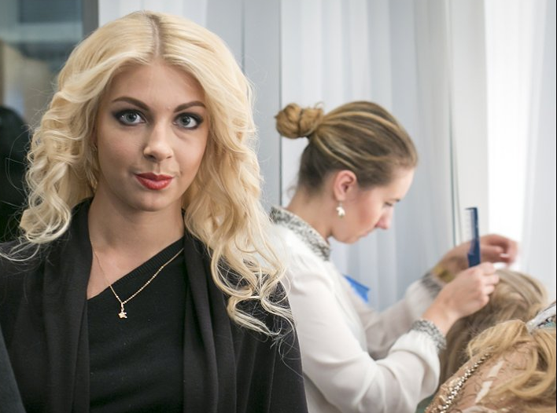  Dad with his new look and April working on me in the background

April wanted to do the best that she could, and we think that she did, but when she was finished she was horrified to see us looking the way we did. She said that the best way to cope was to pretend to be what we looked like – women – mother and daughter. She gave us some tips, and the rest, including how to speak with a female voice, we had to learn.

You might imagine how confused we were stepping out into the world as completely different people, but as Dad said, we were in this together. He said that people should pay for their mistakes, and he was just sorry that I had to pay too. But we agreed that we needed to do our best to be useful to April. Dad took on a job as a shampoo girl and because I had some experience with my own nails, I became a junior manicurist.

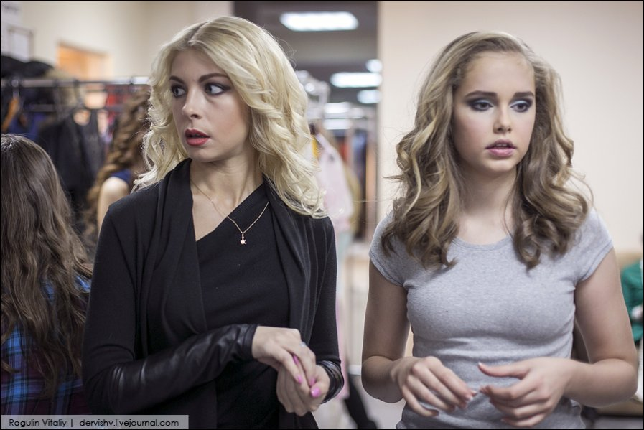

We decided that we need to have feminine names and Dad came up with Eve and Dawn. I was Dawn because I was just starting out. We also got used to female pronouns, and somehow being referred to as she or her helped us get into our roles.

When Mom saw us for the first time she laughed out loud, but when we started talking to one another in our lady voices I think that we both realized that she was shocked. Eve said – “We don’t have to use these voices if you don’t want us to?” It was the nice thing to offer.

“Oh no,” said Mom. “The idea of this was to keep you both away from women by being women working among women, so why not be women for the month?”

She said that Dad could sleep in the spare room, and he accepted that. He just said – “And please call me Eve when I am dressed like this.”

So that was how it all started. If the idea was to keep Eve and April apart by having them work together as two women then I worked. April was no longer attracted to this person, and as for Eve, I think she understood even before the punishment that what she had done to Mom was not nice.

But it also seemed that Mom had over-reacted. And being the people that we were – people who just want to please the people they love – we need people to love. And the kind of people who appreciate people like the people we had become, are men.

I suppose you might have called me “sexually adventurous” but when I was asked to do a manicure for a man who had come in off the street with bad nails, I found myself flirting with him. He asked me out, but I explained that I was staying with my mother, the blonde woman in the hair-wash station.

“Wow, your Mom’s a knock-out!” he said. “Actually, my Dad is unattached so maybe we could make it a double date.”

I said okay, so I guess that makes me responsible for all that happened after that. It was just that Eve is a nice person, and so am I. Her date treated her so well on the night that she felt that needed to give something back, and by the time the evening was over it wasn’t over for Eve. I mean, somewhere along the line Eve must had to explain the presence of something that did not belong on a pretty woman, but by then he was smitten.

Mom had nothing to do with us for the rest of the month, so by the time that she was ready to release us from a feminine bondage, Eve was reluctant.

“While I have been living this way, as you wanted me too,” Eve explained. “I have found a boyfriend who treats me very well. You haven’t even noticed that I have not been sleeping in our apartment for weeks. I sleep at his place. We have sex … I receive him.”

Mom was disgusted and threw Dad out on the spot. Dad still cared for Mom but part of that is knowing when to go.

“What about you?” she said to me.

“Actually, I am undecided,” I said. “You always said that I was a chip off the old block but I should be more like you, and I guess I am both of those now. I have lots of guys interested in me … more than I had girls as a guy. I suppose I have discovered that being a girl is … kind of nice.

The End

© Maryanne Peters 2023

