“One Night Adventure: The Tutor” is a big story.
Maverick has said so before, but it wasn’t until exploring the latest draft version myself that I started to appreciate just how big it is.
While, as the title suggests, much of the action occurs during a single evening, the consequences and choices continue to play out over a longer period. There are a quite a few different endings. Exactly how many technically unique possibilities there may be I’m not quite sure, but at the least there are several substantially distinct outcomes depending on your choices.
It’s in those choices, rather than the ultimate destinations, though, that I think the real enormity of Maverick’s work lurks. As you read through the story you’ll be presented with a few choices at the end of most passages. You pick one and carry on to the next passage. That interaction can make it seem like you’re navigating a fairly simple branching path. What you won’t see is the set of other choices that often exist in a given passage but remain hidden from you, in a reflection of your decisions up to that point. Based on my poking around in the coding, behind the scenes of your visible options in any given passage and the branches they lead you down, there are over 50 persistent consequence flags in play.
To better illustrate the complexity that spawns, here’s a little peek under the proverbial hood, using the game development tools to display part of the story at the passage connections level. Just look at that crazy rat’s nest of interlaced connectivity.
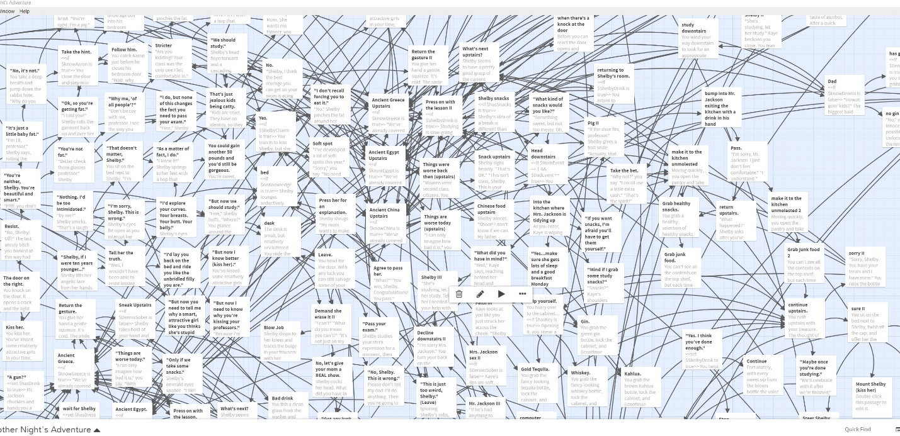
As bonkers as that is, what surprised me even more is this: during my first run through the story, I didn’t encounter any of what’s in that screenshot. It wasn’t that I got a quick “game over.” I went through a decently long tale, making what seemed to me reasonable choices, but somehow I charted a course entirely bypassing that chunk of the maze. It was only after I examined the totality using the development tools that I realized how much I hadn’t yet found.
These branching paths aren’t just trivial filler, either. Within all those twisted tangles lie hidden depths to discover. There are character motives and plot intrigues discernable only under certain conditions, some of which could make you view the story in a different light. There also some subplot divergences that practically qualify as mini stories all on their own, despite being so well hidden that I imagine most folks might need a walkthrough guide to find them. And that’s OK. I think much of the fun will be in the journey because, rather than the specific conclusions, it is within these weaving story paths where most of the “good stuff” takes place.
All that complexity also makes for a lot of nooks and crannies to keep dusted. That’s what I’m still helping Maverick to do. The story probably is 80 to 90 percent finished overall. In the current build it’s possible to complete a run through the whole thing without encountering any bugs or gaps. But, depending on your choices, it’s also possible to run smack into a show-stopping problem. There are a bunch of passages that still need to be fleshed out with content, others that are written but missing full linkage to the rest of the maze, various little coding errors to catch so that that links aren’t broken or flags inoperative, etc. I’ve also got an idea or two to run by Maverick for substantive material to add—stuff I think some of you might enjoy. ;)
We’re working on it!
Riptoryx (1/17/2022)

