Showgirl  Inspired by a Sissi Chloe Cap  By Maryanne Peters  “Sometimes I wonder if you are being deliberately stupid,” Mom said, in response. “We have been invited to the premiere of “Showgirl” and we have to go in costume. That is why you are dressed this way. At last we can put that ridiculously long fair hair of yours to some use: in a fabulous big bun to hold the feather. Now all three of us can go as the Godley Family – a trio of showgirls. It will be fun!.” | 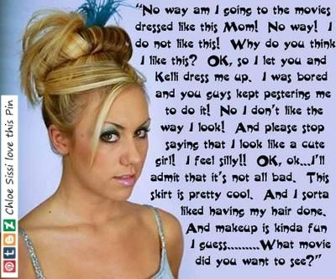

The more I look back on the way I protested the more I understand that I was griimly trying t hang on to whatever masculinity I still had after they had been wearing it down the whole afternoon. I spent all that time pretending to hate what I secretly loved – the hairstyling, the eyebrow plucking, the leg shaving – there was plenty to complain about, but that was all I did. Let’s face it I could have walked away. But part of me loved the attention, and a bigger part wanted to see what I would look like. Could I pass as a woman.

Answer – YES! Like, way yes! I was a babe. Certainly better looking than Mom, who is carrying a few years, and probably better looking than Kelli, who is carrying a few extra pounds.

I even forgot the name of the movie … that’s right “Showgirl”. I was the one of the tree of us that truly looked the part – a tall athletic body.

The premiere was a charity thing, with a red carpet entrance and a reception afterwards. We even had some minor person from the film production team – a casting assistant whatever that is.

Anyway, he spent most of the reception chatting me up, telling me that he could get me into the movies. I almost fell for it, but of course I had to point out, just after he had extended an invitation to go to his hotel room for a minibar nightcap – “A career in the movies sounds great, but wouldn’t my balls get in the way?”

The guy did not miss a beat. He just looked at me a little harder, and then looked at my tight dress (I was well tucked) and said – “Not necessarily. It just depends on the genre”.

What does that mean?

The End

Diversion  Inspired by a Captioned Image by TG Alice  By Maryanne Peters  They call it “diversion”. It is a way of dealing with crimes by direct consultation with the victims. It is still an experimental thing, but it seems to be working. It is for him anyway.  He could have been convicted on a crime and gone to prison. He may even have ended up on a sex offenders register, but his work colleague knew that the consequences of that were not deserved. Still, she was pissed and had to think up a penalty that was a punishment but might also be corrective.  Apparently she said something like – “How would he ever know how it feels. Nobody is ever going to look up his skirt. He will never have to wear one … Hang on a minute!”  The prosecutor talked about 6 months but his lawyer said it would be much less. Still, my man could not even face a day inside if there was an alternative he could swallow.  He talked about shame but as I said to him – “What is the shame in presenting as a woman. I do it every day. Half the population do. The only shame might be in being seen as a man dressed up as a woman, but we can fix that.”  I arranged for the waxing and for his hair to be dyed blonde and styled. He was always slim and as it turned out he had quite feminine features. All that was needed to buff off the sharp edges was a large dose of female hormones and androgen blockers. | 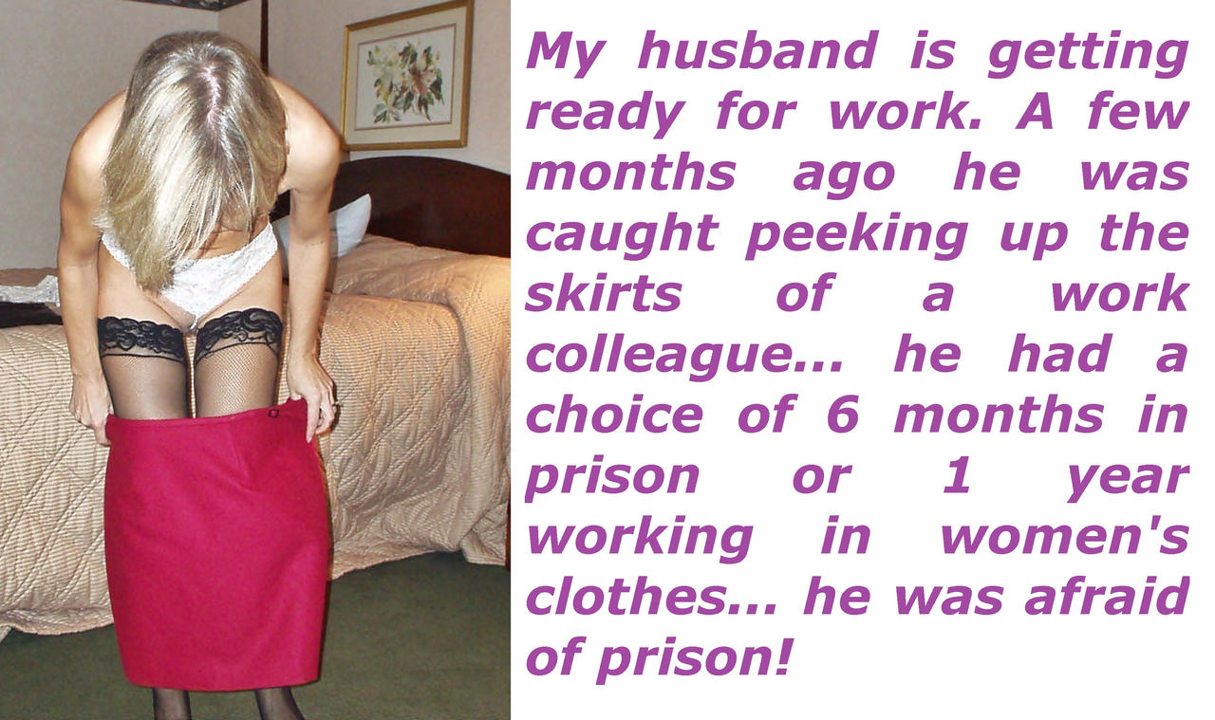

The problem with those drugs is that his ability to have sex was gone, but that did not matter to me that much. The fact is that I was so disgusted by his behavior that sex he been off since he was caught, and I don’t miss it. It seemed to me that he felt the same way. He took the spare room and started sleeping in a nightie and hanging around the house in women’s clothes even though that was not a requirement of the diversion.

The only requirement as the victim insisted was that he wear skirts or dresses. The problem for me was that he had such great legs that he looked better in skirts than I did.

It was not until the year was also up that I discovered that the real reason why he was not interested in sex was because he was getting it elsewhere. It turns out that he is not the only sexual harasser at his workplace, and this other guy is not fussy about what might be hanging under my husbands skirt.

The hormones only allow him to receive but it seems that he might be happy to do that.

My husband has been well and truly diverted!

The End

Father and Daughter  Inspired by a Captioned Image  By Dontshunitfunit on DeviantArt  I am in my fifties but I still have a very healthy sex drive. When I met Gail it was clear to me that she was the same. That was why we got together. It was just for sex, but it all worked so well that marriage seemed like a good idea.  At the time it was just her and her son Dan. He was a quiet kid who was not so interested in sports or the outdoors, but he loved to smile and seemed like a really good kid. We got on well. He told me that he wanted his Mom to be happy, so I was made to feel very welcome.  I never expected him to call me “Dad”, but he did sometimes, maybe just as a joke. But we were close, I guess. Maybe not as close as we should have been, because I had no idea that he was secretly transgender. | 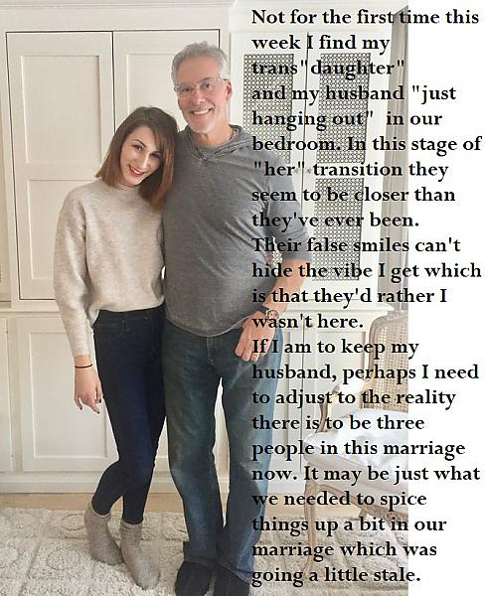

When he came out to both of us, I was supportive. Maybe if I had been his natural father, I would have been horrified that the line would end with Dan’s balls in the hospital furnace, but I had my own kids. I guess when I looked at him then as he shed some tears in what must have been a very difficult moment, I understood the gentle person that he was maybe better than his mother. But she came around to having a daughter, and so relished it.

But the slow transition brought up feelings in me that I would never have thought possible. Perhaps it was because I was right there throughout. Dani was worried about not being feminine enough, or being overly effeminate which is a very different thing. Her mother was disinclined to criticize, but I was allowed to point out to her clothing choices or behaviors that I thought were going too far. Dani was always grateful.

In a way I felt that I had played a role in helping her to become the woman she is. In a way I suppose that she has become what I consider the idea woman should be – delicate, cheerful, tactile and attentive. Perhaps that explains my growing attraction to her. I am not sure why she should have developed an attraction to me.

We are not father and daughter by blood, so there is not the natural aversion to incest. But even as a family member, I never knew Dan when I married her mother. It was only after I knew Daniel that Dani appeared to replace him, taking her female form right in front of me.

I suppose that the first time that she proudly showed me her breasts, grown purely by hormone therapy, that I first realized the problem.

“You are a young woman now Dani,” I told her. “You need to understand feminine modesty. Your cannot flash your tits to a man, even a member of your family.”

The problem was that I had an erection in my pants, and I think that she could see it.

She quickly covered up, but with that cheeky smile that makes her so special. “She said something like – “Thank you for telling me, Daddy. You know that I have come to expect such good advice from you.”

It was the first times that she called me “Daddy” but not the last. I thought that it must have been meant like another joke, but I confess there was a part of me that quite liked it, and that part was already larger than it should have been.

She told me that she wanted to experience a relationship with a man, and she sought my advice on how she should approach it. She did not agree that her mother was better placed. She wanted to hear it from me.

“A relationship with a young man will need to be limited to heavy petting until after your surgery,” I warned. “If it goes any further than that then you should make disclosures about your circumstances.”

“You mean if I want to suck his cock, I will need to tell him I have one too?” I knew then that Dani was teasing me. I just laughed and she did too. We both liked laughing, and doing it together made it twice as good.

I don’t know how my wife got the idea that we were considering sex. I was just showing Dani some typical male behaviors in the presence of a pretty young girl. I am simply helping OUR daughter. When she said that she was open to my coaching going a step further I was shocked. Perhaps I would even have been horrified, were it not for the fact that Dani seemed to like the idea too.

I have to say that I am in a bit of dilemma at the moment. I mean for the two of them this must be really weird, but from my point of view here are the two people I care about most in the world, now both attractive and sexually mature women and … well, as I said before I still have a very healthy sex drive.

The End

Me and My Big Mouth
Inspired by a Captioned Image from PJ’s Caption Corner
By Maryanne Peters
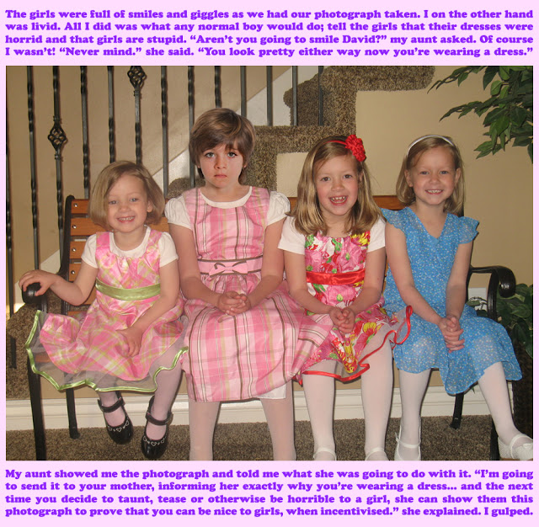

“Oh, that photograph,” said Diana. “Yes, that is me. There are all the cousin’s together. That really was the beginning of the end for David.”

“That is a vey unhappy looking young man,” said Caleb.

“More worried than unhappy, I think,” said Diana. “My mother and my aunt kept a copy each to keep him steered in the right direction, and all because of his big mouth. He had to open up with an opinion on how girls should dress. Things might have been very different had he kept his mouth shut.

“Sometimes a big mouth can be useful,” said Caleb. He had moved in behind his girl, sliding his arms around her body to her waist but with his hands ready to move up to her full breasts cupped in a soft seamless bra under a figure hugging sweater dress. He put his node into the fall of her soft brown hair to take in her fragrance.

“Whatever are you talking about?” she said in mock ignorance.

“Blow me before we go out,” he whispered in his ear. “You need the taste of me in you, and you will be able to see the satisfaction on my face all the way through dinner.”

“You are disgusting” she teased. “I am just letting you know that after my surgery I will be expecting that cock to go wear it belongs and that is not in my mouth. But, alright, get you pants down.”

“Are you saying that after next month your mouth will be closed to me for good?” he said, unbuckling his belt.

“I learned all about keeping my mouth shut when I was David,” she said, dropping to her knees. “But here I am opening it up for you. Maybe this was how it was meant to be?”

The End

A Simple Change  From a Cap by Feminization Beauty Within  By Maryanne Peters  What son would not do anything for his mother, let alone as she was dying in front of my eyes. If she asks that you fulfil her fondest dream, even if it means some sacrifice, would you do it? Surely, if it were in your power to do it, so that she passed on with a smile on her face, you would do it – would you?  “I have always wanted a daughter.” I heard her say it more than once. “But I was blessed to have you, a son who loves me.”  I would do anything, even what she asked.  “I am not long for this world, but if I could only spend these last few months with the daughter I never had, it would mean so much to me.” As she said it, she was touching my long lank brown hair.  “You would look so good as a redhead, if you were a girl,” she said. “Only for a few months, or maybe only just a few weeks.”  It seemed crazy that she should ask this of me, but she did not even have to. I knew what she wanted, and I was ready to do it. | 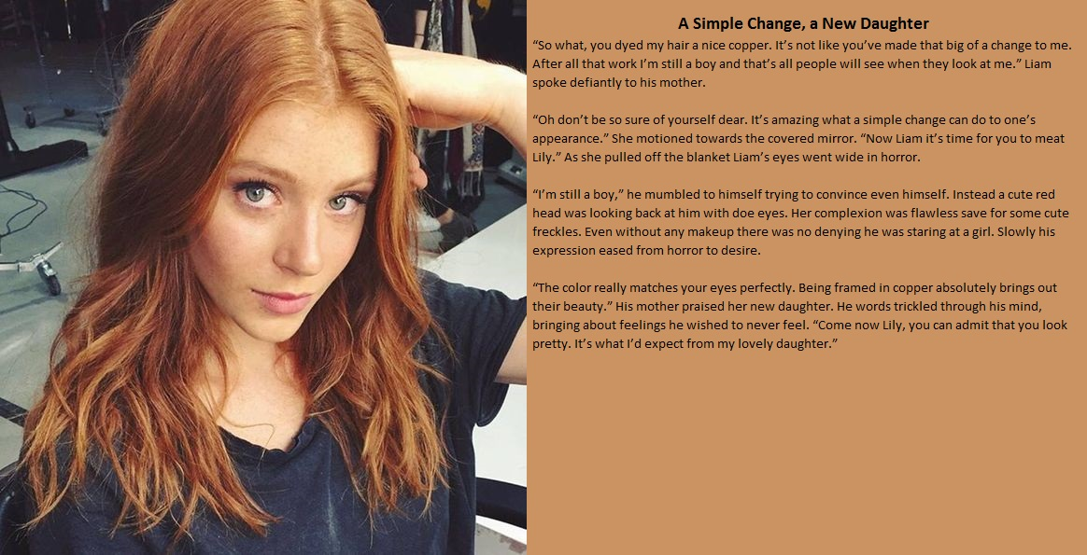

“It is just a simple change. Let me wash, condition and color your hair for you,” she said. “It will take me back to the days I worked in the salon before I met your late father, God rest his soul. I assure you, these are not skills you forget.”

Certainly her other beauty skills were still in use, because even though the cancer had robbed her of her own crowning glory she still used makeup with the skill that had made her a renowned beauty in her time. What I inherited from her was no use to me. I had to live down a “pretty” appearance – it exhausted me sometimes.

“Your hair is thick but fine,” she said. “You are so lucky. Now because you are moving to red I am just going to color up your eyebrows and eyelashes too.”

My eyebrows turned out red alright, and she said that she just brushed them, but I am pretty sure that she numbed my face somehow and thinned them too. But my eyelashes were dyed black, and that seemed to change the whole look of my face.

She was right about the green eyes too. I was simply gorgeous. I just sat there looking at myself. It was like I had met the women of my dreams, and she was looking at me with the same look of love that I felt for her. The problem as that she was in the mirror, but in the moment that did not seem to matter. I found myself playing with my hair and pouting a little, and it was like she was doing it to me over my unspoken objection. I was getting aroused.

“We should find you something to wear so you can go outside,” Mom said. “Come on now Lily, you can admit that you look pretty. It’s what I’d expect from my lovely daughter.”

My name was Lily. I mouthed it to the mirror and watched my tongue flicker suggestively. I could never tell my mother what happened next, but it made me agree that I needed to get changed – I jizzed in my jeans.

It seemed like the arrival of Lily gave my mother a new lease on life. She had a sudden unexpected remission in her cancer. She did not die as expected. In fact, she is still alive, and I am her lovely daughter Lily.

The End

© Maryanne Peters 2023

