Nanami and the Mask of Izanami – Chapter 7 – The perfect Goddess and Super Nanami
Nanami’s House a few days later
Nanami was in her Room holding the brand-new CD from Kasumiko in her Hands which was autographed by Kasumiko herself specially for Nanami and she looked at the Track List and listening to the Music.
“This CD is Amazing! Kasumiko Managed to improve her Music even more and the best of it I have a Special Autographed Version. Oh, today comes out the new DLC for Kitsune Fighter 2 Special time to enter one of my DLC-Codes.” said Nanami happily
Then she put the Game into her Switch and entered the Shop and goes to the Download code Option there she entered her Download code. The Switch then displayed the brand new Kitsune Fighter 2 Special DLC-Fighter the Six Tailed Kitsune Nanami presented by Kasumiko Takahashi.
“I can’t believe it they really have put me in the Game as a hot Kitsune. Ok, time to download the new Me and then I have to test her in the Game.” said Nanami.
The Switch then Displayed some Status Messages:
Download….
Download Completed!
“Time to start the Game. Oh, I’m so excited to see me in a Game” said Nanami.
Nanami started Kitsune Fighter 2 Special and some seconds later the game Displays two Messages.
The First Message was: New DLC Found! Installing… Done!
After that the second Message was displayed.
“Thank you for being so awesome that you have bought this brand new DLC-Fighter. This fighter is based Nanami Miyasaki one of the greatest Fans of the Famous Pop Idol Kasumiko Takahashi.
Kasumiko asked us to do a Special Fighter for her and we simply couldn’t deny her request it was an honor to work on this new Fighter. We hope you enjoy the Character and have as much Fun with it as we had developing it.”
“Oh, that’s really cool they added a Special Message.” said Nanami happily.
“I see you entered the Download code sweetie. now let me see you in the game I’m really curious how my sweet Girl will look.” suddenly Inari spoke to Nanami.
“I guess you’re just as excited as I am” said Nanami with a giggle in her voice.
“Ok, I just have to enter the Quick Match and then here we have her Nanami the Six tailed Kitsune.” said Nanami.
Then the Game loaded a quick Match and Nanami tried out herself quite a bit and after that she said: “I really look Awesome as a Kitsune.”
“And really Sexy too my Sweet Nanami-chan. I would love to have some special fun with your Kitsune form.” said Inari.
“Oh, I can imagine that Inari. ^_^” said Nanami.
Suddenly the doorbell rang and Nanami rushed to the Door and opened it. It was her Big Sister Akira which decided to come to a Visit.
“Hi little Sis long Time no see.” said Akira.
“Hi Akira come in I was playing some Kitsune Fighter 2 Special maybe you want to play too I have got a brand new DLC.” said Nanami.
“Huh? A new DLC I didn’t know of that. But I guess it’s just because I was quite busy with Photo shootings.” said Akira.
Then the two girls go back into Nanami’s Room and Akira puts her bag right onto Nanami’s huge and Comfy Bed. In Akira’s bag were some brand new Bikini’s that she has got as a thank you gift from the Shootings and also her Loki Mask which showed a bit out of the Bag.
Nanami said then: “Here take a seat I must show you the new fighter. You will be very Surprised.”
Akira then sits down on one of the comfy chairs and watched her sister a bit. Suddenly she sees the Name of the New fighter.
“Huh? Nanami Miyasaki don’t tell me they added you into the Game.” asked Akira.
“Yeah, that’s me. How do I look?” answered Nanami.
“You look Amazing! But how they know that you look like this as a Kitsune?” asked Akira.
“Well, I met Kasumiko-chan in the Store of Ayako-chan and Kasumiko asked me if they can add me as a Fighter in Kitsune Fighter 2 Special but they needed some Pictures of me as a Kitsune and then Tings got a bit Wild.” said Nanami.
“Let me Guess. Kasumiko tried your Mask on?” said Akira.
“Of course, dear! I had some very Special fun with Kasumiko.” said Inari to Akira.
“Yeah, and then Kasumiko created a new Kitsune Loki Mask specially for me and after the Transformation I looked like this.” said Nanami and then she shows Akira one of the Pictures:
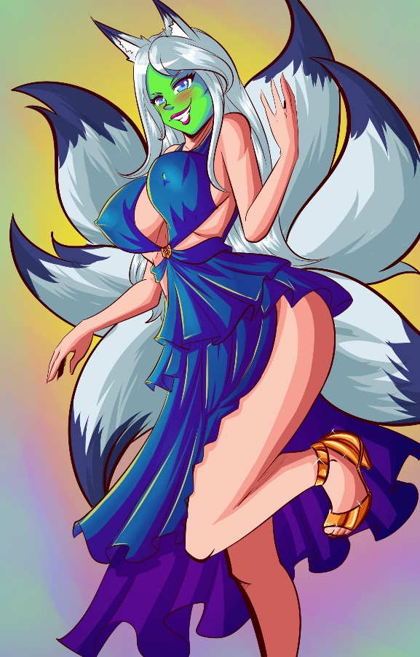

“Oh my God you’re looking amazing! I really wish I could be a Kitsune too sometimes.” said Akira.
“Thank You Akira! But now I’m curious how you would look as a Kitsune.” said Nanami.
“Oh, I can help you out with that sweetie!” said Inari to Akira.
“Nanami, I think Inari can us help out because she has an idea.” said Akira.
“Really? Well, what’s your Idea Inari?” said Nanami to Inari
“Oh, silly you of course I need the Control over your Body and then you two must trust me and do anything I say. Because I can make an Item that transform any Girl who wears it into a Sexy Kitsune.” Said Inari.
“Ok this sounds like a Plan Inari what do you say Nanami?” asked Akira her little sister.
“I’m fine with that! Ok, let me put the Izanami Mask on and then Inari will be here instead of me” said Nanami.
Then Nanami takes the Izanami Mask and puts it on her Face. Suddenly the Mask covered her whole cute Face and instantly Nanami starts to moan in pure pleasure as her breasts and Ass started to grow much bigger and firmer. A short while later her hair gets shorter and changed its color from brown into a silver/white. After that she gets two fox ears and ten Fox tails and then Nanami suddenly exploded into a massive Orgasm and passed out. That was the moment where Inari takes Control of the new Body and after a small mini twister rushed around Nanami’s Room a completely new but Super sexy light red faced Kitsune Girl stands in the Room.
“Yes! Finally, I can have some Fun again thanks my sweet Nanami-chan!” said Inari excited.
“So, you are Inari?” asked Akira
“Yeah, that’s right! It’s nice to meet you Akira-chan. I’m Inari the Sexy Kitsune Goddess of this Mask created by the great Goddess Izanami.” said Inari.
“I didn’t know you’re a Kitsune, but otherwise the Mask is shaped like a Kitsune too so it makes sense.” said Akira
“You’re a smart Girl but let’s Continue with my plan. I can sense you have your Loki Mask in your bag please give it to me I need it for the next Step.” said Inari.
“Sure, but what are want to do with my Loki Mask?” asked Akira.
“Just let me wear it and you will see.” said Inari with a grin on her Face.
With that Inari holds the Mask of Loki up and then it snapped right into her Face but instead of pain Inari instantly starts to moan very heavy and moments later her already big breasts growing even bigger and super firm also her Ass grows a bit more too making it even sexier. Inari’s waist gets a little bit slimmer and she gets super well-trained sexy Abs. Shortly after that her hair started to grow much longer and changed its color from silver/white into a golden blonde color which goes over into a dark blue to the Bottom. As Inari moaned loudly Akira can’t help but she was turned on a bit by the sight of the changing Kitsune.
A few moments later six of Inari’s Kitsune tails were gone but then they are replaced by other Tails. First Inari gets three silver/white Cat tails with blonde tips and then she gets two dark blue Dragon Tails. But that was not all Inari then gets a pair of Demon wings and a pair of Angel wings and lastly two Oni Horns are growing at her forehead. Lastly her Face changed its shape into a perfect mix. It looks mostly still like Inari’s Face but much cuter and more seductive because she has adopted the facial features of Nanami. Last but not least she gets a Halo that flows over her head and then she does a sexy Pose and said: “Finally I can show off my Goddess of Creation Form! Only very few Humans have seen this Form so be happy Akira-chan I can make every whish of you come true!”
“Oh, my Goddess! You’re sexy as Hell.” said Akira with a blush in her face.
“Thank you, sweetie! Now tell me your wish and I will grant it. You can wish for anything.” said Goddess Inari.
“I wish I could transform into a Sexy Kitsune maybe you can make a Special Mask for this.” said Akira.
“That’s a piece of cake for me to do.” said Inari and then she created a new Kitsune shaped Mask which was made out of Japanese Wood and then she infused it with a massive amount of Kitsune Magic.
“And done! Here you have it. This is the Mask of the Kitsune it houses a Kitsune Spirit. Every girl who will wear it will transform into a very Sexy and very Powerful Kitsune form of herself but the face will be in a shade of green. It doesn’t work on Kitsune Girls or Guys. Also, the result Varies from Girl to Girl. If an Oni Girl wears it the Result will be an Onisune. If a Dragon Girl wears it the Result will be a Kitsune Dragon Girl and if a Succubus wears it, she will be transformed into a Kitsune Succubus. Also, it will make the Girl Invincible to any Damage it will also heal any Diseases of a Girl.” said Inari.
“I thank you my Goddess!” said Akira.
“No problem sweetheart but now we need something for Nanami too and I already have something in my mind.” said Inari
Then Inari created a Magic Ring and said “This is the Ring of Ai. Give this Ring to my sweet Nanami-chan it will unlock her true beauty of the Miyasaki Family that’s deep inside of her.”
“I will give it to her. Thanks again Inari!” said Akira.
“Ok, time to go back to normal.” said Inari and then she removed the Loki Mask from her Face and turned back into her normal self and gives the Mask Back to Akira.
“Thanks for borrowing it to me this was a great feeling after all the Time. I hope you like your new Toy sweetheart!” said Inari.
“No Problem Inari and I promise you I will enjoy this Mask.” said Akira happily.
Then Inari removed the Izanami Mask too and a few seconds later Nanami stands back in her Room and as she looked at Akira, she sees a new Mask that is shaped like a traditional Japanese Kitsune Mask and then she asks Akira: “Is this the new Mask that will make a Kitsune out of you?”
“Yeah, Inari has made this Mask with the help of her Goddess Powers and she also made this Ring for you.” said Akira as she gave it to Nanami.
“Oh, it’s beautiful! I wonder what will happen if I put this Ring on.” said Nanami and then she put the Ring on her Hand.
Suddenly the ring glows and then a few seconds later Nanami starts to change. First her legs growing longer and much sexier. Then her hips get a bit wider and her Ass grows much bigger and firmer.
A few seconds later her waist get slimmer and then her C-Cup breasts started to grow until they reached a huge E-Cup also her breasts firmed up more.
But that was not all her cute Face gets a massive upgrade and now she looks like a Super Model Version of herself. Last but not least her hair started to grow much longer. A few seconds later her hair stopped at the high of her now perfect firm Ass and then suddenly mostly of her long hair changes its color from brown to Purple only the top of her hair remained brown.
Then a completely new Nanami stands in the Room and she said in a more sexier sounding Voice: “What happened? I feel so different now.”
“Oh my God! Nanami you’re now even sexier than me.” said Akira.
“Huh?” asked Nanami confused and then she looked in the mirror and sees her new Super Model self.
“Oh My! Is that me? I look super Sexy now! But also, a bit more like Mom” said Nanami.
Then she sits down on her comfy bed in a sexy pose playing a bit with her long hair and said “What do you say big Sis? Should I try to apply as a Supermodel too? Because with this Super Body everyone would book me.”
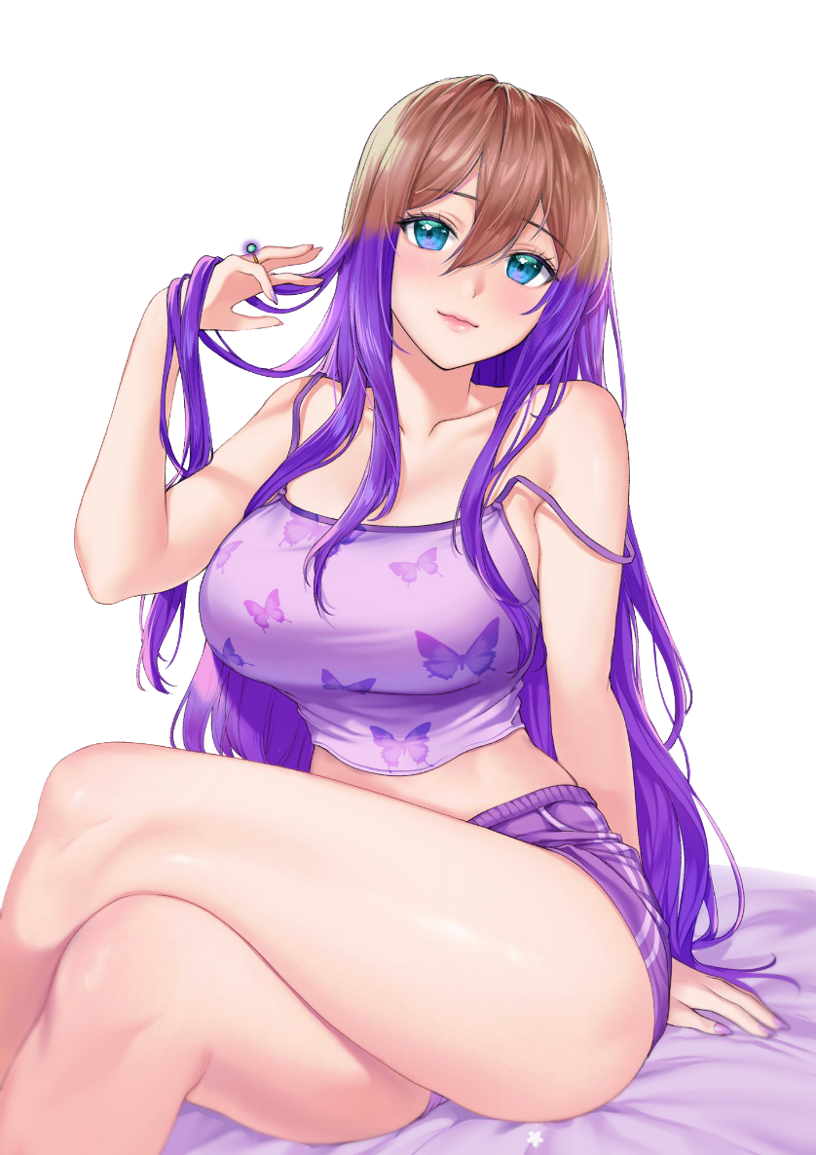
“Yeah, absolutely you should talk with my Manager I’m sure he can get a few Shootings for you and maybe we can do some shootings together.” said Akira with a light blush on her Face.
“That’s sounds like a Plan but first you have to try out your Kitsune mask too.” said Nanami

To be continued…

Thanks to all my Patrons for the Support.
Also, a special Thanks to MegaLinx.

