His Perfect Girlfriend
Inspired by a cap by Becky Number 86
By Maryanne Peters

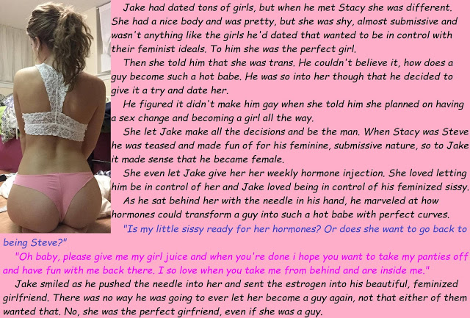

Sure, some people have given Jake a ribbing about it, but most of them who do it have never met me. When they do I turn on the charm. I want to let them know that Jake has the perfect girlfriend, even though she was once a guy. Or, perhaps it is because of it?

It seems to me that women who are born women let themselves go. A transgirl like me always has to look her feminine best. Letting myself go means letting the boy back in. I won’t allow it. I have worked hard to get this far and now that I have a man, I will never let myself be less that the perfect woman for him.

It seems to me that women who are born women get very bossy when they think that they have you in their spell. I think that Jake is in love with me, but the truth is that I like being submissive – I like him to be the boss – I like him to know that he is the boss. I suppose I am old fashioned, or just too “binary”. He is a man and I am a woman (or want to be) so I do what he asks. But don’t be mistaken, I still get what I want. Women ought to know how it is done. They have been doing it for centuries. It seems like a lost art for today’s ciswomen, but not for me.

It seems to me that women who are born women want to change their man into somebody else. What is that about? You meet and fall in love with a guy who may be a bit wild, and the you start turning him into a lapdog. I am the complete opposite. That is why I have him give me the hormone shots. I want him to make me – I want him to make me more of a woman just for him.

It seems to me that women who are born women have to have kids. They have the equipment, and they have to use it. I don’t, so Jake knows that I cannot pressure him to start a family. I am not ruling it out. There are ways, but he knows that I am not going to get pregnant and present him with a future he is not ready for.

Maybe I won’t be the perfect wife, but I will always be the perfect girlfriend.

The End

© Maryanne Peters 2022

Service
Inspired by a cap by Becky #87
By Maryanne Peters

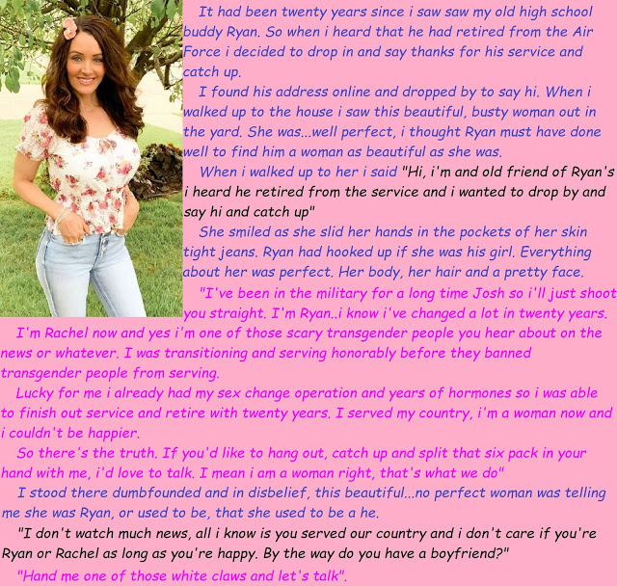

It took a few drinks for me to get relaxed and be able to ask her the awkward questions.

“That is a hell of rack you have there, Rachel.” I felt bad the moment the words had been said, but sometimes it seems like you are talking to a guy even when it is clear you are not. “I mean, getting used to it and all.”

I used to pack a full chest rig back in the day,” she said. “You know – magazines, comms, grenades, tools, dressings. That would stick out to here and could be weighty. Now I have these girls, all soft and jiggly.” I almost passed out when she cupped them and shook them.
“The hair is sure a change from the buzz cut?”

“I have always wanted long hair, ever since was a kid,” she said. “I would have loved to wear it in a ponytail with a ribbon, or braids and colored barrettes. But of course, I never could. I do like to wear something in my hair though … like this flower clip. Do you like it?”

“Sure.” What are you supposed to say?

“I declared myself trans and started to grow my hair out after my last tour. That was in the army before Trump. They paid for everything, including hormone treatment and the surgeries. They wanted to keep me because of all my experience on the battlefield. That counts, you know. The army has always known it. They didn’t want to throw out transgender soldiers. It was a political thing.”

“But what I can’t understand, Rachel ...” I still had a bit of trouble saying the name. “If you felt female all along, then why did you join the military?”

“Ah, but so many transwomen do,” she sighed. “We all say that it is an attempt to kill off the woman. You get told when to wake up and what to wear, you are given a purpose and told that your choices are limited, and the whole culture is masculine. How was Rachel supposed to survive through that? I was Ryan, pure and simple. Except that I wasn’t. Rachel was stronger than I thought. She was always going to win – it was just a matter of time.”

“So, just stop me if I am going to far, but you are like … completely female, like … below the belt?” I felt like a real shit, but I had to know.

“Are you talking about my vagina? Why do guys have so much problem talking about these things. These jeans are tight ladies jeans – what do you think?” She was smiling at me, mocking me, and I was felling it. “Of course I have a vagina. I would be happy to show it to you, but only after we had at least dated once, and even then only if I knew that your intentions were honorable.”

“I supplied the beers, so I would call this a date,” I said. She was almost coming on to me. It made me realize that I was gagging for sex with this woman. “As for honorable intentions, that is why I am here. I came to honor your service.

I think that it is time for you to service me,” she said.

The End

Keeping a Secret?  From a Cap by Becky #88  By Maryanne Peters  She looked at herself in the mirror he sat on the bed, removing his shoes and socks before loosening his time. His eyes were fixed on her perfect ass in that tight black skirt. It was her business outfit. Some guys go for this look instead of the sexy or even slutty things she sometimes wore.  It worked on him, and she knew it would. Simeon March was a different target. Not random this time. No, Simeon she remembered from school. She knew all about him. And she remembered the guys he hung with. Not just like the guys that made her life hell at school – they were those guys.  She waited for him to strip while she admired herself. This was who she always wanted to be – a woman. Not just pretty, but desired by men. So desired that she could pull Simeon March in a hotel bar with her “I am just a business woman and you are just a businessman both alone for the night” routine. She knew he was married and that made it even sweeter.  Perhaps she would tell his wife? Or perhaps she would just tell she would? Or that she might … or maybe not? | 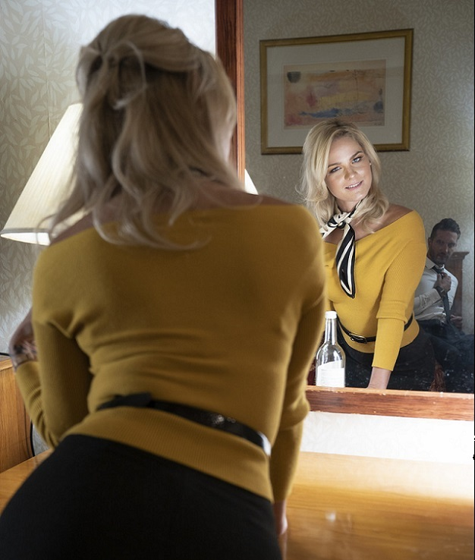  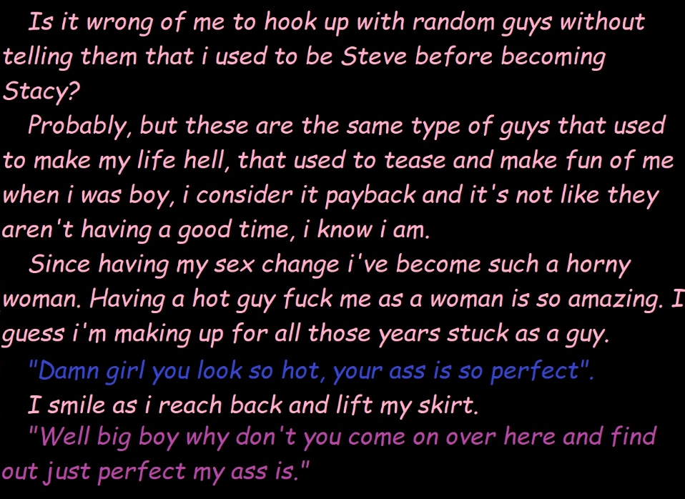

She took her clothes off slowly while he stared. She just gave him the occasional glance -just to check the effect that her slow strip was having on his exposed cock. She looked at that with indifference. She had always hated the one that she had. They really were an ugly organ, but the effect of that thing on her body was what she craved.

He was impressed. She could see that. He should be. This body had cost her, in money and pain. But now she loved who she was. All that angst and confusion was behind her now. She was a woman, and a sexy and empowered woman at that.

He made room for her to lie on the bed but she slowly shook her head.

“Lie back and let me get down to business,” she said. She straddled his body, taut with excitement. She lowered her lubricated pussy onto his standing cock, and moaned a little, almost involuntarily. Regardless of her motives this time, she always loved this feeling. It reminded her that she was complete. But this time she wanted to be on top. She did not want him to give it to her. She wanted to give it to him. She wanted to control his orgasm.

“Now don’t be naughty and come to soon,” she scolded him in advance. His mouth was open and his eyes seeing only sex. He was in her control.

She moved up and down, and when she felt him swell even more she pinched one of his nipples, hard.

“Not yet!” she directed. He nodded. She continued. She gained pace. Her back arched.

No woman can get tired of the feeling. It seems to rack the whole body in a way that a male orgasm, so centered on the groin, never can. She could not help but squeal. It was a woman’s voice now, even in this animal moment.

She fell on the bed beside him, fully satisfied. He had come too, but she barely noticed or cared.

“You look familiar,” he said. “It is an old pick-up line I know, but now that we are done, I have to ask it of you – have we met before? Did we go to school together? I could swear we did, but I am having difficulty picturing you.”

“it is an old line,” she agreed. “And we are done.”

“Just like that? Two ships passing in the night?”

“Two ships never meet,” she said. “We had a small collision.” She got out of bed and went into the ensuite bathroom to expel any part of him. But she had a small specimen jar, just in case.

“You’re not staying for a bit?” He sounded disappointed, even a little petulant.

“Sorry,” she said. “Things to do. Decisions to make.”

She lifted he hand bag off the bedside table. The handbag with the camera inside that had been pointed at the bed.

The End

Sissy Girlfriend  Inspired by a cap by Becky #89  By Maryanne Peters  This whole transgender and non-binary thing has worked out for me. I was always a bit of a softy and really unable to cut it as a guy. But nowadays you don’t have to. You don’t have to be a guy if you don’t want to. You can “identify” as something else. I choose to identify as sissy.  For me being a sissy is being submissive and feminine, but I guess it may be different for others. I always had logish hair, but now it is super long and I kike to wear it up in a high ponytail as only girls can do – girls and sissies that is.  No all sissies like to have breasts, but I do. It is so easy when you get on the hormones. But you need to work them to see that they grow out nice and round and not become a funny shape. And you need to keep them firm. Bras are good but I like to go without when I am wearing just a lacy top with my hot-pants.  Shorts are good because they help to tuck away my pee stick better that just panties. Not that there is much to tuck away these days. I guess the hormones are to blame, but it really doesn’t matter. I call it my pee stick because that is all I use it for.  Nowadays you have to treat transgender and non-binary people with kindness and courtesy. Announcing that you want to present as feminine and for everybody to call you “Mandy” is no big deal. It is not as if I am the only one. It is not as if people have never heard of people like me. | 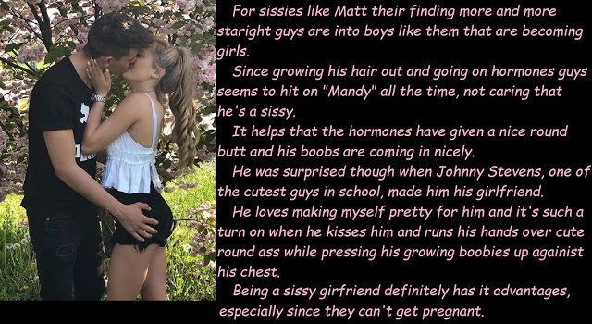

And nowadays guys are learning to understand that people like me make the best girlfriends. I mean, think about it.

We like to be passive and submissive – you will get no argument from me. It will be “Yes, Johnny, what ever you say. Oh, you make the decisions, Johnny. You just tell me what to do.”

We like to be pretty. Real girls let themselves go, or get caught out looking awful. We can never let that happen. We know that a guy needs just two things from a girl – that she looks good on his arm, and she is good in bed. Johnny knows how pretty I am. Johnny knows how I can suck him off and squirm on his cock better than any born girl.

And even if I was to get a pussy, as Johnny has suggested a couple of times (just to provide something extra - it is not like I would be losing anything of value) I can’t get pregnant. I won’t be demanding that we get married to give some kid a father, or demanding an engagment ring or a life time commitment. I am just a sissy … like, forever just a girlfriend.

Although it would be nice to be a wife – I have to say it. Mrs. Mandy Stevens … hmm.

Oh well, where is that man. I am getting hungry for some sex. Oh there his is by the cherry tree in blossom. Come here big boy, and give me a sloppy wet kiss.

The End
Feeling Pretty
Inspired by a cap by Becky for John Number 90
By Maryanne Peters

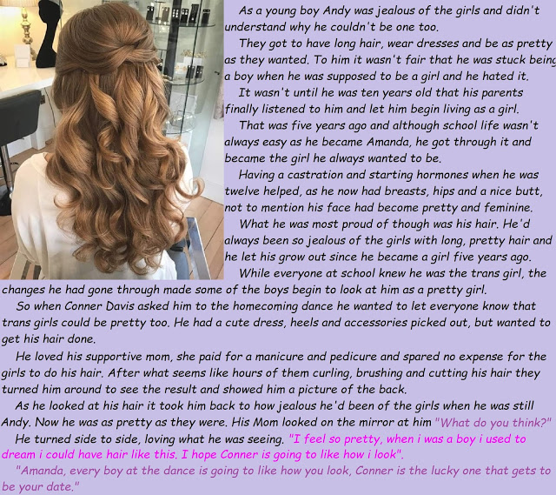

Ever since I was very young, I always wanted to have long hair. To me it was just wrong that other girls got to wear their hair long and have ribbons and bows, I had to have cropped hair. That was how I felt. I was so certain that I was a girl, that it just seemed to me that I was just a very unlucky one to be treated differently.

My favorite fairy tale was Rapunzel when I was in Elementary School. It was before the movie “Tangled” came out, but I did have the poster of the Nickelodeon special “Barbie as Rapunzel” on my wall. To me having hair so long that I could drape it out the window and reach the ground, seemed like the best thing ever.

I was friends with other girls at that school. We used to play games together in those early years when it did not seem to matter who you played with. I was more interested in jumping rope than playing ball. The other girls liked me, but they knew that I was different.

One girl was named Lucy, and she pulled up her dress and pulled down her panties and showed me wat she had. I was shocked, and then I burst into tears. I was not like them. I was not a girl.

I was told about God when I was young, and I prayed for him to take away my boy bits and have my hair grow like Rapunzel’s, and dress me like a princess. I prayed really hard, but He did nothing. I think by the time I started Middle School I knew that He did not exist. How could a loving God do this to somebody like me, who was always good and just wanted everybody to be happy.

But by then my parents were starting to listen. They could see that even letting me wear a dress around the house made me a changed person. Being treated like a boy made me so sad they worried about whether I might try to kill myself. Just pretending to be Amanda made me happy.

I was young, but when it came to this issue, I was serious. 10 years old is not too young to look things up and learn that you are not alone. I sat my parents down and told them – “This is what I am. I am transgender.”

I started middle school as Amanda. I received blockers to stop male puberty, and I started to grow my hair.

I guess that I am just lucky that I have great hair. The natural color is light brown and I am very happy with it natural. I use good quality shampoo and I condition religiously. In the sunshine it shimmers, and it takes curls well, and is light enough to bounce wonderfully. And it is soft and fine to the touch.

I am pretty too, but my pride and joy is my hair. I love to brush it, and handle it – I can twist it into a bun held with a single pin. I can just spend hours doing my hair. I never get tired of it.

And some boys love beautiful hair on a girl. Conner is like that. I could see it the first time he came on to me. I was flicking my hair, and then letting it fall over one eye. I could see he was getting excited. I said that I would let him stroke it, and the moment he did I could see that he was trapped by its, like a spider’s prey in my silky web.

We are going steady now and having sex – as best we can until I have my surgery. But all I need to do is to dangle my long locks in his face and then wind a hank of it around his stiff cock and he just goes off like a rocket. They say semen is good for your hair – is that true?

The End

© Maryanne Peters 2022

