THE CRAFTSMAN PRESENTS

During the midst of a viral outbreak, a group of men watch as their D&D session is put on pause to keep up with the news. The world is suddenly plunged into chaos when a virus begins to spread which transforms men into huge muscular beasts.

The men think they might be safe…until one of them begins to grow.

Featuring — male transformation || muscle growth || contagious transformation || intelligence drain

Enjoy. . .

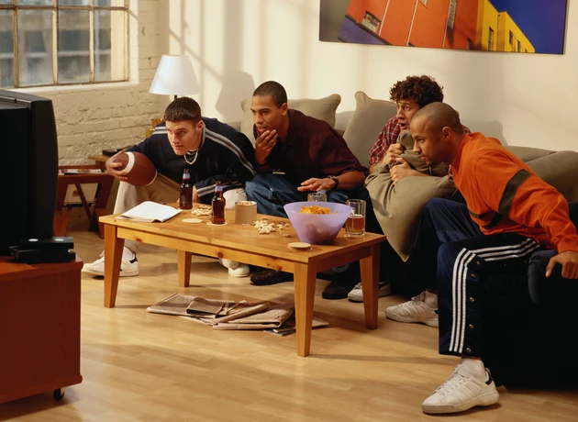

In the flickering glow of a television in the dimly lit living room, four friends found themselves utterly captivated by something they never thought they would be, the news. All of them had finally found a time in their schedule to meet for D&D night and yet instead of starting the session, three of them (Ryan, Damian and Jakub) were sitting on a sagging couch whilst the other (Sam) was pacing up and down. They were watching a sweaty news anchor, beginning to grow tired as they recited what had captured all of the men’s attention.

“Government officials are warning civilians to stay indoors, to lock windows and to please…” The anchor began to huff as he fanned himself. “To please be careful, the virus is…O-Oh goddd n-no I feel…Oh- Oh please-” All three on the couch flinched, Ryan letting out a ‘woah’ as the anchor suddenly convulsed on screen. His shirt shredded at once as his arms swelled impossibly huge with muscle whilst the man’s voice faltered, letting only gasps and groans escape as he reached with one growing hand to the camera. Then the camera tilted over, as another man staggered from behind, begging for help before he groaned and fell on all fours, impossibly inflating with muscle. The television screen cut to an emergency alert, blaring a high pitched tone before it went quiet. By now, even Sam had stopped pacing.

“Holy…shit…”

Sam wasn’t even aware of which one of them had said it but he knew they all agreed with the sentiment. All four of the friends glanced uneasily at each other. It was as if they were trying to wonder…what the hell would happen if they caught the virus? Ryan was already the more muscular and taller of the bunch, though he was only lean because he was the only one out of them that regularly exercised. He was broad shouldered with dark straight hair that he often cut short, rubbing along his square jaw as he felt the faint sting of freshly shaven stubble. Damian was similar but more skinny, a head shorter than Ryan who was barely 6’1 with a more wiry build, he scratched at the back of his neck where he could feel some shaggy blonde hair. Despite the fact they lived in the city, he always looked more like a surfer, even now dressed in a vest and board shorts. Jakub smirked at the notion, stocky and the shortest of the group, he had a surprising strength but it didn’t show. He wasn’t what people would call fat but definitely chubby or ‘filled out’, to put it politely.Jakub’s eyes were a cool blue against pale skin, rubbing his broad nose and bouncing a broad leg out of excitement more than fear.

Whereas Sam himself was the average one, average height, skinny-fat with a stubborn paunch to his stomach and lighter hair. He ran a hand through his dark, curly hair, muttering under his breath, and finally stopped, jaw slack. For a long, tense moment, the room was silent except for the hum of the flickering screen.

“So…no D&D?” Jakub broke the tension. Sam scoffed, Ryan sighed as if it was an offensive joke and Damian remained silent.

“No man, no D&D. We gotta…shit I dunno is this deadly? Do we call our families or something?”
“It only affects men, look," it says. We just gotta like, I dunno maybe wait it out. But I didn’t go shopping so-” There was a sudden gurgling sound as each of the men glanced at one another, wondering where it came from. “You guys hungry?” Ryan shook his head.
“No I ate a fuckton before I got here,” joked Jakub and then all eyes lingered on Damian.

“Uh no I’m fi-” There was the gurgle again as suddenly Damian clutched at his stomach like he was starving. But he knew he wasn't. He had eaten just before they got there, perhaps not with the appetite of someone like Jakub but he definitely shouldn’t have been hungry. That’s when he heard the gurgle again and it sounded less like a hungry stomach, something closer to an upset one. “Uh I think I need the bath- Oh!” Damian tried to stand up but a sharp pain shot through his stomach as he stumbled.
“Woah, woah you okay?” Ryan asked.

“Of course not, he’s not clutching his stomach for fun,” huffed Jakub as he gestured at Damian who stumbled a couple steps away.

“G-Guys I don’t-” Damian almost whimpered as he couldn’t understand just what was happening to him. He could feel his stomach knotting and stretching, muscles tightening in ways that didn’t make sense. A blissful heat began radiating from deep within, crawling up his chest, a pleasurable heat. But it was more than that, he suddenly felt like his own cock was thickening and beginning to grow hard. There was some other voice, he thought Ryan’s that was telling him to sit down but that’s when he Damian looked down at himself, as he could see his own bulge growing in his board shorts. He knew his dick enough to know that it wasn’t just growing harder, somehow his cock was swelling bigger than ever and he looked up in horror. “O-Oh fuck guys I think-”

“Whatthefuck?!” Jakub gasped as he glanced down at himself, his own dick that was a barely impressive five incher was suddenly six inches and then seven and the eight as it started slithering longer and larger. “Oh my god- Damian what the fuck did you-”
“I didn’t do anything! Oh fuck someone call like 911, I think my dick is-” Before Damian could say anymore, he fell to his knees gasping as he almost fell forward on all fours. His feet were the next to bulge and grow, splitting out of his sandals much like Jakub’s pale toes were stretching out of his socks.

“Lemme just-” But as Ryan tried to dial 911, his hand spasmed with a jolt of pleasure as it suddenly grew and crushed his phone like it was made of glass. The shattered phone fell as he screamed aloud in shock, his hand falling as it weighed down before it began to churn muscle mass into his arm, pulling him down faster. “Oh god Sam! SAM!” But Sam was already backing away from the three of them, watching his friends start devolving from the virus. He had no idea how the hell it could have gotten in his home, probably because of Damian or Jakub’s carelessness? But he helplessly watched as Damian had given in and was now on all fours whilst Jakub had already gotten up from the couch. The both of them were grunting and groaning as their bodies betrayed them, limbs thickening with impossible force. Damian’s back arched involuntarily, his shoulders swelling. The board shorts that had clung tightly over him shredded easily down the middle as his glutes grew, threads snapping as thighs and calves ballooned out.

Meanwhile, Jakub’s stocky frame began growing in an almost mesmerising rhythm, pulsating outward. His arms thickened first, biceps bulging until the sleeves of his shirt tore away completely. Then his chest began to grow and Sam could swear it almost looked like the man was puffing out his chest, as if trying to show off the muscle as he chuckled and played with his new pecs, massaging and kneading them. It was like his touch alone was making them swell more like balloons as they expanded faster and faster.

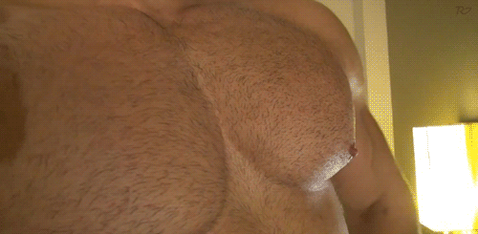

Damian tried to rise, but the new mass of his legs wobbled under him, each step making his knees creak. His hands were planted on the four as he panted like a dog, the fingers flexing and thickening as he couldn’t stop himself from moaning, the pleasure mixed in with the panic. Ryan was already growing with him, though with how tall he was getting, it was becoming almost godly. Though Sam swore he could see Jakub and Damian catching up, especially Jakub whose already broad legs were getting thicker and stretching up further. Much like the others, Ryan’s cock was beginning to grow monstrously large, thickening and coiling through the air as it drooled on the floor. The others were slaves to their own pleasure, Sam could tell that much from the way Jakub’s other hand was grabbing at his bulge and Damian was almost humping at the floor.

“W-What the fuck…” Sam wanted to scream but could only mutter, shocked as he was basked in the shadow of their growing forms. It was as if there were three horny Hulks suddenly in his home instead of his friends. And then he felt it, a slight twinge of pleasure, a sudden heat blooming across his crotch as he found something so salivating about the way Jakub’s thighs thickened or Damian’s biceps grew or how Ryan’s ass was inflating. He was finding it hot. He was getting horny and then Sam looked down to see that his own bulge was far bigger than it should’ve been and swallowed. “Oh fu-”

Sam’s shirt suddenly tore down the middle as the seams gave way to the swelling mass beneath. His chest heaved involuntarily, ribs stretching and pressing outward as his pecs began to swell, subtly at first, then with a shocking quickness. There was a wave of panic mingled in with pleasure that made him stumble back against the wall. His arms twitched, feeling heavier as the biceps thickened. His eyes flicked to Jakub’s massive meaty hands that were still growing and then to his own as the coiling heat of pleasure travelled through stretching fingers. Every subtle motion sent jolts of electric pleasure coursing through him, making his breath hitch and body tremble. His shorts groaned along the seams as his thighs and calves began to balloon along with his ass. But the biggest and quickest change came from his bulge.

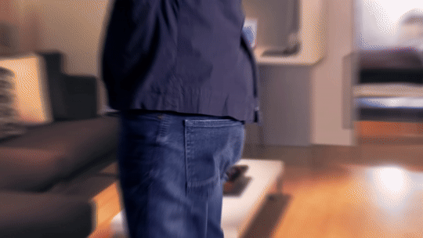

His cock surged whipping so fast that it was almost violent, growing and thickening in a way that mirrored his friends’ own transformation. The sensation was overwhelming, raucous pleasure and horror so tightly together that he couldn’t decide whether to scream or cry out in ecstasy. Whatever this virus was doing to them, it was making all of them monsters to muscle and slaves of their own cocks that continued to throb and grow. His hands shot down gripping at himself even as his mind screamed to try and stop all this, but he just couldn’t. It was like his bigger hands had grown perfectly huge to wrap themselves around his still thickening length. Sam looked at Ryan, Damian, and Jakub. The three of them were now monstrous versions of themselves, groaning and humping as they had long gone past the point of being just tall bodybuilders. Now they were almost reaching Hulk size as the virus claimed them.

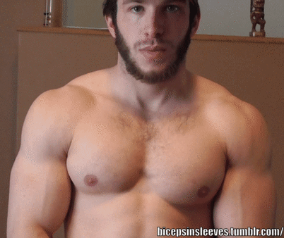

“G-Guysssss-” Sam’s voice deepened into a low groan as his shoulders broadened, his back expanding until the seams of his torn shirt were nothing more than shredded threads around his swelling torso. His neck thickened as he could hear the same deep slow voice escape Jakub as the man laughed, still playing with his huge jiggly pecs, as if goading them to swell bigger. Every touch, every movement sent spiraling waves of pleasure through his body, but Sam figured it was the same for all of them. Damian humped the floor like a wild animal, muscles surging under skin that seemed almost painted on in perfect definition. His shoulders and back had expanded until he looked like some living statue. If he was any shorter it would look like some 80s bodybuilder at some competition, instead of the inhuman monster of muscle that all of them were.

Ryan already looked built enough but now he blushed because despite his size, he remained a head shorter than everyone, a few inches skinnier than the others. He had become the shortest of the group now as Sam groaned and felt his back continue stretching, neck rearing back like his body was just trying to claim more height. His chest pushed upward, pecs rising, nipples erect as he wanted to try and feel them like Jakub was doing. But he wouldn’t need to do as he fell to his knees and the musk and sight of all the other men changing was enough for him and soon enough for them all. The sound of groans and ragged breaths filled the room, interspersed with the ripping of fabric and the slick, wet sound of their fat cocks either being pumped or slapping across their thighs, drooling pre-cum on the floor in streaks. He didn’t know who did it first but it was too late. They continued to throb and grow and throb until one by one they climaxed. Any and all resistance came out of them as throbbing fat veiny cocks shot loads all over the room, loads that were as big as they were pleasurable. The climax was almost violent, animalistic groans and the sound of creaking floor as their backs arched and they sprayed the room with their pleasure. Visceral bliss continued to rock through each of their bodies, as if their huge and heaving muscles meant there was just more for the pleasure to fill, more for their bodies to feel as they continued to cum on and on for minutes, some stripes of white reaching far enough to land on one another from across the room. It was all before all four men, latest victims of the virus, collapsed.

When the final waves of pleasure finally faded, the living room was silent except for ragged, breathing and the creak of the floorboards under their new weight. The air was thick and heavy with musk as threads of torn clothes stained the laminated wood floors. For a long moment, all four of the men just lay there, panting and slick with sweat and seed, sometimes a muscle would flex or a thick soft cock would twitch. But all of them just panted until they heard the sounds of other men, other deep and guttural groans and all of them knew that there were plenty more men the virus was affecting. Maybe there would even be more men they could spread the virus to. They didn’t even know how it worked but surely it worked like any other virus, just being near them could be enough. All of them could agree that every man should look and feel this good and despite earlier resistance, Sam was happy to lead the way.

