Where is My Prince?
A Vignette
By Maryanne Peters

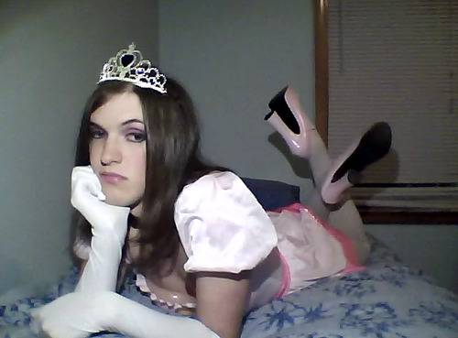

I put the camera on my laptop on shot sequence to grab this image. I had it sitting on the end of the bed while I did my poses but then I just threw myself on the bed just fed up with life, with the lens still pointing at me. I mean, look at me. It is a great outfit, and the shoes are fabulous. I had seen the full length gloves and the tiara in a costume shop and I just had to add them. But what great hair? I had it long so that when it was not tied back and freshly washed and blow dried it looked just right – perfectly feminine. And the breasts? They are really coming along nicely – not quite there but every day they get better. And the makeup? I am getting so good at that. The problem there is the eyebrows. I just needed a little tweeze here and there, and now look at them. Not a man’s eyebrows at all.

I knew I would have a problem turning up to work the following Monday. Somebody was bound to say – “Have you plucked your eyebrows?” It was just that brushing them was not enough for my Friday night solo photoshoot. Now I would carry the consequences. What could I say?

Is that why I was looking so pissed? Maybe, but the really depressing thing was that it was the end of the week, and I was looking fabulous, yet there I was at home alone. I looked like a princess, but where was my prince? Putting aside my uncertain orientation for a moments - a princess needs a prince – right?

Honestly, only minutes after the camera snapped this and I turned it off, I got a call from my boss Patrick.

“I’m sorry to call you at home Brian, but I wonder if you would be able to help me find a file on the database,” he said. “I just can’t find it and it has to get to Singapore before close of business. I have just had to cancel a date tonight – goddam it!”

He told me what he was looking for and I knew that I had the link. It was just a simple case of attaching that to an email and sending it. How could I make such a huge mistake?

He called me back within minutes.

“Thanks for that,” he said. “I have the link and I have found and sent the file. But you attached something else. I am looking at her now. She is absolutely gorgeous, but I can’t help but notice that she looks a lot like you?”

I panicked. Could it be true. Checking my sent folder I saw that somehow I had sent to Patrick with the link, the image of me as a princess. I mumbled something to him. What could I say?

“Don’t worry Brian,” Patrick said. “It is just between us, but on the basis that I meet this lovely lady. As it happens, I have a booking at a very nice restaurant tonight and nobody to take there. Would this beautiful creature care to accompany me? I won’t take no for an answer.”

Who would have thought that Patrick had such exotic tastes?

But who am I to ignore the fairy tale ending. Let him be my prince.

The End
574

Back  A Vignette  By Maryanne Peters  It started with a back problem. In fact it was more than a problem, it was excruciating agony. Such problems are not uncommon, I was told, so why does nobody have the solution? Why do doctors, chiropractors and others just shrug their shoulders?  I was told that a corset might help. The first one was called a back brace – it worked but it just did not give the support I needed. Itb was suggested that I have a custom-made corset fitted that could pinch in tighter. Wearing that I had the first relief that I had enjoyed for years. It is just that the relief that I was getting was changing my shape.  The first one did not have any bra cups, but the shoulder straps were needed to hold the top up and to keep my shoulders back. It did have the effect of making my chest look a little fuller.  It also appeared to change the way I walked. I stood up straight and I suppose that I tended to strut, in a way. I was odd | 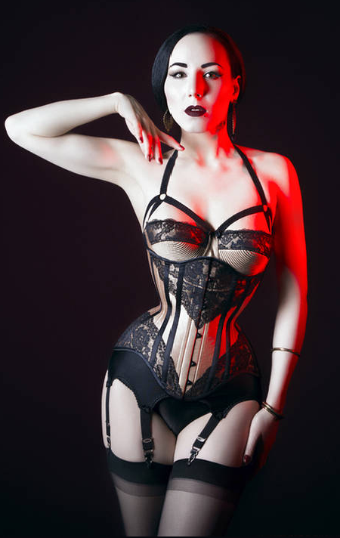

And then there was the fact that I was wearing a corset at all. You can hide it some of the time, but straps were visible, and sometimes it was also very apparent that I had an “hourglass figure” created by this garment. It was a shape that I came to admire, and not simply because it was a shape that allowed me a life with constant pain. There is something very attractive to me about that shape.

I remember the first time that I wore a blouse and a skirt belted in to 20 inches. I had never worn women’s clothes before that, but it looked so good that I felt that I needed to wear it is public. In order to do that I decided to make some other changes to my appearance – nothing too drastic – just enough to look normal … for a woman with the perfect hourglass figure.

But that was two years ago now. Since then I have grown the breasts to complete the curves that fit the shape and I have other restraints to ensure that my groin looks appropriate. And the hair and makeup … I guess I don’t look like a man at all?

But not back pain. Zero. It is so worth it.

The End
397

The Realtor  A Vignette  By Maryanne Peters  If I had any thoughts about living as a woman then they disappeared with time. Beauty is something that might be achieved in youth, but when middle age appears in the mirror one morning you understand that past dreams must be shelved as you splash your face with cold reality.  But business is business and after running my own group for years I had to face the fact that mature women sell more houses than mature men. The numbers do not lie. If I wanted to keep earning I needed to step back and bring in women.  There are other unpleasant things that maturity brings – impotence, fear of death, fear of wasting your life while watching others do what you used to do well.  I started to consider whether I might be able to reinvent myself, and I mean totally reinvent my appearance. It is not the sort of this that men do. In a man it makes you look pathetic, but women do it, often well. | 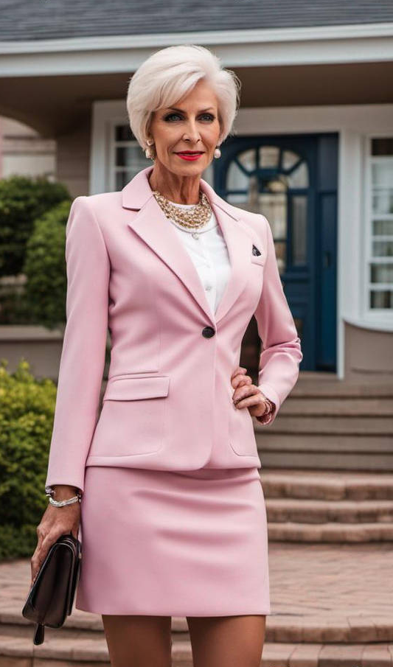

According to the web, it is never too late to transition. The surgeon said that I had scalp to work with and that as an older man with chromic erectile dysfunction bottom surgery could be almost bloodless and entirely effective when it came to sex as the passive party. And I kept thinking of the clothes I could wear, and the jewelry, and the shoes and accessories.

At my age you know what makes a mature woman attractive – it is her style and the way she carries herself. It is the same thing that makes a gold realtor. You need to be confident but patient, the two things that leave a man entering middle age.

Men buy and sell real estate as an investment, but with women what is being bought and sold is dreams. You add to that experience, age and time in the industry to match the property and the buyer, it makes for a great combination.

My surgeon asked me why I had not done it earlier and I really had no good response. I am just glad I have done it. I am selling more properties than I ever had, but also spending a lot more money in keeping looking this good.

The End
382

Superpower  A Vignette  By Maryanne Peters  He reminded her a lot of Wolverine, and it seemed that was something he fostered. He had a great body and when he embraced her she felt like a mouse in the arms of a lion. She liked that feeling.  “I have a superpower,” she said as she lady with those huge arms across her.  “What?” he said. He was grinning. She was fun.  “I mean it, I have a power, and I can prove it to you,” she said  “Alright,” said . “I will play this game. What is your superpower?”  “I can a man turn into a woman with just the right type of kiss,” she said. | 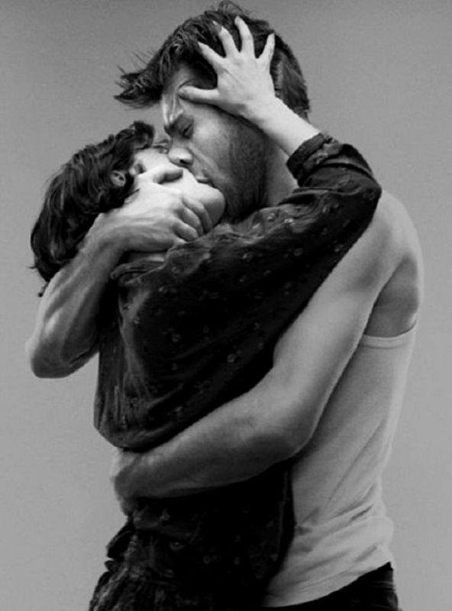

“Like mouth to mouth?” he asked sarcastically. “Like the kiss of life in reverse.”

“Like that, yes. I can prove it to you.” After a puse she added - “You don’t believe me, do you?”

“Of course I don’t! Superpowers are fictional. Worse than that, they are he stuff of comics – they are comical. They defy science. There is no such thing as superpowers because the are impossible – against the laws of physics.”

“I’ll show you, if you let me,” she said. “You are not afraid are you?”

“Of course not,” he laughed.

She put her face close to his amd licked her pretty lips. She whispered – “Suck my tongue into your mouth.”

He looked at her half open mouth inviting him. She was pretty and smart, and she was a little bit weird, but he loved the whole playful thing. She was different from any woman he had ever been with before, and in a way that was hard for him to put a finger on. But he wanted her. He wanted to have sex with her, but more than that. He wanted to know her in every other sense.

He wrapped his lips around hers and he drew her body close to his, wrapping his arms around her. He sucked.

She yielded to him for a while before suddenly stiffening and pushing him away.

“Oh my God!” she said. “You have reversed the kiss! You have stolen my power. You have turned me into a woman!” she reached down to her crotch and added – “Well, almost. Kiss me again.”

He laughed out loud, and again brought his lips to hers for a moment, before breaking off.

“What a minute,” he said. “What do you mean … almost?”

“Look at what you have done,” she said. “I am a woman now. You have made me into a woman by the sheer force of your hard body, your powerful masculinity, your machismo. There is nothing I can do. Surely if you next kiss is as powerful as the last one, this tiny vestige of the man I once was will disappear?”

He was smiling until he looked down and saw what she was referring to.

“Fuck! You’re a guy!” he shouted.

“I was once,” she said. “But now, with that power you have used on me, I can never call myself that again.”

He pushed himself away to look at her and try to understand.

“Are you crazy?” he asked.

“I think you are making me crazy,” she said. “You can’t leave the job half done. Make me a complete woman. Use your super power.

His eyes narrowed a little. He looked her over a little. She looked like a woman to him. Could he ignore what he had just seen? How close could he get and still ignore it?

“I don’t think a tongue is enough to do it,” he said. “I think it might require another part of my anatomy to truly finish the job.”

“Would that involve us both getting naked?” she said with mock naivety.

“Yes,” he said. “Some superpowers are more deep seated.”

“Go on then,” she said mischeviously. “Let’s do that.”

The End
644

Miss Burdizzo  A Vignette  By Maryanne Peters  Anybody who works with cattle as I do will know what a burdizzo is. For those of you boys out there who don’t know, cross your legs before you read on. You all get ready now. Yes, the burdizzo is a castration device. You get yourself a calf or a lamb or a kid – I mean an infant goat and you grab the ball sack with one hand and use the burdizzo pliers in the other hand and squeeze hard. The clamping destroys blood flow to the testicles without breaking the skin. The testes just die and you have yourself a neutered animal.  I know how to use this tool. I was maybe the smallest in the crew so it was easier for Keith to hold down the critter while I did the crushing. I mean you need a stronger frame especially with a larger beast. I mean they have no idea what it will mean to them but they don’t like it.  “You wouldn’t like it either,” Keith would say. But he didn’t know too much about me. I used to dream about it happening to me. | 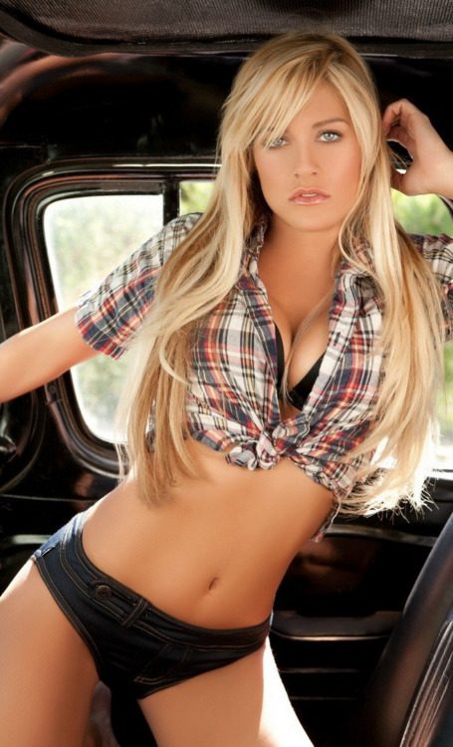

I know some folks will say that makes me sick in the head, but somehow I never thought that my balls belonged on my body. I remember when it all went wrong for me. My voice cracked and I go whiskers and pimples and my Daddy said – “If’n you got balls that’s gonna’ happen.” I hated that. I hated having balls.

Some nights I would dream that Keith was holding me down while a boy who looked a bit like me (but a bit more manly) was pushing the Italian tool towards my crotch. Keith would talk to me as he did to them calves, saying something like – “now you just calm down little one. You have no need of those things. We gonna make you soft and sweet like prime beef should be.”

I might look up and whimper and maybe bite my lip and whimper. But what my eyes were saying to Keith was – “Yes please. I wanna be soft and sweet. Make me soft and sweet, cowboy. Please make me soft and make me sweet.”

Sometimes in my bed I would play with that tool, and wonder if I could do it myself, but I didn’t have the courage. The truth is that I needed to be put to sleep, which was a good idea because they took much much more than my balls and turned me into a heifer and not just a steer.

A year later I went back to the farm and reintroduced myself to Keith and the other cowboys.

“Well, fuck me with a feather,” said Keith. “You ain’t a burdizzo boy anymore. You are a burdizzo babe. We need to call you Miss Burdizzo.”

Keith holds me down as often as he likes now, but he ain’t using any steel tool on me. Hard as steel maybe, but that tool is flesh and a whole lot of blood. That is the one I dream about these days.

The End
522

© Maryanne Peters 2024

