The Boys are Back – as Girls
A Vignette
By Maryanne Peters

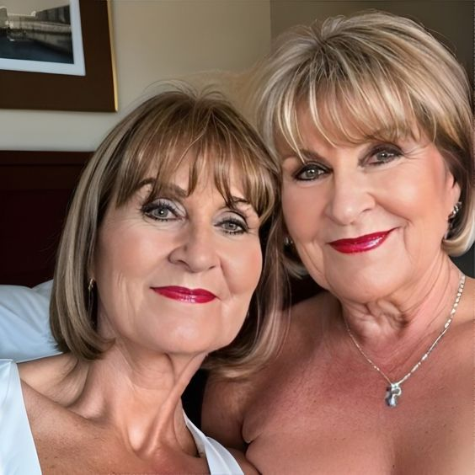

We are cousins – perhaps you can see some family likeness. We were as closer as brothers, maybe even closer, when we got together, but that was only a few times a year. It was just that we had a lot in common. It turned out that we had more in common than we both realized. I took us decades to discover that we both shared the same secret. We were both transgenders. We were both women born into the bodies of men.

It seems strange that it should have taken so long, but we found out by chance when we were both drinking in a bar, commiserating with one another over our failed marriages and distant families. We both said that we both understood our ex-wives and that the problem they had with us was because we were men. We both acted more like men than we were – so, why was that? Because we felt insecure as men … because we weren’t really men at all.

The thing is that we both had a problem, but now it was shared it was more than halved – it almost became not a problem at all. We both decided that we would look into transitioning in middle age. It is not an uncommon thing. There are resources available for people just like us, and we did have the advantage that neither of us was bald.

Our families, much of them shared, were shocked to hear the news, but as we explained we had been bad husbands and bad fathers because we were never meant to be that. As aunties or whatever they wanted to call us, we would offer nothing but love, unrestrained by masculine reservation. That is who we are now.

Given our ages it seems silly to think of us as being boys before we became girls, but now that we are, we do like to thing of ourselves as girls – middle-aged girls, but girls. After all, this is all new to us. Honestly, we both feel like teenagers, discovering what it is like to be feminine, discovering our independence and sense of style, discovering men and sexuality the way it was meant to be.

I think girls can be girls at any age – don’t you agree?

The End

Honeymoon Reveal
A Short Story
By Maryanne Peters

We had only been married for three years at the time and we had never enjoyed a proper honeymoon. The fact was that after we had met on a dating site and almost immediately she had thrown herself in to caring for my young sons … and me. My sons and I had all been devastated by the loss of my first wife Marion, their mother, only a year before I met Cherise, but she helped to pull us all out of our dark mood. She said that it was all she wanted - to bury herself in a loving family.

We took what little time for us as a couple that we could, snuggling on the couch after the boys were in bed, great sex when we knew they were asleep, and just a few date nights when I could find somebody to act as babysitters.

The boys were a little uncertain at first, but it didn’t take much time for her to win them over. I had been won on the first date, but after a year we were married, and the boys were treating her as their mother. She was devoted to them, and she seemed to know exactly what teenage boys needed. She even got involved in their sports and not only was she knowledgeable about football and baseball, but she even had some skills that she could hand on.

I didn’t think much about that at the time. She just seemed to be the perfect mother – able to offer them so much while I was hard at work. She was a great cook and made great dinners, weekend treats and packed lunches for them at school.

It was not until they were mature enough to leave them at home alone that we could even think about that honeymoon. Of course we had a neighbor to check in on them, but we had confidence enough to leave them with just that. Cherise in particular, seemed to have given them a sense of independence that I never had at their age. But the truth is that the Bahamas were only a flight away, plus we were on the phone and online if needed.

We were both looking forward to it.

It gave us the first opportunity to talk about something other than the household, and that meant our future together that we hoped would be long.

Her past never mattered to me. I only knew that it had been difficult and so it was not something she wanted to talk about. I left it at that. I suppose that I thought she might have come from an abusive home because she said that her relationship with her parents had broken down completely. I knew that they were alive and that they made no contact with her, although they knew where she was and could have. As far as I was concerned it didn’t matter. My parents filled the grandparent’s role and they adored Cheris.

The other thing I knew was that she could not have children, which seemed to explain why the boys meant so much to her. She mentioned past surgery. It didn’t ask about such things, and it didn’t worry me.

Our vacation was spent mainly on the beach, but one day we went into Downtown Nassau to have lunch and a look at the sights. The restaurant we chose for lunch was near the market and we chose a view of the street for some people-watching. We were doing this that when a large and very colorful woman walked past.

I remember the conversation exactly.

“Do you think that’s a man?” I said, referring to the woman. It was not said in a nasty tone, but simply asking her for her opinion as a matter of interest, as I often did on other matters. But suddenly, it seemed, this was not how it was received.

“That is a woman,” she said hotly. “She is every bit of woman as I am.”

“Hey, Sweets, take it easy,” I was a little surprised. “But you have always been a woman, and I am not sure she has.”

“Why would you say that?” she snapped. “We don’t talk about my past, remember.”

It suddenly dawned on me what she was trying to say. It seemed unbelievable to me, as she sat there shaded from the Bahaman sun, looking every inch as beautiful as she always appeared to me. Was it possible? There were broad shoulders and hips narrower than for most women. How was it that she could throw a knuckleball to the boys? What other women know the right name of spanners? Who was this person – really? I suppose that the first feeling that I had was rage. I felt betrayed – lied to.

“I certainly would remembered if you had told me that you were a man, or you once were one” I said.

“That is what you don’t understand I have never been a man. Never. I was born a woman and I have always known that. It was just that a deformity forced me to pretend to be a man. It turned out that I was good at pretending, but that never changed the fact that I am a woman, and I always have been!” She was angry too.

“What was it that you said that could have hinted at that kind of past,” I demanded.

“I told you that I could not bear children and that I never could,” she said. “I told you that I had surgery. I was going to tell you more, but you cut me off, remember? You told me that the past did not matter to you, and you did not want to hear about any of that. Do you remember that?” There were tears in her eyes. It seemed odd to me to see them. This was not how things should be.

“I thought you were perfect. I didn’t need to know.”

“Thank you.”she said, using the table napkin to wipe under her eyes before any tears fell. “You’re right. It should not matter. But now suddenly it does?”

“I think you should have said something” I said, wishing that nothing had been said at all.

“I took you at your word – that it did not matter,” she said. “Nothing should matter except who we are now, and what we are to one another. What are we to one another?”

“We’re husband and wife,” I said. “We are on our long-awaited honeymoon.”

“I would not be anywhere else,” she said. “I would not be in any other place, or with anybody else but you. So-what if I was not as perfect as you thought. Many women aren’t. It was nothing more than removing a small piece of ugliness from my body,” she said. Women do it all the time. A nose job or an eye lift.”

She was talking because that is what she did when she was frustrated. It was one of those things that I loved about her. It seemed like a female thing. Perhaps it was. That would make sense.

But I noticed that she was in tears again. It made me think that there had been tears of joy in our marriage, but she was strong and only cried in sadness in caring for, or sharing the pain of others. I had always admired that strength in her. Was it a masculine trait coming through? It had always made me proud to know that this incredible woman was my wife.

Now it seemed to me that this was the first time I had ever seen her cry from her own pain, and it was my words that were causing it.

I suddenly realized who she was and why I loved her. She was the very best of women, which meant that she was right – she was a woman.

I went up to her and took her into my arms. She quietly sniffled into my shoulder, but I could feel her body, stiff from grief and anger, suddenly soften in my embrace, warm in the knowledge that our love was real and constant.
“I should have told you,” she said. “I talked around it, but I never said the words.”  “Unspoken is better,” I told her. “I only wish I could take back all the words I have just said. I love you, Cherise.”  We made love. After all of that said and done, it was the very best of honeymoons.  The End  1420 | 

Bridesmaid  A Vignette  By Maryanne Peters  I suppose it is a common meme on all that transgender fiction to be found on the web – the bridesmaid breaks her leg and her brother or the brides best male pal steps in to fill the breach. He is a regular guy, of course, and thrown into the ladies’ end, the deep, where he flounders for a while before finding his stroke. That could be my story, but it’s not.  The reason I know about transgender memes is because I am transgender myself. I was just a shy withdrawn boy with the heart and soul of a woman. And the bride was one of the few that knew about it. | 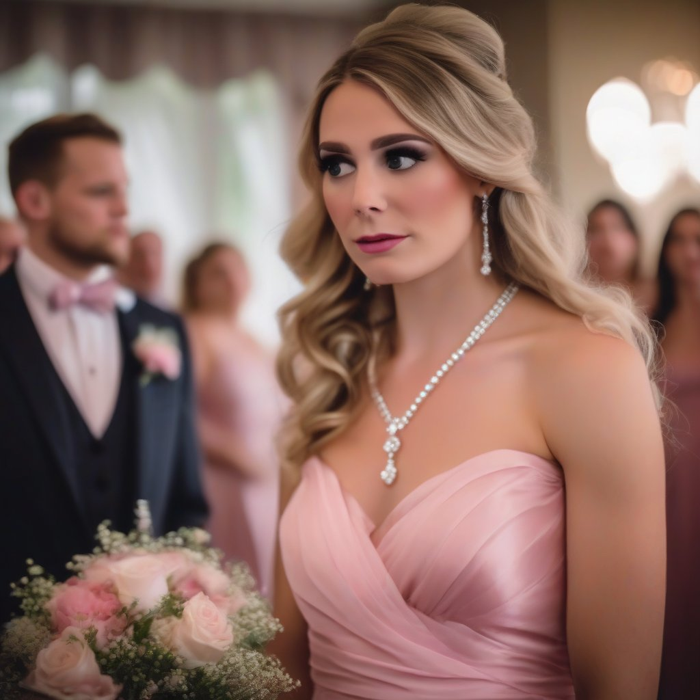  The image is from SoCalSecrets on Deviant Art

Olivia worked at one of those feminization boutiques. I used to go every couple of months to get a makeover and let the really me come out for a night. She did my first makeover and then suggested that looking as good as I did, I needed to go out for a drink and a meal, with her as my BFF. I had a wonderful time with her, and she suggested that we do it again. I did wonder if it wasn’t a push for more business, but after a couple of the dress-up pal dates we became friends – girlfriends.

I suppose that she helped me to develop my feminine self, and that new person was very different from the man that I was. Olivia told me that she had to be. If you want to present yourself as a woman, you can’t hide. You have to step forward and exercise you higher pitched feminine voice. You have to show people your made up eyes, let them see the bosom that has been push up out of flab, show then the line of your freshly shaved legs. You have to forget that you ever were a man. The new you has nothing to do with him.

It sounds like just the thing a specialist working in a feminization boutique might say, but it was just what I wanted to hear.

“Will you be my bridesmaid?” she said.

It seemed to me that she had so many friends, but she chose me. I had grown close to her, even a little dependent, but with her question she confirmed that she was my best friend as well. Of course I said yes.

“This is not dress up – this is real,” she said. “Are you ready? You will need to take time off to get ready. There will need to be real hair extensions from the hen party right the way through to the day after the wedding. Every hour of every one of those days you will be a woman – the woman you truly are.”

It was like a dream, but still I thought that like all dreams, I would wake up afterwards and it would all be gone. But I wonder if the whole idea was to get me so deep into being a woman that I could not back out.

The hen party (which I organized 100% as the new me) was a hoot, and all of her friends accepted me as female. It seemed as if whatever hard edges of masculinity I had before that night out were ground away by close contact with others of my (new) sex, and by a few male interlopers that we encountered.

And then … the wedding – like all weddings, a celebration of the feminine. I simply loved it. Some of the girls said they felt awkward all dressed up, but I didn’t. All I could think about was the day that I would be a bride, just like her. None of that seemed strange.

And then, she turned to me and threw the bouquet in my direction, and I caught it. I was delirious with joy, and all the other girls danced around me. Suddenly they all had suggestion as to the man I might marry, and a few of them would be at the reception, ready to dance with the pretty bridesmaid.

I guess I knew then that I would never wake up and abandon this dream. I had to live this life. I had to dance with every man I could, and then let one of them kiss me and take me to his bed.

I had been turned, totally. Once a man, now a bridesmaid – although, no longer a maiden.

I could give you the name of that feminization boutique, but are prepared?

The End
755

OMG  A Vignette  By Maryanne Peters  I had long hair, although nowhere as long as I ended up with. It wasn’t blonde either, but I think it suits me. I didn’t think so at the time – the time of the big reveal – the time when the real shock was not how I looked but how I felt. I became female in that OMG moment.  My older sister had just started at a beauty school, and she was suddenly surrounded by so many pretty girls. I liked pretty girls although I have to admit my feelings towards them were probably confused. Now I know why. I liked looking more than touching. | 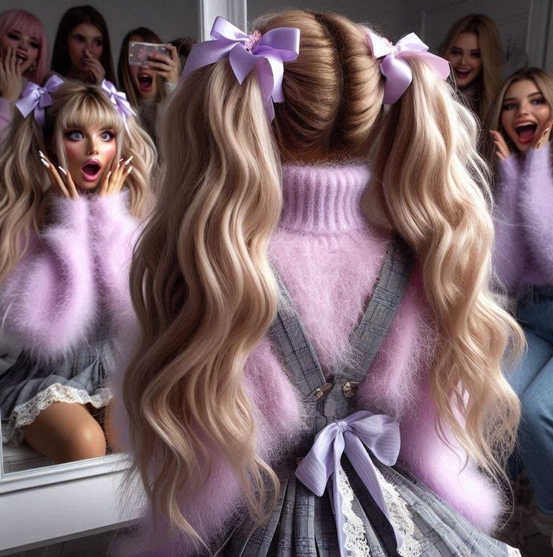
Gel
I was to be their little pet project. It was not as if I volunteered – I was just told that I was going to be beautified. I guess that I figured nobody would know, and the way they sold it, it was going to be fun. What young guy was going to say no to four pretty girls and my older sister? I didn’t say yes either, but that didn’t matter.

There must have been drugs involved, or maybe I was just intoxicated by all the attention that I was getting. They spent a lot of time on my face and hair, but they also rubbed stuff on my legs and attended to my fingers and toes. The whole time they were talking to me in soothing tones and having me lie back.

It was only when they talked about dressing me us that I give a slightly whimper of protest.

“It’s just a woolly jumper and some dungarees,” one of them said.

“Oh my God! That can’t be me!” Putting my hands up to my face only made it worse – such soft feminine hands and with gel nails painted white setting off the lace in my bottomless “dungarees” a short dress showing off my long smooth legs.

“It’s you alright, but who are you?” asked my sister. “Tell us your name, you gorgeous creature.”

She snapped off a picture and all the other girls applauded, calling me “A work of art” and a “true statement of our beauty skills.”

What was I supposed to do. They all wanted to go down town to have some fun and I was invited. How could I possibly say no?

The End

The image was sent to me by Typsie Tinker

Noblesse Oblige  A Vignette  By Maryanne Peters  That is me in the White Drawing Room, wearing a dress in the right color. The painting on the wall behind me has been in the family of for 300 years and is strange for the time – almost a collage painted in oils portraying one generation of my family, all now long dead, fulfilling their duties as members of the English aristocracy. We are not quite princesses, but below princes are dukes and below them are earls, and my father was one of those, may he rest.  The positions allotted to the ruling class are very simple, when it comes to sons. The oldest is the successor and after that you are either in the army or the church. It is all about service. Making money is frowned upon – definitely middle class … and below what was expected of us. | 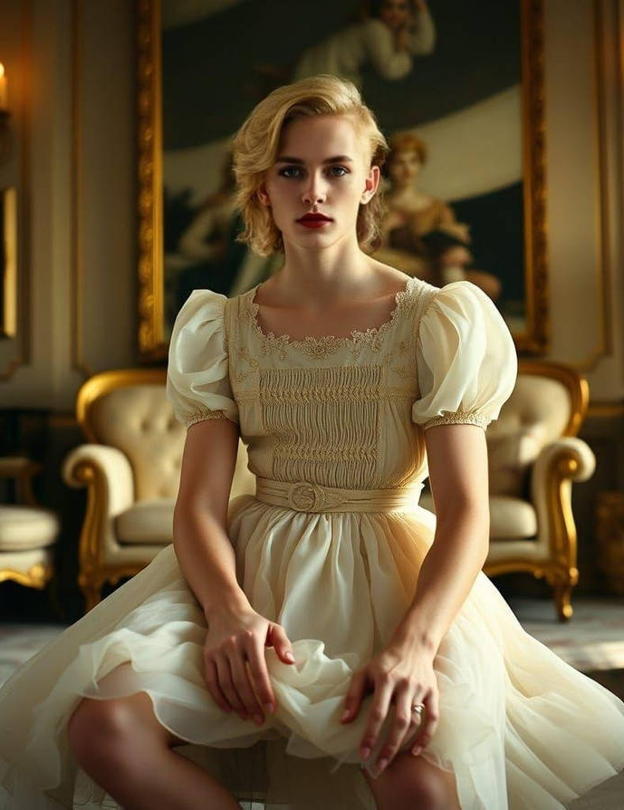  “Princess Life” by Mumbo1979

What people don’t understand about the British aristocracy is noblesse oblige. There are money making peers, and now there are money maker made peers for their success, but they will never truly be of our class. Our class is above such thing. We are bound by duty to serve.

I was the third son. James was the oldest, and now he is the Earl. Then there was Henry who is well suited to the army, and can be the back up for James until his heirs are ready. But me? I was non violent and an atheist, so the tradition did not offer me anything workable. What should I do?

The engagement ring might give you a clue. A little incongruous on the hand of a young man wearing a dress, you might say. But the point is that we have to do what we are bound to do, and sometimes we need to grow into the role we are allotted, just as my brother James must rise to his, and Henry be called upon to give his life.

The daughters of earls have a role too. Their role is keep the ruling classes pure by blood but also by upbringing. I had a sister once, and she was betrothed to another Earl – I wont mention his name. I will say that after my sister was killed in a riding accident he married an unfortunate woman who gave him two boys and then ran off with bloodstock manager. He now understands that what he needs is a proper wife and a mother to those children born at an appropriate level.

James suggested to me that it might be a role I could play. It seemed ridiculous, but as he pointed out, the world is a very different place these days and it seems that you can change sex as easily as one might dress for dinner. In my experience it seems to take a little longer.

My new fiancé approves of what he has seen so far, although James has said that I am “a work in progress”. Nobody seems to doubt that I will be very pretty when my hair grows out a bit and the hormones work their magic on my chest. I have good skin and great legs, although my hands and feet are a little large.

But most importantly I have class, and I don’t mean that in the American sense. I was born to pass on a culture of excellence and service to others. The only question is how best to do that. I think that I have found a way, and I do love wearing this dress.

The End
600

© Maryanne Peters 2025

