Camilla  A Vignette  By Maryanne Peters  She – it seems so wrong to call her anything but that – said that her coat was stolen by a couple of guys who attacked her. They ripped her blouse open and somehow managed to tear off her skirt – she said it was a wrap skirt, whatever that is. So, she was almost naked when I found her. I had my bowling jacket in the trunk of my cruiser so I put it around her shoulders.  She actually started to cry. It sounded crazy when you consider she had seen these guys off without getting a scratch on her – just a little blood on her knuckles. | 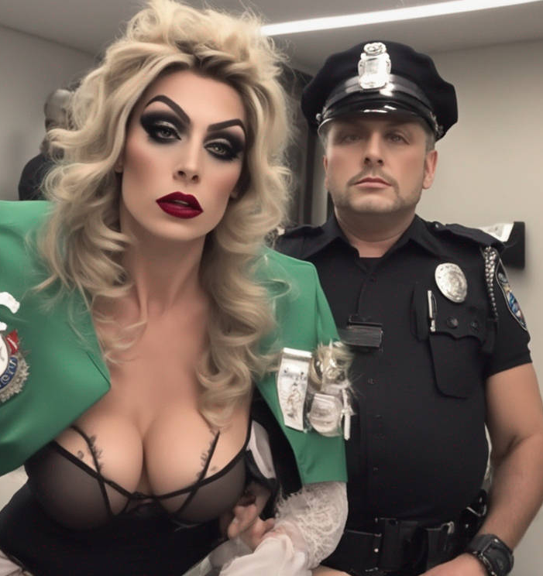

I have to say that I thought – ‘wow, this lady can sure look after herself’ even though it was clear to me that she wasn’t a lady, or even female. It was the voice, even though after listening for a bit, that could be a husky sounding woman. Certainly to look at her, you wouldn’t know, except maybe the height in those heels.

She had tits. I mean, I guessed they were stick on, but they sure didn’t look it. Even after a scuffle they looked great, and the makeup too. It was just like she had walked out of a beauty shop. The hair was messed up a little, because she said they tried to pull it off. But was it a wig? I wasn’t sure. It sure looked like real hair – I mean, dyed, but real.

She said her name was Camilla, but I told her I needed a real name, not the working girl name.

“I’m not a prostitute,” she sad, looking really mad that I had even suggested it.

It was true, I had no evidence of soliciting. She was a victim, not a perp. I apologized and asked for the full name on the birth certificate.

“Cameron James Dunleavy,” she said. “But don’t call me mister. Cam or Milly, please. I go by either. Short for Camilla”

She looked more like a Milly to me. I told her that she was not being charged with anything. There were some offences that might apply, but like I said, she was a wounded party here, even if she suffered no injury. I told her that I needed a statement and descriptions of her attackers.

“One has a broken nose and one has a limp, and probably the mark of the toe of my shoe on his shin,” she said, without a smile.

I did smile. I wondered aloud who was the victim here? She finally gave me a small laugh. It was like the sun coming out after a thunderstorm.

“Thank you for the loan of the jacket,” she said. “You seem like a really nice guy. There are so few of you around.”

It seemed like the kind of thing only a woman would say. It seemed only right that I treat her as one.

“I am going to tell it to you straight, Milly, with a street attack like this and no clear ID, it is unlikely that we will find anybody to charge with an offence. But you have suffered an attack, so if you want I can take you to the hospital, just to check you over. They have counsellors there who can help you through this. My shift is finishing soon, but the hospital is on the way.”

“I am not sure that I need any of that,” she said. “But I would appreciate a ride in that direction.”

Somehow the idea of driving her sounded exciting. It seemed like such a long time since I had a woman sitting in my passenger seat, let alone a woman with legs like hers, and breasts that just see to invite my face into them.

I finished up the paperwork and I told her to wait outside the station entrance while I got my car.

She got in and thanked me again for my kindness. “But don’t take me to the hospital. Could you just drive me home. Please.”

I was hoping that she would say that. I needed to know more about her. I needed to know just how much of a woman she really was. I needed to see her safely somewhere so I could get my jacket back. I said that I would take her home.

I am not sure whether I had any idea what her home might be like, but as she gave directions it seemed that the area was increasingly unfamiliar – not a place where there was a lot of crime, perhaps a higher-class neighborhood. In the end we came to a gated driveway and she pulled a remote from her bag – the gate opened.

The house was huge. She suggested that I come in for a drink. I guess that I was just confused. I just stepped out of the car and opened the door for her then followed her up the steps to the front door.

“Make yourself comfortable,” she said. “Here is your jacket. Thank you for keeping me warm. Let me just go and get into something comfortable and I will be right back to fix you that drink.”

She showed me into a lounge area with plush sofas and art hanging on the walls, and there was a large window to the back garden of the house with floodlit terraces, lawns and trees. It was a mansion.

Could this really belong to Milly? There was a sense of class about her, even if the heavy makeup and those pornstar tits made her look less than that. I wondered if she might be a kept woman, with a sugar daddy away on business. But she didn’t seem the type of woman who would be dependent on anybody.

Then she reappeared wearing an expensive looking robe and wedge slippers. She walked over to the bar area in the corner, revealed behind folding doors.

“What would you like to drink … I don’t even know your name,” she said.

“Tony. Tony Balewood,” I said. “I’ll have scotch if you have it,”

“Blended or single malt?” she asked. Seeing my confusion she said – “I do like scotch myself, so let me pour something special for you.”

From a shelf she pulled out a small bottle and poured the amber fluid into to cut crystal glasses. She brought them over and placed one in my hands before crossing to the other armchair facing me. She put down her glass but she did not sit immediately.

I smelt the whisky – sweet, smoky, bewitching.

“I thought that maybe I should clarify something, before we go any further,” she said. She was facing me, looking down as I sat there, marvelling at the room, and the liquor and the figure in front of me. It all seemed slightly unreal. How much stranger could it get. And then her robe fell to the floor.

There was shock, of course, but it seemed to me that I was looking at the perfect body. She was tall, and that long blonde hair hung down past her shoulders just above her breasts, as pert as a young woman’s. Her shoulders were broad and her arms and legs well-toned rather than muscular. Her stomach was flat, but not hard – her whole body had a wonderful softness to it, despite being as smooth as polished white marble. The only color below her nipples was the brown of her dark pubic hair and the pink of her visible labia. I was speechless.

“I wondered if you might have some doubts, so I wanted to show you that I am totally female,” she said.

“You have a great body,” I spluttered. “I have tell you that I thought that from the moment I saw you. I thought – here’s a woman who looks after herself.”

“Thank you,” she said, with a smile. “I haven’t always looked like this, but I have invested a great deal in this body, so I want to look after it.” She stooped to pick up the robe and put it back on. I took a healthy sip of the whisky. It was wonderful – the best liquor I had ever tasted.

“You mentioned taking things further,” I said, as she sat, crossed her spectacular legs, and reached for her own tumbler.

“I was thinking about sex, should you be interested,” she said, as if talking about the weather. “What with you being one of the city’s finest, and a gentleman besides, I feel that is the least that I can offer. Perhaps you might even consider it a reward, but I am woman who would never suggest that. The pleasure would be more mine than yours, perhaps.”

“Sex sounds good,” I said, although when the words were said they sounded weird.

“Finish you whisky and we will go upstairs,” she said. “But savor it. It’s a very expensive bottle. When we go up I think that I can find you something to wear – I have a few men’s garments I could not bring myself to throw out.”

“An ex-husband?” I suggested.

“Not exactly,” she said. “But very much ex.”

I was ready for the most incredible change in my life, and the first of many nights with Camilla.

The End
1537

The AI image is called “Man caught by police while crossdressing” but I have mislaid the source. This is no crossdresser in my view. And there is something in the expression that show strength and power, or am I just imagining it?

© Maryanne Peters 2026

