All the Same
Inspired by a Captioned Image by the Wonderful Annabelle Raven
By Maryanne Peters

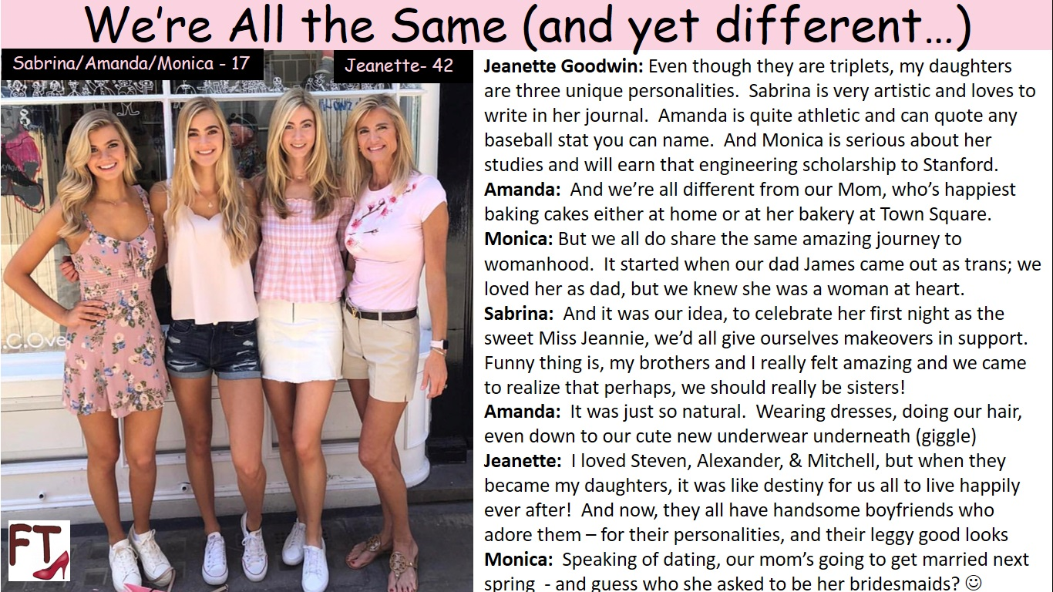

My area of specialization is behavioral genetics. This is the branch of medicine, or psychiatry in particular, that looks at the behaviors inherited from our parents. Perhaps the area of study that has gained the most attention is the study of identical twins, or more rarely identical triplets.

Historically it was said that children who have their origins in a common zygote, the fertilized egg that has split into 2 or 3, having the same genetic material, all traits must be acquired through social conditioning. That means that where different personalities arise, it must be because children were treated differently. But modern studies have almost totally disproved this. As any parent knows, all children are different, and genetic make-up does not seem to change that.

The Goodwin family are a very good example of that. All the children were very different. But yet the intriguing thing here, was that all three of the young men in this family appear to be transgendered.

Now, we have some evidence of differences in the transgendered brain, but we have no basis for any suggestion that this condition is rooted in the genes. In fact, there are many examples of monozygotic (identical) twins where one is transgendered and the other is not. Therefore, I considered that the Goodwin triplets were worthy of further study.

I made contact with their mother Jeanette, over a year ago. With the agreement of her “daughters” I went to see them a week later. My first reaction was one of disbelief. Nobody would be able to guess that the three beautiful young women before me had been born male. Not just from their appearance but also from their mannerisms and general demeanor

Their mother Jeanette was also an extremely attractive women, and only a little younger than me. I did not have the benefit of seeing her when she was the same age as her children, but I would venture to say that she could hardly have been more good-looking as she is right now. Life experience carries its own beauty, in my experience.

Jeanette also stressed to me that her daughters did indeed, all have different personalities. I asked her to describe them which she did. And for all three girls to assess their own personalities and their likes and dislikes. This they presented largely in the preferences in men, all being declared to be wholly heterosexual young women.

In the course of this I was further surprised to learn that their mother Jeanette had also been born a man, something I found totally unbelievable. She proudly affirmed it.

I then asked her to indicate her preferences and she told me that she had always had a thing for “brainy guys” like scientists and such. I have to say that I was delighted to hear that, because that is what I am, and even we scientists have the behavioral traits and human urges that we study and write about. Basically, we’re all the same.

I have to say that I have learned that birth sex is a thoroughly unimportant factor when it comes to desire, and love for that matter. Although love, and organizing weddings are things that I prefer to leave to others in my new family.

The End

Déjà Vu
Inspired by a Captioned Image by the Wonderful Annabelle Raven
By Maryanne Peters

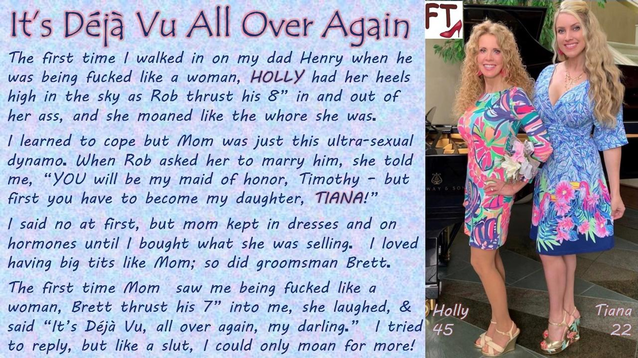

When my birth mom died in a car crash while giving a blow job to a man she barely knew, I should have known that there was something in my genes, but it was only in the months that followed that I discovered that it was the slut gene.

I say birth mother because from the time that my father was single again, he insisted on becoming a mother to me. I don’t mean cooking meals and cleaning house, I mean growing mammary glands and long hair. My new mom was the same size as my birth mom, so she had a wardrobe that could only be added to, and a spousal life insurance payout to ensure that she did not need to work for a while.

So to discover that your father is a cross-dresser – well, that is one thing. But then to come home and hear noises, to go upstairs and find my Mom on her back with a her friend Rob donkey deep in her ass – that is something else.

It was just that she enjoyed it so much. She kept going on about it. She said that she was a lousy lover as a man so she could not blame my birth mother for looking elsewhere. She said that she could never get a rock hard erection and it was bendy and slow to spit. Now she said – “I just lie back and it jiggles away – it doesn’t matter whether it creams or not, I am loving it.”

The truth is that is in my genes too. I had not had much sex and that was for a reason – I was no good at it. It was embarrassing for a young guy to be so inadequate.

“Lie back and take it like a woman,” was Mom’s motto. “You should try it.”

I was bigger than Mom but she bought me a few outfits to try on, just to see whether I might like it. I refused at first, but if you knew my mom you would not that you cannot keep on refusing her. I just dressed at home, for her, so we could hang out like mother and daughter.

It was only a matter of time before Rob proposed marriage. He wanted to move in and get even more sex, but she gave him the ultimatum – “No cohabitation without marriage”. The ring appeared from nowhere.

“We need to make one other thing official,” she said. “I need a maid of honor, and that person has to be my daughter, Tiana.”

Like I said, she is a hard woman to say no to, and she just wore me down. Before I knew it I was on hormones and coming out at work as transgender.

Whether I was or not, it was the only way to explain the breast and my new hairstyles, following along Mom’s example, of course. But what is transgender? It is the change not the condition. You know that you belong in the body of a woman, and you know that when a real man is inside your body.

That happened on the night of Mom’s wedding when Rob’s young pal Brett got his way in the end, after spending the whole wedding getting me drunk and charming the panties right off of me.

It was a week later when Mom came into my room and Brett was hard at it that she had to lean on the door frame and laugh – déjà vu.

I just cried out to Brett not to stop, even with my slutty mother looking on. To his credit, he banged on regardless. He is my kind of man.

The End

© Maryanne Peters 2022

Gordon Labs
Inspired by a Captioned Image by the Wonderful Annabelle Raven
By Maryanne Peters

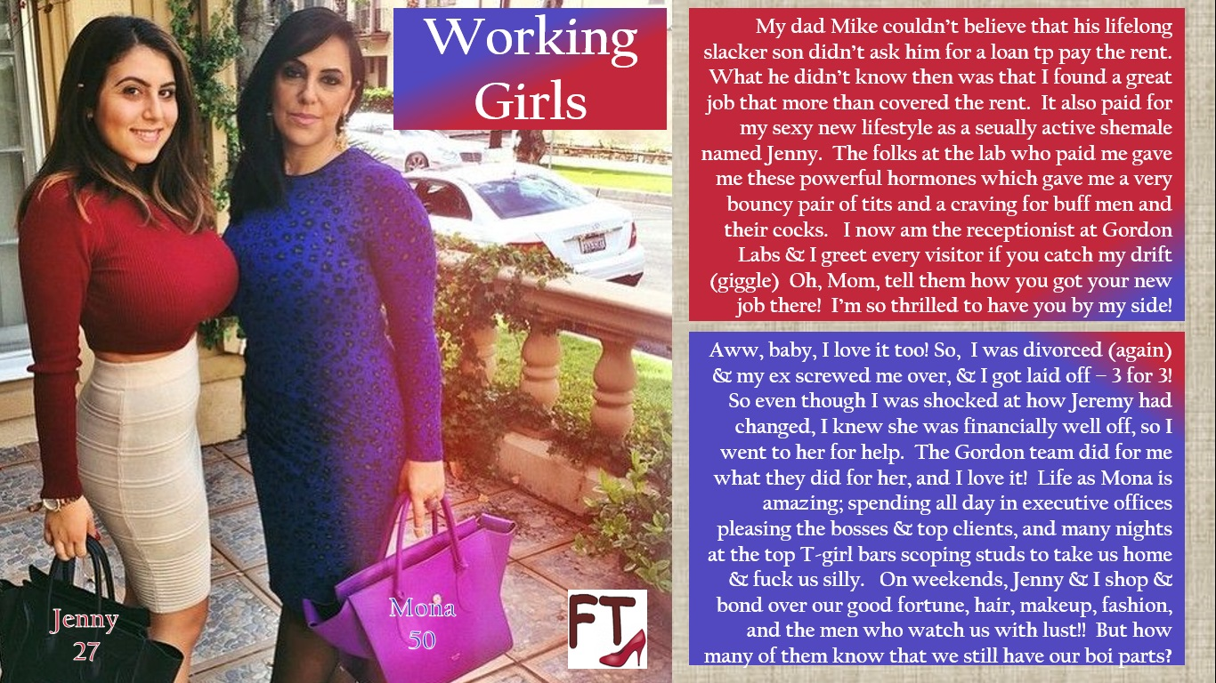

Here at Gordon Labs we consider ourselves to be on the cutting edge of research, but of course like all experimental pharma companies we have to overcome the problems caused by the delays in trialling new formulas. I think we all know that some unauthorized trials do take place. All that is needed is a volunteer – some young slacker who is desperate for cash.

Jeremy X (I wont’ give his surname for obvious reasons) seemed ideal. I would have preferred somebody without a family who might sue, but his only living relative was a father who might also be suitable as a trial candidate.

What we were exploring was whether the powerful hormones that we were using were able to alter sexual orientation. All established studies of human behavior would tell you that this was an impossibility, but we had established through testing before the trial that Jeremy was attracted to women, even if his personality prevented him from doing much about except watch porn.

He signed up for the trial for the money, and now he is Jennifer.

We talked about his father Mike. From our point of view is seemed a good strategy to get the next of kin into the program to, and Jenny said that Mike was also in some financial strife give that he was paying the cost of his third divorce.

“Unfortunately Dad has been dragged through the world by his cock,” said Jenny indelicately. “He might be a little lazy like I was too. He finds a woman and then marries her to keep her, and then he starts looking elsewhere. He would benefit from a change of orientation.”

I suggested that Jenny invite Mike to come in and see the turnaround in his son.

Mike was shocked to start with, but once he could see that Jenny was in full time employment and truly valued by Gordon Labs, and that he was happy, he was prepared to hear us out.

“It is all reversible,” I explained. “Or at least until you reach a point where that will be difficult, but for now you have the opportunity to escape the cycle of marriage, infidelity and divorce, and check out an alternative life.”

Jenny was excited by the thought and was urging her father, but he was understandably reluctant. Gordon Labs also produce a drug that reduces inhibitions but I can say hand on heart that we did not administer that. It may we have been Jenny.

All I can say is that I am glad that it happened. Just take one look at Mona, a mature and glamorous woman and an absolute tiger in bed. She and I are an item. We are talking marriage, and for the first time I think that she believes this time it will work out for her.

The End

The Right Guy  Inspired by an Annabelle Raven cap  By Maryanne Peters  Okay, I admit it – I have a thing about transwomen. There is just something about fucking a girl who used to be a guy that turns me on. I didn’t discover it until after my divorce, but then I found that I could not back to regular girls – genetic women.  There is something about the femininity of transwomen too. They try so hard, whereas some of those born women see born lazy. It is like a transwoman has a man’s view of what a woman should be like, which I suppose got me thinking about whether a transwoman could be made from a regular guy.  I make a living from gambling, and it is a good living. Every now and again, even sticking to the professional gambling tables, you meet a schmuck who will bet their balls on a bad hand. Bert was one of those guys, and it turned out that he was literally prepared to bet his balls.  I like to think that I saw the woman in the man – I mean I saw that he would make a good-looking woman. He was small and slight, and he had great eyes. If it had not been for his eyes, I would not have offered him the deal that I did. I just wanted to see him dressed as a woman, and to make sure that I was right. Maybe I hoped that if he was ready, we might have sex as if he was a fully transitioned transwoman. I never planned to fall in love. | 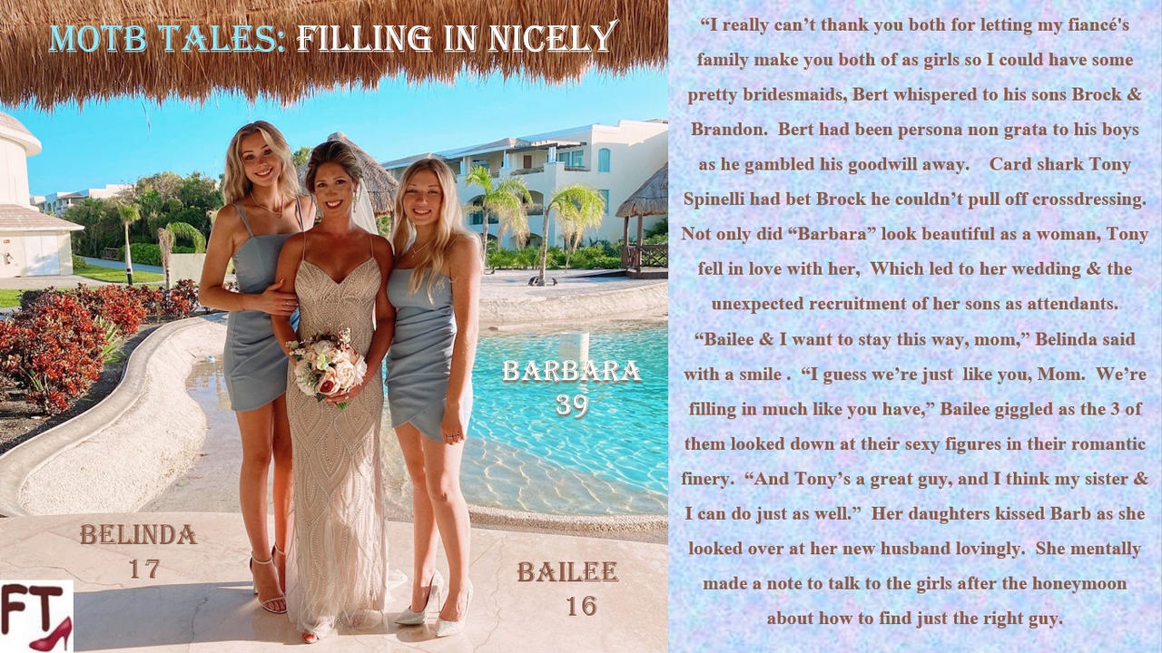

The moment that I first met Barbara I just knew that everything had changed – for her as well as me. She was uncertain, even puzzled, by the way she looked and the way she felt. It was like she was a baby foal, shaking on those long lovely legs, looking around at the world for the first time and trying to understand who she was. I think she knew even then that she was not Bert, and that she never really had been.

For me, to see a man come to the realization that she was truly a woman, right there in front of my eyes, as like a dream come true. I had to help her, and guide her. She cried on my shoulder more than once. She was confused, but she was undoubtedly female. The change was so dramatic, and it was by my design – I was delighted. But falling in love with her was something extra.

She said that she had two sons who hated her. Bert had lost all the family money, and his ex-wife and the boys had walked away. She showed me a picture of Brock and Brandon, and I saw in them the chance to change more lives, and to create more women.

Without telling Barbara, who had no intention of telling her sons about the drastic change in her life, I contacted Brock and Brandon with my proposition. They did not believe me at first, but I showed them a picture of my bride (who had been their father) posing in her bikini post surgery. I wanted them to attend the wedding as her bridesmaids, and I was prepared to pay to please my bride, and perhaps myself too.

I think we would both have been happy if they had just dressed for the day, and the week or so leading up to the wedding, but maybe it is that thing about women and weddings? Anyway, they loved being girls, and even up until now they are staying with Barb and me and living the high life was my step-daughters.

So, I have a thing about transwomen, but to me Barbara is all woman and always has been. She just had the I good fortune to meet the right guy in me. As for Belinda and Bailey, we just hope that they should be as lucky. I guess that means I will be paying for more surgery.

The End

Keeping the Farm
Inspired by a Captioned Image by the Wonderful Annabelle Raven
By Maryanne Peters

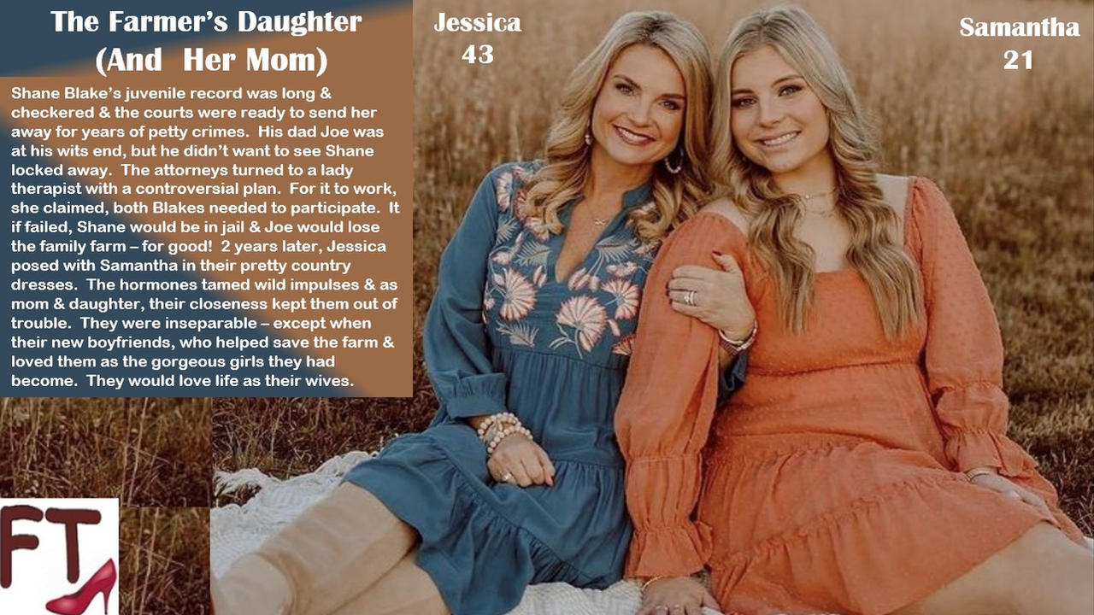

It seems so unlikely that I will have to explain the full story. My son Shane (as he then was) had finally blown it when the fire took out the neighbor’s barn. It was not just his problem but it was my problem too. In addition to Shane facing jail for his third arson conviction, I was sued for failing to exercise control over my delinquent kid.

The attorney’s were my guy and the lawyer for that neighbor, John Flynn. Basically I was ready to do anything to keep the farm, and it seemed like what John wanted was to make me do just that – anything. He was about to humiliate me and Shane. What he wanted was for us to present as women for the next two years. That means not just wear dresses but take drugs and grow out or hair. It would be demeaning, but at least we could save the farm that had been in my family for 4 generations.

But it turned out that John’s motives were more complicated. He had an idea in his head that I would make a very attractive woman. He told me later that it came to him in grade school and just couldn’t shake it off. Instead he watched me grow into a man and get married, become a father to Shane and a widower when Shane was still in high school.

I now understand why John Flynn used to look at me the way he did, all the way through school and even since. It was the look of regret. He wanted the impossible. He wanted the female version of me, which is something that he could never have … until the day that I signed the settlement deed.

I had no idea about this when I signed it. All I knew was that Shane and I became Samantha and Jessica and we submitted to treatments and blood tests to check our hormone levels and we wore only the clothes that John sent over.

Because we were both in it together I guess we just decided that we should roll with it and try to fit in, rather than be sniggered at by everybody. Somehow, if you can pass as female (and we could) it is just easier to be female.

I suppose that I now realize that the women of his dreams that John Flynn saw in me all those years ago, was just under the surface. As for Samantha, I am not sure whether her girlishness was always there or whether she just found it easier to be female given that she was attracted to men, and probably always had been.

Anyway, John took to coming around to check up on me. I thought that he was just tormenting me but then he started bringing me small gifts including expensive lingerie which I was becoming increasingly attached to.

Then he finally came along with a ring. That’s it there on my finger. I suppose that I figured out that with adjoining land there might be more than one reason for saying yes.

The End

© Maryanne Peters 2023

