After Closing Night  For John from a Cap by Feminization Beauty Within  By Maryanne Peters  I needed the right person for the role. It had to be a man. It would not work without that. But they needed to appear as a stunningly beautiful pre-op transwoman.  The role was demanding. I needed a professional actor, but if I was going to have a good run, I could not pay top dollar. I needed somebody fresh from drama school. I needed to be inexperienced enough to be tied up for a lengthy term, should the show be strong enough to continue.  Julian Hallet seemed to be perfect. Those eyes and those cheekbones belonged on a runway model, and he was desperate to make a mark. His work was rough, but he could be honed down into a first class actor in the hands of the right director – somebody like me.  When I first saw him in makeup with the blond wig on, I have to say that I was disturbed by my reaction. Not to put too fine a point on it, it was a sexual reaction. But I told myself that this was the reaction I was seeking from the audience. Jules looked the part – the blonde bombshell.  His own hair was blonde and quite long. I encouraged him to grow it, although we always used the wig on stage. | 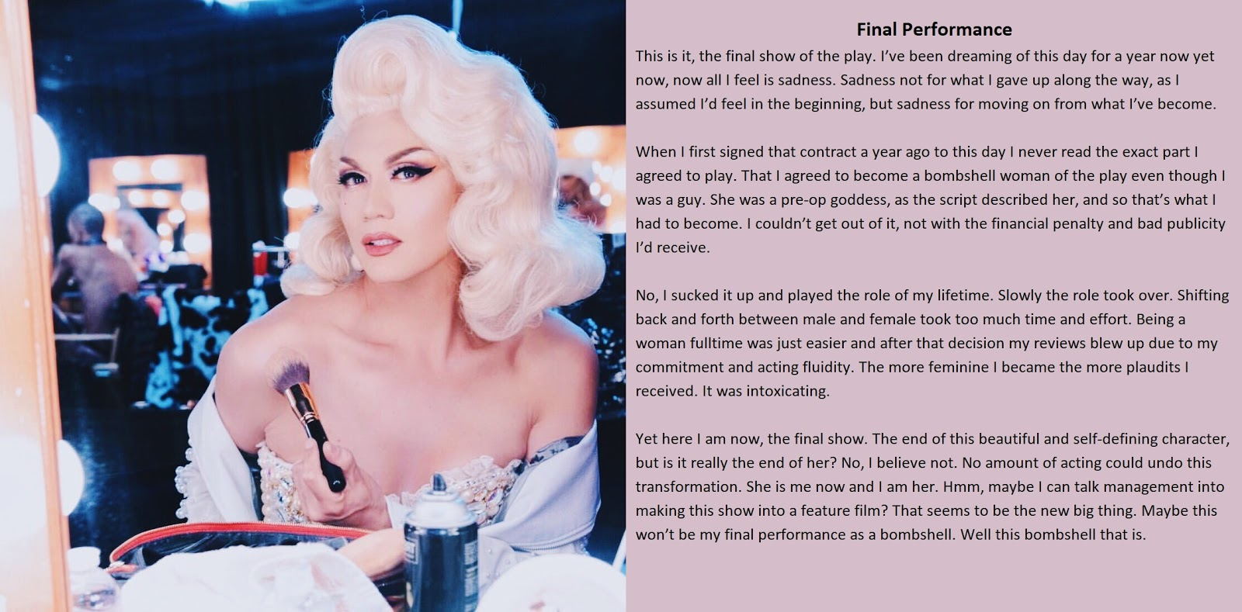

It was off stage that his own hair was useful. It was not long before he understood that it was just easier to be Julia during the day. The plucked face and the shaped eyebrows, and the feminine gestures that had crept into his everyday behavior made him appear effeminate. Jules did not take abuse easily. As a rule, actors don’t.

I persuaded him that rather than correct his behavior he should play into it. I referred him to recent reviews praising his performances for his “perfect feminine demeanor”. I have to admit, much of it was fabricated by me. It was just that I could not bear to see the woman that he had become replaced by that dowdy and pathetic young man.

I simply explained that shifting back and forth between male and female would take too much effort and might compromise his performances. He accepted it completely. There is no doubt that he had come to rely on my direction … not just on stage.

When he stepped off the stage, he would simply take off his wig and brush out his own long blonde hair and be Julia when we went to a bar for drinks. Of course, she would need to change her make up and wear something other than a costume, but I was happy to supply those things.

There is nothing that reassures an actor like praise. I heaped that on as thick as I could. I did not want it to end, you see.

The show had started strongly but had fallen away. I dropped the price of tickets, but I kept it from her. She needed to know that the audience were still turning up to see her, even if I found myself bringing in some paid applauders to keep her happy. I needed to do that. I had fallen in love with Julia. I could not lose her.

That erection the first time I saw her was no fluke, it was a sign. There was a woman in the youth. A good director draws out the essence of an actor. Her essence was female.

I think that she knew it too, deep down.

But all shows have a closing night, especially if they have been losing money for months. She is talking about a feature film. Poor child. There is no hit show. It is just me. I am the audience. And after closing night, I will propose marriage.

The End

The Femme Suit  Inspired by a SpottyCat44 Cap  By Maryanne Peters  “Pretty cool, huh. You can’t even see the seams right. Like, it’s two pieces. The stocking tops hide the end of the legs and the panties are attached to the latex making no seams near the crotch. The top piece which includes the bra goes down to the navel and the straps are the arm holes. So I needed to shave my arm pits – see? You can just glimpse the v-neck seam going down to the cleavage, which I have done my best to hide with concealer. And the seam between the two pieces is covered by the suspender belt.”  “Wow,” said Tad.  “The tits jiggle too. Watch this. Just like the real thing.” | 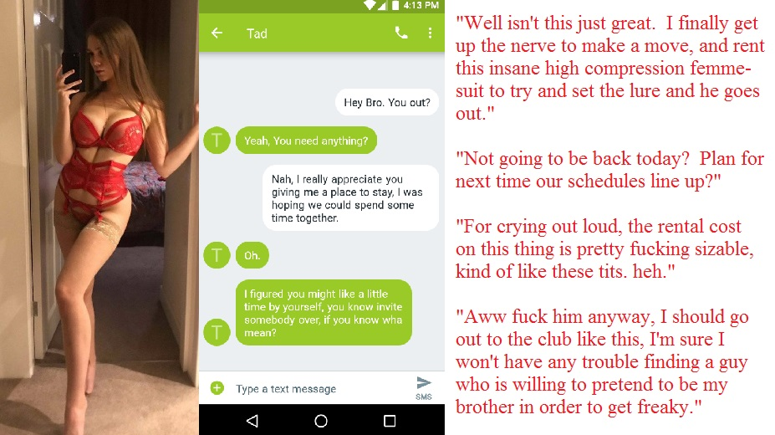 | 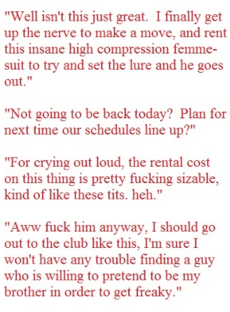

“You did this for me?” he said. He could see enough on his phone as I moved it about at arms length or with close-ups of my new cleavage and camel toe. I knew that with all the money I and paid and the work done, this plastic body looked incredible.

“I know what you want, Tad. I am not stupid. I know you are not gay. I am, I guess. Because ever since I have been staying at your place I have been trying to wrestle with my feelings. I did not know what it was, but I know now. I think it’s love, Tad. Not the brotherly kind. The romantic kind. The sexual kind. And you know, I don’t care if they say it is wrong, I hope it is love. It makes me feel like I have been living under a rock all my life before now.”

“I’m your brother,” he said.

“Step brother,” I corrected him. Even if I was a girl it was still a forbidden attraction, but why?

“I was just helping you out”, he said.

“You know I could have moved out months ago. You like having me around. You like me cooking your meals, cleaning house and ironing your shirts. I have seen you watching me brushing my long hair. I know what you are thinking when I do. I know you are wishing that I was a girl so that you could fuck my brains out. Now look at me. Am I girl enough for you now? Maybe you should come home and find out.”

“I just needed to get out,” he said. “It is not natural.”

“Tad, please. I know you are fighting this. But why? You want me as much as I want you. Now look what I have done for you. Have another look. Come and feel me. Come and feel my smooth legs – they are not vinyl. Look at them. Let me get close to you so you can feel my breasts against you. I could make them real, in time. Don’t you want to explore my female groin through these lacy panties. That could be real too, one day. Come home. Come home and kiss me.”

“I am going to hang up,” he said. I could hear it in his voice. He was aroused. I could imagine his cock standing at attention.

“If you don’t come home, I am going out. I have a dress in my room and a pair of fuck-me ankle boots. I’ll find a bar somewhere. I find some poor guy and tell him that I want him to pretend that he is my brother if he wants to bed me. Because I am in love with my brother.”

“hey. No. That would be dangerous,” said Tad, with genuine concern that I could feel. “He will find out that you are not real. You could get hurt.”

“I don’t care.” I was starting to cry, and I let him see it. But it was true. Would I have to throw myself into a dangerous and violent situation to prove it to him? “If I can’t have you, I don’t care. If you won’t let me suck your cock, maybe any cock will do.”

“You suck cock?” he asked.

“Yours, definitely.”

Tad said: I’m coming home.”

The End
Best Vacation Ever
Inspired by a cap from Anne Michelle’s World
By Maryanne Peters



Rick and Ted always thought that they had a lot in common, but then many guys do. The usual stuff – travel, good food, cocktails rather than beer, golf rather than motor racing, soccer rather than football. They just seemed to be on the same wavelength. But they had one thing in common that neither of them realized.

They both admired women. As they sat at a bar they would check out good looking women and sometimes join them. They enjoyed talking to women, but when it came to bedding them, they always seemed to prefer to decline.

“I enjoy your company too much and I don’t believe in humping on twin beds in the same room,” said Rick, and Ted agreed. They always seemed to agree.

They rarely talked about sex. Neither liked to lie. They were too close for that. And yet it seemed that they had know one another so well, that it seems incredible that their common secret remained unknown for so long.

They had discussed the golf trip for some time. It gave them a chance to head to a warmer climate and play golf and enjoy good food and drinks in one another’s company. As they would be taking their golf clubs they would need to travel light. The problem was that they both discovered that their carry on was overweight.

“I will just check it in,” said Rick.

“Only one of us needs to do that,” said Ted. “An extra bag on this flight is expensive. I will check mine in. Give me some of your heavier items.”

Rick looked worried, so Ted took things into to own hands before Rick could stop him. The bag fell open.

“I can explain,” said Rick. He was casting around in his mind for a believable lie, but that was not how things were between them, or every should be. It would be a test of their friendship, but he needed to say it. “I wear women’s underwear, just because it feels more comfortable to me.”

Ted looked at his friend and smiled. He snapped open his only bag and said – “Just don’t mix your up with mine,” he said. Just like Rick, his bag contained bras, panties and slips to wear under his clothes.

“Let’s neither of us check in an extra bag,” said Rick. “Lets throw out some of this menswear and do this trip fully dressed?”

The airline employee watched in amazement as the bundled together some stuff and asked her to dispose of it.

The first stop on their arrival at their destination was a salon for hair extensions, manicures and makeovers. Then it was to their luxury twin unit to drink mimosas in their slips and plan a shopping trip before their first trip to the golf course, hoping for better scores off the ladies’ tees.

“I hope you don’t this this too weird,” said Tammy. “But while I am dressed as a woman I am attracted to men.

“I am exactly the same,” said Rachael, raising her champagne flute.

“This is going to be the best Vacation ever!”

The End

After Lock Up  Inspired by a SilversTG captioned image  By Maryanne Peters  I was like a kid in a candy store – I mean locked in a candy store. An alcoholic trapped in a liquor store. I secured the mall after closing, and doing the security night shift, which suited me. That is because at night I became somebody else.  The cosmetics store did their own lockup, but with so much stuff being shoplifted from that place we had a box of stuff in the security office. And I had a wig, and a pair of high heels in my size, and a pair of breast forms too.  I had another job in the afternoons – just surveillance monitoring which I did dressed as a guy. Working nights I would not get out of bed until the afternoon and I would sit out my time watching the screens just growing impatient for the moment I could be free of these man-clothes.  Under those clothes my body would be shaved down and ready. As closing time got near, I would always find myself getting over excited. I would have to take a moment to have something to eat, while waiting for everybody to leave. The real me was like the jack in the box – a coiled spring pressed tight, waiting for the moment to burst free. | 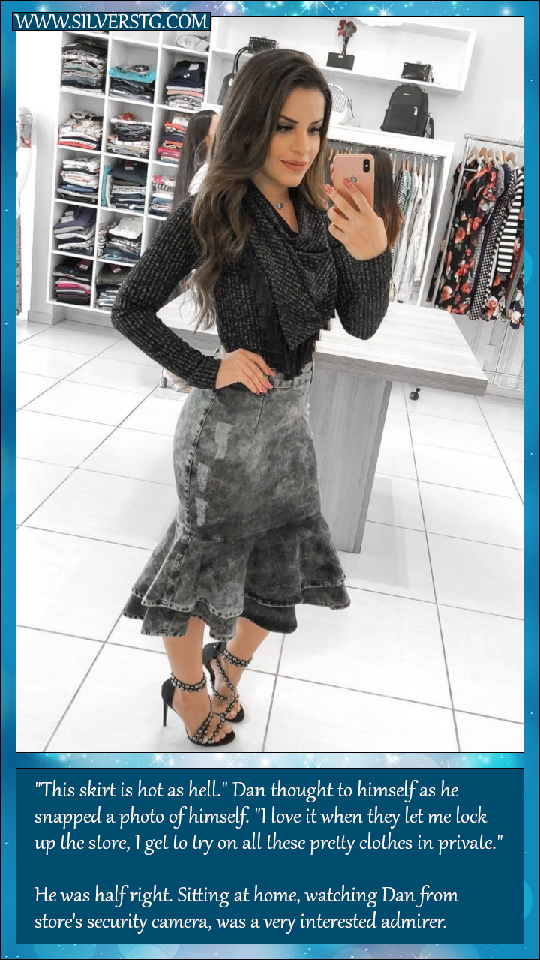

I would say my goodnights as the last person left and wait a moment for the place to get quiet, and in case anyone might return. And then I would slip off the outer layer and pull on my butt-padded pants with the tucked front like a camel toe. I would slip my breasts in my bra and put a slip over the top, then pull on my pantyhose and slippers before I made up my face a hair.

I had acquired a real skill with makeup, there at the mall and at home in my tiny apartment. My eyebrows could be bushed up when I was being a man then brushed into shape after dark. My wig always looked good, but I needed a cap as I had been growing my hair about as long as a guy can wear it. Then makeup, mascara and lipstick, and a little brushwork on my cleavage.

The I was ready to hustle down to the boutique in my slippers, with my heels in my hand, and start getting dressed. So many pretty clothes! This was why being a man was just so awful. This is my true life – the life I lived at night!

I would try on day clothes but as it was night I liked to dress for the evening. It was just like my curse that I could never step outside the empty mall and into the nightlife I dreamed about, where everybody would whisper: “Who is that beautiful woman?”

It was like the fairy tale – the one about the dancing princesses locked away but dancing … just dancing all night. They were being watched by the soldier wearing the Cloak of Invisibility, I think. I was being watched too.

If you spend time watching CCTV I suppose you should realise that there is always somebody watching. I guess that you never think that somebody will be watching an empty mall. Except that it was not empty, was it? There was a dancing princess swanning about.

In fact I had never met my boss. I had been hired off my surveillance work and night shift people don’t meet daytime people. I had no idea who he was when he confronted me. Then he introduced himself as the owner of the business, one of the largest surveillance and security firms in the state.

So I asked him what I could do for him. This could be my big break.

“I am an admirer of the beautiful woman who haunts or client’s mall after closing,” he said grinning at me. I thought it was some cruel joke just before he fired me. But he got very serious very fast. He said: “What you could do for me is to allow me to meet her, in daylight. I have to tell you, I and more than an admirer. I must meet her. I know who she is. I see everything.”

I felt that I needed the job. I really had no choice. My jump out of the night and into the day was forced on me, you see.

Not that I regret that it happened. I did lose my job, but I still work for the same guy – just in a different capacity.

The spell is broken. I am released. The dancing princess is free, and her prince will give her anything she desires, if I will be his. I happily will be.

The End

Watching  From a Cap by Feminization Beauty Within  By Maryanne Peters  I have even forgotten why she did it. It doesn’t matter to me anymore. I am just who I am now – not what she made me.  What she did was incredible. But that is her trade and her skill. The hair, the face, the body – her work, with a little help from Miss Estrogen. That little lady took away everything else, but she gave me these tits and this butt.  Guys go from being shocked, to sneering, and then suddenly they start to look at you with confusion and then lust. When that happens, everything changes.  The initial shock came after I was dropped from the team and my football-crazy girlfriend said that if I played like a girl, I should be one.  Was that the reason? I don’t care. I can’t even remember if it was dropped ball or a missed tackle. Nobody seemed to disagree with the punishment.  The sneers came when she had me wearing pink and a little mascara. How can somebody force a guy to shame himself that way? Did I really love her that much? I forget.  Body changes are supposed to be slow. It’s supposed to take months to get a body like mine, and hair this long. How long has it been? Could I have my timing wrong somehow? It seems only last week that I was out there with the guys running around on the field. | 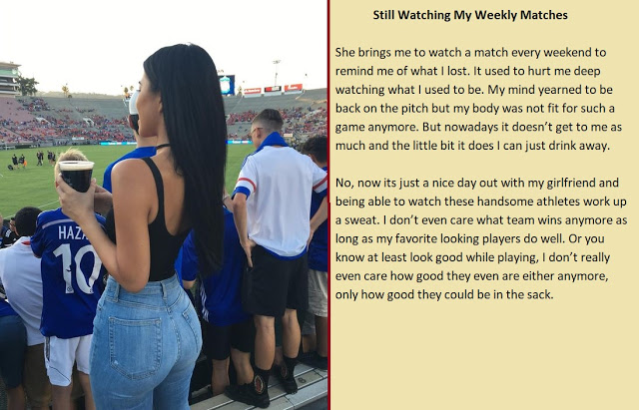

Now the only running I am doing is staying just out of the reach of those guys I used to play with. Strange that they forget who you were when you look like this. Just flick my hair, jiggle my tits and wiggle my butt. I was them for an hour or so every weekend, being watched, and now here I am and those guys can’t keep their eyes off me.

Suddenly they all want to know how good I am in the sack. The lucky ones might just find out.

The End
© Maryanne Peters 2022

