The Ultimate She Mask Kitsune Fusion

Akira was on the way to Kasumiko because she was invited to a Gaming Session to try out the new Kitsune Fighter Pro and as we all know Akira loves Gaming so she can’t resist. But Akira was not alone, her younger Sister Nanami who was also invited by Kasumiko was beside her.
“I can’t wait to try out the new Kitsune Fighter Game!” said Akira happily.
“Yeah me too! I really want to kick some asses with Ahri.” said Nanami.
Then they arrived at Kasumiko’s Apartment and Akira rings the Doorbell. Kasumiko instantly rushed to the Door and open it and then she said “Yaay! You’re here please come in and take a seat the Download is nearly Complete. ^^”
“Sure, thanks for the Invite Kasu” said Nanami.
“Oh, you’re welcome I hope you don’t mind that I have invited my good friend Kodaka Lu’an too. ^^” said Kasumiko.
“Hi Girls! I’m Kodaka nice to meet you.” said Kodaka a little bit shy because she knows Akira and Nanami where both Famous Models.
“Nice to meet you too Kodaka I’m Akira Miyasaki and this is my younger Sister Nanami Miyasaki” said Akira to Kodaka.
“Alright the download needs still 30 Minutes in the meantime let us eat some fresh Ramen.” said Kasumiko.
Then all take a seat at Kasumiko’s dining table and Kasumiko cooked a fresh Bowl of Ramen for each and while they eat they talk a bit about different things how they meet each other and so on also they talked about their experiences as She Mask with one exception Nanami talked about her experience as the She Mask of Izanami.
“Oh, so you found a different Mask?” asked Kodaka.
“Yeah, it still works like the Mask of Loki but it is a bit more Powerful and I can use some Powers even if I not wearing the Mask.” answered Nanami.
“Girls! The download is finally Complete!” said Kasumiko excited.
Then all girls take a seat on the Big comfy Couch and they start to play some Rounds. The first thing they notice is that Kasumiko was available as one of the Fighters in the Game also they saw Akira and Kodaka as Fighters too.
“H-how did I come in into the game. I’m not even a Kitsune?” asked Akira confused.
“I also didn’t know that I’m in the new Kitsune Fighter.” said Kodaka.
“Well the Game had a Kitsune starter Campaign a while ago and I have supported the Developers with some Advertising and as a thank you they allowed me to add three Fighters on my Own. And I have decided that my best friends and myself should be in on top of that I supported the game with 500$ to suggest a cool new Feature but you will see it later. ^^” said Kasumiko.
After Kasumiko’s explanation they have some awesome Fights and they had much Fun also Akira’s Kitsune form looks super cool the Developers did a really nice Job on her.
Suddenly after some fights a Message popped up and it said: “Character Fusion is now unlocked!”
“Huh Character fusion?” asked Kodaka.
“Yeah that’s the new Feature that I have requested. With it you can let fuse any Fighter with another one to create a Completely new one. Let us try it! First, we choose Akira as the first Fighter and then Me as the second one and voila we have Akimiko as a fighter now with all Skills and Specials from Akira and Me is that not cool. ^^” asked Kasumiko.
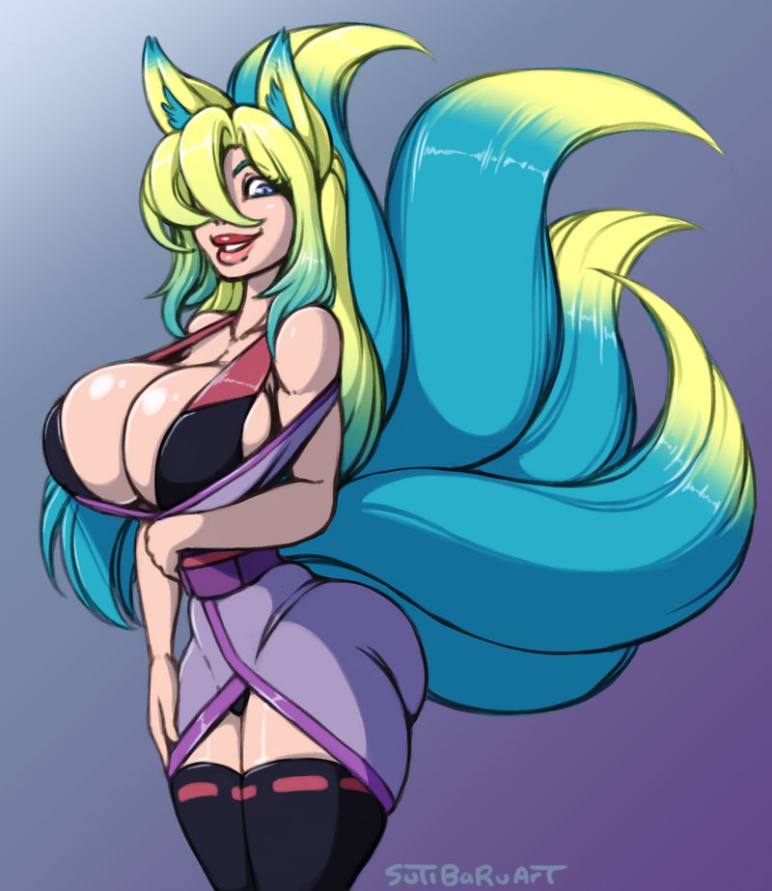

“Wow! That’s cool you’re looking awesome Fused together” said Nanami.
“I wonder what I would look like when I fuse with you Kasumiko” said Kodaka.
“Let’s find out together. First we choose Me and then Kodaka and here she is Kodamiko” said Kasumiko happily.
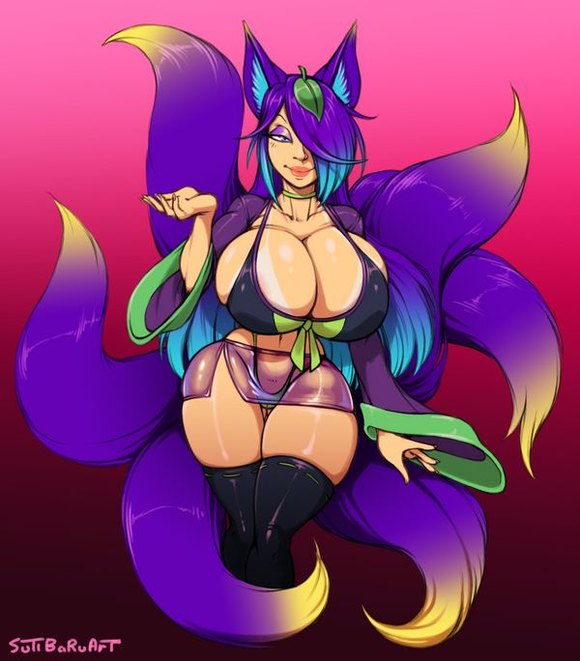
Then Akira said “Ok, let’s try this out. I choose me and then Kodaka and yeah here is Kodira.”
“Uhm we look nice fused together Akira.” said Kodaka and blushed slightly.
“Yeah all Fusions are really showstoppers. Too bad we can’t fuse together in Real Life.” said Kasumiko.
Then they experimented with the Feature a little bit more and they Fuse different Fighters together and every time the Result was Amazing suddenly an Idea came in Nanami’s Mind and she said: “I can let you Fuse together. All I need to do is to wear my Mask and then I can Fuse people together but the Fusion will be limited to the time I wear the Mask. If you Girls are ok with that, we could try it out. But first you all must wear the Mask of Loki.”
“Oh, cool let’s try it out Girls!” said Kasumiko excited.
“Yeah this sounds like a cool idea little Sis.” said Akira.
“Uhm I guess we should try it.” said Kodaka.
“Ok Girls but please put your Masks on first.” said Nanami.
With that all girls takes their Copy of the Mask of Loki closer to their Faces and then the Transformation Fun begins.
The first one was Kodaka the Mask jumped out of her Hands directly into Kodaka’s Face and Kodaka tries to remove the mask in her first shock but then she let her Grip go and instantly Kodaka feels pure pleasure. In the meantime, her Body starts to change, Kodaka’s legs are getting longer and more defined giving her Legs of a Goddess then her breasts are getting bigger and they firmed up, soon her Hips are getting a little bit wider and her waist slimmer giving Kodaka a sexy Hourglass Body. Then her belly gets flat and she becomes a Sexy and well-trained female six-pack. Also, Kodaka’s Ass gets bigger and much firmer.
Then as the Transformation was almost over Kodaka can’t hold back anymore because of the pleasure and she let out a lustful scream as she gets a heavy Orgasm as she twisted in the Mini Tornado around Kasumiko’s Apartment. Finally, the Twister comes to a halt and there stands a completely new Kodaka. Kodaka has now a Body of a Kitsune Queen, her former D-Cup breasts are now a Double D-Cup and her already long Legs are even longer and more defined. She has now a perfect round Ass and a Sexy six-pack but that was not all her Kitsune features have improved too. Instead of only one Tail Kodaka has now Four Tails. Kodaka’s Face is now Lime green and feels more like rubber on top of that Kodaka wears now a sexy Make-up with purple eyeshadow and her full Lips wears a sexy pink and cartoonish Lipstick. Kodaka’s Outfit has changed into a very Sexy but elegant Kimono which shows off her expanded cleavage her long legs and her awesome six-pack really well. Then Kodaka strikes a Sexy Pose and said with a more seductive voice “Wow! What a rush! I’m feeling better and sexier than ever before! Time for some Fun!”
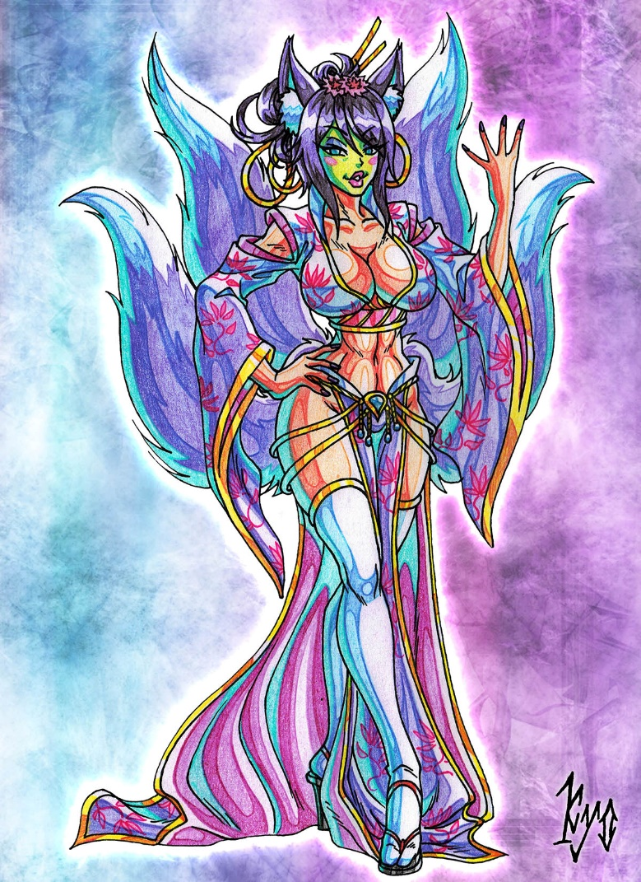
Then it was Kasumiko’s turn to put the Mask on. As soon as she holds the Mask closer to her Face it jumped out of her hand directly into Kasumiko’s Face but other like Kodaka, Kasumiko was not in shock instead she enjoyed every second of the Transformation and just let it happen. Suddenly the Transformation begins.
Kasumiko’s legs becoming a little bit more Muscular longer and sexier giving her real goddess like legs, then her hips getting a little bit wider and her Ass gets bigger, rounder and firmer. Kasumiko’s Waist shrunk a few centimeters and her Belly gets flat also her Abs get more toned giving her a really sexy well-trained female six-pack. Shortly after that her Breasts are also getting bigger and firmer her formerly C-Cup Breast grows to a huge Double D-Cup. Then Kasumiko can’t hold back anymore and she started to moan lustfully in pure pleasure as she feels an Orgasm is building up deep inside her but before the Orgasm hits her, she was engulfed in a mini-twister and bounced around the Apartment. Then in the Twister it happens Kasumiko’s Orgasm hits her hard and she Came three times and she let out a scream of pure pleasure. Then the Twister stopped and a completely new Kasumiko stand right besides Kodaka.
Kasumiko has now longer and sexier legs, her Hip is wider and her Ass bigger and firmer. Her already big C-Cup Breasts are now huge Double D’s and she has a really flat belly with a sexy female six-pack. Kasumiko is wearing now a sexy J-Pop Outfit which shows off her new curves amazingly. But that was not all her Face is now lime green in color and she wears a Sexy Make-up with light blue eyeshadow and her lips are fuller and cartoonish Red. Then Kasumiko strikes a Sexy Pose and said in a more seductive Voice: “Time for Fun! I hope you Girls are Ready!”
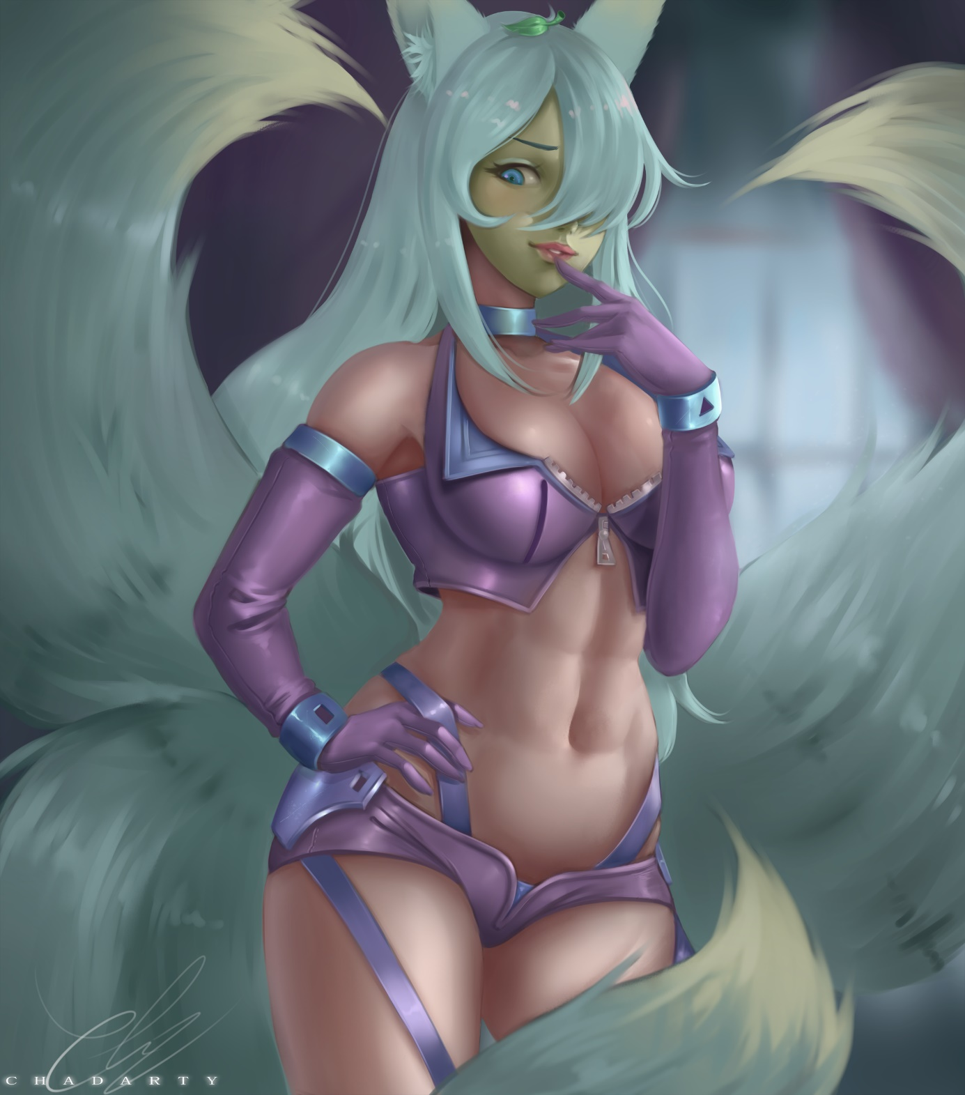

Now it was Akira’s turn to put the Mask on she takes the Mask and slammed it directly into her beautiful Face and then the Transformation begins. Just like Kasumiko Akira instead feels pure pleasure and she moaned lustfully as the Mask warps around her head. First Akira’s long and Sexy Model legs getting more toned and a bit more muscular then they expand a few centimeters giving her even longer and sexier legs. Shortly after that her Hips getting a bit wider and her Ass is getting bigger and firmer. After that her waist shrinks a few centimeters, her belly gets slimmer and her already sexy female six-pack is getting a bit more defined. Finally, her breasts started to expand too. Akira’s already big D-Cup Breasts grows to a huge Double D-Cup. Then Akira moaned louder and louder as she feels that a massive Orgasm is building up in her and she was about to come but then she was engulfed by a mini twister and while she spins around Kasumiko’s Apartment she let out a scream of pure pleasure and she climaxed at least four times.
Then the Twister stopped and a completely new Akira stands in the room. Akira has now massive Double D-Cup Breasts much longer and sexier legs, an amazing Ass and a sexy female six-pack. Akira is wearing now her tight Sport Outfit which shows off her expanded Curves amazingly well. Akira’s Face is now lime green too and feels more like rubber and she wears a Sexy Make-up with a pink Eyeshadow and her full lips are now cartoonish Red. Akira strikes a sexy Model like Pose with her Hands on her Hips and then she said in a sexier Voice:” I feel Amazing! Now it’s your Turn Nanami-chan!”
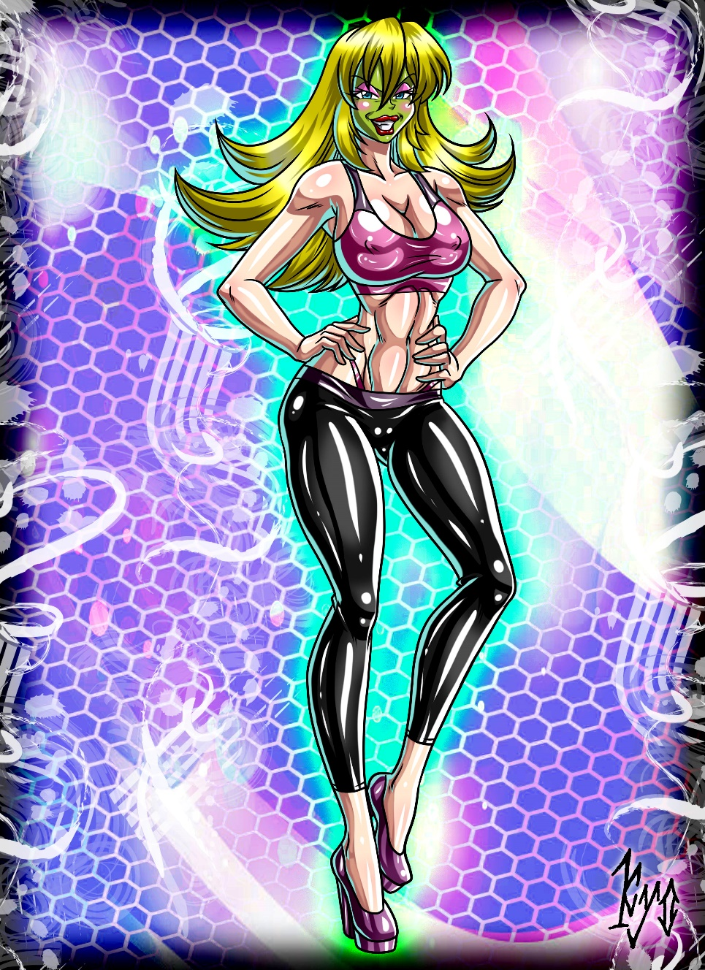

“Ok I see you Girls are now ready time to put on the Mask of Izanami.” said Nanami.
Without hesitation Nanami put the Mask of Izanami on and then she starts to transform too. Of course, Nanami instantly feels pure pleasure and she moaned lustfully as her Body started to change first her Hair changed in color from her original brown into a light Blue like Kasumiko but with red tips. Shortly after that her Legs are getting longer more defined and sexier and her Hips are starting to expand followed by her Ass which gets bigger, rounder and extremely firm. Then her waist shrinks a few centimeters and her belly gets flat and more defined also she gets a sexy perfectly-trained female Six-pack too. Now it was on the Time for Nanami’s breasts to get bigger her C-Cup breasts expanded until they reached a massive E-Cup also, they firmed up. But that’s not all, Nanami’s teeth changed their shape a bit and giving her cute Cat like Fangs.
Also, two cat Ears on top of Nanami’s head are growing and she gets two Fox tails and two Cat Tails making her a Catsune. Nanami was almost finished but then she feels that a huge Orgasm is Building up in her and she starts to moan louder and louder with every second but just before her Orgasm hits her she was engulfed by a Mini Twister and rushed through Kasumiko’s Apartment and in the Twister she can’t hold back anymore and she screamed lustfully and in pure pleasure as climaxed at least four times. When the Twister stopped a completely new Nanami stand right besides Akira.
Nanami has now long and Sexy legs, a big and really firm Ass, her waist is now slimmer and she has an amazing and perfectly trained six-pack. Also, her breasts are now a massive E-Cup and she has two Fox Tails and two Cat Tails which were the same Color as her hair. Nanami is wearing now a similar Sport outfit of that of Akira but with green highlights it also hugged her amazing figure nicely.
But instead of a lime green Face Nanami has a light Red Face now and it also feels more like rubber. She wears now a Sexy Make-up with light blue eye shadow and she has full and cartoonish purple lips and her eyelashes are a bit longer giving her an amazing look.
Then Nanami strikes a really sexy Pose and said in a more seductive and sexier Voice: “Meow! Time for Fun Girls! I hope you’re ready for a new experience! Nya~ “
“It’s time to fuse you girls together and I think I start with Akira and Kasumiko Nya~” said Nanami and then she uses her power to fuse Masked Akira with Masked Kasumiko together and after a bright flash there stand an completely new and sexy Kitsune Girl in the Room of course it was the Fused form of Masked Akira and Masked Kasumiko named Akimiko but she was also masked.
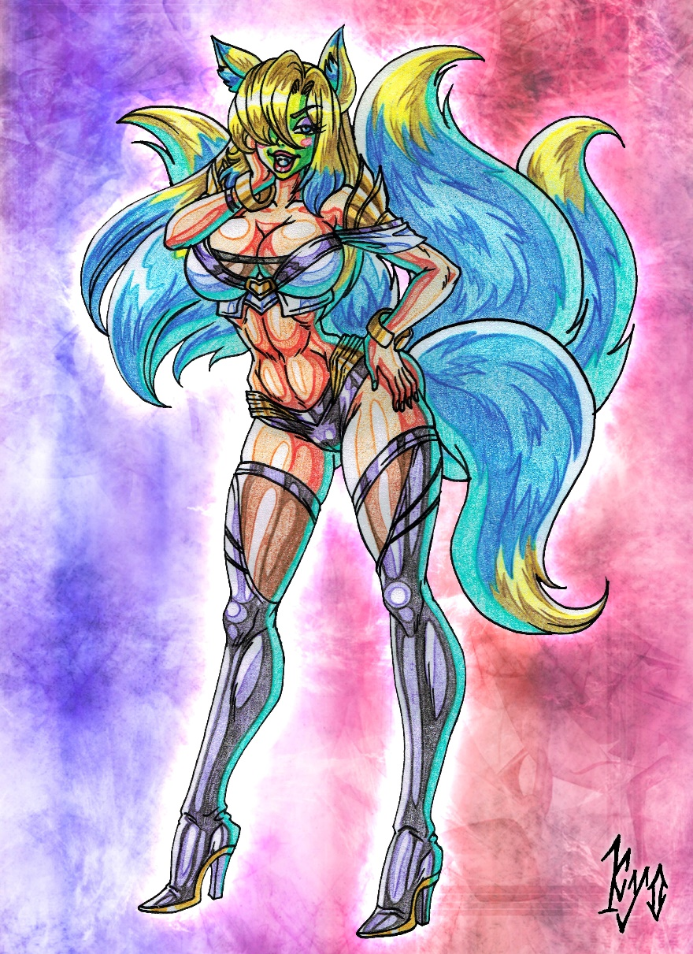
“Oh, yes! I’m feeling Awesome time for some Fun!” said Masked Akimiko with a mix of Akira’s and Kasumiko’s seductive voices.
Masked Akimiko looks like a perfect Mix of the Two girls but of course because of the Mask she was even sexier and she wears an Outfit similar to K.DA Ahri but modified into a sexier version which shows her awesome sexy female six-pack.
Then Nanami said excited: “Nya~ You’re looking hot Akimiko maybe we should let you Fuse again but this Time with Kodaka.”
“Oh, I love the thought of being Fused with her.” said Masked Akimiko.
“Yeah I’m also fine with this Idea let us Fuse into a perfect Girl.” said Masked Kodaka
“Ok girls get Ready!” said Nanami and then she used her Fusion power again to Fuse Masked Akimiko together with Masked Kodaka and this Time the Result was really Amazing instead of two sexy Masked Kitsune Girls there stand now only one but stunning Masked Kitsune Goddess in the Room then the new Girl said in a mix of Akira’s, Kasumiko’s and Kodaka’s seductive Voice: “I feel Amazing! Get Ready for the sexiest Kitsune of all Time! Here comes Akimidaka!” then Akimidaka strikes a sexy Pose.
Akimidaka has Blonde, Blue and Purple hair also she has Full Nine tails five of them are Blue with Blond tips like Akimiko’s and four of them are Purple with white tips like Kodaka’s tails. She has also an amazing body. Her breasts are a full E-Cup and perfectly firm and her Ass is also big and perfectly firm. Akimidaka has an amazing sexy six-pack and the hairstyle was also a mix of Both Girls. Akimidaka’s Outfit was a mix of Akimiko’s sexy J-Pop outfit and Kodaka’s sexy Kimono resulting in a sexy J-Pop Outfit with Kimono Elements.
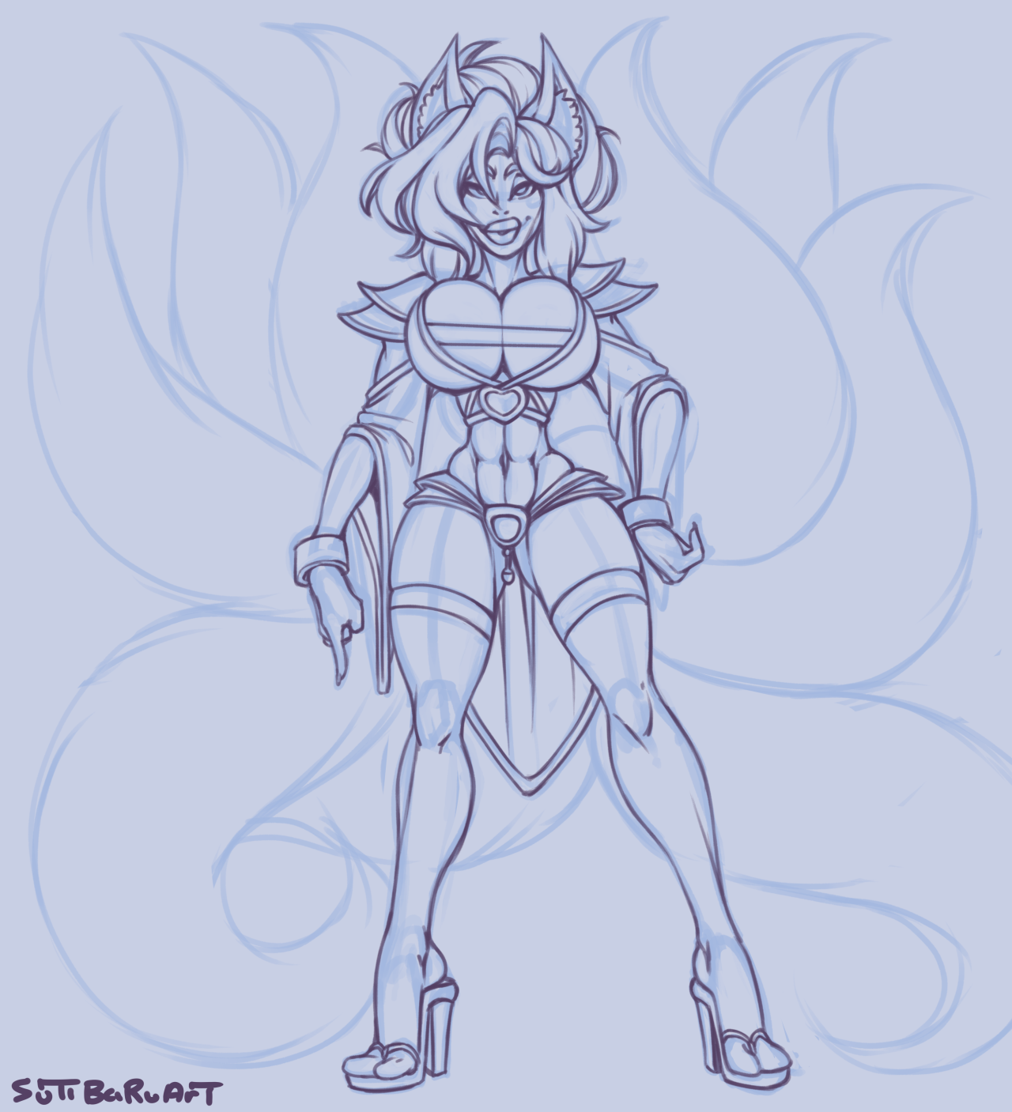

“Meow <3 You`re sexy Akimidaka I would love to have some Fun with you. Nya~” said Nanami.
“Well you are also really a cutie Nanami and a Sexy one I must say. Come here and let us have the night of our lives!” said Akimidaka.
Then both Girls have one hell of a night and they having hot sex and the best time of their lives.
The End

Credits:
Thanks to StarGizar for letting me use Kodaka Lu’an for this Story
Also, thanks to all Involved artists like Kyo-dom, Chadarty and SutibaruArt for these great Pictures
And of course, thanks to all my Supporters on Patreon. ^_^

