Chapter 12: Trick

She was. Barely, though, with those clouded, almost unfocused eyes of hers.

Then, Ragatha put a hand on her chest.
At first, Pomni thought she would potentially touch herself—oh god—but it turned out to be something else. She grabbed a tiny piece of the fabric, almost like pinching it, and pulled.

The fabric of her dress stretched up to a certain point, until… it didn’t. It stopped and instead just… popped off. With a cute little clicking sound. A stylized miniature version of her clothes remained attached to a coat hanger between Ragatha’s fingers, leaving Ragatha completely naked.

Pomni stared (probably very stupidly) at the tiny dress, then at Ragatha’s nude body. She wasn’t able to process these two revelations right now.

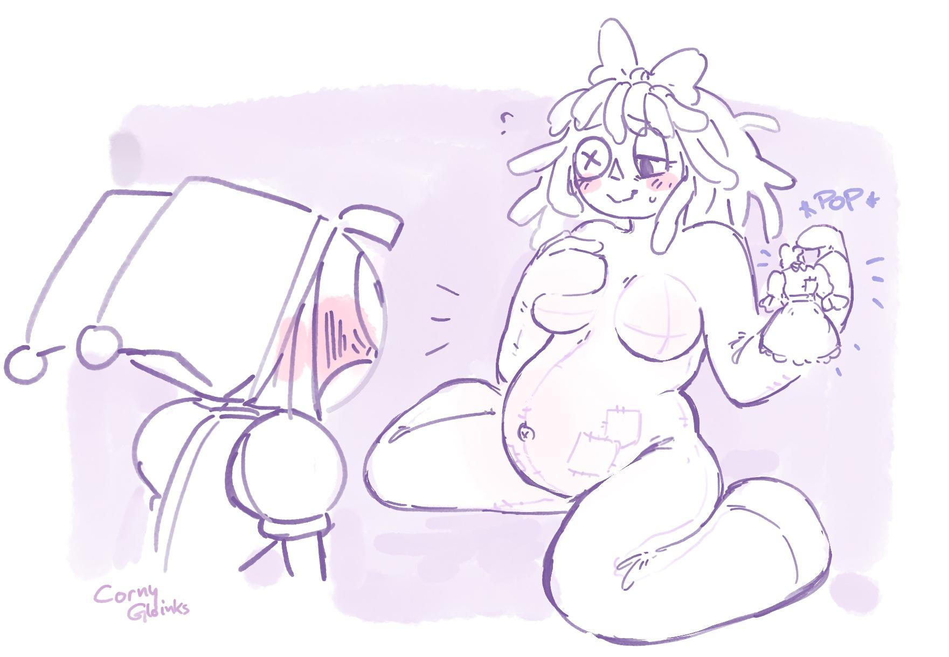

“Caine gave me the ability to change my clothes to sleeping attire whenever I want, because it’s… kind of important to me. Usually… I’m not meant to be… uhm… f-full nude. My normal clothes just pop back on after a while if I don’t change into others, b-but…”

Pomni only vaguely understood what Ragatha was saying. All she could do was stare. At her plush, nude body, how it looked even softer without clothes… her plain, nippleless breasts, which were sewn in such a way that they emphasized their roundness. Her beautiful, stitched-up belly; her belly button that looked like a literal small sofa cushion button, slightly indented.
She couldn’t see between her legs, but whatever there was—or wasn’t—it must’ve been just as aesthetically pleasing and stunning.

Pomni must’ve stared idly for a while, because she only noticed Ragatha talking when she grabbed Pomni by the hands.

“...too much…?”

“Huh?”

Ragatha’s flustered expression had taken a turn toward anxiety.
“I asked you if this was too much. If… I… shouldn’t have…”

Before she could end her sentence, Pomni was all over her. Kissing her face, grabbing her by the waist, pressing her own tiny body against her to feel as much as possible.

Talking was hard, but she could manage to say “Best … trick…” at least, inbetween the wild making out. She could feel Ragatha relaxing and reciprocating the kiss and the fondling, her hands stroking over Pomni’s back, up to her neck, back down again, until a videogame-ish pop noise interrupted them.

Pomni looked down just to see that Ragatha was wearing her usual clothing again, smirking sheepishly.

Frustrated, Pomni tried to grab her dress and pull it off again, in the same way Ragatha did. But all she could manage was for it to stretch, moving the ragdoll with it.

“Nnnhhhhh!! Off!!” Pomni moaned, impatiently, making Ragatha chuckle. Then she took one of Pomni's hands and put it on a certain spot, guiding her fingers to pinch the fabric instead of grabbing it forcefully. “Like this. Now pull.”

Pomni did so, and after some stretching, the dress came off in the same way as before, now dangling between Pomni’s hands.

This was interesting, but certainly by far not as interesting as Ragatha, so she threw the dress behind her to snuggle up against Ragatha again, pressing her head between her breasts and squeezing the ragdolled human’s fluff between her hands.

“Oh… oh my…” Ragatha commented, flustered, but with clear labored breathing.

“I… I want you…. so… so bad….” Pomni slurred, barely intelligible, “I would…. l-love to … t-take you… like I normally would….”

Ragatha panted softly. “Then… it’s maybe time for… another trick?”

“Another??” Pomni moaned, overwhelmed by that information. She was barely holding it together as it was.

Ragatha gently guided Pomni to stand up while her dress clipped back on, unfazed. Then she took Pomni by the hand and led her to her bed.

“I’m going to show you something… uhm… rather unique. Jax knows about it, but please don’t tell anyone else, alright…? It’s… a bit embarrassing.“

Pomni nodded enthusiastically.

When they were both on the bed in a seating position, Ragatha took one of Pomni’s hands again, guiding it between her legs. Pomni followed her guidance eagerly, until her fingers touched her crotch. As expected, it was just as soft as the rest of the body, with nothing there.
Or… wait… there was… something. A seam, just as on the rest of Ragatha’s body. Or rather, a cross seam, where four pieces of fabric met.

She looked at Ragatha, who looked back; curiously, nervously, and unsure, but also somewhat… expectantly? Was she waiting for Pomni to figure out something…?

Pomni pushed against some of the seams, which caused Ragatha to slightly gasp.

Worriedly, Pomni looked up to her, fearing it might hurt.

“R… remember how I showed you that our unusual avatar parts can cause intense sensations…? Well… for me… it’s the seams…”

It was as if Ragatha had given Pomni the code to a packed-full safe. Secret intel that would change the course of Pomni’s world. An object of power. Or any other metaphor for overwhelmingly great power out of nowhere.

Suddenly, Pomni noticed all of Ragatha’s seams at once. How many there were. How interesting they looked, how enticing. On the sides of her arms, her legs, her neck… even her hands.

And those between her legs…

Pomni brushed more against them, which made Ragatha immediately pant.

“Ohgodohlordohgaaawd” Pomni stuttered, “g-g-good trick good trick”

“That… w-wasn’t the trick yet…” Ragatha stated, panting, her oh-so-plush hips pushing against Pomni’s fingers ever so slightly. W-wait… her oh-so-plush hips pushing against Pomni’s fingers ever so slightly!?

“Y… y-you’re bleeding again,” Ragatha stated, breathlessly.

“It’s fine” was all Pomni could muster to answer.

“You dork…” Ragatha commented and then actually, in reality, really, started to spread her legs a bit further apart.

OH. GOD.

“Now….. Pay attention, Pomni….” Ragatha said, and maneuvered one of her own hands between her legs.

Pomni felt like a newborn kitten, with its head being too big to be held upward without wobbling, barely understanding her surroundings, and taking in everything in a very limited manner. There was only Ragatha—only her seams, her hand joining in next to Pomni’s, the craving for her.

Pomni felt Ragatha’s finger doing something… maybe… adjusting? Or… what….

Her own fingers came closer to Ragatha’s, trying to understand what she was doing. It felt like she was pulling on some of her seams? On the thread…?

Then, Ragatha made a noise; a soft moan between pain and relief. And in the next moment, Pomni felt something plush slightly spilling forward.
Cotton filling.

Ragatha had just opened some of her seams.

“Oh…. oh my god…. R-ragatha, a-are you ok?” Pomni managed to somehow say coherently.

Instead of answering, the other woman smiled and guided Pomni’s finger to the filling, then gently coaxed them into pushing.

The moment Pomni's index finger dipped ever so slightly into the filling, Ragatha moaned—and how.

It was the sexiest thing Pomni had ever heard. It sounded so… so……. deep. Not tone-wise, but regarding meaning. It was as if Ragatha let out all of her carefully wrapped-up feelings, all at once. Feelings she usually downplayed or revised to avoid hurting or confusing others, or hid altogether.

This was none of that.
The sound she made was pure. Raw. Conveying a wealth of information about her. So full of desire, of lust, of pain, of craving for intimacy, of fear about opening up so much—both emotionally and physically, literally.

It sounded simultaneously juvenile and mature. Like a vulnerable girl, making her very first experiences and being overwhelmed by it, and like the hottest bombshell of an experienced woman who could crush one between her thighs.

From the first listen, this moan was unquestionably addictive.

Pomni couldn’t hold back. She needed to coax out more of these sounds from Ragatha. Almost on its own, her body pushed her finger in further.

It had the desired effect. And then some.

Ragatha was moaning even louder, her arms reaching around Pomni, holding onto her, her whole body shivering.

It wouldn’t have surprised Pomni if she’d suddenly respawned somewhere else, due to spontaneous demise. How, in fact, was she still alive? This was so, so, so overwhelmingly hot.

But then Ragatha said—no, moaned, no—screamed!—something that tipped Pomni over the edge.

Her name.

Her motherf ?$* g name.

Ragatha screamed it with everything she got and everything she desired; helplessly, encouragingly, passionately.
And with that, she turned Pomni’s name into a spell - one that would make her nothing but her dedicated devotee, at her service, ready to fulfill her.

Pomni pushed her down on the bed, now starting to thrust her finger in and out, watching Ragatha’s face with the utmost tentativeness and fascination, and listening to every little sound she made. Ragatha writhed and squirmed, spreading her legs further for Pomni, pushing her hips against every thrust, one hand still clinging onto Pomni, the other on her beautiful middle, as if she herself could barely believe all of this was happening; Including the pregnancy.

“Yes! Yes, e- AH ---- e-exactly like --- AH, THAT!” she moaned as if every word was part of a lewd melody, “You- AH--- POMNI! Ahhhhh ------ you’re doing… s-so AH -- so well!”

She was being f )$# d senseless and still trying to comfort others?? F !§ k, why was this so hot??

Motivated by her words and obsessed with her responses, Pomni thrust deeper, harder, quicker.

This caused Ragatha to completely lose her ability to form sentences, and instead moan and scream her heart out.

With her free hand, Pomni fondled around on Ragatha’s dress again, until she got the right way to grab it and clip it off again. She needed to see her in the nude. To see every thrust impacting her plush body, making her curves sway, to see Ragatha touching her lovely, stitched-up belly, to see her own fingers vanishing inside her.

It looked painful at first sight, but Ragatha’s reaction quickly overwrote that concern, making it nothing but hot.

With her dress detached, Pomni could now clearly see how Ragatha was touching her curvy body… how her hand dug ever so slightly into her soft skin, forming delicious indentations, showcasing how overall soft she was. Pomni’s eyes hungrily followed Ragatha’s hand stroking over the curve of her belly, holding onto it now and then, accompanied by loud moans, then driving higher, until she began to massage one of her overflowing breasts.

Holy shit. Ohgod. Oh. GOD.

Ragatha opened her eye, dazed, managing to give her a weak but cocky smile.

Then the dress clipped back on.

Pomni moaned frustrated, making Ragatha laugh between the moans. She detached it again for Pomni.

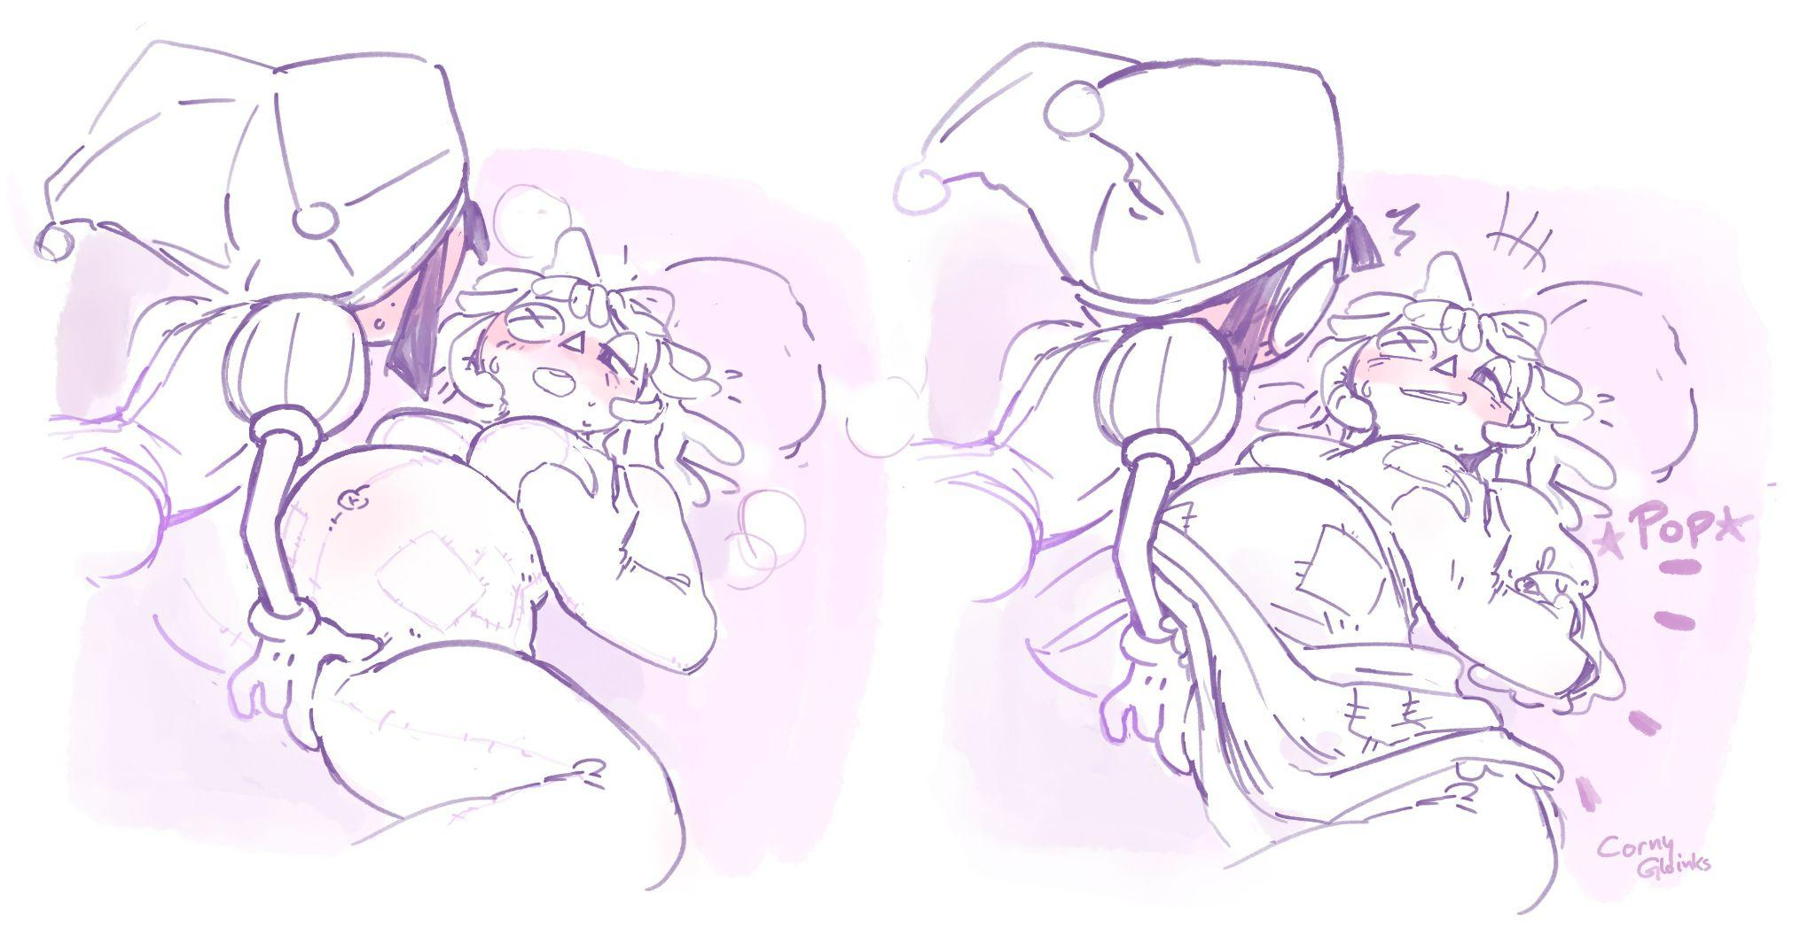

It continued like this for what felt like hours. Pomni just couldn’t stop. Anytime she thought things might finally calm down, Ragatha made another enchanting noise, or moved her body in a more than beguiling way, and Pomni found new reserves to just keep going.

Ragatha, too—not once did she indicate that she wanted Pomni to stop.

It only ended when Pomni literally collapsed onto Ragatha.

