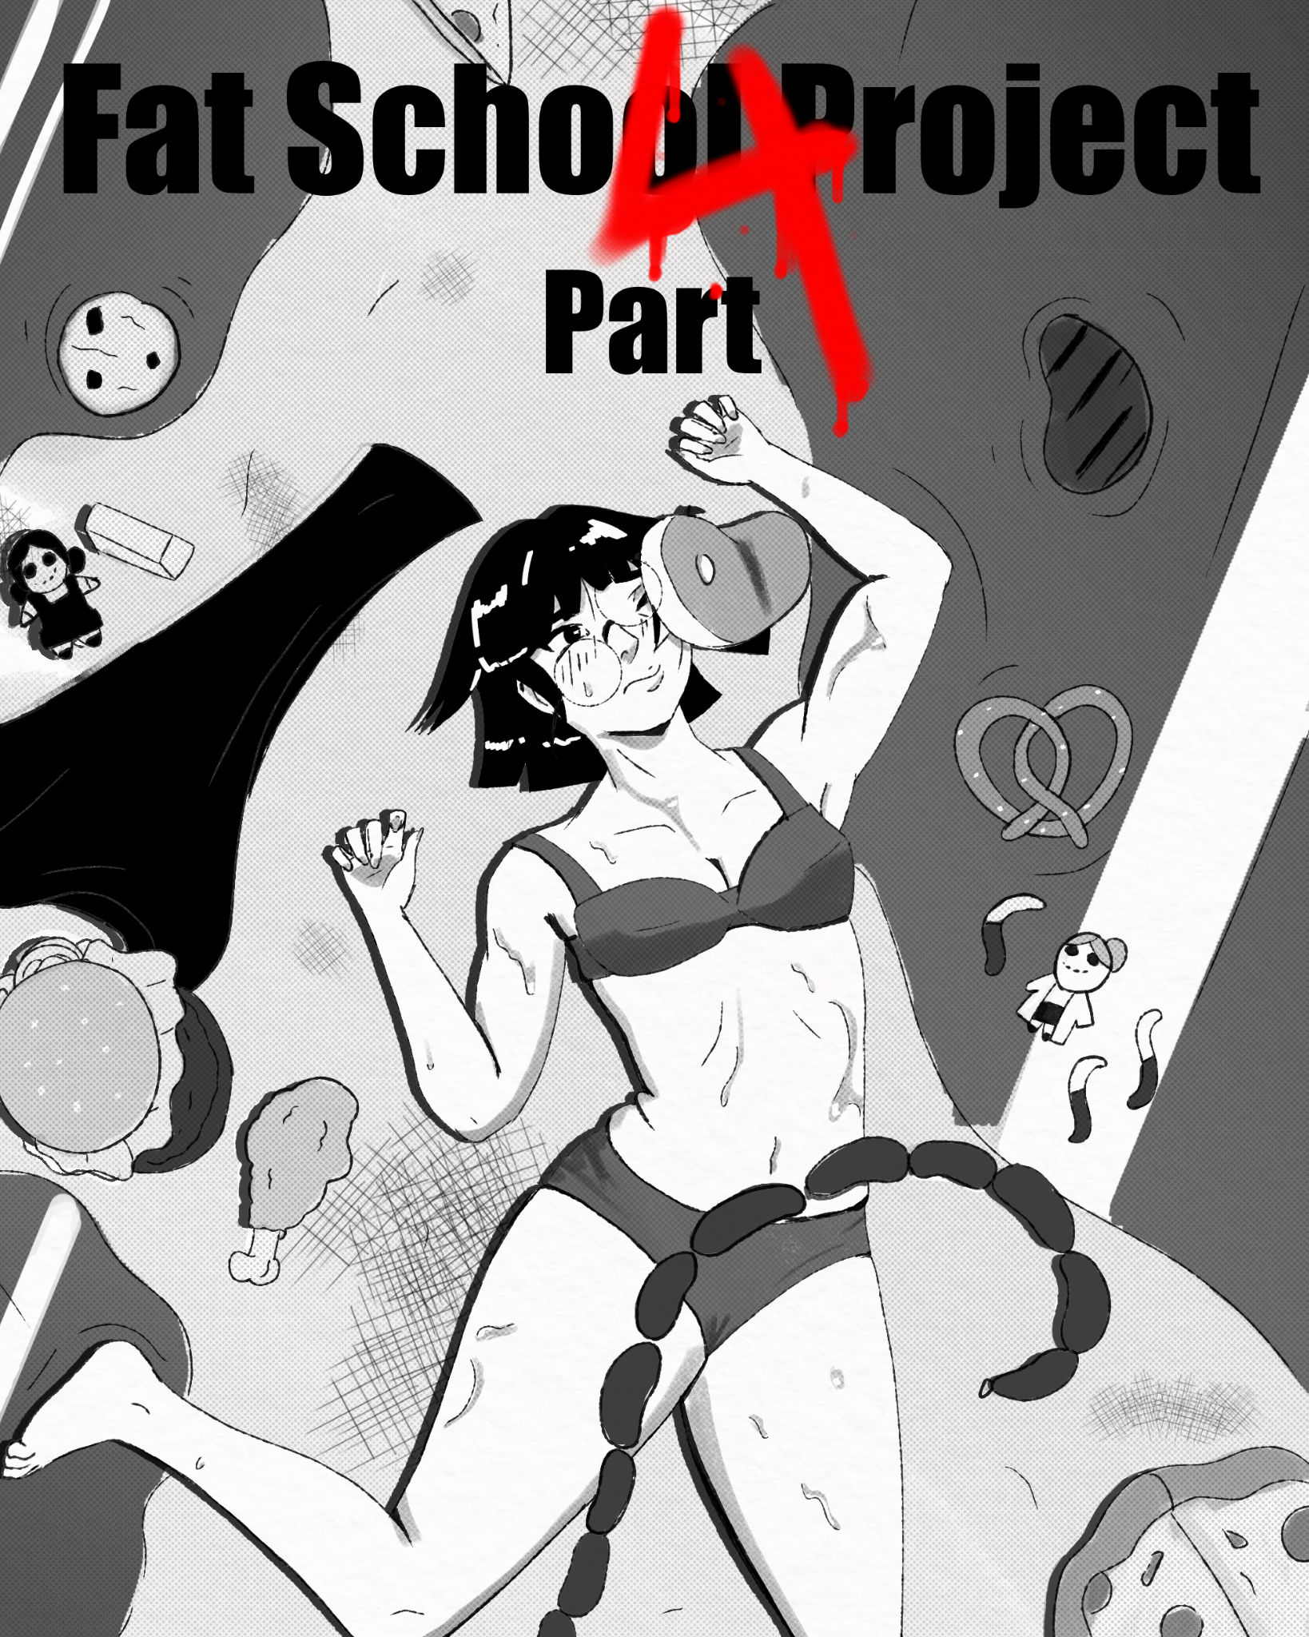
Cho woke up to the smell of food.
“Mmh? Mom, is breakfast ready?”
A moment passed before she shot up to a sitting position, eyes open. The basement was covered in food stuff, a whole buffet's worth.
“Wait, were am-” memories of the previous night came rushing back all at once. Lanna, the old san Graso, zoe…
“Oh yeah” Cho looked around at the mess she had made. She should be horrified with herself, but all she felt at the thought of zoes demise was horny.
“Cho, are you awake?” The voice of Lanna came from somewhere else in the room. Cho followed the voice to a part of the basement that seemed to be a cleaning station refitted to be a shower; it was running.
“Lanna, are you in there?” Cho asked.
“Come in! Come in! We overslept, it's already 7:00!” Lanna replied. Cho was too far from home to make it there and back to school on time, so she reluctantly slid off her underwear and hopped in the shower. Once inside, she immediately felt Lannas wet soapy body press against hers.
“Ah! L-Lanna what are you doing?” Cho turned beet red, as the other woman smothered her with affection.
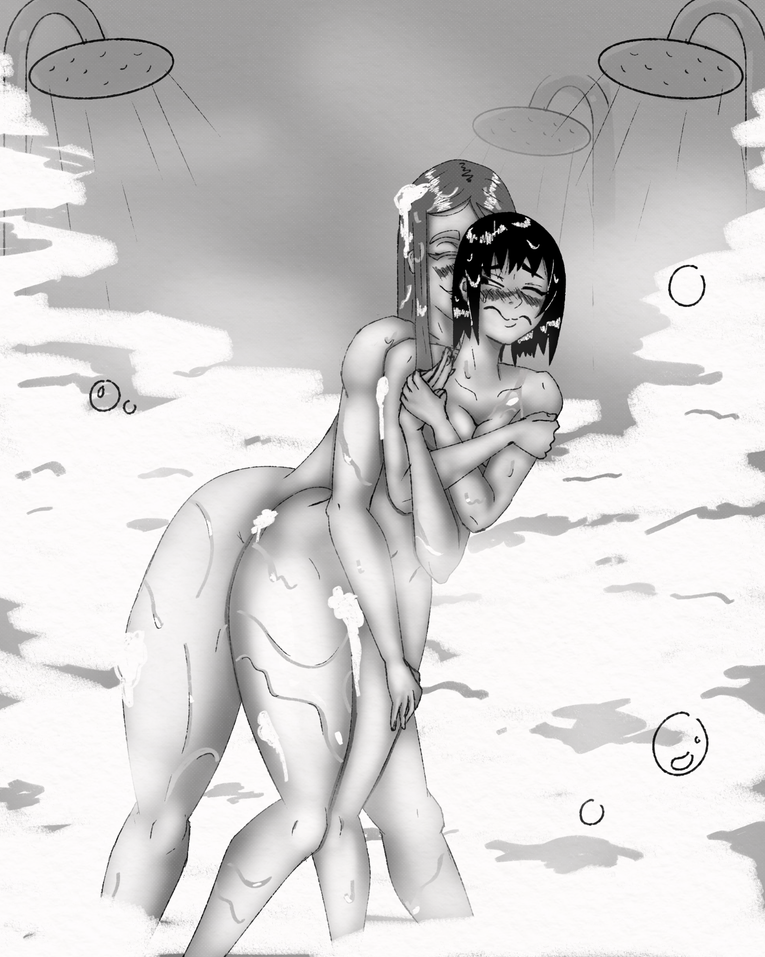
“I'm cleaning you. you're still absolutely covered in Zoe goop; Also just saying good morning,” Lanna chirped. She had a dopey smile on her face, which was something Cho was still not used to.
“Cut it out” Cho batted Lanna away and started washing up; she really wasn't sure what to say. She had gone four years without popping anyone. It was all down the drain now, she was right back to square one.
So what? You saw what a hopeless food bag that girl was, she was practically begging for it! Cho sighed and started rinsing off.
“So, have any big plans for Prom?” Lanna asked.
Plans?
“Well, I'm guessing the same thing teachers always do, stand around and make sure the students don't hurt themselves or start fucking”. Lanna looked shocked.
“Do my ears deceive me? Did San Grasos sweet innocent little math teacher just do a swear?”
Cho didn't respond, she just stood under the hot water, looking at the last remnants of Zoe swirl down the drain; she felt empty. She had been bottling up her desire to pop someone for so long, and now that she had finally released, she just felt like a used up tube of toothpaste. Eventually she spoke.
“What about you?” she asked. Lanna looked excited, and conspiratorial.
“You might say… I plan on making this year's prom… a blast.” Lanna answered. Cho raised a brow.
“Meaning?” Cho already knew where this was going. Lanna put a finger over her lips.
“Shhh, it's a secret. But…” Lanna stepped in closer. “If you really want to know, '' She was wrapping her arms around her, a snake around a mouse. “You have to agree to help me.”
Cho bit her lip.
That was two weeks ago, and Ms Kim still didn't have an answer. It was clear that Lanna was planning something completely off the deep end for prom. Obviously she should warn McClain and make sure Lanna does not harm any of the students.
And yet, you haven't.
“Ms.Kim, How are things going?” Butters asked. Ms. Kim was startled, almost falling off the ladder she was on.
“Oh hey, Ms Butters, hehe. Things are going great, just putting up the last of the streamers.” she said, stepping off the suddenly very scary ladder.
Kim had volunteered to get the cafeteria decorated and ready for prom, and while she claimed it was going great, that was a lie. The cafeteria was full of fatties lounging around and snacking.
“Are you girls helping?” Butters asked the girls. They all nodded, looking rather proud of themselves.
lies.
Managing all these lazy fat girls and getting them to do any real prep work was no small feat. Most of them would just do one thing, get tired, get hungry, snack, do one thing, get tired, get hungry, snack, repeat.
At least I'm almost done.
“My my, its seems Ms. Kim really pulled through for us didn't she?” Kim and Butters turned to see Ms. Merkel enter the cafeteria.
“Oh, Ms. Merkel, it's been so long how have... you… been…” Butters trailed off, as Merkel completely ignored her and gave Kim a very affectionate hug. Kim blushed, pushing Merkel away despite how weirdly happy the hug made her. Butters looked surprised.
“I didn't know you two were so close, I've known you for over a year Ms. Merkel, I thought you hated hugs”. Merkel scowled at butters.
“Well just because I don't like your hugs doesn't mean I can't hug a friend” Merkel said. Butters and Merkel didn't seem to get along well, Merkle's icy personality didn't mesh well with the fiery Latina’s. Butters shrugged.
“Ok” she put her hands on her hips. “Hey Kimmy, I have some leftover Jammbong, you want some?” Kim perked up.
“Yeah sure.” She ran over to Butters.
“Jamn...what?” Merkel asked in confusion.
“Oh, you didn't know?” Butters asked. “Its her favorite food. C’mon aren't you friends?”
Merkel gave Butters a withering look, Butters gave Merkel a sly smile.
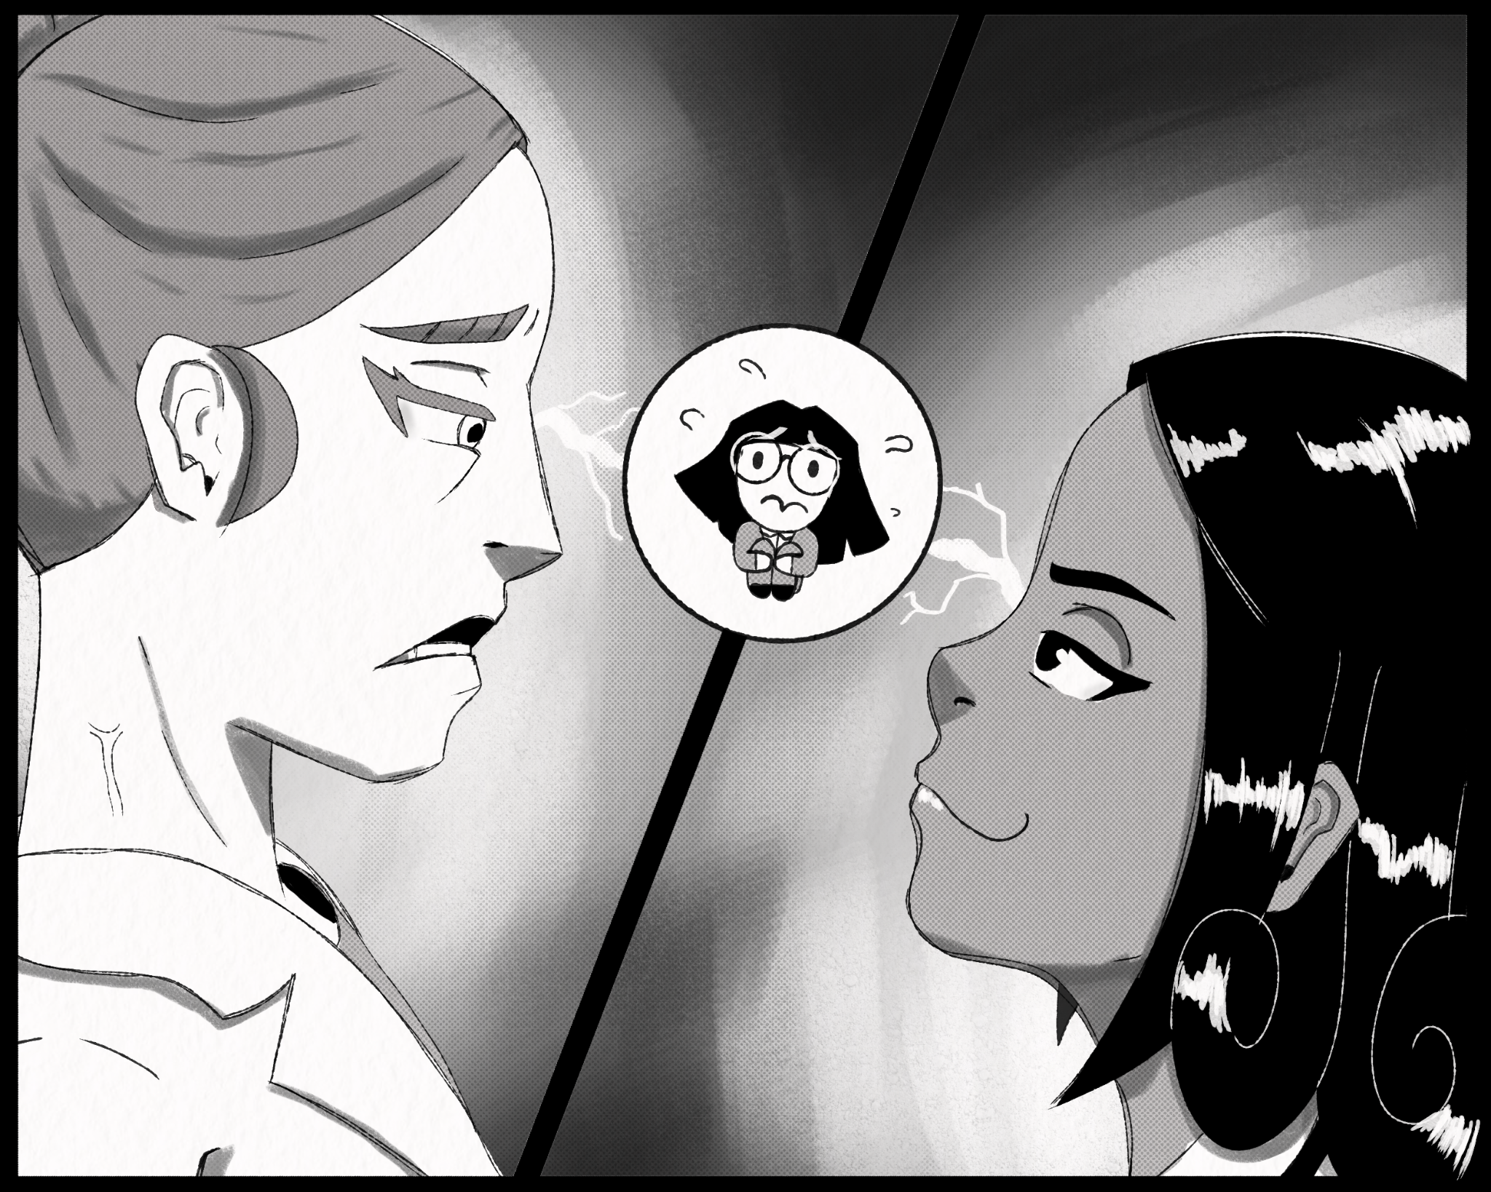
The week leading up to prom was… interesting. Both Merkel and Butters began some kind of weird competition. Each woman was vying for Kims attention; each day Butters would try to get Kim to come to her cooking club, and each day Merkel would try to get Kim to help with experiments.
“Ms.Kim, Come bake with me, I'll let you lick the spoon!” Butters would say.
“Cho, could you be my lab assistant for the day? I promise It'll be fun!” Merkel would ask.
“Ms.Kim Come eat lunch with me, we can share!”
“Cho, let's feed Stacy her lunch, It's a two woman job!”
“Ms.Kim I made you cookies, have some!”
“Cho I made you a little lab assistant outfit, try it on!”
“Ms.Kim.”
“Cho.”
“MS.KIM!!!”
“CHO!!!”
prom is tomorrow.
“Siiiiigh'' Ms.Kim looked at herself in the mirror. She was trying to distract herself, trying on different dresses and shoes over and over and over. “I still don't know what Merkel is planning.” She had a pretty good guess, but if she was going to stop her she had to report her to McClain now, she didn't have any more time. “Then why haven't I already?” She had weeks to tell him; yet she didn't. Shame washed through her, as she thought back to her moment of weakness with Lauren…and Zoe. Kim rubbed the bridge of her nose.
How many times are you gonna do this Cho?
Ms. Kim started talking to her reflection.
“Do what?”
Act like you don't want to pop some bitches, do it anyway, feel guilty, act like you don't want to pop some bitches, do it anyway, feel guilty, act like you don't want to pop some bi-
“Ok I get it.”
Kim thought about that night again, Zoe blowing up like a balloon, an apex of hedonism and excess, god just thinking about it made her drool.
Then she thought about Debra. When Kim made her that Jiambong, it didn't satisfy her sexually, but it did satisfy something deeper; something she didn't even know was there. Butters may be able to help her move on from popping girls, like ACTUALLY move on this time… but Merkel. Kim didn't want to admit it, but no one in her life had made her feel so alive before, and the fact that two serial bursters just happened to find each other felt like a miracle; did she really want that relationship to slip by?
She could feel a headache coming on, she had to make a decision, she was out of time.

Call Butters: (Wholesome, no bursting)

Call Lanna:(Dark, bursting)

