Let Him Feel It
A Vignette
By Maryanne Peters

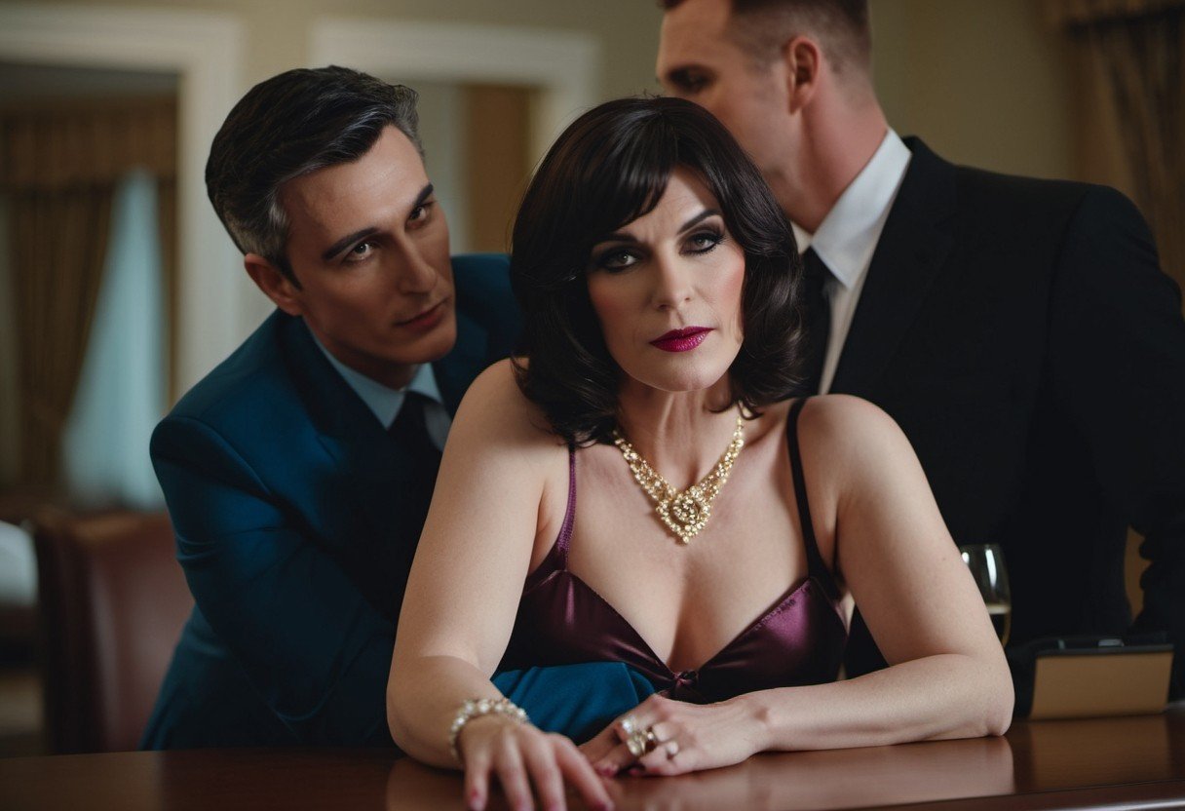

I mean, I knew both of them very well. I had worked with Don and Adam was with another firm I dealt with. It was just that after dating Adam a few times we caught up with Don at a function and he looked at me strangely.

“Don’t I know you from somewhere? I am sure we have met before?” he said.

It is a question that I both love and I hate. I love it because he sees me as a woman, and cannot see the man I was before. That makes me feel secure in my feminine skin. But it is a question, and so demands an answer. Should it be the lie – “No, I don’t think we’ve met before”, or the truth – “We used to work together, back when I was a man.”

But Adam stepped in immediately. I am still wondering whether I should love him or hate him for it.

“Hey Don, don’t you recognize the guy you used to work alongside? Rachel here used to be Riccardo. But she is a complete woman now. I mean just look at her – she is so hot … and classy too!”

“Oh my God! Riccardo! I mean Rachel! You look fabulous!” Don was flabbergasted, but it seemed like in a good way. He was looking me up and down with fresh eyes. Why do guys do that when they are told that a woman was born as something else?

“So, you have a pussy and everything?” Don asked me, while I did my best to look impassive, like a purple dildo on the shelf – a sex object – fascinating and slightly weird.

“Let him feel it, babe,” said Adam. The look on his face was one of pride. His girlfriend was special.

Should I love him or hate him?

The hall was empty, so the three of us went there and I leaned over the table while Don came forward. His hands were hot, and so was I. It was a long gown, cut low in front to show off my great tits, and tight around my great butt. I just hat a VPL (visible panty line) so I was wearing no underwear other than my push-up bra and thigh high stocking.

“Wow!” said Don, as I maintained my deadpan sex object look.

But then Don tickled my clitoris, that had been perfectly engineered for a woman’s most exquisite pleasure. Oh my God indeed!

Yes, Adam won’t be getting the cold shoulder tonight

The End
415

Author’s Note: The image is from Fredstar09 and is one of his “Preparing for Initiation at the Club” series, but this one told me another story. What do you think?

The New One  A Vignette  By Maryanne Peters  I had come home from the party early. Walt had been talking to some of his business buddies and I was bored.  “That’s okay, sweetie,” he said. “You go home and slip into something nice and I will be along shortly.”  I took our limo and told Pedro (our chauffeur) to go back and wait for his master, not that I said that word. I don’t even use the word in relation to myself anymore. I hadn’t used “Daddy” for a long time too. It seemed inappropriate. Afterall, We were married in all by the legal sense. He was in love with me, and I (in my own way) loved him | 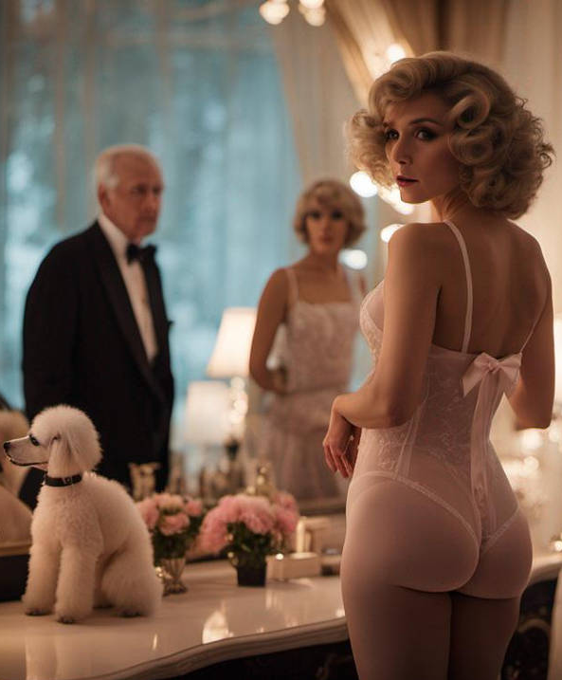  Something from Priscilla called “the Johnsons are home” “

I picked out some nice underwear – something that showed off my beautiful breasts, grown only by hormone therapy. Something with a see-through front so that he could see my trimmed bush, and the vestige of a penis, and only a penis, beneath it. I douched my bussy and lubricated a little, just in case he felt like some action when he got home. He was old, but he was fit and kept a jar of blue pills in his bedside drawer.

I lay in bed and read for a while. I had taken to reading romance novels on my kindle. I used to think that it was my sense of romance that had helped us in our relationship. I had come to think of it as being based on love, not on sex, and certainly not on money. If I had been a gold-digger when it started, romance had changed all of that.

I heard him on the stairs and I rushed to the mirror. I needed to check. My hair was perfect and my makeup still fresh from the party. I gave myself a wink as if to say that sex was bound to be the way this evening would finish.

But then I saw him enter and to my shock, he was not alone. I snapped my head around to see who this was, the stranger who would enter the bedroom of Mr. and Mrs. Johnson.

It was a boy. You might not have thought so because of the blonde wig and the low cut sleeveless white cocktail dress revealing a hopeless attempt to creates a cleavage with wired strapless bra. He could have been me, years ago. He was just as pretty, but still had the hard edges of androgen about him. If he was on estrogen, it would have been only a few months – softening takes time.

Walt could see the look of shock on my face, already turning to rage.

“I can explain, darling,” he said. “This is Crystal …”.

I keep a pistol in the toy toy poodle on the dresser, and for a moment I thought about pulling it out and waving it about. It would just be to make a point. It was not loaded. The point being that I was annoyed, and entitled to shoot an intruder. But instead, I just turned and stared. What kind of a name is Crystal anyway? It sounds like a truck stop whore.

“She is in a similar situation to you, sweetheart, or as you were once…”.

I suddenly thought that it might be his own hair. There was plenty of it, but no styling, and the body was hairless and showed the early signs of hormone softening. I looked at him accusingly. It was apparent that I had decided not to speak. I would let my eyes scream at him.

“She just needs a place to stay … an environment where she can develop … perhaps with your help.

Watch my screaming eyes, you bastard!

“Look, I will show her to the spare room,” he said, through shaking lips.

Men find it hard to deal with feminine anger on this scale. I was having a hard enough time managing it myself!

“Come along Crystal, let me show you where you can go.” He shuffled over to her and guided her back to the door.

Straight to hell, as far as I am concerned.

He came to bed only seconds later. He slipped off his clothes and sidled towards me. I slapped him on the hand very hard. No sex for you, you prick! As much as I wanted it, he needed to know who was running this household, and it certainly wasn’t him. He just pays for it. There is no place for a new one.

The End
760

Melding  A Vignette  By Maryanne Peters  Do you believe that a person can have powers that are supernatural? I never did. I am still trying to understand how it happened or what she did, but I can’t deny what I saw with my own eyes.  My father met and soon after married Ada, the one I called “the woman in black” because that was definitely her color.  Initially, I might well have thought that she had bewitched him, but as time went on I decided that I quite liked her. She was pretty and feminine, just the way I wanted to be. | 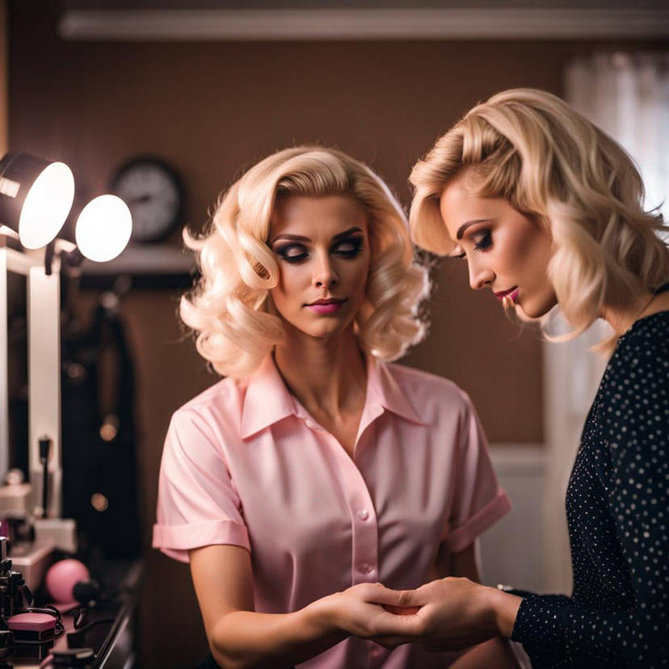  Image: A sissy femboy groomed by stepmom by henkis90 – but it was that strange thing with AI and hands that caught my attention

I was the youngest of three boys and my mother may have been the one who got me started on my love of pretty things, and feminine things. But as I grew up, I realized that I was lucky enough to live in a country (as it was then) that allowed freedom of expression when it came to gender and sexuality. I considered myself to be gender fluid. With two masculine sons I was a disappointment to my father, but nothing more. But Ada convinced him that she had the answer.

To me she was what I would have called a bimbo, with styled blonde hair and always made up impeccably. At that time I was more into a goth look, dying my hair black with lipstick to match. Ada was not disapproving of any of it, but she kept on telling me that I should be thinking about the future.

“I have done some palm reading in the past,” she said. “Give me your right hand and let me take a look.”

I guess I figured – why not? I placed my hand in hers and at first she just held it in her left hand, tracing the lines with her right hand.

“I see a future just like mine,” she said. “You will marry but you will have no children. You will meet an older man with three children – two sons and a daughter,”

“I am going to marry a man?!” I said, in a sort of shock. I had always imaging a life of free sex with any of a number of genders.

Then it really started to get weird. She pulled away her right hand and it seemed like her other hand and my right hand she held, had melded together! My arm looked just like hers. I could feel myself changing. It was almost as if I felt myself becoming a younger version of her.

She did it again a few days later – the same trick or illusion she was able to engineer somehow, But by that time I had really become the younger version of her, wearing bimbo pink with my hair dyed blonde and styled, and my makeup done to her very high standard.

Even without melding, we share a special bond. I sometimes wonder if she might have born a boy … not that it matters because now she is 100% female. I like to think of myself as close to that, or only scalpel’s width from it. What I am definitely not is gender fluid. Who would want to be, when you can be all girl?

Now I am looking forward to my future – that older man and a ready made family, just like my stepmom has.

The End

Just a Little Alteration  A Vignette  By Maryanne Peters  I never thought that I looked like a girl. If you had told me that I could be made to look like a girl in less than an hour, I would never have believed it. Which is why, I suppose, I agreed to all of this.  I had long hair, that was true, but I kept it tied back low and oiled. It was just that I started to grow it and I used oil to keep it tidy and I just never had a haircut again. It was no girl hair.  I had a masculine face. Girls used to say that I was a good-looking guy. I had full lips, but not really a girls mouth.  I had a good body. Slim and not so muscular, but I was in good shape. I looked after myself. | 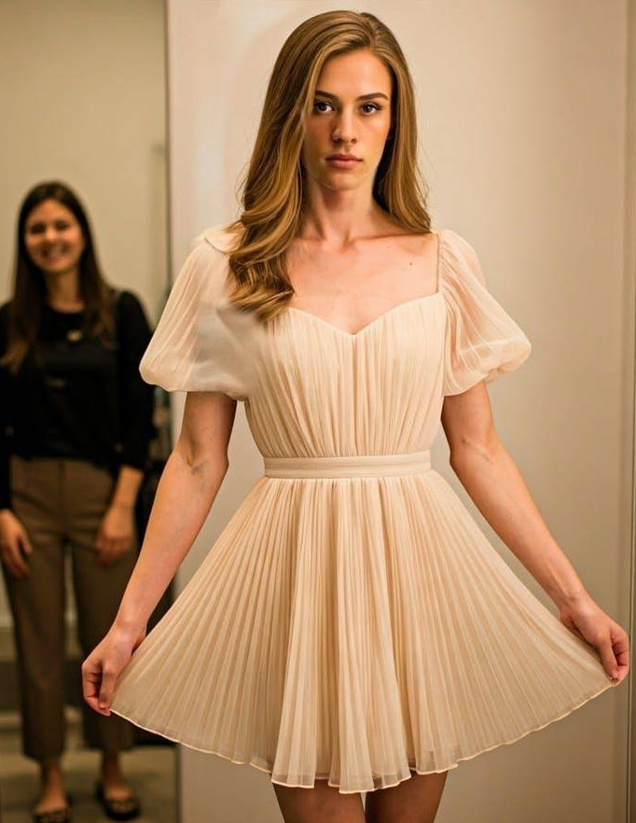

How could it take so little to change me? I allowed my cousin Jenna to do it because I was staying with my aunt and uncle who were then called away. It was just us and she was ready to go out, but not with her male cousin.

“If I can make you look like my female cousin, then promise me we can go out together as two girls,” she said. “You decide whether you look like a boy or a girl when I am done with you. If you look like a boy, then wash it off and we’re done, but if you look like a girl, then we are going to have some fun!”

All she did was wash my hair and use some rollers to give it body, then curling irons at the ends. She only brushed my brows and added just a little makeup. She had me wear a very light dress, something that I barely noticed I was wearing, but under neath there was a strapless under-wire bra and very strapped pair of high waist panties.

I didn’t even shave my legs. That came later. That came after I saw myself in the mirror with my hands holding the hem of my dress.

“Boy or girl?” she asked.

I wanted to say BOY. I wanted to shout it out, but I just couldn't. Look at me. I couldn’t. It was like I could feel my lips moving – “Girl”. The word even came out in a high toned whisper. A girl’s voice.

I shaved my legs while she got ready. I discovered that my aunt’s feet were the same size as mine and she had a pair of heels that looked perfect with the dress, and a pretty handbag too.

That night changed my life forever. I discovered who I truly was. And it was down to my cousin Jenna, although my new boyfriend Mark might also have had something to do with it.

The End

The image that inspired this story is called “Caught” by mumbo1979 on Deviant Art

Unbending  A Vignette  By Maryanne Peters  We are almost the same age, but despite his efforts Nathan looks so much older than I do. My youthful look is down to all the estrogens that my body produced after I had my prostate removed. The removal of a relatively unimportant gland can have unusual effects.  The impotence was expected, and surprisingly welcome. I had come to dislike sex with a demanding wife. She left me and I shed no tears. Nathan was there and alone, having lost his wife to cancer a year before. He simply invited me in and I stayed. | 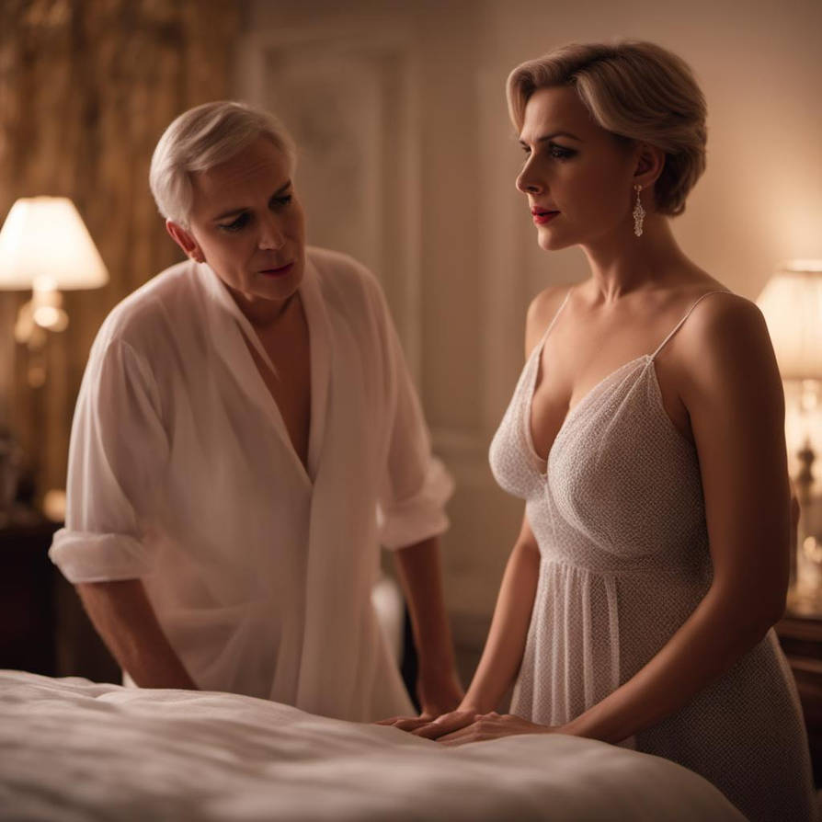  “Honey, bend over - sissies must obey their husband” by Natachaamy

But then everything changed – everything changed when I changed. To be honest, I loved it. When you reach the age of 60 it is like there is nothing else to see or do, and all your life is good for is running down the days until you die. But imagine finding that you are turning into somebody else, or even some thing else, and that everything around you is suddenly bran new because of it. Imagine wanting to do everything you did as a man, all over again but as a woman.

My urologist said that “the hormone issue” could be fixed with the right cocktail of drugs, but I decided that I wanted the youthful appearance and even the breasts. They grew to be very large – too large to hide – so why hide them. I found it easier to dress as a woman, have my ears pierced, get my nails done and my hair styled.

Nathan was surprised, and then amazed, and then randy. I told him that I was still me, but that was a lie. I was somebody else, and I quite liked the way he looked at me.

One thing led to another and sex followed, and then a marriage proposal and finally a wedding. It was mainly because I wanted to experience marriage as a bride. I knew that it would be different and it was. Weddings are performed with the bride as the central player and the groom an unimportant extra.

The only problem with all of this is anal sex. I just don’t like it. I do like not having to perform to have sex, and I do like the feeling of being filled, but using the anus is messy and dirty, and a dilated butthole can result in very unpleasant leakage.

The other thing that I don’t like about anal sex is the lack of love. I had always enjoyed love face to face, and Nathan demanding that I bend over and look at the wallpaper while he does what he does, is not really what I want.

So I decided to buy myself a vagina. I did it while he was on a business trip and when he came back he barely noticed. He was never interested in what I had left so why would he even notice that it was not dangling below the opening of his attention.

I needed to heel before I could invite him to try out the new me. I wore my new nightie but I wore makeup and the earrings he had bought me for our first anniversary, and once I had him panting I told him flatly, that I would not be bending over for him ever again.

It was slightly pathetic the way he whined, and I do not appreciate being called a sissy. I think I am well past that point now, but Nathan still had no idea.

“The only sex that you will be having with me from now on will be face to face, with your old cock inside my brand new warm and lubricated … vagina,” I told him, and I jumped onto the bed on my back with my legs open.

For a moment I thought that he was having a heart attack – his eyes were wide open and he seemed to be gasping for breath. He looked so old, and I felt so young. But he finally recovered enough to crawl between my thighs gushing about how beautiful I was and how perfect a wife I had become.

“Just remember, Nathan, I am not a sissy now and I won’t be taking it up the back anymore.”

I think that he has caught on. His joy was there for me to see – face to face. This is how I want it from now on. I am unbending on this.

The End
756
© Maryanne Peters 2025

