PAGE 1
5 panels

Carlos, for our final issue opening, I was thinking we could play with some iconic scenes from Rogue and Gambit’s past. The idea I had in my mind was maybe 5 stacked panels that all show Rogue & Gambit reaching out to one another. I’ve collected some scenes for you below, but feel free to include something different or to not include all of these. I also apologize for all the reference pics here! It’s only this page, I promise! ;)

PANEL 1: Gambit reaching out to Rogue when they initially “break-up” since they can’t touch. I included this one because it’s a big moment for them but also… cowboy boot Rogue!!!!

1 Caption: “Heartbreak…”

2 Gambit: --become me--let me become you--
3 Gambit: --no secrets, no shame--

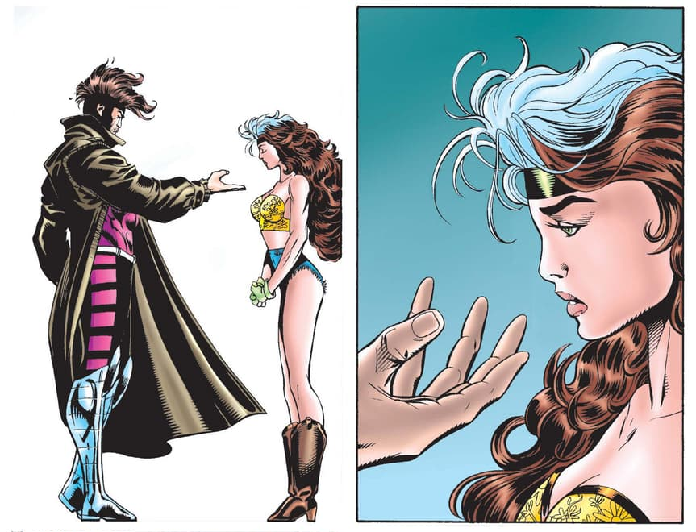
PANEL 2: Rogue reaching out to Gambit. Rogue continues to see Gambit after his death and is continuously reaching out towards him. There are some images below to also give a reference for her costume.

4 Caption: “…loss…”

5 Rogue: Damn you, Gambit!

6 Rogue: Don’t you dare die on me!
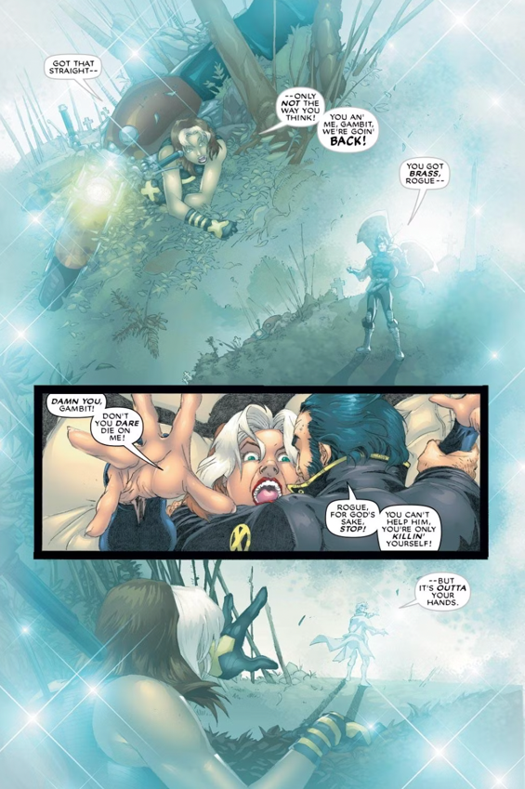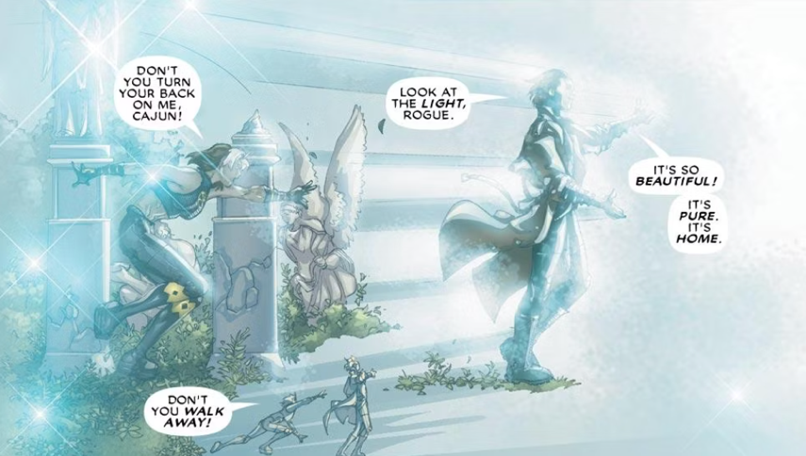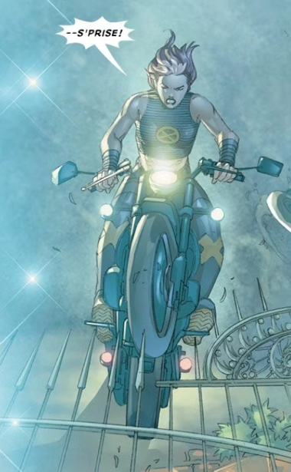

PANEL 3: Gambit reaches out to Rogue. The second “breakup” after Rogue sees all of Remy’s memories. They were prisoners in Antarctica and we get another kind of cool costume to show off if you want to go with this one. He’s on the cliff on the below page reaching out to Rogue who is leaving him in the snow. For reference, this scene is from Uncanny X-Men 348 and 350.

7 Caption: “…More heartbreak.”

8 Gambit: But… I love you.

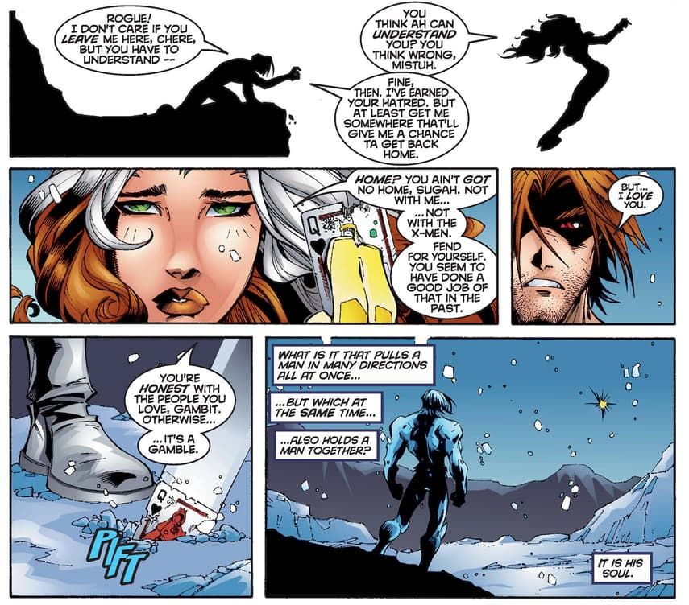

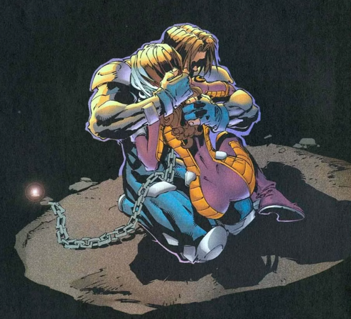

PANEL 4: Rogue reaches to Remy. Rogue learns to control her power and they finally share a kiss.

9 Caption: “We’ve gambled…”

10 Rogue: Here goes nothin’--

11 Rogue: --cher.
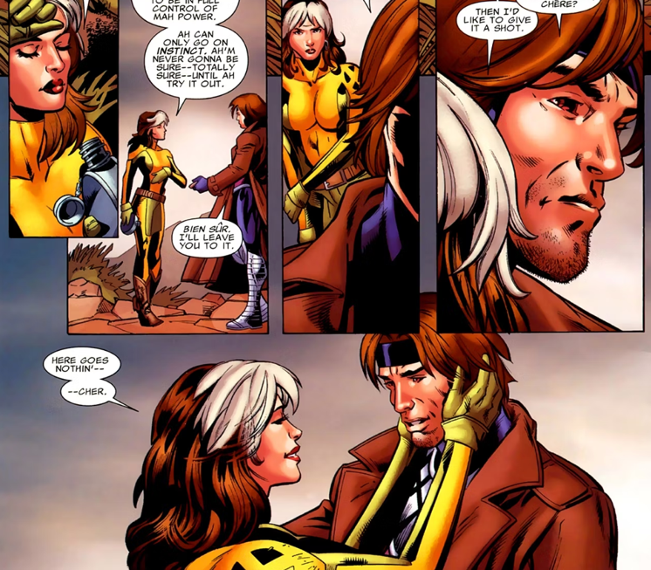

PANEL 5: They reach for each other! Wedding! They are reaching for each other right before their first kiss as a married couple at the altar.

12 Caption: “…and doubled down…”

13 Off-Panel: …introducing Anna Marie and Remy LeBeau…

14 Off-Panel: …as HUSBAND AND WIFE.

15 Caption: “…and through it all…”

