Cowboy on the Corner
A Vignette
By Maryanne Peters

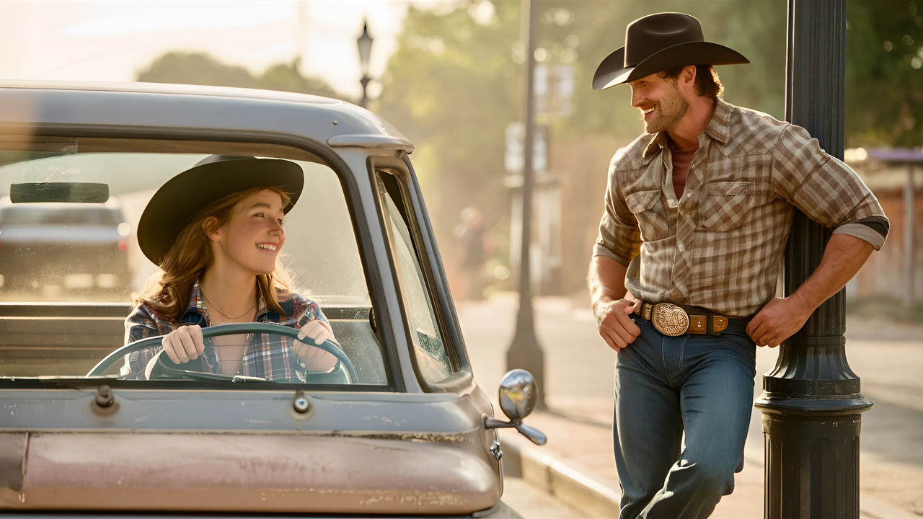

I pulled over when I saw him standing on the corner. It was Trent Mulligan, a man I knew well although quite some time had passed since we had spoken. Unlike some, he had never showed me any ill will, and so if I was going to stop to talk to anybody it might as well be him. But that was not why I pulled over – it was because I had never realized before what an exceedingly handsome man Trent Mulligan was.

Growing up I would never have been attracted to him. In fact, we did grow up together and I was never attracted to him. But now everything seemed different. My jeans only had my legs and my fulsome butt in them now, and my plaid shirt contained a large pair of cupped boobies now perfectly formed. I was a woman at last, and by God he looked good.

“Hi Trent – just doing nothing … as usual?”

“Just watching the world turn, Missy … as usual,” he said with a smile. It was more a manly grin. It seemed clear to me that surgery had confirmed a new preference and I enjoyed that thought. Women should be attracted to men. That is nature at work.

“I try to stay in the shade these days, on account of my skin,” I said. “I have to stay pretty these days, just because its expected.”

“You are that, for sure,” he said. “And you’re going by the name Mia these days, as I understand it?”

“That right. It’s Mia, and You-a.” An attempt at humor.

“You sure are looking mighty good, but don’t look for a job in comedy,” he grinned. “You’re not herding cattle these days then?”

“No, I am breeding and training horses on Daddy’s farm, working out of the yards and cottage on Collins Flat,” I told him. “Daddy has finally come to terms with everything. In fact, he sort of likes having a daughter. You know, fathers are always disappointed by their sons, but not by their daughters.”

“So you turned out all right, then?”

“I like to think so. What do you think?”

“I think that you were always good with horses,” he said. “I don’t ride much these days, what with the ATRs we have these days. But maybe I will pay you a visit soon? I noticed that you have been around for a while. You left town earlier this year and only got back last month.”

“Well I never, Trent Mulligan, are you spying on me?”

“I don’t just watch the cows and clouds,” he said.

“You’re right. In had to go into hospital for some surgery. But I am all healed up now.”

“Like I said, I may be in need of a ride, should my vehicle break down, if you don’t mind me callin’ on you, Mia?”

“I’ll look forward to it,” I said, putting the truck into gear. “Maybe pack a toothbrush.”

I drove off with a smile.

It feels good to be complete at last.

The End

The Image is from Robyn2801 of Deviant Art, and I think she called it “Standing on a corner in Winslow, Arizona”

Indelible  A Vignette  By Maryanne Peters  If it had not been that shade of red then I may have been able to avoid what happened, but many will say that I brought it on myself. I did go on about the standard of presentation of my all-female staff. It was simply because I appreciate feminine beauty and hate seeing a woman dress down for the sake of political correctness. Over time those extra little things that make a woman appear truly attractive have been evolved. Lipstick is just one of those things.  Kaylee was one of those young women who called me sexist. She was not unattractive, but stridency makes a woman ugly – don’t you think?  Do you know what the purpose of lipstick is?”she railed at me. “Red lips mimic red vaginal lips – blood infused labia as pointers that a mammal is ready to receive sex from the male of the species. It is a sexual invitation painted on the face of a woman. It is obscene!” | 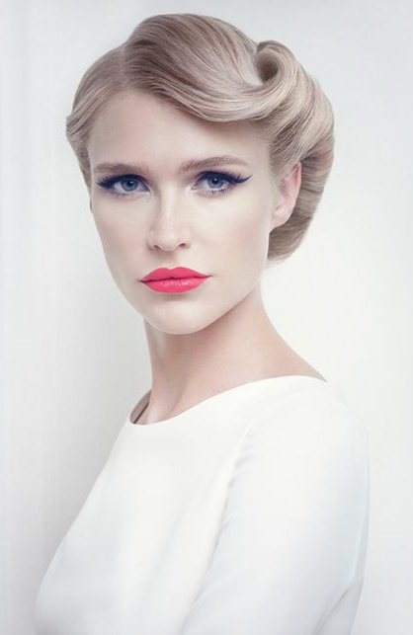

I never knew that, if it is true. It was just her vehemence that made me laugh in her face. If she was mad before then that drove her completely over the edge. Still, I would have never expected her to do what she did to me.

I am not even sure how it happened. It may have happened at my home, which is where I found myself. Or perhaps it was on the way home – somebody in the back seat of my car? There were drugs involved – it must be. A syringe to the neck perhaps, and then time to lay me out and do what they did.

I woke up and noticed that my hair was longer, and it was blonde. Extensions of some kind which could be pulled or cut out – that would be easy to deal with. But then I looked in the mirror and saw my lips. It seemed that they were not my lips at all – they were pouty and bright red. I thought I could simply wipe the color away, but I couldn’t even using detergents and solvents. Whatever had been used it was indelible. On my upper eyelid too, inedible black like a tattoo that could not be shifted, made my naturally blue eyes stand out.

It seemed as if something had been done to the skin on my face too. It was not just smooth but totally hairless, as if every hair had been pulled from it. Even women and babies have a light fuzz but I had nothing. I had a face like a Barbie doll. Then I saw that my legs had received the same treatment.

What would you do? I had to confront whoever had done this to me, and if that wasn’t Kaylee it would be somebody else at her instigation, or it might beany one or more of a number of other women who disliked me. They needed to be confronted. But they were all at the office and that was where I needed to go.

I suppose that I could have just turned up dressed as a man. It was as easy as going to the barber shop and getting these blonde locks shorn off and turning up with those lips and those eyes, indelibly feminized. Everybody would laugh at me, and quietly snigger for as long as I continued to look like a freak while I sought a remedy or waited for the colors to fade and whiskers to slowly return.

Or, there was an alternative. It was one they would not expect, but as I thought about it, it was becoming more and more attractive. I could show them the standard of feminine appearance that I had been talking about. As I looked at myself, I decided that I would look fairly attractive as a woman. I could walk into the office loud and proud and give them all something to think about.

Instead of going to the men’s hairdresser I went to a salon to have my hair and makeup done – just no need for lipstick and eyeliner. And then to a few shops to get some shapewear to the right outfit to wear over it, and the kind of shoes that a fashionable professional woman should wear.

I simply walked in with my head held high. Kaylee was dumbstruck. I was sure that it was her, or she had a hand in it, but nobody said anything. Nobody except Malcolm, my immediate superior who asked me what name I would be using from now on and whether I might be free for dinner. There is a man who knows style when he sees it.

There is going to be no fading of these colors and no beard returning, not anytime soon. It’s indelible, you see. I just need to work on other permanent solutions to make the best of it. One thing a woman learns, especially a woman like me, is that style never fades.

The End
832
© Maryanne Peters 2025

From a story idea from Throne entitled “Face It” where permanent lipstick leads to an office worker being teased

Finally  A Vignette  By Maryanne Peters  I had always had a dream of going to a party wearing a strapless pink minidress with petticoats. Is that a strange thing for a boy to dream? Of course it is! I did my very best to shake it all my way through high school and college, and through a failed marriage. Every time I thought that I had got on top of these thoughts, I would go to bed and have that dream again.  I never dreamed that I would ever get to live it, but then I got testicular cancer and my whole world changed.  It was not as if I was ever going to die of it, even though I was slack about seeking a diagnosis. The fact is that virtually all men survive testicular cancer, even bilateral non seminoma cancer like mine. The only effective treatment was bilateral orchiectomy – both testicles had to go, no question about it.  It would be no problem I was told – I could save some sperm and take male hormones daily to stay being manly. But the fact of that led me to wonder … do I want to stay being a man? Could I not take the drugs and see what might happen to me?  I have to say that my urologist was less than pleased with my decision, but he had to agree that no real damager would result if I took the option of avoiding androgens for a while. | 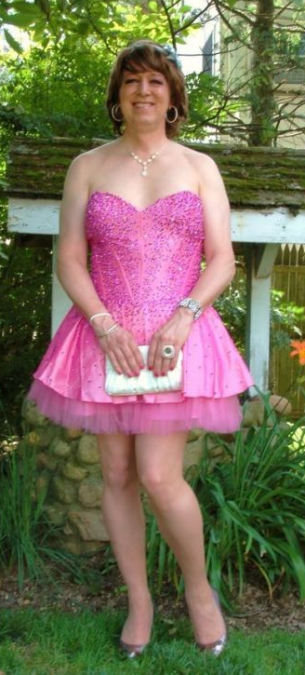

I let my hair grow to a length that might be considered androgenous and I waited for my body to soften a little as it did over time. I adopted what I would call a gender neutral identity, at least for a while. But that dream kept happening and so I knew that I had to take the plunge.

I invested in a full body wax. It was an ordeal, but it was remarkably transforming. Body hair seemed to be the only male thing about me, apart from my voice and my crotch. Even without taking female hormones my chest had swollen a little, as I was warned might happen without androgens. But without hair and with softened skin, I looked feminine enough to get away with appearing in public in women’s clothes.

My friends were surprisingly understanding - perhaps because they all knew that I had lost my balls and figured that turning female was the awful consequence of my cancer. I said nothing about it being my choice. I just said that I was coping as best I could.

Leo actually asked me out, and that gave me the opportunity to live my dream. I bought the dress, and the right shoes. I had my hair blow-waved and my makeup and fingernails done. I wore my mother’s jewelry, just buying some hoop earrings and a clutch bag. I was so happy that I almost burst out of my skin.

Leo said that I looked beautiful. He said that tragedies can have a positive, and that turning me into a woman was just that. I had to kiss him to settle the deal. I will need to make other changes now, but now I am ready to go the whole way … finally.

The End
535

Three Years Later  A Vignette  By Maryanne Peters  Joseph is my cousin, but maybe like third cousin or one of those “removed” cousins or whatever. Anyway, we only saw him at Christmas, which was like a big thing for our family. We all get together in one place, or we try to. So up until Christmas 2024 I had only seen Joe maybe three times in four years.  We are not very religious, but we like all the trappings of Christmas including the feasting and the giving of gifts, and stupid games that everybody can play, some with funny penalties. They are all supposed to be a joke and so nothing painful or permanent, and nother unduly embarrassing.  Joseph was always pretty good at these “parlor games” so maybe it was to his surprise when he lost in 2021 and I had the chance to pick the penalty. | 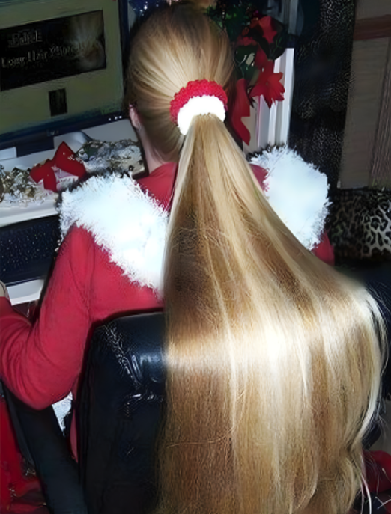

My penalty was that he was not allowed to cut his hair for a whole year, until next Christmas when his honoring the commitment was to be inspected. Everybody thought that it was not such a bad fine, but his mother said that he would have to keep it tidy, and maybe tie it back if it got really long. That was going to happen and it made me think about why I chose this penalty for my cousin. I suppose that it was because I imagined that his hair would look really good if it was long. He had that soft fine hair that just fell around his face, and it was a honey color that would only get lighter if it got longer.

I am not saying that Joe looked like a girl, but his hair did look as if it belonged on a girl, even when not that long. It was the kind of hair that if you saw him from behind you might think that he was a woman, and then he turns around and it is clear that he isn’t. I guess that I just wanted to see how it would look when it was longer.

I have to say that as Christmas 2022 approached I was praying that Joe had honored the deal and that I could see it. I had told myself that it would be cut off but at least I could catch a glimpse of my cousin Joe with girly hair.

It was tied low at the back when I came in the room, and he was facing me, but he looked different. I am not saying that his face looked feminine, but it did not look as masculine as I remembered from the last time we were together – or was that just me.

“Hair inspection time,” I said. He just pulled the rubber band from behind his neck, and I could see that it was everything I had imagined it might be. It was only hanging over his shoulders at that time, but it was straight and shiny, and it shimmered like a satin curtain. It was so beautiful that I could feel an erection growing in my pants. I moved to stand behind an armchair so nobody could see.

“It is hard work to look after it, but Mom insists that I do,” he said. “And it always seems to flop over in front of my face, so I have to tie it or clip it back.” He shook his head slightly and sure enough, it fell in front of his face and I could see that it was almost blond at the tips. My penis jumped. I would have to deal with this in the toilet, but before I did Joe’s mom spoke up.

“It has grown so fast it is incredible,” she said. “In just a year I could never have grown such wonderful hair to that length. I wish I knew your secret, Joseph.” He looked very pleased with himself.

I made my excuses, and I sidled away in search of the bathroom and toilet tissue to deal with my problem. It just seemed so wrong that something that beautiful should be swept off the hairdresser’s floor as trash. But there was nothing I could do, except, maybe … ?

I spent the whole of 2023 wondering if Joe had deliberately lost that game and given me the right to extract another penalty from him. It seemed very clear to me that he knew what the penalty would be as he actually asked me whether I was going to allow him a haircut. Of course I told him no. There would be another year, and again I would have to wait until Christmas 2023 to come around.

I had all kinds of dreams about my cousin – the kind of dreams that you shouldn’t have about another family member, least of all one who was of the same gender. But in my dreams she wasn’t. That’s right – in all of my dreams she was a she, with breast that wobbled when we had sex, with me deep in her vagina, with her long hair spread across the pillow around her face, or hanging like a satin curtain if she was on top of me, riding my cock.

I knew that this Christmas I would to be prepared, and wear some kind of restraint to stop me from embarrassing myself. I needed it.

His hair was so long that he kept it woven into a tight braid down his back. It went all the way down to past his shoulder blades.

“I am not taking it out, but you can pull on it if you like,” he said. “It is all my hair.”

I accepted his offer, but only so I could touch it. I swear my hands were shaking when I grabbed it. I had intended to pull hard on it, like a playful boy against boy thing, but when I felt those soft silky fibres in my fingers may hands just ran down stroking it. My penis hit the wall downstairs.

“You can keep it if you want … when I cut it off tomorrow,” he said.

“Maybe we will play for one more year,” I laughed. “But I will accept it as a trophy if it comes off.”

Actually, the thought of that braid pinned to my chalkboard seemed exciting, and perhaps it might live under my pillow some nights. And yet, I still wanted more. Could I win another penalty from Joe. Or perhaps he would let me win?

However it happened, it was my call. He did not plead with me to choose another penalty – he just looked at me with a sigh of resignation.

I spent another year in a state of sickness. That is what you have to call it. My cousin Joseph was a boy - albeit a boy with beautiful girly hair – and I was a boy too. My dreams had to be gay in some way, even if the body I dreamed he had was female. It was all about the hair. I had a serious hair fetish. I looked at images of long hair, and long hair porn to try and switch my focus from Joe, but it always came back to him. His hair was real. I had touched it. I could touch it again, if only December would come around.

We spent that Christmas at Joe’s house that year. We were invited in and my parents started chatting. I asked where Joe was.

“He is up in his room, honey,” my aunt said. “On his computer. You can go up if you like, but I have to warn you, there have been some serious changes over the past year. But Joe can tell you about those.”

I rushed up to his room. The door was open, and as I walked in, the sight that faced set me trembling.

It was Joe’s hair, draped over the back of his chair, shining in the light, long, soft and silky. But it was tied back with two festive scrunchies, and Joe was wearing a Christmas outfit of some kind. His room looked very different. The seasonal theme was dominant, but under that it was more like a girl’s room than a boy’s. He was busy looking at something, and I just stood there shaking. I just found the composure to take that photo, before he spun around in the chair and stood up.

It was a dream come true. Joe was wearing a dress and makeup on his face, and I could see from the V-neck that the breasts pushing out in front were real.

I was just overcome. There is no other word for it. I just dropped to my knees, my eyes wet with tears. I just blubbered out the words - “I knew it! I knew that you were far too beautiful to be a boy! You’re a girl! I knew you were all along. I want you, Jo. I wanted you for years and I think you know it. Growing out that beautiful hair was all that was needed to turn you into a girl – my girl!”

Jo flicked that beautiful hair across a wonderful breast and stroked it lovingly.

“You’re my cousin, for God’s sake. Yuk!” she said.

The End
1545

My Father  A Vignette  By Maryanne Peters  If I wanted to be a man, I would want to be just like my father. I say that now because there was a time when I did want that – to be like him. That was a time when I thought that I could get over this gender dysphoria thing, if only I turned my mind to it. It was the kind of thing he would say. We can always deal with anything if we truly want to. But that just meant that I did not announce to my parents in kindergarten that I wanted to be a girl. Instead I waited until high school to tell my father that I wanted to transition into being a woman. | 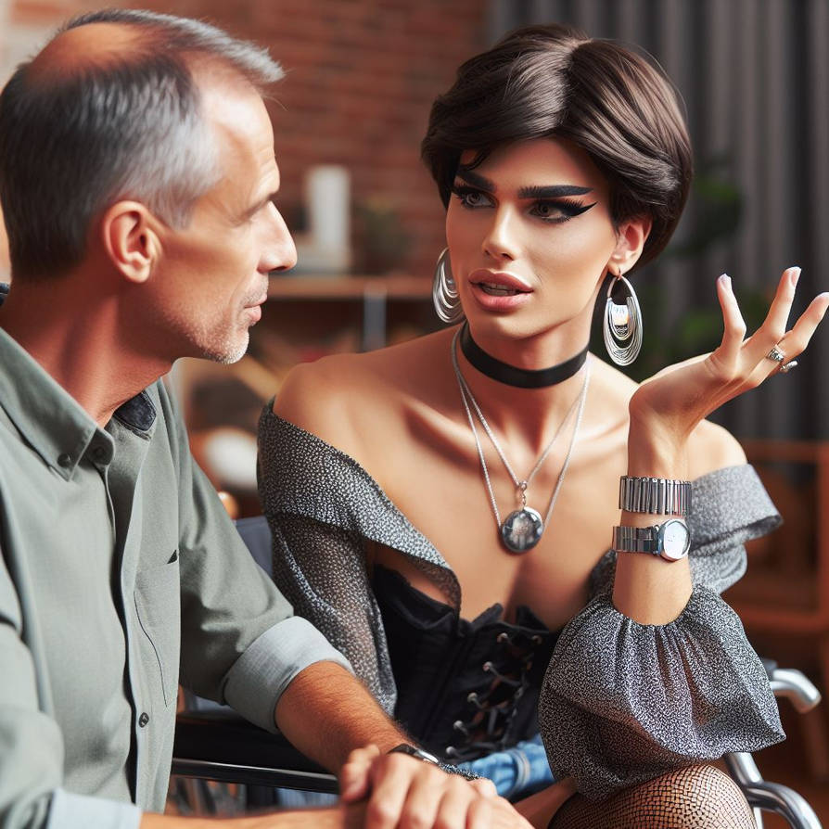  A Supportive Father by ssbbwpassion on Deviant Art

My father has always been a listener, as my mother will tell anybody. He is always calm and rational, and understanding of the feelings of others. He would hear somebody out. Even when I decided to dress up to tell him – in a shoulder-less dress with a corset and black stockings and heels, and silver earrings, a choker and pendant and heavy makeup. It was dramatic for a reason. I guess that I wanted to challenge him to be emotional about it. I was not going to be his son anymore. I was going to be his daughter.

But there he was, with that listening face and his hands gently together, nodding quietly as I spilt out all those years of frustration. Perhaps I had imagined shouting from him, and tears from me, but that didn’t happen.

“I know what you are talking about,” he said. “I know what gender dysphoria is. I want what all parents want, and that is that their children can be happy. To be happy, you have to live your life as your true self, not what anybody else wants you to be. All I ask is that you love your parents as much as we love you, although even if you didn’t, we would still love you. Now, tell me whether you have a new name that I should start using.”

God, I love that man. I just wish I could meet somebody half as good as him.

The End

370© Maryanne Peters 2025

