Three Ingenues
A Vignette
By Maryanne Peters

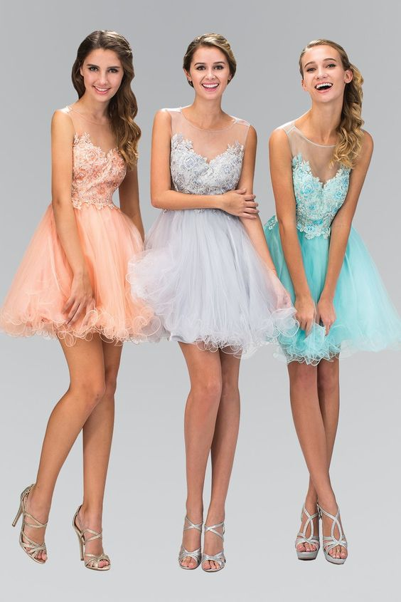
Ingenue definition: 1. a young woman who has little experience and is very trusting

I suppose that most people think of transgirls as being tough – the very opposite of an ingenue. I think that we were, but fragility and sensitivity are so much a part of being feminine – don’t you think?

It helps to be pretty, and we try very hard. It helps to be slim, and we stick to our diets. We like to say that the only fat on our bodies is that which the estrogen has added all over, to keep us soft and looking weak. We love to wear dresses with frills or soft tulle – it makes us appear lighter than air or almost supernatural as if we are nymphs or fairies, or innocent creatures of fables. We love our long hair that we have worked hard to grow and care for. Practical cuts are not for us – casual is hair down with bouncy curls, but other a stylish updo, perhaps.

Because we were not born girls we want to be extra-feminine. We want to be the kind of girl that boys want to look after and protect. We don’t want to appear forward and hungry for sex even though we might be. We want to be shy and fearful of the power of men and the pain that their organs might cause fragile little beings like us.

Some might criticize us for this approach to life, but we are three in this together and we all have the same vision of the feminine allure. It might be a little old-fashioned, but if we can all catch the right man – somebody who truly appreciates a woman who is more of a woman than most, except internally. But nymphs and fairies don’t give birth either. The whole idea is simply yuk!

We are ingenues. But remember, there are three of us. If you cross us we may need to change tack and call on some strength for the past. You would be we advised not to give us cause to do that.

The End

Irresistible  A Vignette  By Maryanne Peters  Perhaps because my staff were always giving me a hard time about my old-fashioned manners and conservative style of dress, I was in favor of a diversity hire. We had two races other than white covered, so when I was looking for a new secretary the office manager put forward a candidate she described as “gender non-conforming”. I thought that it would be to test me, so I had no choice but to go through with an interview.  The person who arrived was clearly a young man, with colored long hair, wearing eye makeup and behaving in a very effeminate manner, but wearing what might possibly be called “neutral” clothing – that is pants and a shirt with a very slight floral pattern under a jacket of a slightly feminine cut. The disarming thing was that the boy was charming with a cheerful disposition, and he had impeccable credentials. He had excellent typing and data input skills and two testimonials referring to his “natural and extensive ability to organize”. That was what I was looking for, and what I needed. |   This image by LindaSummers214 on Deviant Art is entitled “The Boss can’t resist his sissy secretary”

I had decided that I wanted to hire this person (being careful with pronouns in these difficult times), but I did have a few concerns about what my clients might think. With some reticence and after confirming to them that I would be inviting this person to join the firm, I felt that I should express my views.

“I think that a relationship between a man and his secretary should be an honest one – don’t you?” I began. “I understand that you wish to express yourself but I my nature is more … reserved, and my clients value my advice for its … traditionalism. I wonder if you, from time to time, wear women’s clothes and opposed to … unisex apparel?”

“Would you like me to wear women’s clothes?” they said, but on seeing my discomfort, they did not wait for an answer. “I like wearing women’s clothes, and I am keen to fit in … if that would help.”

“Well, I think that it would, if you would be so kind?”

The name on the employment contract was Dean but the suggestion was that I use the name “Dee” and I could use the female pronoun to refer to her. She understood that I would be more comfortable with this, and the name and pronoun did fit when she appeared for work on her first day in a dress.

I think that she may have lifted her voice an octave or two as well, and when she answered the phone should could well have been mistaken for being female. If a client would then appear at my office and have her come to greet him or her (or them) at reception, it would have been confirmed absolutely that my secretary they spoke to over the phone, was a woman. If I had any doubts they disappeared on the second day when she appeared for work in her black long sleeved blouse and short black dress.

“At the risk of being accused of molestation, can I just say that you look very attractive today.” I think it was the long legs and high heels that made me say it. Such words I would never suggest be spoken by another, but they just came out. I was trying to make a point. “It is just that the skirt is very short.”

“I like to show off my legs,” she said. “I think that I have good legs – don’t you?”

I was at a loss for words. Those legs were simply the best I have ever seen on a woman, and she was that. They were the perfect shape, and so smooth. She later told me that she kept her whole body hairless, which led me into thoughts that had not entered my mind since I was teenager.

“And please feel that you can compliment me anytime,” she said. “I am dressed like this for you, so perhaps I am entitled to expect those words?”

It was totally inappropriate perhaps, but I asked her whether I might purchase so business attire for her. After all, she was right, it was my request and I understood that she would have no proper wardrobe. I can only imagine what clothes she donned in private – perhaps frills and lace, or skimpy and sexy. I had in my mind that I would assist her by buying something more moderate, but she had to wear it so she needed to come with me, or rather I needed to go with her.

We went to a boutique nearby. I remember the look on the shop assistant’s face when we entered. I am not sure whether she realized quite what Dee was, but I don’t think that mattered. She reserved for me a look of disdain as if I was some kind of “sugar daddy” paying the bill.

As it happened, any thought of purchasing staid outfits was quickly dispelled. Dee got what she wanted and I paid. I was to learn that was how things were to be with her.

The thing is that this was what made her such a good secretary. She would manage my diary and make decisions about appointments – like short meetings where she knew they would be difficult, or other more pleasant meetings before lunch so they might roll into a meal. And for meals she would book at healthy places most of the time, but steakhouses when I needed a treat.

Her typing was first class, and everything arrived in my inbox with explanatory notes and reminders about the client so I could easily deliver small talk if required.

She was quite simply the best secretary I had ever had. She was so good that I made the mistake that I have always warned others never to do – I fell in love with my secretary.

I thought that I had the easiest cure for such love. It was – tell yourself that this person is not a woman, and because you are not homosexual, this cannot happen. It seemed like a good idea but it didn’t work. I actually thought about telling her to drop the female clothing and dress like the man she was, but I could not bear the idea. And, I think that I realized that she might well refuse such a request. It seemed to me that she had become so accustomed to dressing as a woman that the man in her had disappeared totally – if he was ever there at all.

That thought made me feel less guilty about having brought about this situation for her. But the truth of it was that I reveled in her presence. Her soft hair, her wonderful legs, the smell of her – they all delighted me in a way that is so hard to describe.

But I was too old. Even though even though the thought of her brought on a male arousal in me, it was never one that could be called functioning. That was in my past. She deserved what I could not give her, and it was only a matter of time before the man who could give her that, emerged and visited my office.

He was divorced and wealthy despite of that. He swept her off her feet in every sense, which was something well beyond me.

I think of her often. I wonder now if she is a complete woman. I hope that she is, but even if she is not she was irresistible.

The End
1278

Author’s Note: The image is credited to Linda Summers of Deviant Art. I do enjoy working with images including AI generated pix.

Rose  A Vignette  By Maryanne Peters  We were partners in business, David and I, and flower production was a tough business. Every time that you buy a flower give a thought to where it came from. There is beauty, and fragrance, and delicate textures, and colors that can brighten a day, but they are not easy to grow, and to transport and keep fresh, and distribute to so many wholesalers or individual florists, and get paid for without some dispute as to price or quality.  We were both married at the time, and we had the pressures of responsibility for wives and families. We knew one another well, and we rarely disagreed, but we mainly worked apart. Dave looked after production and I looked after distribution and invoicing, and we trusted one another’s ability in the tasks that we did. | 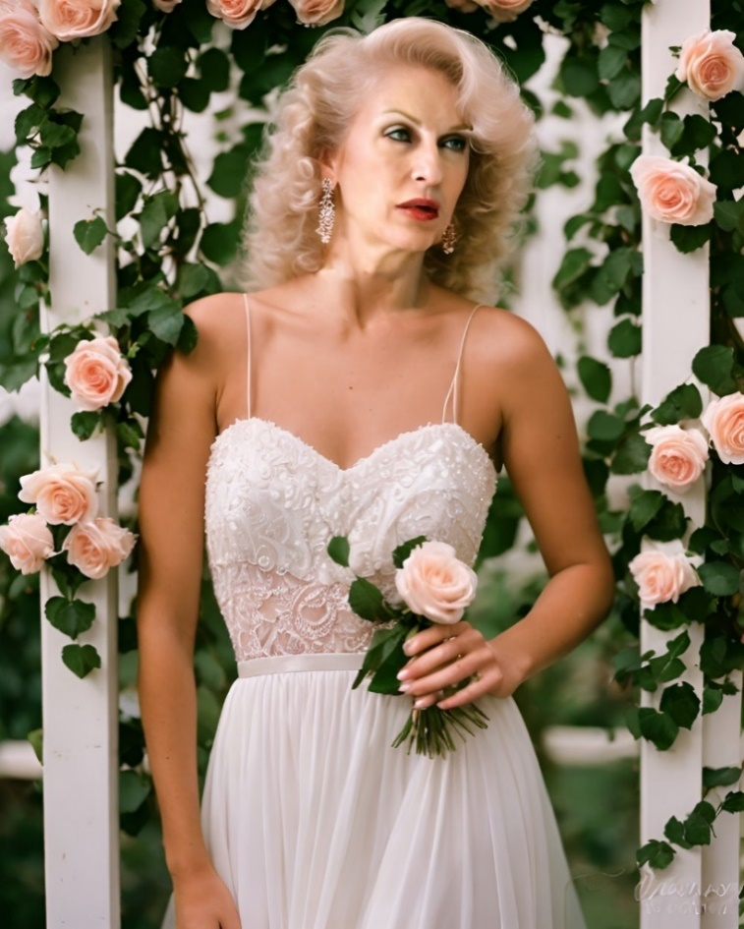

Perhaps we should have been closer, especially as we both lost our wives after many years of marriage. We gave each other sympathy rather than support, and we each carried the burden of the business alone to allow for other’s grief to heal. We never had a chance to share much in the way of feelings, and certainly not secrets. Perhaps we were just good at burying such things? I was, in any case.

I had always nursed the idea of becoming a woman. It was deep in my psyche and yet with the business, the marriage, and the family, I was able to put aside such thoughts as if they were a childhood fantasy. It was just that when my wife died and my children set up their own homes, it all came flooding back once I was alone.

She had a name by then. I called the woman in the mirror Rose. She was not attractive when I first gave her a name, but there was something to work on. I had the good fortune to have kept my hair, with only a couple of spots where a surgeon could pull the scalp forward to create a feminine hairline. It was just that it all seemed too late to do anything like that. But nobody was watching but me, and with every little step I realized that I might be able to realize that feminine dream.

Dave started to notice things when we met. I felt that I had to tell him, and I also told him that he was the first to know. He was surprised at first, but then he was fascinated. He asked me to come into one of the giants greenhouses where the pink roses grew, and as we walked through the heady floral perfumed air he picked up a bud that had fallen and dusted the moist soil from it.

“This has broken from the stem, but if you stay rooted, and with the attention of a good gardener, I am certain that you will bloom into the perfect rose,” he said.

It seemed to me that he was the first person to see me as a woman, even though I was barely trying at that time. His message was that he was ready to offer me the same kind of attention to see me blossom into the Rose I wanted to be. He never looked at me in any other way after that, from bud to full bloom, I was his prize flower.

I am no fresh flower, but for him I have done my best. As I stand to exchange vows with the man I have fallen madly in love with, I give thanks to heaven that I am finally me at last. Rose.

The End

A Suggestion
A Vignette based on an Idea from Throne
By Maryanne Peters

I used to say that I could fuck anybody, but it was only supposed to be girls. The fact is that I had a huge sex drive and it seemed so powerful that it was unhealthy. It was affecting my social life, even with the guys I mixed with. We were all interested in girls, or should I say ‘pussy’ because it was the entrance that shouted at me. The guys would joke about women being meat, but for me that was real.

It was when I started to do anal that I decided I needed to do something. I was looking at some guys and in my head I was imaging them over a table, pants down, with my cock up their ass. It was just another hole to fuck, but it was now becoming gay, and I was determined not to be that.

So I went to see a therapist. I saw that he offered hypnotherapy and I told him that I just needed to get these gay thoughts out of my head, just like he might get the craving for a cigarette out of a smoker’s head.

“Have you considered that you might be gay and this whole excessive sex with women might just be your way of denying it?” he said. “It appears that you are not particularly attracted to women if you only see them for their genitals. Perhaps you are truly attracted to men?”

I was pissed by that. I asked him whether he could help me or not – just do what you do. I laid back while he made some “suggestions” as to how I should behave.

The next time I went out with the boys just happened to be the time when I got a lecture about cooling it down a bit with the women we met. I was told that I was too hot and heavy with the girls, and it messed up the chances for all the other guys. I told them that I would stay right away from women that night to clear the way for them. If I had made a promise like that the week before I never would have been able to keep it, but that night was different.

The guys picked up a group of girls and I was the odd one out, I guess. I left them to it and ended up talking to some guy in the bar who was alone like I was. He was not the kind of guy I imagined fucking. He was like me, a real guy, but even more so.

“I see that you are not chasing the girls like your friends,” he said. “Just in case you might be thinking about it, I am not gay.”

“Hey, I believe that men should have sex only with women,” I said. “Somebody who takes a man inside her, has to be a woman. That’s what I believe.”

As I think about those words now, I wonder why I even said them. Or perhaps I wonder why I said them, or why I said them in that way. It was like I was inviting him to think of me as a woman. It was as if that was what I wanted.

What was the suggestion that the hypnotherapist planted in my head? All I know is that the rest of that night was a whirl, and a warm and wonderful wall. I said goodbye to my friends and the girls they were talking to, and I went to another bar with my new friend and then he took me home to his apartment, where it so happened the girlfriend who had left him months ago was exactly the same size as me.

I woke up in his bed and in his arms. The feeling of his hot jizz inside me was still fresh in my mind and I wanted that feeling again, there and then. Everything had changed but I knew that there was more that had to be changed.  It was weeks before I went back to the therapist to ask him what he had suggested. But that time I was wearing women’s clothes full time, I was styling my hair in a feminine style and earing makeup, and I was on hormones.  “This was not any suggestion I made,” he told me. “I just invited you to consider another way to get sexual pleasure. You don’t always need to be a giver where you need to be the potent one, feeling that you have to prove yourself. You can be underneath and invite your partner to play a dominant role. That was my suggestion. You were the one that denied you would ever consider a male partner, but I had a feeling that this was a lie you were telling yourself. Perhaps I was right?”  I guess he was. Looking back on it, I was not really attracted to women. I only fucked them to prove to myself that I wasn’t gay. I didn’t need to prove that. I am still not gay. I am a heterosexual woman. I just needed a good man and a little surgery to establish that.  The End  865 | 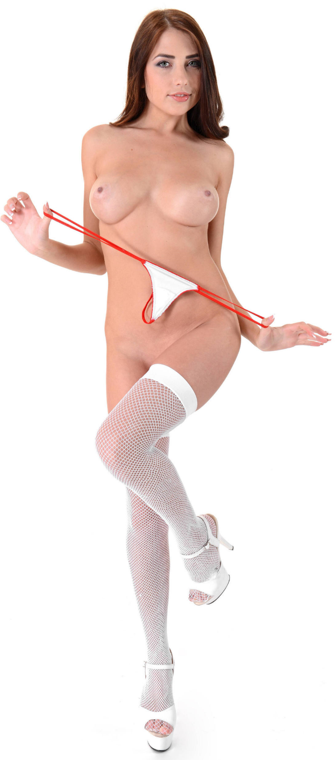
From a story idea from Throne he suggested be entitled “Booted” where “A homophobic jerk goes to a hypnotherapist to make himself even more aggressive with the ladies he dates …” but the therapist turns the tables "You turned me into some kind of gay bitch." The therapist tells him that 'bitches deserve whatever they get' from rough men.” I departed a little from his idea with this one
Determined  A Vignette  By Maryanne Peters  There is no room for sissies when it comes to changing sex. And I don’t mean changing gender, because that is the easy part. Gender is masculine and feminine, and we can be one on one day and the other the day after. I can still be masculine if I feel like it – but I try hard not to be. But changing sex is final. If you are one of those who are uncertain, then don’t do it. I am not one of those. I have never been more certain of anything in my life.  It just took a little more time than what I would have liked. I wanted the job done properly and that meant making money, and men can do that better than women, and much better than transwomen. You need to have a target and go for it, and if that means putting off your dream, then live with that. | 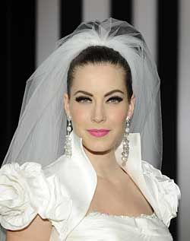

And when I was ready, I told the surgeons to just do it. I wanted to be beautiful, and I think that they did a good job. Then I was free to free my femininity, but to fully adjust takes time and effort. I think it would be fair to say that I am still working on it, but it is easier now.

The next thing that I needed was a husband. I had never really thought about sex with men throughout my entire life as a man with gender dysphoria, but I suppose that I had always understood that being a woman meant being a wife. There are plenty of transwomen who will disagree with me on this and say that you don’t need a man to be a woman, but it was just the way I thought.

I wanted to find a man who shared my view of the world, and didn’t care about my infertility. I discovered that this was more likely to be a man who already had a family and didn’t care for another. The man I found was a divorcee who was rich and driven, the kind of man that I liked.

After a few successful dates he asked me whether we could have sex. I had all the equipment and I had taken the effort to maintain it in working order for just this moment, so of course I agreed. Any woman should know, and I am one now, that the way to a man’s heart might be his stomach, but the way to his wallet is his cock. That applies to marriage too – he needs to sample the merchandise.

I suppose that I always considered that sex with a man might be repulsive to me, but to get and keep a husband I was ready to accept a little unpleasantness, as perhaps all those lesbians married to a man might understand. So, I was pleasantly surprised, if not overjoyed, to learn that taking sex from a man as a woman is a truly wonderful experience. I discovered that I adore the manly body on another even though I could barely wait to get rid of mine.

And here we are on my wedding day. I have made my vows and received his, and I am as happy as any woman could be. I think we will be good partners in life. He knows what he wants, and he will go out and get it, and he knows he can count on me to support him. We share the same driving force, I think.

The End

590

© Maryanne Peters 2024

