Becoming a Bitch
Inspired by a cap by Becky for John Number 91
By Maryanne Peters

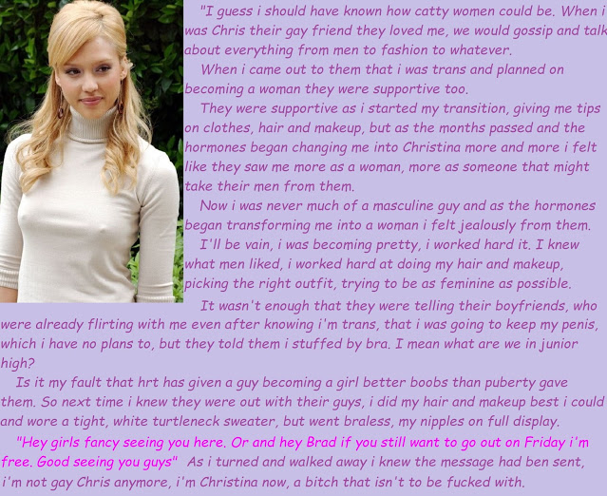

People used to joke that we were fag hags for including Chris, but gay guys can be fun to have around. Sometimes when the three of us were out together, it was good to have a guy along, even if he was gay. He used to talk about men, but to us it was only gay men he was talking about. Our men were not gay.

He also talked about being “one of the girls” but we never thought that those words meant that he wanted to be a girl, but rather that he just wanted to be with us. We were happy to include him and he was always good to go shopping with. But he was advising us on what he thought looked good on us, and which hairstyle was right. Gay men are good at this kind of thing – right?

People say that if you are transgender then that it what you have always been. In some ways that seems to show that Chris was lying to us, or at least not telling us the truth. But if he had told us from the beginning, would it have made any difference? Probably not, because he was still a guy. It was only when that changed that everything changed.

“She” still hung around with us. Chrissie wanted our help to learn how to be more feminine and to fit in as just one of four girls. Nothing hides a transwoman better than t be in company with real women. I don’t mean that in a nasty way, but that is what we are.

Chrissie started on the hormones and grew her hair, which was already quite long. She decided to go blonde and we all agreed that was the right look. Then she had some surgery on her face. It did not seem like much at the time but when the swelling went down we realized how dramatic it was – we could still see that it was Chris, but all the maleness was gone. She really did look like a woman, and not like a man trying to look like a woman.

She told us that she had us to thank for the way she carried herself too. She had as examples “three of the best girlfriends in the world who moved with class ad style” and that she copied us in every way. For some transwoman movement can be a giveaway, but not for Chrissie. We were happy for her. We accepted her gratitude. We were happy to help a friend.

But then she started to take on a shape that nobody expected. Just when our tits were starting to sag she sprouted a pair of perky teenage boobs that swell to perfect shape. And her hair looked perfect, and she was always well turned out. She said that it was because - “transgirls need to put in extra effort” but that was not true. She had been not just feminized by beautified. Beside her we were starting to look plain.

Bitch!

I could see my boyfriend Brad staring at her. I said to him – “Hey, that’s a guy, remember? That is the Chris that you always ‘the faggot who hangs around with the girls’. Well, he may be wearing a dress these days, and have a nice pair of boobs, but that is just a stuffed bra. And he has a cock too, and he is not about to lose that.”

It was like she knew what I had said, because when she turned up braless in that turtleneck sweater, all three of the guys could see that she was not wearing a bra. And the jeans too, were so tight in the crotch that it would have been a battle to get anything but the smallest penis in there without it showing. It was like she was saying with letting everything hang out – “I am a woman now, so you guys would not be gay if you wanted to get it on with me.”

What a bitch.

The End

New Cheerleader  From a Captioned Image by Becky #92  By Maryanne Peters  Honestly, I never noticed her, before she was a she. They said that there was a guy called Steve who was under some of the lifts, and would otherwise dance around like some kind of queer. I never saw him. I was looking at the girls if I was looking at the cheer team. There is nothing wrong with me. I am not gay.  Apparently he had long hair, this Steve – and he wore it in a man bun or something. All the more reason for me not to take any notice. He sounds like the kind of guy I might spit on.  To me it seemed that she had come out of nowhere – out of nowhere to steal my heart. That sounds soft and foolish for me to say it like that, but that what was it was like for me. Nobody would call me sentimental, but then suddenly my heart literally goes nuts when I see her.  When the guys on the team told me about Steve, I was crushed. I did not want to believe. I begged her to tell me that it wasn’t true. I begged her to tell me that she was really a girl.  “I am,” she said. “And I have always been a girl. But it is also true that I was Steve, and that I cannot lie to you about that.”  She looked at me with those big brown eyes and she had me all tied up.  “Let me prove to you I’m a girl,” she said. | 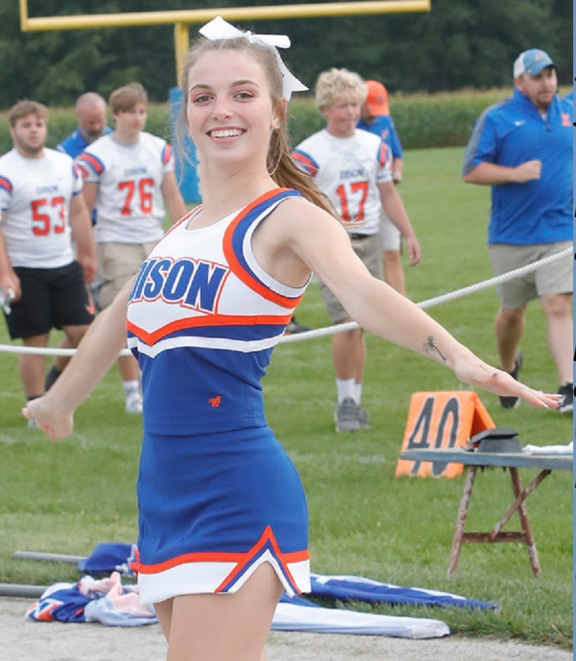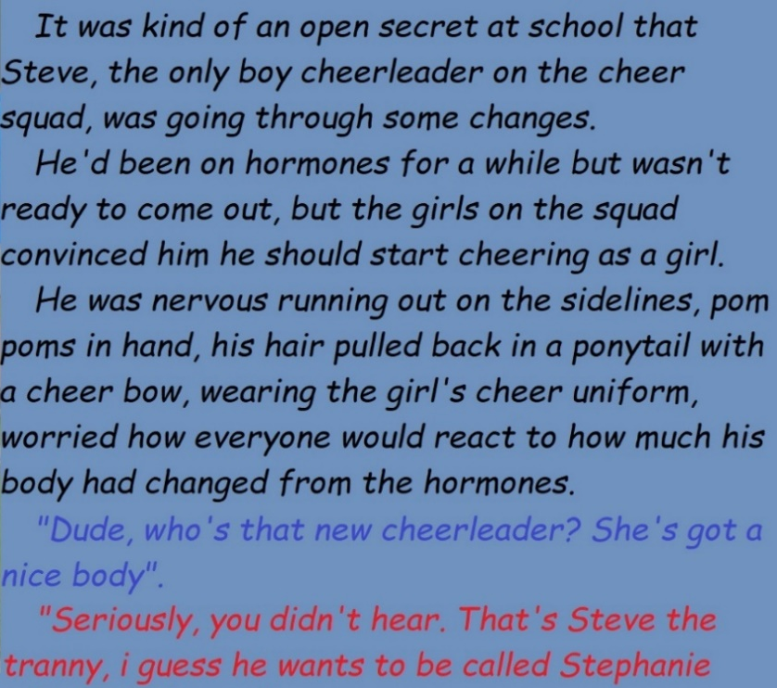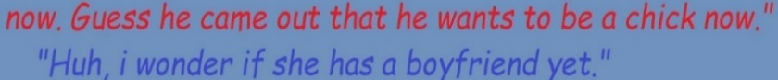

Every guy likes sex, right? It’s an animal thing. So how can it be so different with Stephanie even when you do the same things? Well, slightly different things, like anal because she does not have a pussy yet. But she blows like nothing on earth. Is it love?

When she is under me with her butthole winking at me and her squealing for me to get inside before she goes crazy, I don’t even notice those extra things she has. I don’t want to notice. I just want to play with her tits and see that look in her eyes when we cum together. That look of a pleasure that makes the world stand still for that moment.

So when the guys started talking about her, talking about “Steve the Tranny” I was freaked out. What would the guys say when they hear that I am fucking that very person.

But then one of the guys said “I wonder if she has a boyfriend yet” like he was interested in my girl!

“She has a boyfriend,” I told them. “That would be me.”

The End

First Salon Visit  From a Captioned Image by Becky #93  By Maryanne Peters  Daddy calls me a sissy, but I always say to him that I am proud to carry that name. I am not one of those aggressive people like my brother Rod, although he is never aggressive towards me. He understands that I would rather be a girl.  “I may be a sissy Daddy, but I am your little sissy, and I love you sooo much.” He hates that, but he can’t hate me. I am just so sweet and so loving.  I won over Rod and then I won over Mom. For a long time she backed Daddy and was always telling me off.  “Matt, take that off and put on some pants!” I was always wearing anything I could find to wrap around me as a dress. I just don’t this that a girl should wear pants, except maybe to ride a pony.  She got me a dress to wear around the house on the condition that I wore boy’s clothes everywhere else. And then she got me my first set of girl’s underwear. It was even something that I could wear to school if I had thick clothing over it.  But a sissy can’t hide her nature, and the teachers started asking questions.  “If Matthew is transgender then perhaps you should accommodate some suitable clothing?” the school counselor suggested. | 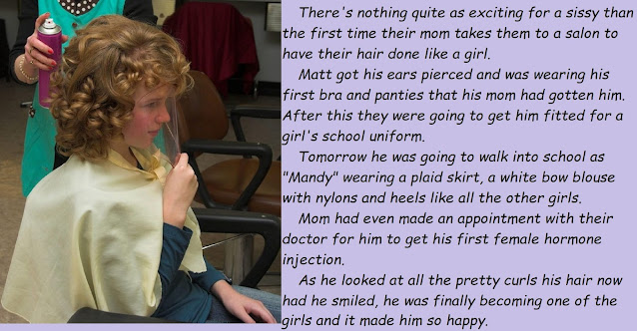

At my school “suitable clothing” is prescribed. The boys wear the boys uniform and the girls wear the girls uniform. It was a suggestion, but Mom and Daddy just decided to accept the reality of the situation. Mom booked for me to go to the salon and get my hair done. I was so excited that I almost died. It was like – the best day ever! My hair was quite long but very soft because I use Mom’s special shampoo and hair stuff all the time. Mom suggested feminine curls. Like – of course! As feminine as possible please! I almost wet my pretty panties.

I begged to have my ears pierced as well, and Mom agreed.

The girls at school think that the girls’ uniform is drab and ugly, but I just love it! It is just so girly with the white bow blouse and the skirt, and the pantyhose and cute shoes with a little heel. I just can’t wait to be Mandy, another schoolgirl!

But for now, I just want to enjoy these soft bouncy curls. I think that Daddy won’t be able to call me a sissy anymore – will he? Now he will have to call me a girl. His little daughter Mandy.

The End

Fulfilment  From a Captioned Image by Becky #94  By Maryanne Peters  That’s right. A success story. High school jock to sparkling eyed beauty, and it was down to me – the plastic surgeon. I had this photo as one of my testimonials. Those eyes looking at me, driving me crazy.  The truth is that I did very little to the face. The nose and chin are those of the young man I first met, and the eyes are his, but just not looking at me the way the do now. All I did was grind away the brow bone to open up that face to the light that now shines so brightly on it.  Breast implants are so common these days, but t get it right you need to place them deep against the diaphragm so that the hormones can do what they do and cover the shaped sacs with full and soft breast tissue. A doctor is entitled to admire his work, but in Nicky’s case they took my breath away.  My area of specialization is more about the genitals, and that is where I did my best work for Nicole. The boy had a good size penis which always helps a surgeon in providing all the material needed. You need to preserve the glans of the penis for a clitoris and simply discard the erectile tissue – the corpus cavernosum and the corpus spongiosum – as if it were a tumor rather than healthy tissue, because for her that is what it was.  You need to prepare the vagina with care, and in the knowledge that some day, perhaps very soon, some man will enter what you have created, rubbing past that clitoris you have construction and bring this new young woman to that moment of shuddering ecstasy … why is this so hard for me to explain?  I am a surgeon. This is what I do. She is another success. Just not like all the others. | 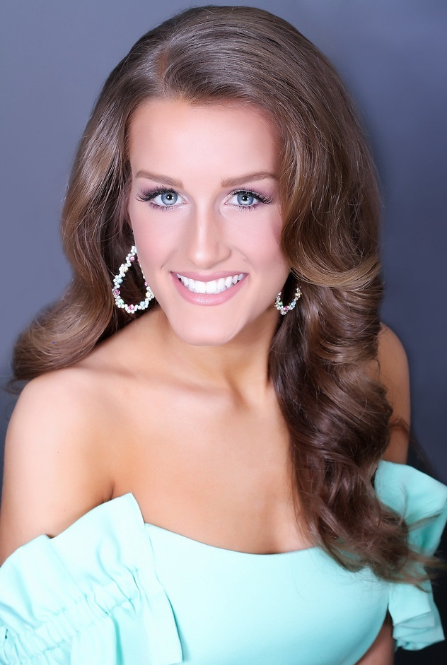  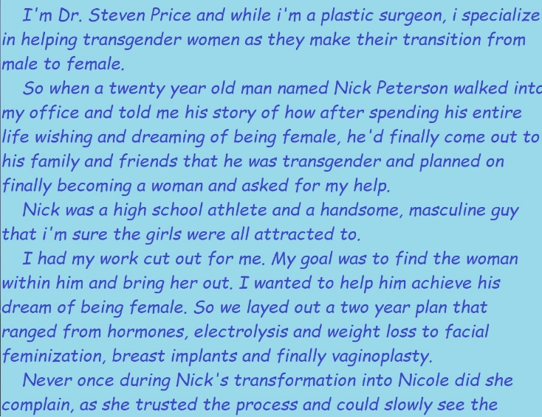  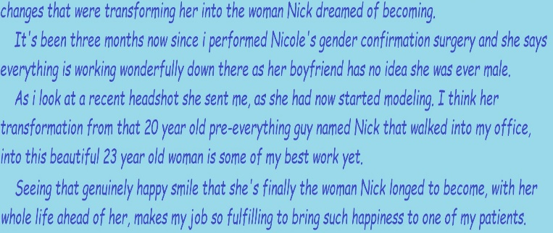

My problem is that I did not fall in love with all the others. I fell in love with her.

The crazy thing is that as long as she was just Nick, I felt nothing. He was a patient with a serious condition. He had gender dysphoria. He was an intelligent and athletic young man who would have been a great success in life were it not for the fact that his dysphoria was crippling him psychologically. The established treatment is gender confirmation surgery, although I prefer the term sex reassignment surgery because that is what I am facilitating.

Of course when a young man pleads – “Help me Doc”, I am empathetic, but I am professional. I know what I have to do. Prescribe the hormones, plan the surgery, arrange the counselling. It is all part of a program and you barely have time to take notice.

But then when I attended the new Nicole a few days after surgery, I met somebody I had never met before. When I removed the dressings and the packing allowed her the first glance of the work I had done, I looked at her happy face, then without makeup, and that beautiful hair tumbling around her shoulders and I heard the squeal of delight. She simply mouthed – “Thank you Doctor Price” with those pretty lips of hers, and I was smitten.

There is the photograph of my success, smiling at me, with those eyes taunting me. She has a boyfriend, I am told. Somebody enters the tunnel that I built, regularly I dare say. She screams and he grunts, and I can only dream.

But I need to put such thoughts aside. I am a professional. I need to be happy for the patients I have made healthy an happy. Fulfilment is its own reward.

The End

Her New Life
Inspired by a cap by Becky # 95
By Maryanne Peters

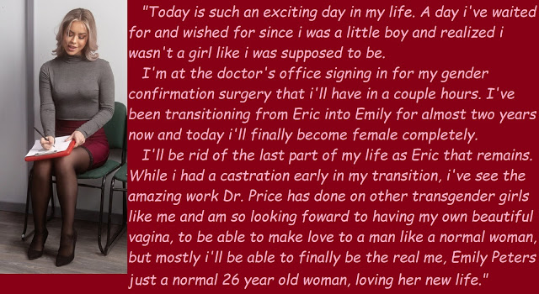

Today is a day in my life that I could never have imagined. Today I say goodbye to my son Eric forever. It really feels like that, although he has looked the way he does now for quite a while. He went right through high school and the start of college before he gave us any inkling that there was something wrong. It seemed to us that he was “one of the boys” – as long as he was surrounded by young men just like he was, he seemed to be fine. It was when he started to face a future on his own that he realized what he had been fighting all those years.

They said it was depression. It seems so common among young people these days. It was the attempt at self-mutilation that I could not understand. Apparently at the root of it was the gender thing. When it was explained to me at Eric’s bedside in hospital, I felt like saying – “You must be mistaken. Not my Eric. He is a normal young man. He had had girlfriends. He plays football”. But I said nothing. I just looked at him, lying there looking so sad.

“I’ve wanted to be a girl all my life, Mom,” he said. “It was just that I knew it was not possible without magic. But earlier today I was visited by Dr. Steven Price who is a plastic surgeon. He explain that nowadays, something close to magic is available.”

This Dr. Price recommended the castration that Eric had attempted, preserving what he could “for use at a later date”. But from then on it was clear that Eric would be following a different course, and as a mother I had to be there to help him through it.

I cannot deny that helping a daughter was something I had no experience of having had two boys, but there was something pleasing in watching and young woman learn about the joys of womanhood. But still it never struck me that my son was gone forever – not until the final surgery.

When you give birth to a child and you are told while the agony of the delivery is still upon you – “You have a son, and he is perfect”, I cannot explain to you the joy unless you have experienced it. I am not a religious person, but when you look at that tiny body you can see a gift from God. And there everything is, including that tiny penis and a sack for his little balls. Who would dream of cutting such perfection away.

And as he got older I could see that he would be a good looking young man. His body was not as large as his older brother but it was strong and lithe. Of course girls were attracted to him. Now his muscles have been eaten up by female hormones and replaced with something soft and curvy. How can this happen to my perfect manchild?

But he has gone, as if he never existed. I have photographs if I want to look at them. It seems hard to do that now.

And now I have Emily. I have a daughter. For a long time after my boys were born I wanted a daughter, but none came and then my husband died. I immersed myself in the care of my sons. They were everything. And now Eric is gone.

Now there is Emily. Pretty and soft Emily. I understand that she needs me more than Eric ever did. She is just starting out in the world. She has to learn all about being a woman, and I will be here to help her. I love her as a mother should, perhaps even more so now. But there is a part of me that still mourns my Eric.

The End

© Maryanne Peters 2022

