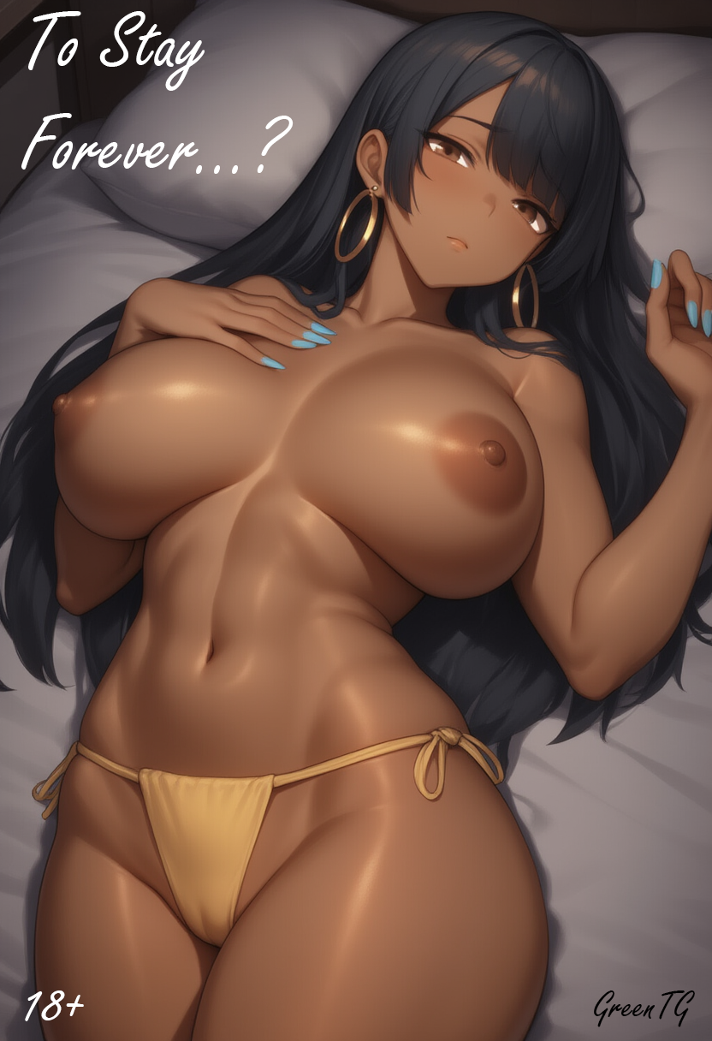

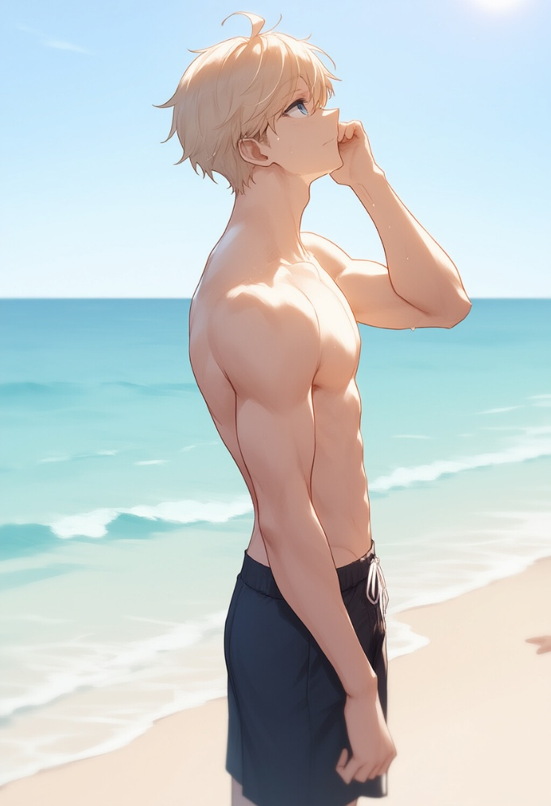
The sun was scorching straight down on the top of my head, and the sand beneath me was almost hot, as if warmed not just by the light, but by the memory of the past two weeks. I sat on the shore in my gray trunks, lazily leaning on my knees, squinting at the endless deep blue of the ocean. The wind was warm, salty, full of coconut oil scent, and it gently wrapped around my whole body. Everything around me was perfect: white sand, endless azure, a few clouds in the sky, and the smooth, laid-back music playing from a beach bar somewhere behind me.
My name is Zach. Zach Taylor. I'm twenty-seven, from San Diego. I work in IT—DevOps engineer, to be exact. All these years, I wrote scripts, maintained infrastructure, fixed bugs at four in the morning, and listened to managers once again “redefine the vector.” After the pandemic, I’d racked up enough vacation days to reward myself with this little gift: two weeks in Brazil. Rio de Janeiro, Ipanema, Copacabana, nightclubs, alcohol, laughter, sun, girls... My God, the girls. It felt like the most beautiful female specimens had all gathered here—vibrant, tanned, juicy, sexy. And if someone thinks otherwise, that person is clearly not someone I’d ever trust, because I’m sure he’s a liar.
Today was my last day, and tomorrow morning was my flight back. My last day—of course I decided to spend it here, on the beach, with no plans, no rush, just soaking in the sun, just trying to live this day in a way I’d remember it forever.
'Maybe I should take a walk,' I thought, stood up, brushed the stuck sand off my thigh, and headed along the shoreline, letting the water wash over my feet. I walked slowly, lazily glancing around: a couple of local guys in nothing but shorts were juggling a ball, a girl in a white bikini adjusted her hair and, at the same time, clearly knew she was being watched. I was just walking, soaking in the moment, but something inside me suddenly ached and clenched, like a premonition? 'What the hell am I talking about? What premonition, I just don’t wanna leave, that’s all. This is paradise.' I took a deep breath, the sea air felt like it soaked through me, reaching all the way to my heart. I closed my eyes for a second and, half-whispering, almost absentmindedly, said to myself:
– I really should check out a strip club before I go... wanna finally see those hot, famous local Latinas everyone talks about... Ohh, If I could, I’d stay here forever...
And right at that moment, as soon as those words left my lips, something changed. At first I thought it just got hotter—like the sun had suddenly come twice as close. Then a strange shiver ran down my spine, and the blue shorts I was wearing suddenly started sliding down, while the trunks underneath them seemed like they were... moving.
— Hey… — I breathed out, grabbing my waistband with one hand. The shorts really were slipping down, but I didn’t even get the chance to think much about it. My body at that moment… how should I put it… started to throb. And no, it didn’t hurt at all, but it felt strange. Unsettling. Scary, even. My muscles, like someone was erasing them, started to shrink, like the air was being let out of them with each pulse. My shoulders slumped, my chest… it felt like everything inside was being rearranged.
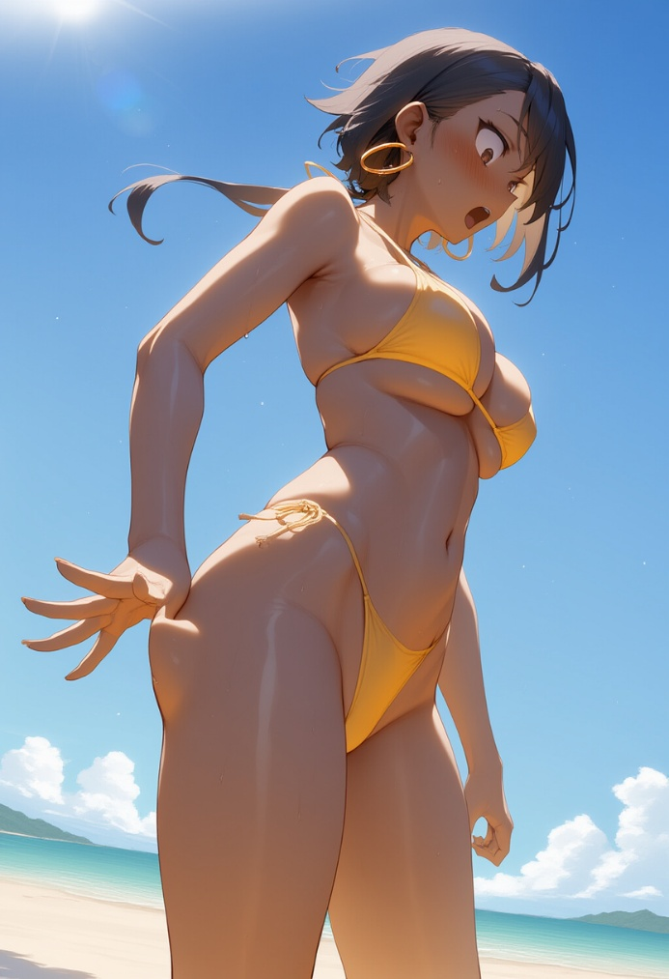
— What the... — I started, but my voice broke into something completely different, like I’d gone hoarse and was trying to speak clearly, but couldn’t manage my own tone. It came out high, raspy—almost feminine.
I clenched the fabric of the shorts in my fist, but in the next second they… disappeared. Just vanished, like a mirage on hot asphalt. I froze, and only then—only when my hand was left in the air as if still holding invisible cloth—did I look down.
At first I didn’t understand what I was seeing. Small, neat, round breasts, hugged by a yellow bikini top, barely covered. My… breasts? Not a single hair. Smooth, sun-kissed skin. I blinked and looked lower — and saw hips. Not my hips. They were wide, feminine, heavy—yet somehow graceful.
Something pricked my earlobes — barely noticeable, like a mosquito bite but with a weird electric tingle. I flinched and suddenly felt weight on both sides, my lobes stretched, and something started swaying against my cheeks. But I didn’t even have time to process that, because along with that sting, it was like a dam had burst.
I felt my breasts — the tiny ones I’d only just noticed — start to swell with weight. I looked down and watched it happen: the yellow bikini top no longer just covered my chest — it was supporting it, pulling it in, holding it back, like my new curves were trying to break free. I felt every movement, every shift in weight, every tiny change — the skin stretching, nipples tightening, the fabric getting tighter and tighter.
— No… no… no… — the voice, my voice, no longer sounded like mine. Each new “no” got higher, sweeter, dripping more and more with a syrupy tone meant to seduce. — ¡No… por favor, no...!
What? Spanish? I tried to cover my mouth with my hand, but—
In the same time, my hips… God, my hips! They were widening, as if someone was pushing them open from the inside, making everything rounder, fuller. My waist was pulling in, my stomach going flat, skin stretching tighter. I felt my ass… I don’t even want to describe it, but I felt it — so round, firm, heavy… Yeah, yeah, yeah. Heavy, because my legs shifted position. My knees turned slightly inward since my pelvis had grown heavier, thicker.
— ¡No, no, no! Dios mío! ¡Qué es esto! — I almost screamed, now clearly with a feminine, high-pitched, melodic voice, like my throat had already forgotten who I was just moments ago.
I grabbed my breasts the moment I felt the touch of my new long hair trailing down my back — smelling of coconut, sun, and salt, so soft, gentle, and silky. But I didn’t even notice that then. My hands were tightly gripping these huge things that had suddenly appeared on my chest, and I couldn’t help but scream:
— ¡Mis tetas! ¡Por Dios, son mías! (My tits! God, they’re mine!) — the cry burst out in a kind of hysterical, almost musical tone, like I was imitating a Latin soap opera — but I wasn’t acting. It was all real. This was really happening to me.
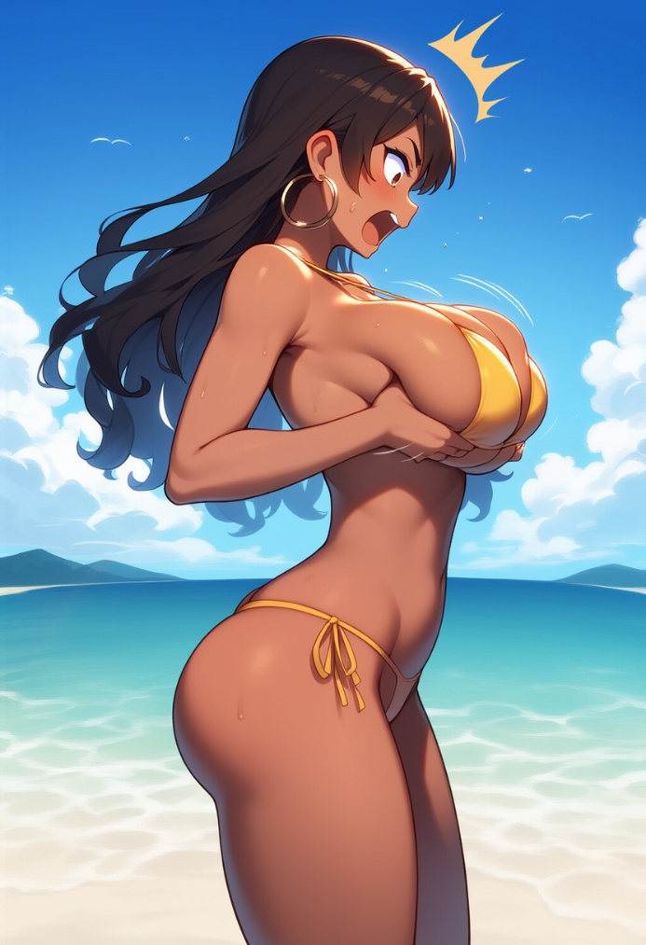
I couldn’t stop. I clung to them like I was trying to make sure they wouldn’t vanish like my shorts had, and at the same time praying that all of this was just some illusion. But no. I felt everything: the warm weight, the stretched fabric of the top, the cool ocean breeze brushing the skin between my breasts, the way my nipples tensed irritably at the slightest movement of my fingers… These were real female breasts. My breasts, my tits, my boobs, goddammit!!!
— ¡Son reales! ¡Están ahí! (They’re real! They’re right there!) — I screamed, my eyes darting wildly as my palms instinctively squeezed, feeling the soft, yielding flesh and at the same time experiencing the sensation, like my brain still couldn’t believe this was actually happening.
And then I heard it — at first faintly, and then more clearly — but not me, not my voice, other people. Someone laughed. Not loudly, more like a restrained, almost polite chuckle, but distinct. I froze, still clutching my tits. My eyes instinctively widened and snapped toward the sound, and that’s when I saw them. These people — they were all looking at me. Oh fuck. They were LOOKING, like I was just some crazy chick acting weird, and not a single hint of shock in their eyes about my sudden transformation. I saw it very, very clearly.
The guy in the shorts, the one who’d been spinning the ball earlier, stood there with his mouth open, blatantly staring at me. The girl in the white swimsuit squinted, like she was trying to decide whether I was a star or just nuts. Someone with a towel under their arm clearly wanted to ask if I was okay, but just stood there, hesitating.
I jerked my hands away from my chest like I’d been electrocuted, and they fell heavily, unexpectedly, pulling the top down to its limit. I felt the straps digging into my shoulders and the skin beneath my breasts. I flinched, ran a shaky hand through my hair to fix it, and felt earrings clink against my cheeks, tickling the skin. Earrings?! That’s right! Earrings! Big, round ones, like those beach models in ads — heavy, warm from the sun. I could feel how they pulled down my earlobes and, I swear, it made me feel even more insane.
I looked down, but my gaze slammed right into the cleavage spilling out of my bikini top, and I couldn’t even see the lower half of my body beneath it, so I had to lean in even more just to see them — my legs. They were slender, smooth, golden-tanned, and the toenails were painted! Waist, hips, ass, top, panties — everything on me looked like I’d just walked onto the beach like this and had always been like this. There was a shiny oily trace on my stomach, and water sparkled on my thighs. I… I was some kind of teenage wet dream, a caricature of a girl.
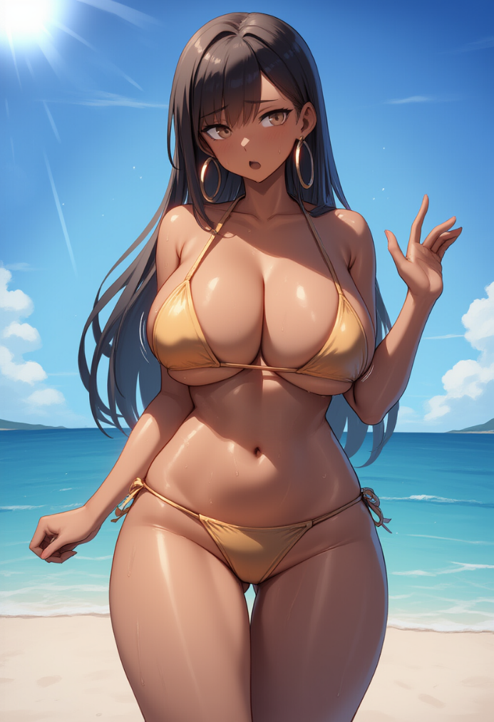
— ¡Dios mío! (God Almighty…) — I whispered, but my voice still sounded like the sigh of an actress in a love scene, and I couldn’t deny it anymore. I pressed my lips together, looked away. Someone waved at me, probably a tourist, and it looked like they were smiling, like we knew each other. And without knowing why, I lifted my hand just a bit in response. My fingers curled into a lazy wave on their own, and my wrist made a graceful flick like it had a mind of its own. I felt the top shift slightly higher, and for a second my boobs lifted with it. I immediately dropped my hand and cast my eyes down hard, blushing and cursing myself. This felt like a goddamn nightmare.
— Esto... esto es una broma (This… this is a joke), — I whispered to myself, glancing around and stepping back.
— Sí, es una broma. Algún tipo de magia o virus brasileño idiota. O gas. O... (Yeah, a joke. Some kind of dumb Brazilian magic or virus. Or gas. Or...)
I swallowed. Took a breath. Looked at my fingers — long, with glossy blue polish. They were trembling. I bit my lip — it was softer, fuller, plumper than I remembered — and staring up at the sky, the same sky I’d been looking at before all this madness, I whispered again:
— Oye, quienquiera que haya sido, yo... Sólo estaba bromeando... Lo quiero de vuelta... Devuélvelo todo, por favor... (Hey, whoever you are, I… I was just joking… I want it back… Give it all back, please…)
And I froze, eyes closed, arms lowered, still feeling the heavy weight on my chest, the tight pull of the top straps on my shoulders, and the panties snug against my hips. A long second passed in silence, and I felt the wind brush through my hair, settling it across my shoulders, the fabric of the top stretching with my breath, and my breasts trembling with the movement. But no — nothing changed, even though I was desperately hoping, standing there, waiting for it all to vanish like a hallucination. But everything was still the same.
Still the same, goddammit, still the same. I opened my eyes — the bright sun blinded me for a moment, but my vision returned quickly. I was still standing on the ocean shore, still in this body that moved on its own, breathed differently, felt everything around it in a new way, and, god, it felt like it was screaming to the whole beach: “Look at me! I’m here! I’m a woman! And not just a woman, but a fucking sex bomb!” I pressed my lips together, dug my nails into my palms, and forced myself to exhale.
— Vamos, Zak… tú puedes con esto… piensa. (Come on, Zak… you can handle this… think.)
I’m a programmer, an engineer — I know how to solve problems, how to handle chaos. I’ve survived the wildest night bugs in production, deployed under pressure while the whole team ran around like headless chickens. I can handle this too. I have to. Let’s take it slow. First... first, I need to get back to my stuff. The backpack. Check if everything’s still there.
I took a cautious step forward, already sensing that even moving now had to be done differently. And I was right — I noticed it immediately, because each step now rolled through my hips in a strange new way, and I had to move differently just to keep my balance. My center of gravity had clearly shifted, and somehow, maybe even instinctively, without knowing why, I started walking differently — smoother. I tried walking the old way at first, like a man, but it felt completely off. And now every step seemed to highlight these curves even more, to underline the fact that I wasn’t just a woman — I was the kind of woman who strutted proudly down the beach in a bikini, in a body people couldn’t stop staring at.
I could feel the fabric of the panties sliding between my thighs, the bikini top stretching tight every time I moved my shoulders, the breasts swaying and pulling down with each second, distracting me, demanding attention. Every movement screamed how I looked now, reminding me of it again and again, as if I could ever forget!
— ¡No los mires! No los mires… (Don’t look at them! Don’t look…) — I muttered, trying not to meet anyone’s eyes, even though I could feel their gazes on my skin. It felt like even the wind knew I wasn’t who I used to be anymore.
I reached the spot where my towel and backpack were lying. Everything was there, exactly as I left it when I was still myself. The backpack — that same familiar worn-out black one with the tag on the zipper I’d attached before the flight — stared back at me, almost asking silently, Who are you? Is this stuff even yours? I shook the thought off quickly with a jerk of my head — and instantly cursed myself as the hoop earrings tugged at my lobes and brushed my cheeks. Not the time to get distracted. Of course it's my backpack — what the hell am I thinking?
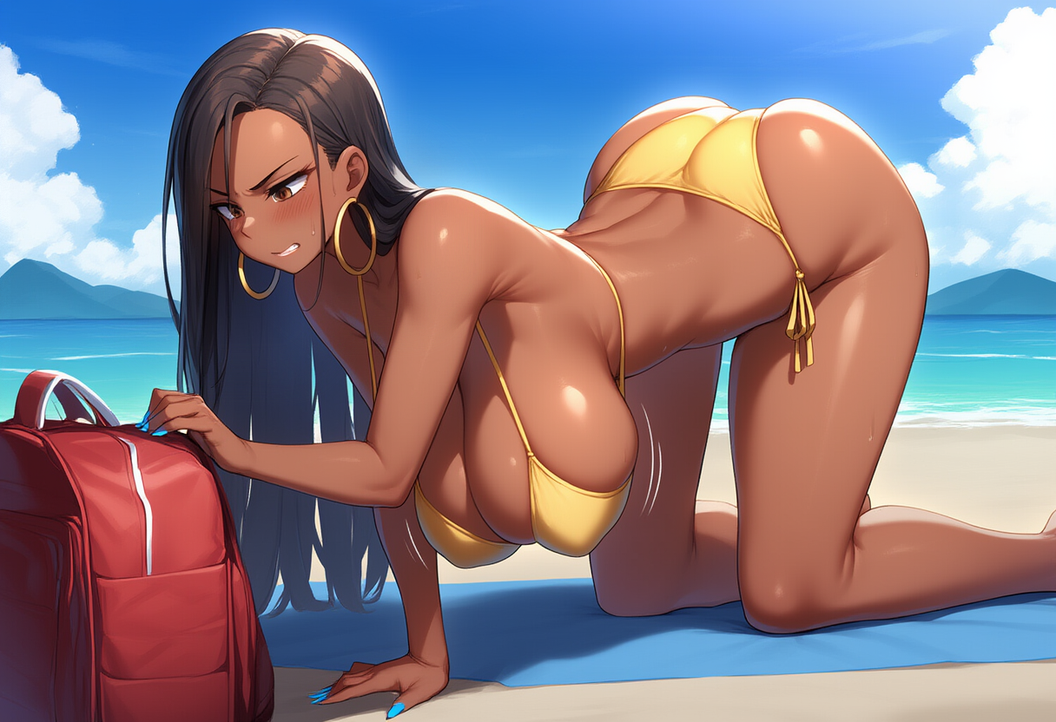
I dropped to my knees carefully, but even that turned out to be tricky in this body. My thighs spread out, my belly pulled slightly inward, and my breasts... oh God. As soon as I leaned forward to reach for the backpack, they sagged a bit. First just like heavy water balloons, then like two weights on elastic bands. The bra stretched tight, the straps digging into my shoulders.
— ¡Maldita sea! (Goddammit!) — I hissed through my teeth, furious at this body, at its physics, at how I could feel every inch of the fabric pulling, feel the tits slipping slightly to the sides, barely held in by the bikini top. I was angry and scared all at once.
Finally getting on all fours to better rummage through the backpack, I realized that everything I just bitched about — the sagging, the pulling — was just a warm-up. The moment I dropped to my hands, I instantly felt it shift again — my tits hung even lower, like they were trying to touch the sand. The straps pulled so hard I had to gasp. And my back arched on its own under the massive weight, lifting my ass high up in the air for everyone to see.
— ¡Esto es un chiste! ¡Un maldito chiste! (This is a joke! A fucking joke!) — I growled, feeling my belly tense involuntarily, the breasts swaying heavily side to side, almost spilling out of the bra, and my hips in that ridiculous position seemed even wider and softer than I could’ve ever imagined.
I finally reached the backpack and grabbed the zipper, noticing how thin and long my fingers were — and that ridiculous manicure with the nails only made the look feel even more complete. It was hard to even unzip it, my fingers were shaking, but I managed. Inside, everything was exactly as I remembered: the towel, sunscreen, charger, sunglasses… and the passport. My passport, with the hotel key card inside.

I pulled it out carefully, like I was afraid it might explode in my hands or turn to dust the second I opened it. I sat back on my heels — as much as this body allowed — and opened the cover. The photo inside was me — Zack Taylor. Short blonde hair, blue eyes, strong jaw, serious eyes… but as soon as I glanced at the text next to the photo, I suddenly realized I couldn’t read a single letter. The letters… I mean, I know English, I’ve spoken it all my life, thought in it, worked in it. But now — it felt like a foreign language. The symbols blurred into some meaningless mess in front of my eyes. I squinted, stared harder, looked again and again, whispering the words, trying to read them:
– Za…k Tay…lor? – I tried, but I could tell I was only reading the name because I recognized the letters that looked like Spanish. Everything else felt alien. – ¿Qué demonios...? (What the hell...)
I flipped through the passport. Everything was there: visa, boarding pass, hotel card, even the transfer receipt. All the things I myself had put there. Only now, looking at these pages, panic started rising in my chest — I couldn’t understand them. I knew these were my documents. I knew it. But they weren’t mine.
– Tengo que ir al hotel… (I need to get to the hotel…) – I muttered, clutching the passport and hotel card like a life raft. – Mi laptop… sí, tengo que revisar mi laptop. (My laptop… yeah, I need to check my laptop.)
I stood up. Or rather, tried to. But my tits and ass swayed so sharply, so heavily, that I nearly lost my balance. It felt like the whole body moved with a delay, like someone had installed shock absorbers in it. I flinched, watching the shadow of my breasts fall across my stomach, the bikini top stretch tight, everything shaking and bouncing with every single movement, no matter how careful.
And then I felt it again… those stares. They were everywhere. People. Men. Women. Someone lazily looked up from their phone, someone else held their gaze just a second too long. And I knew they were all looking, even if they pretended not to, and just that thought alone made me shrink. I instinctively reached to cover myself with my arms, but froze halfway. What’s the point? Even my arms now looked thin, fragile — they couldn’t cover even half of what was suddenly grabbing everyone’s attention. On the contrary, I’d probably just draw more of it.
– Tengo que taparme… (I need to cover up…) – I murmured, glancing around.
I wanted to disappear, to sink into the sand, to hide — to hide these breasts, these hips, this caramel skin that was now on full display. I looked down at my towel beneath my knees, my backpack lying nearby, and the T-shirt. Just a simple gray one, nothing special. Los pantalones… ¿Dónde están mis pantalones? (My shorts… Where are my shorts?) — I whispered, and immediately felt stupid, because I remembered seeing them vanish, dissolve like they were never there, replaced by this yellow bikini… But the T-shirt was still here — part of the same set as the shorts. I remembered buying it all, packing for the trip.
Bending down sharply, I grabbed the towel and the T-shirt. At that very moment, my breasts bounced so suddenly that the bikini top jerked, digging into my shoulders, and my hair—now long, wet, smelling of sun and coconut—fell right into my face, sticking to my lips and eyes. I squeezed my eyes shut, cursed, flinging my hair back with one hand while the other, trembling, fumbled to unfold the towel.
— ¡Maldita sea, por qué es tan pequeña! (Shit, why is it so tiny?!) — I squealed, throwing the towel open.
I clutched it, wrapping it around my hips, squeezing the fabric as tight as I could, like that might somehow fix the situation. The material clung to my skin, damp and smelling of the sea, and I immediately felt the edge of the towel start to slide up my thigh. One more inch and everything I was trying to cover would be out in the open again.
— ¡No, no, quédate ahí! (No, no, stay right there!) — I hissed, holding the towel with one hand and the gray T-shirt with the other.

I yanked it toward me. The T-shirt was bigger than my new body, and something about that hit me weirdly inside, like something clenched in frustration. But now wasn’t the time for that. I shoved my arms in and pulled it over my head with a sharp motion. I felt my wet hair snag on the fabric, tugging backward, the collar catching on the strands, but it finally passed through and it seemed like that was it, but then...
— ¡Mierda! (Shit!) — burst out of me when the fabric hit my new shape and stopped, like it’d slammed into a concrete wall.
Breasts. Those… those insane, colossal, out-of-place tits that I still couldn’t process as mine—they’d become a wall, a mountain, a damn obstacle between me and getting this shirt on properly. The fabric jammed against the top of them, stretched tight at the seams like a drum, and refused to go any further. I pushed. Again. Yanked it down. And immediately felt the cloth bite into my nipples, pulling so sharply I involuntarily exhaled, lips pressed tight.
— ¡Ay Dios…! (Oh God…) — slipped quietly through my teeth.
This wasn’t just “uncomfortable.” It was like someone had shoved my boobs into a vacuum-sealed bag and cranked it tight, and then the straps dug into my shoulders—both the bikini top and now the T-shirt. It didn’t hide my chest. No. It highlighted it. Clearly, provocatively, outlining every curve, every slope, emphasizing even the parts I wished I could just forget.
— ¡Estás bromeando conmigo! (You’ve got to be kidding me!) — I breathed out, looking down. Where there used to be a flat torso, the T-shirt now stretched so tightly the shape of the bikini top showed through, and every breath… every single breath made my breasts shift under the fabric. Not just move—they bulged, pulsed, practically jumped out at you.
I yanked the hem down hard, trying to stretch the fabric, but that just made it worse—the bikini top shifted slightly, and I instantly felt the shirt wedge between my tits, creating the kind of cleavage that would make any guy's knees buckle.
With a final effort, I managed to squeeze the tight shirt down, and on one hand I felt this strange sense of victory, but on the other—bitter regret, because now it was hard to breathe, and I didn’t even look… any better! Damn it, damn this body! What the hell was happening to me?!
I took a deep breath to calm myself. The T-shirt stretched again and even cracked a bit under the arms, tight as ever. The tension eased just a little when I exhaled.
— Laptop. Necesito... salir de esto. (Laptop. I need... to get out of this.)
…
Finally. I’d finally made it. The hotel room, just like the hallways, was cooled by the air conditioning, filling the air with a refreshing chill that pierced straight through me, giving me goosebumps. I stood with my back against the door, breathing heavily, eyes closed — lashes far too long, too thick, brushing against my cheeks with every blink like waves of soft tickling. Ugh... this was hell. Not the painful kind, but the kind that overwhelms. Everything. Emotions, sensations, stares, heat, the weight of my tits, the smells, the sounds — and worst of all, my own reflection in every glass surface I passed on the way here.
When I’d just left the beach, wrapped in that towel and stuffed into that damned T-shirt that highlighted instead of hiding, I tried to walk fast. But fast wasn’t an option. My hips swayed. My legs were too long, too flexible to just “walk.” They moved like they were dancing, even when I tried to keep a low profile. People stared. Too many. Some raised their eyebrows in surprise, others gave me long, examining looks like I was part of the local flavor — some touristy beachside attraction that stumbled out of a bar. Everyone stared. Especially the men — with interest, with curiosity, with want. I recognized those looks. I used to look at girls like that. And now — now I knew what it felt like to be looked at like that. I wasn’t a person. I was... a body.
I had to stop several times, ducking into random alleys just to catch my breath — no, not even breath, more like my sanity. I lowered my head, trying to hide, only to feel my long hair immediately fall forward again, sticking to my cheeks and neck.
— ¡Vamos, vamos… ya casi llegas…! (Come on, come on… you’re almost there…) — I muttered under my breath, teeth clenched, feeling the T-shirt ride up again, baring my stomach, forcing me to yank it down, which made my tits shift again. The cycle was endless. I squeezed my thighs together, pressed my arms tight to my sides, and kept moving toward the hotel, step by step.
By the time I finally reached the entrance, I was on the verge of tears.
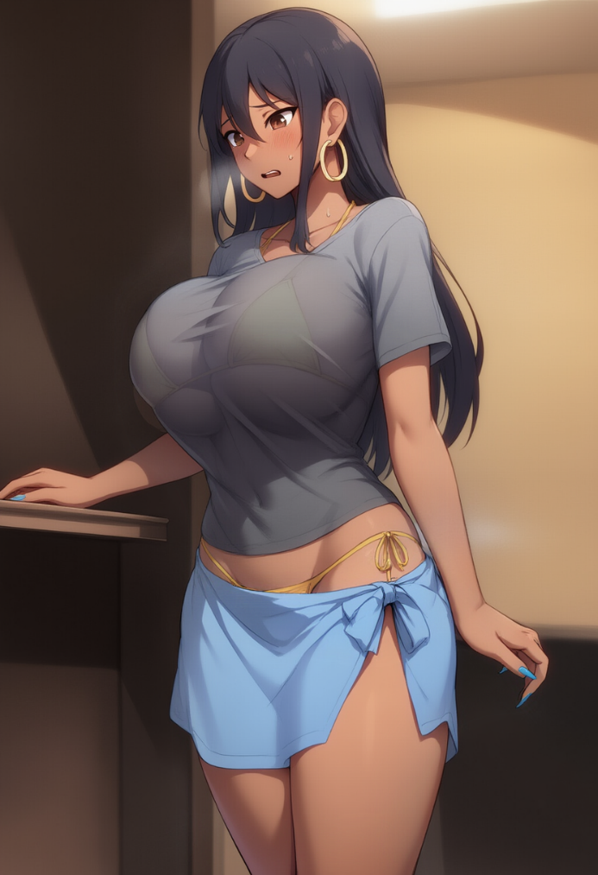
The small lobby, cool and filled with the scent of AC and laundry detergent, should’ve felt like a safe harbor. But the moment I stepped through the door, I noticed the receptionist — young, neat ponytail, light blue uniform — glance up at me. And her look… it wasn’t surprise. No. It was… judgment. Not “What’s with this girl?” but “Mmh, some beach bimbo. Wonder who she’s here for.” Her eyes ran down me — from my forehead to my feet, pausing at my chest — and one eyebrow lifted slightly.
I swallowed. Walked closer, feeling my breasts bounce with every step. The T-shirt stretched, and despite all my effort, the towel was rising on my hip again, and I could already feel the cool air tickling the inside of my thigh.
— H-hola… tengo… tarjeta… (H-hi… I have… a card…) — I stammered, holding the card out toward the girl behind the desk and caught her raising an eyebrow. I was speaking slow, tense, like the words didn’t even want to form into sentences on their own.
— ¿Nombre? (Name?) — she asked dryly, taking my card and immediately tapping it to the reader, and I… I hesitated. Name. Why was she asking for a name? I came to my own room, I had the key card — here it was, real, with the hotel logo, the magnetic stripe, the room number… but her eyes were stern. Expectant. She clearly wasn’t going to let me go until I said whatever she thought any “me” was supposed to say.
— Eh… Zak… — I began, but the words stuck in my throat. It didn’t sound right. It didn’t sound like a name that could come out of this voice. — Z-zak Taylor… (Zak Taylor…)
I said it quietly, almost in a whisper, and the name, on my lips, sounded… foreign. Out of place. Like me — soft, curvy, long nails and massive tits — had just called myself a bearded car mechanic. The girl at the desk narrowed her eyes slightly, tilting her head like she hadn’t heard a name, but a strange note in my tone. Her smile didn’t twitch, but I saw it — something changed in her eyes. Maybe it softened. Maybe it turned a bit more ironic.
She raised an eyebrow, squinted a little, glanced at the card again, then back at me, and slowly placed the card down on the counter, pushing it toward me just a bit.
— ¿Una amiga de Zak? ¿Verdad? (A friend of Zak’s? Right?) — she asked, tilting her head slightly.
I froze. My throat tightened.
— Sí… sí… su amiga. (Yeah… yeah… his friend.) — I forced the words out, barely believing I actually said that. Not just out loud — to the receptionist. That I was a friend of myself. Of the guy who no longer existed.
She nodded slowly, like she was weighing something. Then she spoke again, with a fake pleasantness, but her voice had turned firmer:
— Mira… puedes entrar. Pero si hay problemas, llamo a la policía. ¿Entendido? No es la primera vez que chicas como tú hacen líos. (Look… you can go in. But if there’s trouble, I call the cops. Got it? It’s not the first time girls like you cause problems.)
Girls like me. I swallowed. Said nothing. Just nodded. And took the card. My fingers, thin, with long nails, trembled. I didn’t look at her. I didn’t want to see whatever version of me she saw in her eyes. Me, who wasn’t me.
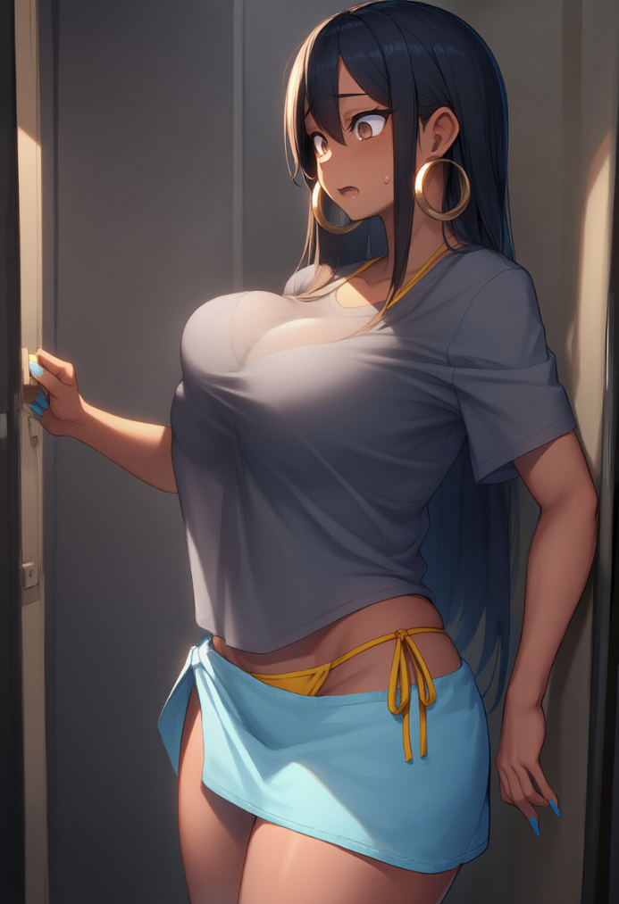
...
And now I was in the room. The door clicked shut behind me, and with that sound came not relief, but weight. My whole body — this whole body — suddenly, as if sensing safety, decided to exhale. But not like a man would — heavy, solid, leaning into a wall. No. Softly. Strangely. With a weird arch in the back and a hip jutting out. I leaned against the door — without thinking, just so I wouldn’t fall. Because everything was pulling me down: my breasts — heavy, hot, swaying with every breath, my legs — long and not mine, and the hair, that damn hair… it was everywhere. It tickled my neck, clung to my shoulder blades, flew out in every direction and smelled like… God, it smelled like Brazil had taken up residence on the back of my head. God, even this hair, long, damp, like it was made just to drive me insane by simply existing. I ran my hand through it again, trying to toss it back, but it bounced, soft, silky, spilling over my shoulders.
— ¡No puedo más… esto me sofoca! (I can’t take this anymore… it’s suffocating me!) — I gasped, grabbing the hem of the T-shirt and yanking it upward. I just wanted it off, to get rid of that hot, clinging fabric that felt like it was squeezing the air out of me. But the moment the shirt started going up, my tits jolted, and I felt the fabric catching on the bikini top, the straps across my back pulling tighter than they should. And the moment I finally dragged it over my head, I realized I wasn’t just pulling off the shirt. Everything — the top, the fabric, the straps — it all went up in one motion.
— ¡No, espera…! (No, wait…) — I stammered, but it was too late.
The bikini top slipped off my shoulders, yanked off my tits, and the second my arms dropped and I was free of the fabric, I felt it. My breasts. My tits. Free, heavy, exposed, breathing. They bounced forward like they, too, were finally breaking free with me. A wave of warmth washed over my skin, and the nipples instantly tightened in the cool breeze from the air conditioner, and I, barely able to breathe evenly, felt them — those two firm, overly sensitive, massive mounds — shoot forward, embracing their freedom with terrifying boldness.
— ¡Dios mío…! (Oh my God…) — I breathed out, slowly stepping away from the door.
I felt every movement, every sway of those… those… I didn’t even have words. This wasn’t just “breasts.” These were two heavy, full, warm lives stuck to me, bouncing with every step, so insanely sensitive it made me want to scream. Just the cold air alone sent so much tension through my nipples it felt like they were trying to scream it out — to my body, to the world, to me. I took a step… and my tits swayed. I took another… and they jolted even harder than before. Soft, heavy, reverberating through my upper body.
— Esto es… esto es ridículo… (This is… this is ridiculous…) — I whispered, and then I caught a glimpse of myself in the mirror out of the corner of my eye.
It was big, nearly full-length, standing in the corner of the room. When I first arrived here — still being myself — I actually liked the design choice. And now I didn’t want to look at it. Even from the side, catching my reflection felt unbearable. But then… then I turned my head.
And I saw her.
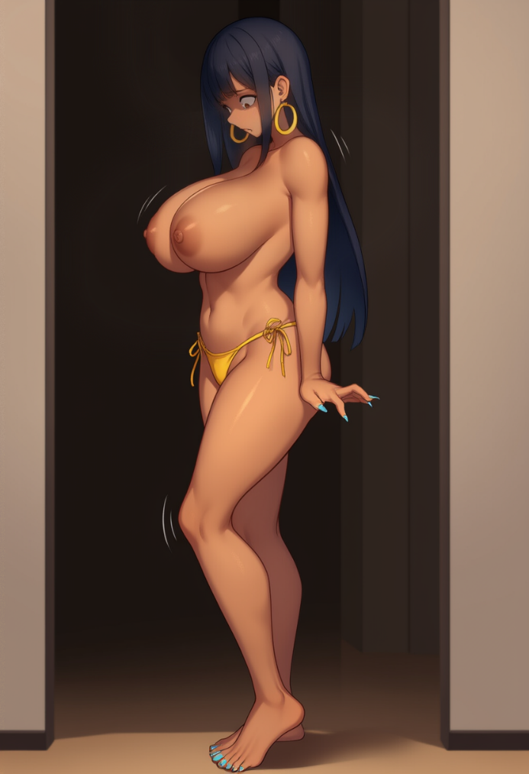
The woman. In yellow bikini panties, tits out, with long legs beaded with sweat, hips that looked like they’d been sculpted for a sunscreen commercial. Her nipples were dark, raised, like two bold little dots, and her breasts… the word “huge” didn’t cut it — they hung so low the shadow from them covered the lower part of her body. Her stomach — flat, warm… perfect. Her hips — wide, glowing. And her face… her face, which, despite all that beauty, showed pure panic. And the worst part — the truly fucked up part — was that I knew it was me.
— ¿Quién eres…? (Who are you…?) — I whispered, stepping closer.
I moved toward the mirror slowly, and with every step, my tits swayed gently back and forth like two pendulums, pulling my shoulders slightly backward just to stay balanced. I wasn’t walking — I was gliding. And now, I didn’t just suspect it — I knew it.
As I got almost flush with the mirror, I raised my hand — thin, nails painted — and slid it across the reflection, over the cheek, over the lips. She—me—I flinched.. The lips were soft, warm, so damn full… I blinked, and immediately felt the brush of lashes.
— Yo no soy esto… (I’m not this…) — I said, and now my voice felt amplified by the silence of the room. I heard it clearly. It was high, sweet, vibrating like it was enjoying the fact it sounded that way. I closed my eyes. Took a deep breath.
And again, my breasts swayed.
They never let me forget. Not for a second. I looked at myself again and for the first time noticed how high my hips sat, how arched my lower back was, how tight my waist curved in. I didn’t just feel like a woman. I felt like the embodiment of attention. A body made to be seen. To be wanted.
And no matter how much I tried to ignore it, the body wanted to be seen.
— ¡Maldita sea…! (Goddammit…) — I growled and grabbed my tits with both hands. They were warm, firm, soft, and way too sensitive. My nipples stiffened under my palms, and my palms lit up with their touch — and it was so damn strange that this was my body, my tits I was feeling.

Heat pulsed in my stomach and I clenched my eyes shut.
— ¡No, no, no! ¡Necesito pensar! (No, no, no! I need to think!)
I rushed to the bed and grabbed the backpack. It was lying there in the corner like it had been waiting all this time. I hadn’t taken out my laptop for the entire vacation, but right now, I was damn glad I brought it. It was like it was talking to me: “Come on, you’re a programmer, an engineer — get it together, start diagnostics.” The laptop was in its case, zipped up tight, and cursing my long nails, I still managed to pop the latch and tear the zipper open. I sat on the bed right away, tossing my hair back as best I could. But the hair fell right back into place, tickling my neck and wrecking my focus.
As I flipped the lid open, I heard it — that hum, so familiar, sometimes annoying, but right now… comforting. The screen flashed that familiar blue, and I almost cried just from how familiar it was. This was my world. But as soon as the loading finished and I typed in my password, a short message in white appeared over the blue background.
"Incorrect password. Try again."
That message appeared on the screen. Simple. But suddenly… I didn’t understand it. The letters looked familiar, almost readable, but they were slipping past me. I squinted, trying to mentally translate it… but nothing. Looked like the system was mad about the password? Seriously?
— ¿Qué...? (What…?) — I whispered, trying not to panic, staring at the screen like that would make the message go away. My fingers were shaking. Maybe I just messed up. Of course. The damn nails get in the way. I exhaled, wiped my palms on my thighs, immediately noticing how soft the skin there was — and instantly clenched my teeth. Focus, Zak.
Enter.
"Incorrect password. Try again."
— ¡NO! (NO!) — I cried out, flinging my hair back. My chest clenched — from despair, from fear, from this raw, unbearable panic spreading through my body like I’d opened a door not to a laptop but to a fucking void. My fingers flew back to the keyboard. I could barely type, the long nails tapping and snagging on the keys, breaking rhythm. Maybe caps lock? Yeah, maybe I… didn’t turn it on? Or maybe I did?
— ¡Mayúsculas… puede ser… vamos… vamos…! (Caps… maybe… come on… come on…) — I whispered, exhaled, and typed the password again, slow, careful, like every character was the last hope of getting back to myself.
Enter.
"Incorrect password. Try again."

I screamed. Out loud, desperate, almost animalistic:
— ¡¿QUÉ DEMONIOS ESTÁ PASANDO?! (WHAT THE FUCK IS HAPPENING?!)
I slammed the laptop shut, hitting the lid like I wanted to crush the damn thing, then collapsed onto the bed. Flat on my back, arms spread, like I’d just given up. My tits… Jesus Christ, those tits. They immediately spilled over my chest like two warm, living pillows thrown on top of me. I felt them spread sideways, stretching my skin — my fucking skin — under their weight.
— Respira… respira… (Breathe… breathe…) — I whispered, and somehow that helped. I tried to slow down, breath by breath, trying to find some rhythm, to get control back. One breath in — my tits rose, heavy, like I had to lift them with willpower, not muscles. One breath out — and they sank again, soft, crushing. I closed my eyes, counting: uno, dos, tres… (one, two, three…). My eyelids fluttered with every blink — yeah, fuck, even that I could feel now.
I lay still, arms spread out, wearing nothing but yellow bikini bottoms, sometimes staring at the ceiling, sometimes at my own thoughts when I closed my eyes. But one thought — one I didn’t even want to acknowledge — drilled into my brain so hard I couldn’t ignore it anymore. It was impossible.
— Tengo que saberlo… ahora mismo… (I have to know… right now…) — I whispered into the silence, like the words might either confirm my fear or make it vanish.
I sat up suddenly, and my tits dropped onto my stomach like two sacks of water, heavy with inertia. They bounced forward, then down, and as I stood up I had to grab them with both hands just to stop the madness. I sucked in air through my teeth, blinked like I could erase the moment, and made my way toward the suitcase, holding all that mass in place.
Opening it, I pulled out every document — receipts, maps, travel papers — and started looking through them. The first thing that hit me, like a pillow with a brick inside, was this: I couldn’t read what was written. I knew it was English. I knew it. But it was like someone had put a filter over the letters — they looked familiar, but they didn’t register. I couldn’t read them. Not "boarding pass", not "passport". I could only guess, only assume based on the shapes of the words, my memory of what should be there, context clues.
But then… then I saw the hotel instruction sheet. It was bilingual — English and Spanish. And I realized I was reading the Spanish side as easily as I used to read English yesterday. Clear. Fast. Instinctive. No hesitation.
— "Para asistencia… llama al número en la…" (For assistance… call the number on the…) — I whispered, my whole body trembling. This… this was Spanish. I understood it. I knew it. I spoke it! And it wasn’t just some words printed in front of me — no, I could feel the intonation, I could hear the nuance. It sounded natural. Like a part of me. I realized, with absolute clarity, that I now knew only Spanish. And the password… could it be…?
— No… no puede ser… (No… it can’t be…) — I muttered, shaking my head, feeling the long earrings sway and brush against my cheeks.
And in that moment—knock-knock-knock. Sharp, clear banging on the door. I flinched and slowly turned my head toward it.
Voices. First a man’s — rough, irritated, growing more forceful. Then a woman’s — trying to smooth things over, but with a clear edge of annoyance. I couldn’t understand the words. Just the tone.
— She had a key card, that’s why I let her in, I’m sorry.
— I don’t give a shit! I’m filing a complaint! My stuff is in there!
The man’s voice grew louder, and it sounded… familiar. He was clearly pissed, but also confused and scared. The woman replied fast, clipped. It was English, I knew it — I could tell by the rhythm, by the sounds — but now… it was just music without notes. Without meaning.
— ¡Mierda…! ¿Qué quieren? ¿Por qué ahora? (Shit… what do they want? Why now?) — I hissed, but the knocking didn’t stop. It got louder.
— Miss? If you don’t open, I’ll have to open the door myself! — the woman said, loud, sharp, firm.
I couldn’t make out the words, but something deep in me knew this was bad. Really bad.
The banging intensified, and before I could cover up — even throw a towel or T-shirt over my tits — the lock clicked from outside. I jerked like a cornered animal, grabbed the edge of the sheet, but the fabric slipped uselessly through my thin, trembling fingers. The door creaked open, and the hallway light hit me like a spotlight.
I froze. Standing there was her — the receptionist in blue, ponytail tight, her eyes scanning me with no more irony. Just irritation. And next to her… next to her stood a man...
Tall. Blond, pale-skinned. Wearing only shorts — the same kind I had. And his face... IS THAT ME?! WHAT THE FUCK?!
I couldn’t breathe. Everything seemed to shrink to that one moment, like the world had frozen, and I couldn’t tear my eyes away from his face until he spoke — sharp and angry — in my fucking voice.
— What the fuck?! — he yelled, stepping in. His eyes went wide. He took another step forward. — What… What the fuck are you doing here?! Who the hell are you?! Did you steal my stuff?!
I backed away. One step. Two. My heart was pounding so hard it felt like it would burst out of my chest — out of this new, massive, female chest, bouncing with every motion, even when I tried to hold it down with my wrist, which sank into the soft flesh. I instinctively let go of my boobs and pointed at him, wanting to say that he was me, or something like that — but the weight of my tits distracted me again, slapping into my ribs, and I… I squealed.
The world spun. Everything blurred into a symphony of floating lights, the noise of their English words — so familiar and now so alien — melting into a chaotic orchestra with all the notes in the wrong order. And I… for the first time in my life… fainted.
