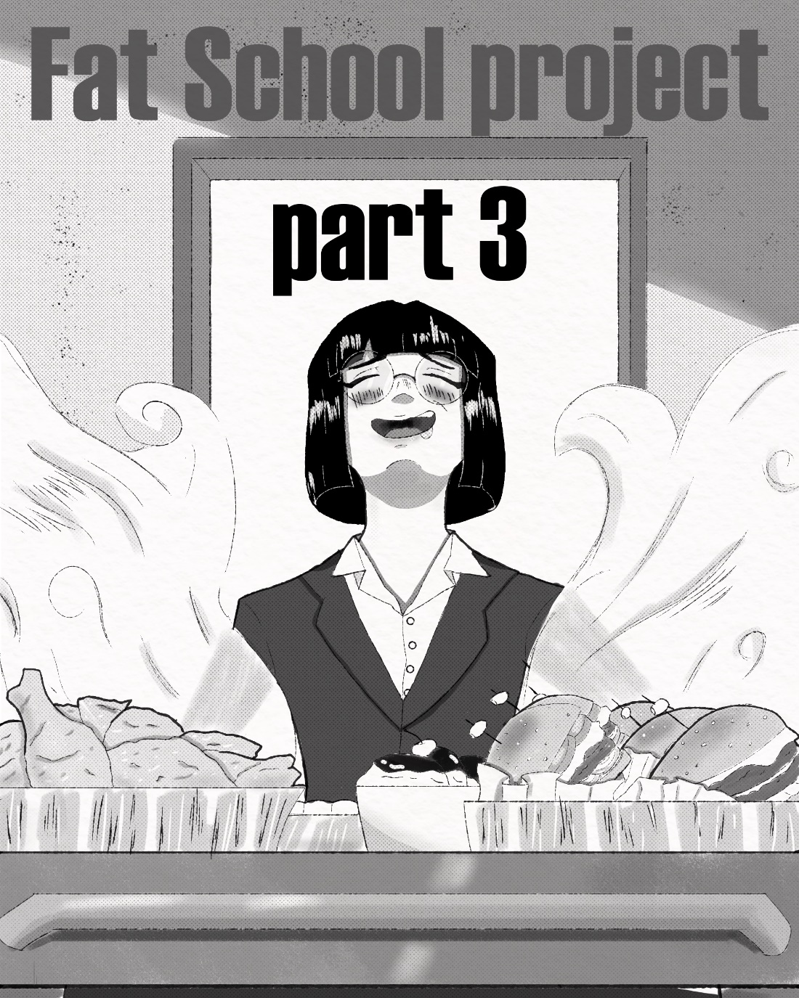
Ms. Kim woke up. “Good morning world!”
She had an unusual pep in her step. “Do you know why its good?”
She made a smiley face out of bacon and eggs. “That’s right!”
She continued talking to herself like a maniac until she arrived at
“San Graso High!”
Ms. Kim practically skipped from her car to the front gate. “I’m READY!”
she was even quoting spongebob, that's just how happy she was.
The Small woman fluttered into her classroom, as the first bell rang out, and her students waddled in. “Good morning, Class! Are we all ready for today's lesson?”. At her words, the entire class groaned in annoyance, as they were all too lazy or stupid to be bothered with math. Each student was at least 200lbs of hot fat pork, already winded from the walk to class. “Oh, don’t be like that, I’m sure you’ll all do great!”, Ms. Kim got a mischievous look on her face. “If not then, I hope you're all hungry.” she said, before dragging in a cart full of food, giggling in excitement.
February 5th
“Now Amber, remember, each wrong answer is another piece of clothing I’m confiscating”. Ms. Kim was standing over a huge Brunette, who had been stripped down to nothing but a skirt and leggings; those however, barely contained Amber's huge ass and smooth fat legs. She was trying in vain to cover herself, but the fat girl could only just get her arms around her massive chest, leaving her belly exposed for all to see.
“Ms. Kim C’mon this is so embarrassing!” Amber wined, face flush. “Why can't I just get stuffed like everyone else?” she asked, while desperately trying to keep her fat tits from slipping.
“Sorry Amber but, we both know you get questions wrong on purpose when I do that. your just too much of a piggy for food to be a punishment.” Kim pointed at the girl's chest. “Oops, looks like one slipped out.” Amber looked down; despite her best efforts, one gravid breast spilled out, revealing a small dark nipple. Amber's blush spread through her body, as the class laughed.
March 12th
“Ms. Kim, Beth stole my *BURP* snack cakes!” said a blond girl, as her overstuffed body wobbled in anger.
“Nuh uh, I was just taking them back after Jessica stole them earlier '' Beth, an equally overstuffed and round blond, shouted back. Kim rolled her eyes, these two were constantly bickering like siblings, usually it was over food or about which one of them was hotter. Jessica was a massive hourglass figure, while Beth was more of an all-around gainer.
“You know how hungry I get; I need at least 10,000 calories a day to keep up my gorgeous figure!” Jessica pawed at the snack cakes in Beth's hands.
“Fuck off!” Beth moved the cakes out of Jessica's reach. “You already ate like 12 boxes! And YOU KNOW, I can't go without food for more than an hour or I get lightheaded; I need more!”
“NO, I need more!”
“Fat ass!”
“Lardo!”
The two desperately fought for the right to stuff themselves fuller, their fat bloated bodies mushed and squished against each other, trying to assert dominance.
“Now Girls, if you’re going to fight like that then-“ Ms. Kim opened a desk drawer. And pulled out a dozen boxes of snack cakes, “I'll just have to stuff the both of you!”
April 27th
“370lbs! I see you’ve been eating well sandy!” Kim chimed, as Sandy stepped off the scale, a look of embarrassment on her face. She used to be the closest thing in this class to skinny, now look at her. She always tried to stave off any unnecessary eating; at first. But eventually San Graso had changed her, dulling her mind and inflating her apatite day by day until she was just like the other girls, a fat glutton with zero impulse control, and Ms. Kim was weighing her like a prized pig. “Ok now-“Ms. Kim lied down flat on the scale. “Sit on me, and let's measure the weight difference”. Sandy was hesitant, but knew any defiance would mean even more food, and even more weight on her frame. She sat on her teacher with a FLOMP, knocking the wind out of Ms. Kim.
“Uf…ok..now just..oh fuck…take the new weight at subtract the..nnngh” It looked like Ms. Kim’s head was about to pop off with how red it was, a single vain bulged from her forehead and she started to sweat.
“Uh, Ms. Kim, do you need me to get off?” Sandy asked.
“Yeeeaaaah I do nnnngh… Oh you mean literally?... no, just, a little longer.”
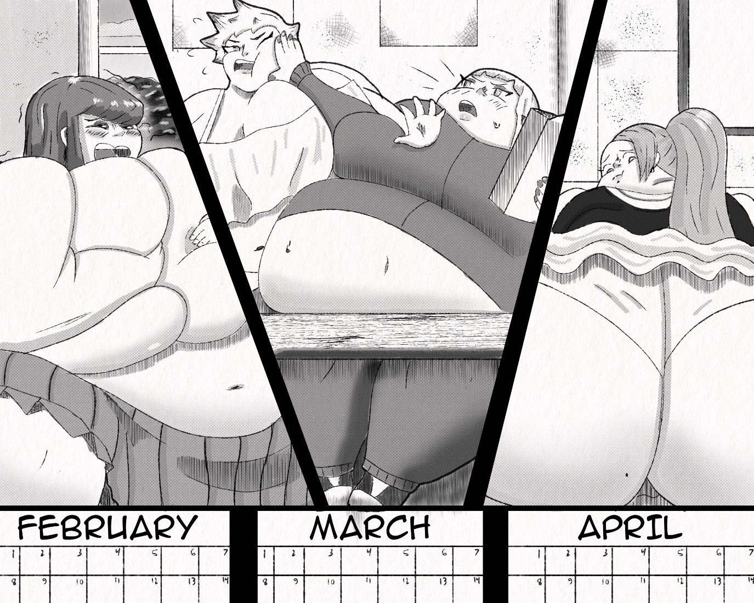
May 3rd
Lauren ate another burger, her belly growing bigger with each swallow. ``Come on piggy eat! Eat eat eat stuff stuff stuff, it’s what you were made for, your far too stupid to do anything else” Ms. Kim was relentless, stuffing more and more down Lauren’s fat pie hole. “Your gonna eat and eat and eat piggy, what's wrong, too full? Well too bad because your gonna keep growing and growing until… until… Oh my god!” The desk that Lauren sat in, creaked ominously.
“Msh Kwim? *Gurgle*” Ms. Kim stepped back from Lauren, and finally took in what she had done to her. She was huge, enormous, GARGANTUAN.
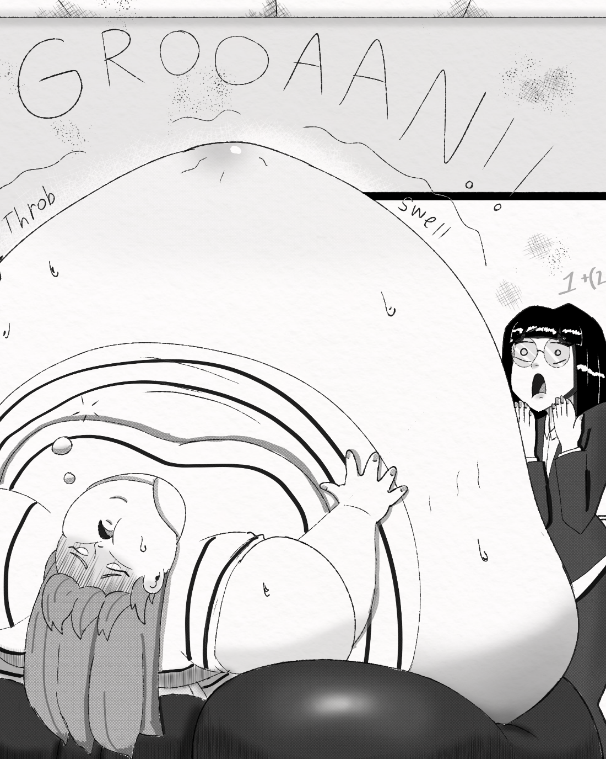
At the start of the period, Kim had started stuffing her. She had gotten something wrong about multiplications or something and so she started feeding her burgers. “*BUUUUUURRRRRP* no mwore burgash”. Lauren was already so so stuffed from her previous classes, so Ms. Kim was going to go easy on her, first just one burger then two, then five, ten, twenty, forty. Only now did she realize that she had been relentlessly stuffing the poor girl for almost an hour and she wasn’t looking entirely…stable. “Msh Kwim am I done? Can *Grumble* I shtap eatwing now? Pwease? *BUUUUUURP* I…I Fweel*Gurgle* Funny…” the girl's body was trembling, tight and round, her clothes ripping at the seams. Kim looked around her classroom. Her other students looked at Lauren in shock. No no no, I- I was just feeding her, nothing illegal I certainly wasn't going to… going to.
“Oh shit I went too far, oh no no no! she's the size of a car, someone get the nurse!”
…
After school that day, Ms. Kim checked up on poor Lauren in the infirmary. She was still utterly, massively overstuffed. She took up two beds, and her fat swollen arms still stuck out from how much her midsection blew up. However, her body had stopped shaking, and her skin wasn't as dangerously tight looking; all in all, it seemed that Lauren was at least returning to a safe level of fullness.
The Nurse, a woman named Hannah, began to thoroughly chew Ms. Kim out. “Look when you do that kind of thing, you need to remember the girl’s limits. When she was brought in here, she nearly burst just from the gas building up inside her; can't tell you how long we had to burp the girl; nearly turned the place into a goddamn gas chamber. I mean what were you thinking? Do you have any idea how much trouble you could have caused? Do you really want the BURSTING OF A STUDENT on your record!?” If only the nurse knew. Ms. Kim's past as a serial burster was something known only to the principal and vice principal, and while stuffing and fattening the students was expected, it was also expected that the students graduate in one piece.
“Yeah, no you're absolutely right I…I don’t know what came over me”, That was a lie. Ms. Kim knew exactly what came over her; herself. After making sure her student was ok, Ms. Kim was called to the principal’s office.
…
“Do you know why I called you Ms. Kim?” McClain asked. Kim couldn’t really answer right away, she was far too distracted by the sight of Vice Principal Tanner; who was dangling from a rope harness, hogtied, with a blindfold and ball-gag; she was making muffled moans and grunts.
“Mmhf”.
Ms. Kim stared. “Sorry but uh… what’s all this?” Kim asked
“All what?” McClain turned to the tied up and now twitching form of Tanner “Oh, she's being punished.”
“Hmmmmf” Tanner moaned in delight.
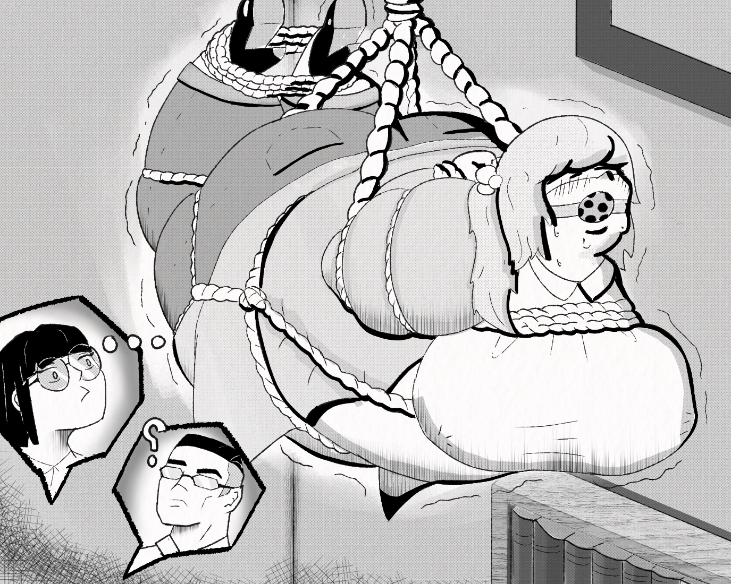
Okay.
Ms. Kim rubbed her arm, “you called me because... I almost made a student uh… explode” Kim admitted; a child admitting they broke a vase. McClain slowly walked over to his tied up VP, who tensed up at his approach.
“Yes Ms. Kim”, he rotated Tanner to face away from him. “Because. You nearly made. A student.” He gave Tanner’s ass a thunderous slap, producing a shriek of pleasant pain out of the fat woman. “Explode”. Kim didn't say anything, only continued looking ashamed. “*SIGH* Look Kim, it’s not a big deal THIS TIME.” McClain turned away from the now dripping form of Ms. Tanner and leaned on his desk. “Considering your history, I was expecting there to be a bit of a… learning curve for you here. I'm just glad you stopped yourself before things got…messy.” Kim simply looked down at her hands, clutching them tightly. She was so sure that she had that part of her under control now. She had been here six months now and been stuffing students silly for four of those; all without incident.
“I guess I don’t have as much self-control as I thought.” she said, voice cracking, tears welling.
McClain’s expression, for the first time since they met, softened, only slightly. “Look, girls these days are hungrier and have less self-control than ever. A few high school girls eating themselves into oblivion isn't that rare anymore, especially with a student body this fat.” McClain put a hand on Kim’s shoulder. “We can sweep one or two burstings under the rug, but we have a job to do at this school, and that's to make these girls as fat and stupid as we can, so they`ll be ready to be exploited by their capitalist overlords”. He gave a smile. "Feel better?"
Silence…
“PFFT!” Kim suddenly burst out into a fit of laughter, causing McClain to just look around awkward. “I'm sorry I shouldn't laugh he he, it's just… you, comforting a crying woman, with that smile is, *SNORT* just something I never thought I'd see”, Ms. Kim was giggling up a storm now. McClain just shrugged, a more natural smile on his face now.
“There is one more thing I wanted to talk to you about.” McClain said. Kim whipped the tears from her eyes.
“Hmhm *Sigh* yes?” She readjusted her glasses.
McClain fished a flier out of his desk drawer and handed it to Kim. “Proms coming up” Ms. Kim looked at the thing, it read San Graso Promenade May 25th at 7:00PM bring food.
“Is the prom not catered?” Kim asked
“It is”. McClain answered.
Of course.
“But for us it's more than just a night of food and fun. Prom is when the Project heads will come and check on our school's progress. They`ll check for how well the school is run and how fat and submissive the girls are. If we score too low then they`ll take our funding, or worse”. He didn't explain what worse meant but considering these were the heads of an evil government conspiracy, yeah, no thanks. “Every teacher must attend, and each teacher will be scored based on the state of their own students. So far yours are some of the biggest students here, right behind Ms. Merkel and Ms. Butters so, I wouldn't worry too much.” McClain sits back down and points a fountain pen at Kim “But still, I don't want to see a single pound lost from a single one of your students, got it?” McClain said.
“Yeah, goa thah?” Tanner added
“NO TALKING PIG!” like lightning McClain was out of the chair again and slapped Tanner in the face so hard she went spinning. He turned back to Kim “ANY QUESTIONS!” What the fuck are those two?
“NO SIR!” Kim shot up from her seat.
At that moment, from the corner of her eye…did…did she see movement from behind the door? Oh shit was someone eavesdropping?
“And Kim” McClain’s toned softened again. “Please no popping anyone”.
…
Ms. Kim tried looking around for anyone who could have been listening in on her conversation with the principal. Nothing, not a soul in sight. This was bad, Ms. Kim did NOT need the fact that she was a serial burster to get out, that would not be pretty. Suddenly, Ms. Kim felt extremely annoyed. At last, she had found a place where she could let loose, where she didn't have to pretend to like skinny girls, where she didn't have to spend every waking moment denying who she was, but even here, there was a major part of her that she had to choke down. Her face went red in frustration. “Fuck!”
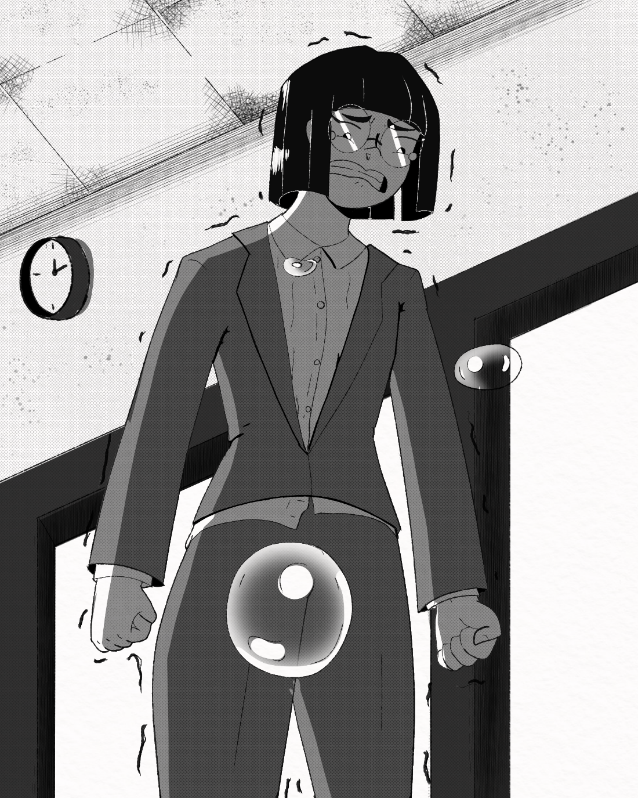
“Ms. Kim?” a voice came from behind her, making Kim nearly jump out of her skin. “Oh, I'm sorry, I startled you, didn’t I?” The voice was warm and motherly, soft, and sweet, like butter.
“Oh! Ms. Butters, he he. Afraid you caught me in the middle of a fit here, he he he, oh this is embarrassing”
“Oh, my stars are you ok? You just seem very upset. Oh, baby girl are those tears?” Ms. Butters motherly instincts were kicking in.
“NO!” Kim shot back, shocking Ms. Butters. “I mean, no. sorry I just think I need some time to…” to do what? Loathe? Wallow?
“Well to be honest, I nearly hurt a student today. I almost hurt them very badly and now I'm wondering if it's alright for me to be here anymore.” Ms. Kim said. It was the closest thing to confiding she could do, not without spilling her guts. There was a long silence.
great, now she knows what a shitty person you are.
Then, all at once, without warning, Ms. Butters grabbed Kim by the wrist and started power walking with all the force of a mom about to smack her kid when they got to the car. “Ugh, Ms. Butters, what are you?”
“SHH! You're coming with me!” Butters stated.
…
“Oh my gosh” Ms. Kim looked out at what she assumed was the home-ec room, or maybe the kitchen in a 5-star restaurant, she really couldn't tell.
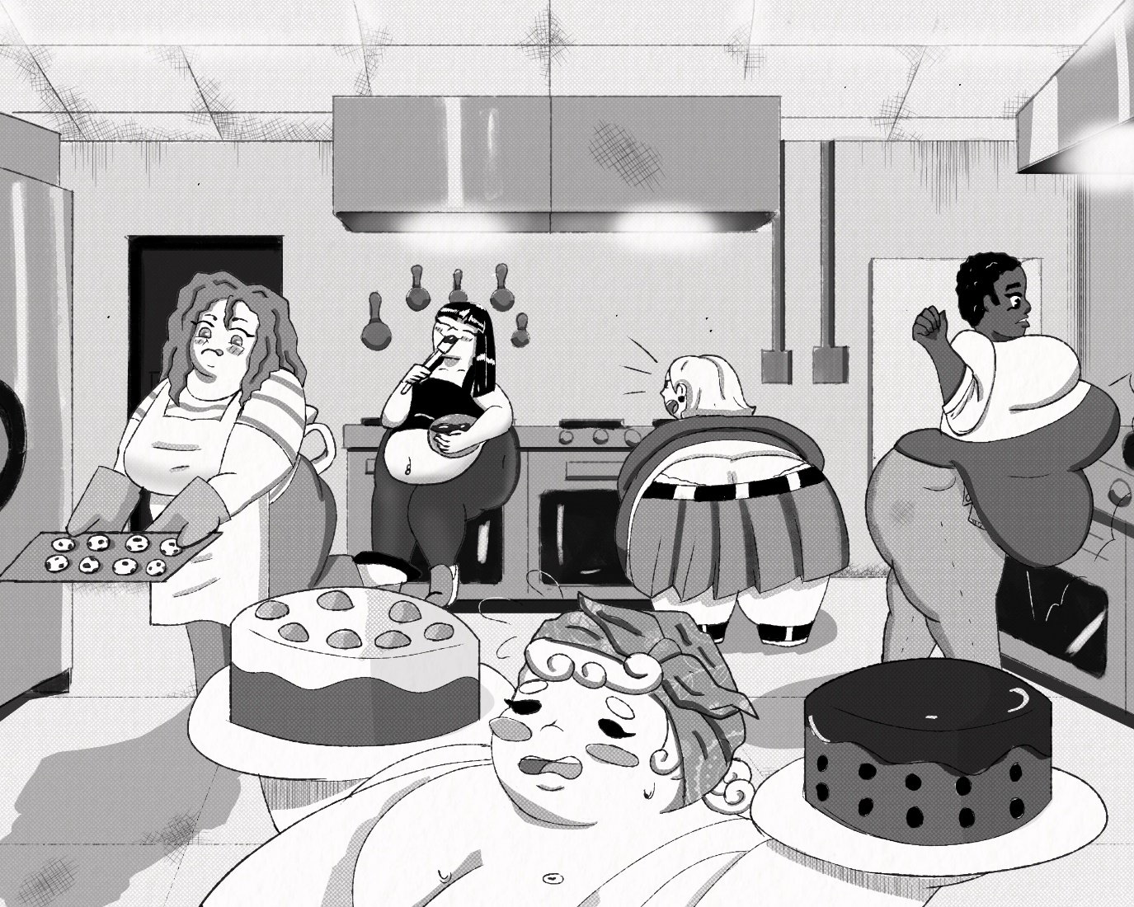
The room was outfitted with over 12 stove tops, 12 ovens, 6 microwaves, dozens of cabinets and spice racks, and more things Kim couldn't even take in. The room was also filled with fat girls, all cooking their own dishes with big chubby smiles. Ms. Butters addressed the whole room.
“Cooking Club, this is Ms. Kim and she will be helping us cook today.” she said
“What?” Kim asked.
“Hi Ms. Kim!” the whole room said in unison. Ms. Kim was amazed to see that they had prepared a literal banquette of food, but rather than stuffing their faces they were rapping it up. while some of the girls baked, others were wrapping the food in saran wrap and putting it in nearby fridges, BIG ones that could no doubt hold huge stores of food. “What is this all for?” Kim asked Butters.
“Prom. The Cooking club always prepares food for the event.”
“I thought the prom was catered”.
“It is, we just provide extra, so all the lovely deers can eat till their heart's content.”
“Isn't it also bring your own food?”
“Yes”.
I love this school.
That aside, Ms. Kim still didn't understand why SHE was here, sure it was nice to see the plump little things run around and work up a sweat but.
“I brought you here to teach you” Butters smiled down at Kim.
“Teach me what?” Kim asked.
“The true joys of feeding someone”. Ms. Butters quickly got Kim to work, and it was clear that the small Asian woman was no cook. Most of the recipes in the cookbooks looked too complicated, so Kim eventually chose something easy; a meatloaf recipe she saw on the first page. An hour passed as she cooked.
“Alright, time for a taste test, everyone bring your dishes over to Debra”. Butters gestured over to possibly the single largest student at San Graso. Debra McTaggart, sat near the opposite end of the room. Ms. Kim had first seen Debra during her stealth mission through the school a few months back. At the time, Ms. Butters was stuffing her face full of pie, and at the time, the girl was massive, but now.
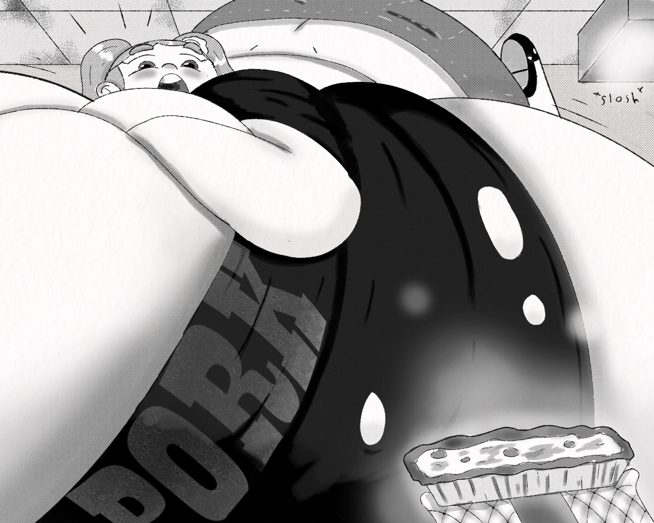
“Oh, that smells sooo good, gimme gimme!” Debra said. The girl had eaten herself to the size of a truck, or maybe she had eaten a truck, who could say. She clearly gained most of her weight in her belly and boobs because she was lying on them. Her tits each look like they weighed as much as Kim. her stomach had blown up to the point were it more resembled a waterbed than stomach. Debra lay there atop her own mass, fat legs kicking back and forth in excitement.
“Here Debby”.
“Eat up”
“Hope you like it”. Each girl began bringing small samples of their dishes over to the massive girl, dozens of small samples. She ate each dish with a chubby smile on her face, reveling in the taste of each one, and let loose adorable coos of delight.
Ms. Kim smiled. “So cute”
“Are you ready Ms. Kim?” Butters asked.
Brought back to reality, Ms. Kim looked down at her dish. As she looked at the casserole dish full of a mishmash of beef, herbs, and ketchup, or wait, shit was that hot sauce? she suddenly felt very self-conscious. “Uuh, my dish isn't that good, maybe just skip me, he he.” she blushed. Ms. Butters gave Kim an arched eyebrow.
“Why did you make this?’ Butters asked.
“W-why? Well, you told me t-”
“Was it out of love?” Butters interjected.
Kim was taken aback. “Love?”
“Yes LOVE!” Butters shouted. “Love for the food! Love for the one you're feeding it to! Love for cooking! Love for the act of feeding itself! LOVE IS EVERYTHING!” a long silence. “I can tell you made this dish out of impatience, not love.” Butters said.
Love?
well of course she loved feeding, it's what she lived for, its her deepest passion. Right behind making girls explode. Butters grabbed Kim’s shoulders with a firey look in her eyes.
“For people like us, food is how we share our love. I may not know what brought you to this school but, everyone here shares that. Food brings people together, it sustains them in both body and soul, it gives them joy and pleasure, and it gives us joy to give that to the people we feed.” The woman's words were starting to stir up emotion in Kim, she listened intently. “Think back Kim, think of times when someone made food for you. Not just any one though. Someone who loved you, think back to when someone who loved you shared their love through the food they made for you, can you do that?”
Kim closed her eyes. She looked back, and back, and back. When was the last time…someone made me food? Most of her life, it was her that did the feeding, and she didn't even cook. Obviously, she loved the girls she fed, but it was always in a lusting passionate manner. It was always about stuffing the piggy, making the fat girl eat, making the fat girl bigger, making her go pop. Was that love? God she was so fucked up. Wait, no she did remember.
“Jjambbong” Ms Kim whispered
Butters cocked her head. “That's Korean fish and noodles, right?”
“Mhm” Kim could still remember the smell of it. “When I got good grades on a test, or when I got really sad or hurt, my mom would make it, it was my favorite. I would always get so excited when I came home from school and I could smell the fish and the broth.” it reminded her of mom, of her…“Love”. Kim opened her eyes. “I know what to make now,” Butters smiled.
“Hey, teach, we're hungry, so we're gonna go home now” one of the cooking club members said. “Yeah, snacking on ingredients can only hold a girl over so long you know,” said another. Ms. Butters waved the girls goodbye.
“Ok girls you did great today, make sure you all stay well fed!” she said to the group of small hippos that was the cooking club. Butters turned to Debra, who was a good foot higher off the ground than earlier from how much her belly had swelled. “Make room in there Debby, Ms. Kim’s gonna make you something lovely!” Butters padded Debra's massively swollen ocean of a belly, making it slosh and making Debra moan. “But *BUUURP* so fuuuull, I don't know if I can *HURP* *BELCH* fit more in me.” Butters shot Debra a look. “Debra, Ms. Kim is going on a journey of culinary self-discovery! And that journey ends inside of your big fat belly. Now will you deny her Debra? WILL YOU?!” Debra simply gurgled and burped in response. Butters smiled at Kim.
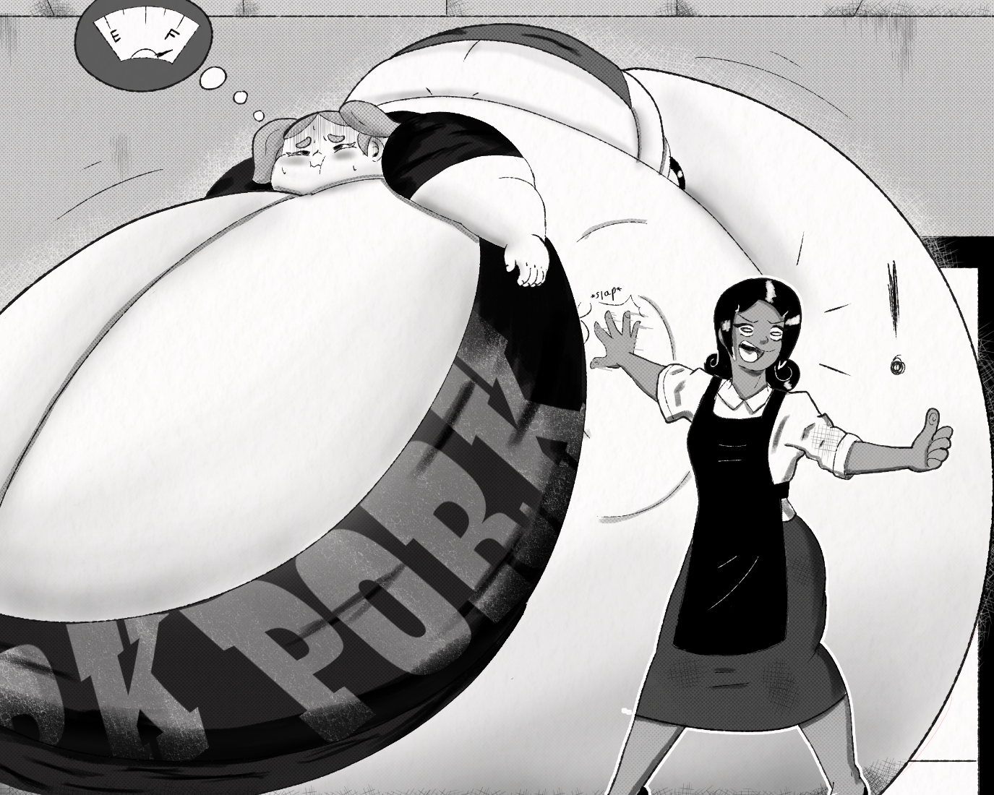
“She`ll do it!”
Another hour passed and the sun was beginning to set. “It's done” Kim brought out a large bowl. Then opened the lid and.
“Something looks different,” Ms. Butters said. It was definitely Jjiambbong, but something about it was off. like something was missing. Ms. Kim poured Debra a bowl.
“Here, I hope you like it” Kim tried handing Debra the bowl, realized that the girl's tits were too massive to get within arm’s reach, so decided to shimmy to Debra's side and passed it to one fat hand. “I'd like you to try it as well Ms. Butters, at least as a thank you for waiting on me.” Ms. butters nodded and took a bowl for herself. She took a spoon and started to slurp, cooling the noodles as she ate them. Her eyes widened at the taste, after she gulped it down, she looked at Kim, stunned.
“It's not spicy” Butters whispered. Ms. Kim had prepared a traditional Korean seafood dish, and in a move that would make every southeast Asian mother faint, SHE REMOVED. THE CHILLIES! Ms. Kim spoke.
“When I was little, I had a really sensitive tongue, so I couldn't handle spicy food. So, every time my mom made anything, she would set aside a small pot just for me. So, every time she made Jjambbong, she had to basically make it twice just so I could enjoy it. I think, more than anything, that's why It's still my favorite, because it was a labor of love I guess.” there was a pause. “So…uh, do you like it?” Butters smiled, a tear in one eye.
“It’s deli-”
“MORE!!!” cried Debra, without even realizing it, Debra had gulped down the entire bowl in 10 seconds flat. Gone was the overstuffed expression she wore a moment ago, instead a look of sheer animal hunger is all that remained. “More! Please! *BURP* Gotta have more! More yummy noodles in my *URP* belly!” the whale of a girl begged. With a start, Ms. Kim grabbed another bowl. “NO! All of it! Please!” she had both fat arms out, grabbing the air desperately.
“Oh ok”. Kim grabbed the whole pot and maneuvered it into the hands of the pubescent pork palace. Without any utensils, she simply tipped the whole thing into her gullet. Kim expected there to be tons of spillage, but the girl was like a fire hydrant in reverse, sucking up noodles and liquid before it could even start to spill over. Butters let out a low whistle.
“Wow, you got her into a feeding frenzy, usually my cooking is the only thing that does this to her, great job Kim.” she gave a thumbs up.
“*GULP* *GULP*”
“So, do you understand why I called you here now?” asked butters. Kim just gave a confused look.
“Look, we both know the deal with this school, and while I won't pry into your past or what got you here, I can tell that you`re the type that likes to test people's limits when it comes to food.”
Or break them
“So many feeders these days; all they care about is getting girls as big as possible, about getting them as fat as possible, about seeing just how much a girl can hold without bursting.”
“*GULP* *GULP* *GULP*”
“And look don't get me wrong, mama likes to get frisky with some fatties from time to time too he he. But people forget what being a feeder is really all about” Butters gently grabs Kim's face and makes her look her in the eyes. “It’s about sharing our love through food.” and with that Debra emptied the whole pot in one final, epic gulp.
“*UUUUUUUUUUUUUUUUURRRRRRRRRRRRRRRRRRRP!!!* SHO YUMMY!!!” Debra squealed in food engorged ecstasy; then passed out, in an epic food coma.
…
“Thanks for the help!” Kim called out
“Anytime!” Butters replied from her own car in the school parking lot. It was sundown and Ms. Kim got in her car and sighed. “Sharing our love through food huh?” wasn't that what she did with Sandra and Sheila? She loved them, so she filled them with her love until they burst. But maybe there were other ways she could do that after all.
But why? What's wrong with our way?
“It hurts the people we love”.
Hurts them? They love it! Do we force girls to eat NO. do we tie them up and force food down their throats? NO. Did Sandra or Sheila ever ask us to stop NO NO NO! It's not fair! Why is what we love to do wrong? If girls want to eat and eat and be filled with so much love that they explode, then why make it illegal I THOUGHT THIS WAS AMERICA!
“But maybe we can learn to share our love in other ways, better ways. Maybe…” Kim thought back to the adorable smile of Debra, and how much joy it brought Kim to see someone enjoy something she made that much. “Maybe just making girls fat and happy…is enough for us.”
*RING!* *RING!*
Ms. Kim was startled by the sound of her phone ringing. “Who could that be?” Kim wondered. The number was unknown, and usually she wouldn't pick up but, right now she needed a distraction from her own brain. “Hello?”
“...Sheila O Connor and Sandra Stewart”
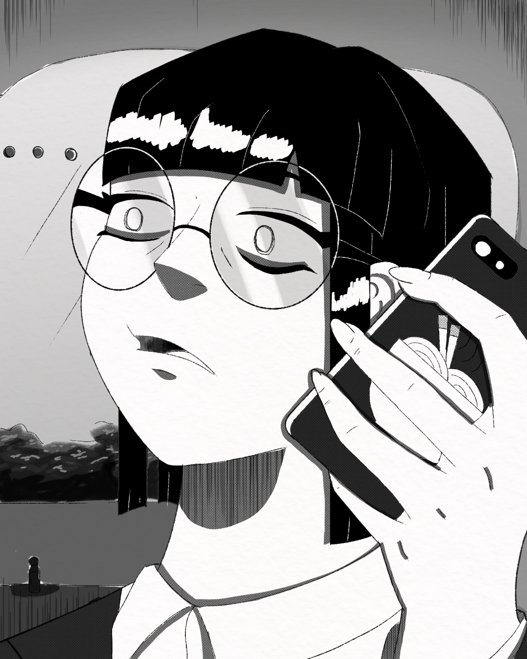
Kim just sat there for a moment. Then her blood turned to ice. “W-who… Principal McClain? Is that you?” Kim asked. What the hell was this? The voice sounded distorted; whoever this was they were using a voice modulator. The voice spoke again.
“I'm going to send you a location on your phone. Be there before 8:00 PM" *CLICK*” and that was it. They just hung up. Ms. Kim started shaking like a baby deer. A notification popped up on her phone, it was an address.
“That's like 40 minutes away!” Kim looked at the time. 7:00PM. She frantically typed the location into her GPS and started her car. she couldn’t call the cops, not with the risk of this person telling the authorities about her past. 7:02PM. Kim bolted from the parking lot. She drove down the highway like a madwoman. The location was unsettling, it was some old construction site, abandoned a long time ago. “Mysterious voice who knows my past. Creepy abandoned work site. I’m going to get murdered.” 7:35PM She came up on a stop light and screeched to a halt. “Come on come on!” Kim looked at her phone. Maybe she should call them back, get more explanation, or at least more time. But when Kim looked at her recent calls. “Its not here” gone, no incoming call was listed within the last 3 days let alone within the last hour. “Great, so there also some kind of anonymous hacker type, great, he he he fucking GREAT!!!” and she ran the red light. 7:37PM.
…
7:52PM she arrived. The site was wide and flat, in the center was a large skeleton of a building, scaffolding and raw materials surrounding the massive structure. Kim got a text. “Come inside, leave your phone in the car”. Ms. Kim was about to cry.
“No phone, no calling for help when I’m getting murdered, or kidnapped, or worse”. She supposed this must be her punishment. Her punishment for being a burster, her punishment for being born with a love of bursting babes and stuffing sweeties. Her punishment for being crazy. “I guess it’s what I deserve”. As she approached the massive building which would surely be her doom, Ms. Kim noticed something peculiar. “This… this place looks like San Graso.” half-finished and falling apart, but still the resemblance was uncanny. It was definitely a school building, a big one, and it had the same layout and shape, but. “Why is this here?” Kim walked into the building, it was mostly just a large empty space, the only light was that of the moon, shining through the ceiling. And it illuminated a figure standing in the center of the…
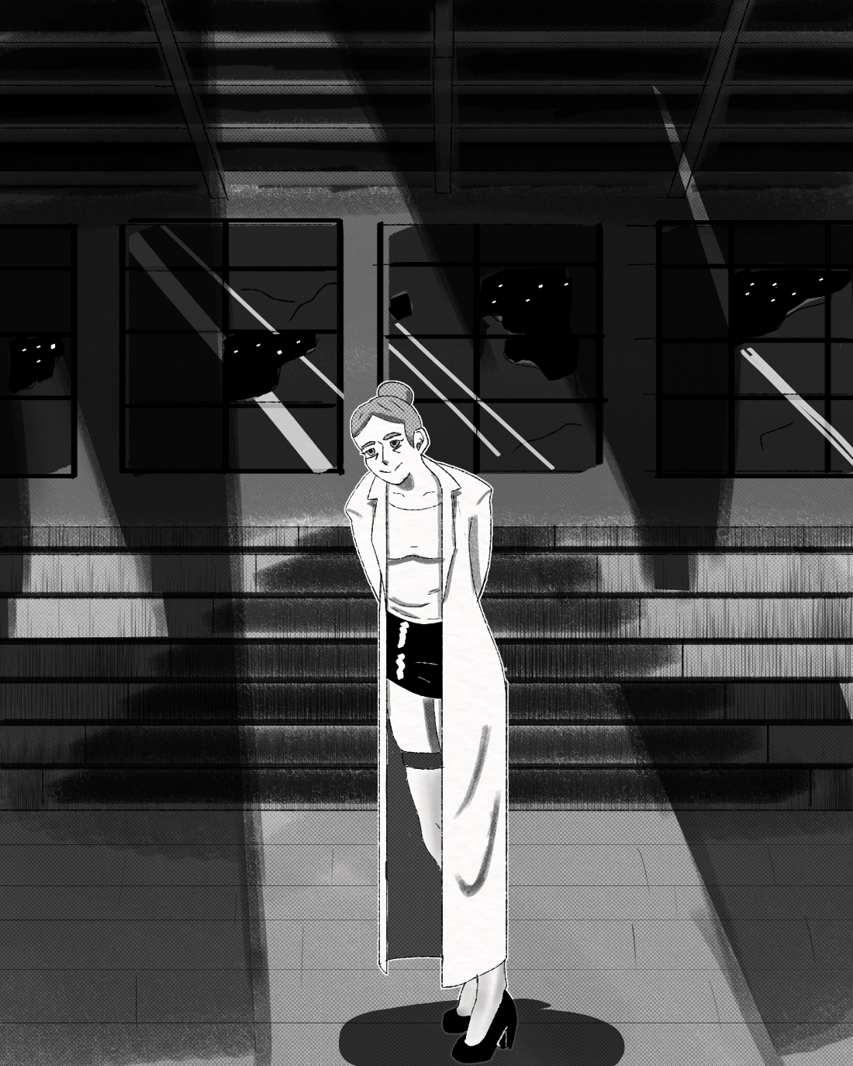
“Merkel?” Kim asked, her small shaky voice, echoing. The figure stepped out in full view now. Indeed, it was Ms. Merkel, bun, lab coat and all.
“Hey Kim,” Merkel said.
“W-What going on? W-why did you-” Ms. Kim tried to sound angry or commanding but her shaking, cracking voice, combined with the tears at the corners of her eyes, ruined the effect. Suddenly, strangely, Merkel got a bashful look on her face, embarrassed even. Kim was taken aback, never imagining that she would see the cold and severe German woman look… BASHFUL.
“I`m sorry. I probably really freaked you out, but I had to keep the call from being traced and I had to make sure it couldn't be linked to me in any way.” Merkel said. Kim just stared, looking even more scared now. “Oh shit, sorry! That probably didn't make you feel any better, did it? Uuuh, okay first thing, I'm not here to do anything bad to you! Let me just make that clear. Is that clear?” Kim said nothing. “Okay good! Um, second thing I know everything. Like everything, Sheila, Sandra, the bursting everything.”
Ms. Kim felt like passing out.
“But it's okay because” Merkel walked up to Kim and grabbed both her hands. “I'm the same way!” The silence in the room lasted a while, as Kim tried to process what she just heard. “Do you need a second?” Merkel asked.
“...yeah” Kim replied.
Kim caught her breath for a moment and considered the chemistry teacher, who luckily wasn’t going to murder her. Somehow, she knew everything about her past now, how was this possible? Wait. “You were the one listening in on me and McClain earlier; weren't you?” Kim asked. Merkel raised her hands.
“Guilty as charged. I meant to ask McClain about the plans for prom but that's when I overheard… things.” Merkel gave Kim a smile and blushed. “I had to learn more about you, so I hacked into the school's records and found yours.” Merkel suddenly looked very excited, her blush brightening, her eyes sparkling. “AND AND ICH GLAUB MICH KNUTSCHT EIN ELCH!!! I FINALLY FOUND SOMEONE WHO POPS GIRLS TOO!!!” Merkel was giggling, twirling, bouncing around like a little girl, saying God knows what in German and it was such a bizarre sight that Kim almost didn't register what Merkel just said.
“You… you like popping girls too?” Kim asked, afraid to even say the word “Too”.
“Kim, I don't like popping girls” She grabbed Kim’s shoulders. “I. LOVE. POPPING Girls” Merkel started speaking in a very dreamy tone, reminiscing. “I remember the first time. I was working at SYNLAB on an experimental new fertilizer. It was supposed to make plants grow to twice their normal size. Didn’t work, the plants did not respond to it at all… but the people who ate them did.” Ms. Kim suddenly was transfixed, her face going a bit flush. “My lab assistant was the first to try one, a blueberry. For whatever reason, the chemical didn't take effect until it was metabolized by human cells. Oh, Kim you should have seen it, first she started fattening, she got fatter and fatter and fatter right before mein very eyes. I tried to get help at first, but it turned out that she wasn't the only one who ate the fruit. `` Kim gulped, a warmth was starting to build in her nethers. “My whole lab was growing out of control; they were like human blueberries. Eventually though, their bodies couldn't contain all the mass building up inside them, they started growing rounder, and rounder.” Merkel's grip on Kim's shoulders was tightening, and her face was inching closer to Kim’s with every word. Both women were starting to breathe heavily. “They grew fuller and fuller. They grew so big that they blocked all exits, I was trapped between all my colleague’s growing bodies. Just before they could crush me though, they stopped growing. But I could feel their bodies growing tighter, and I could see their skin thinning, I could hear their moans turning to screams, and then…oh god!” Merkel's whole body jerked and shivered.
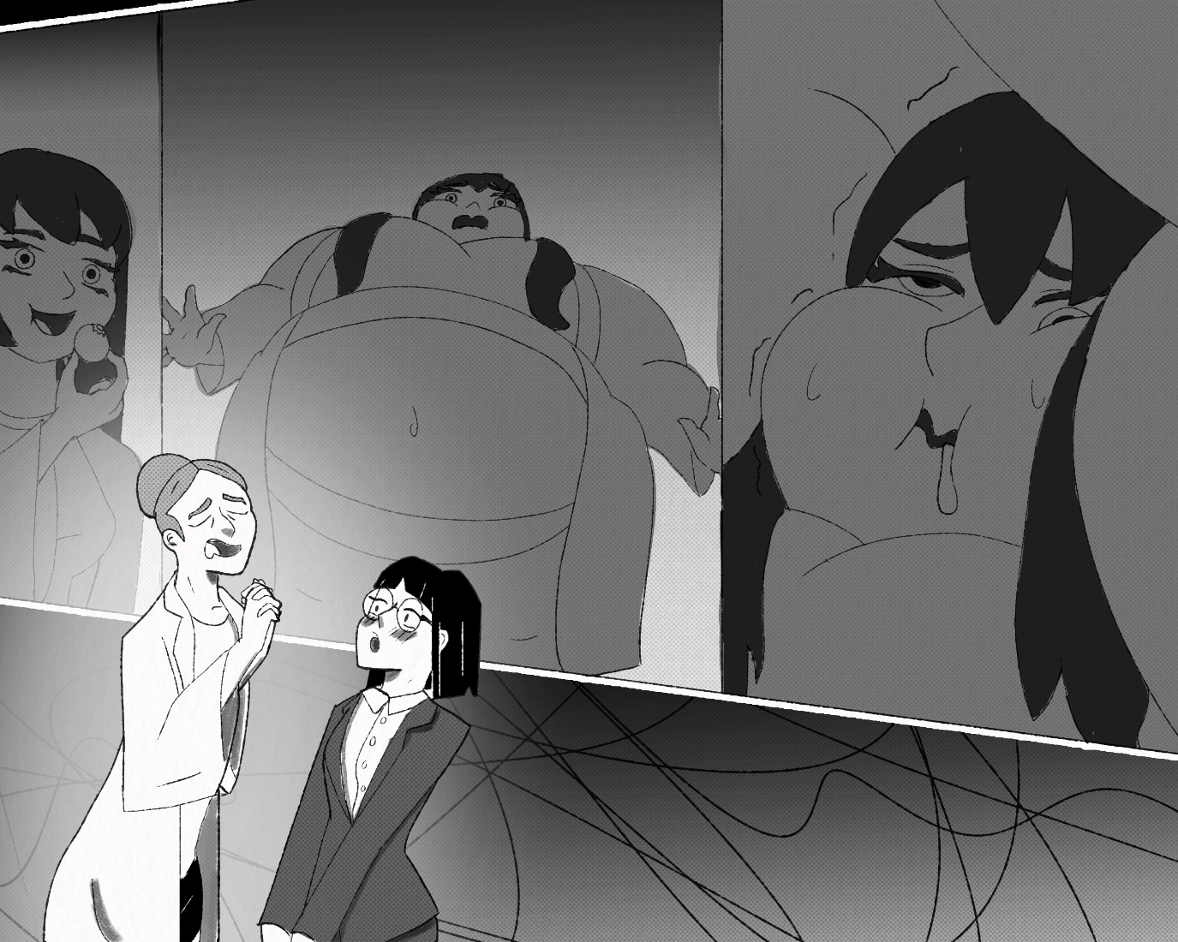
“Pop” she whispered. Kim was speechless. Then she pushed Merkel away, trying to regain her composure.
“Look, Ms. Merkel-”
“Lanna” Merkel interjected. “It feels weird calling each other Ms. Merkel or Ms. Kim outside of work,” said Lanna.
“Oh, uh…ok Lanna” Ms. Kim said, then noticed Lanna had an expectant look on her face. Kim sighed in resignation. “It's Cho. that's my first name”. Lanna perked up.
“That's a beautiful name,” Lanna said, like a girl in love.
“Look Lanna, you're right ok, I used to pop girls but” she thought back to all that Ms Butters had taught her that day. “That's behind me now. I'm better, I'm fixed. feeding girls, making them full and happy is enough for me now”. Lanna stood there for a moment, a stunned look on her face.
“Oh, you poor thing.” Lanna rushed over to Cho and gave her a hug. Cho didn't know what to say. “You are NOT broken; you do NOT need to be FIXED. YOU are fucking PERFECT do you hear me? Anyone who told you otherwise can BURN!” Lanna said. She seemed genuinely upset. Cho had known Lanna for a few months now, but she was surprised at how much Lanna seemed to care about her. She had to admit it felt nice. “You must have had such a hard time. Always hiding your true feelings, surrounded by cute fatties but unable to pop a single one. Oh, I'm so sorry.”
“N-no, I… popping girls is wrong Lanna, we can't, it's not ok”. Cho meant to say the words with conviction, but the way she said them just made her sound sad.
“Shhh shhhh it's okay, you don't have to be ashamed anymore. Here, I have a present for you”. Lanna grabbed Cho’s hand, and led her deeper into the building. “Do you know what this building is?” Lanna asked. Cho shook her head. “It was apparently the original San Graso High. Apparently, the principal at this san Graso was a lot less strict on the whole popping student’s thing. He used enormous industrial feeding tubes, experimental and unsafe drugs, he made so much noise that the project heads had to decommission the whole operation.” Lanna led Cho down a stairway, leading to what would have probably been a basement or boiler room. This whole thing would have usually tripped all of Cho`s- I’ve seen enough horror movies to know where this is going- alarms, but for some reason she felt very at ease with Lanna. like she was a trusted friend she had known her whole life. Weird. “It really made me think though, how fun it would be to be part of THAT project, now I could have some real fun with that. Oh, look who it is''.
“Hello Mistress! OH, and Ms. Kim Hello!” the voice came from a figure at the end of a dark hallway, backlit by an ominous orange glow. The figure was small and round, almost like a ball, and it wobbled its way toward the two women.
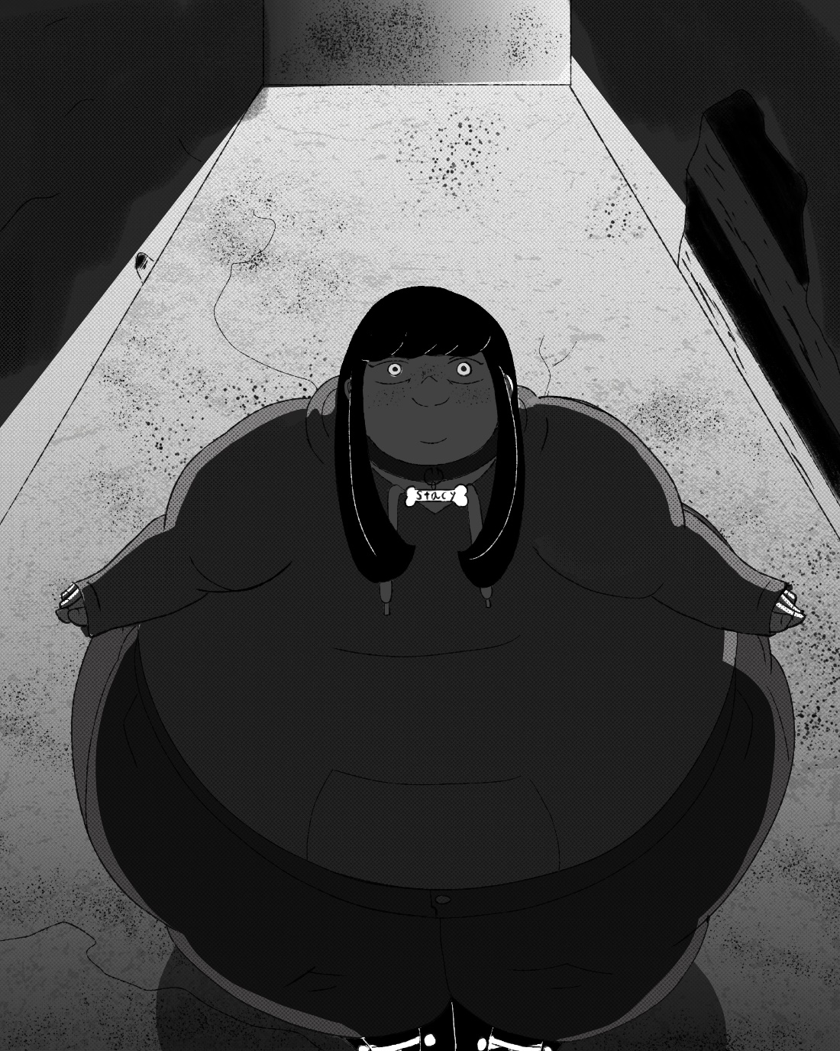
“Stacy?” Cho said, Shocked. Yes indeed, it was the shy little marshmallow of a girl. Cho hadn’t seen the girl since she witnessed her being blown up into a gas bomb by Lanna, all those months ago. Something about the girl now however seemed; off. She had a far more wide, outgoing smile than she expected, Cho pegged her as the shy, anxious type. Not only that, but she noticed that the girl now had a dog collar around her neck, even had the little bone with her name on it. “What are you doing here? Shouldn't you be home?” Cho asked.
Stacy put her hands on her chubby cheeks and blushed. “Oh, I live here now, mistress Merkel took me in.” Stacy looked up at Cho with barely contained excitement. “I'm hers now”. Stacy squirmed in glee, obviously very happy about that fact.
“Stacy, keep Cho company while I get her present ready.” Lanna said.
“Yes mistress,” Stacy chirped. And Lanna went down the hallway. A moment of silence passed. Stacy looked up at Cho. “So, your full name is Cho Kim?”
“Yeah yeah, choke him?-I hardly know him! choke on deez nuts, I've heard them all before. But seriously, Stacy, what's going on here?” Stacy looked forward again.
“I can't tell you. It's a surprise.”
“No, I mean…with you. Why are you with Lanna?” Stacy perked up.
“Oh! That's what you meant. Well.” Stacy squirmed a bit, like a girl about to admit who she has a crush on. “One day, in class, Mistress gave me some tablets and soda water.” Cho flinched. “It was something that Mistress had developed, and it blew me up really big like-” Stacy spread her arms out. “SUUUPER big, bigger than I thought a person could be, and it felt.” Cho swallowed. “It felt amazing” The young girl started rubbing her belly. “I’ve never felt so full and tight, it was totally different than eating. Because, you know, when you're eating, you still can stop whenever you want, so you never get like… dangerously full you know?” Cho didn’t know what counted as ‘dangerously full’ to a girl as full and round as Stacy, but she just nodded. “But that day, when all those bubbles were filling me up, I had no control, none, absolutely no way to stop myself from getting fuller and fuller and bigger and rounder! I just had to take Mistresses abuse, and it felt so gooooood.” Damn, it’s like this girl wanted to explode “I just wish I would have exploded!” Cho shot her a look.
“What?”
“My skin was so tight, everything felt so so good, but *Sigh* It wasn't enough you know, I wished I could have just- just BOOM!” she gestured with both arms, becoming more animated as she spoke. “So, after school that day, I asked her. I asked Mistress if she could make me explode. She said she would only do it if I abandoned everything. My friends, my family, my home, and devote myself entirely to her.” Stacy stopped for a moment, then started breathing heavily. She was giggling to herself and looked at Cho with one of the horniest looks she had ever seen. “ And I did it! I left it all! Who does that right? I must be the biggest degenerate alive! I live in this building now; Mistress feeds me slop every day and uses me for her experiments! Day in and day out! I love it so, so much! And one day, she’ll feed me too much or one of the experiments will be too much for me and then-AND THEN!!!”
“Stacy! Stop being horny and get Cho in here, it's ready!” Came Lannas voice from down the hall.
“Yes Mistress!” Stacy took Cho’s hand and led her to the end of the hall. They entered a small space, probably an old boiler room; Cho immediately stopped, when she saw what was in the center of the room. Sitting on a bed, was a massively fat woman. She was ginger, and had tantalizingly pale skin, peppered with freckles like seasoned meat. The girl had to be at least 900 pounds. Next to the woman was an enormous tank; Cho thought it a boiler at first but upon seeing the hose attached to it, and the face mask attached to the hose, Cho got a much clearer picture. Lanna popped out from behind the woman, she was wearing lingerie now, very BDSM lingerie, with spikes and leather.
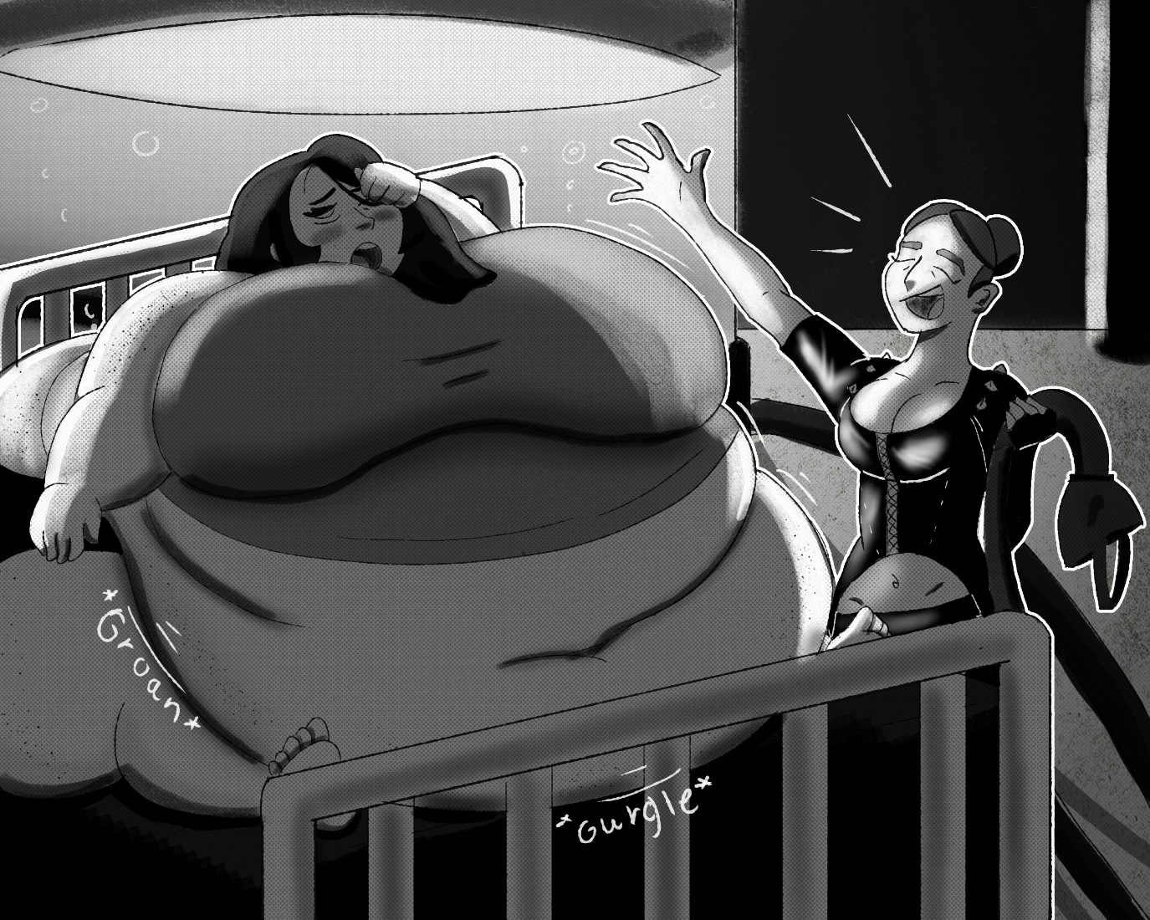
“Surprise!” Lanna threw her arms in the air, a smile on her face. “Her name is Zoe, she's 34 and I’ve been fattening her up for about a month, when I found her, she was only 140 pounds, honestly I think it’s some of my best work.” Cho couldn't believe it; Lanna had made this woman nearly octuple her weight in only one month? Wait, why was she thinking about that? A woman’s been KIDNAPED!
“Lanna You can't just kidnap women and fatten them up!” no matter how hot it is. Lanna waved her hand dismissively.
“Don't worry, I’m no monster. I always make sure to go for willing subjects, if they aren't willing at first, then I convince them, like this one here.” She slapped Zoe’s belly, sending a jiggle through her body. “I used to prescribe weight loss pills to her a while back. But she always confided in me that she only took them because of her husband wanting her to lose weight. So, I switched her diet pills with some appetite pills. After that she was so hungry all the time that she didn’t care what her husband thought anymore. Then I offered her the same deal I made with sweet little Stacy.” Stacy waved to her. “Abandon everything and devote yourself to me, then I'll feed you to your heart's content, and she agreed.” Zoe moaned in discomfort.
“Soo hungry, Lanna, can you please hook me back up to the feeder again?” Lanna arched an eyebrow at Zoe.
“Oh? Last night you said I fed you too much, and that you would never want to look at food ever again.” Zoe looked bashful.
“T-that was yesterday, I'm hungry NOW.” Lanna just chuckled at the gluttonous woman.
“You see Cho, I've been doing this for a long, long time, I've never gotten caught, hell I've never even been suspected. I must have popped something like…” Lanna went over them all in her head. “At least 60 by now.”
60? How is that even possible, how do you pull off feeding a woman so massive she burst without calling attention? Fuck 60 times? For some reason, Cho found herself feeling a bit… What's the word? Starstruck at Lanna. As If she was some celebrity now. Zoe spoke.
“That’ll never happen to me though, I can hold over 50 Gallons in this tummy. Plus, I have total *Urp* self-control.” she said haughtily, the belch jiggling at least 2 of her chins. “Now Come ooon I'm hungry!” Lanna walked over to Cho, who backed away slightly. “I was going to pop her tonight. But when I discovered your situation, well… I think you should do the honors.” Lanna said. Cho was utterly speechless for a while, before she looked down on the ground, and started speaking in a quiet wavering tone.
“N-no it's wrong we can’t…” yes
“It's illegal, it's immoral, it's” yes yes a thousand times YES!
Cho clutched her head. It felt like she was splitting apart. She could feel the different parts of herself warring inside her. She was confused, and horney, and scared, and frustrated, and jealous, and nauseous and she just wanted to throw up.
“Cho” Lanna said. Cho looked into Lannas eyes. “I know it may seem scary, so let's just take things slow.” Lanna raised her hands to Cho’s collar. “We want to make sure none of Zoe gets on our clothes. She began unbuttoning her. Cho tried pushing Lannas hands away, but she put next to no force in resisting. Eventually all the buttons were undone. “Don't you wish you could just let go?” Lanna asked, moving to undo Cho’s belt.
“Yes,” Cho finally said.
“Wouldn't it be great if you could stop hiding?”
“Yes” It felt so good to say it. The German woman's words were hitting every emotional chord she had. The desperate wanton lust she felt was unbearable, and she wanted nothing more than to just let it out. Lanna was busy undoing Cho’s slacks; the tiny Asians clothes slid off her like butter, Cho offering zero resistance now. Now Cho was in nothing but her underwear and shoes.
Lanna took Chos hand. “I used to be in the same position as you, always hiding, always being told I'm sick in the head, but then I got smart. Then I figured out ways to avoid the law, now I can pop as many girls as I want.” Lanna took Cho’s other hand and got even closer to her. “I can protect you! If you just do as I say, then we can pop as many hungry cuties as we want, together forever.” Lanna put Cho’s hands on her chest. “We're sisters Cho.” Cho looked into Lannas eyes, both not blinking.
“Give me the hose,” Cho whispered. Lanna smiled, as she handed it off. Cho approached the bed bound fatty, hose in hand.
“It's about time! I'm wasting away over he- BRALMF!” Cho stuck the hose in while the woman's mouth was open. She could literally feel herself vibrating with desire; if this girl didn't explode, then Cho would.
“HIT IT!” Cho said, Lanna eagerly obliged, flipping the switch on the big tank. Immediately it weared to life and began pumping a calorie rich slurry down the ginger girl’s throat. She moaned in discomfort, as the slop started pumping up her stomach. Glorps and gurgles could be heard coming from the girl's body, as it desperately tried to contain more food. “Oh, what's wrong? Piggy can't handle it?” Cho’s voice suddenly took on a bizarre and sinister quality; almost motherly, yet sadistic. As the girl drank, she started to grow. Only in her stomach at first, but eventually the calorie packed goop was making its way into her fat cells. Cho looked on in amazement “Wow, Lanna what is this stuff? She's fattening up by the second”. Lanna got a smug look.
“My new formula, it kills the metabolism almost entirely, while at the same time, keeping and accelerating the metabolic process of adipose cells and lipids to, well it's all very technical” Lanna said.
“Wow, just, WOW!” Cho squealed. Watching Zoe grow was audio visual, every time the girl gulped, she swelled a little more, and every time she swelled, her body let out a growl of protest. Zoe began to moan even louder, as she had already gulped down 5 gallons. “Oh it's ok piggy, mama Cho will rub your belly” Cho kicked off her shoes and pounced on the woman's belly.
“Ulk!” Zoe nearly hurled with the added weight, but with the hose in her mouth, nothing would be allowed back up. Cho was surprised to find that under a soft layer of belly blubber, Zoe felt quite full already. Cho smiled knowingly.
“You're such a little liar, you said you were hungry, but I can tell you were still full all this time”, Cho started rubbing Zoe’s belly, and gave her a very seductive look. “Oooh but you just wanted more anyway, didn't you?” the woman continued to moan in fullness, as Cho rubbed and squished her swelling whale of a body. Zoe continued to grow and grow, fat flowed from her like a fountain of hedonistic gluttony. No thoughts came from the fatty’s brain other than the overwhelming throbbing of her midsection. For minutes this continued until suddenly there was a creak coming from the bed, followed by a *CRASH* as the whole thing collapsed under the girl's gargantuan girth.
“OooooohhhhhUUUURRRRRP” Zoe belched through the tube the vibrations coursing through her and into Cho. Ooooh this fatty vibrates too, Cho likey. It seemed like the impact had shaken the woman up too much, because now the noises coming from her belly were growing much louder, as if a reaction were building up inside her.
“My my look. At. you. What a mess you've become. Breaking beds, belching up a storm, whatever will I do with- Oh my!” Cho was interrupted by the woman's body; she began to bubble up at an accelerated pace. The fall had clearly shaken the woman up too much, and now her body was becoming less stable by the second. The soft gelatinous fat, growing and growing inside her, was becoming too much for her body to contain. Her belly now completely covered her legs, her arms were blowing up like inner tubes, swallowing up her hands. Her body's folds and rolls were starting to round out.
“Too big, shoo full, sho round, I feel *Gurgle* weird” the girl moaned, her body firming up rounder and rounder. Cho smiled.
“Aw, feeling a little splody are we? Well don't worry it will pass” when you explode “just keep eating, that will make you feel better”. God Cho was loving this, feeding the students was great, but that never felt like THIS. no limits, no mercy, she was going all the way! Suddenly there was another creak, this time however, it was clear that it wasn’t from any bed. Zoe’s growth was beginning to slow down, much to her dismay.
“Can't gwow anymore, Can't Move, Oooooh Sho Fwuckin Faaaaaat! AH!” she yelped, as her belly button popped out with enough force to send a ripple through her roundness. The girl was now truly and utterly full of fat, more fat than person. Cho could feel her insides grow tighter and tighter and tighter, both her and the woman were hyperventilating, Lanna on the side lines was busy touching herself at the sight of all this, Stacy was in the back of the room, with a somewhat jealous look on her face but otherwise was just as turned on as everyone else. Cho looked at the gauge on the machine. 30 gallons. Zoe moaned, her eyes crossing. 40 gallons. Zoe’s breasts were leaking some cream from the sheer fatty internal pressure her jugs were under. 50 gallons and-
“STOP!” Cho boomed at Lanna. Lanna looked surprised but did as asked. The slop stopped flowing, and the woman let out a belch of relief.
“Oh GAWD that wash too much *GLORP* OOOOH I never want to look at food ever again.” Cho looked around for a moment. Where was it? Where was ah hah! Cho bounced off the whale of a woman and dashed over to her clothes. Lanna looked curious.
“Cho? What's wrong?” Lanna asked. Cho gave no answer, and after a moment she found what she was looking for. A chocolate bar. She immediately ran back to Zoe, now a belching ball of rumbling blubber.
“Hey, hey fatty?” Cho asked sweetly. Slowly, the woman grogley looked over at her, blinking dumbly. “Catch” Cho threw the unwrapped chocolate bar right on the girl's face.
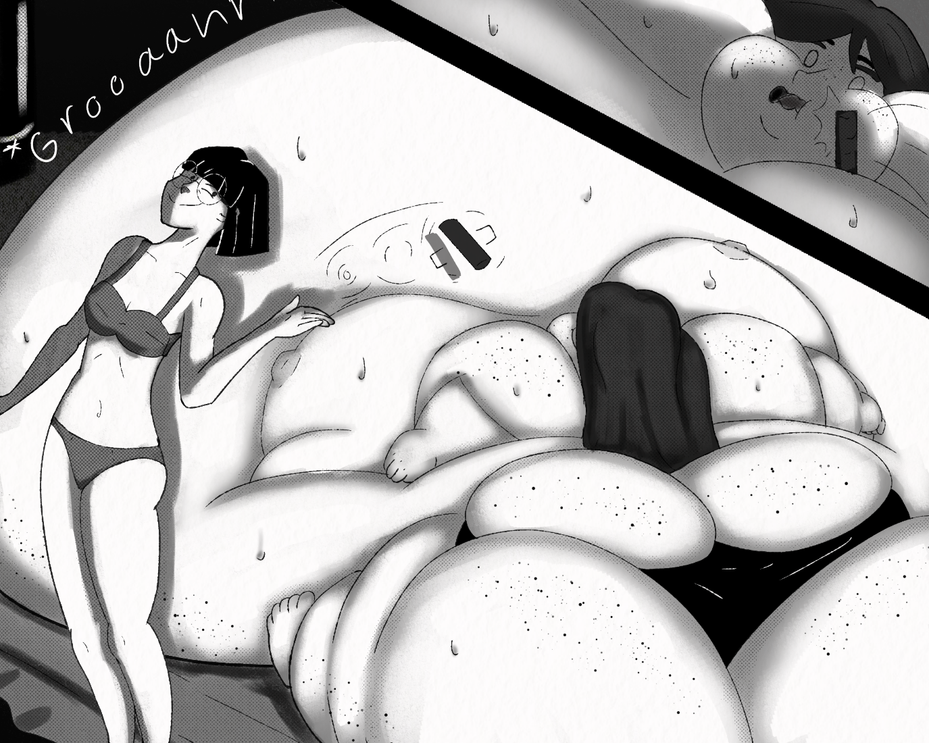
“NO, I'll eshplode!” the woman reacted to the sweet like Cho had thrown a bug on her face. she violently shook the thing off, landing it on her tits. “Get it *UUUUURRRLP* away fwom me!” The woman just looked at it now, fear in her eyes. When Lanna realized what Cho was doing, she Immediately started laughing.
“Oh, I like that, that's genius!” Lanna praised.
“What's wrong piggy? Don’t want it?” Cho asked with a hurt expression. This was her favorite part. Making a girl pop herself. She gently started rubbing the woman's firm yet spongy bulk, causing her whole massive body to shiver at Cho’s touch. “*Sigh* ok, you don't have to eat it, I can just rub your belly until it feels better”. And so, she did, for a while Cho just sat there, gently rubbing the woman's, throbbing, rumbling body; until.
“Ah, aaah” Cho looked over at the woman's face. she was desperately trying to get at the chocolate on her tits, her tongue desperately trying to fish for it. Her arms had blown up to useless dirigibles, so she had to try to reach the chocolate with her tongue. Cho recognized the look in the woman's eyes, not hunger no; but a wanton food lust that cared not for fullness or the limits of the human body. “Nom, mmmm” in one lunge, she scooped up the chocolate and swallowed. “Mmm chocolate…*Grumble* ooooh *BUUUUURRRP* OH FUUUCK!!!'' The woman quickly regretted her decision, as her whole body began to swell anew. This time it didn't matter if she stopped eating, her body was fighting a losing battle now, and gluttony was the winner. The girl just grew and grew out of control, Cho was now climbing to the summit of Mt.belly, and started animalistically humping and panting, lust completely overriding her other faculties.
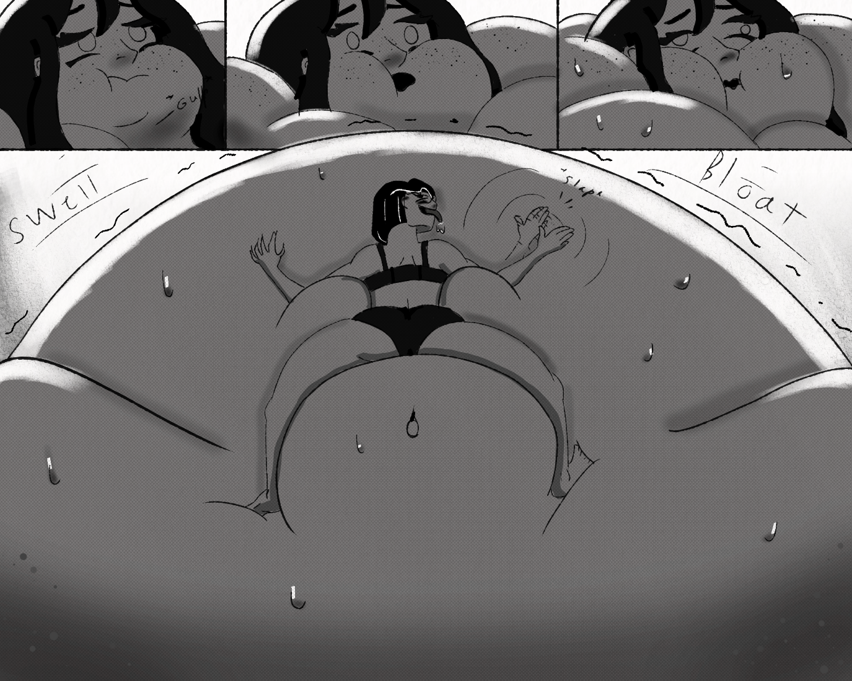
The woman's body could no longer contain the absurd pressure inside it, and now the goop was welling up her throat, and shot out her nose and mouth like a fountain. Her body started vibrating now, Cho heard a muffled SNAP followed by a big surge in growth, like a bomb went off inside her. Zoe’s stomach was turning red, and now Cho could see the veins in her body, as her skin grew thinner and thinner, and the pressure built and built and built and-
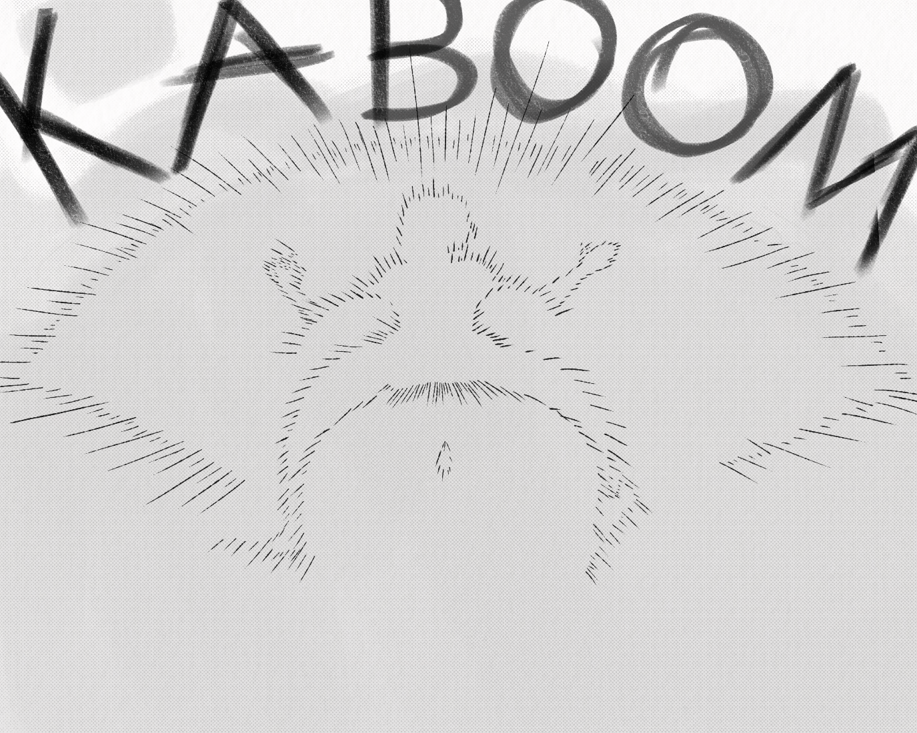
That was it, the woman's body exploded in a massive tidal wave of pink goop, nearly flooding the whole basement, and sending Cho and Lanna flying into the walls of the room.
…
Stacy was the only one still conscious after that. The goop left by the fat woman was flowing into the storm drains around the room now. She wasn't in the splash zone, but she still got some of the women on her converse. “Oh mistress, when is it going to be my turn?” Stacy wined to herself. Hopefully before prom. After that, Mistress would have to relocate. Stacy knew little of Lannas plans for Prom, all she knew was that it would end in a bang.

