The Glance Back  Inspired by a Captioned Image by TG-Alice  By Maryanne Peters  I suppose that glance back gave me a moment of pause. The fur trim on the wedding dress made it hard to see the rest of “her” face. Was it a look of accusation? Or was it gratitude?  I prefer to think that it is the latter, but I had complete faith in Jerome. I was confident that what I had started he would finish. I knew it when he pulled up he long dress as they headed for the limousine and place his hands on between her butt checks. Under the corsetry she only wore the tight gaff and chastity cage that was her destiny.  She was Marcia now. She was Mark when she was my husband, but now she is Jerome’s sissy wife, and he dream has come true. I still don’t completely understand, but I have moved on. I am now with a real man.  I thought that all of these weird “sissy” ideas were just evidence of latent homosexuality. I had no idea about it when we married – I just liked the fact that he did anything I asked of him. I just thought that he was a lovesick puppy, and power can sometimes blind you to reality.  But even now it is hard to comprehend. It was not enough that he should serve me, but he needed to be totally submissive, and sometimes that included some ridiculous maid outfit, and sickeningly obsequious behavior. It did sicken me. In the end I could not put up with it.  Then he started talking about being submissive to a woman was not enough – only a man could truly make him feel truly controlled and passive. I told him that I knew just the man. | 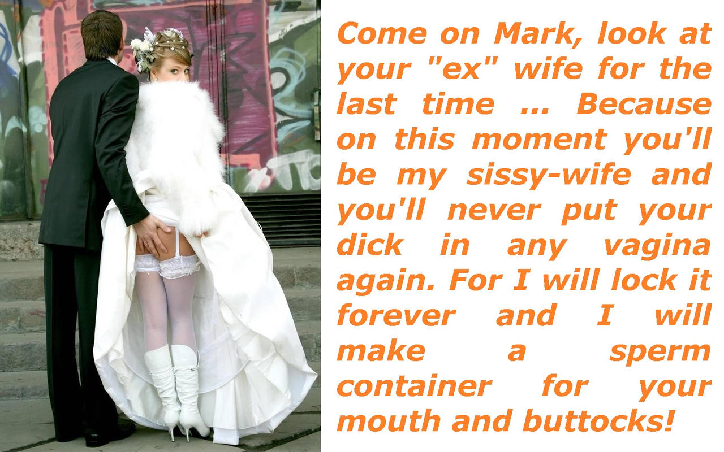

This is not the kind of thing that you discuss with a stranger. The truth is that I found the idea of divorce distasteful – it sounds like failure and I don’t like failure. But I needed male company, and Jerome was just one man. It turned out that he was not my type, but I liked him. But it turned out that I was not his type either – the kind of woman that Jerome really likes is not really a woman at all.

I happened to mention my husband’s strange proclivities and Jerome expressed an interest in meeting him.

Mark (as he then was) expressed reluctance in something of a panic as I recall, as if he suddenly realized that his urges were taking him to a place beyond his control. Yo see, the problem with being totally submissive is that you cannot say no – not to me and not to Jerome, nominated by me as my successor.

I think that look over her shoulder was the same that I saw every day I saw Marcia since Jerome took her away, a sort of pleading panic cry for help but at the same time the excitement of achieving yet another level of total submission.

But as Jerome pointed out, the divorce was no failure – it was a success for all concerned. I got out of being married to a whimp, Jerome got the girly whimp he wanted, and Marcia … well, I think she got what she wanted. Actually, I don’t really care if she did.

The End

Driving on Easy Street  Inspired by a Cap Image by SpottyCat44  By Maryanne Peters  Anybody who tells you that a school can take a regular guy and turn him into a simpering sissy who wants to be a girl, is feeding you bullshit. Who would believe that? No, not me. I am that way I am because it works for me. It is that simple.  My father’s new wife Nora sent me to St. Magdelena’s School for Wayward Boys after my last misdemeanor. It was that or jail, so it was not like I had any choice.  Choices – I have had time to think about those. It is true that I was heading for a life of crime. Why? I suppose I was just lazy. Getting things by taking them is just so easy. Working seems so hard and the rewards so small that it just seemed dumb to me. Why not just take what I want. That was my choice, and I would have kept on taking until I discovered that there is a way to get whatever you want without getting into trouble. You just have to find somebody who will give you whatever you want. It is not a crime to receive. That is what I do now. | 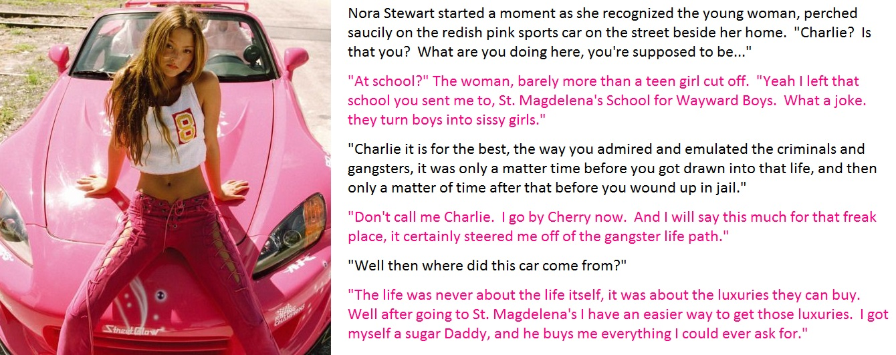

If there is one thing that I learned from St. Magdelena’s School for Wayward Boys it is that boys don’t receive anything except a beating – you have to learn to be a sissy and then a girl. Some sissies get what they want; most girls get exactly what they want. The school taught me all I needed to now about how to be attractive to men and how to be passive and yielding. They had example of successful alumni to follow – fully transition girls and one or two male-organ-intact sissies who were living the life others can only dream about.

I wanted to learn and learn fast, and then put those lessons into practice. For the first time in my life I put in the effort, and I got the reward.

I put myself out on the web as a sissy / potential transgirl seeking a man with everything who was “ready to give it to me”. I got lots of responses. I had to check out a few creeps before I fastened onto my sugar daddy, and fasten on to him I did – like a leech.

You might think that leeches are nasty creatures, but hey, they have to live like any other animal. The way I figure it, it is not their fault that they are a leech. A leech has got to do what a leech has to do. It is not my fault I am the way I am.

And my sugar daddy, it guess he is the way he is by nature too. He has to give to be happy. He gives, and I receive, and we are both happy, provided that we use lubricant.

The End

Blue  Inspired by a Feminine Beauty Within Cap  By Maryanne Peters  My sister got to choose the punishment because I had almost completely ruined her wedding. I spilt paint on her wedding dress and if it had not been for some swift work the day before the wedding, she would have had nothing to wear.  It was not deliberate. It was genuine accident, but I am not sure that she ever accepted that. I had been going on about it being such a ridiculously flouncy and femmy outfit, so I guess she felt that a punishment should pick up on that. The fact is that the whole household was full of flowers and frills, in anticipation of the wedding.  “You will be joining the bridal party as my little sister,” she announced.  My mother was just standing there staring at me disapprovingly and nodding. I was stuck. It was a lame protest to say: “As long as I don’t have to wear pink like the rest – I will wear blue.”  So this is the outfit. Little blue dress and 4 inch blue heels, set off with a posy of pink flowers.  And the hair? The bride wore her hair down and everybody in the bridal party had to have hair the same length. That meant hair extensions for me and another bridesmaid. In my case in a shade not far from my natural color, with a soft curl.  Make up was all done together too. I had no say in the matter. The bride calls the shots. It is her day, and she wanted everybody in her party to look fabulous. | 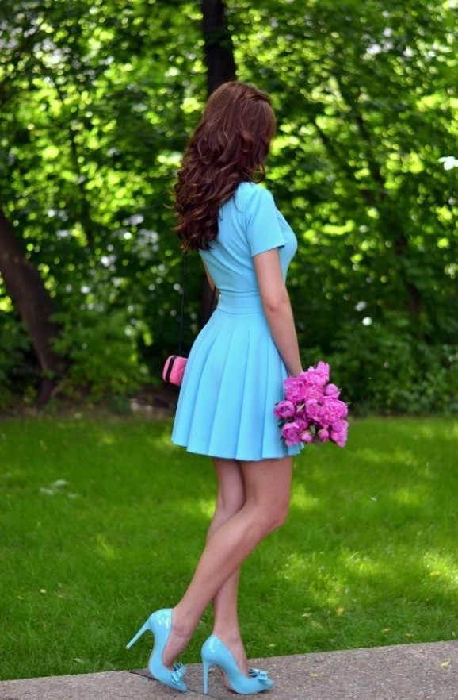  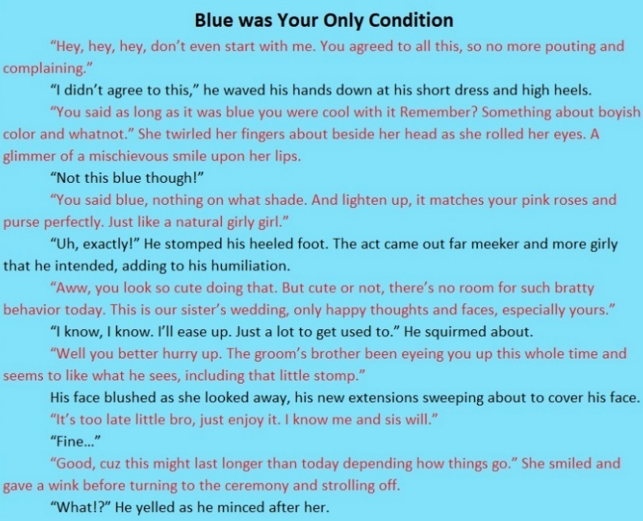

We all had a professional makeover. The problem was that it was too good. My sister looked great, and so did her two bridesmaids in pink, but it was the third bridesmaid – the one in blue – who stole the show, if I say so myself. In heels I was the tallest, and that made my dress the shortest. How was I supposed to know that my legs would look so good in heels? How was I supposed to know that my facial feature would look so stunning with the addition of color and shading?

The problem was that I sort of fell in love with the girl in blue. I just looked at her and decided that she was a beautiful woman and that she should act that way. It all came easily to me for some reason.

And I was not the only person who fell in love with the girl in blue that day. My sister was right about her husband’s brother. I thought that explaining to him that I was not a real girl would put an end to his flirting with me, but it just seemed to encourage him.

Blue is still my color, but probably a lighter shade for my own wedding dress.

The End

Kilty  Inspired by a TG Alice caption  By Maryanne Peters  I was proud of my Scottish heritage and so when I visited Scotland a few years ago, I decided to buy some tartan of the clan whose name I carry – Clan Hepburn. I have to say that when I saw the pattern of it in bright red, I was moved somehow. I ended up having two kilts made from it – one what they call a full kilt with a throw over the shoulder and the other a modern kilt. There was enough fabric left to make a kilt for my wife, so I had that made too.  I went a little crazy and bought the white shirt with the dress front and the coat, and the belt and sporran and socks.  The people at the shop said to me – “If your wife has the tartan dress then we have an outfit that will match yours exactly – why don’t we add that to your bill.” So I bought that too | 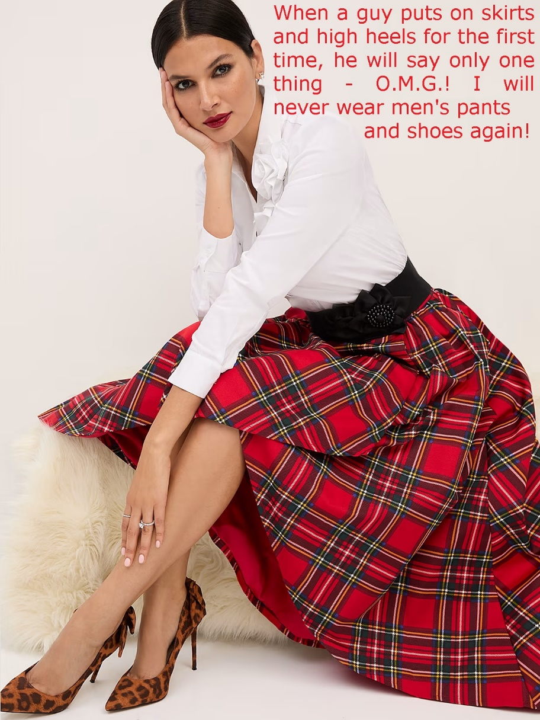

She hated it. In fact, she hated it so much that she broke into a rant against everything Scottish.

“I don’t like whisky. Bagpipes sound awful. The idea of eating the boiled stomach of a sheep is disgusting. The Scots are a bunch of primitive sheep and cattle herders known only for being drunk and blood thirsty. You wear your kilt if you like, and you can wear this one too.”

Isn’t it funny that a man’s kilt and woman’s kilt are basically the same garment but the one can make you feel like waving a sword and charging into battle, and the others can make you feel the need to shave your legs?

It just lay there, as if calling me to slip of the male version and try female. The urge was odd, but the effect totally unexpected, and even supernatural. When I wore tartan for the first time I felt in touch with my ancestry somehow, but when I wore a woman’ garment for the first time it was like being in touch with my own soul. I had Scottish ancestors but a feminine soul.

I felt more Audrey Hepburn than a Laird of Hepburn.

This is what I look like now – totally at home in my new gender – newly divorced and newly surgically corrected. You’ll never see me in anything other than skirts and heels from now on.

The End

Debutant  Inspired by a Cap Image by SpottyCat44  By Maryanne Peters  I understand now that there is no history of dizygotic or fraternal twins in my family. That means that mother was not hyperovulatory and more likely to produce more than one egg, and it puts the chance of me being a monozygotic or identical twin higher than being a fraternal twin. But that didn’t happen. If I had been an identical twin I would have been a girl, just like my sister.  My mother always said that twins were special and also might share a special bond, but fraternal twins are just siblings who happen to have been born together. Knowing that seemed to rob me of something.  But we didn’t know this when we were younger. If we found that we did not have that special bond then we were determined to build it. We did lots of things together. We wanted to wear clothes that were the same, but of course that meant both of us dressing like boys. It would have been silly for me to wear girls clothes, except when we were playing “princesses” which was our favorite game to play. Somehow we were closest when we were both princesses. | 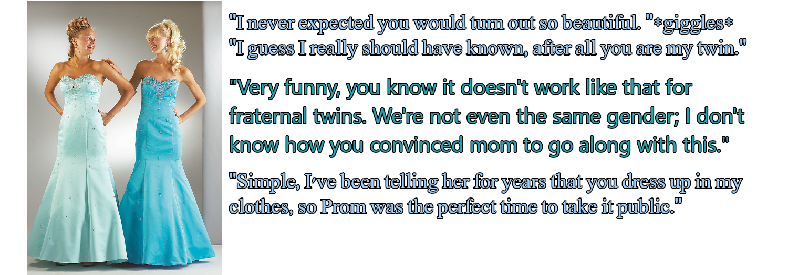

I had to watch as my sister grew into a beautiful young woman, while I became more an more male. It was like fate was driving us apart. When were little and both wearing boys clothes people might think that we were identical twins. Now it was clear that we weren’t. We weren’t special anymore.

It is true that I did put on my sister’s clothes from time to time, but it was not like I was driven to do it. It was just like trying to recapture the moment when we were truly twins – like grown up princesses. But I found that I envied my sister. She seemed to always look great, always be surrounded by supportive friends and always be happy. I was a boy in constant competition with other boys or being teased for not being manly enough. It was like a horror movie where I was in the body of a beast when I wanted to dance like a princess.

“I think you could be transgender,” my sister said to me.

“You think so? I am not so sure,” I told her. “I wish I had been born the same as you, and out of the same amniotic sac so we could be real twins, but that doesn’t make me trans … does it.”

“The thing is that we can’t change your chromosomes,” she said. “But you have always been more like a sister than a brother to me. Maybe you should see whether that it what you really should be?”

“I couldn’t do that while we are at school. That would be crazy.”

“Well maybe at graduation time? We could go to the prom together as twins. What do you think?”

It seemed like a crazy idea, but the more I thought about it, the more I liked it. At our school there was a tradition of some people doing some crazy things at prom, and this could be that. Even if I just spent the night as a girl maybe I would learn something about myself. Or maybe it would change my life. Either way it was a way to make a public statement about how close we were, my sister and me.

She arranged everything – the matching dresses in blue, but different shades of blue, the hair and makeup. All I had to do was to grow my hair for a few months so it could be styled – in my case half down and half up in curls on top. And before the big night we both got waxed and worked on our deportment.

My sister arranged for us to take as our dates the Haversham twins – identical twin boys from another school who had their own prom the week before and were up for a bit of fun.

To get our mother on board my sister had to “out” me as trans, which seemed a little premature and sent our father into a tailspin, but I corrected things by calling it “experiential”. But even before the big night I started to get so comfortable with my feminine persona that I started to wonder if I might really be female inside.

I suppose what settled it was prom night. I mean, I think that we both look great – what do you think? And the whole night it was like I cold just look at my sister and know what she was thinking and she could knew what I was thinking. The Haversham boys were the same – I mean thy knew what they both wanted, and actually we knew what they wanted too.

Somehow the fact that I had something ugly firmly restrained in my panties did not seem to worry my date.

“We have always wanted to date twins, my brother and I,” he said. “And we have always wanted to … you know?”

I looked across at my sister and she nodded. It confirmed that we are twins, and we are sisters.

The End.

© Maryanne Peters 2023

