The Lesson  Inspired by a Tiffany Captioned Image  By Maryanne Peters  “Do you follow baseball, Tim,” said Glen Pilkinghorne to the smartly dressed young man seemed a little nervously in front of him. Glen went to the comfort of his reclining armchair.  “I do sir,” said Tim, forthrightly.  “Are you a betting person, Tim? Because if you are, let me tell you that there are always consequences from making a bet.”  “I don’t generally gamble Sir, no.”  “Chris is a gambling person … or was,” said Glen, looking up at the ceiling. “Made a bet and lost. You don’t think that it is unfair of me to hold Chris to a bet, do you?”  “I am aware of the bet that you are talking about, Mr. Pilkinghorne. She has told me about it.” | 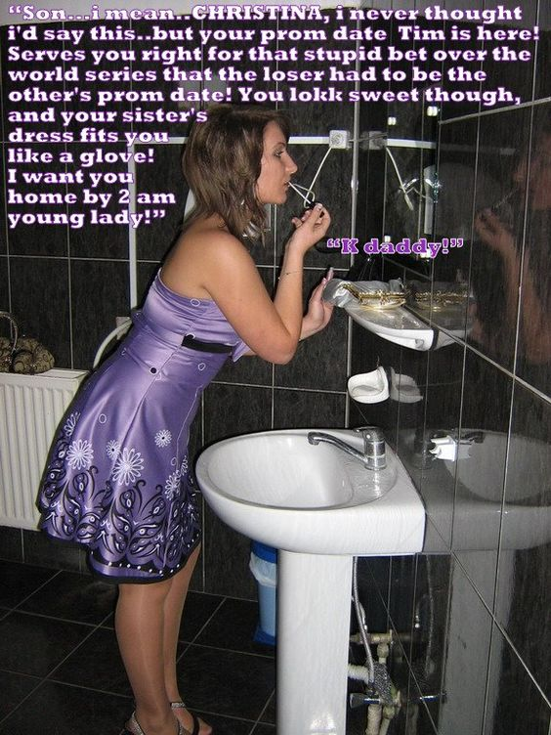

“Well, I am glad that she has,” said Gary. “I don’t think a fellow should be deceived. That would not be right. You know what she can and cannot do?”

“I know that she has physical limitations, Sir, but it is nothing that we cannot work around.”

Gary had to admire the directness of this young man, even if his choices confused him. Then he suddenly realized that a work around might refer to sexual anatomy.

You know that Chris is a virgin … in that respect?”

“I respect your view on that, Sir,” said Tim.

Gary frowned. What did that mean? Was it that the boy believed that somebody in Chris’s position could not be a virgin? Or was it that whatever virginity there might have been what already lost? Chris had adopted this new persona well ahead of the prom that very night, and that persona was overtly alluring and sexual. Any young man might be turned on. Some may even be able to forget that under the smooth body and extended hair, Chris was not a girl at all. But what did that say about Glen as a father? He had held his son to a bet that may have lined the child up to be on the receiving end of sodomy, and all just to prove a point.

“You understand that after tonight, the bet has been satisfied – right?” said Glen, leaning forward. “Chris will go back to being a boy, and you will be looking for a real girl to date.”

“Sir, I don’t wish to upset you given that your daughter is in my care tonight,” said Tim. “But I think that you should be aware that after tonight and with Chris’s obligation to you discharged, it might not go the way you think.”

“What are you saying?” said Glen, but he knew.

“Chris is a woman now, or she soon will be,” said Tim. “She has discovered herself, and I have discovered that I am in love with her. Maybe I was even before the bet was made, which I was confident that I would win. She was confident of that too. In fact, if she had won, we probably would have switched things around to say that she lost. She knows your views on wagers.”

Glen felt a fury rising, but when he followed Tim’s distracted stare and saw his beautiful daughter descending the stairs on her prom night, somehow it did not seem to matter than he had been used.

The End

The Point of No Return
Inspired by a Captioned Image by Tiffany
By Maryanne Peters

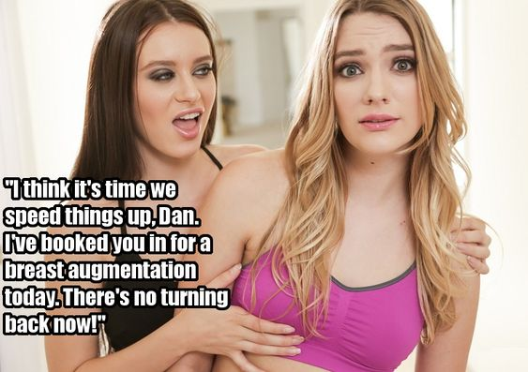

People tell me that it happens all the time. There were even images and videos on the internet. “Girl feminizes boyfriend”. It’s a thing. It is not always latent lesbianism. Sometimes a girl just wants to have fun. Sometimes girls who are obsessed with beauty the way she is want to play with their metrosexual boyfriend like some kind of real-life Barbie doll. It does happen.

When it was just styling my long hair and applying a bit of make up and then us going shopping together as besties that seemed like a fun thing. But then winter turned to summer and I needed to have smooth skin to wear skimpier clothes – smooth skin and a more feminine shape.

With everything I have learned about hormones since I never would have agreed. She just said that it would help me keep my skin and hair looking good and help held with body hair. I just hated the waxing so I agreed. She didn’t tell me that it would leave me impotent! She didn’t tell me that I would grow tits!

Suddenly I was unable to function as a man, but she seemed even more turned on, so I just went along with things. Maybe the hormones played a role in that too. I seemed to have loss the ability to rebel, or at least the inclination to do it. I just let her call all the shots.

She had me color my hair and use a female name - Danielle. The changes just kept going.

Then she started talking about the breast implants. She has a great pair of tits, but I don’t have much. I never even wanted tits.

“But guys like a girl with big boobs,” she said. “And two guys like two girls with big boobs. What chance have we got with you carrying a pair of grapes where you should have melons.

“Guys”. That is what caused the look of shock on my face. She wants us to double date as besties! Of course, I was horrified. What happens when after a guy has bought me drinks and a meal and has told me that I am beautiful, he gets me into bed and discovers that I have a cock?!

Well, I suppose we are going to find out!

The End

She’s All Mine  Inspired by a Captioned Image by Tiffany  By Maryanne Peters  I met her when she was a man but dressed as a woman, as she did on occasions. Even after I learned her secret I was smitten.  She explained her family situation and that she was bound to a wife who did not love him. They had not been intimate for years so she was now able to grow her hair out a bit, keep her body shaved and even experiment with hormones, but leaving the marriage was not an option. They depended on her family’s money, and they were religious and opposed to divorce.  It seemed to me that what I needed to do was to have her wife Julie end the marriage. It was just a question of how to arrange it.  The first thing that we needed to do was to arrange for me to meet Julie and then get close enough to her to get her talking about her marriage and how to end it. | 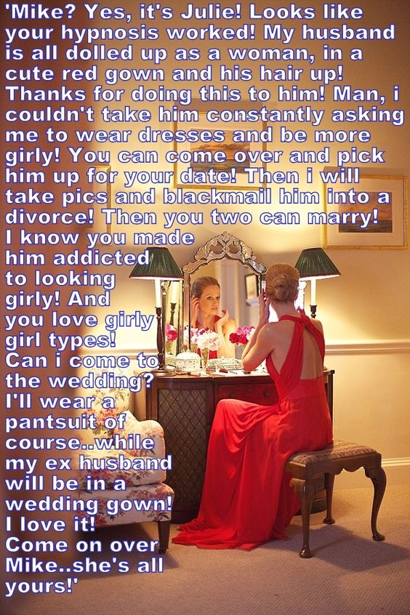

It did not take too much effort to do that. I hid the fact that I knew her husband and explained that I was a hypnotherapist and a good one. Immediately Julie started to think about how she could use my abilities to free herself of her unwanted husband.

“Could you hypnotize somebody into anting to kill themselves or take crazy risks with their lives?” she asked me. I knew then what kind of person I was dealing with and how I had to free the woman I adored from this harpy.

“No, we have codes of conduct,” I said. We would never place a life at risk.

“I was just curious,” she said. “But I do have a husband who is a problem for me. Could you hypnotize him into being unfaithful? Actually, forget that, I am not sure that he could do that, and even adultery is not a grounds for divorce in my family. I need annulment, you see.”

“Ah, the religious issue!” I said, pretending to ponder for a moment. “Well, annulment can occur if your husband does not meet the requirement for a church marriage. For instance, if your husband was not a man.”

“What are you talking about?” she said.

“Well I am not saying I would do this, but if I was to hypnotize your husband into believing that he was transgender and wanting to change his sex to female, then the church would find that he could no longer be your husband. But this would be a breach of my ethics, I think?”

“How much?” she said. “How much money do you need to put your ethics to one side?”

Of course, no hypnosis was needed. I would not know how to do it. All I had to do was to say that I had met her husband and hypnotized him into wanting to be a woman.

It was only later that she explained that he was always suggesting the clothes that she might wear as if trying to live his female life through her. That did not matter to me. One of the things that attracted me to her in the first place was her hyper-femininity.

She kept talking about blackmail, but as I said to her, that was unnecessary. Once the surgery that my Darling begged for was done, theirs was no longer a marriage between a man and a woman and no longer countenanced by her parents church. There could be an annulment and a reasonable property settlement and they would both be free.

She ended up footing the bill for the surgery, and my fee was also very healthy given what I had achieved for her; and my lovely fiancée has a chunk of money as agreed.

And now she is all mine, and yes, I am happy to invite Julie to the wedding.

The End

Kissing Men
Inspired by a Captioned Image by Tiffany
By Maryanne Peters

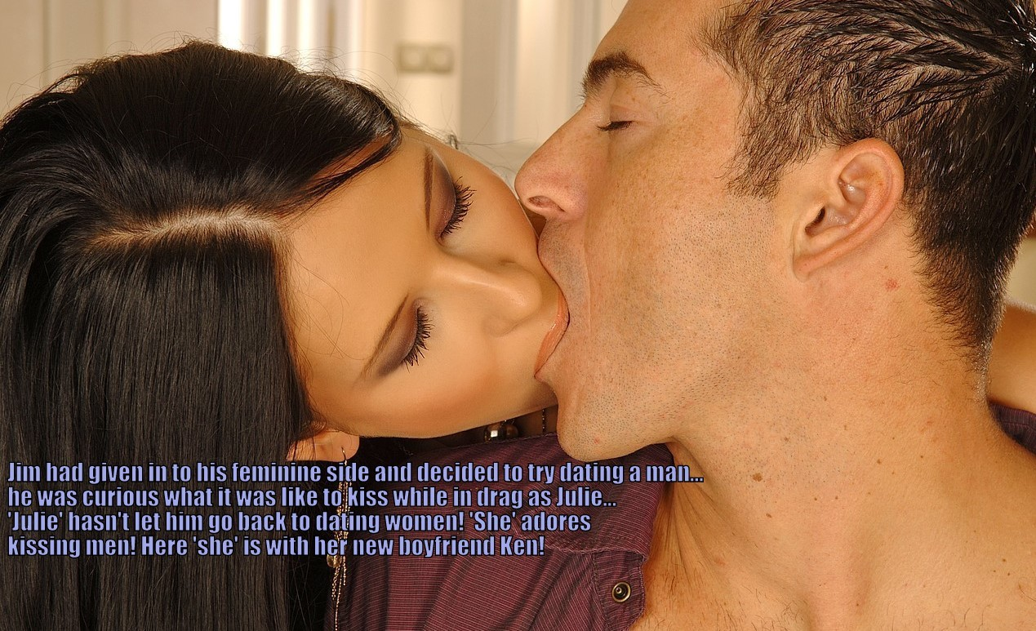

Do all men have a feminine side, or is it just men like me? I love women and I dated plenty. I can relate to them on a level that most men can’t and I never really understood why. It was just that somehow I was never able to develop long term relationships – or at least not sexual ones.

“I really like you, Jim,but more as a friend that a boyfriend.” I don’t know how many times I heard that being said to me, or something similar. It is the kind of thing that girls say to a gay man, who maybe is not sure whether he is gay.

For me, I never believed that I was – gay, I mean. Generally I think of men as being unattractive. Muscles and heavy feature faces have never been marks of beauty for me, on men and on my own body. Does that make me strange?

I have nothing against gay men, but somehow the idea of a man kissing a man has always seemed wrong to me. Like beard on beard, stubble on stubble – it seems unnatural. I had very little facial hair, and I kept it that way.

Maybe I was even a little in love with myself. I liked the way I looked – attractive but not in a particlarly masculine way, but not pretty either. I had nice hair too. It was straight and dark, like my mother who was half Korean. I liked to keep it long but tied back. I think long hair is sexy on a man, and I was happy to care for it, and for my skin.

I don’t know where the idea came from, but I started to wonder how kissing a man, or more particularly, being kissed by a man, might be different from kissing a girl. I know that you see agresssive female kissers on the movies, but I never seemed to date one like that. As for myself, I am a very gentle kisser. I somethings think that the mee brushing of the lips and a slight exchange of breath can be the sexiest of kisses. But what would it be like to be kissed by a man.

I just knew that it could not be a gay kiss. It seemed to me that the kiss I wanted to experience was the kiss that a man might give a woman. That is why I invented Julie.

She came into existence by accident. My cousin’s girlfriend was throwing out some clothes and I offered to drop them off at the charity shop, but I could not resist going through some things first. I just decided that I would keep the stuff and drop it off later. It seemed like everything was there for a complete outfit, as if dropped into my lap by fate. I could dress as a girl and go on Tinder. Just for one night. It was just meant to be an experience – once only.

I bought some makeup online and played around with it in front of the mirror. I was surprised how color and contrast as described in the YouTube tutorial could have such impact. It made me wonder why men don’t use makeup. It really does make a difference, even just a little.

I took some profile pictures and siged on to Tinder as Julie.

Ken was not the first. I met another guy and we had a drink but I just did not feel right. It made me wonder if the whole thing was a bad idea. It was like the male me was telling me that this was a bad idea and I should back out. I should ditch the cosmetics and give the clothes to charity as intended, but I figured that maybe I would it a second try.

The moment Tom walked into that bar I was all aflutter. I know what that means now – it is like your heart starts racing and you feel almost faint. He was nothing like the man I had been. He was so masculine he had like a forcefield around him. He kissed me on the cheek and I could smell him and feel his whiskers on my plucked cheek. I wanted to kiss him then and there.

We had dinner and we talked, but don’t ask me what about. Maybe I didn’t say anything and just watched his lips move and his toungue bounce around inside his mouth, craving that it shoud be inside mine.

At the end of the evening I kissed him, or rather I let him kiss me. He was so powerful that I seemed as his tongue could reach way beyond my mouth – maybe right into my belly. I just let him enter me that way, and surrendered to him. I don’t think that I have ever been that thrilled in my life. It was not a sexual thrill, which is just as well because I was tucked har into shaping panties. It was the thrill of being dominated and held in the arms of a man who die to protect his girl.

I suppose I became just that, that night. I had a lot of explaining to do, of course, but there is nowhere I would rather be.

Have you tried it? Kissing men, I mean? It is a revelation.

The End

Team of Three  Inspired by a Tiffany Caption  By Maryanne Peters  Sure they had a point to prove but it is just when you share a small place like ours, there is no room for being the odd one out. You just have to fall in with the others and be a team of three.  I just thought that I had lucked out bigtime to be sharing with a pair of hotties. They said that they chose me to join them because I seemed to be a gentle and unassuming guy, rather than some macho brute.  It was only after I had moved in that they told me that they were both dudes, or at least they used to be. Yeah, I laughed. It was better than abusing them – right? I was, I suppose “less than understanding”. Anyway, they were not happy. They said that I needed to know what they had been through before I could make fun of the. | 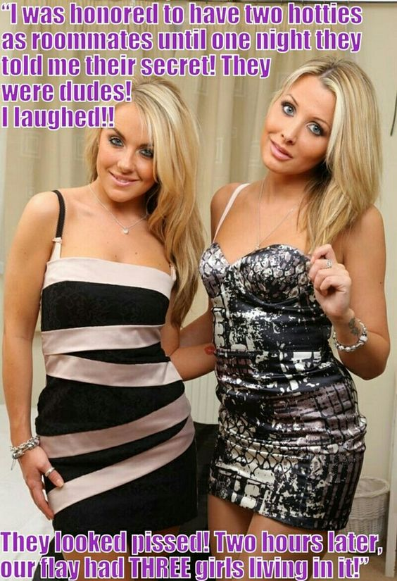

It was not like they forced me or anything. They just said that I should submit to a makeover and they gave me a girls name. They have not used any other name since. When they were done they said that our flat was now occupied by 3 girls, me being one. I went along with it and did the mincing walk and the limp wrist, and they told me off for that.

“We are not drag artistes! We are transwomen.” I had been scolded, and not for the first time.

Still, I went to work as a guy on Monday just like nothing had happened, but when I got home I was one of the girls. It was like our thing. I was the same size and we shared clothes and even shoes. Somewhere along the line I ended up sharing hormone doses as well, and slowly but surely the maleness drained out of me, and I ended up just like them – blond and sexy.

That means going out on the town together – the team of three. We go looking for guys. Initially it was just a way to get free drinks and maybe a meal or a lift home – together of course. The team works together.

But then I started to get into guys. Maybe it was the hormones, or maybe it was like, peer pressure, or whatever. I mean, we do everything together, even get fucked together. We are the team of three.

The End

© Maryanne Peters 2023

