- Typos/Grammatical Errors
  - moths
  - 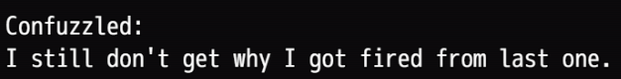put (the) in between “last” and “one”
  - Suggestion: put “for” before “now”
  - comma after second yeah, change “on” to “in”
  - 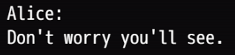comma after “worry”
  - 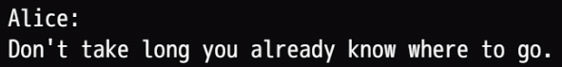Suggestion: add “too” after take, comma after “long”
  - Suggestion: maybe change instances of “gonna” to “going to”
  - 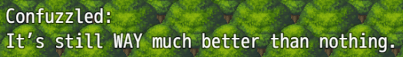weird phrasing. Maybe change “WAY much” to “a lot”
  - 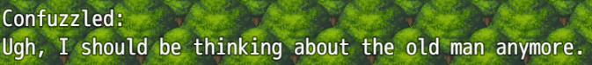”shouldn’t”?
  - 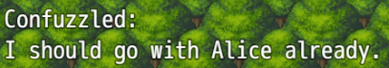 implies he’s already with Alice. Change “with” to “see” or “find” or something else
  - change “much” to “many”
  - 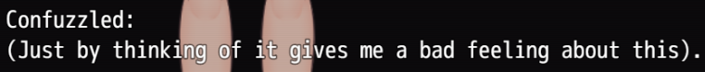Suggestion: kind of wordy but not incorrect, maybe change “thinking of” to “remembering”add “...” to the beginning and remove capitalization to the T in “That”. Sounds like he is continuing from something
  - 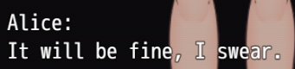change the period to a exclamation point, sounds more appropriate
  - add “do” after “Why”
  - 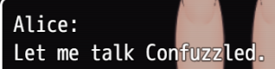The text box before this one should have “...” at the end since the protag is getting cut off by Alice
  - change “on” to “in”
  - 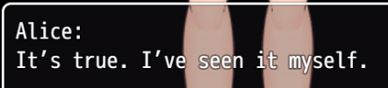 Suggestion: change the first period to an exclamation point
  - 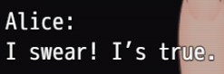”It’s”
  - change “one” to “ones”, change “can” to “could”
  - 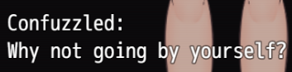change the sentence to “Why can’t you go by yourself?”
  - double space in between “rope” and “something”
  - 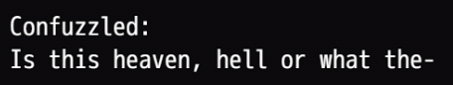add a comma after “hell”
  - delete space before question mark
  - 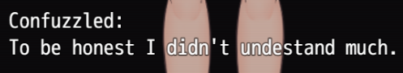missing r in “understand”
  - add a comma after “later” or make this two sentences
  - 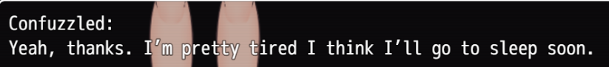add a comma after “tired” or make this two sentences
  - delete “than”
  - delete the first comma
  - 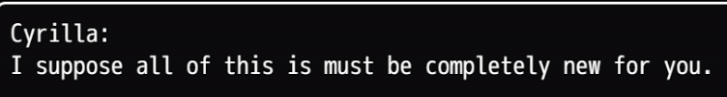delete “is”
  - double space after “it”
  - delete “to”
  - double space after the first sentence
  - double space after the first sentence
  - change “where” to “space” or something else
  - change “don’t” to “not”
  - remove the “e”
  - 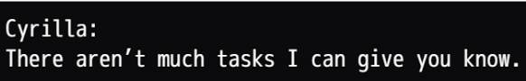change “much” to “many” and “know” to “now”
  - 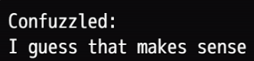no punctuation
  - generally broken sentences. You can ask me later for clarification
  - 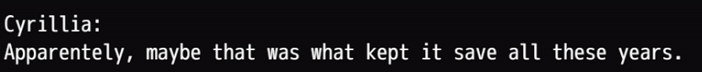change “save” to “safe”
  - make this one sentence
  - misspelled because twice
  - change “warmth” to “warm”
  - delete the first “if”
- Gameplay errors
  - 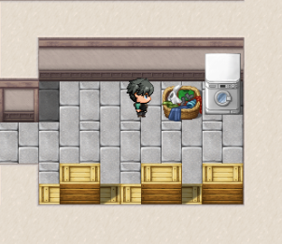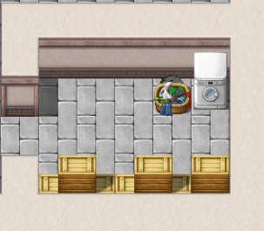 can walk into laundry
  - 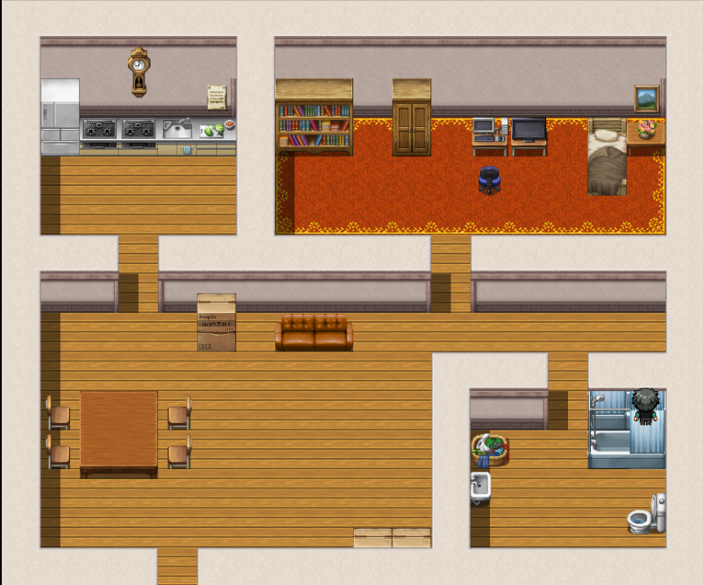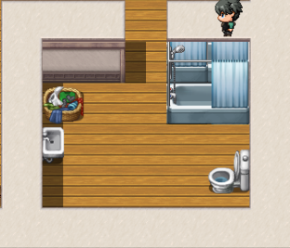 can walk into shower and through the wall

