Reliving Mom’s Life  Inspired by a Captioned Image by Tiffany  By Maryanne Peters  People cannot believe that it started like that.  “How could your mother think that you were a cross dresser? Like, you used to be on the track team – a jock?”  I am starting to wonder now if she was planting stuff in my brain. It was in my drawer, so I just took it down to her when she was doing the laundry.  “No Sweetheart, that’s not mine. I would wear nothing that youthful, with the C cups but the wide back. Oh Sweetie! It’s yours! You should have told me!” | 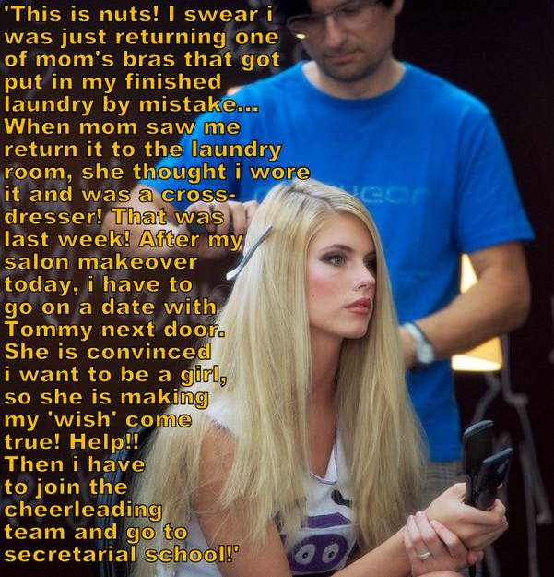

I had no idea what she was talking about. It was not mine. I swear it wasn’t. Why would I have taken it down to her? But it wasn’t hers, and as she showed me - it fitted me perfectly.

“Sweetheart, I can understand why being transgender is something that you would want to keep secret, but it will do you no good to hide your true nature. It will just lead to depression. I want you to know that I will support you through all of this. I can help you to make your wish to become a girl, come true. But we need to get on with transition. We need to start you right away. You need proper medical advice. I will tell you what to say. Then you need blockers and hormone therapy. But the first thing you need is a makeover.”

She seemed to know all about this stuff. I did not have a clue what she was talking about.

The next thing I knew she had booked the makeover. Then she told the school, and the school told everybody. Mom said that I needed to take a few days off so we could work on things, and the school agreed. Staff and students would need to be briefed on how to accept a trans-girl in their midst

I have to say that I did need time away from the guys. It all just got on top of me – the confusion and the salon and everything. It took me a while to come down and start to think about what was really going on.

But by the time I did come down I had lost my athletics scholarship and Mom had enrolled me in the secretarial school she wished that she had gone to. She said work as secretary was the way to find a rich man – something that she was never able to do. And then, before I knew it, I was going out with Tommy from next door, the young man set to take over his father’s business after college.

“If you were to succeed at secretarial school, you could go work for Tommy and then you could get married and have a happy life. You could succeed where I have failed. I just want you to be happy, Sweetheart. Dumb athletes don’t succeed beyond high school, believe me. But with the body you will have and that face, that hair. You are going to be a success, my Darling!”

The funny this is, that however it started, things seemed to be going just the way Mom planned.

The End

© Maryanne Peters 2022

His Bitch  Inspired by a Captioned Image by Tiffany  By Maryanne Peters  I just wanted somebody to take charge – is that so wrong? Some guys lead, and other guys follow, and others … well, they are not even guys at all.  He told me that it was embarrassing having me tagging along behind him all the time – “like a lost puppy”, he said.  I suppose he thought that if I was dressed like a girl, it might be easier to explain, even if he only dismissed me as – “Oh her! That chick just follows me around. What is a guy to do?”  He made me a bet – I lost I would have to dress as a girl for a month. I knew I was going to lose. I wanted to lose. It was not that I was interested in beig a girl – at least not then. I just wanted to be with him. And he was right – it was easier to be his girl than a submissive follower.  But the hormones changed everything. They were my idea, but they turned out to be a master stroke. He started to see me differently. He started to see me as a girl. | 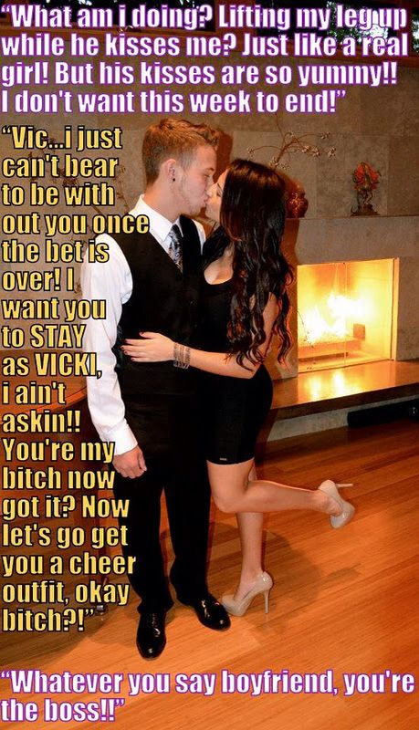

“The puppy has grown up,” he said. “Now she is a bitch. She is my bitch.”

He let me touch him. It was more than I could have dreamed of. And then he kissed me. It was amazing! I felt that I was no longer in control. If I had only been acting as a girl up to that point, when our lips parted and I tasted his tongue, I was a girl. I was his girl. His little bitch.

The End

Cannot be Stood Up  Inspired by a Captioned Image by Tiffany  By Maryanne Peters  Larry set his sister up to be my date to the prom. I wanted a date, but for some reason I was having trouble finding somebody. I guess I am particular about the kind of girl I hook up with, but his sister was willing and she was tidy – a great body.  But then I got the call - she said that her leg was in plaster, but I never got to see it. What I wanted to see was that dress I got for her on her body and those shoes too. I like the girl I escort to look great. It reflects on me. I have an image to protect.  She said that her cousin Laura would go as my date as she could barely walk, let alone dance. She sent me a picture of Laura. She sure looked good, but they can do things with photos. I figured that I could always turn my back if she was not up to my standard.  “Sure,” I said. “I will send a limo around. Make sure she is in it by 6:45. And make sure that she is wearing what I sent, and gets the $500 makeover I paid for.” | 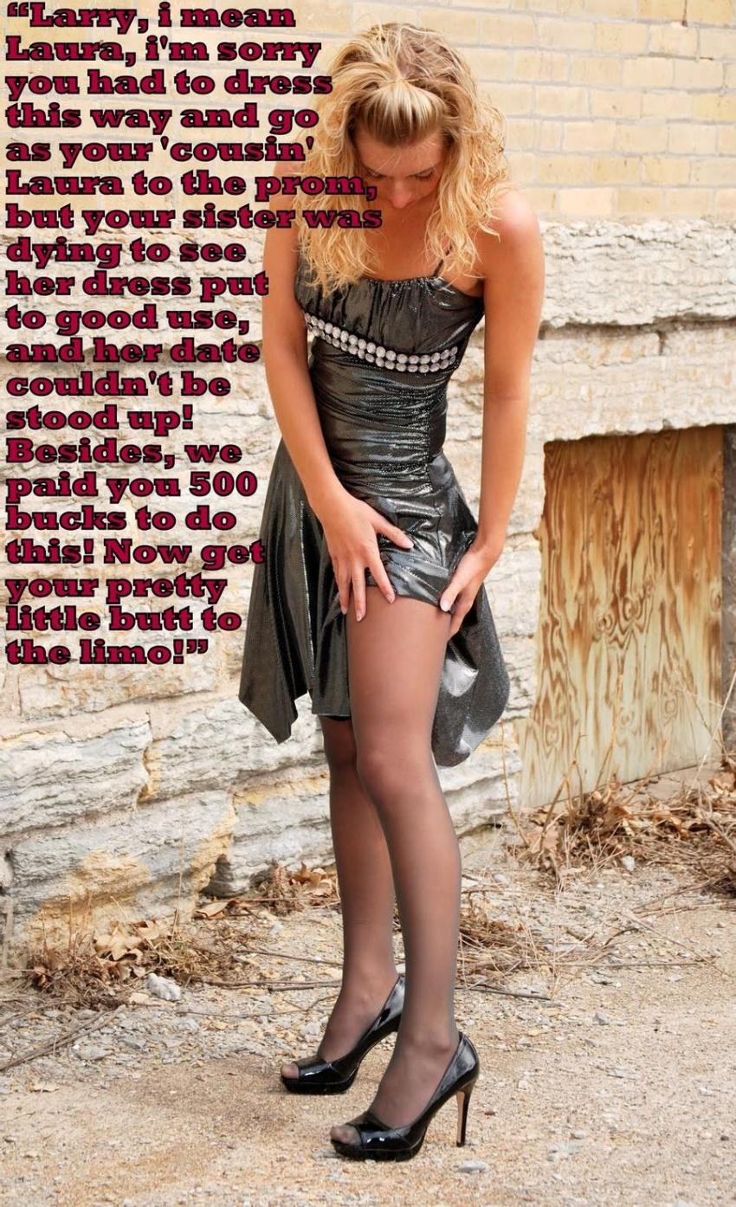

I had the limo pick me up around the back so I could look her over before we were dropped off making a big red-carpet entrance. Laura stepped out of the limo and checked her stockings. I swear that she had better legs than Larry’s sister, and she looked gorgeous. There was a definite family likeness.

“I am still getting used to these shoes,” she said. Her voice was deep but sexy, and somehow familiar. But she was talking to me without introducing herself, as if we had already met - as if she knew me.

She looked up and I saw those big brown eyes … and I suddenly realized what I was looking at.

“Larry? Larry! Is that you?”

“I am Laura tonight,” Laura said. “I am your date – bought and paid for. Body wax, breast forms, hair extensions, makeup, the works.”

“What are you doing?” I was shocked, but I could not get over the fact that Laura was one super hot chick, and surely only I could see that underneath that look was maybe my closest pal, Larry.

“I guess I wanted you to have a date to the prom that you could have a really good time with,” said Laura. “Not even my sister would go with you. I guess I understand what you really want in a woman, and I am that woman, at least for tonight, but maybe …”.

“If people knew I my date was a guy I would be sneered at. I have a reputation.”

“Yes, you have a reputation for sure, but to be honest it is that you have the biggest ego in school. But anyway, people will never know I am anything other than a girl. I mean, look at me.” Laura did a twirl.

Despite knowing what I was looking at, I was getting aroused.

“I suppose that I have a confession to make,” she said. “We are close, you and I, but my feelings for you are even stronger than you could ever know. That is why I wanted you to have a date who wants to make you happy and proud. That is why I wanted to be your date.”

That was when it all clicked into place, and I told my girl to get her pretty butt into the limo so we could make our entrance – the guy with the big ego and his adoring girlfriend who loves him despite of it … or maybe because of it – I like to think.

The End

Sergei’s Story
Inspired by a Captioned imaged from Tiffany in her Mandy phase
By Maryanne Peters

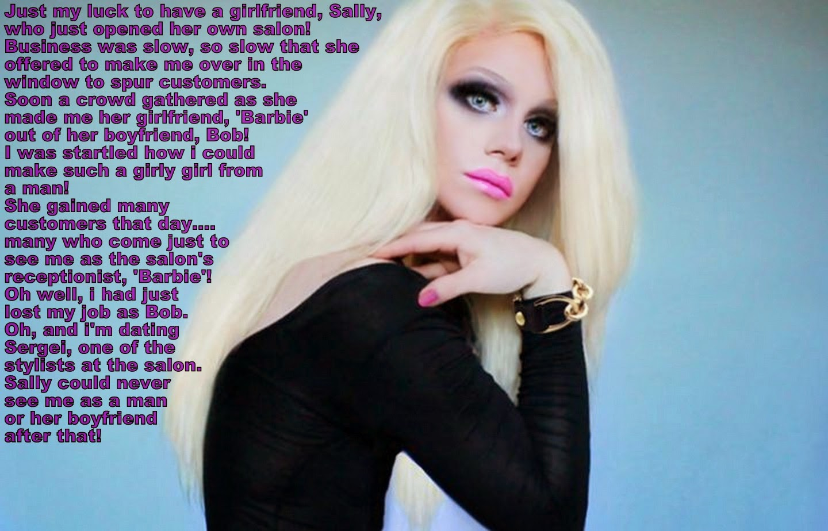

People think that because I am a women’s hairdresser that may be I might be gay. Well let me tell you, I had never had a gay thought in my life until Barbie. Even now, I refuse to believe that this is a gay relationship, and it will no longer be one when she agrees to be rid of that growth on her otherwise perfect body.

I suppose that I am not one who goes for big breasted girls. The little breasts that have sprouted on Barbie’s chest are perfect for me. They are so fresh and childlike on her tall slim body. And sensitive too. It came as a total surprise to her that a light touch of my tongue can send a jolt through her. I won’t touch that other thing, which the hormones have shrunk to a useless tassel.

Sally suggested that she try the estrogen pessaries to slow the beard growth after the depilation and to improve her skin, and Barbie just gave in. She is like that. I adore that submissiveness. She says that she was never like that before, but now she seems to have found her place.

She wanted to help Sally and so she agreed to the makeover, but then she became the salon’s biggest selling feature. People came to see “Sally’s boyfriend Barbie” – so beautiful that they all wished that the same could be done for them.

Sally got so busy so quickly that she needed to recruit new stylists and I was available. When I walked in I was simply introduced to Barbie as “our receptionist and our best advertisement”. I had no idea of who she was but would I have cared? One look from those beautiful blue eyes and I was bowled over.

When she opened her mouth to talk, I was confused at first, and then disappointed. She said that she was with Sally, and Sally was the boss. But it soon became clear that Sally was not interested in Barbie, and perhaps she was not that interested in Bob either? I was interested, despite the problem with anatomy.

It turned out that it was just a small problem – very small. I hardly notice it when I am ramming home those pessaries and licking those swelling nipples.

She calls it just dating, but it is more than that. I have heard her call me “my boyfriend” and I love that. I call her “my girlfriend” but of course she is not yet a complete girl.

I will give her time. It has all been so fast for her. It is an incredible story, but I am sure it will have a happy ending for me.

The End

Nurse Adams Awakes
Inspired by a Captioned imaged from Tiffany
By Maryanne Peters



It was when Dr Adams used a roofie to seduce Amy that the nursing staff knew that he had gone too far. That is rape. A report would have got him suspended. Proof would get him struck off and unable to practice medicine.

But (and there is always a ‘but”) could we prove it? Would her report be believed? That is the power of Dr Adams. He is a charmer, and his word easily accepted. And he is such a good doctor – For the sake of reputation Memorial Hospital management would not want to believe any complaint of sexual harassment against anybody, but least of all the handsome and charming Dr. Adams, their star surgeon.

And he is a good doctor. He has saved lives and made other lives better. Is the world a better place without him doing what he does for patients? If only his behavior could be modified. If only he could be modified.

The feminization flash mobs were all about turning men into women in a matter of hours. We are talking about a body wax, attachments, hair extensions, even an injection in the throat to make the voice high. Some of the results were hilarious. Still, the victims had to be willing. No means no – right?

Well, not if you use a roofie just like Dr Adams did. The benzodiazepine compound he used on Amy made he appear to be conscious and in command while really she was numb and open to his suggestion. It was the kind of compound that we could use repeatedly to keep our victim under control, but implanting a radio-controlled dispensers and a shunt in the breast forms stuck onto his chest. Just in case we also had a radio-controlled shock system under the groin strap that allowed our subject to urinate like a woman and to have an anus open to function in more ways than one.

We could not resist adding female hormones to the mix either – slow release patches under those firmly anchored breast forms, although it seemed that they would hardly have time to take effect. Our thinking was just to give Dr Adams a taste of life as a pretty nurse, being leered at and badgered by the male doctors of Memorial Hospital.

And Nurse Adams was surprisingly pretty. Those big brown eyes really belong on a woman, especially under a well plucked brow, and that chin somehow looks not very masculine at all. Plus, I cannot help but say it, there is something about that roofie induced blank look that sickeningly attracts the wrong kind of man to a girl like Nurse Adams

It meant that she had to be helped through the wards a little, and introduced to all the male doctors, and mellowed out with a little shot from those secret dispensers. It would only be a matter of time before it all ran out, and Dr. Adams would reappear and find the solvent needed to strip the feminine from his now hairless body.

We were ready for that. We would explain our actions and warn him against recriminations, but take any consequences if he was to lash out. Our point had been made the moment that we saw Dr. Marsh pull Nurse Adams to one side and suggest that she accompany him to the secure radiology room for a private consultation. This is what we have to put up with!

But when Nurse Adams appeared a while later looking a little disheveled but very happy followed by a very satisfied Dr. Marsh, we were a little puzzled, to say the least.

Of course Dr Adams is no longer a nurse, but to our surprise she is now, very firmly, one of us.

The End

© Maryanne Peters 2022

