Jerri-Aimee  Inspired by a Captioned Image  By Maryanne Peters  Sharon sat behind the huge desk that had been her husband’s, as Maggie ushered in the tall handsome stranger. She did not stand to meet him. She sat, as she always did. She would not invite visitors to sit. She preferred them ill at ease. | 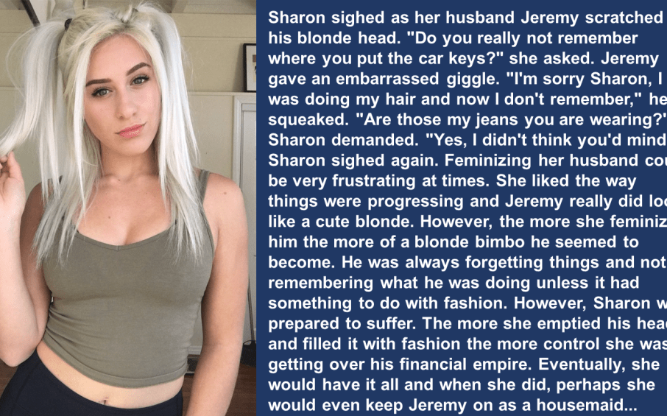

“Patrick Hudson, Attorney at Law”, he said. “I am here on behalf of Jerri-Aimee.”

“Who?” she said. She genuinely had no idea who he was talking about, probably because she never would have expected any action from that quarter.

“The young lady who used to be your husband, Jeremy”, he explained.

For a moment Sharon was a little perplexed. But then she laughed. And she threw her head back and laughed so more.

“A young lady? That sissy little shit Jeremy is a young lady? You have to be kidding me. That thing is a mindless trans-bimbo. Still my husband, but not for long.”

“As you say, still your husband,” said Patrick. He did not help himself to a seat, and did not look at all disturbed by remaining standing. “Still subject to the laws protecting matrimonial property in this state. The laws that protect her rights to the businesses established by her in what I might call, her previous life. That is not to say that you do not have a share – not more than half but much less, I suspect. But with 46% in the hands of public shareholders, and Jerri-Aimee’s share now controlled by me, you do not have control.”

“You had better take a seat,” said Sharon. This was no joke and she knew it. She reached for her phone to call her own attorney Brent. He was the one who had assisted her in taking control. He would have an answer. But she disliked him. He was smarmy and not good in bed. That was the price she had paid for his assistance, as what he had done for her was not always ethical, or even legal.

“I will sit down,” said Patrick. “But you are in my chair. You see, I have the support of four of the public shareholders, and directions from them in this folder. Their 24% of the company and Jerri-Aimee’s 27% is enough to remove you. That is what I am here to tell you. I have been appointed to replace you. You may leave, and you should do so immediately.”

“You can’t do this,” said Sharon. “How could you get the authority you need from that airhead?”

“Well, not so much of an airhead as you think,” said Patrick. “You see I am actually attracted to pretty little blondes like Jerri-Aimee. My mother runs a clothing boutique and Jerri-Aimee is so into clothes she always seems to be there. My mother suggested that I meet her and listen to her story. When she mentioned you and this business, well, that is when I …”.

“Get out of my office!” screamed Sharon. Her cellphone rang.

“As I said, it’s my office now,” said Patrick. “Call Brent. I know he is your lawyer. I suspect that is him calling you right now. I have taken the liberty of sending him the papers before I walked in here. He will confirm what I am telling you.”

Sure enough, the caller was identified as “Dickhead”. It was Brent. But instead of picking up she glowered at Patrick. “Where is Jeremy?”

“You mean Jerri-Aimee,” he said. “Thanks to you, no longer male. A pretty young lady these days. Very attentive and playful. She is living with me at the moment. As you are aware, her divorce will be coming through soon, and I hope that when it does, she might consent to be my wife. I have every intention of marrying into money. That means less for you, I’m afraid.”

The End

The Therapist’s Solution
Inspired by a Captioned Image
By Maryanne Peters

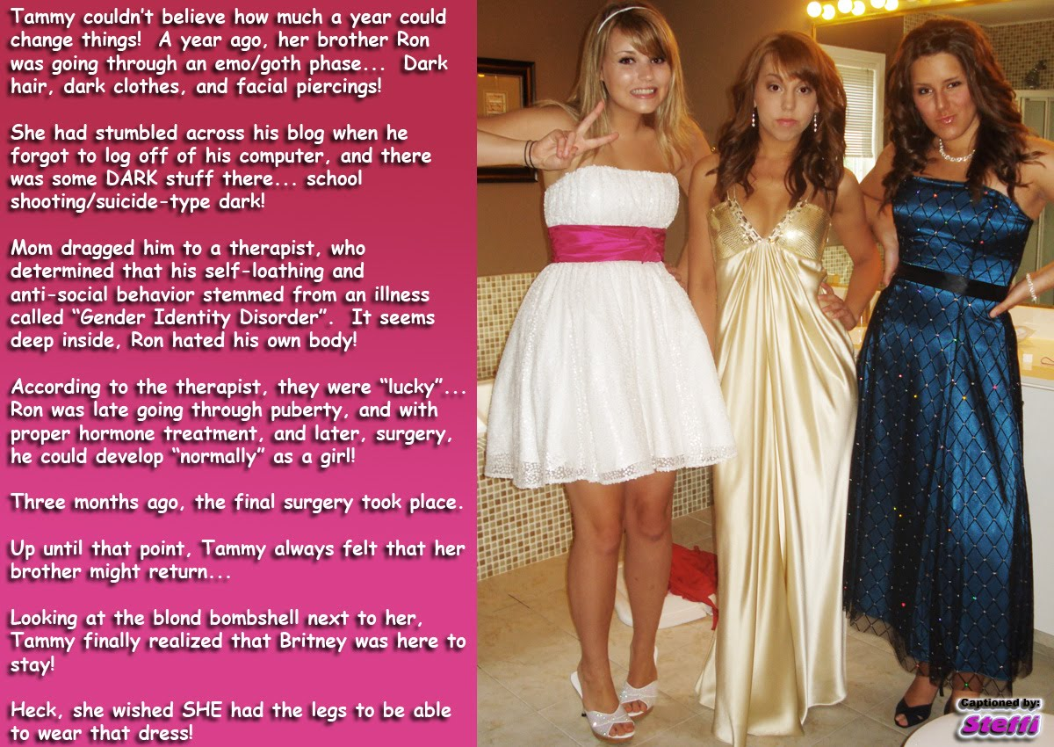

It must be every mother’s nightmare – to have a son so bent on violence that you fear not just for him, but for everybody he might come into contact with.

By now, with all the school shootings that we have seen, and other random acts of mass murder, we know the signs. The trip to the therapist confirmed my worst fears. Ron just grunted and snarled at him, but the therapist knew. Something had to be done, and that was when feminization was raised as an option.

It turns out that all of the darkness in my son was driven by self-loathing aggravated by the dread of a male puberty that was just around the corner. The therapist took me to one side to discuss a radical treatment for my son’s disorder involving first some secretly administered drugs to stop puberty and to allow Ron to develop very differently. I agreed immediately. What caring mother would not?

As well as the drugs the therapist favored regular sessions with Ron including “suggestion” to readjust his personality to the new shape that he was taking on.

At first he was just very confused, but then his sister Tammy came to the rescue helping to guide him through the changes, and lead him out of the blacks and dark greys of goth style into the pink and pastel shades of femininity. At that time, they were truly best friends as sisters.

Then one morning Ron skips down the stairs to breakfast and says: “I want to be called Britney from now on. And I want to have my hair dyed blonde. And I want to wear pink and white all the time.”

I knew then that my fears were over. The whole house became brighter on that morning. The dark foreboding that had been present in our home while Ron brooded was gone in an instant. His (or rather her) future was bright.

Britney is now my delight. So warm and full of fun. She now is the very essence of life – the opposite to what she would have been had Ron remained.

Now all I have to worry about is Tammy. That girl is just so jealous of her sister. Now, look at them together: Britney joking around while plain Tammy has that sour blank look on her face. No wonder I have that look of pained frustration on mine.

The End

Jennifer Now  Inspired by a Captioned Image  (Please help to identify the author)  By Maryanne Peters  It was not that I thought my parents would really throw me out. They are religious, but I thought they would still love me.  The truth is that I am a bit religious too. I always wondered why God had given me the body of a boy and the mid of a girl. I suppose that I treated it like many Christians have to – he is testing me. He has a plan for me. I just need to have faith that it will all work out.  And then God gave me Caleb. If I had thought that I could have lived a life as a man and setting about finding a wife, the gift of Caleb meant that was clearly not the path He had laid out for me.  A big, strong hunk of man, with a brain not well given to thinking, but a good heart and an obvious longing for the right woman. | 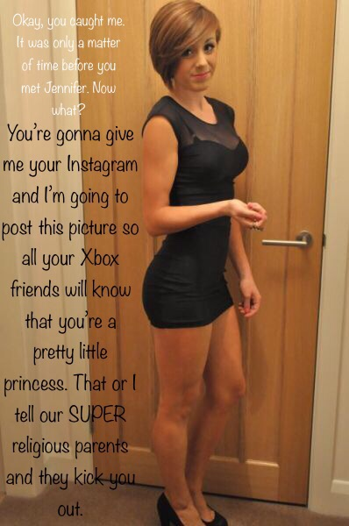

I thought that I could be that woman. All I needed was for him to catch me dressed, with my hair freshly washed and blow dried in my femme mode, rather slicked back, and just a little makeup on. That was just too easy.

I had guessed that he would take a photo, and I was OK with that. But then to have him ask me for all my contacts so he could tell them all, and then expect my parents not to learn – what kind of a ‘or else’ is that? Sometimes he is just so dumb. So why am I smiling? Because he did not call me a sissy – he called me ‘a pretty little princess’.

“Do you really think I look like a princess?” I asked him. I knew exactly how to deliver. I had been practising the look in the mirror and the simpering voice on my sound recorder. I saw him gulp.

“Well you sure don’t look like …”. But I had to stop him with a raised hand – thumb crossed so he could see my nail polish.

“I’m Jenny, Caleb,” I said. “I have always been Jenny. Please don’t tell anybody. It can just be our secret. What do I have to do for you to persuade you to keep this just between us?”

I had been creeping towards him as I said it. And there I was close enough from him to smell my perfume: “Doe Musk 45” – said to make a man grow an anther; guaranteed to drive him mad with desire. And he could see my fake tits in the see-through top – a realistic cleavage between two glued on forms that move just like the real thing. So of course I let them move.

“Maybe you could give me a blowjob?” It was like question. How cute. He did not demand it, although if he believed I was so scared of being outed, he would have.

I stroked his rough face with the back of my hand. I liked to feel a man that way.

“That is not the way I was brought up, Caleb, and you know it. We haven’t even dated!”

The look on his face was why I want this man: Puzzled and lustful.

So I added: “Maybe just take me out to the diner for a burger and a shake. I am dressed to go out. Then, since you would be paying … well, a girl has to recognize generosity like that. Then well I guess I would be obliged to suck on this.”

My other hand dropped to feel the growing tent in his crotch.

I am the one who posted all my contacts on Instagram. Me and Caleb on our first date. Him kissing me in the booth at the diner. Even placing my phone carefully to record as a video me bringing him to orgasm on my first blow job.

Of course my parents saw it. So did Caleb’s. Everybody now knows that we are together.

God willing, they will come to understand why.

The End

New Role  Inspired by this Captioned Image (who?)  By Maryanne Peters  I have to say that I have always been obliging. That is a good characteristic – don’t you think. I like to be helpful, and I like to keep things clean. “Cleanliness is next to Godliness” my mother used to say – she was a wonderful woman. Maybe I always wanted to be a bit more like her?  My wife did not marry me for sex – that is what she says. She tells me that I was never very good. I suppose that she is right. She likes sex to be rough and quick, whereas I have always thought that it was nicer to take a little time. What do you think?  She did not marry me for my money either. I had no family money like her, and I was not earning anything like she was. She said that my job was earning less than she would pay a maid to keep house. I had to agreed.  Was it my idea or hers? Does it really matter? This is where I ended up.  The maid outfit came the first time she brought a guy home. I was upset. I went through the usual protests about the vows we had taken and my devotion to her, but she just took the guy into our bedroom and locked the door.  Did I cry? I don’t remember. I would now. I was upset, I am pretty sure.  Anyway, the guy she was with said when they stepped out into the living room: “It is a bit freaky having a guy hanging around while I am fucking you. Maybe you should dress him up as a maid. He would look good in drag.” | 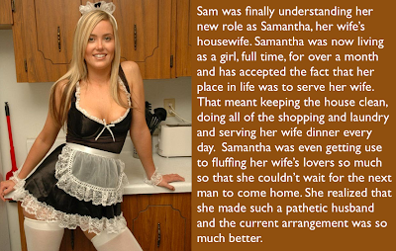

So, my wife bought me the maids outfit and told me that was what I would be wearing from now on. I had a new role. I would be keeping the house clean, preparing meals for the few evening she was at home rather than being taken out by men, and I would also be serving any man who she brought home to give her the pleasure that I could not provide.

Most men would have walked out, but that is not the man I am, or I was. I was still devoted to her, although I am not sure why, but to be honest I quite liked the idea of serving. Is that strange?

“Samantha” could have just been a transvestite sissy maid I guess, but I am quite particular in getting things right. I thought that if I was going to be a female servant, then I ought to be as female as possible. Being a servant was something that came naturally to me but being female would require effort.

And drugs too. Aren’t they incredible? I used patches and suppositories. Those hormones make your skin so soft, and when my hair grew longer that was soft too, and blonde! I mean I have always had fairish hair, but do hormones make you blonde?

My tits grew to a good size. Not silly, but sort of sexy. My wife said that the maid outfits were now slutty, but they were not my choice. She brought me a smock to replace the small dresses in black and lace. But her boyfriends insist that I wear those sexy things when they come around. Did I mention that I am a very obliging person?

She always said that I was there to serve them as much as her. She said that meant “fluffing” them. Do you know what that is? She gets dressed in something nice and I get these guys excited. I know a few tricks. I have experience from another perspective after all. Did I mention that I prefer it slow.

The problem for her is that when she is ready and I am serving him they tend to call out: “Can you wait a bit Baby, the maid is still doing her thing”. Lately she has been getting very annoyed.

In fact, lately some of her male friends have expressed interest in having me look after their homes instead of hers. In fact, all of them have asked me, so it seems very hard for me to make a decision. What do you think?

Is it time for me to take up a new role?

The End

Arranged Marriage  Inspired by a Captioned Image  By Maryanne Peters  You may or may not know this, but there is a problem in India finding brides for eligible young men.  For years people have been using cheap ultrasound devices to determine the sex of embryos and simply aborting the female one. It was all because of tradition and the requirement of fathers to provide a dowry to marry off their daughters. Daughters became a burden.  So it resulted in something that we call the sex ratio imbalance – there are so many more men that none can find a wife. | 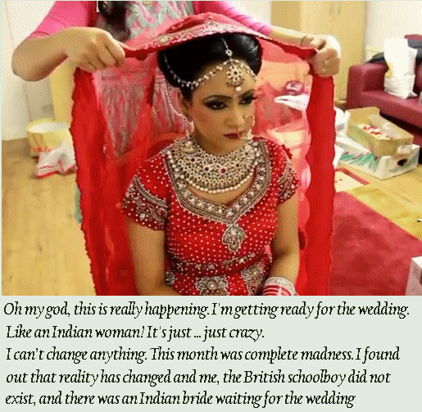

So tradition has been turned on its head. Households with daughters are no offered inducements to provide brides, and if a dowry is still required then the groom’s family will provide the means to pay it.

So, what does a British schoolboy have to do with this? Well, my father ran the UK branch of a large Indian business run by a man called Dinesh Rahul. My father did not like him at all, but he was aware that Mr. Rahul was desperately looking for a bride for his son Ashok, known as Ash. I don’t know why, but my father said that he had a daughter.

I think that my father wanted to find out whether Mr. Rahul considered him worthy of providing a bride. Probably he thought that Mr. Rahul would simply reject my family of being lesser than his, but the fact is that my family was of high caste – if you know what that is. My family had a strong enough background to be of interest to Mr. Rahul, so he asked for more information about his daughter.

Then my father was in the embarrassing position of having told Mr. Rahul a very stupid lie. He came to me and asked me to send an email through to Dinesh Rahul introducing myself as my father’s daughter Jasmina.

“That is what you young people do”, he said. “Just go through the motions. Then you will have to refuse this Ashok. Perhaps lead him on a little first”.

I think that my father was formulating some kind of cruel joke on his boss by having pretend to be a desirable Indian girl online, and then finally to disappoint his boss’s son.

I sent the email he suggested along with an image. It was an image of me using one of those gender changing filters. Perhaps I should had added a couple of ugly moles or something, but to be honest I was so entranced by the image that came up that I was quite proud to send it off untouched.

Mr. Rahul forwarded my message to his son, and immediately I received a message from Ash telling me that I was beautiful and that he understood that I came from a very good family. I showed my father.

“Tell him that you are worried about your father’s position in his father’s company”, my father insisted. “We have the opportunity to use this boy to cement my position, even if you don’t marry the boy”. He was teasing me. But he was serious. He had me extract from Ash that statement: “Dearest Jasmina, be assured that your father is highly valued with my family company, as evidenced by the fact that our liaison is approved of”.

“What is this word”? my father said.

“Liaison? It means communications”, I said. I was aware that it has a sexual meaning also. Things were getting complicated.

Then it all became very difficult. It was announced that Mr. Rahul was coming to London and that Ash would be with him.

“Unfortunately I will be in America that week”, I replied.

“We can wait in London for your return”.

I told my father that he would need to break the news that I had been hiking in the Rockies and had killed by a bear … or something! It was clear that Ash was not going to be easily discouraged.

“The simple thing is to call off the trip to America” my father said, although it was entirely invented. “Instead we need to make you look like the girl in the image you sent. You meet him and you dislike him. Traditionally our culture arranges marriages but sometimes the first meeting kills the match dead. That is the way it should be”.

And how was I going to be able to present as his daughter Jasmina? He said: “You under-estimate your father, and your mother’s beauty skills. Place yourself in her hands”.

It seemed a crazy idea, but I went along with it. When you think about it my father had painted us into a corner, and this seemed like a workable way out.

There was just one problem … or maybe four. The first problem was that when I was dressed as Jasmina with the extensions in my hair and the makeup on, I sort of fell in love with Jasmina. The second problem was that Ash did too. The third problem was that I had feelings for Ash too – certainly enough to feel that it was necessary to tell him the truth – that there was a serious obstruction to me being his wife, and he should see it before it got serious – it was right here between my legs.

“Oh my God”! he said. “All my dreams have come true. My family have done everything to find the perfect woman for me, and now here she stands before me”!

That was only at the beginning of this month, and now look at me. I am an Indian bride.

But somehow arranged marriages have a way of working out.

The End

© Maryanne Peters 2022

