Stuffed Turkey Dinner

“W-wait- Mmrpgh!!!” Aik was interrupted as a thick tentacle forced its way into her mouth. Instinctively she grabbed at it with both hands, squeezing tightly, but it penetrated her defenses with ease. Fighting back with her tongue did little, and the creature went down her throat and into her stomach almost immediately.

Slkh! Slkh! Shlkk...!

The only sounds she could hear were of slimy tentacles having their way with her body. They made short work of her clothes, tossing them to the ground and leaving her completely exposed. The creatures squeezed tightly around her torso, legs, and even neck, all lifting her high into the air, as she uselessly fought and struggled against their embrace. They hugged and squeezed her soft thighs as they forced her legs open and teased the opening of her sex.

“Mmfff!!!” The brief alarm she felt was shoved aside as she suddenly felt them squeeze their way into her; she felt her pussy spread open to welcome its intruder, as one or two other tentacles made their way sliding between her supple ass cheeks to get to her backdoor.

It all happened so quickly that ordinarily she’d be fighting through the pain, but it was at this moment that Aik realized there was none. In fact, these tentacles felt like pillows squeezing her body, tight but warm and comforting. Despite a tentacle filling her throat, normally leaving her to gag and choke and moan, Aik found that she could breathe just fine. The tentacles making their way deep into her from all ends only filled her with a pleasurable kind of pressure, and it made her eyes roll back.

At this moment smaller tentacles burrowed their way deep into her ears, squeezing easily into the tiny orifices like an octopus hiding between rocks. Her hearing was abruptly muffled, but that heightened the sensation of everything else happening to her: she could feel every slide of every tentacle on her skin, every thrust inside of her body, every comforting squeeze into her flesh.

The creatures began to attend to her more sensitive bits, flicking and playing with her erect nipples and clitoris. They squeezed her ample breasts, now wet with the slippery juices that covered each tentacle. One particular tentacle paid special attention to her clit, sliding along and around it, appearing to listen to Aik’s moans and whimpers and acting accordingly. Her body became increasingly sensitive as the tentacles took over her, and she gave herself completely to them, a series of small orgasms rocking throughout her body as she accepted this heaven.
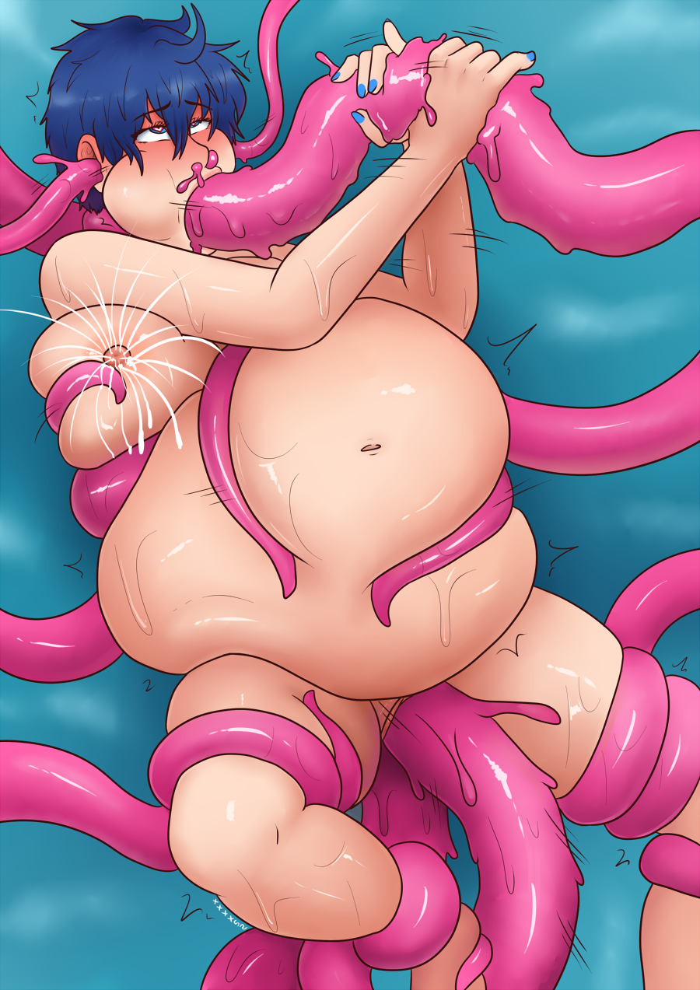
Just when the constant pleasure seemed to plateau, the tentacles seized her attention again, suddenly increasing their speed and intensity. Her body was squeezed tighter, the thrusts into her pushed faster and rammed deeper, and all of this was bringing her to the brink of a gargantuan orgasm to surpass anything she had ever felt. Her high-pitched squeals and moans filled the air, encouraging the creatures to work harder, servicing their new host to the best of their ability.

Her moans went higher and higher as the feeling intensified, and just as she reached the very peak...

An explosion inside her, not just of pleasure but of something warm and wonderful. Were they filling her with juices? Cum? Whatever it was, it filled her throat so quickly that it came back up and spluttered out of her nostrils and ears. She felt her stomach grow heavy and warm, swelling larger and larger as the creatures continued to pump their ejaculate into her.

Each orgasm was more intense than the last, and Aik found herself sounding more and more desperate and primal for the next hit, as her moans vibrated through the tentacle pounding her throat. She grabbed at it with both hands, jerking it off furiously, encouraging it to go harder, faster, and give her more of its sweet juices. She also felt a small pressure in her breasts, feeling the tentacles squeeze them tightly and forcing them to squirt out streams of milk.

“Mmnghore!! Mhhore!!!” She begged them for more, she never wanted this to stop. Dutifully, they obeyed, as the tentacles filled and bloated her burgeoning belly. It was getting huge, and she looked down at it with pride, excited as it got so big that she could barely see her own legs underneath. She could hear and feel the liquids sloshing around inside, as tentacles lovingly squeezed and hugged it.

She couldn’t believe her luck; this was like a dream. This could be her life now. Just pleasure, forever. She-

“Hnmmh!!” An excited moan as a tentacle slid slowly across her clit.

“Hnnghh”, the tentacle rubbed circles around it, flicked it.

“Mmnnh! Mnghh!!!” The sensations heightened. She could feel another orgasm coming. This one might be the most intense yet.

“Hnn..!”

“HNAAAHHH!!!”


“Wake up, sweetie!”
Pleasure washed over Aik and her mind went blank for a second. Her body convulsed as a powerful orgasm rushed through her, and she squirted all over the bedsheets. Her eyes rolled into the back of her head as she moaned, and she let herself lie there a bit, before coming back to reality. The tentacles were gone, it was just a dream, and she found herself in a queen-sized bed in what appeared to be a lavish hotel room.

“Aww, did I give you a good dream? Come on, you need to wake up. We have to prepare for Thanksgiving dinner.”

Aik looked sleepily up towards the voice, and gulped nervously when she realized who was talking: it was Kitten, her sadistic roommate, dressed in a short, red silk dress. Wait, what was that about a Thanksgiving dinner?

Aik tried to get up but found she could barely move. She looked down and saw she had been stripped naked: her nipples were erect and slathered with saliva, and her belly was greatly distended. She tried to move her legs but they were bound tightly, along with her arms and wrists underneath her. She didn’t know what was going on, but knowing Kitten, it couldn’t be good. She tried to struggle out of her restraints, when-

SLAP! Slosh~!

Aik yelped as Kitten gave her large stomach a hefty smack. It jiggled and she could feel the liquid inside rushing around.

“Wh-?”
”Almost there, sweetie! Just a little bigger, and we can move on.” Kitten slid her fingers across Aik’s erect and needy clitoris, making her body involuntarily shudder in pleasure, before the raven-haired domme grabbed the thick hose that was firmly planted in Aik’s asshole. “The turkey needs to be stuffed, but there’s no harm in pre-stuffing it a little first.”

Aik looked up at Kitten in pure confusion.

“You know, the turkey for Thanksgiving dinner? ... The American holiday where people eat a lot. I know we’re not in America, we’re in Japan, but it’s fun. Don’t worry about it.” Kitten sat up and began to idly play with Aik’s pussy, occasionally sliding a finger past her clit. Aik was so sensitive at this point that every tease made her shudder and whimper. Kitten continued, “We rented out this massive manor just for the occasion, and you’re the main course! It’ll be fun, don’t worry.”

“Hello?” There was a voice at the door, followed by a knock. “Is she ready?”

“Almost!” Kitten shouted back, and then turned to Aik. “Looks like we need to speed things up a little.” She gave Aik a playful slap! on the pussy and grabbed a small tank of water and a hose from beside the bed. Aik yelped and struggled from the slap, before seeing the tank and really having a reason to struggle.

“Shh~! Just a quickie!” Kitten reached over and pressed the nozzle of the hose to Aik’s lips, before forcing it deep down her throat. She then turned a knob on the tank and water began to make its way into Aik’s stomach.

“Mnngh!” Gulp, gulp
The bound girl succumbed to her fate, dutifully swallowing the water as her housemate rubbed her belly and occasionally teased her sex. For a few minutes Aik lied there, letting her mind calmly drift as the water filled her stomach, before she was rudely interrupted by Kitten yanking out the hose from her throat, followed by the larger hose being pulled from her anus with an audible pop!

Kitten gently stroked Aik’s hair. “Mm, that’s a good girl. Keep it in, ok?” Aik bit her lips, looking down at her tremendously bloated belly. If this is only ‘pre-stuffing’, how big is it supposed to get..?

The door opened and in came a tall man in a suit. “Ms. Kitten? Is the turkey ready?”

The hostess turned and smiled at him, and then gave Aik’s belly one last smack! “Yup! All yours. Please take her to the dining table while I make the final preparations.”

“Yes ma’am.” The man walked over to the bed where Aik lay, and unzipped his pants, letting his massive dick flop out. Aik swallowed nervously, and felt completely helpless and exposed in her bound state. Yet, she couldn’t help but feel a little excited, imagining the thought of that hog insid-

“Haahh-!” Aik gasped. The man had swiftly grabbed her and thrust his manhood deep into her asshole. Luckily the hose had prepared her a bit, but he was huge. She struggled just a little and couldn’t help but moan as he positioned himself in and out of her as he got a good grip, lifting her up to face him, almost like a hug. This squeezed her round, sensitive belly against his but she noted that he was being gentle, as the pressure wasn’t too great. The man gave a few more thrusts for good measure, getting a few more moans out of her, before carrying her out of the room.

She bit her lip and stifled a whine, trying to move up and down on his dick, but the only successes she got were the minuscule bounces he made as he walked down the hall. That tentacle dream made her so horny, that even though she should be protesting right now, all she wanted was to experience more orgasms. Despite the restraints and implications of what was to come, she was a little excited. She was too distracted to notice the colossal Victorian manor they were walking through, and soon they reached the main dining hall.

The man dropped her on the edge of a long dining table, already prepared with dishes and silverware. Portraits of important-looking people lined the walls, and enormous, gorgeous chandeliers hung from the ceiling. The hall, however, was empty, and Aik looked up at her only companion for now.

“Hey- mmnh!!!” The bound girl was interrupted by the man slowly removing his dick from her tight young ass. She felt every centimeter, and her body shuddered in excitement. The man noticed this and paused a moment, before thrusting again, delving deep inside her. Aik gasped and moaned, already cumming as her hole convulsed tightly over the man’s dick. In response, he grabbed both of her tits and squeezed tight, positioning himself and then thrusting into her with gusto. He took his time, going long and deep, as Aik moaned loudly, eyes rolling into the back of her head and tongue sticking out as she climaxed again.

A few minutes later, the man released a hefty, masculine grunt as he performed one last deep thrust into her, making her body shiver and the contents of her belly shake, as he came inside of her. She moaned in pleasure, letting her head lie back onto the table, taking it all in.

“You done?” A door opened, and the sound of high heels filled the hall, as Kitten entered the room. Heavy footsteps followed her; the guests have begun to arrive.

The man in the suit zipped up his pants and gave a small nod to both Aik and Kitten, before taking his leave. Aik felt a little sad, still too lost in her last orgasm to worry about what Kitten possibly had in store for her.

“Had a good time? We could hear you from the front door, you know. It really put our guests in the mood,” said Kitten, as she stood in front of Aik. “Our first guest is already ready. It’s a little early, but then again, preparations are best done early anyway, and we need to get you all stuffed up!”

Aik couldn’t really see much past her roundness, but she did hear the unzipping of pants. That, coupled with all the footsteps in the background, made her realize what was coming.

“W-wait, what’s-”

“Heyy!! Turkeys don’t talk!” The first guest interrupted Aik’s protest, and cracked a huge smile at his dumb joke. Kitten smirked, and grabbed an apple from a nearby fruit basket.

“Good point, sir! I forgot one essential part of this dish.” The sadistic hostess stood in front of Aik, and then began to lean forward, purposefully pressing her own body against the bound girl’s bloated belly, making Aik squirm and whine in discomfort. This only made Kitten press harder, pushing almost all of her weight onto her nude housemate, and their faces got so close that their lips nearly touched. Aik tried to look away, but Kitten smelled excellent, a sweet fragrance wafting off of her from what must have been her perfume.

“Open your mouth, turkey,” Kitten said, prying her fingers between Aik’s lips and forcing them open. Aik gasped in panic before the hostess shoved an apple into her mouth. Kitten made a point to grab at Aik’s chin and stretch her mouth even further to accommodate the decently sized fruit, and almost immediately the bound girl’s jaw began to ache a bit. The apple was pushed deeper into her mouth until it stayed put, making an effective, albeit large, ball gag. Aik’s teeth sunk deep into its juicy flesh, further locking the apple in place.

Aik whimpered meekly, trying to move, as Kitten gently kissed the end of the apple and then eased herself off of Aik’s very full belly.

“Well, time to begin!” Kitten gestured to the first guest to start, and start he did. The gagging scene with the apple was more than encouraging, and his throbbing erection was eager to make its way into Aik’s warm, wet pussy. So much attention had been given to her asshole that the introduction of a large dick into her sex was a very welcome sensation, and her head immediately fell back in intense pleasure.
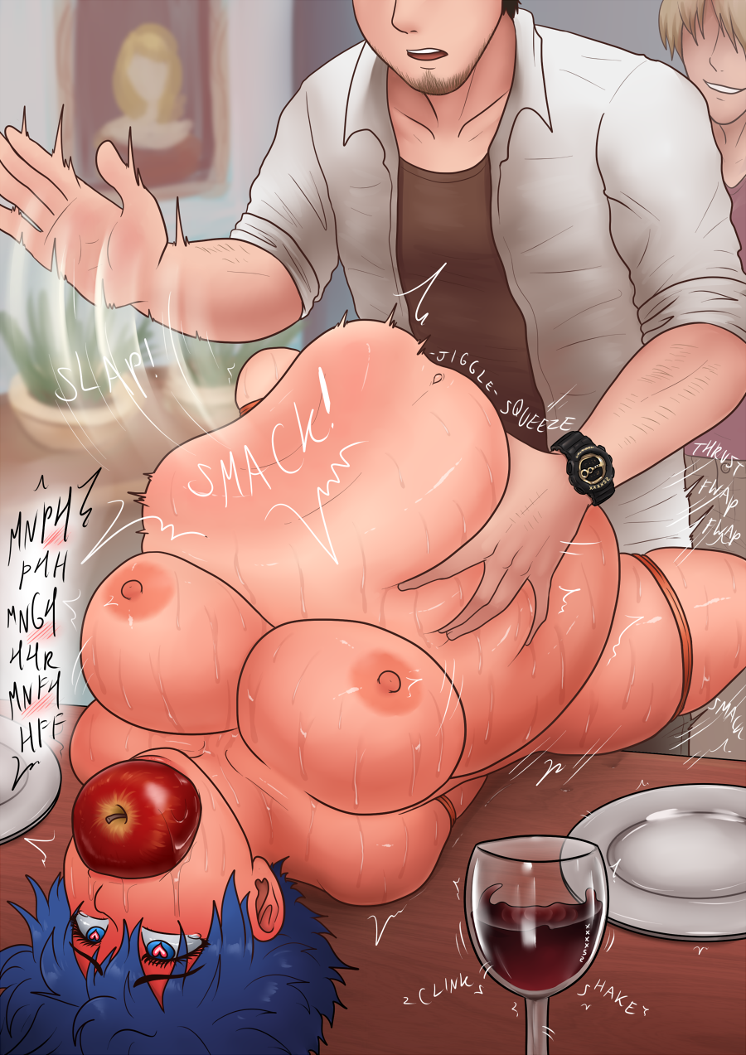
That guest was the start of a very long line, resulting in hours and hours of pounding and filling. The men would alternate between pussy and asshole, sometimes in the same session. A few even teased both holes at the same time, fingering her and making her squirm and occasionally squirt all over the floor. Every man finished his session with a healthy pump of seed into her, adding to the growing amount of liquids filling up her swelling belly.

Just like in her dream, the pleasure became constant and she loved every second of it. It would plateau, and her mind would drift in and out, before being brought back by the occasional smack! on her belly, or rough grope and squeeze, which would result in a jiggle and shake of her increasingly bloated stomach.

A few guests made the obvious joke of eating out the “turkey”, deftly licking and playing with her sex and making her body wriggle and convulse in ecstasy. Some would also suck on or nibble at her erect nipples, squeezing and teasing her breasts.

At one point, some guests even tried to fuck her face-down with her belly pressed against the table. All the new weight pushing down on her titanic stomach made her eyes water, and she whined and moaned in protest as they fucked her hard from behind. The men took turns giving her ass a powerful slap, having fun listening to her yelp with a hint of excitement in her voice. After a good while, they returned her to laying on her back, her belly much larger and fuller than it was before.

Time passed, and Aik lied back and took in everything; her mind was swimming and everything jumbled together. Every thrust, every squeeze, every smack, all blended into one immense feeling of pleasure, and she closed her eyes and let them roll back.

She snapped out of it at a strong pressure in her belly, and opened her eyes to realize Kitten was on top of her, tying her stomach tightly with the same rope that was used to tie the rest of her body.

“Mmm, did you have fun~?” The hostess paused and simply smiled at Aik, and for a brief moment Aik looked at Kitten and realized she had also been busy the past few hours, as her dress was partially undone. The red garment normally had an underboob window, but now it was stretched open for her tits to hang freely. She had splatters of cum all over her face and body, her mascara was running, and her lipstick was smeared. Aik couldn’t see it from where she was lying, but Kitten’s dress was also lifted and her creampied ass was in clear view for all the guests to see. It appeared Kitten had her own party in the background of Aik’s servicing.

“HnMMHH~!” Aik cried out a muffled yelp through her apple gag, as Kitten resumed binding her. She had orange rubber wire in hand, and was tying it very tightly around Aik’s belly, contorting and squeezing it hard. The pressure was immense, and made her eyes water. She whined and squealed in protest, as Kitten gently shushed her with a sympathetic “Ohh~”, before yanking the soft wires even tighter.

The crowd of satisfied guests were were gathered around them, watching in amazement. Comments of “It can’t get any tighter, right?” and “Fuck this is hot” rippled through the crowd, and some guests started openly masturbating.

“Are you sure she won’t squirt any of that out?”

In response to a guest’s inquiry, Kitten cooed in pleasure, “No, she’s well-trained. She’s a good girl. Aren’t you?”

Aik looked up at Kitten with pleading, misty eyes, as the hostess gently stroked her hair. Kitten squeezed the rubber wires over the “turkey”’s stuffed belly one last time and then gave it a loud smack!, before grabbing two butt plugs from the table and shoving them up Aik’s pussy and asshole. They were thick, and Aik certainly felt them push into her, but she knew the pressure from this cum mixture inside of her could easily blow them out if she wasn’t careful, and she didn’t want to find out what would happen if she failed.

Kitten walked off and came back with a huge bowl of orange marmalade glaze. “And now for the finishing touch~,” she said, as she readied a ladle and began to slowly pour the glaze over Aik’s body. The “turkey” shivered at the sensation: the glaze was warm, comforting, and it crept all over her skin. The hostess finished the dish off by pouring a bit of glaze over Aik’s pussy, and then leaned forward and very slowly licked and sucked it off. Aik’s swollen body jolted in pleasure, and her eyes rolled back as she whimpered and moaned at Kitten’s mercy.

“Now boys, why don’t you help me ready the centerpiece?” Kitten discarded the bowl as Aik was lifted by several men onto a massive platter festooned with green lettuce and spinach. The dish was then moved to the middle of the tremendous dining table. Butlers and maids set the table with delicious foods such as roasted turkey, mashed potatoes, stuffing and cranberry sauce. They filled the glasses with wine as the guests clamored to their seats.

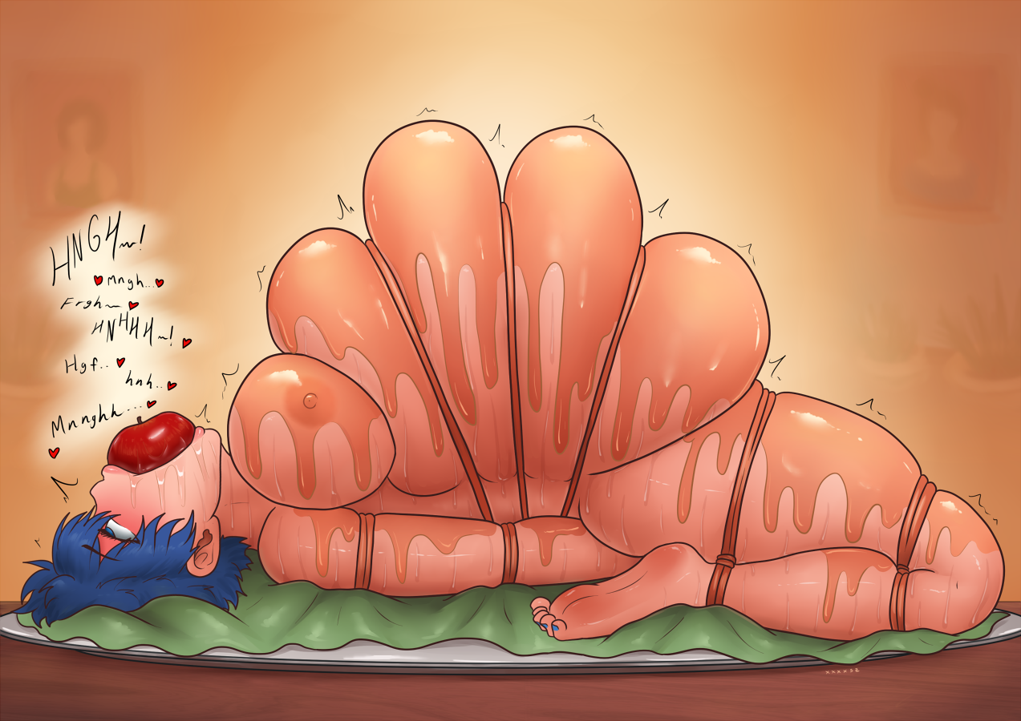

The intoxicating aromas wafted through the air and only added to the immeasurable sensations that Aik was feeling: the substantial pressure of her restraints mercilessly squeezing her huge, soft belly, as well as the liquid sloshing around inside and the focus she needed to keep it all in, the sweet smell of the glaze, the ache in her jaw from her apple ball gag, the juices flowing along her pussy and her twitching clitoris, and the waves of pleasure still going over her from all of the events that unfolded that day.

Kitten stood and held up her glass for a toast. “Everyone, thank you for joining me for this lovely Thanksgiving dinner. I especially thank you for helping me prepare the turkey!” Laughter rippled among the guests as Kitten patted Aik’s stomach. “Now please, don’t be shy. Dig in! There’s plenty for everyone!” The guests clinked their glasses and began to eat, as Kitten sat down next to Aik, who was trembling in seemingly endless ecstasy.

“Mmnhh... Nnghh...”

Kitten reached over and teased Aik’s clitoris, giving it a little pinch.

“Hnnff!!”

“I know, I know. Thanksgiving is the best. I can’t wait to do this again next year.”

