The Date
Inspired by Captioned Image
By Maryanne Peters

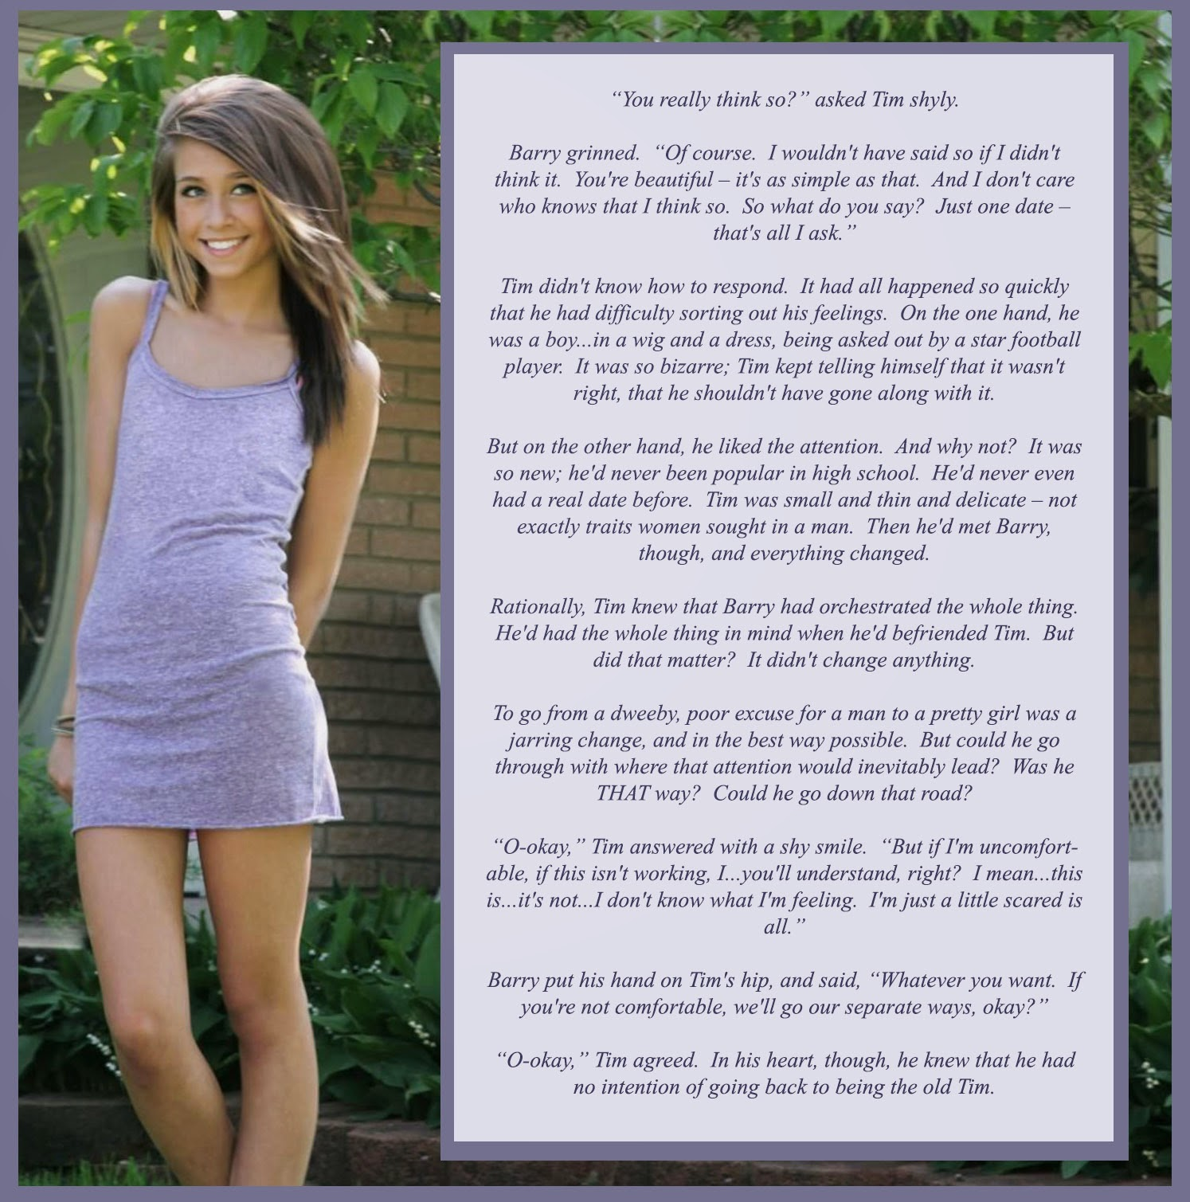

Just look at that face. Even with only the hint of makeup, that is clearly a girl’s face. Try telling me that you don’t see it. Don’t call me a queer. That is a girl. That Timmy is no boy. She is a girl. She is Tammy – my girl.

Even that body in the tank top dress. Sure, there are no breasts, but they will grow. So will her hair, which is even lighter than the wig. But look at those legs, and the hips. No boy is that shape. This is a girl, I tell you. Any fool can see it.

Nobody calls me a fag. I am the toughest guy on the team.
All I did was make the suggestion. I just wanted to see if I was right. It was like I could see it, and nobody else can. What am I saying? Nobody even noticed Tim – he was invisible. He was a nothing – a nobody. But from the moment that Tammy stepped out looking like that, I was smitten. This was somebody now. A girl.

He agreed to go on a date with me as Tammy. I took her somewhere quiet just in case somebody should see us. But it is a small town, and I did run into one of the guys. He never even recognized who she was.

I would like to think that even if he had I would have been able to handle it. I would have said that Tammy is a girl, because I say she is. Is anybody going to argue with me? Not in this town. Not even Tim.

But I was never out to threaten. I wanted Tammy to want to be with me. I did not want her to feel uncomfortable and pull out of the date. She was entitled to feel uncertain about it.

So I played it cool. I was the complete gentleman. I was watching her and imagining have her on the end of my cock, wriggling and squealing. But I bit my tongue and nodded my head as she chatted away.

It seemed like she was becoming more girly with every minute that passed. She had never appeared in public dressed as a girl before – at least not to my knowledge. She became confident, and then playful. It was great. Better than I could have imagined.

When I took her home, I asked her whether we could do it again and she said yes.

But then she said: “In fact, I don’t think I want to go to school next week as Tim. Tonight is the first time I have ever felt truly comfortable. Don’t be surprised if I tur up to school next week as Tammy”.

What am I going to do now? If she goes public as trans and I continue to date her, that makes me a tranny-lover. Am I ready for that? I am not gay, remember?

But she sure is pretty, and that little body keeps me dreaming.

The End

Normal Life  Inspired by a Cap  By Maryanne Peters  Somehow, I knew it from the first minute that I rolled the pantyhose up my freshly shaved leg. It was something more than a simple thrill, it was a feeling of comfort, as if I was at last at home, in a warm happy place, out of the horror that was my life. | 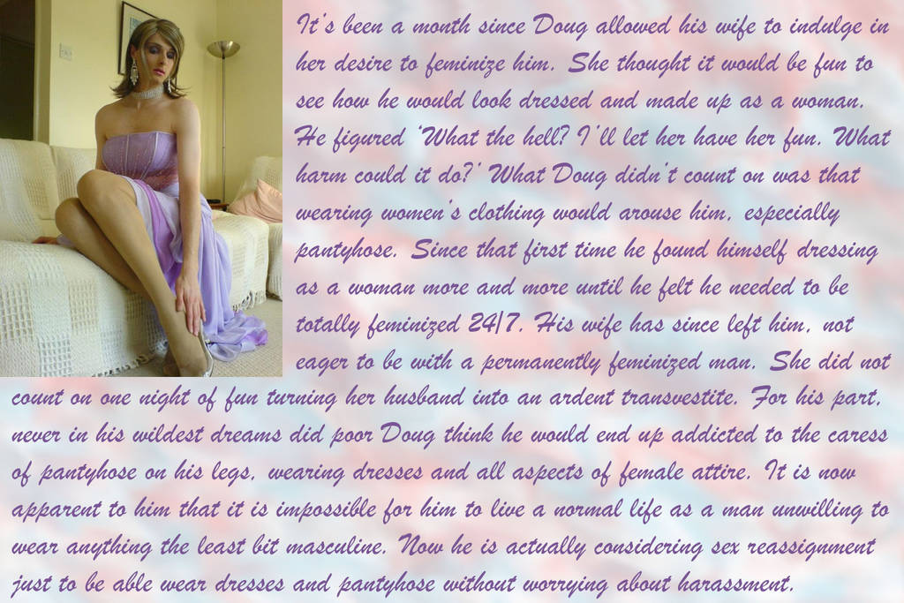

I can blame nobody else but me for my circumstances. I had been driven all my life. First by my parents, who wanted their youngest son to achieve as they had done, and my brothers before me. Then by my own pride and ambition, and the hunger for money.

I had thought that Sabine might meet my need for a diversion, but one that did not stand in my path. She was foreign, attractive and quirky. She pushed me to go to odd bars and shows, to visit places and see things that were strange to me, and I loved her for it. I made sure that my proposal was suitably odd – I had the ring baked into a cake which I gave her in a hot-air balloon.

I married Sabine because she offered me some release. But it was not enough. The burden of work, the stresses of constantly having to perform at the highest level, were wearing me down, eating into me. In small moments I could feel it. It was panic. Mind-warping fear. Just for an instant, but terrifying.

But the moment that she suggested the cross-dressing, everything changed. She worked as a stylist, specializing in exotic looks. She had some clothes for a customer which she explained, were about my size. I should try the dress on.

“No, no. You cannot wear this dress with legs that look like that,” she said. “There are stockings to go with it so you will need to shave your legs.”

I laughed. I thought: ‘what the hell. Let’s do it’. I wear pants every day. Summer is a long way off.

And then, as instructed, I bunched up the right leg of the pantyhose and I rolled it up my smooth right leg. And a light went on. A wonderful soft, rose-colored light. As if I had entered a warm room – no, a new world.

I think that she knew something was wrong. I slipped the luscious fabric onto my other shaved leg, and I gently smoothed both and pointed my toes to admire the shape. I had gorgeous legs. Legs that had remained hidden my entire life. That seemed so wrong. Something this beautiful needed to be on display.

And as I stood and pulled the pantyhose up to my waist, I realized that there was something that destroyed that image. There was an ugly bulge in my crotch. And suddenly that seemed wrong too.

Honestly, I was trembling when I slipped the dress on.

“What’s wrong?” Sabine asked.

“Is it cold in here?” I asked, but it was not. It was warm. Not the room. Just me. I was glowing. I could see it in the mirror. Before the wig and the makeup, and any of that stuff that she went to work on after that dress went on, I could see in the mirror that I was no longer me. I was somebody else. Somebody calm, and relaxed, and at peace with herself. Her.

There was arousal, and that surprised me. She saw it to. She came up to me and thrust her had down the top of my pantyhose to fondle the erection.

“Well, look who likes to dress like a girl,” she whispered. Still she insisted on the wig and the mascara, eye shadow and lipstick before we had sex. By the time that happened my cock was engorged to bursting. I started on top, but she rolled me over and bounced up and down on me. It seemed like she was fucking me. When we came together it was, without, the best sex I have ever experienced.

I suppose I thought that sex would never be the same again. But I was wrong.

A weekly cross-dress, or maybe two or three times a week, should be enough for an ardent transvestite. Is that right? I really don’t know. What I do know is that it was not enough for me. I needed to dress every night. I could not wait to get home and tear off the horrible clothes that I had to wear and put on something pretty.

It was worse than that. It got to the point that I could not go to work unless I wore panties and pantyhose under my pants. I even had a bra thing, just a flat lacy bikini top that I could wear under a business shirt without it showing. But I needed to wear it just to be able to function.

At that point Sabine refused to help. It had been her idea but now it had to stop. She suggested that I get psychotherapy. I went because she asked. He said that I had “Transvestic Disorder” and that there was no treatment beyond acceptance. He expressed doubts that this was a new discovery on my part as he said that usually arose around puberty.

He was more concerned when I told him about my thoughts of my genitals. He said that was more in line with a diagnosis of “Gender Dysphoria Syndrome” but that would have arisen even before puberty. In any event, he was of no assistance.

I started to pluck out my beard. I bought a home electrolysis kit and got to work every night. That was too much for Sabine.

“It was supposed to be fun,” she said. “I don’t want permanent changes. I don’t want to be married to a feminized man.” She left. I thought that she might come back, but I have to admit that I did not make too much effort to see that happen.

Then of course, they started to notice at work. The only thing that I had mentioned was that I was “toying with stress relieving techniques”. But now I was turning up at the office with a hairless face, partly plucked eyebrows and hair way too long.

And my work was not up to standard. Somehow, I had new priorities. They could have dismissed me, but instead they offered me “redeployment” with no client contact. I could have a job in analysis if I was prepared to take a massive cut in salary.

The only thing I asked was: “Is there a dress code? I mean, can I come to work in a dress?”

It was that best decision I ever made in my life. I am good at my job but there is no stress, and I get to wear dresses and skirts and pantyhose every day! I grew my hair and I get to wear it in different styles. I do my best to look fabulous at work, and after some initial misgivings, my employers and co-workers have accepted me, totally.

The girls at the office have been a huge help in my adjustment to living as a woman 24/7. I have always believed that key to success is to constantly learn and improve, and that is what I have done. So much so, that there is not a person who could meet me for the first time who would not believe that I was a born woman. Ok, I have had a little work done to improve my look, and I take blockers and hormones, but most of it is in the confident way in which I present myself.

Sadly perhaps, Sabine is out of my life now, but you do not lose your family. They were shocked, but over time they have come to accept. I think that they quite like the new me. I do. I like her a lot.

The only thing left to do is to get rid of what is left, these ugly male bits. I can’t wait for that to happen. It is the only barrier to me living a normal life.

The End

Trading Places  Inspired by a Captioned Image  By Maryanne Peters  “I never thought I would ever be able to do this,” he said. “But the truth is, I love it. I love being a house husband.”  “But Matt,” I implored him, “This is not being a house husband, this is being a transvestite.”  “Somehow it just seems more natural like this,” he said, checking the pot roast in the oven.  “But the hair and the makeup? And what is with walking around half naked, with that bubble butt, and, … are those tits real?”  “Oh, you like them?” He seemed very proud and turned to face me, pushing them up. “Gabby bought them for me, and the butt implants too. Aren’t they great?” | 

I was suddenly aware that his crotch seemed very empty as well. I was too frightened to say anything. I was still coming to grips with the guy I had worked so closely with up until a few months ago, seemed to have been transformed into a woman.

“Honestly, getting laid off is the best thing that ever happened to me” he explained. “I mean, you guys were great, but the relentless stress of it all, I’m glad its all over. All I need to worry about is what is in the oven and how tidy the house is – all things within my control. Honestly, it’s empowering.”

“But, I can’t believe that Gabby wants you to be like this,” I said.

“Don’t be silly,” he scolded. “Why else would she insist that I dress like this and take the tablets. Of course, this is how she wants me. And I just do what I am told. She’s the boss now. She makes the decisions. She worries about the mortgage. Not me. I don’t have a worry in the world. As long as I keep house and stay looking pretty, I will always have a provider. It’s a great life.”

“You are taking pills?”

“Hormones, you silly boy,” he said. “How else would I have skin this soft and hair this silky? And they make me feel so good. So peaceful and calm. Not like I used to be. Not aggressive and nasty. I am a nicer person – don’t you think.”

“I don’t think I know you, Matt,” was my honest reply.

“You should stay for dinner,” he said. “Get to know the new me a little better. And meet the new Gabby. She is so in control, sometimes it scares me. Of course, I will need to check with her first, but I want you to stay. I will call her and get my dress on. It’s just easier to work around the house in my underwear, but I need to be properly dressed for when she gets home.”

He rushed off the make the call, wiggling his expanded ass as he hurried to the phone. He chatted away in happy high tones. He got the go ahead and I agreed to stay.

Matt insisted that I take the big reclining armchair in the living room and read “Sports Illustrated”. He bought me a pair of men’s slippers that were too small for me, but still more comfortable that my shoes.

“Are these yours?” I asked.

“They used to be, but now I wear these”. The slippers he wore had white faux fur and 2 inch heels. “Before I fix you a drink would you like me to rub your shoulders. You look a bit tense.”

If anything, he was the cause. I tried to relax, and he worked on the knots at the base of my neck, but his face was way too close to my cheek and I could smell an intoxicating perfume – all flowers and spices. Finally, I felt the tension escape as if a dam had been released. He whispered in my ear: “That’s better, now let me get you that drink”.

He brought me a caipirinha – something I had never tried. It was made of limes and Brazilian rum. He said that he would never make it for Gabby. “Caipirinha is a man’s cocktail. I have the ingredients and I have always wanted to make one.”

“It’s delicious,” I said, because it was.

A slam of the door announced to arrival home of my friend’s wife, Gabby. He immediately swung into action, rushing to collect her things and make her comfortable opposite me.

“Did you have a good day, Honey,” he said. “Here is your cosmopolitan. Would you like me to rub your feet? Would you like some snacks? Dinner won’t be long.”

Gabby showed a disinterest that I found slightly abusive. Here was a guy who had sacrificed every ounce of his pride to please this woman, and it was clear that she looked at him as if he was filth. If it was true and she had agreed to all of these changes, why would she treat him this way.

When he was back in the kitchen, she sipped her drink and asked me: “What do you think of my little man-wife?”

“To be honest I am pretty upset about it,” I said. I really could not care less if I offended this woman, who had done these awful things to a previous colleague of mine. “He tells me that you are having him take hormone pills. That can’t be good.”

“No, it’s not,” she admitted. “I probably went too far there. I suppose I wanted him to understand what I had gone through when I was in his position. When he was in charge. He was an asshole as a husband, you see. But I had to go out to work, and it was not long before I was earning more than him. He lacks ambition, you see. So, we traded places. But you are right. The pills have been too much. He can no longer perform as a man. He wants me to be the dominant partner during sex. The breasts and butt were his idea. Frankly, they do not turn me on. The only thing that I like about him is that he is constant proof of my dominance in this relationship.”

“I don’t think that is healthy,” I said. “Marriage should be between equals. I think most men understand that.”

“He didn’t” she quipped. “And now he lives by the rules he set.” She laughed. Not quite the laugh of the arch villain of melodrama, but close enough to it.

“Frankly, I think that he is a better wife that you deserve,” I said.

“Well, if you think that, maybe he should go home with you,” she said. “Maybe I can find a man like the one you are talking about. An equal. Because my man-wife is certainly not that.”

I stretched out in the recliner and sipped my cocktail. Damn, it was good. And my neck felt great. Great smells were wafting in from the kitchen. If only I had somebody as caring as the person in there to look after my every need. If only.

The End

Pageant Mom  Inspired by a Captioned Image  By Maryanne Peters  I was pretty, but not as pretty as him.  So tall, with legs longer than mine, and slim hips as only a boy dressed as a girl can have.  He has thick hair like me. Beautiful hair that should grow as long as mine was when I was his age. Until then those extensions will have to do. He will need to live with them after the contest and learn to care for and style long hair. Good hair is a must for competitions.  Good skin too, and he is blessed with that. All his friends seem to be erupting with greasy pimples. Some of the girls too. Not my Josh. Perfect skin.  All of that is wasted on a boy. It seems sometimes life is playing a cruel trick on us, besmirching something as beautiful as this with the addition of ugly male genitals – like shit on a rose petal. | 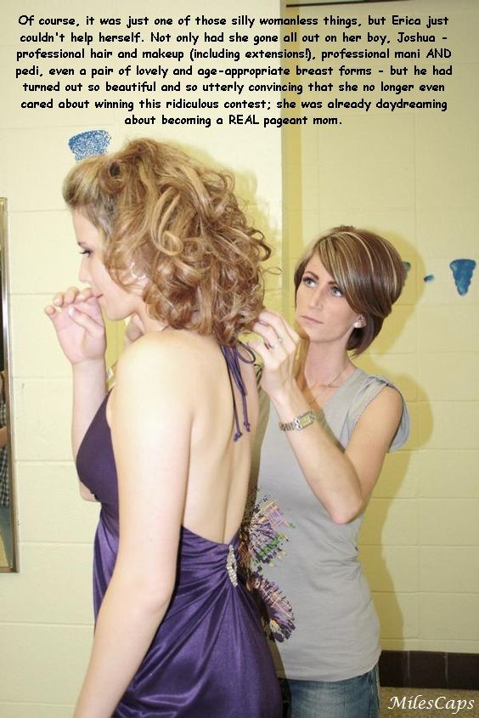

He did not want to do the pageant. I pushed him into it. I made him all sorts of promises. I was so keen to see him as a girl. I hoped that he would be passable. He ended up being truly beautiful. It was not surprising considering the money I spent on the hair, the manicure, the pedicure, the breast forms, the girdle.

I told him that I would not have him hamming it up. I did not spend all of this money to have him go on stage as a drag artist. He looked like a girl and so he needed to behave like one. In the lead up to the contest I had him modify his behavior even at home, the idea being that it would become second nature.

I suppose it did. I think that he found himself slipping into his feminine self even at school. He was fortunate to have Brad to cover for him. Big and gentle is Brad, the boy from across the road. Brad was somebody who ensure that nobody teased him for these new traits.

Brad was there watching at the pageant, right near the front, strangely entranced by the whole thing, or at least the appearance of my precious rose. He had to win. I would have burned the place to the ground if he had not.

But where do you go from here? The world deserves to have such a blossom on constant display. There are plenty of pageants around, but now I am talking the real thing. There is no room for boys in those contests. My son needs to bloom, to become the true Rose.

I am sure Brad will help. Somehow, he has already been able to change her attitude. Somehow on his regulars visits to her room in the evenings, he seems to have convinced her that she can live as a pretty girl 24/7.

The End

So Wrong  Inspired by a Captioned Image  By Maryanne Peters  “But you are wrong, Sweetie” I said to her. “You could not be more wrong. Why do think I am wearing this underwear and slip? Why do you think that my hair is styled like this? Why do you think I invited you around here, months after we broke up? Why do you think that the house is full of flowers?”  “Oh, it’s all very pretty,” she said. “It is perfect for you. Everything just screams sissy around here now.”  “Not sissy. Feminine. It’s the way I like it, because today is a special day for me,” I explained. “Of course, you are bitter, and so you cannot share the day in the same way as others of our mutual friends, but I felt I owed it to you to tell you face to face. Perhaps even to thank you.”  “What are you talking about?” she said. | 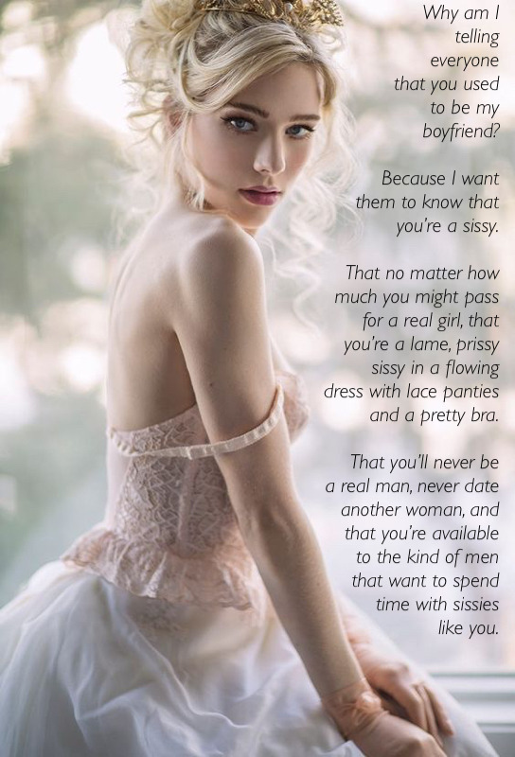

“Well, thanks in no small part to you, today is my wedding day.”

My words had just the effect on her that I hoped for. Her mouth opened and closed like a fish drowning in air. She was silent now. She was not telling anybody who I had been before, now.

“Who? Who would marry you?”

“Bradley Parkes, of course. You know how he loves slim pale blondes. Just like me. When you got chubby and ruddy he lost interest in you, didn’t he? Why couldn’t you just hold it together until he put a ring on it?”

“But, but, he would never marry a sissy,” she said, her voice cracking. “He is no fag. I will tell him.”

“But you’ve told everybody already, remember? He knows. Everybody knows. I have no secrets from my friends, even from my enemies, but certainly not my fiancé.”

She repeated it: “He would never marry a sissy,”

“He’s not marrying a sissy,” I explained. “He is marrying a woman. I had the surgery three weeks ago. The surgeon promised that I would be ready for him tonight, and I know that I will be. I have prepared myself to perfection. He will have his virgin bride tonight, but one well equipped to show a man all the pleasures that he expects.”

She staggered back, and found a chair to support her large butt.

“Oh of course we have fucked like rabbits when I was in my sissy phase and could only offer the back door,” I said. “But even then, I was a woman to him. More of a woman than any one he ever met, he told me. So as for your contribution to helping me be that, I want to thank you.”

“You bitch,” she said.

“Thank you for using that word,” I said. “So totally appropriate to my new gender.”

“You are still a sissy. Everybody knows what you are.”

“And everybody accepts me for what I am. Everybody except you perhaps. I want everyone to see how far I have gone to be the woman I am now. I am proud of it. I am proud of myself. If you think that you can belittle me by referring to my past, you are so wrong. Now I need to put my dress on. Wish me luck.”

The End

© Maryanne Peters 2022

