Girl in the Mirror
Inspired by a cap by Becky for John Number 81
By Maryanne Peters

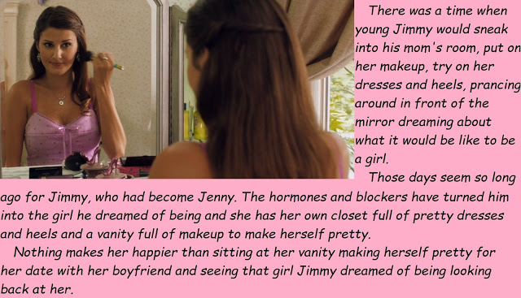

What is about girls and mirrors? Take my girl Jenny for instance. She spends ages in front of the mirror in her room and yet when she walks past a mirror she always checks herself out. In elevators she is always smoothing an eyebrow or adjusting a lock of her long brown hair. And when we go out, she spends ages in the powder room, because there has to be a big mirror in there.

Not that I really can complain. I mean it is like she says – “You want me to look pretty don’t you? You want the guys to see me hanging on your arm and think that you have the prettiest girl at school as your girlfriend, don’t you?”

I do want them to think that, because she is. But also, because I want the guys to understand that she is truly a woman. Because she has not always been that.

At school Jenny used to be Jimmy. That’s right, Jenny is a transgirl. I mean, it seems ages ago now, and I cannot even remember her when she was Jimmy. Why would I even notice? It was just that one day I said – “hey, who’s the hot chick?”

One of the guys said – “You’re kidding. The hot chick is a guy. Used to be called Jimmy and now wants to be called Jenny. Transgendered they say, so we have to watch what we say. Just ignore the freak.”

But I could not ignore her. She just got more and more beautiful everyday. My head was on a swivel whenever I walked past, and she started to notice.

She started to smile at me in the hall. It gave me a hard on, especially when she started t wear those tops that show that she had a great rack blossoming there.

After a while I just decided ‘to hell with those guys’ – I wanted to ask her out. I wanted to get my hands on those titties, and my face in that hair.

She actually said to me – “Hey, you’re the big died around here. Do you actually want to go around with me given my … history?”

I just said: “I never liked history. I am more into geography. The way things are now. The hills and the valleys and what lies between, and all that shit.”

It turns out that Jenny for that stuff, and for guys like me. It is like I say to my pals – “Tell me if I am wrong – Jenny is the best looking girl in school. And she has a libido like a guy. She can’t get enough and knows how to send a guy into orbit. One night with her and you would be wishing she was your girl. But sorry, that girl looking at herself in the mirror over there … she is all mine.”

The End

© Maryanne Peters 2021

Meeting for Lunch  Inspired by a cap by Becky for John Number 82  By Maryanne Peters  “I have to tell you that I find it hard to look at you, Mark,” said Lindsay, instead concentrating on the menu.  “It’s Mary, Sweetie, please. You are just drawing attention to us. Is that what you want? I want us to able to meet and talk, and settle a few remaining issues, like two adults.”  “Just a woman and her ex-husband having lunch?” sneered Lindsay.  “I can’t deny that I am your ex-husband,” said Mary. “But I am ex-male too. Just one more snip and it is all done.”  “So, you are really going through with this? You are cutting off your penis? I seem to remember we had a lot of fun with that thing. Do remember that … Mary?”  “I remember. I don’t regret our time together, but it was not the real me. That does not mean I did not love it … or love you. It is just that I am a woman, and I always have been. I tried to be somebody else, but I failed. What you see now is the real me.”  “I see that you close to wear my dress. But the heels are a mismatch and the bag, that is just plain prissy.”  “I do love this dress, and you said that you never liked it. You wanted me to take it, remember?”  “As a memento of me, not something to wave in front of me like a red rag to torment me.”  “Lindsay, I never meant to do that. It was just so that you would recognize me. It has been a year and I have had some work done. I would want you approaching the wrong woman.”  “It is still you. I still see the man in you.”  “Cruel, but probably right. But I can tell you that I have a boyfriend now - he doesn’t mind. He loves the way I look. The only thing he does not love will be gone very soon.” | 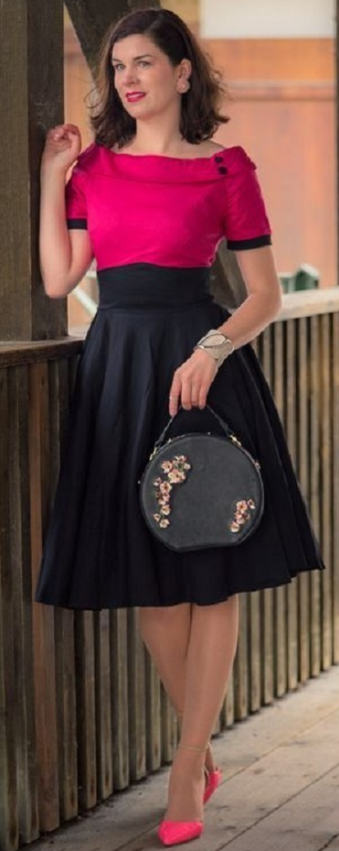  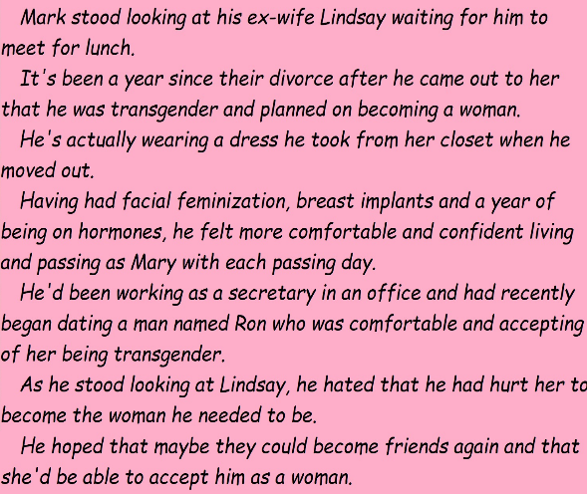
“I just don’t understand how you could think about having sex with a man, or at least doing whatever you might to in bed. Honestly, the thought of it disgusts me. You were not gay when we were together. Maybe if you were it would be easier for me to understand.”

“I wasn’t gay then, and I am not gay now. For me it is two people. Mark loved you, and you loved Mark. But for me, I now understand that he never existed. This is who I really am. My man sees me only as a woman. He is not gay. I love him. You need to accept that. I am not gay either. I am a woman, with only a small piece of flesh to be turned inside out to confirm it.”

“So what do you want from me then? Why did you ask me to meet you here?”

“Well, now this is where it gets a little awkward, so perhaps we should each have a glass of wine. I will pay for that, and even the whole lunch if you’ll let me.”

“I am not even sure that I want to have lunch with you. Just get on with it.”

“Well, Okay. I just want to say that I was sad to hear that you had broken up with your guy. I wanted you to move on after I left, and I was happy that you had found somebody. But he moved on weeks ago, right?”

“Hey don’t worry about it. A real woman can always find a guy.”

“I am glad that you have that attitude, even if it comes with a barb, because the reason I felt that we needed to meet was to ensure that I gave you the news personally, before you heard from anybody else.”

“What news?”

“Well, Ron and I are together now. We have been dating for quite a while. But it only started after you and him had already broken up.”

“Ron? My Ron? You are going out with my Ron? Don’t tell me you are having some kind of sex with Ron?”

“Like I said - he sees me only as a woman. He sees the real me. I am in love with him and he is in love with me. We have sex but he wants me to have a vagina. That settled it for me so I have booked the surgery. After that we plan to be married.”

“You bitch! You have stolen my man.”

“He didn’t know me. It was coincidence.”

“I told him about you. I even referred him to your profile picture. He must have sought you out. But why? I am a real woman. You are just … a bitch”.

“Well at least that acknowledges that I am female.”

The End.
His Perfect Girlfriend
Inspired by a cap by Becky for John Number 83
By Maryanne Peters

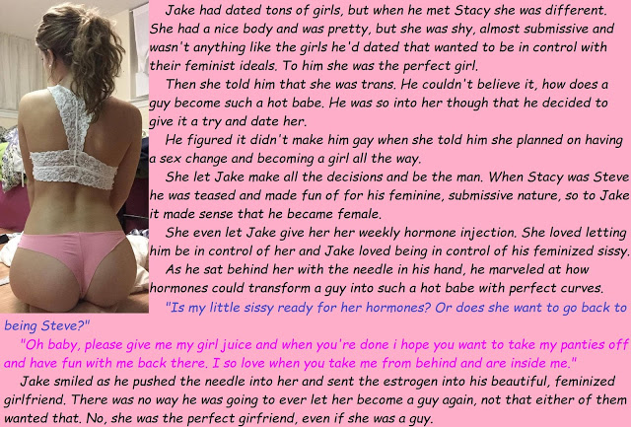

Sure, some people have given Jake a ribbing about it, but most of them who do it have never met me. When they do I turn on the charm. I want to let them know that Jake has the perfect girlfriend, even though she was once a guy. Or, perhaps it is because of it?

It seems to me that women who are born women let themselves go. A transgirl like me always has to look her feminine best. Letting myself go means letting the boy back in. I won’t allow it. I have worked hard to get this far and now that I have a man, I will never let myself be less that the perfect woman for him.

It seems to me that women who are born women get very bossy when they think that they have you in their spell. I think that Jake is in love with me, but the truth is that I like being submissive – I like him to be the boss – I like him to know that he is the boss. I suppose I am old fashioned, or just too “binary”. He is a man and I am a woman (or want to be) so I do what he asks. But don’t be mistaken, I still get what I want. Women ought to know how it is done. They have been doing it for centuries. It seems like a lost art for today’s ciswomen, but not for me.

It seems to me that women who are born women want to change their man into somebody else. What is that about? You meet and fall in love with a guy who may be a bit wild, and the you start turning him into a lapdog. I am the complete opposite. That is why I have him give me the hormone shots. I want him to make me – I want him to make me more of a woman just for him.

It seems to me that women who are born women have to have kids. They have the equipment, and they have to use it. I don’t, so Jake knows that I cannot pressure him to start a family. I am not ruling it out. There are ways, but he knows that I am not going to get pregnant and present him with a future he is not ready for.

Maybe I won’t be the perfect wife, but I will always be the perfect girlfriend.

The End

© Maryanne Peters 2022

Updates
Inspired by a cap by Becky for John Number 84
By Maryanne Peters

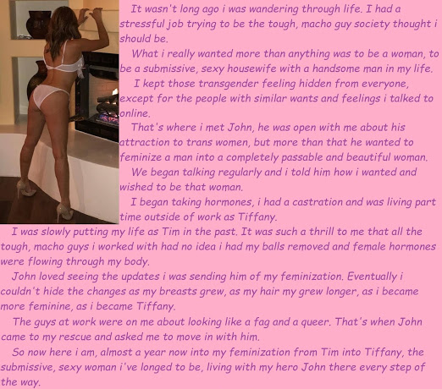

Update 1.
I have started taking the hormones that you arranged for me. I know that it will take weeks for them to have any effect of my body, but I already feel the effect on my mind. Just to know that all of those male chemicals in my bloodstream have been neutralized and replaced by girly ones is absolutely thrill. Oh John, thank you so much. I will not disappoint you. I intend to go all the way, with you beside me.

Update 2.
Yes, I can feel them. I swear that I have tiny breasts. I am using cream to soften the flesh and allow the new mammary glands to swell into something truly beautiful. You may not be able to see them yet so I will not send you an image just yet – the attached image is of my legs which are freshly shaved and moisturized. I will never let another hair appear on them, unless it is to have them waxed. Would you like to pay for that to be done?

Update 3.
Thank you for agreeing to pay for the Brazilian. It was an ordeal, I can tell you. But it felt good to squeal and even shed tears of pain – it is what a girl would do, and that is what I am now. I am fully out now. I would never have had the courage without your support. It feels good to explain to those assholes that somebody out there wants me. Many of them can’t say the same.

Update 4.
I have done it. My balls are gone. I wanted to prove to you that I am serious, and this seemed like the best way to do it. I want to be yours. The surgeon’s invoice is attached.

Update 5.
Thank you for arranging payment. I feel that castration has really got things moving. There was still man stuff inside me, but that is all over now and the female hormones are running free. Attached are some images of my titties. As you can see, they are quite a good size and the areolas have good color. I am putting them on display at work. The guys are having real trouble accepting that I am truly female, but with visible breasts and my new hairstyle, they just have to face reality. I haven’t told them that I am nutless yet, but if anybody asks, I am happy to say that I have “had surgery down there”. Who knows what they would make of that! It is exciting to feel so womanly.

Update 6.
You can see how long my hair has grown! I have been using all the tricks to promote fast hair growth, including special vitamins and inclining the bed to get more blood to my scalp. I really am very pleased with how much hair I have. People tell me that the orchiectomy has nothing to do with it, but I feel it might. Anyway, it is soft and full and I am keeping it in my natural brown, unless you would like me to go blonde?

Update 6
I am sending you an image of my in my underwear so you can see how good my booty looks. I wanted somebody else to take the image and George from work offered to do it. That is his fireplace in the background. He really does have a beautiful home, and lots of art as you can see. Anyway, when I was down to my panties, he did notice that I have a little penis, so I had to explain that I still have that but no balls. I felt that I had to show him the scar, but I told him that I was a one-man kind of girl.

Update 7
Yes, yes, one thousand times yes. Of course I will move in with you. I owe the woman I am entirely to you. I have always been yours. I will pack a few things and be right over.

The End

© Maryanne Peters 2022

Note: I am not sure if you have seen this before. I lopped off the bottom of the cap about GRS and then I thought it was worthy of this treatment.

Making Them Jealous  Inspired by a cap by Becky for John Number 85  By Maryanne Peters  It is not my intention to upset the girls. I really would like to be one of them, but is it wrong to say that your first duty its to yourself, and your own wellbeing?  The most important thing to me is to express my femininity. I guess it is true that transgirls try harder. It is not because I think that people will think that I might be a man after all these changes … I mean, take look – what do you think? No, it is because I have wanted this all my life, and now that I have it, I want to flaunt it.  I have not had any surgery yet. What you see is all me, and a fair volume of hormones that is true. But I developed like this naturally, picking up some of the curves that my mother is famous for. I feel as if this women inside me all along has just burst out all over the place. She needed to escape now here she is! And with a shape like this why wouldn’t I wear a tight dress to show them off.  As for the color – pink has always been my favorite color. I love to wear pink. And the frills are just so feminine.  If anything I am still a little self conscipus about my wide shoulders so I tend to go for sleeves or bubble sleeves just to hide the frame that I once had.  I have heard that the girls also talk about my hair being too perfect. I grew it long because I have always wanted long hair, and I take very good care of it to keep it looking good. My transition adviser said that good hair and skin is the key to success as a transgirl, and I have always thought that was good advice. When I flick it or let it fall in front of the guys I see the effect that it has. | 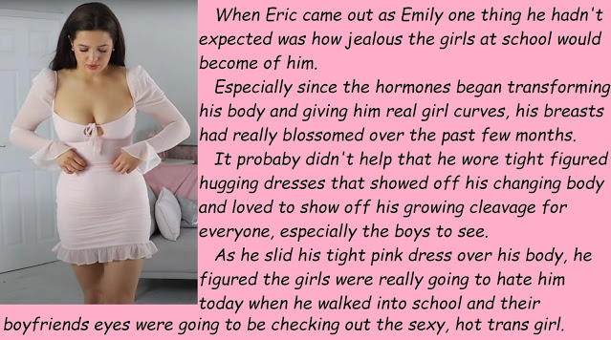

Oh yes, It is them I am out to impress. I want to get them looking and keep them guessing. Keep them wondering about whether it really is true – was Emily once a guy called Eric? That cannot be possible. I mean, look at her. Look at me.

I don’t want the girls to be jealous, I just want to be a woman, and a desirable one. Having other girls jealous of you is just an unintended consequence. But don’t expect me to less of a woman because your boyfriend is obsessed with me. That is your problem, not mine. Have you thought about fixing your hair and maybe changing the way you dress?

The End

© Maryanne Peters 2022

