Jock to Joanne  The image is from Flonker on Deviant Art  By Maryanne Peters  “You know, the worst thing is that you look better than me,” said Rafe. “I have been cross-dressing for years and I finally get my old friend the big jock from school to dress up and … you’re simply gorgeous! I’m a bit envious.”  Rafe was standing in the back-stage dressing room of the Crosstown Club dressed only in a black slip and looking at his friend Joe clad in pink. It was a Saturday morning and the Club was deserted, but it was the ideal place to dress Joe for the party that afternoon. | 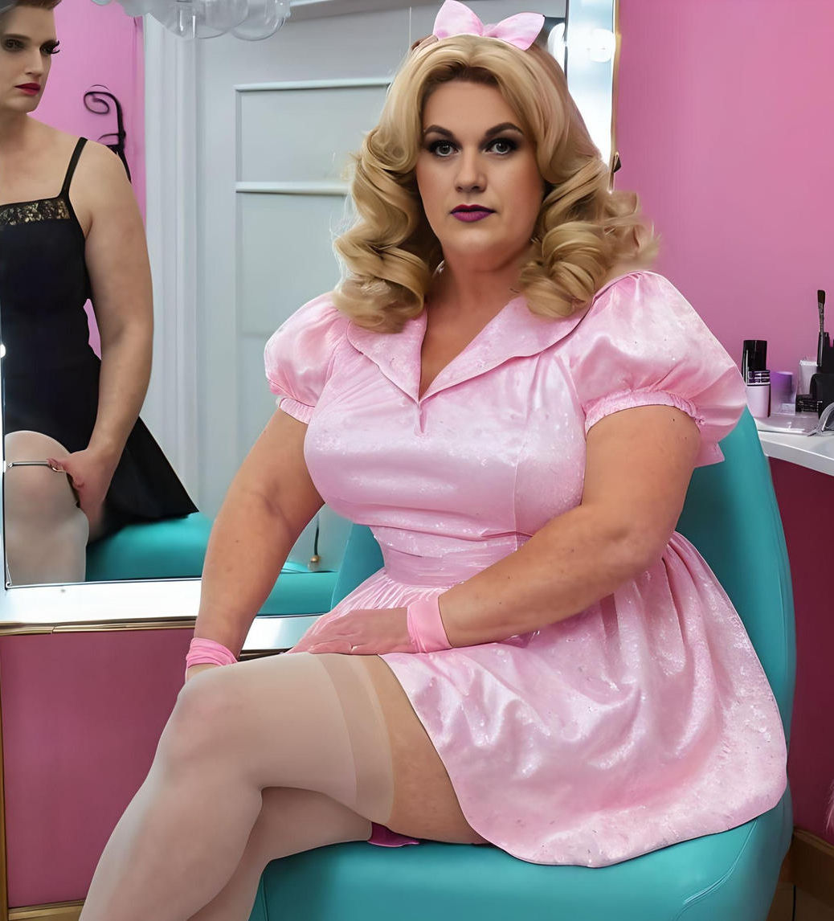

“I think a bit of flab looks better on a girl,” said Joe. “Since that hip injury took me off the team, I seem to be all flab.”

“You have excess flesh where it works,” said Rafe. “You have it in the chest where I have been able to work a real cleavage, and it is on the thighs and the butt where women carry it. And your legs are just great – mine look a little too sinewy. You are lucky there. But also, your face. Your brow line in surprisingly feminine, and that wig looks so natural on you.

“Do you really think so?’ said Jo, playing with the curls at the shoulders in a way that looked strikingly girlish. “Do you really think that I could fool somebody? Who am I kidding? Not when you are my size.”

“There are plenty of big women around,” said Rafe. “And when you are big you can’t hide away. You have to rock it. Honestly, the only thing that gives you away is the voice. If you just did something about that, you would be totally believable.”

“I do like the idea of seeing whether I could fool people,” said Joe with a mischievous smile. “I don’t like to think that I have shaved my whole body for nothing!”

“Go online and look up “feminize your voice”. There are all kinds of tools and tricks out there,” said Rafe. “But we don’t have much time. You had better get onto that.”

The drag shows at the Crosstown Club were famous, and the sound control booth had headphones and playback and was online. While Rafe went through the final stages of becoming “Rachael”, “Joanne” set to work on following the prescribed exercises to lift his voice a few octaves and have it stay there for the whole afternoon, and maybe the evening.

“I’m ready,” chirped Joanne, and Rachael smiled. Was there nothing that this person could not do. Always the star on the field even though he was a linesman, and now relishing being the big pretty girl in pink.

They got into a cab and headed off to the pink party. Rachael ran into people she knew, but Joanne headed for the bar.

“Wine only,” Rachael warned. “It is more feminine, less in volume and won’t have you putting on weight.” Joanne winked back. She seemed so natural in the feminine role that Rachael could hardly believe it. Still, it seemed like a good idea to keep an eye on her old schoolmate. But that was not how things went.

In fact, it wasn’t until Rachael visited the Ladies Bathroom later that night that Rachael saw Joanne again. Being sensitive to her gender she waited until she thought that the room was vacant before she went in to borrow a stall, but when she sat down to pee, she thought that she could hear grunts from the next cubicle that sounded familiar.

“Is that you, Joe?” she whispered through the partition.

“I am almost finished,” came back the reply, in a feminine voice that showed signs of extended practice. “I am just getting myself ready. After I am done, why don’t you freshen your makeup beside me and then come out and meet my new friend.”

She waited for Joanne who emerged looking a little flushed but perhaps even prettier that when they had left the Crosstown Club backstage several hours before. Still, Joanne applied fresh lipstick and a little mascara with surprising ease before leading the way out and into the crowd, and across to the bar.

There, standing alone and evidently waiting for somebody, stood a huge man. He was taller than Joanne even in her heels and powerfully built. His face seemed to light up when they broke from the crowd, Rachael looking across at her friend who had a similar expression on her face.

“Rachael, this is my friend Orrin,” said Joanne. She went straight up to him and took him by the arm, allowing him to place a tender kiss on her forehead. “He is a football player too, and he is still playing.”

“You must be Rachael?” said the giant, with a voice that sounded surprising intelligent for a man of that size. “Joanne has old me all about you.”

“So, you have found somebody to talk to?” said Rachael to Joanne.

“Oh yes,” said Joanne with a huge smile on her red painted lips. “But the truth is that we are done talking. Orrin has found a private spot out the back and he has offered to take me there and fuck the last bit of man out of me, and I have told him ‘please do’. I just needed to make sure that I am clean to receive, if you know what I mean. This is all new to me, but very exciting!”

As they walked off together, the two largest people in the room and perhaps the best-looking couple there, Rachael had to look on in amazement. She had never witnessed it before at such close quarters, but it seemed clear to her that this was love.

The End
946
© Maryanne Peters 2023

