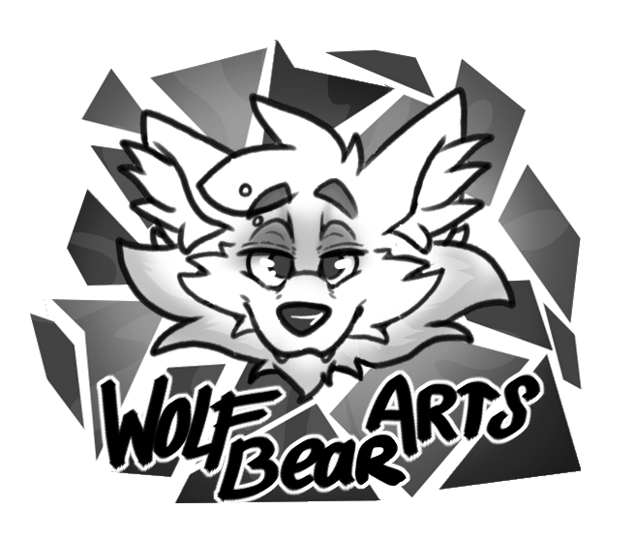
WolfBearArts
Commission info

Things I need to know bevore we can get started:
#1 What type of commissions do you want/how many do you want?
#2 Do you life in the EU or outside of it?
#3 I need a mail that is conected to paypal from you.

STEP 1:
First off, go over the different types of commissions and what they cost. [ Commission types can be found at the bottom of these rules]
If you are confused about the prices, you can always ask me about it. But try to have a idea of how much your commission will cost you, before going any further.

STEP 2:
You give me a small summary of your idea for the commission.
I will go over it to see if it is something I’m willing to do. If it so happens that it sadly isn’t somthing I want to make, then the commission ends here.
But if I’m fine with it, then we can go to step 3.

STEP 3:
You give me a full discriminant of your idea.
Try to keep it clear and to the point. No back stories about the characters/worlds are needed most of the time. And know what you want. If you change your mind before we get to the sketching, and want to change certain details, that is not a problem.
But it will make it harder for me to keep the correct information in one place. So be sure of what you want.

You can also provide reference. This can be pictures, videos, or palets and anything else you think is helpfull.

Keep in mind that depending on how far up you are in the list, the faster I will get to you. This can take an undetermined amound of time.

If you change your mind during your waiting time and don’t want the commission anymore, that is completely fine, no hard feelings.) for some other reason. Like financials problems. That is of course fine as well.

Just keep in mind that once I start sketching, there is no turning back.

STEP 4:
I will make a thumbnail of the commission. And show it to you. Here you can give pointers and advice or eddits if needed. But you can only do this onces.

STEP 5:
When we have settleld on the thumbnail, I will send you the invoice and then you can pay me via paypal. At that point I will start sketching.
When the sketch is finished. I will show it to you and you can give (for one last time) some small eddits.
After that, I will start working on the final version. Ones it is finished. I will make contact with you and sent the commission to you.

If the commissions are bigger then usual, or a comic, you can pay in steps. First half when I start sketching and the second half when I start with the line and or coloring work.

STEP 6:
This is the most important step of all!!!
Enjoy your commission ;)

EXTRA COSTS:
There are extra costs in certain situations.
*If you want drawn dialogue ( with or without tekst balloons ) in your drawing. That will cost you 5 euros extra with a maximum of 40 words per drawing.

* It also depends on the complexity of your character, and or backgrounds. This is something we can discuss during (STEP 1)

( NOTE )

All payment goes via Paypal

At this moment, only Character commissions are open, and the other commission types ( Comics and sequences ) are being reviewed and updated as we speak.
So if that is one of the commissions you are looking for. Don't worry. They will be here soon.
