Besties
A Short Story
By Maryanne Peters

I thought that it was just me when Shelly had me dressing and acting like a girl. I was not really “one of the boys” so Shelly suggested that we could do things together, if I was ready to become her sister. I suppose that there was a longing to overcome my shyness, and dressing as a girl just seemed to fit. I was unrecognizable as me, so I could become somebody else. So, I did. I became Lonette. Somewhere along the line Alonzo (people used to call me Lonny) just died.

If I had one friend in the world it was Jason. He was shy like me, so we just hung together playing video games, at least until I became Shelly’s “girlfriend”.

“So, if her is just like you, Jason can join us,” Shelly said. “He can become Janelle.” So, I guess he just followed along for the ride. We were both in, but Shelly was at the wheel.

It all seemed quite harmless. Mom just laughed about it, and Dad, well, I haven’t seen him for years.

Nobody notices guys like Jason and me. Nobody notices that our hair is too long and our bodies are shaved or plucked. We were just a pair of shy little guys who became girls when we got to be with Shelly. Shelly did what she loves to do. She just has a thing about changing guys into girls.

She says that hair and makeup are her thing, and she loves a challenge, but we knew it was deeper than that. I now know that she really didn’t see us as guys at all. She has a thing for big black men, and she thinks that is the only kind of man a girl should be with is black alpha males. She never said it to us, but it is like she thinks small guys like us don’t deserve to be called men. Maybe she figures that people like us are girls on the inside, or something. She was always talking about bringing out the woman inside us.

I think that it worked for Janelle. Before I knew it, she was saying that she did not want to dress as a guy anymore. She wanted to go full time as a girl. She came around one morning, and Shelly dressed her up in a dress and a high ponytail with a ribbon, and off she went to school.

The place went right off. The principal called her parents and they came around. I was there waiting with Janelle as a friend, but still Lonny. His folks walked in and the shit hit the fan. They had never seen Janelle as Janelle before. His Dad started shouting and his Mom started crying, and Janelle just sat there and said: “This is who I am”. I never knew that either.

So, Janelle moved away, and it was years until I saw her again.

Shelly said that Janelle was “her best work”. She was casting around for somebody else. And then she found Mike.

Mike was not so scrawny but he was not a big guy. He was not shy either. He was chasing Shelly. It was crazy really, as she was with Marcus, the captain of the basketball team. But Mike was persistent.

“Don’t you think Mike would make a pretty girl, Lonette?” she asked me. To be honest he still seemed manly enough so that I did not think it necessary to warn him of what kind of person Shelly was.

But the kind of desire Mike had for Shelly makes a man do strange things. Shelly led him on and made all kinds of promises, I suppose. She brought him home after school and showed him how she transformed me. He thought it was funny until she said: “Your turn”.

I am not sure if she ever let Mike get very far, although I don’t think she was 100% loyal to Marcus. Anyway, she kept grooming him, and me. That included compulsory “girlshakes”, some pink smoothie which we now know was laced with feminizing chemicals.

Mikes hair was long but curly. When Shelly used the straighteners on it, it was shoulder length. Mine was even longer. I think I looked pretty good as a girl, but Shelly was right, Mikki looked gorgeous.

I think she took a photo and it got to Marcus, and maybe got passed around from there. Anyway, Shelly decided that it was time for us to go that little bit further.

Mom was away for the weekend. Mikki and I were dressing up and walking around in Mom’s high heels when Marcus came to the door. He had with him two huge guys from his team: Deshaun and Jamal. She had asked them to come over, to take us that little bit further.

Jamal was massive. I mean he was a big guy, but when he was naked, he was massive, and he got naked pretty quickly. I mean, where did he hide that thing. It did not seem possible, and when he told me to put it in my mouth, that seemed unachievable. He just laughed at the look on my face. We can both laugh about that now, my first time.

I looked across at Mikki and Deshaun was cuddling and kissing him, as he watched Marcus doing the same to Shelly. It was clear that he understood. He was not scared like I was, just shattered knowing that Shelly would never be his, and that she did not care what would happen to him.

I heard Deshaun say: “Don’t worry about her, Pretty Baby, I promise I will take to heaven tonight”. There was a gentleness in his voice that I think Mikki picked up on as he leaned into the embrace. It was as if in that moment of feeling crestfallen and betrayed, any arms around you feel good.

Contrast that with my position. Jamal had just stripped down and shoved his cock in my mouth. I didn’t get hugs until afterwards, but by then, or soon after, I knew that his feelings were genuine. He said it was the best blowjob he had ever had, but only because my mouth was so small I was just working the tip of his penis. I didn’t know how to blow a guy. I am not sure that I do now.

But now after months of dilation I can take Jamal inside and with my feet above my head I can watch his face in his moment of orgasm. That is my joy.

Janelle says I should get bottom surgery like she has. Mikki is a starter too. We are all the same, you see. T-girls. Besties.

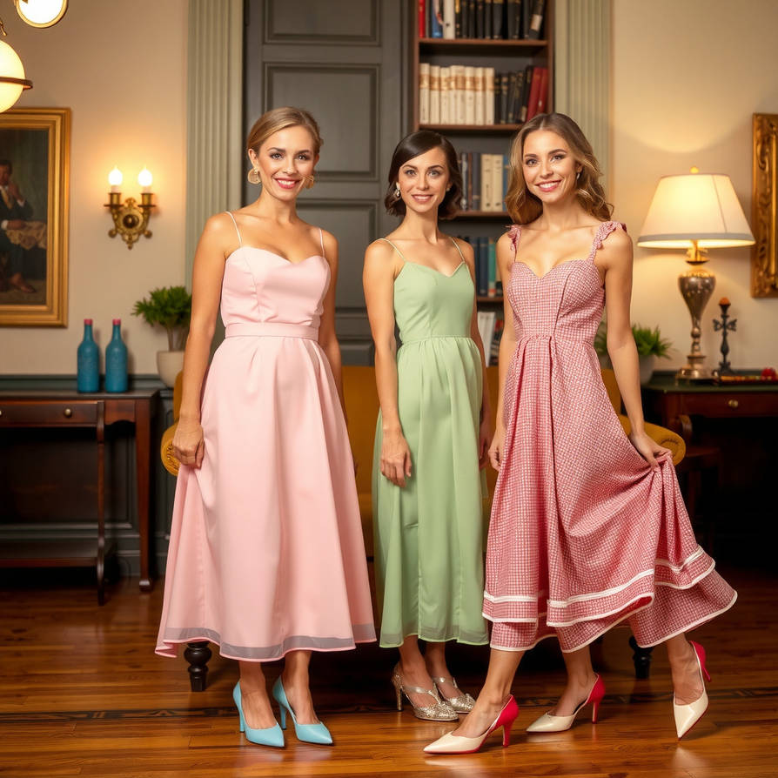

The End
1121

© Maryanne Peters 2026

