The Candidate’s Wife
A Short Story
By Maryanne Peters

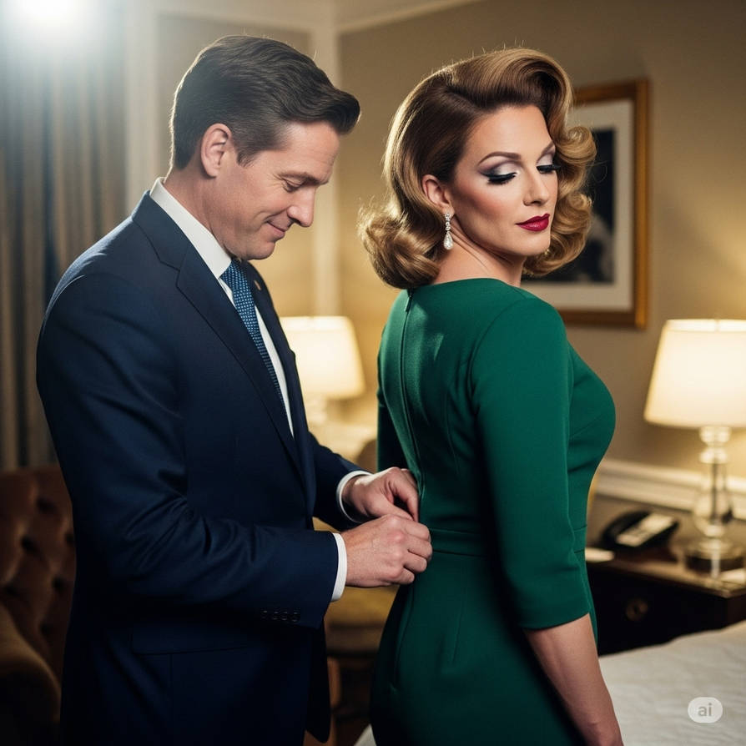

I have always been interested in politics, but it was my sister Madison who brought me right into, in a way nobody would ever have expected. It was when she got engaged to Alex Dillon who was standing for state senator in what was expected to be his first step on the road to the Presidency of these United States. Madison seemed to have lucked out. Alex was perfect, if a little staid.

He told her that they should get married before the campaign started. He needed to have a wife on his arm from the start. The wedding was rushed and it quickly became clear that they did not really know one another, or at least she did not know him. It turned out that they were incompatible – worse than that – they hated one another.

Divorce was not going to look good. Madison agreed to being whisked away to a secret location while the campaign team worked out how they were going to fix this. I was not really part of that team, but I was working as an aide and staying close to my sister.

Then I received a call from Alex asking me to come and see him. He was alone except for a rather striking looking woman standing behind his desk looking at photos laid out. I walked in and Alex asked me to look to the right and then look to the left.

“I can definitely see what you are getting at,” said the woman, in a husky voice. Then to me she said – “So, you are Madison’s younger brother? I understand that as children you sometimes pretended to be her?”

“That was years ago,” I laughed it off, not with some embarrassment. “We have a family likeness I guess, but it had faded in adulthood.”

“Fundamentally not,” she observed, holding up a photograph of what turned out to be my sister and comparing it to me. “How committed are you to Mr. Dillon getting into the State Senate House?

“Totally,” I said. “I believe in him and his policies. He will be good for the state, and if he gets the opportunity, he will be good for the nation too.” It rolled off my tongue as if I said it several times a day, which I did.

“I am glad to hear it, because we are going to ask you to do a great service for Alex Dillon, aren’t we Alex?”

“That’s right,” said Alex, looking uncharacteristically awkward. “Zach, I don’t know how to ask you this so I am just going to say it – would you be my wife?”

I just laughed, but then I saw him looking at me intently – a serious expression that puzzled me. There was something else there too, but I only came to understand that much later.

“What are you really asking of me?” I said.

“You know that Maddy has left me, right?” he said. “Well, to put it directly, she has fucked my campaign, except that nobody knows about it yet. I know that you are a big supporter of mine, and I know just how similar you two are in appearance. This lady here is Crystal, and she is a specialist in something called feminization. I mentioned that there might be somebody who could stand in for Maddy, at least until I get elected. I mean you, Zach. Would you do that for me?”

“Just a minute … you want me to put on a dress and pretend to be my sister? How on earth do you thinks I could pull that off.” The whole idea seemed crazy.

“If I can do it, you can.” The words were from the woman named Crystal. “I was once a man, and I am going to say it – a man more masculine than you are now. I now specialize in helping men to become women. Looking at you I see that you have features that transwomen would give an eye for – modest height, small hands a feet, plenty of hair, good skin and a voice that is not deep at all. Oh yes, I think that you could pull this off, with my help.”

“But you have to agree, Zach,” said Alex with an expression that was pleading verging on desperate. “I know you back me to win this. Will you help me to do that?”

“What about Maddy?” I had to ask.

“She and I are over, but she will lay low so that we can do this,” he said. “We have arranged for her spend a month in Europe … maybe more.”

The election was only a month away so I couldn’t see why he would need more time, but I was wondering how this would work long term. He would just have to announce that Madison was not happy to a senator’s wife.

“I can see some doubt in your face, so let me make a suggestion,” said Crystal. I still found it hard to believe that she was not a woman, but she did have those big hands. “Work with me to become Maddy’s twin, and if you don’t think that it will work, you can pull out.”

Alex looked doubly concerned, but he nodded – “Can you do that much?”

“I can and I will,” I said. I really thought that Alex Dillon had what it takes to be a real representative of the people. He was a listener and a doer, not just a money collector and a talker. If I could play an even more significant role in seeing him elected, then I was ready to do that.

So I went around to Crystal’s spa, which as it turned out, serviced both women and wannabe women. She said to come wearing clothes that I was happy to lose because my transformation would include waving goodbye to what male clothes represent. It all sounded a bit strange, but it came to make sense.

“Femininity should not be an act, but a way of life,” she explained. You can adopt for an evening out, or for a week or two, or for the rest of your life, but you live it – you don’t act it.”

But it turns out the starting point is bare skin. I had to ensure waxing, some shaving and even more treatment on my face. There was eyebrow shaping too, so there would be some changes that I would need to hide if I could not proceed. There would be no wig that I could pull off too – hair was woven not mine, which was not short. Breast forms and butt pads were glued on too. All of this created a new me that was not male, and could not be simply shuffled off.

I received instruction in my speech and the movement of my body, which somehow seemed easier when I was in female underwear, with my new curves looking real, and with me having to brush my long hair aside constantly. I wore my first dress to practice sitting down and standing up, and getting in and out of a car. Crystal said that she did similar things for women. In fact, she had met Alex when one of his team approached her to help Madison with her performance etiquette” – how ironic – my sister needing help from a woman who had once been a man.

Apparently, Crystal had found Madison difficult to polish in the way she wanted.

“I think that we can do better with you if you will let me,” she said. “I think that a political wife always needs to look attractive and sophisticated, calm and fully prepared. She needs a salon look that will make her look a class apart, but still be able to talk to the lowest person, and let a little angel dust fall.”

It was her suggestion that I adopt the hairstyle that some might call outdated – the side parting and open forehead and the soft curls resting on the shoulders. The fact is that I liked the style too. I really liked the complete look that she came up with. It made me feel a little like royalty – a modern version of Britain’s Queen Elizabeth – elegant, perfectly presented but warm and friendly. I imagined myself waving to onlookers, and perhaps accepting flowers from children, smiling and thanking them gently. I could do this for a while – be a politician’s wife.

My appearance had already worked its magic on one person – me. Or perhaps it was that idea of being looked at and admired – people would see a woman of sophistication married to a powerful man. If I wasn’t her, who was I anyway. I was nothing. For all my cleverness and natural charm, I would never amount to much. As her I could have a moment in the spotlight.

But I still had to prove something to Alex. When I met with him with this new look I needed to be 100 percent convincing. I needed to work on my voice and my posture, or you might call t my bearing – the way I carried myself. I was pleased to watch his reaction.

“My God, you’re gorgeous,” he said. “You are better than the real thing. I love the hair – conservative and yet stylish. Maddy would never agree to that look, but it is absolutely perfect.”

“Maddy? Maddy who? But I am Madison, darling, your wife!” I spoke with the feminine voice I had been working on, high but not shrill. I remember that film about Margaret Thatcher – she practiced a feminine voice that was lower pitched – a voice that men would listen to, a voice of authority.

“Of course you are,” he said with a knowing smile. “You are Madison, not Maddy.”

The real Madison had been waiting for the signal to leave the country, and to spend her time in Europe using our mother’s maiden name. Within a day she was gone, and I moved in with Alex, in the home they had not really been sharing for some time. She had her own room in the house with Alex staying in the master bedroom. I moved into her room, but the idea was that we would step out of the house together and stay that way as required. I would adopt the admiring look in public engagements, and on his signal approach him to be drawn in close and perhaps give him a kiss on the cheek.

The only other step taken was to call in all the images of the old Madison and replace them with the new, just in case people might be drawn to comment on the slight differences – the slighter heavier brow, the broader shoulders, an extra inch in height. It was surprising how little there was between brother and sister, once the hair and makeup came into play.

The campaign kept us busy. There were breakfast meetings to start the day, and working suppers that went into the night. I would attend some simply because I wanted to be a part of all of this, but when I wasn’t with him I was working on my presentation and my voice. For me it seemed that best thing I could do for the man I backed for state senate, was to be the best wife I could be. I wanted to hear the whisper – ‘Alex Dillon is so lucky to have a wife like Madison’. I wanted him to be proud but I wanted to be an asset to him.

I suppose that the first real time that we had together was the morning of election day. The campaign was to officially close on that day, and so there was no morning meeting. I decided that I would make breakfast for Alex as a treat – Eggs Montreal with perfectly poached eggs and homemade Hollandaise sauce. I called him down and made sure that when he arrived in the sunny breakfast table I was looking my best, even doing it all myself, and with the addition of a frilly apron.

“Wow, you look like a goddess and you can cook too!” he said, after his first mouthful. I simply gave him a little curtsey. It was just in fun, but it seemed to confuse him. I had always thought of Alex as being totally unflappable, but this small gesture seemed to have flapped him completely.

“Madison, I know that maybe you’re going to think what I am going to say is the weirdest thing imaginable, but I owe you this confession … I think that I am starting to have feelings for you.”

I should have been shocked, or disgusted, or something other than the feeling of pride that I did feel. What woman doesn’t want to hear something like that. But I wasn’t a woman. I needed to say it, as best I could.

“I am not saying that I’m gay … I’m definitely not … but somehow the fact that you were a man but you are now a woman … it is just so sexy that you are driving me crazy with desire.”

I suddenly found my heart pounding as if knocking on my ribcage screaming to get out.

“I have feelings too,” I said, almost breathlessly. “I don’t know how much of it is down to the hormones Crystal has been giving to me, but I am feeling so much like a woman and so much like you wife, that I am wondering if I might be going crazy!”

Did I not mention the hormones? She said that they would be good for my skin and hair, and they were. But they were not to play with my head – only my body, making it more female every day of the campaign.

Somehow, we ended up kissing one another, and then going up to what was from then on, our bedroom, to have sex. It was a little painful for me, but yet it seemed so natural. It was sex between a man and a woman, with only a small useless appendage lying in the way.

The results were already coming in, and with only 10 percent of results in, we had the calls coming in planning the victory party. An appointment at the salon was already booked, and Crystal, now acting as my stylist, had an appointment booked for me at the salon. I needed to look my best for the worshipping crowd, and I did. What is more, we looked every inch the power couple deeply in love with one another, perhaps because we were.

That night seemed as if it would be the best sex of my life, but that was before I got my vagina that took me to a whole new level. Yes, the changes needed to be permanent. You see, Maddy is now Maddalena Giotti, and Italian housewife with no connection to Alex Dillon. I am now the one and only Madison Dillon, wife to Alex, the man set to run for the White House in 2028.

The End
2503

Author’s Note: This story was based on the image I have used, one of a series of images by Kathleen43 on Deviant Art called “Campaign aide to replacement wife for campaign”. It was such an intriguing idea that I started to write it immediately as a vignette, but it just grew!

© Maryanne Peters 2026

