Are You Awake, My Darling?
A Vignette
By Maryanne Peters

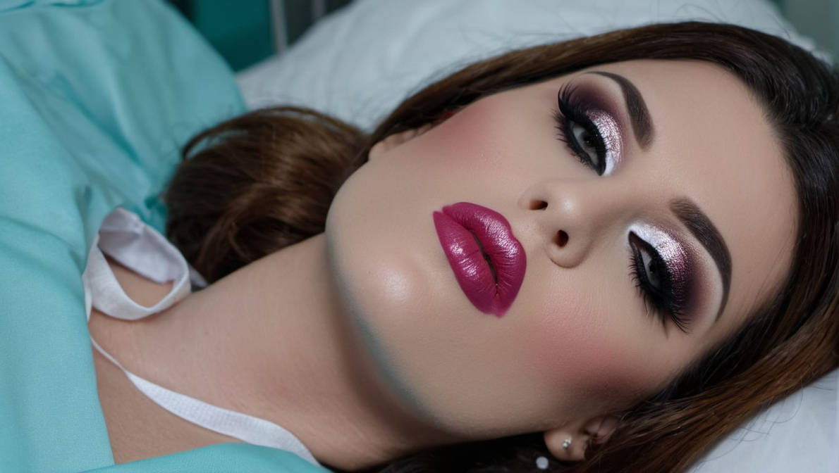

He held up a mirror in front of my face and he peered over the top to enjoy my reaction. I was still in my hospital bed wearing a patient’s hospital gown and I was only just recovering consciousness, but I could see that he had been at work, or perhaps had the work done by somebody with skill. My face was as smooth as polished marble and fully made up, and my hair dad been extended, colored and styled. It was arranged on the pillow to show every inch of my beauty above the shoulders. I might still have the eyes and the jaw and chin of Greg Mullen, but everything else screamed woman.

“What have you done?” I croaked, but the sound that came out seemed to confirm that there was much more than the face. There was no scar on the throat but it was not a man’s throat and neither was the voice.

“You are complete my darling … complete in every way,” he said.

I knew what that meant but I could not reach down to confirm it … or did I even want to? Perhaps it was some muscle relaxant which wore off over time, but in that moment, I was helpless, just looking into that mirror with half-closed eyes still clearing and knowing that he had won.

He had seen me perform in a drag show and had asked me for a date, dressed as a woman. It does happen from time to time, and the response needs to take the opportunity presented, without causing misunderstanding or disappointment. The best way to do that is to claim to be a heterosexual man, even though I wasn’t that. It just makes it easier for him to understand that it will go no further than a few drinks and a meal alongside somebody who appears to be female.

To that end I know how to present as female rather than being in drag. Drag is performance art, whereas presenting needs to be real life, although so as to meet expectations my female appearance would need to be “fabulous”. Then the conversation would turn to the show with encouragement for him to come again and bring all of his friends, and then perhaps suggest a small gift of cash to help a struggling performer. Almost all drag queens caught in this situation should collect something for their efforts.

He paid, and his gift was generous. But he was not interested in the show. He spent the whole time talking about whether I had consider living as a woman full time and having a sex change. It didn’t matter how many times I told him I was a man and lied to him that I had a girlfriend and had never considered for a moment having sex with a man. He just stared at me as if he was deaf to my words, delivered in as deep a voice as I had.

“I am rich and powerful, and if you were a woman I could give you a life others can only dream of,” he told me. I stayed until the end to collect, but I found myself more troubled as the evening went on.

It was not until afterwards that I discovered who he was. Yes, he was rich and powerful and he had got there through criminal activities, some involving violence. And he wanted to date me again.

I just avoided him. I ignored his cards, flowers and other gifts. When he turned up the show, I would glimpse him and then never look in his direction. I just had to hope that he would go away. He kept pestering me for a date, so I finally accepted, but I turned up at the restaurant dressed as Greg Mullen, which is who I was then. I had not shaved for a few days and I did my best to look as manly as possible.

“I don’t know you and I don’t want to,” he said. “You are keeping me from the woman I want, and people who get in my way have short lives.”

I fled, but I hoped that I had made my point. He had seen the real me. There was no woman.

And then I woke up and I was her, and I was beautiful.

But there is no going back, and as a matter of personal safety, no walking away let alone running.

Until my vagina healed I was forced to take him in my ass, but my guess is that he would have realized that he was not the first. But, given his reputation I was expecting a brute – he was surprisingly gentle.

And then the moment came for me to receive him as the woman he had made me, in the passage he had constructed among the wreckage of my manhood. It would be face to face with any contrivance to enter the other way. It was body on body the way nature designed that people should have sex. I told myself that this was my fate, to lie back and take the man who had mutilated me and just accept my agony.

But it was not like that. It was a joy totally unexpected.

When he collapsed beside me, he said the words I had never heard before and somehow doubted I ever would – “I’m hopelessly in love with you, but I guess you know that.”

I do now. Now, it seems for the first time, I am awake.

The End
921
Stepping Outside  A Vignette  By Maryanne Peters  I had lost my job and I could not afford to pay the rent or keep up the payments on my car. I suppose that I ought to have been depressed, but I am not that kind of person.  Instead, while I sent out my job applications, I decided that the time had come for me to simply try dressing as a woman full time – just between jobs. It had always been a fantasy of mine to wake up the morning and slip off my nightie to put on a bra and panties and a nice dress – something old fashioned and very feminine.  I really do think that women in the fifties and sixties are the archetype of the feminine mystique. It seems that the only people who truly appreciate that are men. Certainly the postings of me dressed in outfits of that era got the biggest responses from men.  I had my fair share of indecent proposals, but it was when I was without a job that I started to go back through them looking for somebody who might be genuinely interested in the woman I was presenting as.  I had never thought of myself as gay, but when presenting as female, the idea of being adored and fondled by a man thrilled me. It would be foolish not to admit that some form of sex might follow, but could I do it? I was keen to go as far to the edge as I could. | 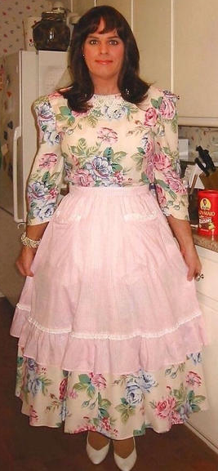

And then I came upon a fairly recent post from a man called … well, let me call him Paul. He said that he thought that I looked like just the kind of person he would like to have living in his house as a wife. For him it was not about sex – it was about having a feminine presence in his house who shared his ideals of womanhood. He was looking for companionship first, and if that led to intimacy that would be nice, but it would never be demanded. The role would be full-time live-in and would include full support plus a banked monthly “salary” and the full use of a car. I asked him to send me a photograph.

There was something about the look of him that made me say yes to his crazy proposal. He was older but in very good health, and he had kind eyes. He was one of those men who looked like a husband who would be happy simply to have a wife and nothing else. But, at the same time I could also see the signs that he was wealthy. I was not wrong about anything.

The image of me was when I set off to meet him. I guess that the dress was a costume and the wig not the best, but I looked pretty (I think) and he could see that I was happy and positive. Staying with him for a while seemed like an experience worth trying. Plus, by the time I had been there a few days eviction and repossession had already happened so, while I did not tell him, I had no other option.

I suppose that I thought that I would just stay in the house, and maybe wander around the garden sometimes, but things just happened.

Firstly, we hit it off. He loved my positive attitude, and I liked his intelligence and clever sense of humor. Secondly, he really did need a wife, and I like cooking for him and tidying up his home office and his bedroom. Thirdly, it soon became our bedroom, initially just so that we could snuggle together, but then I just opened myself to him and that was that.

He wanted me to go out with him. He wanted for us to shop together, or walk in the park, or go out to dinner or a show. He said that he would be proud to walk out with such a pretty wife. It was just that I felt that I looked like a crossdresser and I did not want to embarrass him.

Everything else was really my doing – growing my hair and the laser treatments and the hormones. It was all about being a more realistic woman for him. And of course, I had to tone down some of those classic outfits. I will happily wear them around the house, just because he has a traditionalist about women’s clothing. But I have more modern outfits for stepping outside these days, and he like those too.

Who would have thought it - tomorrow we are out shopping for an engagement ring.

The End
770

Retiring  A Vignette  By Maryanne Peters  My boss accused me of being a retiring personality. If you have not heard the phrase it means that I was shy and avoided meeting other people. I had my reasons. That person was not me at all.  I lived a man’s life because that was the easy thing to do. I had been born a male, but that was never what I felt myself to be.  I admired those like me who were ready to thumb their nose at the conventions and live their true lives, but I just did not have the courage or inclination to do that. It was not my nature | 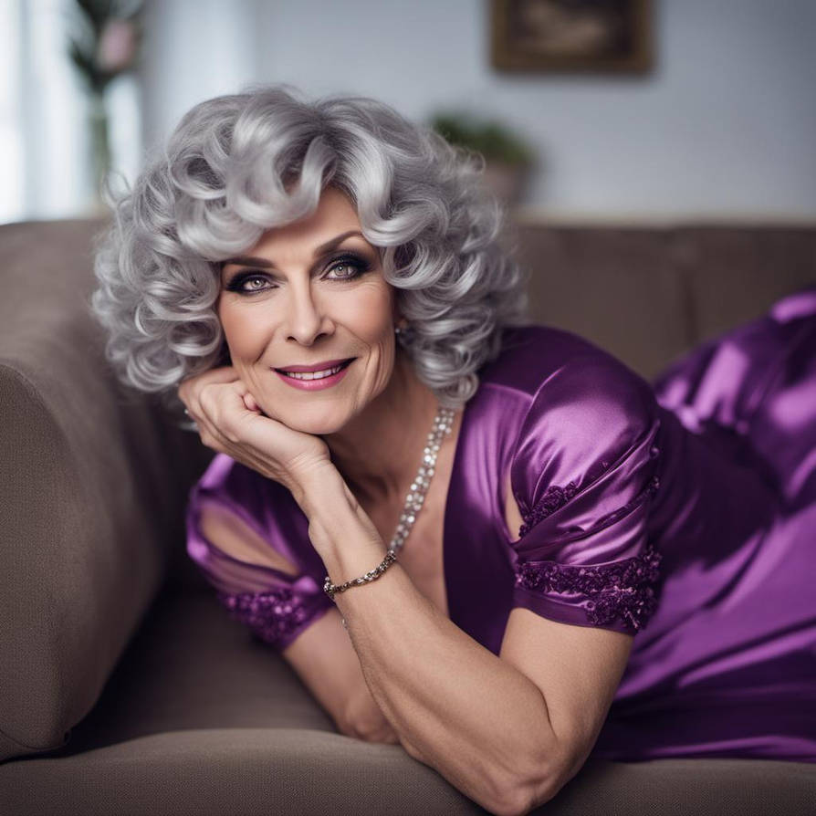  The Image is from Robyn2801

But it seemed to me that retirement gave me that opportunity to reinvent myself. I had been offered a very generous early retirement package, not because I pushed for it (I would never do that) but because my entire division at work was being replaced by AI. I was still short of 60 and I was encouraged by some successful senior transitioners.

My hair was grey but I still had plenty of it, and the hormones that I started taking even while still working, had a very positive effect on that, and my skin. It seemed as if hormones were almost an age reversing drug, given me new feelings and a sense of vim and vigor that had been lacking in my life.

At the final divisional retirement party we were all given a gift card, and I decided to spend mine on clothing and burn all my male clothes on my first day off. As I stood there wearing a pretty dress but still a long way off being a convincing woman, I watched those flames and I started to think about why I had always been so withdrawn. I came to the conclusion that it was my gender dysphoria behind all of it. I did not want to present to people as a lie, and that is what I was for my entire life before that. It seemed that the new me did not have to be like him.

But I needed to pass first. I had determined that I would wear only women’s clothes from the day I came home from my last day at work, and I have stuck to that. But wearing them outside was something I needed to work into slowly.

I now feel 100% confident, my breasts having filled my bra and my hair looking great, and now having the final surgery to correct nature’s mistake. I am putting my glam shots out there. I have a lot of catching up to do. I am retired, but no longer retiring.

The End
Running Back  A Vignette  By Maryanne Peters  I never thought of myself as being pretty, although Jack always said that my lips did not belong on a guy. I was not short and I was athletic in build – my coach said I was a gazelle – born to run. I played hard and I had broken my nose twice, leave it a little to one side. Jack said you would never notice if you saw my blue eyes either side of it. As for the hair – sure, it was long and a strawberry blonde as Jack called it.  I really looked like a long haired guy, and I played football. I was a running back, and all I needed was room to run. If you gave me that, and maybe Jack to block for me, I could score touchdowns anytime you liked. That was what I did. That was what I loved to do. | 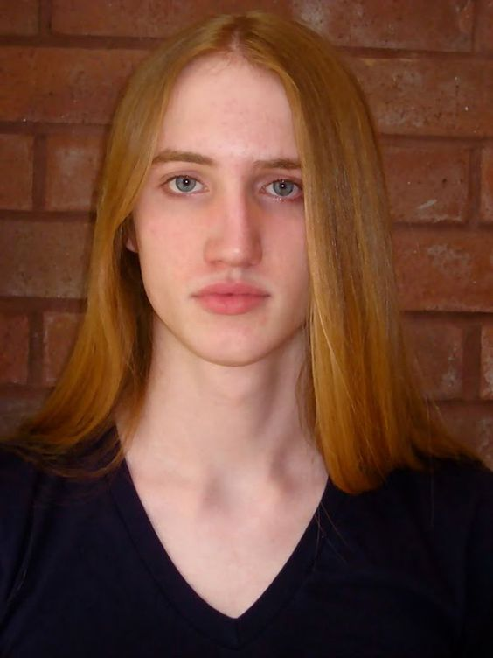

But I suppose gazelles break their legs too, and maybe when they do life is over for them. There are lions to eat them up. My injury seemed like death to me. There were complications. It seemed like my football career might be over. I fell into a deep depression.

But Jack was there, running my protection as he so often did.

I never thought of myself as gay, but I just wanted to be held close by another. Is that so strange?

Jack is not gay either but as he said it – “With those lips and your beautiful red hair it doesn’t feel gay to hold you in my arms.” I was vulnerable and glad to hear those words. Physical contact in times of stress can be so soothing, and a kiss can mean so much more. The first one was not a passionate kiss, but a loving kiss. I think that we both understood that. To friends who had become so much closer somehow.

I think that he felt a little uncomfortable about the whole thing, because he left quite suddenly. There was a part of me that felt that it was right from him to put some distance between us, but the truth is that I had learned that I needed him. His absence made me understand that he presence near me had become essential not just to my happiness, but my survival. I wanted to call him to come back, but I knew that he was deeply conflicted so it was over to me to make some changes. That is what I did.

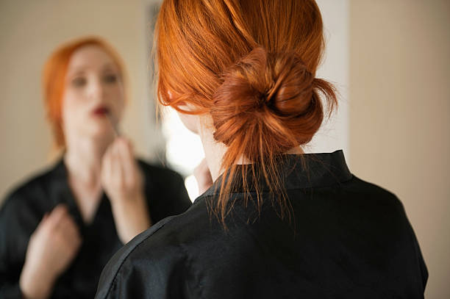

He came running back. Everything has changed. I don’t want to play football any more. I want to be his girlfriend and girls don’t play football, especially pretty ones.

The End
442

High School Party  A Vignette  By Maryanne Peters  The girls always said that I had the most beautiful hair. I only wore it long because I thought it looked cool. I thought I was cool, hanging out with the girls as I did.  My hair was blonde and naturally curly, so it sat on my head like a blonde wooly shapka. One of the girls pulled strand out and showed that it would be well past my shoulders if it was straightened a little with those GHD things.  “Go on, let us do your hair,” they all clamored. Who doesn’t like being the center of attention. | 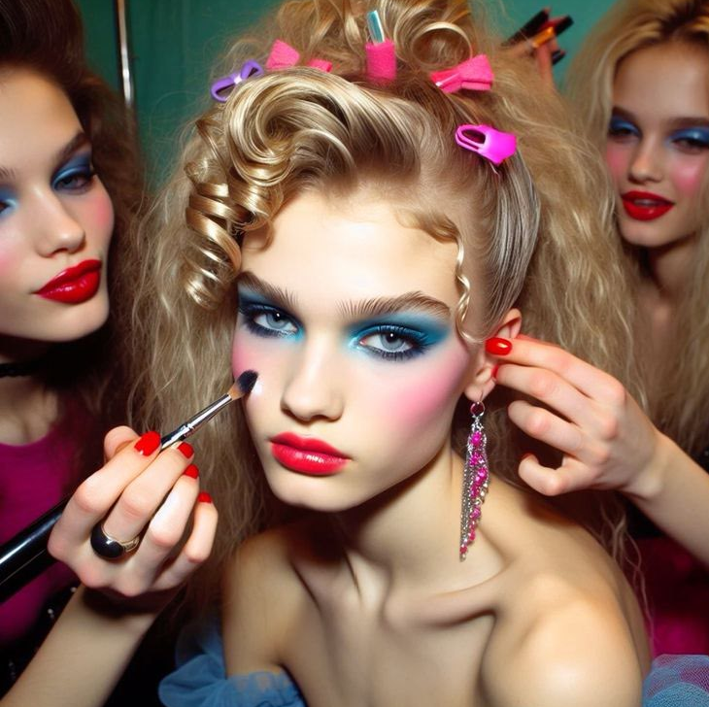

So I let them give me that makeover, and they went way past the hair and all of those colored clips – the next step was eye make up and blusher and lipstick, and before I knew it I was headed off a party in a dress and heels, with my legs shaved and everything!

Sure, I was a little grumpy when I saw myself, but what I was not ready for was to see all those guys at the party staring at me and to overhear the whisper – “Who’s the babe? – she’s new.”

All the girls giggled, and I did too, because I was one of them.

I got talking to one of those guys, who clearly thought that I was a girl and he was interested in me. I found myself telling him a whole pack of lies about who I was and how I was from the country and a bit of a sporty tomboy, but now I was in the city I was hoping to get a job as a model and maybe find a start in the fashion industry. I don’t know where these ideas came from but I really said them as if they were the truth. I even started wondering if they might be the truth.

I had always felt more at home around the girls at school and I never knew why. I can say that I was attracted to girls, but it now seemed to me that it was the way they looked and behaved that attracted me. Sex with girls had never been in my thinking.

And now suddenly, just talking to this guy and looking up at the first stubble on his chin, I was thinking about sex, and not with girls.

That party changed my life, forever.

The End

© Maryanne Peters 2024

