A Feminine Side  Based on Captioned Image (Unknown Author)  By Maryanne Peter  We were doing an installation like we did every day. I was doing the wiring and Bart was tapping away out the keyboard checking the interface. Some lady walked by and had a look in on us and asked us if we would like a coffee. We both said yes.  “That was no woman. That was a guy,” I said.  “Just somebody expressing their true self,” said Bart. “I think all men have a feminine side. It is just more predominant in some.”  “That’s weird. You’re weird Bart.”  We both laughed. We enjoyed working together. I had worked with plenty of programmers but I really got on well with Bart. We were a good team. Close, like we got together after work regularly and talked about life. We talked about all kinds of shit on the job too. | 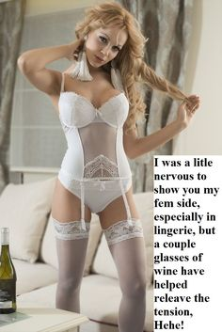

“I have a feminine side,” said Bart. He seemed serious, but I preferred not to take it that way.

“I would love to see that!” I was just making light of it, or trying to ignore it.

“Would you? Would you really?” I looked across at him. There was a strange expression on his face. “Would you like to meet my feminine side?”

“Sure,” I said. I did not want to disaapoint him and it was clear that saying no would do that. “We finish up here and we knock off and we’ll go around to your place.”

“Give me time to get ready,” he said. “Come around at 6:00 and we can share a bottle of wine.”

“Wine?”

“My feminine side drinks wine!” He grinned broadly.

I thought: ‘This is going to be fun’. I was thinking that it would be a huge joke. He might put a scarf around his head and some lipstick on, and act the goat for an hour. I could go along with that.

So I was there at 6:00 I had my phone ready and switched to camera.

He called out for me to come in. I opened the door with my camera in front of my face. I clicked a snap and then when I looked at the screen I thought that my phone had somehow switched over to a lingerie ad – you know what phones are like. But when I lowered the phone, the image on the screen was standing there – in white underwear and with long blonde hair. It was the girl of my dreams.

“Well,” she said, in a husky but girly voice. “Meet my feminine side.”

“Bart?” I could not believe that I even asked. I looked around the room for a moment expecting to see him somewhere to jump out laughing and introduce me to his beautiful accomplice.

“When dressed like this I prefer Beth,” she said. “I hope you don’t mind but I have already started drinking. I needed a couple of glasses to settle my nerves. This is big for me. But here I am. What do you think?

“You have breasts!?” I could see flesh above the bra.

“It’s a pushup, but I have been developing a bit of soft skin on my chest. They look real don’t they?”

“And your crotch! What is going on down there?”

“It’s the lingerie – it is designed to keep everything tucked away as tightly as possible. I could wear a leotard if I wanted to. And these panels on the side hold me in and give me some curves. I have a dress hanging on the back of the door. If you want to go out, we could. But only if you think I could pass as a girl. I would not want to walk out with you looking like a guy in drag.”

You don’t look like a guy at all,” I said.

“So you want to go out?” she asked with a pleading look.

“Turn around,” I said.

“Yes Sir,” she said with a smile, as if enjoying the instruction.

“Is that a hole in the back?” I could see that it looked like it was – a hole in the with fabric with a pink plug.

“You don’t dress up like a girl on the outside with dressing up a little on the inside too,” she said, swinging her hips and looking at me shyly.

I knew then that that was the place I wanted to be.

The End

© Maryanne Peters 2021

Temping  Inspired by this Captioned Image  By Maryanne Peters  Mom said that the agency only handled women. It was part of some “affirmative action” thing – in particular, they were looking for women to expand into jobs that were not normally done by women – have a temp fill the role and prove something.  She complained that computer systems work was an area that was dominated by men.  “If I had the right candidate, I could slot them into a spot that would earn big money,” she said.  The job that she was describing was just the kind of stuff I did for fun, and I really needed the money to be able to buy that car from down the street.  “Can’t you make an exception and get me that contract?” I pleaded with her.  “No exceptions. I only contract out women. So unless you want to be a girl, no dice.” | 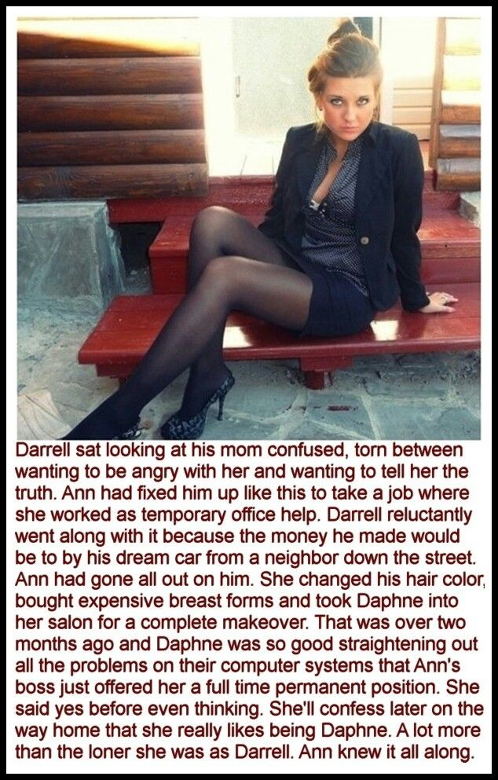

But then she looked at me, strangely. She said: “Well we might be able to but that long thick hair of yours to some use. But I am telling you, that if you are not going to do this properly, you will get me into serious trouble by referring you to the agency.”

“Mom, don’t worry. I know computing back to front.”

“That is not what I am worried about, Darrell,” she said. “It will be in passing yourself of as female.”

My jaw must have dropped to the floor because she just laughed. “It won’t happen otherwise,” she said. I am not going to have my company employ you directly. If you want this job, you have to go through them. And to go through them you have to be a woman. But I think you could get away with it.”

“Come on, Mom! No way!” It was male pride that made me say it. But I was not a big guy and certainly not manly looking. She was sizing me up. I was thinking about the car. I was thinking about what I was prepared to do to get the money to buy it. “Do you really think I could do it?”

All that I had to do was to do exactly what she said. The agency was important to her, and I understood that she was breaking the rules to get me work. It was important that I not let her down. That means looking and acting like a woman.

“We are going to have to get you proper breasts,” she said. You have a little flesh from a late puberty up there, and with good forms we may even be able to work a cleavage. That will help. And I will need to book you a full body wax … and hair coloring. Mousy is not good enough for a professional woman. Unlike men, an untidy appearance can mean sloppy work standards. Unfair, but reality. And voice coaching to lift the octave and improve elocution …”.

It was all sounding way too much, but when she told me how much the contract was worth, I was ready to lie down and grit my teeth as the body hair came off, and sit in the styling chair for three hours for the treatment, coloring and straightening.

“Your mother tells me that you are Daphne from now on,” the colorist said. “What a beautiful name. And what beautiful hair. You can wear it down around your shoulders but for work I recommend that you wear it up in a loose bun. Let me show you how. And we will have to get those ears pierced.”

I was ready for it, to keep things safe for Mom, and for me too. Nobody wants to walk around town pretending to be a girl when everybody is looking at you and thinking: ‘Hey, that’s a guy!’

“You have such great legs,” Mom said. “A girl with legs like your would never hide them. We need to get you some short dresses and skirts, and some nice tights, and shoes with a bit of a heel.”

“Mom, I am a computer programmer, not a runway model!” But she was in charge. I had agreed to follow her instructions, and that was what I was going to do.

When I was ready, I set off for the agency wearing my short skirt and heels, and introduced myself as Daphne. I had renamed some code on my Github profiles and they asked me to do an exercise rather than present a CV. They knew their stuff. I aced it in less than 15 minutes.

And the following day I was presenting myself to Mom’s boss as her niece Daphne – He knew that she only had a son at home. But I had won the job through the agency.

The photo she took of me in my velvet suit was about a week or two after I started. It was a Friday and I planned to go out with some of my co-workers once the day was done. She said that I looked so good in that outfit that she just had to take my picture. I could not resist that look. I had actually done my own makeup that day. By then I was quite good at it. Plenty of eyeliner but understated lipstick colors and clear nail polish. It is good for a day night look, just in case after work drinks turn into something more.

Well, looking like that, they did.

I had all the guys at work hitting on me. I suppose I should not have, but I really started to enjoy it. I mean, I was a long hair computer nerd, and now suddenly I was the center of attention. I wanted to agree to everything but I am not that stu[id. They were buying but I had to watch how much I was drinking, and I had to turn away the guys who were getting to close.

The problem is that in a crowded bar when somebody is squeezing your tits and you do nothing, they think you are approving. That is the problem with breast forms. The expensive ones feel like the real thing to them, but I feel nothing.

His name was Rafe and he was into me – or should I say Daphne - in a big way. He just would not let me be. When I told him that I was ready to leave he offered to get me a cab. Out on the street he was trying to grope me. It was then that he said had been tickling my tits all night.

I waited until the cab pulled up before I gave him the bad news.

“They’re false,” I said. “Latex and silicone breast forms stuck on my flat male chest. I am false.”

For some reason I started to cry. Maybe it was the look on his face. He was shocked. He was not a bad guy. I quite liked him. But now he look desolate. I got into the cab and we sped away.

I told Mom that I could not go back to the job. I had been forced to give myself away to one of the guys at work, and now everybody would know.

“You could say you are trans,” she said. “I could be in trouble with the agency. Why don’t you do that? But you like this job. You have to go back.”

I could that this could be bad for her, so the following day I got dressed in something really feminine so that I could just ride out the abuse that I would get in style.

But nobody said anything. Everybody was just normal. Even Rafe just smiled at me and said “Good Morning” just like any other day. It was like he had forgotten overnight. Nobody knew.

Later in the day when I went to the mainframe room, Rafe stepped in and closed the door behind him.

“Thanks for not saying anything,” I said.

“I thought about this all last night,” he said. “Why would I tell anybody your secret. I think that I am falling for you, Daphne, because what you are hiding really doesn’t matter to me. I think that you are the most lovely woman I have ever met. We can work through your transition together. You need to be the woman you were meant to be.”

He had me in his arms. His face had a crazy look, like he was out of his mind, and it was down to me.

Have you ever looked into the face of somebody like that? I just had to kiss him. I just had to.

The End

The Walk Home  Inspired by a Caption Image by… Who came up with this?  By Maryanne Peters  I barely knew her brother. All I knew was that he worked out of the night club on 37th and that he dealt in drugs. I guess you assume that means ecstasy and coke and stuff like that, but clearly roofies too and as it turns out, something else – hormones.  She said that she would meet me there and when I arrived the barman sent me to the blue door off the corridor opposite the bathrooms.  The moment I walked in there something was sprayed in my face and I just lost touch. I did not fall over exactly, but my balance was out of whack. I could not walk without help, and I did not even know who was helping me. | 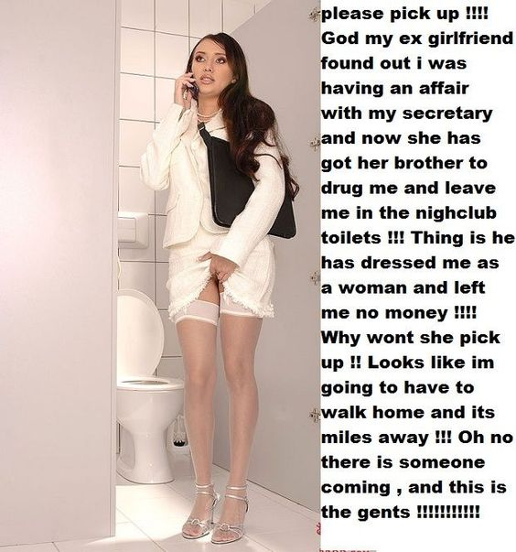

It was like I was in a trance. I was vaguely aware of what was happening but it was as if I could do nothing to stop it, or more like I just did not care what happened.

I remember being led somewhere and lying back while they seemed to tear the skin off my face, and my arms and legs too. There was an injection in my throat and I was to cry out but it was just a little squeaking noise like a mouse. I remember somebody tugging at my hair and painting my face and my fingernails and toenails, and then dressing me. And then I was led as if walking on stilts back to the corridor at the nightclub and I was dumped in one of the Men’s toilet cubicles.

I just sat looking at the walls for what seemed like ages, until slowly my surroundings seemed to make sense. They certainly made more sense to me that what I was wearing.

I was dressed in women’s clothes. It was a short white sleeveless dress with a jacket over the top, but Could not take it off because there was a large black satchel over one shoulder that seemed to be stuck to it. I was wearing stockings and high heeled shoes that also appeared to be stuck to my feet. And there was glue in my groin to. Somebody had been playing with my nuts and my cock. Everything was still there under the lacy panties I was wearing, but it had been rearranged somehow and was held together with a big rubbery glob.

There was long dark hair hanging down. It was not a wig and seemed to be solidly attached to my own hair. I could not pull it away from my scalp.

I could reach inside the satchel. There were some papers and there was my phone. What could I do?

It did not take a genius to work out what had happened. She had done this - or engineered it. The last thing I remembered was seeing her brother. I needed to reason with her – get her to undo everything. Beg forgiveness or at least understanding. Even offer to go back to her if that is what she wanted, but as a result of this it was the last thing that I would want.

I called but she wasn’t picking up. Who else could I call? The Police? What would they do?

I decided that I should head home. I rummaged around in the oversized satchel. The papers were pictures. A man and a woman having sex. Me, as the man, and my secretary. The proof of my infidelity stuck to my body as a torment. There was no money to pay for a cab.

I started to think about walking home. It was a long way. And wearing high heels! It seemed impossible.

Just then I heard the door swing open. I did my best to stay silent. I would wait for him to finish before I was ready to venture out looking the way I did. But he was not there just for a piss. He went into the stall next to me. It seemed to me that I might be able to sneak out once I heard a sound confirming that he was fully engaged. But there was nothing.

Instead, I looked up to see that a man was looking over the partition between stalls, clearing standing n the seat.

“Well, well,” he said. “I thought I could smell a woman’s perfume and it made me curious enough to break custom and look over the top into next door.”

“I can explain,” I squeaked, rummaging through my befuddled brain for a story. “I am hiding from a stalker.”

“In the men’s restrooms?” he put an arm across the top as if casually talking over the back fence.

“It’s a lesbian stalker. She won’t look for me in here.” Whatever had been done to my voice it made me sound like I was sucking helium.

“You are in luck,” he said. “The best defense against a lesbian stalker is a man. May I offer my services.”

“Do you have a car nearby?” I asked. I really needed to get home.

“As a matter of fact I do,” he said. “And it is at your disposal.” Opened the door to my cubicle and stepped down to meet me. He was taller than me – a good looking man.

“Don’t you have to do … to do something first?” I pointed to the bowl.

“No. Like you I was hiding from a stalker. I have just broken up with my girlfriend. She is a rather ferocious type. A recent addition to the female sex, so call me kinky if you like, but I seem to find myself attracted to a woman with something extra,” he said.

As we walked to his car I wondered if this was chance or design.

The End

Similar  Inspired by this Caption Image by … who?  By Maryanne Peters  Have you heard of “Similar Attraction Theory”? You should look it up – it might help to explain things. Basically, it is the debunking of “opposites attract”. In fact, people are attracted to partners who are similar, in appearance as well as attitudes. She was attracted to me because I was like a male version of her. I was, but not now.  Maybe I was attracted to her for the same reason, but I did not want her to change. I thought that she was perfect the way that she was. I told her often enough.  “So why not do as I ask?” she would say. “All I am asking is for you to grow out your hair the same length as mine. If you think that it is so perfect then why would you not want that too?”  The hair was just the start of it. Then she started saying that we looked so similar that we could be twins, and we should have matching outfits. It was supposed to be like matching colors, but I would wear the male version and she would wear the female one. But then the differences began to blur. | 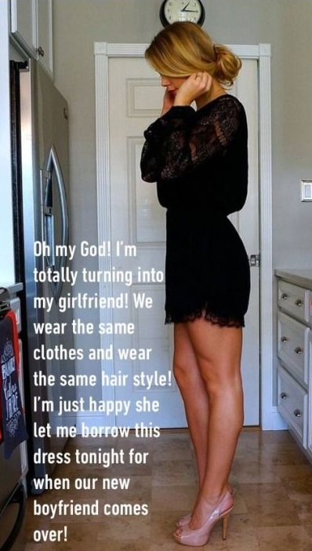

Malcolm looks a bit like us too, I guess. I mean he similar eyes and cheekbones, except that he is huge and has heavy brows and a big chin. He is a real man and makes me realize that I was never really one of those. When he met us, he said that he always had a fantasy of being a boyfriend to a pair of twins.

I had to explain to him that we were not twins – we were not even related – we were just friends – in fact we were sexual partners.

“Even better,” he said with a sly grin – you know the thing.

“We are sexual partners because I am a guy,” I said. I expected that would knock the stuffing out of him. He looked momentarily surprised, and that was all.

“Even better yet,” he said. “I am always ready to try something new.”

So it is the three of us now – me and her and our new boyfriend.

The End

Hubris  Inspired by this Captioned Image (who?)  By Maryanne Peters  Sometimes success can be a pain. I mean, I knew that I was good at my job. I used to say – “Bring me anybody and I will turn her into the perfect lady”. There is a word for it – “hubris”. It comes from ancient Greece and means excessive pride in defiance of the gods, and it always leads to trouble.  People always said that my husband was a pretty man and I suppose they were right. Beauty is my thing. Is it hard to understand why I would marry a man with that fair hair and those wide set blue eyes.  When somebody asked me whether I could turn my skills toward making my husband one of those “perfect ladies” I had to point out that while I could make him look like one, that was not my service. The look is only a fraction of it. I could do the makeover with ease, but skills were in coaching deportment. Teaching a woman how to present. | 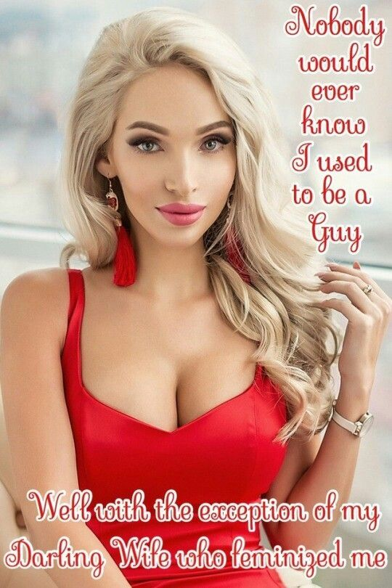

But the challenge got me to thinking. What better advertisement for my services could there be? “Bring me anybody” was my call, and here was somebody. We could spend time together like I could not with my other subjects. We could work on this intensively. All it meant was to take that accrued leave and give me free rein to make the changes that he would not be able to hide – hair removal, hair extensions, eyebrow shaping, lip plumping, pierced ears.

Once that was done I explained that his every action would need to be modified. He should get into a feminine mindset. While he wore a nightie to bed, we would be lesbians, without the need of a strap-on. He seemed to enjoy the idea. I did too, for a while.

He started to lose rigidity, and I could not work out why. He was keeping things from me.

I proved my point. I paraded my beautiful “client” and some people asked what she was like before.

“But you have met this client before – don’t you remember? This perfect lady, before I worked my wonders, was my husband”. That is what she was.

“I am not sure that I want the extensions taken out and to cut the rest of my hair.” It was her talking, in that perfect voice with the firm but feminine intonations that I had coached were the very essence of ladylike speech.

The breast implants were her idea. And then when she went in for the brow and chin shaving it seemed as if he was gone for good.

And as if to nail me to my own easel and leave me hanging there, she started to court men. It was as if I had created the very opposite of Frankenstein’s monster – a creature designed to attract rather than repulse. Attract and then tease, using all of the skills learned from me. I have always assumed that it could go no further, not just because of anatomy but because he was heterosexual. But now I am not so sure. Frankly I would rather not know.

I am still her “Darling Wife” or “the one who made me the woman I am today”. That was not what I wanted.

Must hubris be so painful?

The End

© Maryanne Peters 2022

