Grace on the Gridiron  Inspired by a Caption by Amy Harris  By Maryanne Peters  My wife had been a ballet dancer, and in the early days when I had a pro-football contract and she had a position in a leading city dance company, I knew how hard she worked. She trained as much as I did, but she spent time on developing muscles to extend the flexibility of the body, and she worked on balance. A ballet dancer must be able to move at speed from a standing position and maintain balance under pressure and distraction. There was plenty my players could learn from ballet.  What prompted it was one terrible game where it seemed that everybody in the team either fell over or fumbled the ball, or both. I had the worst rant of the season in the change room after that game.  “Whatever you want us to do Coach, we’ll do it,” they said to me. Nobody likes losing, but to lose looking like uncoordinated idiots is much worse.  I spoke to my wife about a skills course at her ballet class, late in the evening after all her students were gone.  “And have them dress like ballerinas,” I said. “They need to get the lesson that women have better skills in certain areas. It will do them good.”  I have to say that my wife was not pleased with me for making the suggestion. She had to rustle up a bunch of pumps, tights and leotards in maximum sizes to kit out the boys, but I said that the college football fund would pay her for that and her lessons.  I decided not to go to the first training session, which started with basic positions, but I went to the second of the 13 classes with a bag of balls.  “That Michael, your kicker, has some true talent for ballet,” she said to me. “He seems very keen to push on with it.” | 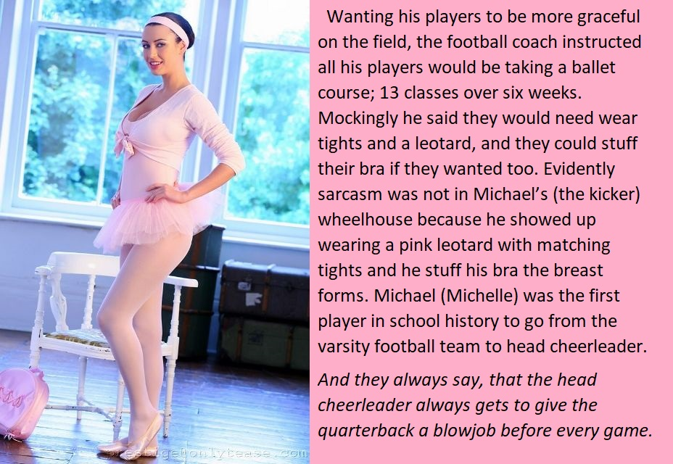

I looked where she was pointing and there I saw Mike in his pink outfit with a pink hairband holding back his long dark hair, doing little jumps and demi-plies behind the others.

The photo is what he looks like now, after the breast implants really signaled the end of his football career. In fact, the hormones had robbed him of a lot of muscle mass in the weeks before, but he could still kick a ball better than many.

But the truth was that his heart was no longer in it. Michelle is really a dancer these days, and a good one. She only really got into cheerleading to stay in touch with the guys, and she excelled at that two.

Staying in touch is important. If I have achieved one thing as a coach it is to keep the team tight – once a team player you are always a member of the team, even if you have tits. Ex-players like Michelle have a role to play, although quite why an ex-kicker seems to spend so much time mentoring our quarterback has me puzzled.

The End

My Better Mom  Inspired by a Cap Image by SpottyCat44  By Maryanne Peters  When Mom got together with Tyrone, I have to say I was shocked. It is not that I am racist or anything like that, it was just that he was so different from Dad. He was not a big guy, but he was athletic. I was only 11 at the time, but even a 11 year old understands what sex is, and how some women need a man for that. I guessed that was what this was all about.  Certainly he was never going to be a provider. Whatever job he had he quit when they got married. Mom said that Tyrone could stay home to look after me. She said that he would do whatever I wanted – that we should do everything together.  Those preteen and early teen years are so important for a girl. They really are the years when you truly become a woman, and Tyrone shared that with me too.  We became a pair, and my mother almost dropped out of the picture. The truth is we were never close. Her career was what matter to her.  It all started when he told me that he liked dancing too. Or rather he said that he had always felt an urge to dance but was too embarrassed to express himself. He said that I should not be nervous and that I should just let go, and he would show me how. | 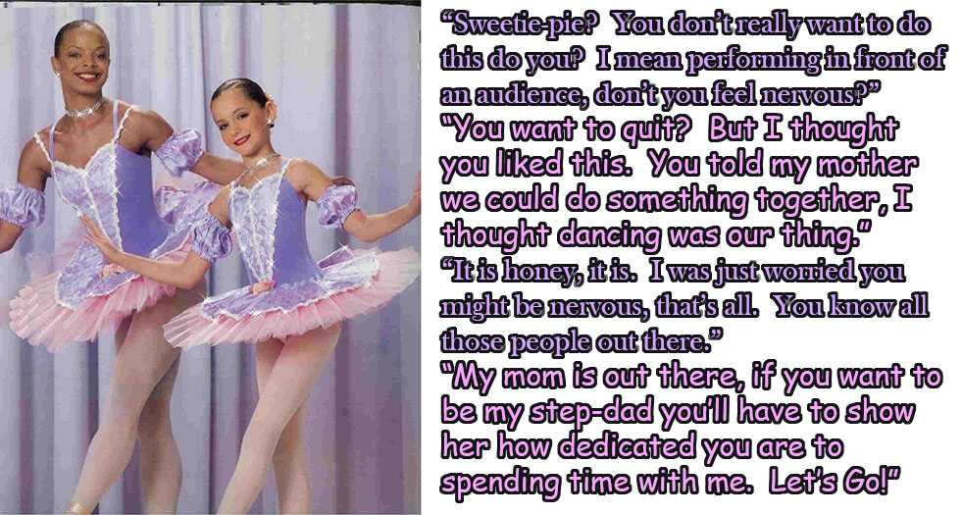

When I told him that when we practised together, he would need a leotard like mine, he said yes. And when I suggested a tutu like mine, he agreed to that too. He had nice hair too. It was not too crinkly, and he wore it quite long and slicked back. He kept on growing it so that it could be pulled back into a bun, like I wore when dancing. He liked doing my hair and told me that he would love to have hair like mine, but of course he was Africa American.

For I first big performance he said that he would be right there with me. Some of the other girls did synchronized pairs with their sisters or mothers, so I asked him if he would do that with me. That meant matching costumes, and matching hair, and makeup. And he said yes.

So that was us. See how beautiful he looked. He still had those masculine shoulders then, but his legs looked really good in tights. So good that somebody from the audience approached him afterwards to talk to him, thinking he was really a girl.

He said his name was Jamal and he was huge, and black, and kind of scary. I did not want my stepdad to tell him that he was really a guy, so I said: “Tyra, can we go now?”

“Tyra” took the hint and started acting really strange, and Jamal said that she looked a lot like Tyra Banks, and she just giggled. It turned out that Jamal was divorced and caring for his daughter was also a dancer, but not a very good one.

Anyway, everything was different after that. It is like I said, we shared our girlhood. While Mom was at work, my best friend and the kind of Mom every girl dreams of, was Tyra. Except that we were even closer because we were finding out all about womanhood together.

For a while, when Mom came home Tyra had to become Tyrone, and perform what she called “Husbandly duties”, but Tyra explained that this was becoming more difficult ever since she decided that she was going to share puberty with me too.

Anyway, Mom was going to find out and she did. She went apeshit. I just held onto Tyra and told Mom to leave her alone. I think I also might have said that I hated her, but that is not true. I just no longer cared about her. Not the way I cared about Tyra. She is my better Mom.

Anyway, she said Tyra had to go so we both did. Now we live with Jamal and his daughter, and we are a very happy family.

The End

Awesome  Inspired by a SilversTG captioned image  By Maryanne Peters  I think that I was more intrigued than shocked when she suggested it. I suppose that most guys would retort: “You’ll never be able to make me look like a girl. You’re crazy.” But the truth is, I thought she might manage.  She certainly thought so. They all had a project to do a radical makeover. Some had their mothers as models, one had her grandmother, but only she took her brother along.  She introduced me to class as her friend Diane. I said nothing. The cheerleader outfit was her idea and supplied by a friend. The wig was from the class supplies. But the makeup was all hers. It was not overstated. I just looked pretty in a natural way. So how was she going to blow away the teachers?  Well, this pretty young girl sitting on the gym bench is … my brother, Daren!”  I just sat there with that look and in that pose. The teachers looked me over and spoke with me to confirm that I was indeed a boy. Job done. She got the A, in fact an A+. | 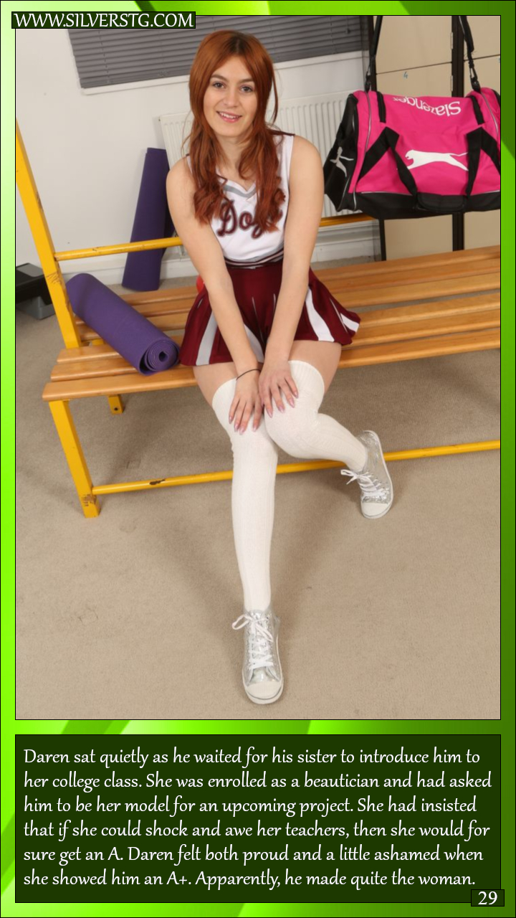

So why was I ashamed? Well, it was because it was not really her work, it was mine. She tried to do the work but ended up getting it all wrong. I was not expert – not then – but I could see the problem. The skin tone was not natural. The eye shadow looked like a drag queen’s, and poor use of highlight near the brows. I have to say that after her first attempt I went online and watched maybe a half dozen tutorials before I worked it all out. I just did it and she threw up her hands.

Anyway, she was struggling, but the A still stood. One of the teachers called me up, and said that the were considering revising my sister’s grades.

“We think a professional did that makeup on you,” the teacher said.

“Definitely not,” I said. I wanted to defend my sister but I was not going to lie. So when I was pressed I had to admit it: “I did it. I did my own makeup.”

“Show us,” they said. So I went in and I sat down and they put a huge case of makeup in front of me and invited me to do it again. So I did.

It looked a bit weird without the wig, and maybe because of that and my own natural hair color I adjusted the colors I was using a bit, but the result I thought was even better.

“You’re a natural,” the teacher said. “And you make a very attractive woman, even with short hair. Have you thought about a career in beauty. Honestly, your sister does not have the talent, but you definitely do, in spades.”

So that’s how it all started. That is why my sister works the checkout at the supermarket and how I run a successful beauty business at the mall next door.

I’m Diane now of course. I know there are male makeup artists but everybody agrees that with the looks I can create, I have to be a girl.

The End

Not working
A Short Story for John from a Cap by Feminization Beauty Within TG
By Maryanne Peters

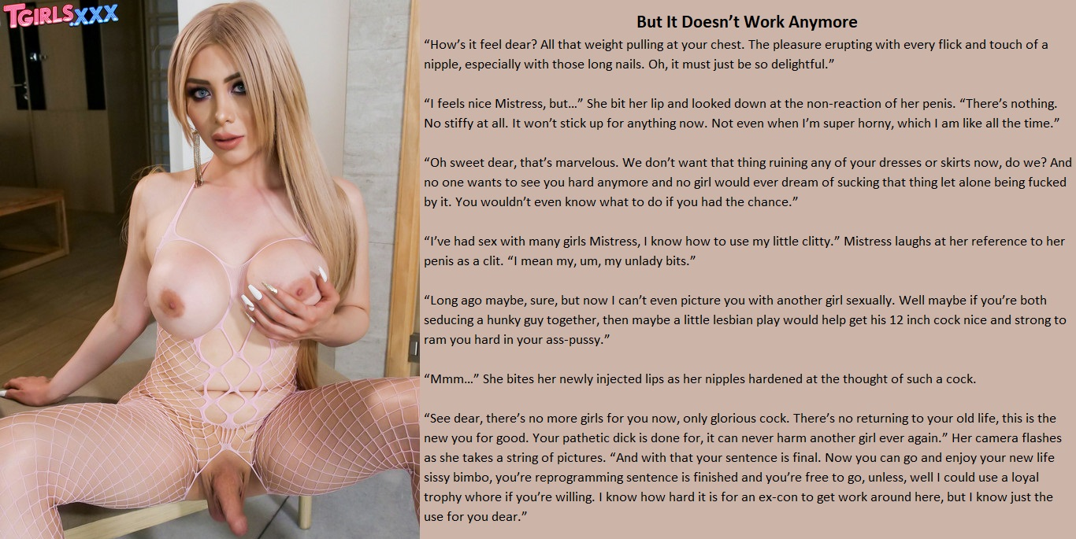

Prison was tough for me. I was always a pretty boy, you see. The moment that I walked into that hell hole I could see everybody staring at me, and I knew what they were thinking.

I was not gay. Not then anyway. It is just that survival is more important than pride. Survival is everything. There is no such thing as a proud corpse.

I had to take it. I just needed to make sure that I was not the jailhouse slut who could be taken by anybody. I stuck with Carlos and few of his boys. They fucked me, but they made sure nobody else did.

Most guys like Carlos like their jailhouse bitches “femmy”. That was not me either, but you have to adapt. I grew my hair so that Carlos could have something to run his fingers through as I sucked his cock. He smuggled in some hormones and some makeup to, so that he could fuck me face to face, and think of me as a woman, with my dick hidden with my hand.

To be honest, in those days I preferred it doggy-style so I did not have to look at the man fucking me. But things change. People change. And Carlos was good to me. I made him happy. When he fucked me on my back, I could see how happy.

I owed him, and he would not let me forget it. I was going to get out before him, but he asked me to wait. It seemed crazy. He would not be interested in me when there were real girls to be fucked. But of course, I said yes.

“Go and see Maritess,” he said. “You can stay with her. She will get you work. She will look after and keep you safe until I get out.”

I suppose the option was for me to run, but I had no family when I got out. My parents and my brother would not take me in. My parole officer asked me where I would be staying, and I had the address in my pocket.

“Carlos has asked for some improvements,” she explained. I thought that the soft smooth body and the long blonde hair was enough for him, but he had booked me in for breast implants and lips surgery to give me a permanent blow-job pout.

Maritess did not approve of me. I am sure that she felt that I had turned Carlos gay somehow, but how could she understand what it was like for somebody like Carlos. He needed to fuck somebody and her liked girls. I was as close to that as he could get in the joint.

I called her “Mistress”, but I hoped that when Carlos got out, he would put her in her place. Until that day she would torment me with the effect of the continuing hormone shots that she administered. My balls had turned into the size of hazelnuts and I seemed to be always flaccid.

She said that she had “reprogrammed” me, in refusing to let me refer any part of my body as being male, or behave in any way like a man, but in truth the maleness was fucked out of me in prison. I am not the enemy of women that I once was. I am one of them now. One of us, just with a little bit of something extra – with emphasis on the word little.

So I make up for it by trying to be extra pretty. You’ll never see me without my hair looking nice and my makeup perfect. I like to be attractive you see, to men in particular.

Of course Maritess is right. I still want sex. I want it all the time. But now I am pale and soft and weak … and pretty in the kind of way most real men like. A woman beneath me fighting to get away is no longer my interest. I need a man on top of me, giving me what I deserve. Please, please, give me that.

I’ll wait for Carlos. I won’t be another’s trophy whore. She can forget that. But what is a girl to do while she waits?

The End

Building a Family  Inspired by a little piece from Elena  By Maryanne Peters  We live in the small village where I was born, on the coast of the Baltic Sea. I have travelled a bit and I know what is out there, but my village is home, and I want to stay here.  I feel safe here. My husband was away from the village when was killed. Steve’s wife got ill when they were away and she died in a big city hospital.  Steve was my next door neighbor long before he even married that girl. He helped me out with things that a man could do because my son was never able to. He was either too idle or too distracted. Steve was always willing.  Steve’s daughter Katherine was really too young to understand her mother’s death, but I was there to help him with her. It was the least I could do given all he done for me. If his daughter needed a female role model, it could be me.  But I am not a young woman, and what Kathy really needs is a mother who will still be there was after I have gone. And Steve needed a wife too. Somebody who would stay in our village. | 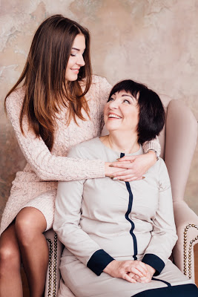  "Look at me, my girl," my mother said to me, "I am very pleased that Steve was able to make a bad young man a proper woman and a good wife, who always wears skirts and pantyhose! And I'll help him make you a good mother to his little daughter!"

Steve and Kathy are like my family. I just wanted to keep them with me – to make them even closer to me. I wanted to make them my real family. But at the time the only real family I had was my son Anton.

It was not that Anton was a disappointment, it was just that he was a lost soul. Unlike his father he is just one of those people who needs to be led. He has a kind heart and he was very passive; so passive that a mother would fear for him, as I did. He was always being led into trouble by more powerful personalities, and so he was lumped in with all the bad young men in our village.

He needed protection. I knew it, and he knew it.

Again, I faced the problem of my own mortality when I thought about it. Who will look after my boy after I am gone? He needed somebody good; somebody strong like … like Steve.

It seemed a crazy idea, but as it formed in my head it seemed as if it could give everything that I wanted. All I had to do was to convince Anton and Steve that this would do good for all of us.

I went on line and read all about boys who become girls and how they do it. I could order the drugs and I did. I could add things to Anton’s morning tonic. I could tell Anton not to cut his hair – which was already long. And then, as he became self conscious about his change of appearance I could keep him inside and slowly introduce him to the habits and skills that a woman ought to have.

Then I told Steve that Anton was considering a change of gender. He had no real association with Anton but as a favor to me he agreed to encourage the boy to consider the possibility of stepping out of the house dressed as a woman.

It took some time for Anton to agree to present himself as Antonia, and even then it had to be in another village some distance away, but when he did, Steve was thrilled. From there it was just a matter of time, and plenty of encounters arranged by me.

And then last summer Steve proposed. Steve had only one condition and by that point Anton had all but disappeared and Antonia was dominant. I was there to tell him all about the joys of womanhood and to assure him that I would love to have Katy as my granddaughter. It was something that their wedding would deliver to me.

So I have built my family around me. The three people that I love most in the world are related to me by marriage. I could not be happier.

The End

© Maryanne Peters 2020

