Self Experimentation  Inspired by a Captioned image by TGFusionist  By Maryanne Peters  As a scientist, let me explain to you something of the advances that have been achieved through self experimentation. Spinal anesthesia had never been tried before August Bier injected cocaine into his own spine and temporarily paralyzed himself. Dr Barry Marshall found a cure for stomach ulcers only after he infected his own stomach and then showed that simple antibiotics would cure it. Sometimes if you want to prove that a drug will work as you say it will, you have to administer it upon yourself.  It is not just the cost - the protocols for human trials are just so difficult. I admit that I was impatient. That may not be a good trait in a researcher. Gus cautioned me against it, but I called him a doubter. He told me that what I was describing was gene modification by hormone treatment – an impossibility.  Just like Bier and Marshall, these are the kinds of statements that spur somebody on – that prompt them to take risks. It is for the advancement of science. We live for that.  So, I did it. I injected myself. I wanted to see the changes, and I keep a log of all that happened to me – all the changes in my body. I had to be scientific.  The thing is that the changes were not just to my body, but my brain. That was not what I expected. I expected female secondary sexual characteristics, quite obviously, but a scientist must assume that the brain function of both men and women is essentially the same. It must be, considering it at a neurological level of course.  I suppose that the first obvious and unexpected change was just how much I liked my new body. It should have felt awkward and uncomfortable, especially the breasts, but I loved them. | 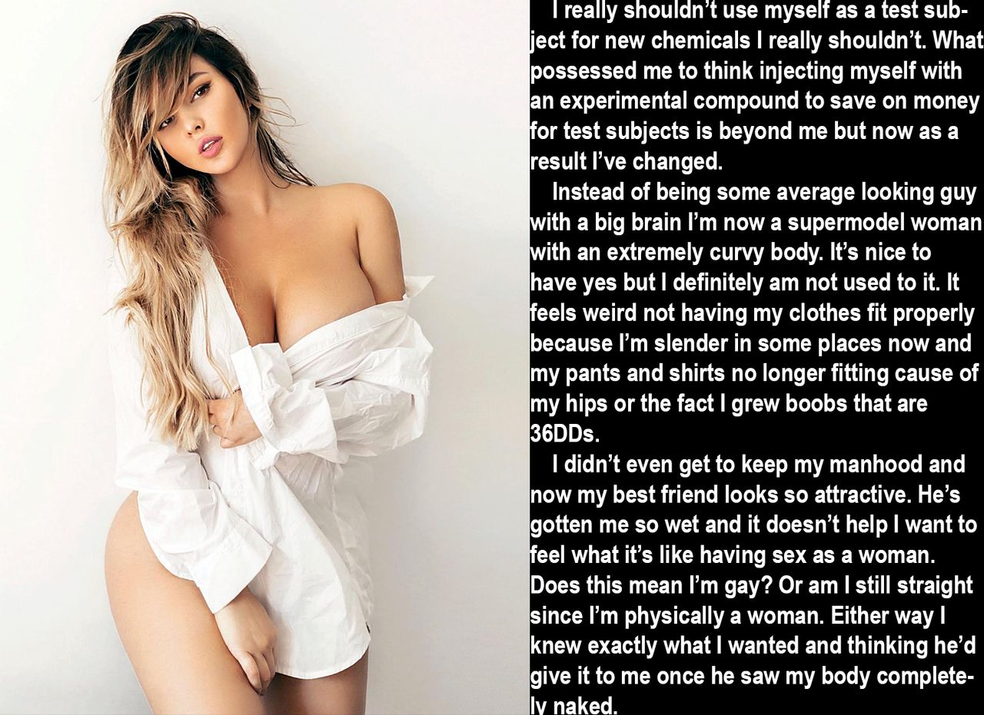

Short hair just did not look right on that body, and when I got impatient waiting for it to grow I got the extensions, in blond.

I know I look good. I was always rather ordinary looking as a man – practically invisible. Being a scientist and researcher invisibility can be an asset. Nobody can call me invisible now. I have to say that I prefer not to be. I am guilty of “strutting my stuff” I guess.

Who was I trying to impress? I told myself that it was not about anybody else but me. I was showing off for myself, hence the inordinate time being spent in front of the mirror. I was obsessed with new body – not sexually for some reason, but because I knew that it was beautiful. But I now realize that I was deceiving myself. It was mainly for Gus.

Gus had always been my best friend and collaborator. Neither of us were gay. In fact, neither of us was particularly sexually active. I wasn’t anyway. We worked and after work we might share a drink and a meal. That was it.

My new body changed everything. He watched it all happen. I could see that it was disturbing him. I started to make notes in my log about his reactions. I caught him staring at me longingly, especially after I got the hair extensions and started to wear lower front tops under my lab coat.

But that was not the strange thing. My body now appeared female so who could blame him? No, the thing was that I started to find him sexually attractive. What I knew was that hormones are not supposed to change your sexual orientation, but it was becoming increasingly obvious to me that it was changing. In fact, a libido that I was never really conscious of started to rise up in me. My penis had almost disappeared into the folds of my scrotum, which was now empty with my testicles having shot inside me weeks before. Now the who area seemed to get moist when I looked at Gus in profile.

That is my lab coat in the image. I put my camera on a tripod and posed in it. Then when I was happy I invited Gus around to my place and greeting him at the door wearing nothing but the coat, open to the navel.

He seemed uncertain for a moment, but only a moment. Then he was all over me and I was all over him.

We had sex that night, but it was anal. I would like to have a vagina and given what has been happening science dictates that I should wait to see what develops and maintain my log. But as I have explained, I have a tendency towards impatience, and I did mention the libido – didn’t I?

The End

Replacing my Baggage  Inspired by TG-Man on Deviant Art  By Maryanne Peters  So that was the story I had to say to Customs and TSA. I mean I don’t look anything like my passport photo. Not any more. I just felt that I could not explain my personal background. And the truth of it was that it was a bit like what I said. It just came over me.  My bags had disappeared – that was true. Apparently they had got chewed up in the baggage handling machinery, together with a few others. Heading home with all the men’s clothing I had bought in Milan, now just oily rags stuck in some cogs or conveyor belts.  I had nothing. Except I did have that policy on my credit card, and receipts for everything I had lost. They said as I was still there in Milan Malpensa I could buy replacement clothing.  I was not asleep, but I woke up then and there. I was talking on my phone and looking across at a boutique with just the most gorgeous outfit in the window. It is the one I am wearing. A pink shawl jacket with matching pants, and a grey top to match the lining. Women’s clothes. My secret desire.  I have always wanted to wear women’s clothes. Maybe that was why I went into fashion, but I ended up in menswear. Because the truth is that I had found out that women’s clothing was not enough for me. I needed to be a woman.  Now I was in a foreign country with nothing to wear and money to spend. I woke up. I could make this happen. Right here. Right now. | 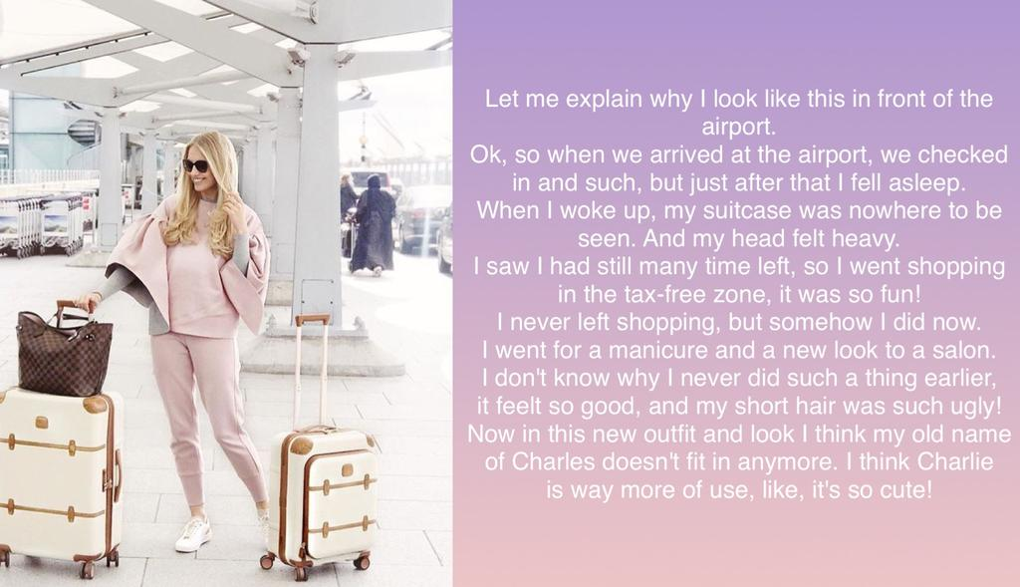

I had time. The baggage handling collapse had delayed the flight. I could buy everything and still have time to go to the salon right there in the departure area. Once I had bought my new outfit and filled my two new suitcases I still had hours to get the body wax, the manicure, the blond hair extensions and the makeover. I was in heaven.

Honestly, I never even thought about the consequences. It was as if a huge burden had been lifted off my shoulders. I could consign Charles to history and be Charlotte (Charlie for short), the woman I had always dreamed of being.

The truth is that I never spent enough time with trans-people to understand it, but does it happen this way for others? You fight it and tell yourself that you will beat it, and then one day you just look across and say: “Fuck it. I am going to do it!”

And I had the credit card in my hand and I was talking to card company and the guy said: “You are all good to go, Sir. You can buy up to that value.” And I was looking at the very thing I wanted to buy, and it was so stylish and feminine, and pink.

“Thank you,” I said. “And its not Sir. It’s Miss.”

The End

Eight Months Later  Inspired by a Captioned Image  (Kenneth2Willow Deviant Art)  By Maryanne Peters  What my brother Kevin failed to understand is just how fit and athletic you need to be to be an award-winning male dancer. Ballet is hard. And I think it is even harder for boys.  Am I a sissy? He had no idea what a sissy was until he became one. Mom knew that I was no sissy, because, like she said, she knew the training I did and the work that I had to do, every day, to be at the top in my chosen hobby – classical ballet. | 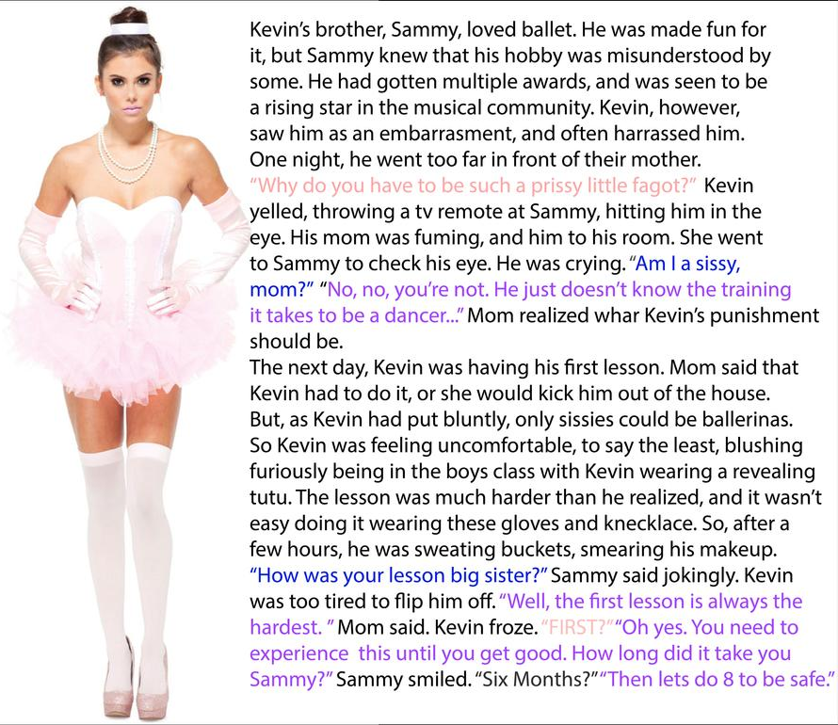

The truth is that I got into it to get to get close to girls. I guess that I was more interested in girls than my older brother. It seems to me that I now know why.

And Mom was quite specific. She showed the ballet instructor my black eye and insisted that Kevin attend training in a tutu. It turned into a full outfit.

But as it turned out, he was better suited to being a ballerina. Kevin was too weak to cut it as a male dancer, and although he is a year older than me I have better muscles to do the required lifts. That is what training does. The girls in class feel confident with me. The tutu suits Kevin, and not just for punishment.

Eight months later this is my big brother, or should I say my big sister. The truth is that she will never be a great dancer, but ballet has taught him a grace of movement that he was just never able to shake off, and he seems to prefer wearing his hair up all the time, and wearing makeup even at school, and the tightly bound groin that is necessary if you are a boy ballerina is what is inside her panties all the time now – She prefers it that way, even though it has caused “testicular atrophy”.

And you can’t look like this and walk the way she does without getting attention. It started as taunting but now the boys are looking at her differently, and the rumor is going around school that she gives the best head and maybe something else besides.

He was only doing two lessons a week, but that seemed too much for him.

So, who is the sissy now, Kevin?

The End
Twinkles
Inspired by a Captioned Image by SilverTG
By Maryanne Peters

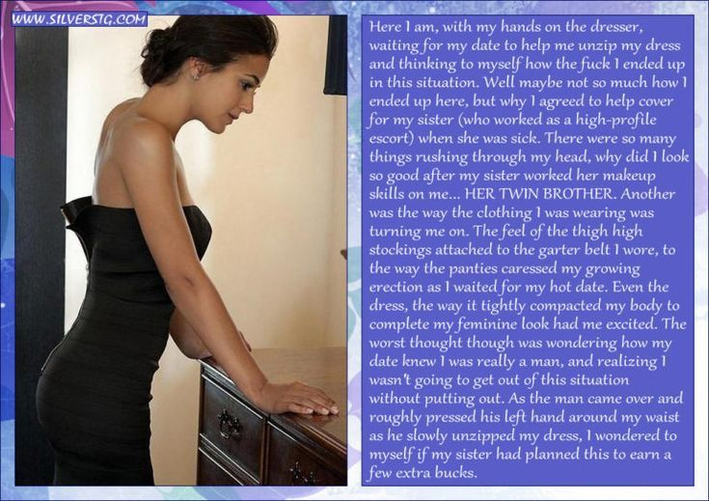

“It is not prostitution,” she told me. “As an escort for this agency, I do just that. I just partner them for an outing. You just have to put an arm through his, laugh at his jokes, and look like me.”

And that last bit was why she even bothered asking me. That last bit I could do. Even though we were fraternal twins, one of each sex, the resemblance was about as close as you can get to identical twins. I was just a bit taller, and of course I had no tits and I had a penis.

“That won’t matter,” she said. “I can do the work needed to give you something up here and nothing down there, just so long as you don’t take your clothes off. Twin calls.”

“Twin calls” or “Twinkles” was our code. It means if your twin calls on you to do something, you are bound to do it. I had used the code to enlist her help on many occasions. She had too. It might have been even, but probably more in my favor. Whatever was the score it did not matter. The twinkle call was an absolute. I would be dressing up as a girl.

When I protested about the eyebrow plucking, she said: “If you don’t look like a girl you can expect trouble. Probably not from the agency’s customers – they are vetted – but you can’t go out on the town looking like a tranny. You have to do this right or you are not meeting the call.”

The hair extensions could be pulled out, and the beard was no issue as I was always clean shaven. The problem would be concealing my outrageously pretty shaped eyebrows the morning after. I would need two tiny merkins above my eyes.

Then I put those stockings on over my freshly waxed legs and I knew something was wrong. I was not supposed to feel this way. The feeling of the fabric and the sight of those legs in the mirror were a turn-on, and the way my growing dick pressed up through the lacy fabric of the waistband of my panties just made it worse. How could I hide this? I had to jack off before going out.

But then as I waited for him in the lobby of his hotel I looked at myself in the mirror and it started all over again.

Somebody from reception came over and told me that he had requested that I come up rather than wait downstairs. They gave me his room number and access to the elevator. It seemed a better idea to leave a public place.

He opened the door. I held my bag in front of my crotch and smiled. He was tall and good-looking. He seemed dressed to go out – just missing a jacket.

“Come inside,” he said. “I’m sorry. I had to take a phone call.”

“Can I borrow your bathroom?” I said.

Did the bag slip? He said: “Of course. But perhaps I can help you with that.”

“I am not a whore,” I said. It seemed a weak protest. If I was not that, what was I?

“Of course you’re not,” he said. “You’re just what I asked for. Now stand over by the side table and let me unzip you out of that beautiful dress. I want to see your legs full length, and also to see what you have in those panties of yours.”

The End
Undercover Cheerleader
Inspired by a Cap Image by SpottyCat44
By Maryanne Peters

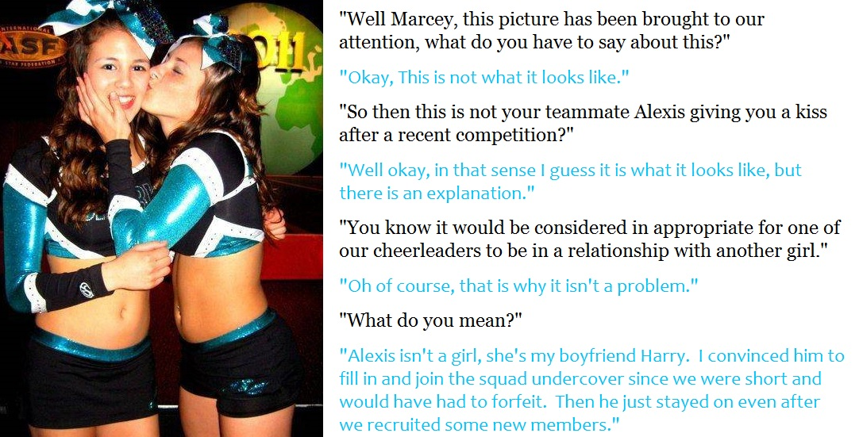

“Are you saying that Alexis is a guy?! She is one of our best. We need her for the lifts.”

“That was our problem remember? We could not find any girl with the strength for those lifting moves we needed to win the championship. With his background in dance I knew that Harry had the strength and could do all the other moves. He was willing to do anything to please me back then. So I asked him if he would become Alexis, and he did.”

“How could we be fooled like that?”

“Harry had to go deep undercover. He could not just pretend to be Alexis – he had to become Alexis. That is exactly what happened. The hair extensions and the Brazilian wax were just the start. Alexis has been living as Alexis ever since she agreed to do this. That meant moving to live with her aunt as her parents hassled her.”

“But she doesn’t act like a guy … not at all.”

“Her aunt helped with that. And I did my part, and so did the two other girls on the team that knew she was not a real girl.”

“Even most of the team don’t know?”

“Just enough of us to shield her in the changing room while we get her fully taped up.”

“How can she hide that even with the high kicks and the like?”

“Well to be honest, what the hormones and everything “that” has not been so big lately.”

“Hormones?”

“To be honest that is turning out to be a bit of a problem. Alexis is losing strength which is what she is on the team for. In fact she is pushing to have a guy or two brought into our routine. Her boyfriend Kevin has said he was interested. Apparently he lifts Alexis all the time. I don’t know the moves, but there is one she calls “the standing butterfly” which she says needs a man’s strength … but I don’t know what that is.”

“So Alexis is still your … your boyfriend?”

“Well, I guess we are just plain friends now. That kiss is just a kiss between close friends. I can’t understand why it is such a big deal.”

The End

© Maryanne Peters 2022

