The Perfect Woman
Inspired by a cap by Becky for John Number 71
By Maryanne Peters

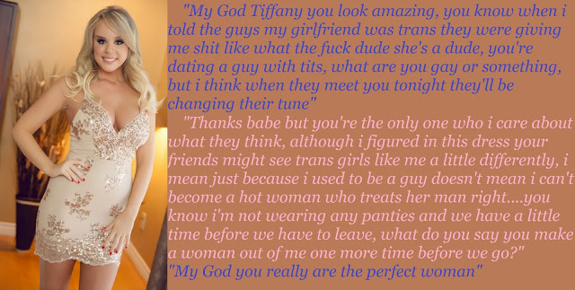

I have to say it: Ever since my vagina healed, I just can’t get enough sex. What am I saying? Even before that I needed to have my guy inside me, right up to the hilt, filling me with his hot cum.

Maybe T-Girls just try harder – what do you think? I mean when I look at some cis-women I think that they really don’t care what their man thinks. You need to know what he wants and give it to him.

If he likes your tits big, then get the biggest tits that you can. Okay they weigh you down and make it had to run or jump, and sometimes to find dresses that fit, but if that is the price that you pay for keeping you man happy, pay it, and pay it with a smile.

Sure long blond hair is high maintenance. I wash it almost everyday and get the color redone every couple of weeks, but long hair turns him on. Sometimes he likes to wind it around his cock and spurt all over it. I just rub it is and smile, and say “Thanks Babe. Sperm is good for my hair. It will help me to grow it even longer … if that’s what you want.

Never be seen looking less than gorgeous, that is what I say. He needs to see you at your best, so make sure that he does. And when you go out with him, make sure that every other man is jealous of him. Half of that is the way you look, and the other half is the way you look at him. Show everybody how much you adore him. You want the other guys to think – “Why does my girlfriend not look at me the way she looks at her guy?” And maybe the girls are thinking: ‘He must be something special from the looks his is getting from his girlfriend.”

But most of all, the perfect woman is hungry. I guess that comes from being born to hunt for sex, and it seems that doesn’t go away with your balls.”

“Babe, I am so hot for you right now. Let’s just find a place - a back seat or a broom closet – and fuck … fuck like there is no tomorrow. Pleeeease Babe.” Word like that will grab him by the balls every time.

But if he says – “Can we do it later?” you must not pout. Nothing turns a guy off a girl like complaining. Just sit him down and get him a beer of something to eat and maybe sit on his lap and just cuddle up, just to let him know that he in in charge of your life and that you can wait.

The perfect woman is patient. Hungry but patient.

But if he doesn’t get a hard on soon enough just remember that there are plenty of guys out there in search of the perfect woman, and that is you – right?

The End

Online Flirts
Inspired by a cap by Becky for John Number 72
By Maryanne Peters

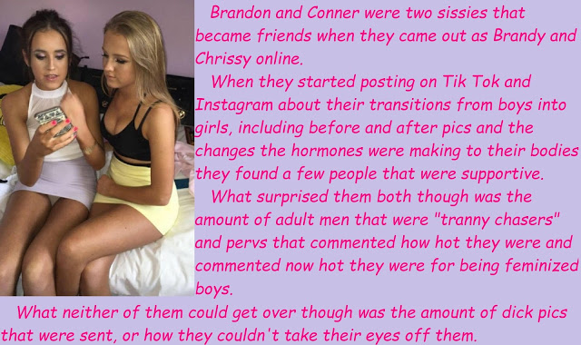

My father says that social media is to blame. He hates Tik Tok and Instagram. He says that that they took his boy Conner and turned him into a fag. Well, he is wrong. I am not a fag. I am a girl.

Sure, I had no real thoughts about becoming a girl until I met Brandy, or Brandon as she was then. She only lived a few blocks from me but when you see some young guy on Tik Tok dancing like a girl you just assume they are on the other side of the country. I don’t remember quite how we got together, but Brandy explained to me how this whole social media things works.

You need hits and that gets you sponsorship. Brandy had a plan in mind and she had worked out how to make it work. Yes, Brandy was transgender ready to go the whole way and have other people pay for it all. She needed sponsors for hair products, clothing and makeup, and patrons to build up her funds for hormones and surgery.

“It would just be so much more successful if there were two of us,” she said. We can share clothes and do each other’s hair and makeup. It will be great!”

I told her that I was not sure. It was not where I thought that I was going. But somehow I got caught up in the whole thing. That is what social media is all about. You sort of get hooked.

We called ourselves “Two Sissies in Transition”. Brandy figured that there were enough people out there interested in such a thing to subscribe and to give to our appeals, but I don’t think even she could have guessed at how successful we might be. Like it is said, there are plenty of “tranny chasers’ out there, and they all want to see how your breasts are coming along, or how good your legs look in really short skirts.

Then we started to get the dick pics and all the suggestions of what they would like to do to us. The good thing about social media is that we can keep these guys at a distance. All we needed to do was to lead them in a little deeper and get their money.

If that meant shots of my butthole, I was up for that, but when Brandy said that they wanted coverage of us shoving things up our buttholes I resisted … at least at the beginning. It is just that if you want some old perv to open his wallet you have to open something too.

Brandy and I would do ourselves and sometimes do each other. These weirdos wanted us to show them how much we enjoyed it. I have to say that I didn’t at the start, but as we went on it seemed like pretend happy squeals were replaced by real happy squeals over time.

In return they would send us pictures of oozing cocks and we would reply with words like: “I would just love to lick every drip off the head of your dick.”

Like I said, my father was furious. But a lot has happened since we started all this as you can see from the image. That is me with the light hair. They are my breasts, which are bigger than Brandy’s. That is my soft blonde hair, my long smooth legs.

The clothes and makeup are supplied by national retailers who just want our endorsement and more packages flood in to my house or Brandy’s. This is how social media works.

I have to say to my father – “I am sorry Daddy, but Conner is gone for good. I am Chrissy now, and Brandy and I are influencers.

He calls us online flirts.

The End

The Tapes  Inspired by a cap by Becky for John Number 73  By Maryanne Peters  They worked for me. I used them when I was at high school. I was an anxious girl – very unsure of myself. I cannot remember where they came from. Perhaps my mother bought them for me. I just remember the name “Virago”, so that was what I searched for online. And there they were – the very same tapes. Old cassettes. I had to dig around in the attic to find a player that Lance could play them on.  There was sort of white noise with ambient music in the background. Lance thought that they were weird but I told him that they had changed my life and turned me into a success at high school. He could listen to the tapes while he did his homework, and then go to sleep with his ear buds in.  Lance just shrugged and agreed that it was worth trying. He knew that he had problems. He had become a loner at school and he was just not happy there. It would not be too much of a burden to humor his mother.  What neither of them really understood was that the Virago tapes were targeted very specifically and had Karen received them in the original packaging she would have seen the warning “This product is intended only for women or girls”.  But by the time that Karen and Lance came to realize that something was very wrong it was too late. Lance had effectively ceased to exist. He had been replaced by the vivacious, outgoing and extremely popular Lindsay, not that dissimilar to the girl Karen had become when she used the tapes. | 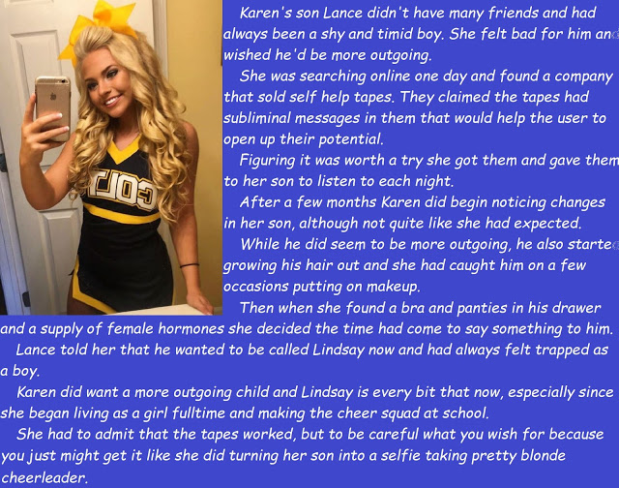

Perhaps if Lance had been less isolated from his mother he would have shared something more about his sudden changes of ideas, but the loner secured the black market hormones and the feminine underwear and concealed these from his mother while he went about rebuilding himself from the soft new flesh outwards.

Karen first became aware that something was not right when her son bounced down the stairs with curlers in his hair and an announced that he wanted to be called Lindsay and that he would going to school that day and every day after that wearing a dress and makeup.

It was only after she returned from her meeting with the principal that Karen found the hormones and the other drugs that had effectively chemically castrated her child.

But that was a year ago now, and once look at Lindsay proudly wearing her cheerleaders outfit should convince any doubter that supplying the tapes was no bad thing.

The End

Getting His Girl Curves  Inspired by a Becky cap for John Number 74  By Maryanne Peters  To be honest, I have forgotten how it all started. My friends say that I was never the way I am now. They say that I was just one of the guys, and we would play ball, and climb trees, and play tricks on the girls. And now I am one – a girl.  My Mom says that when you get to a certain age you start to realize who you are, and who you are going to be. She says that if you are lucky that happens before the hormones take over your body. She said that made me one of the lucky ones.  I had never even heard of hormones! Mom explained that male hormones would take away my singing voice, make my hair dark and greasy, cause huge ugly acne to erupt out all over my face and make me stink. I now understand that everything that she said was true. It happened to my pals.  “I don’t want that Mom,” I said to her. “I Love my fair hair and you always say that my skin is so good. Who would want that to be covered in itchy spots?”  “Fortunately, there is a way out for you,” she said. “Girls have pretty hair and unblemished skin by not having boy hormones but girl hormones instead. We just need to put a couple of special sticking plasters on your chest. | 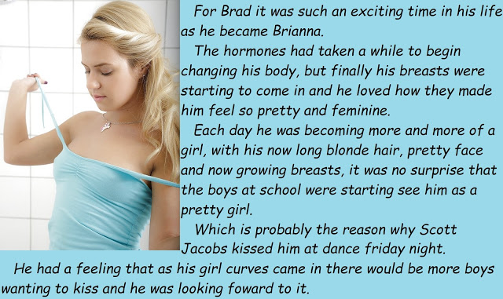

It seemed so easy. He watched all the other boys sprout horrible hairs and have smelly stuff oozing out of their skin and their scalps, and out of their johnnies. Brad just shook his growing blond hair and laughed. He was taking a different route, and everything on his path smelt of flowers and felt like talcum powder.

“But you will not be able to call yourself Brad next term,” my Mom said. “You will need a name that fits the person you see in the mirror. Look at yourself. Who will you be?”

“Brianna”. The name just came. I look like a Brianna, don’t you think.

My friends asked me what was going on, but I said that my name was Brianna now and that meant that there was a bunch of things that I would not be doing anymore. I would not be playing ball or climbing trees, and I would certainly not be playing tricks on the girls. And if anyone of them thought that they might play tricks on me, then I would tell everybody that he was my boyfriend.

Then my female hormones really kicked in. It is still early days but take a look at my chest. Yeap, those are breasts. Little ones maybe, but round and soft and really pretty. Even though I have no bra on under my blue top, all the boys are staring at them. Don’t tell me you won’t notice them.

And this is how I look, even without makeup. My blonde hair goes all the way down my back and I like to brush it and keep it healthy and shiny.

With all the girlfriends I have, I have just started playing with makeup. I wore some for the dance on Friday night. Mom said that from the photos she has seen I was easily the prettiest in the room.

“You made the right choice, didn’t you Brianna?”

I guess so, but I really can’t remember making it.

Scott Jacobs sure thinks that I did. He ended up dancing with me most of the night, and he kissed me outside before Mom picked me up.

She had been watching me from the car.

“You are getting your girl curves,” she said.

The End

Pretty Amazing  Inspired by a cap by Becky  By Maryanne Peters  She called it “pretty amazing”. Not implants or anything like that. A pair of natural breasts, round and perfectly matched and on display in a bikini top that I would never dream of wearing. Why? Because my tits are irregular and not nearly as nice as hers.  And look at her hair too. What right does a boy have to have hair like that so long and thick? My hair is thin and brittle and mousy in color. Mandy’s hair seems to bounce and shine.  Female hormones? I have got those. I am female, for crying out loud!  She is not even wearing makeup. She doesn’t need to. I seem to have blemishes everywhere and yet she has perfect skin.  Sometimes it just seems so unfair that a guy like Matt can just swallow pills for a year or so and be more of a girl than I am.  You might say, or even she might say – “But you have a vagina”. Oh yes, I have one of those. I have been menstruating for over two years now so I know all about vaginas, like I know all about menstrual cramps, headaches and mood swings. It seems that Mandy only knows how to giggle or just laugh out loud. That looks says it all – “Ha fucking ha, who needs a vagina?” | 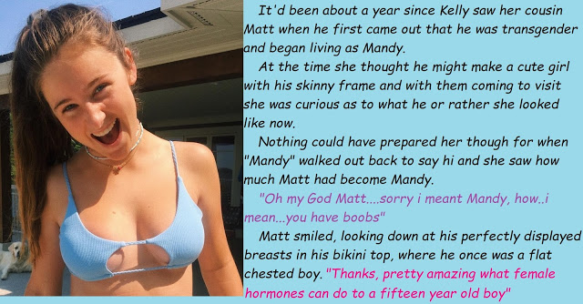

It’s pretty amazing alright, but forgive me for not congratulating that bitch.

The End

© Maryanne Peters 2022

