Beach Hook Up
A Vignette
By Maryanne Peters

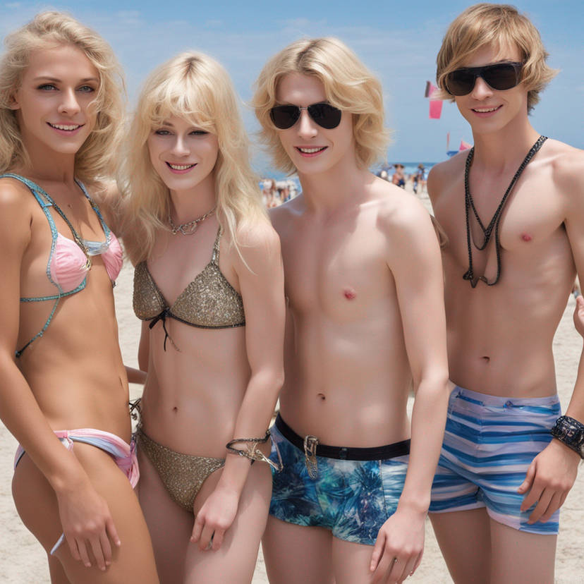

There are 4 men in this photo. That’s right – four boys. That is me on the left, Candy in the gold bikini and that is Caleb and George on the left. You might see the bulges if you look closely – I mean, on Candy and me. The hormones that have given us both those wonderful titties can go some way to reducing the size of the contents of our panties, but people can still notice. You can use a latex gaff that you are supposed to be able to swim in, but it can be uncomfortable. We like to go natural and keep the boys looking up at our little jigglers in their bikini top cups and at our pretty faces and lovely blonde hair.

It is always hard for transgirls to go to the beach, but Candy and I are beach babes. The secret to being that is waterproof eye makeup and keeping good skin and hair, and waxed bodies. You have to look natural when you are outside. You put the work in to stop your skin and hair from drying out, and you take full advantage of shade and sunscreen, but you have to be natural. If that means that you bikini bottoms show what the shouldn’t, then you just have to live with that.

I suppose some guys will see us and think that we look like meat on a hook, and then get a little closer and realize that maybe we are not girls at all. The things is not to care. We are what we are – pre-op transgirls enjoying life on the beach. If you don’t like what you see then you can move on and try to find something prettier than this!

We were just on our beach loungers under an umbrella when Caleb and George came over. We figured that they must have seem our bulges. We were not showing them off, but not hiding them either.

There sat down in the extended shade we had. They said something about needed to stay out of the sun even with lotion on. It was true that they both had very pale skin just like ours. We got to talking and before we knew it we were swimming together and then sharing sodas at “Shady Shakes” up by the carpark.

“These guys are almost as pretty as we are,” Candy whispered to me. “Do you think that they are looking for girlfriends or looking to become girlfriends?”

What do you think?

The End
420

The image is “Beach hook up 3” by Zebra102

Uncle Ben Is Coming to Stay  A Vignette  By Maryanne Peters  “Now you met him last night and he is clearly comfortable around you, so he will be coming to stay with us … he is moving in tomorrow.” The face had a look of determination. Argument was pointless and potentially damaging. “I have told you that there would be changes around here and you will just need to get used to it, son!”  He was confused and a little hurt, but a son’s love is important, and the boy knew that – especially when having been raised by a solo parent all these years. Things had not been getting any easier at home and “Uncle” Ben had money. Still, there was no doubting the reason why Ben was moving in. It was for the sex.  He had heard them at it, last night. After dinner they had shared the couch and Ben had been snuggling up in a way that made the boy feel very uncomfortable. And then, a good while after he had gone to bed and they would have assumed he was asleep, he could hear them having sex in the room next to his. There was the grunting and then squealing. No son could be comfortable listening to such noises | 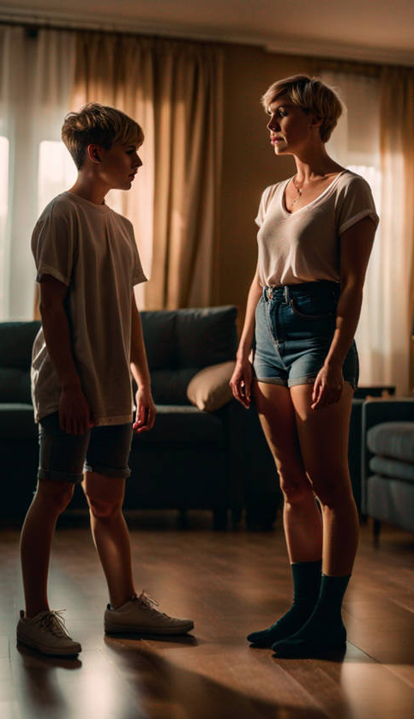  Image by Natachaamy on Deviant Art

The hardest thing for the boy was thinking about Ben having sex with the person who was once his father. There had been so many changes that he had to deal with. He had never realized that his father had always nursed the idea of becoming a woman. It was only after his mother had left that his father felt able to turn his dream into reality.

His mother never gave him the option of going with her, but even now he doubted if he would have done that. He had always felt connected to his father, and that had not changed since the transition began. If anything, he felt closer given the idea that he was going to have the mother that the woman who had given birth to him somehow never could be. Plus, there was the emotional side of transition alone that made him feel the need to be supportive.

“She” (as she now was) looked like his father still, but her female body was now complete. The cost of that had set them back, but he knew the importance acted to it. A son’s love is important too.

It is just that there is something very strange about the thought of his father, now modified to take a man and please a man, lying on a bed with a man on top, being fucked. It was slightly sick, and yet somehow slightly stimulating.

“Whatever makes you happy, Mom,” he said.

The End

Waisted  A Vignette  By Maryanne Peters  It was a back injury that got me into a corset for the first time, but I really liked the way it made me feel. It makes you adjust the way you stand in front of people, and I never realized before how important posture is in making you feel more self-confident. I  I was also proud of my waist. I cinched it in tighter and tighter and it just seemed a crying shame that the clothes I wore never showed off my new figure. I have to admit that I now had something of a female figure, and it was perfectly suited to a whole variety of women’s clothes.  At first, I just dressed in private, but it was not very long before I longed to show off my new form and fashions in public. | 

I just didn’t want to be a man in women’s clothing. Perhaps in this day and age that sounds stupid. I live in a modern liberal city and I have seen men walk down the street in complete feminine outfit but a man above the shoulders with a full beard and shortish hair. This is somebody saying that they prefer the clothes that women wear and they don’t give a damn about what people think. I was nothing like that. It seemed to me that a corset allowed me to present better and I did not want to be the subject of abuse, or even slight disdain. If I presented my much improved figure to the world, I wanted to be admired, not derided.

So I decided to dress fully as a woman, including some padding up in front and down at the back, and just walk down the streets as a woman might. I took some care the conceal my face with the right wig and makeup, but I have to say it, with a waist like mine the other curves were all that people were looking at.

I think that pride in one of the strongest emotions. When you feel admired it is like nothing else matters. I found myself slowly slipping in to this imaginary woman I had become, and with the desire to show more of myself, I decided that I could find out how easy it would be to discard the padding, which meant going on hormones.

I told my doctor that I was transgender. At the time I thought that I was lying to him, but now I am not so sure. Was there some inner feeling that was driving me on? I could have sworn that before that accident had seen me hooked into a corset, I never had a thought of being of another gender, but almost from the moment I started on hormones I started to think about events in my childhhod that might have signaled the existence of an inner female.

The truth is that my sexual activity had been limited, but always with women. Was I hiding the fact that I might be attracted to men? I could have sworn I wasn’t until that night when a man walked up to me in a restaurant and asked me to dance. From the moment that his hand slid around my narrow waist and held his lower body to mine, it seemed to me that I had been doing things wrong for most of my life.

The hormones have do their business on me know. I have thrown away the padding and the wig. This is all me – the breasts, the bubble butt, the long hair pinned up. He says that I have perfect posture. I put it down to good corsetry.

The End

Replay  A Vignette  By Maryanne Peters  She knew that it was him even as his back was turned. He was wearing the blue track suit – the one without his name across the back of it, so as be in comfort and not be noticed. She knew the back underneath it – broad and black, like polished ebony and just as hard.  “Well, this is a surprise,” she said, “After last night.”  When he turned she could see that he was holding a large bunch of roses. He pushed them slightly towards her.  “I didn’t thing that one would be enough, so I got a whole bunch,” he said. “It looks like I got the color just right … the same color as your hair.”  He had stroked that hair, so soft and sweet-smelling. It had all seemed so perfect, until she had hit him with a baseball bat … or at least that was what it felt like.  “Look, Rose, I owe you an apology, and probably a lot more than that,” he said. | 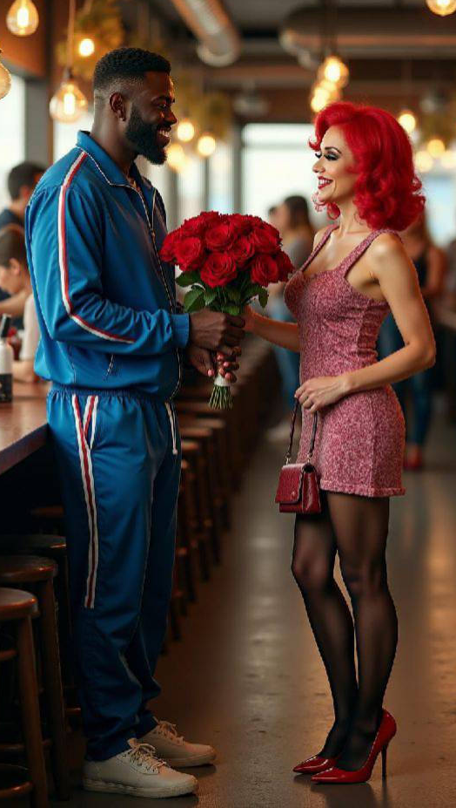

“I understand, Leroy,” she said. “It was my fault for taking it too far. It is always difficult to know when, because there really is no right time to say it. At the beginning means that neither of us will get to know one another, and I don’t apologize for doing that. I thought you were a great guy, and I guess you have proved that by turning up here today – the flowers are an unexpected bonus. I will have to take them out to the kitchen to put them in some water. I may even let them sit on the bar tonight, but I am definitely taking them home. They are gorgeous.”

“You are gorgeous,” said Leroy. “You deserve better. I was the one who pressed you too quickly. I knew you wanted to tell me something, but whatever it was, I wasn’t interested.” He added in a whisper – “I just wanted to get inside you, baby.”

He looked flustered, as he had the night before, as if he was reliving it. She could not help but to sneak a quick look at his crotch. There was room in that tracksuit, but did she glimpse movement?

“Leroy, I wanted you inside me too,” she whispered back. “It was just that I needed explain my … my shortcomings. I wanted to give you what you wanted, but nature has been cruel, in my case.”

”I was hoping that we could have a replay,” he said. “You know, take it a few yards back and start over … maybe even tonight? The truth of it is that I can stop thinking about you. I barely slept last night. Woman, you are messing with my head.

She liked being called “woman”. She liked him. She had from the moment he started chatting her up even with his teammates all around him.

“The manageress is a fox, don’t you think?” he had said to them. “I would sure like a piece of that ass.”

They had gone and he had stayed behind, after paying for everybody and leaving a big tip. He said that he needed a nightcap, but he had just wanted to talk to the sexy lady in charge. She pretended to be more busy than she was, but he was persistent. He stayed until the end, offering to walk her home.

But that was the day before. She would soon be very busy. The restaurant had a few customers from the morning trade but lunch and dinner were her responsibility.

“A replay? Do the rules allow that, Leroy?” she said.

“You make the rules, baby. I just play the game,” he said.

“You’ll just distract me if you stand around looking at me with those huge dark eyes,” she said. “Okay, we back up and start again from the moment your friends left the premises last night. Come back the same time tonight and walk me home. We’ll replay it from there.

“I’ll be here,” he said. “I will help you to carry this bunch home, all the roses.”

The End

The Perfect Life  A Vignette  By Maryanne Peters  It is what I have always wanted. I love being beautiful. I was born ugly, you see. I was born deformed. I had a growth in my groin. I could not wait to have it removed and have the body I always dreamed of – the body that was the prefect shape, all the way down.  Proper diet and exercise is needed to be perfect. If you want the perfect body and the perfect life, you need to follow the rules. I do, but I still know how to enjoy myself, and I do.  My hands and feet a little large for my preference, but I spend my time making them look pretty. I keep them smoth and soft with proper creams, and I paint my nails | 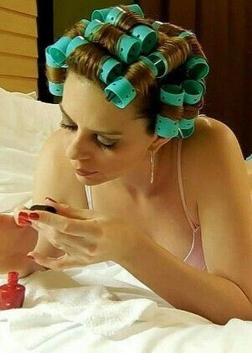

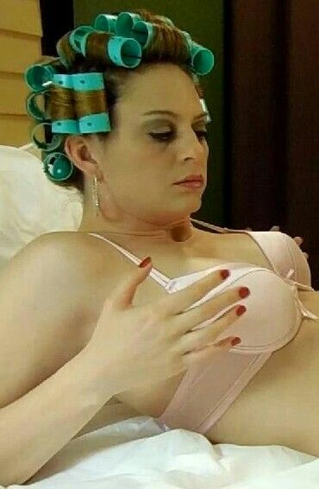 | My nose and brow might be considered a little prominent, but I have not resorted to surgery. Good makeup skills are essential, and a proper skin regime. People don’t look at the details when they look at a beautiful woman.  I have good hair too, and I care for that too. I love curls but I mean soft curls rather than stiff perms. I have learned to do my own roller set, and I keep mr hair in curlers until I am ready to present myself to the world. Then I brush out my curls so that they frame my face with a perfect surround of bouncing shiny hair. I love to laugh and through my curls around so that they catch the light, and maybe just push one back as it hangs over one eye, to catch the attention of some admiring man.  But let’s face it – what they are really interested in is these, my breasts. I pride myself that they are home grown through years on hormones, but I have used hormone creams and skin treatments to ensure that they are just the right shape, and I think they are the perfect size for the woman I have become. A good choice of bra is important too. It needs to be comfortable and containing, but give those who stare the comfort of knowing there is more to come, if they get lucky with me.

A little eye makeup, some pink lipstick and hoop earrings. I think I am ready. Time to brush and spray my hair and slip on my dress and shoes.  There is someone special tonight. I don’t think that I will bore him with my origin story. It is a second date, but I think that I should try to have fun, and find out exactly how serious he is.  It seems like I have the perfect life now that I am the woman I always wanted to be, but the past comes back to haunt me every now and again. If things go well, we will have sex and he will understand that I am a woman and I can give him almost everything a man would want.  Almost. If he is serious, he should know what I cannot give him. If he deserves to know, I will tell him, and that maybe the end of it.  The problem is that I like him. I like him a lot, and I even know that after just two encounters. That is the flaw in my perfect life.  The End  545  © Maryanne Peters 2025 | 