Christian Feminization  From a series of Captioned Images  Ex virtuousmodestlady.tumblr.com  By Maryanne Peters  Let me explain. Our Lord Jesus Christ tells us to be kind and tolerant, yet holy scripture is clear: Homosexuality is an abomination. At the same time God has blessed us with intellect and the application of that has led us to all of the advantages of modern pharmacology and surgery. We must use all of these things to rid the Christian world of the scourge of homosexuality.  I am not in any way belittling the power of prayer, but while through prayer God may intercede even to move the planets from their orbits, he will not interfere with the human soul, and the right of his children to choose the straight path of the path of sin. Free will is God’s gift to mankind.  Is homosexuality a choice? All the “Conversion Therapy” courses and all the “Pray the Gay Away” meetings have not made a dent. So, what is God’s answer to being born into a sinful condition? If we cannot change the mind, we can change the body, and adjust other behaviors that are simply learned.  So here I am, the Feminization Supervisor at the Christian Feminization Academy. And I can assure you that I am very busy. |   I am Madam Sharon, the Feminization Supervisor here at Christian Feminization Academy.  Here at CFA we seek to rid our students of their sins. Their worst sin is their past homosexual practices. Most of the boys that come in have been involved in homosexual sex, which is not allowed.  We have found that we cannot rid them of their attraction for males. So our approach is to turn that attraction into a heterosexual attraction, by making our students into girls. That will make them heterosexual, and proper Christian ladies, ready for a normal relationship with a future husband.

We accept all ages into the Academy, but we like to start them young, before the inclination towards sodomy has taken physical hold. Signs of attraction to other males or clear fascination with the masculine body are clear signs of the perversion. Early entry can allow us to put a stop to the production of male hormones that can only lead to misaligned sexual urges, using the age-old method.

Then the work of the female hormones introduced into those young bodies can be done without the obstruction of male chemistry. For our older subjects we recommend radical surgery as soon as possible, including vaginoplasty, breast implants, full body hair removal, facial feminization and scalp adjustment, and voice surgery to ensure that our ladies speak only with a trill that can also reach the high notes required for the church choir.

After that the hormones can be administer and our extensive training program undertaken.

We make no apology for training our new women to be wives and mothers as a first priority. For mature men who have careers but are gay and therefore need to be feminized, we say: “Give up that past life of sin in its entirety. Do not mix with the depraved people that you once called your friends. Instead surrender your life to a strong Christian man, who with discipline and vigorous sex, will convince you that you have chosen the correct course.

After all, our new women are not fully able to bear the children they want to, but with pregnancy suits and mock child birth they can experience motherhood from the beginning for the children that they can adopt or have carried by surrogates.

Being a wife and mother is the highest honor a woman can have, and they can be that kind of woman. She is even more feminine and certainly more virtuous and modest that a biological female, for their very shape has been fashioned by man for the glory of God. Amen to that.

I am doing God’s work. With my team I am ridding the world of sin and vice, and creating more goodness and beauty.

I try to be an example to all our new women, because I, just like them, was once a man. And now I am the Feminization Supervisor at the Christian Feminization Academy.

The End

The Pastors Wife  A Christian Feminization Story  By Maryanne Peters  I was a very sinful, dirty, unbridled young guy who did not believe in God and always insulted the believers. Naturally, I was close to the top of Rebecca Brown's list of sinful guys to progress into virtuous Christian ladies.  People think that the Christian Feminization Academy exists only for those who volunteer – good Christians in search of way to put sin behind them and find a life that can be approved by God, but sometimes the Academy can be repurposed to deal with people like the person I was.  There was nothing voluntary about it. I was kidnapped and moved in Paradise town. I was locked up and subjected to intensive “force-of-mind prayer”. Do you know what that is? The church has in its number people who are called “telepaths” and exercise their mental powers to cleanse the minds of certain sinful subjects. People like I was. | 

Back then I would have told you that such a thing defied science, because it does. But that was because in those days I believed in facts and logical deduction from empirical evidence. Science is the opposite of faith. Things are only true if you can prove them. Faith is knowing something to be true even if it defies science. That is how I acquired faith. By the force of the prayers of others my mind was scrubbed clean of sin. All of the love of a sinful male life was tossed right out, and along with it went my surly male personality. I became an empty vessel for God’s will.

Rebecca handed me on to the Christian Feminization Academy to acquire a new purpose and to ensure that I was surgically prevented from ever returning to that prior existence. My body was transformed into one fully female and my head was filled up with thoughts of skirts, dresses and pantyhose. And when I was not thinking about being pretty my mind was opened to God. I consider myself devout, with an unquestioning faith in Christianity.

Just imagine the former sinful guy who attacked the church now spends her mornings sitting in a pew at church, and her afternoons teaching Sunday School!

I became a pastor's wife and a mother to our adopted children, smuggled out of a Godless Middle Eastern country to escape the religion of demons.

And I have offered to help Rebecca Brown in her work. There are more unbelievers out there - Buddhists and Muslims, atheists and Satanists. People in need of rescue. I thank our Lord and Savior that I was rescued, and that I was held down so that the devil could be drawn from my body. No crime has occurred because I now forgive and approve. No crime will be done to others because with restraint and force-of-mind prayer, those others too, will come to follow.

And when they experience the entry into their body, first of God into their soul, and then of a husband into their new vagina, the will see the face of God.

And every night, once he is spent and I have his seed inside me, I pray and pray and pray some more, in the hopes that Rebecca Brown will succeed in her mission to turn each and every sinful boy into a virtuous Christian lady!

The End

© Maryanne Peters 2021

Author’s Note
This story owes much to Elena’s original: From sinful guy to pastor's wife.

First Wives  A Christian Feminization Story  By Maryanne Peters  We Mormons avail ourselves of the Christian Feminization Academy from time to time, because nobody has achieved the levels of success that they have. Although it is firmly believed within the Church of the Latter Day Saints that our practices and focus on family have eliminated female homosexuals and reduced the number of male homosexuals to small number, our church is inclusive, so a place for these people must be found.  Our position is that our bodies are a gift from God, a blessing we received because we were righteous in the premortal life (Abraham 3:26) a veritable temple of God (1 Corinthians 6:19) but temples can be renovated and put to better purpose. It is not to disrespect a temple to repaint it and perhaps install a new doorway.  And for some members of our church there is a demand for more women – for more women than men. If men are available, and they seek relationships with good Godly men, we encourage this. | 

Of course, there are the well-established policies against polygamy which reflect the reality that the Mormon church must meet the requirements of modern society, but many of us know that this society is sinful – It is not our society but one created by sinners. For the society that our Great Prophet Joseph Smith foresaw we need only look to His words.

Render unto Caesar, and to the federalists render to them the belief that we are bound by their laws, but take another wife, because that is the direction of our true faith.

The “new women” that blessed modern surgery can make available to us, come to a marriage in a state of purity. The vaginas fashioned in large part by God’s own hand guiding the surgeon will heal to produce a new virgin, but one with experience in pleasuring a man. This must surely be the ideal first wife somebody who can respond to a husbands thirst and vigor with the energy of the man they once were, but with all the beguiling beauty and assets of a woman fashioned purely for the pleasure of her husband

You can always marry your second wives for bearing children, but first wives need to be able to introduce you to sexual relations, and graduates of the Christian Feminization Academy are the best able to do that. All that we demand is that until we can set up our own facility (should the numbers demand it) there is proper respect for our beliefs and practices. We are all Christians after all.

Then, within easy access of the Temple, we might have our very own LDS Feminization Academy to ensure that men who seek to follow our original traditions can have as many wives as they like. And if there are men who might not be homosexual in nature but who might consider that being a sister wife unburdened with childbirth or children is a future that might persuade them to a new orientation, then perhaps that is another way to ensure the plurality our church requires.

The End

© Maryanne Peters 2021

The Light of Christ  A Christian Feminization Story  By Maryanne Peters  Because I am not taking hormones, I prefer to adopt the dress recommended by the Biblical housewife. Skirts are feminine, and I have chosen femininity, but I prefer to keep them heavy and long to conceal the ghastly secret between my legs. Shapeless button up blouses help to conceal the fact that I have almost no breasts. I just need to ensure that my skin is hairless and soft and my hair long and shiny. As for my face, I just need t accentuate my eyes a little, because it is from those that the light of Christ will shine forth. I do not want lust – I want love.  I truly believe that when God sends to me that man who sees me for what I am, a woman of faith a modesty with a pure heart, he will ask me to marry him, regardless of all the imperfections of my body. He may take me as I am, or he may ask me to make the modifications that others have made in advance of our wedding day, and I will yield to him, because that is what a biblical housewife should do.  It is gone already, as far as I am concerned. I am no longer a man and a sinner. I am being reborn as a woman, and I should make it my mission to be a pure woman, free from sinful thoughts.  He will see the grace radiating from me and he will fall in love with me. It will be the purest of loves – as pure as my love of God, for nothing can be as pure as God’s love for me and for all those that he has directed by his divine will, should attend the Christian Feminization Academy.  And if my husband says to me that he would like me to have breasts implanted for him to bury his face between, with saucer sized nipples for him to lick; and if he says to me that I should have my deformity removed and cast into the flames as replaced with a tunnel of love made to his scale, the I will say to him ‘ “Please God, YES. Let it be done and let’s fuck like rabbits!” | 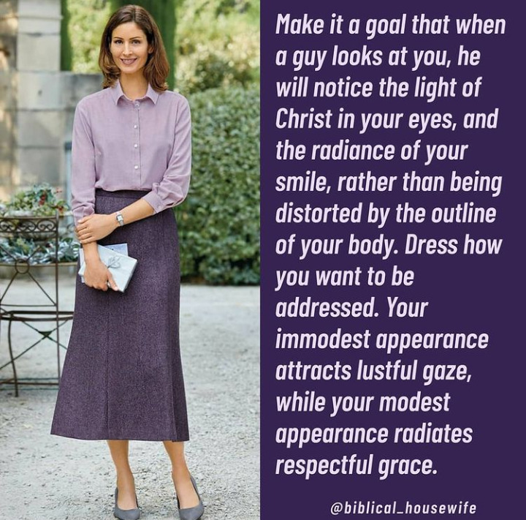

But in a modest and respectful way of course.

The End

© Maryanne Peters 2021

Bring Him Around  A Christian Feminization Story  By Maryanne Peters  Not everybody who chooses a wife graduated from the Christian Feminization Academy finds it easy to accept her. For some there is always the nagging doubt that she may not be a true woman, despite the church affirming her status before God.  In the words of Saint Paul: “Wives, submit yourselves to your husbands, as is fitting in the Lord.” Colossians 3:18  “Do everything without grumbling or arguing, so that you may become blameless and pure, children of God without fault in a warped and crooked generation. Then you will shine among them like stars in the sky as you hold firmly to the word of life. And then I will be able to boast on the day of Christ that I did not run or labor in vain.” Philippians 2:14-16  I took those words to heart. But I had a mission before me, and I knew it. | 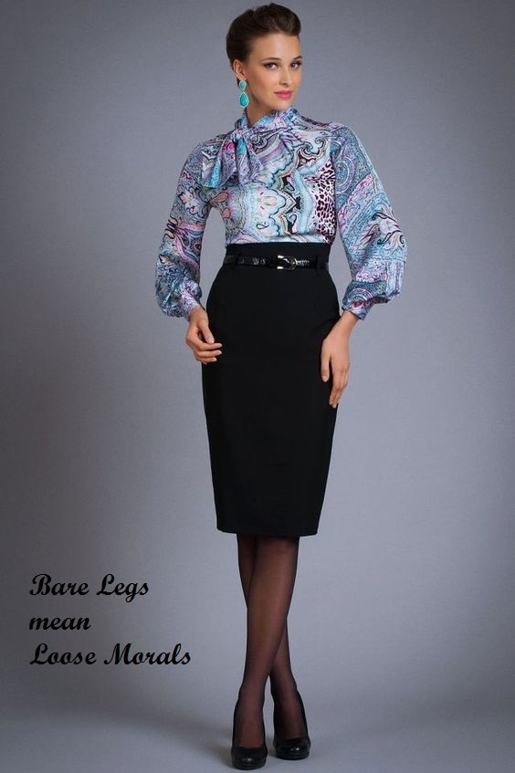

Graham was a severe man. In many ways he reminded me of myself, when I was a man. But the know of that equipped me better for the task ahead. A man is a simple creature – he needs only adoration, service and sexual release, and I was ready to provide all three.

That say it of Academy girls – none are more feminine than we are – demure and graceful in our public presentation, and wanton and hungry in bed. God has truly worked His miracle in this great institution! The Christian Feminization Academy is a cathedral! By its work all of the energy I wasted in the pursuit of men and in my own gratification is now directed in accordance with the Word of God. I will labor in vain no more. I will be no part of a warped and crooked generation. I will lie beneath Graham and watch for the stars in the sky.

It was only a matter of time before I brought him around. I may be bigger than him but I am soft, weak and passive, and usually lying down or on my knees before him. He accepts that I am a woman, because I have been so completely feminizied, you see.

Praise be, the Christian Feminization Academy.

The End

© Maryanne Peters 2021

