Bill Next Door  Inspired by a Tiffany Caption  By Maryanne Peters  Bill lived next door. I knew Bill was a cross-dresser. I knew that he liked to live as Michelle when his wife was out of town, as she was regularly. I knew that he was itching to go outside as Michelle. So, I did the neighborly thing, I suggested a date. In fact, two or three. Strictly platonic. Just to give him a chance to wear his heels.  It might seem crazy to you, but when I was told that I should “bring a partner” to the work function, I chose to call Bill. I had nobody else in my life and I was confident from our nights on the town together that nobody would pick him as a guy.  Michelle looked great, but she was also smart and had opinions. She ended up talking to my boss for a big part of the evening. I was a little worried at first but she totally charmed him, so I left her to it. | 

“That Michelle of yours is a knockout,” he said to me that following morning. “And so clever and with a sense of humor that most women seem to lack. Finding a woman like that shows good judgement, young man, and being able to keep her shows me that I have been underestimating you …”.

When I got home from work that day I called Bill to come and see me. I was going to thank him for everything. The promotion and the raise allowed me the chance to buy a place, but that would mean moving away from Bill.

But it was Michelle who came to the door. She was wearing the shortest of short skirts and heels, and a mesh top with black bra underneath showing a pair of small real breasts pushed up to catch my gaze. With her blond wig and freshly applied makeup she just looked so sexy that I lost control of myself. The moment that the front door had closed behind her I pulled her into my arms and kissed her long and hard.

She said that her wife was expected home that very night and that she needed to get changed.

I begged her not to leave my apartment. I insisted that she never change back to being Bill again. I never wanted to see that man again. I only wanted to see her, and see her every morning when I woke up. It all just spilled out of me – the proposal, my plans for our future together, the end of her marriage – everything. I guess that it was love makes you do.

How could she say no?

The End

Her Daddy’s Wife
Inspired by a Captioned Image by Tiffany
By Maryanne Peters

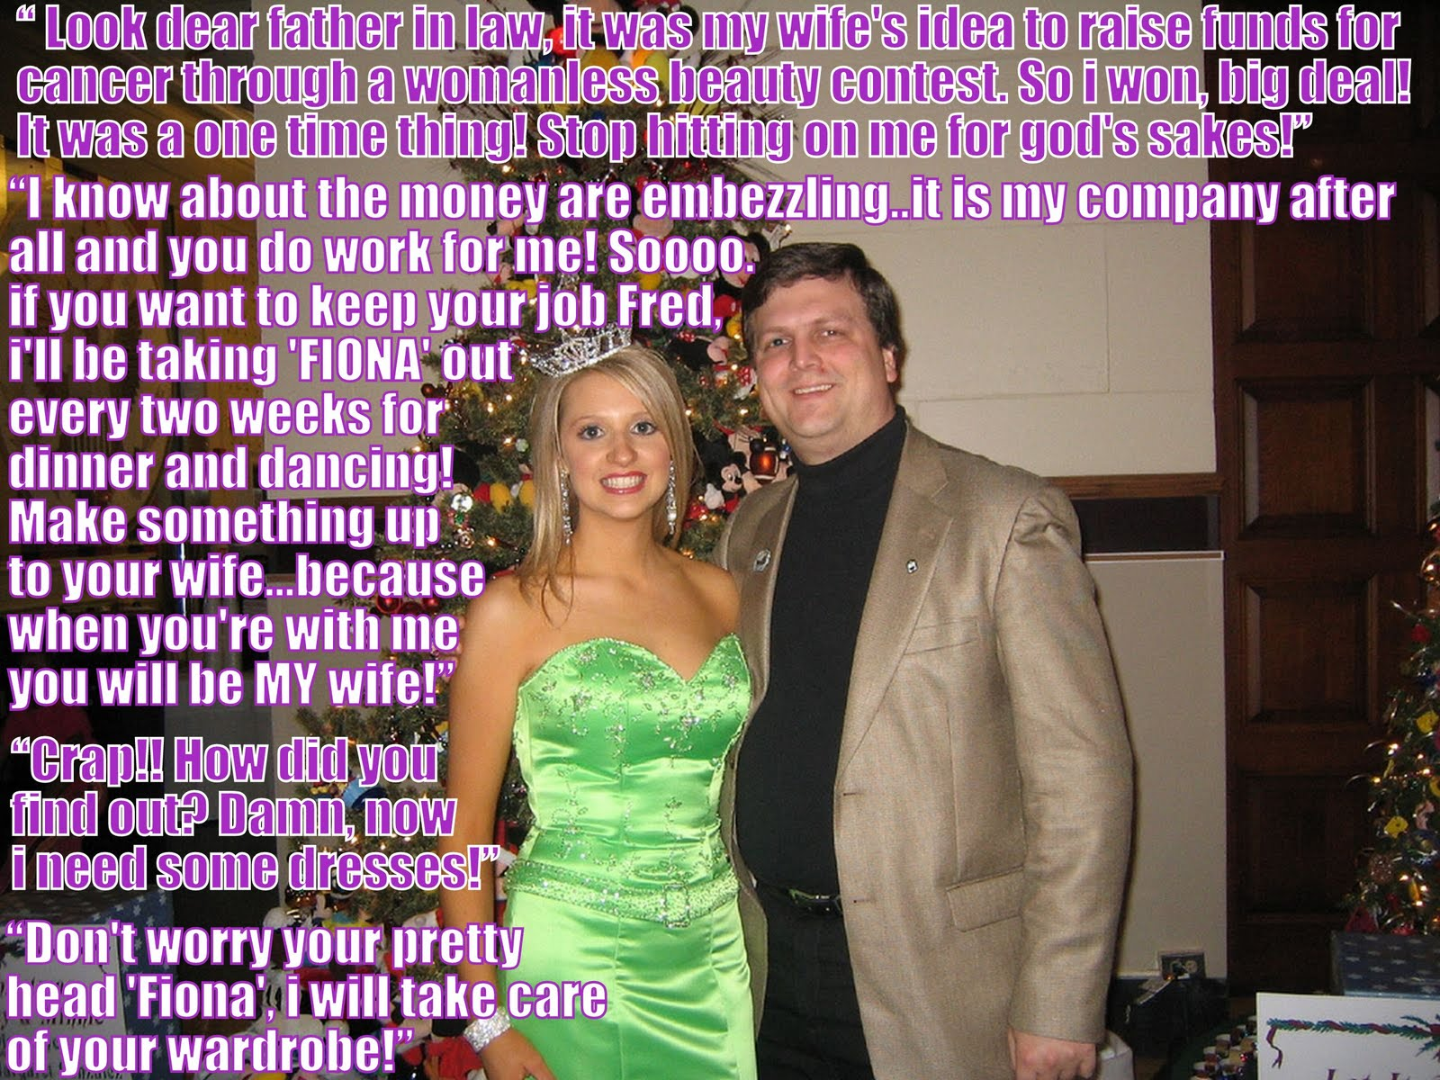

I seemed like everything had turned out right for me – I had married into money. My father in law ran a successful business and he was prepared to take me on in a management position. It was just that I was not much of a manager. He was exasperated but he suggested that maybe I should just take the salary and sit at my desk. If only I had done that, but with all the money passing through I just could not resist siphoning off a little for myself.

I wish that I knew whether it was really my wife’s plan to reveal the other side of me to her family with that damn pageant. She sure understood that I would not do things by half if I was going to enter. Probably I should have restrained myself and left other guys to dress up, but I entered and then I just had to win. “Fiona” was just far too pretty.

That should have been the end of it, but the day after that photo of me with my father in law was taken, he rolled into my office and suggested that maybe Fiona should be sitting at my desk.

“I don’t know whether she would be any more useful, but she would sure be better looking,” he said. And he said it more than once. He went on and on about Fiona. He even suggested that he take her out on a date.

But when I flatly refused things started to get ugly. That was when he told me that he knew that I had been embezzling money from the business, and he had the proof that would send me to jail. I mean – look at me. What chance would I have behind bars.

“If I want to take you out, Fiona, then you are coming with me,” he said. “I will arrange the clothes, so there are no excuses.”

That was just the start. Once we had been out a couple of times he complained that he could not bear “to see my Fiona in man drag during the day”. He wanted me to be Fiona 24/7. What is more, my wife was happy to let it happen.

“My father was right about you all along,” she complained. “You are useless, and even more useless now that you seem to be not even a man anymore. I think that you like being Fiona way too much. I want a divorce.”

Like I said everything turned out right for me – I had married into money – twice in fact.

The End

Sentenced to Daughterhood
Inspired by a Captioned Image by Tiffany
By Maryanne Peters

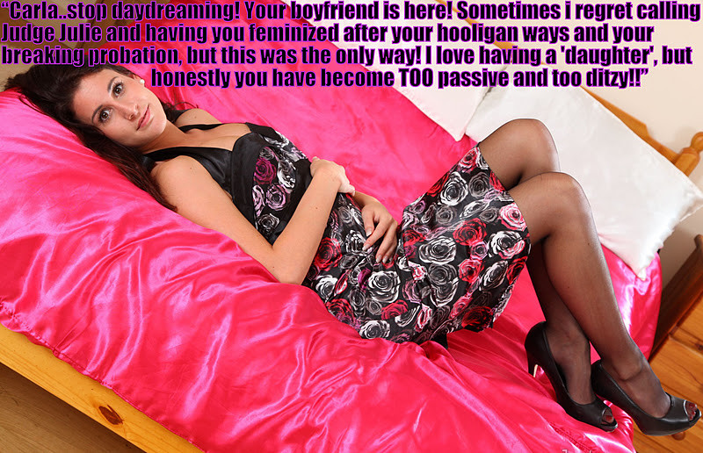

I have read a lot about it since. I sort of had to. I think it was that first shot of hormones that did it. I just felt so different. I didn’t want to fight it. How can that be? I hadn’t wanted it before. It would have been the worst fate imaginable. All my thoughts then were hateful and aggressive, whereas now my thoughts are… what are my thoughts?

Judge Julie, not Judge Judy. Just the local woman who seems to know how to resolve all the problems around our town. It is that kind of place. Even our local probation officer will go along with her decisions. I guess he figures that if her solutions work, then that it is better than sending me back to jail at the cost of the taxpayer.

Like I said, I read up about it afterwards. She just said that it was “adolescent toxic masculinity” and the best cure for that was a shot in the butt – an injection I mean, not that! I could howl blue murder but when the choice a clean shot in the butt or have the entire population of Gage County Jail looking to give me a dirty shot in the same direction.

And I guess I was thinking – ‘Oh yeah, what the hell are hormones and what are they expected to do to me? I am tougher than any of that stuff’. Because I thought I was. I thought that I would be out with the boys as usual, but just being careful that I wasn’t seen “consorting with other criminals”.

Then the next thing I knew I was just sitting around the house reading Mom’s magazines and not wanting to go out. Instead, I was oohing and aahing over the latest fashion, hair and makeup styles and just chatting with her about nothing much at all.

Mom said it was like having a daughter, and somehow I kind of liked that.

She said that I could be really pretty if I wanted to be. I didn’t believe her but she said that she could show me. She did a real number on me and had me looking pretty good, but then she suggested that we put on dresses and go down to the mall, so we did.

Have you been down there? What a great place! They have everything there. I had never been there before. Nobody knew me. Mom introduced me to everybody as her daughter Carla. It was great.

I had my makeup done at Sephora and on the way out I literally bumped into Kelvin. He was so nice, picking up all my things and sitting me down at the juice shop and buying me a drink. One thing led to another and well …

Oh, there he is at the door!

“Mom! It’s Kelvin picking me up. I won’t be home late, but don’t wait up!”

The End

Back at You  Inspired by a Captioned Image by Tiffany  By Maryanne Peters  The reality is that hypnosis cannot make you do things that you do not want to do. That is the way that Mike explained it to me. I am what I am now because I always wanted this, and now I have her to thank for it.  The truth is that I was living my feminine life through her, and she was not responding. Okay, so I have some set ideas on how a woman should dress and present herself. I suppose that a man who is a woman inside is entitled to such ideas. Heeled shoes and dresses over flats and pants anytime, so far as I was concerned. She was more inclined to practical outfits.  She sent me to see Mike and he explained what she had asked of him. He said that she had suggested that I be hypnotized into wearing the clothes that I wanted her wear, and so I could leave her alone to wear what she wanted to wear.  Somehow, I felt able to tell him everything. | 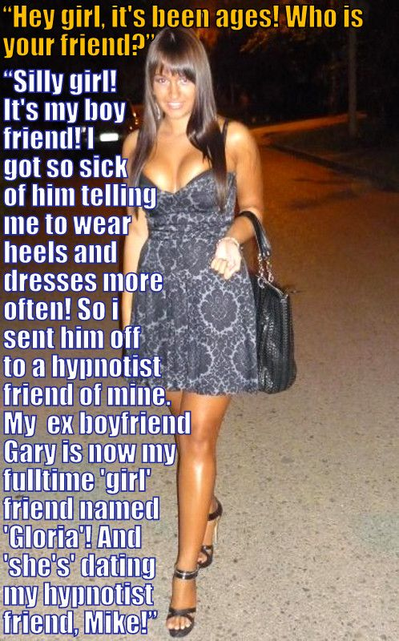

“The truth is that I am jealous of her,” I said. “I want to be able to wear all the things that I want her to wear. But I am a man.

“Is that really true?” he asked me. “What sits between your legs is your sex, not your gender. It sounds to me as if there is a woman inside you trying to break out. Why not set her free?”

So that was how I became Gloria. There was a hypnotist involved but no hypnosis.

That is what happened … right?

The End

No Changing Back  Inspired by a Tiffany Captioned Image  By Maryanne Peters  “I’ll bet you. I’ll bet you anything. I’ll take that bet.” How do you teach your youngest son about the evils of gambling? He needs to understand the consequences of taking a chance.  I could see in Randy the seed of what had cost me plenty in my lifetime so I was keen to deliver the lesson.  “Don’t offer me something you don’t have,” I told him. “And this bigger deal than washing my car or mowing the lawns if you lose. Losing money is permanent, or at least has a duration, so let me think …”.  Some of his sister’s clothes were sitting in a basket for disposal. That is where the idea came from. She had a long dark wig too. I just pictured Randy dressed like a girl with a sour look on his face.  If you lose, then 1 week living as a girl.” | 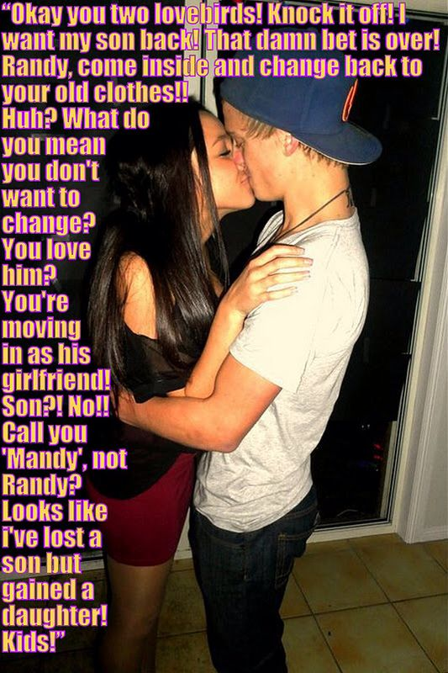

I am not sure whether he even gave it much thought. He was so sure of himself as gamblers often are, or just plain reckless. He stuck out his hand to shake on the deal. I held my hand back a little to give him the chance to pull out, but he grabbed it. Deal done. Bet made.

I was glad that he lost. He needed to learn that you can’t bale out of a deal. Like I said – consequences.

“No, I said a week living as a girl, not just pretended to be one. You will sleep in that wig, and a nightie. I will sign you a day off school tomorrow so you can work on passing, but for the weekend you are a girl, and on Monday you go to school as a girl for 4 days. That is one week, starting tonight. And no complaints. You could have pulled out but you didn’t. You signed up for this.”

To his credit he swallowed deep and did not whine, but I knew that he was furious with me.

His sister thought it was a great joke. She said that it would be like dressing a life size Barbie just when she thought she was too old for that stuff. She talked to Randy about the importance of not appearing to be a boy dressed as a girl.

“That is asking for trouble,” she told him, while I looked on. “If you want things to go easy then you need to blend in. I will help you. You need to do as I say. Now we need to get tweezers and a razor, and my makeup box.

I have to say that when Randy appeared for breakfast the following morning, I was impressed. Not only was he honoring the bet, but he was making the week living as a girl look easy.

I went to work and when I got home Randy was helping his mother with dinner. My wife had reluctantly approved of my tough love stand, but now she was enjoying having another daughter, and one more interested in cooking than “our older daughter”. I noticed the ladylike demeanor. Randy seemed curiously capable.

That night Randy fielded a call from his best pal Jack, talking about Saturday morning activities. I heard him say – “Sure, we can meet up, but I may not be able to do that. We might look at doing something else. It is just that … I lost a bet and … well, I am dressed different. Actually, I am dressed as a girl for a week. Or rather, I am a girl for a week.”

I smiled. Consequences.

Anyway, I had golf in the morning and I was gone before Randy got up. When I got home I was told that he would be with Jack all day. Then that he would be staying over at Jack’s place. I sent Randy a text message to remind him that the bet applied wherever he was, and he texted back that he was honoring the deal.

It was the Sunday when Jack came around to our place that I caught them kissing. To say that I was shocked was an understatement. I mean Randy was not big on girlfriends but “call me Mandy” was the biggest surprise of my life

Consequences, huh?

The End

© Maryanne Peters 2022

