The Valet
A Vignette
By Maryanne Peters

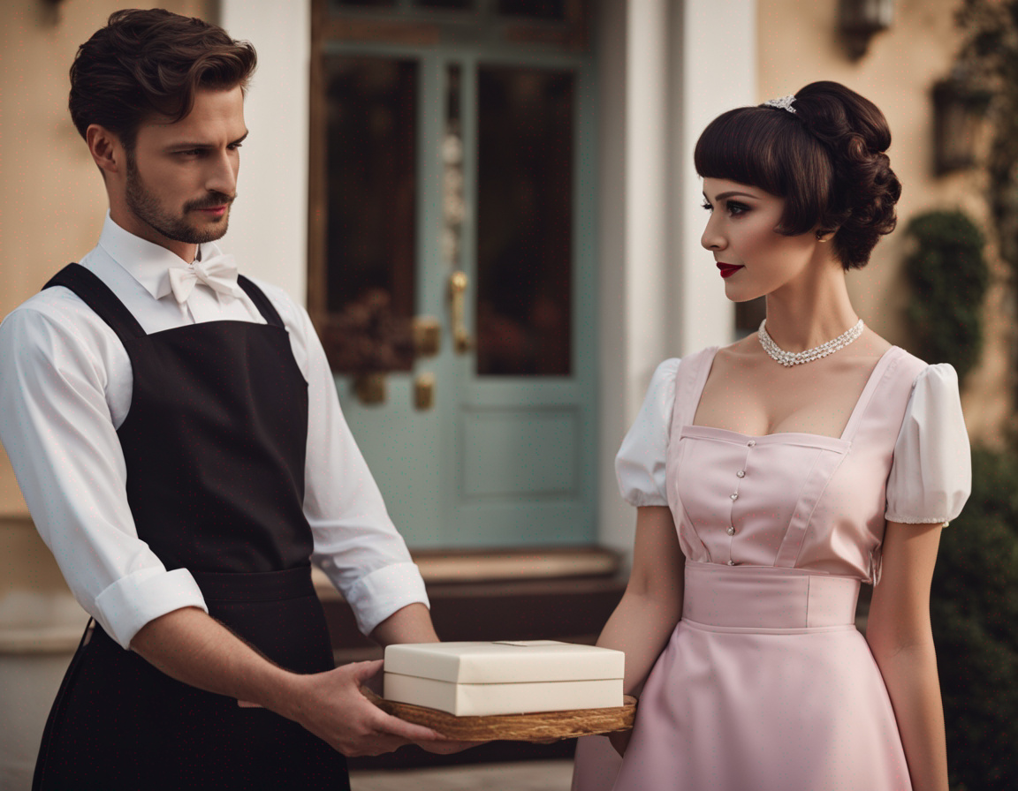
“Says 'Saucy lingerie.' By any chance, is it yours?” by jeimyjeimy on Deviant Art

It was all so wrong, but I could not deny my feelings. I was a young heterosexual male, kidnapped by a wealthy pervert, feminized, pumped full of hormones, dressed up in outrageous princess outfit with ornate hairdos pinned to my own thick bobbed hair. Somehow he thought that he could turn me into some kind of creature who might find him attractive, or at least worthy of some kind of Stockholm syndrome affection.

I used to think – ‘why doesn’t he just rape me?’ You cannot make a person attracted to women by nature, attracted to any man, let alone him – a disgusting, depraved old reprobate. Perhaps there was a cocktail of drugs working inside me to cut down my will, and make me open to feelings that don’t belong. I was determined to fight back, even though my body was soft and weak. I still had my mind and my will.

He would send me gifts with little notes expressing his love for me and his desire for the body I was slowly developing. He tried to call that “romance” and somehow imagine that he was not involved in the things that I was forced to do – as if he were only an observer of everything, he was forcing upon me.

He would have these gifts brought to me by his valet, Marcus. I think that Marcus found it hard to look at me, as if he knew that his part in this whole ugly charade was deeply evil. I used to sneer at him, and sometimes refuse to accept it, but I was powerless to protest in that way. I still needed to survive, and if that meant behaving in the manner of a ridiculous caricature of things feminine, then I could do that.

Then, one day I decided to take him on. He came to me with a little box of something – lingerie, I think.

“Why can’t you look at me?” I said. “Are you seriously ashamed of what you are doing here?”

He looked up at me, and for the first time I was looking into his eyes. Despite his darkish Mediterranean appearance, they were blue and sparkling, just like that sea. For some reason, internally, I gasped.

“I dare not look at what I cannot have,” he said. “I have watched you over the past year, and I fear that I am falling in love with you.”

Was it drugs in my system? Or was it just the hormones shrinking my maleness and making me so proud of the breasts I now displayed with pleasure? Or is that all of us are capable of falling in love with anybody, regardless of who we think we are?

“Oh my God! I feel the same way,” I whispered. “Can you help get me out of here?”

The End

Orange and Black  A Vignette  By Maryanne Peters  I thought I was a tough guy when I was sent to the slammer for armed robbery. I thought I could look after myself. I had a plan that the first guy who tried to manhandle me I was going to go nuts at and put him in the hospital, then nobody would go near me. It was a good plan. But that first guy just picked me up as if I was a rag doll, and he laid me out face down and shoved his cock deep inside me. He just fucked any resistance right out of me. I just felt like crying like a girl – the girl I had suddenly become.  People can say whatever they like about one act never being enough to destroy manhood, but what do they know? They did not go through what I went through. | 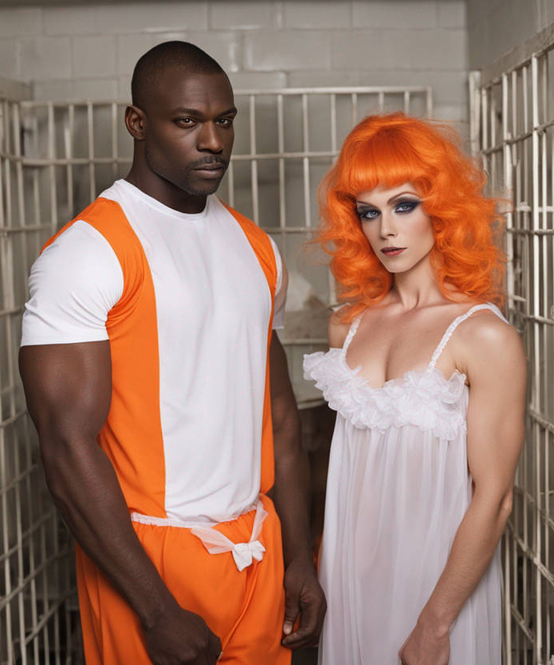

After something like that you only think about survival. I did not want it to happen again. But for all the men in the white section of the prison, I was the girl with a cock – the pretty boy that everybody wanted to fuck. My own kind had turned on me, and rescue came from a place I never expected.

Tevon Andrews was big and black, and he had won respect from everybody in the prison. Not only was he untouchable within the black sections but he had (I was told) eliminated an informer in the white section and dealt with a troublemaker in the Latino section. He was owed by everybody.

“There is gonna be a price for my protection, but I won’t force myself on you,” he told me. “We’ll be sharing a cell and while we do, you have to be lookin’ like a woman. You’re gonna swallow the pills and wear what I say. I like white on a woman, especially a white woman.”

Then he produced the orange wig. I had to wear it every moment that he was around, and that was always. I only took it off when I slept, and when I would comb out my own growing hair, softer and finer from the hormones he had me taking.

He was true to his word, and he never forced himself on me, but when we walked around the prison or sat in the dining hall, he was always beside me, sometimes holding my hand, and sometimes with his arm around my waist. We were a couple, and I thanked God that we were. Nobody would lay a hand on me, and even a sneer at me was likely to result in a broken nose.

It was me who offered him my body. I simply crawled into his bed one night and accepted his embrace and later, his huge cock. I did it with love and respect, and not in fear. I learned that to have inside you, stretching you to the point of pain, can be a beautiful thing if that penetration is driven by love.

I found out who I really was in that prison – I was a woman, Tevon’s woman.

And getting out did not change anything. I waited for him. I threw away the wig but I dyed my hair – not quite that orange – more strawberry blonde.

I am counting the days until my man comes inside me again, but until then I visit him as often as I can. I always wear white, but I love orange and black.

The End

Bargirl  A Vignette  By Maryanne Peters  I had made some money and lost some friends and family because of it. I simply decided that I was in a position to let her loose. She was a better person than I was – Ida – the woman inside me.  The money I had made I spent to make me look more like her - a woman. I did not try to hide my age, or at least not too much. I had lived a life, and I always thought that the right kind of men would find that attractive.  It was not that I was looking for men, I just wanted men to look at me. I had only had sex with women, and I was not expecting my preference to change. | 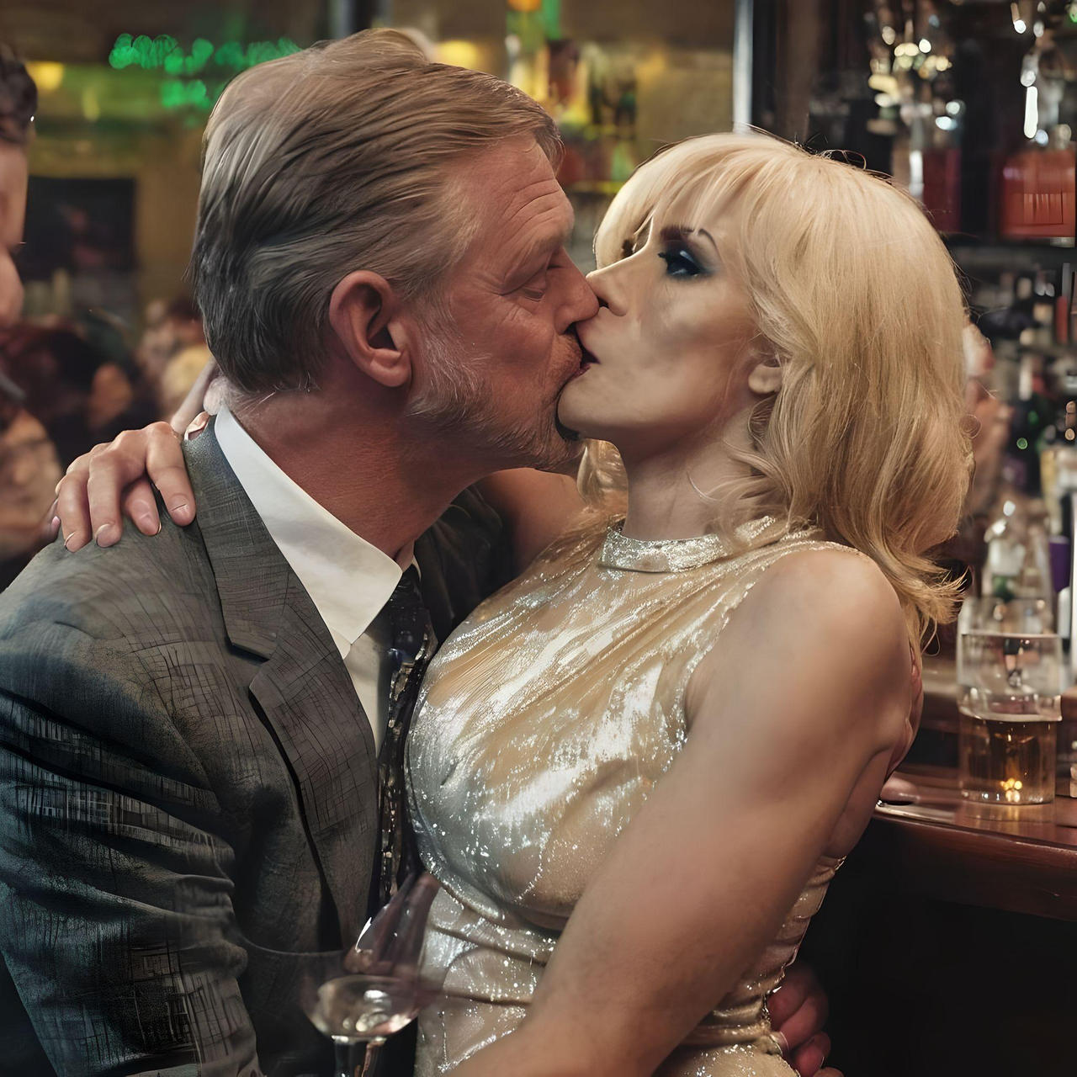  Sissy Being Roughly Kissed by Man at the Bar by Linda Summers 214

I would dress in an alluring style – not overtly sexy so that I might be mistaken for a whore. I was going for the divorced business woman waiting for a blind date to turn up. Sometimes I would even turn to a man of appropriate age and say something like – “You wouldn’t happen to be Kevin, would you?” It was just to use my cultivated feminine voice and have a man take a closer look, and perhaps win a compliment. It would never go further. I would make excuses and go.

But part of the problem was my own lack of confidence. When I first went out like that, I was unsure of myself and I preferred darker bars, and in such places you rarely meet the right people. And those bars seem to have staff and customers that seem part of the furniture. I did not want to be seen to reappear and become just another bargirl – if not looking to get laid then at least to win a free drink or two. I am not that kind of person. I needed to do better in this new life I had chosen.

There was a bar down on Harding Street. It was tasteful – lots of mahogany but well lit. I felt confident enough in my appearance to go there. All the scars of surgery were gone, and I had grown my dyed and repositioned hair down to my shoulders. I was accomplished with makeup and now had the cheekbones that I wanted. I chose a dress that covered my great breasts but showed off my even better legs, and I decided to go without jewelry that night – I don’t know why.

I could see immediately that this bar was frequented by executives or businessmen, and not the kind who don’t live their work – those who take their tie off as they leave the office. I was never like that.

“Do you know a guy called Kevin?” I asked the barman. “He might be a regular here. He has asked me to meet him and I am a little late. I hope I haven’t missed him. A lady is entitled to be a little late – don’t you think? I suppose I am duty bound to wait for a while. Could I just have a club soda with a lime wedge?”

I just took a seat at the bar where I could see customers arriving and they could see me. It is the place a woman might sit if waiting for a blind date, I think. It meant that I could be seen, and that was what I was there for. To be looked at and admired for what I now was – a woman.

Some men would smile, or even better, look me up and down and imagine me lying naked across their bed. Regardless of my past male heterosexuality, I still liked that thought, and the look it brought to a man’s face.

If I was approached with a few words, I might smile and explain that my date was just about to arrive, but occasionally I had been known to accept a drink on a “no strings attached” basis.

I noticed a man come in out of the corner of my eye, because the barman signaled to him and then spoke to him, gesturing towards me.

To my surprise this man immediately came towards me. He was a little older than me perhaps, but with a good head of hair and a youthful wispy beard. He was wearing a bespoke suit a silk tie and before I knew it he was kissing me, pushed up against the bar!

“Darling, I’m sorry I’m late,” he said. “I am Kevin. Kevin Stockton. The man who intends to steal your heart … if not tonight then tomorrow night, or the night after that.”

It seemed so difficult to understand how a sexual preference can change in an instant, as if a bolt of lightning had readjusted me to suddenly behave more appropriately to my new body. I had invented Kevin just to be a bargirl that night, and then suddenly I was on a path that would end with love.

The End
860

Hair Passion  A Vignette  By Maryanne Peters  I am a transwoman and a hairdresser. I had always dreamt of having long feminine hair when I was a boy, and being able to braid it or curl it. When I left high school I decided to follow my dream – to become a hairdresser and a woman – in that order. Well, once I had a trainee position in a salon, I was ready to transition, so pretty much at the same time.  Hair is my passion. I love the texture of it, and I get immersed in all the colors I can bring out in it, including all the combinations and highlights. I love the styles, from the simple shiny bobs to the ornate updos. I think that I am privileged to love what I do. So many people are not so lucky.  It seems to me that me have a very poor lot in life. There are a few interesting cuts for men, and I have been know to have male clients, but for most of them they can only look forward to losing their hair, or a good part of it. | 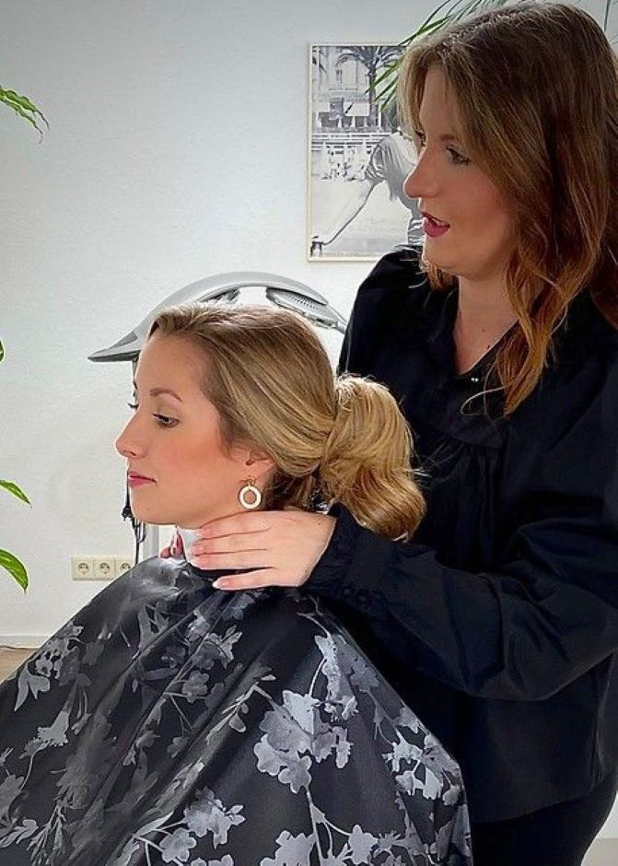

For the protection of my own hair, I arranged my orchiectomy as soon as I could, and I swallowed gob-fulls of hormones to keep my hair full and soft. I look after it and I tell all of my customers how to do the same. I sell the product I recommend, but even if they want to use another product I will suggest a haircare regime that works.

I have to say that when a woman with beautiful hair comes in and asks for it all to be cut off, I find it hard to conceal my horror. I always suggest that they consider a new style before going to a pixie or even a buzzcut! If they want to continue then I will try to find a junior to come and do the dreadful deed, and if there is still hair to work with, I will come back to rescue what I can from the wreck.

I hate masculine hairstyles on a woman. I am so glad to be a woman and to look like a woman, that I simply cannot understand why somebody would reject all of that. I am told that there are videos on the internet showing women with beautiful hair having it all shorn off! Even the thought of that makes me physically sick.

Ladies, just think of those poor men with their receding hairlines and little holes in their mops on the top of their heads, watching hair go down the drain in their showers. How awful. Who would want to be a man?

Now, I have the smock on you, and the collar, but with all this beautiful hair, let’s talk about some suitable style. Perhaps something wash and wear – practical but feminine. I have to explain, I simply won’t do anything that will rob you of such beauty.

The End.

Mr. Nussbaum  A Vignette  By Maryanne Peters  Mr. Nussbaum was our neighbor and a really nice man. He was one of those people who would carry up a parcel left in the building foyer and addressed to us up the elevator and leave it outside our door. If you needed a cup if something or an exotic herb, he would have it and refuse any return. He was about as good of a neighbor as you could have.  He was always asking after me and asking me what I would be going on to after high school, but I just told him that I was still thinking about my future. He wished me well, with his usual warm smile.  It was not until I was locked out and I asked Mr. Nussbaum to buzz me up and ended up sharing a drink with him until Mom came home, that I really opened up to him. He gave me a European drink that was sweet and I guess a little stronger than I was used to. I told him that I felt a bit like a round peg looking for a round hole, when they were all square.  “Or maybe you’re a round hole looking for a round peg?” he suggested. I really didn’t know what he was talking about, but we started to talk about what work might suit me. | 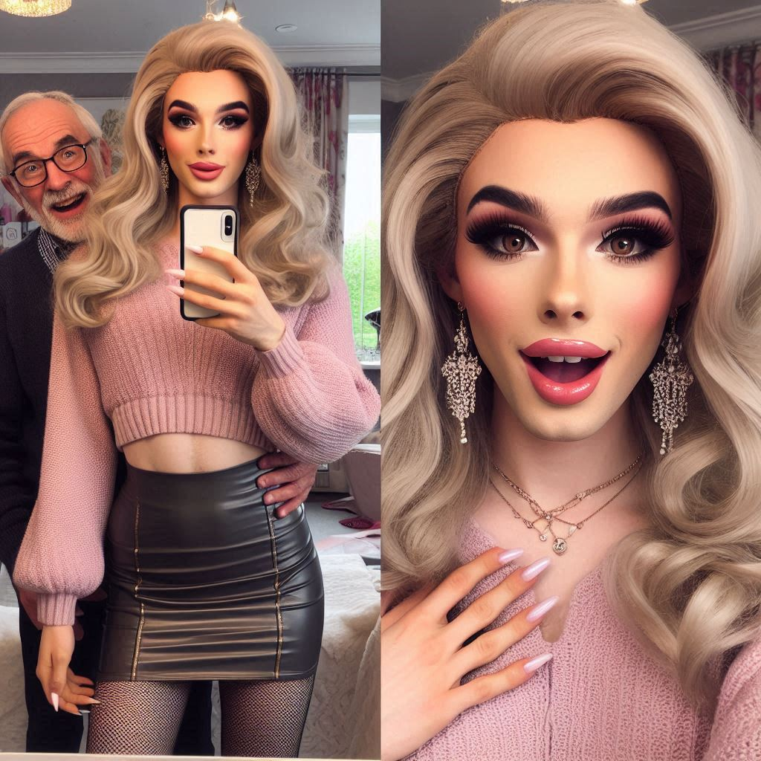

“Perhaps I am old-fashioned, so forgive me for saying this, but those are all the kinds of jobs that young women seem to do so much better than young men.”

I told him that that I thought he was wise and that I would value anything he had to say.

“Alright, I’ll say it,” he said. “I think that you would make a very pretty young lady, with the right effort by the right people.”

I was maybe a little shocked, but actually more pleased. You see, I had always thought the same thing. I had always had a hankering to see just how pretty I might be.

“What do you mean by the right people?” I asked. I could see that he was pleased.

“Well, I am aware that there are feminization specialists out there, and some offer a service where they would come to your home to do a complete makeover without you having to step outside. Or, they could even come to somebody’s neighbor’s home, if you like.?

“That sounds great!” I fizzed.

“It’s even better than that,” he said. “I will pay for it. Call it my treat.”

So, the following week I went around to Mr. Nussbaum’s apartment and there were two ladies there, who had not always been ladies.

When they were done I didn’t believe that it was me. They had done the whole thing – a body wax and stick on breasts, panties to tuck my junk so I could wear a tight leather mini-skirt to go with my black tight and heels and my pink cashmere sweater. I was fitted for a gorgeous long blonder wig and a makeup job that you would not believe! I was a knockout. I wanted to take about a zillion selfies.

Mr. Nussbaum looked just about as happy as I was, maybe even happier!

“Oh Mr. Nussbaum,” I gushed. “I feel about as happy as a … girl could feel. How can I repay you for introducing me to the person I was always supposed to be?”

“Don’t be silly, my sweet child,” he said. “I don’t want anything at all, except your happiness … and your gratitude … and perhaps a blow job every now and again?”

The End

This story was inspired by the AI images included, prompted by FeminineFantasy7 on Deviant Art and entitled “Cross dresser with his older boyfriend”, but that was not the words it spoke to me
600

© Maryanne Peters 2025

