On Your Knees
A Vignette
By Maryanne Peters

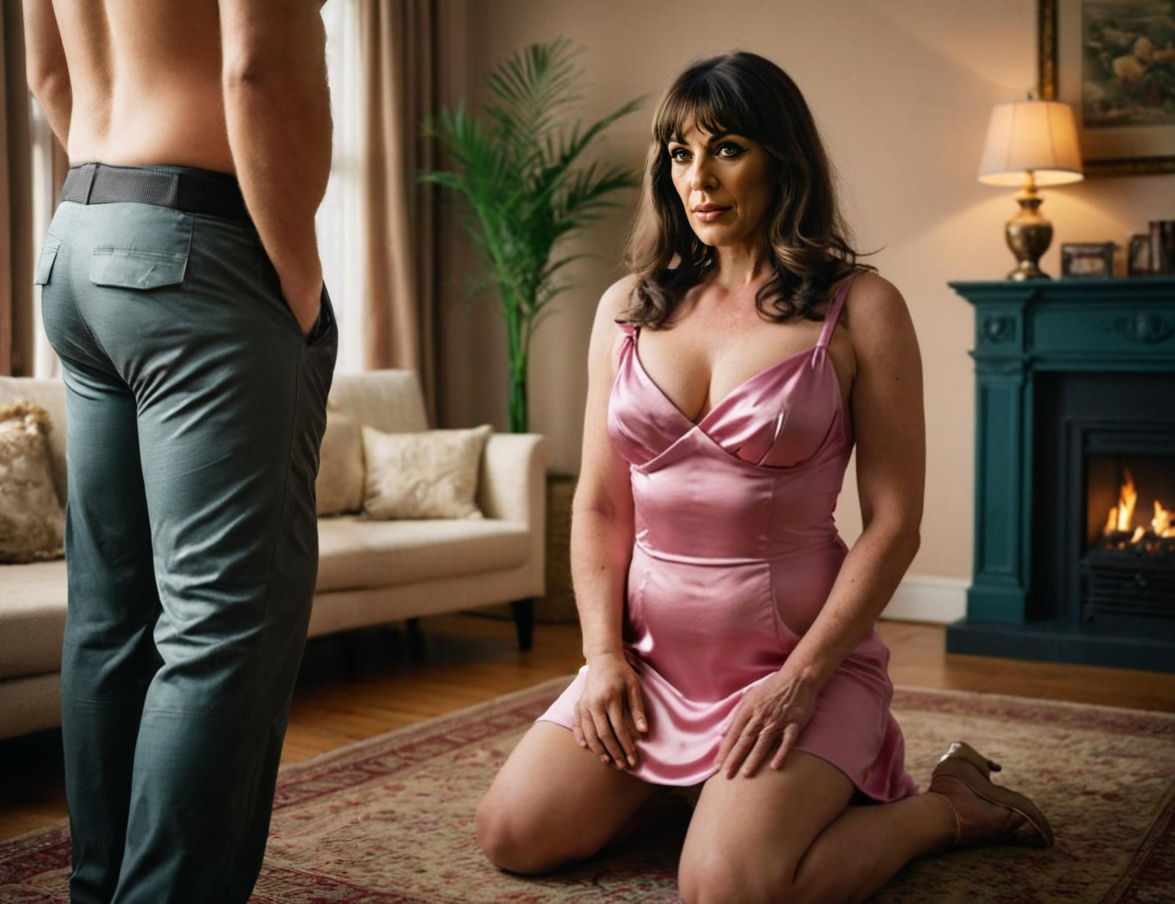

When I heard that Kevin Hallett had changed his sex and was living as a woman up in Seattle, I could not believe what I was hearing. I just had to seek him out, and not with any good intentions.

I disliked Kevin Hallett, and maybe I even hated him. In high school he just seemed to have everything that guy – smart, great at sports, popular with the girls – and everybody said that he was a gentle soul with it. It seemed that he had everything that I didn’t have, and I wanted it.

Then he moved on to college and I went to work in my father’s engineering business. I did very well, and only better when my father died, and I bought my family out. I was in a financial position to be able to drop everything and head up to Seattle, to find Kevin and to fuck him.

I really didn’t care what he looked like. Just the thought of laying out the great Kevin Hallett and getting inside that guy and dumping a load into him sounded oh so satisfying to me. My guess was that he would now be weak and passive, but I still had to get him alone and close to his bed – or mine. But it would be good to fuck him in his own home.

I decided to engineer a casual meeting. I actually hired a private investigator to watch Kevin for a couple of weeks and find a regular routine so that I counter work out a place to meet by chance.

It so happened, that he went for a run on a Saturday morning, which came as no surprise. I was told the route, and I picked a spot quite near to his place and just before his exercise would be over. I got there early and waited, walking out just as the large woman slowed and checked time and heartrate.

It was Kevin all right, but surprisingly attractive – even pretty. The long dark hair was tied up in a high ponytail. The shoulders were broad but had lost their muscle, and the sports bra held back a good-sized bust. The legs were long and smooth and might be the envy of many women.

“Excuse me, it sounds like a corny line, but don’t I know you from somewhere?” I had rehearsed it. I knew Kevin well enough to know that he would not ignore it.

“I think you do, because I know you,” The voice was surprising soft and feminine. “We were at school together. I am Kim Hallett, but you might remember me as Kevin Hallett.” There was a sly smile, as if this line had been said before with amusing results.

“Wow! Kevin – I mean Kim. You’re gorgeous! Who would have thought? I bet you have a story to tell.”

“Well, I do. If you have time I live just over there,” said Kim. “It is cold, and I have coffee brewing and a fire burning inside. Why don’t come in for a bit?”

“It is cold,” I agreed. “Sure, why not?”

As I followed her (because she had clearly earned the pronoun) I found myself admiring her butt, and as she turned the key, I was close enough to smell her. It was not the smell of a man. It was slightly erotic and even arousing. This change had been radical. I was getting seriously horny.

“I need to take a shower,” she said. “Help yourself to a coffee.”

I poured out a coffee from the machine and I looked around. There were some photos on display but none of Kevin. A few family photos without him. A few photos of Kim – clearly an outdoors sort of girl. There were some books about transgender subjects on clear display as if to signal to a visitor – “Yes, the owner of this place is a transsexual”.

I leafed through a few magazines. Women’s magazines. Fashion and food, and lifestyles of the rich and famous.

When Kim came back in the room she was wearing very little. It was just a plain pink silk mightie, or if it was a dress it was basic. She was e=wearing shoes too, with a small heel but enough to show off those long, athletic legs. Her dark brown hair dangled around her broad shoulders but her arms were no longer powerful. That made me feel powerful. Kevin Hallett had been reduced to this – a girl. She was tall and pretty and her eyes seemed to invite me in, but he was nothing like the man I hated.

I took my shirt and sweatshirt off together and threw them on the armchair behind me. I want Kim to see my manly chest and the shoulders I had developed. I felt totally in control and I needed to show her that.

“Get down on your knees,” I directed her. She complied without question. I reached for my flies, now out of necessity more than anything else.

“I will suck your cock if you like but I would prefer to have everything you have got swimming inside me,” she said. “I am not dressed like this to have a chat. My bedroom is just across the hall. Come with me.”

She stood up and headed for the door. I followed. It was as if I had already lost control of everything.

“Let me take this off so you can play with my tits, but I will keep the shoes on,” she said. “I think that heels in the air are sexy, don’t you?”

As she lay down she leaned up and one of her big hands reached forward to wrap around my cock, firmly but without squeezing, to pull me towards her bush with its bright pink slit seeming to quiver slightly in anticipation. It was warm and moist and I shuddered with a sigh as her body swallowed all that I had.

“Fuck me, manchild,” she said.

Manchild? What was that supposed to mean? I was in charge here. This bitch was my conquest. This huge dickless creature was mine to fuck. But it was only that act that was in my head. Everything else was gone. I was not going to say anything. I was going to let my cock do the talking, and the spitting.

I rode Kim as hard as I had ever ridden any woman and she just called out things like – “That’s it baby. Give it to me. Oh yes!”

And then came the moment when I felt her internal heat and my cock did what it was made to do and both of us took that tiny step onto a higher plane – the doorsteps of heaven. I could only gasp and call out to the God I can only believe in, in that very moment.

The noise she made was half feminine squeal and half the quarterback’s cry of victory.

I hated Kevin Hallett, but he is gone, and I think I am in love with Kim.

The End
1170

Thanks to tanyab49 on Deviant Art for the image. Every now and again, despite all the repetition and awkward inaccuracies, AI imaging throws up something with an obvious story …

Shanghai Nights  A Vignette  By Maryanne Peters  In 2015, it seemed to me that China was the place of the future. It was growing at a huge rate, and was set to overtake the United States as the strongest economy in the world – it was just a matter of time. For that very reason I studied the Chinese language alongside my business degree. I figured that while so many others in my class were smarter than me, I would have an edge when it came to dealing with China. 2015 was the year I went to Shanghai to work on my speaking and reading skills, and to scope out opportunities.  China had a new President at that time. His name was Xi Jinping. Xi is a very common name in China, but the way his name is written in a Chinese character is very similar to diao, which means sly, cunning or tricky. I was told he was all of these.  But he had a program based on anti-corruption, which is good for business, and relaxing rules on private property ownership, which was good for investment. Things looked promising for China under this new relatively youthful, leader. | 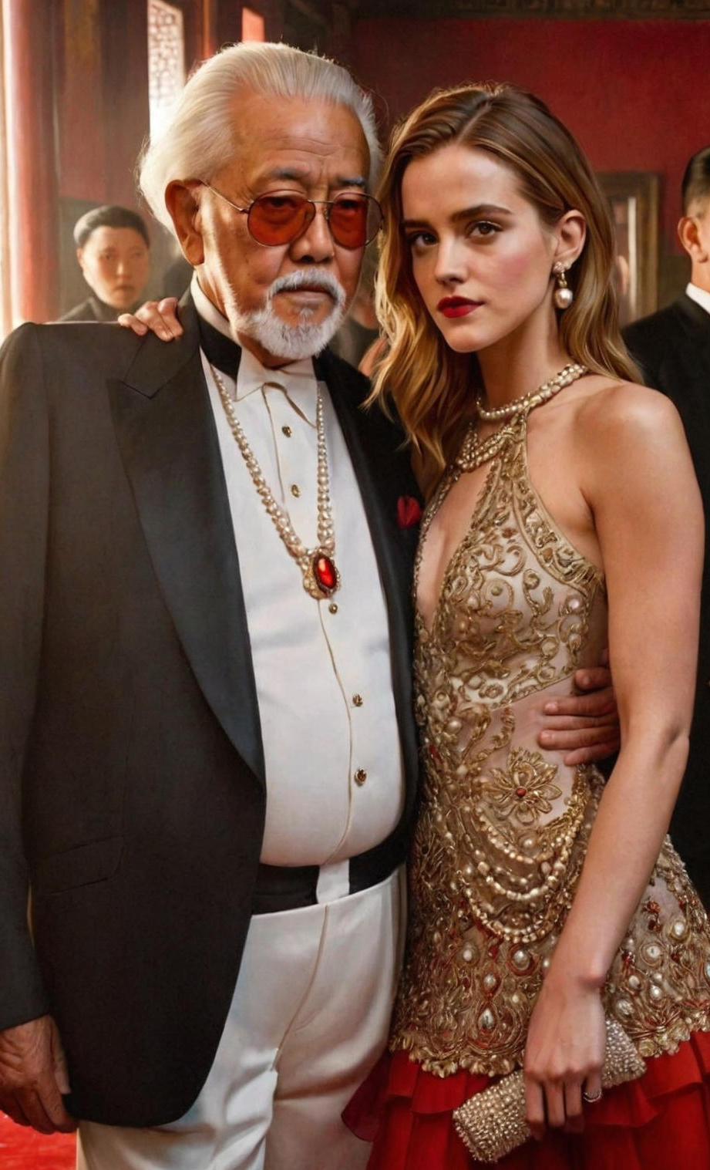  Image by Maria Callisti, used with her permission

After only a week in Shanghai, having seen sights, I was ready for work and I was offered a job working for a large fast-growing pharmaceutical company. At that time pharma in China was growing at 3-4 times the rate of the economy as a whole – the fastest of any industry. President Xi regarded it as important, and he was unconcerned that Chinese pharma ignored US patents and fabricated test results. The FDA and other sections of the US government were becoming increasingly hostile, and I was supposed to be some kind of American buffer. It was interesting work, and they paid me at foreign rates, but I could live cheaply in Shanghai and save money for my future.

My role was consider important enough to have me report directly to the owner and manager of this very large business, and man called Liu Mingxin. I was one of the few allowed to call him Lao Liu, or old Liu, a more informal address than Liu xiansheng, or Mr. Liu. He seemed to be fascinated by me, somehow, and I couldn’t understand why. He was always staring at my light colored hair, which I guess I wore longer than Chinese men do.

At that time, China had a reputation for producing low value-added bulk pharmaceuticals and copies of popular drugs without licence. There was virtually no research and development and no investment in innovation. All the money went into new machinery to make more drugs, and expand into more copies of drugs already in production overseas. Lao Liu had no concern about the illegality of anything, provided that it was not some against the law in China – he was aware of the consequences of that. I suppose that it was only a matter of time before the company started producing methamphetamine for export.

Like I said, I liked my job, so maybe I closed my eyes to a lot of what we were doing. Somehow it seemed as if I thought that asking not to told certain things no only gave me the ability to deny knowledge of it, but rather the belief that it was not happening.

Lao Liu confronted me about it. He said that I was living in a fantasy.

“The world was not what you want it to be – the world is what I want it to be,” he said. “At least here in China that is the case. If I want you to be my servant, or even my wife, here in China, then I can make it so, and there is nothing that you can do about it.”

I just laughed. I could see that he was serious, but I just laughed in his face. I have seen this in China many times. A man with power will let it go to his head and believe that he has the power of life and death over his minions. Even though President X had enacted a series of policies designed to increase equality, he was just the same. The old tradition of emperor and peasant still runs deep in tradition.

From that moment Lao Liu decided that I was to become his wife. It sounds crazy because I need to confirm that when I arrived in China in 2015 I was a man – a naïve young man, but a man.

But among the bulk drugs that Lao Liu’s company produced, was a whole host of endocrinal drugs – androgen blockers and estrogens, and drugs to weaken the resistance of body and mind.

To add to that, Covid19 came around and China was locked down completely. I was trapped.

It is not that I didn’t fight back – I did. But this is not a story of my relentless battle for freedom from an evil megalomaniac. No, in fact it is a very different story. This thing is that he loves me, and he always did. I have now come to the view that he saw something in me even when I did not. I never even knew that it was there until my breasts grew and my hair as well, and there was only the three of us in his mansion – him and me and his aged aunt who instructed me in all things feminine.

Those times are over now. I am free to leave, if I like. But I choose not to. I choose to stay in Shanghai with the man I have grown to love.

The End
930
My Sister’s Sister  A Vignette  By Maryanne Peters  It was not as if I really wanted to be a girl, it was just that I admired my sister so much that it was starting to get a little weird. She was just so beautiful that people’s heads would turn as she walked by, and nobody could even see her little brother walking beside her.  She had the most beautiful hair and it always looked perfect with almost no effort. She could just wind it into a bun and there would no be a single hair sticking out, as if she had just stepped out of a salon. | 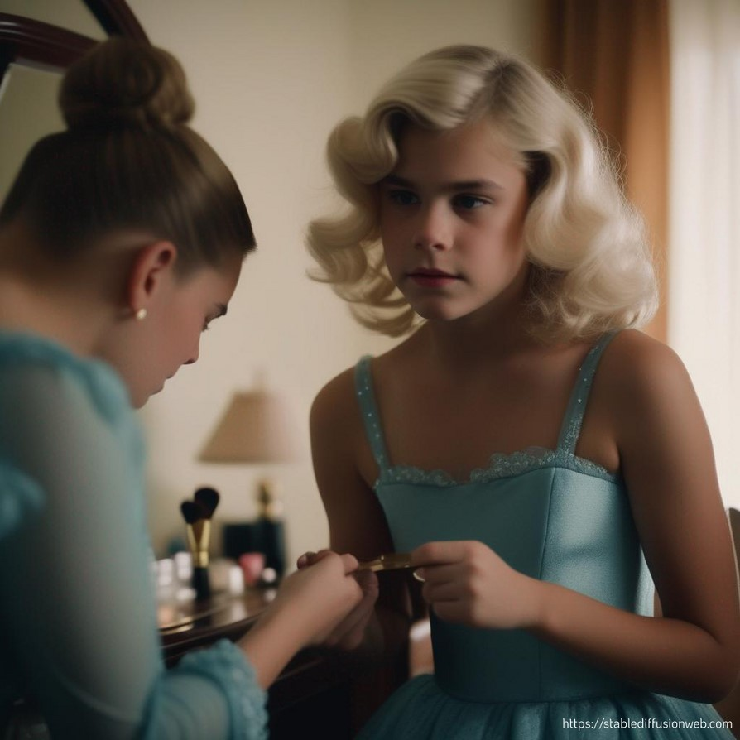

I grew my hair longer and I tried to do what she did with it, just in private. I was proud of the fact that my hair was blonde, but it always looked messy. And of course, she was a girl and she could wear makeup to look even better, and jewelry and fabulous clothes.

Like I said, it wasn’t that I had any real desire to lose my boy parts. I just wanted to be like her in all other ways. But these desires I had to keep secret because I was a boy, and boys are not supposed to want to be like their sisters.

And then one night, when I was playing with my hair, it seemed like I had achieved something pretty much close enough to the perfect soft bun, and I was admiring it with a hand mirror and my dressing mirror to check all angles, and she walked into my bedroom. I had always insisted that my parents knock first (and they did) but I had no rule for my sister because she never walked in.

“What are you doing?” she said. “Oh, you’re putting your pretty blonde hair up. I think it would be prettier down with a few curls. Why don’t you let me do your hair, Bro? And maybe you can wear something of mine? What do you say?”

I tugged at the bun to rid myself of a feminine look, but it was too late. She had seen me trying to be like her and now it seemed that what she was offering was something I needed to do. She had come into my room to tell me that our parents were not going to be home that night, so she was in charge. She took charge and I let her.

Like I said, I adored my sister, but from a distance, I guess. She was a girl and I was a boy, and at the age I was, girls did girl things and boys did boy things. But everything changed that evening. She discovered that she had a secret sister, and a sister was all that she wanted. And I discovered that what I really wanted was to be my sister’s sister.

My life had changed forever. I don’t think that I will ever be as pretty as she is, but she would like me to be, and it is going to be a whole lot of fun trying to make it so.

The End

Wookie Princess  A Vignette  By Maryanne Peters  I am sure that everybody knows something about wookies. You probably know that these hairy giants come from the planet forest planet of Kashyyyk, and that while they were taken as slaves by other creatures, they are clever and have their own advanced codes of honor. Some wookies have even been known to be force sensitive and join the ranks of Jedi knights. We know that they care for their young, and care even for other races who are less advantaged in terms of size and strength. But what of their womenfolk. Have you ever seen a female wookie? Well, there are none, at least none exist until they are needed, or desired. |   “Let the wookie make you his girlfriend” by kathleen43 on Deviant Art

I had worked with the wookie Takachan for about a year, and I was with him during the battle on the Planet Ovakajar. I was injured in that battle and there is still a slight scar on my left leg to show for that, but I would have died had it not been for Takachan. I told him as much, and I told him that I was in his debt. He waved the suggestion away. I could not speak Trewook in those days, and as we all understand, while wookies can understand many languages, due to their vocal structure they can only really express themselves in their own language. I made it my mission to be able to communicate with my savior.

In time I was able to speak his language quite well, and it was only then that I learned of his secret desire. That desire was me. He wanted me to be his mate. I just laughed and said to him (as bet I could make those noises) that if I was a woman perhaps I would consider it, but I was not – a woman I mean.

Then he told me that all wookies are born male, and that when a male reaches a certain age he has the ability to change a willing volunteer into a female form that he can mate with. But he said that if I was willing then it must not be because he saved my life. He said that it was his duty to do that, and I owed him nothing for doing it. But if I felt that I was a person that I could love and commit to, then perhaps I might put aside my male past, and become his woman.

“I value our friendship more than anything,” I said, and then I switched to bark at him in my bad Trewook. “But I think I like being a man too much to make it that close.”

“I will tell you this one thing,” he woofed back. “Nobody who has ever been changed in this way has ever wanted to go back.”

The idea intrigued me. Could it really be true. I had to yap the question – “Nobody? Not ever?”

“Nobody? Not ever?” he barked

So, I could go back. He could change me back. I could do what he wanted, so why wouldn’t I?

“Do it then,” I said.

He had me undress and then he laid on top of me and I felt myself enveloped in his thick warm fur. What hair I had on my body seemed to disappear into his and I he pulled back I felt my chest swell. I suddenly realized that he was inside me, or something was, and as it withdrew from me there was an audible moist plop as I understood that a new cavity had been gently formed. He kissed me with those lips that were the only part of him not covered in hair, and my lips parted as if begging for his tongue.

The hair on my head had grown suddenly to well below my shoulders, and he arranged for it to be dressed, and me also, with a robe and with jewelry. And yet in the mirror I was still me, only beautiful and feminine.

“But what is with this hairdo,” I had to asked. “It looks like Princess Laila.”

“You are my princess,” he said, taking me up into those strong hairy arms.

He was right. There was no going back from this.

The End
720

Bodies  A Vignette  By Maryanne Peters  He sometimes jokes that his body is an investment too – the application of thousands of dollars on expensive food and drink. He says that the investment in mine is a small sum by comparison.  He paid for everything. The scalp surgery to give me that great head of honey blonde hair, the breast implants just the size he likes them, the vaginoplasty to create for him that sheath made to measure him.  “You could spend a little money on yourself,” I said to him once. “Maybe a little tummy tuck? A hair transplant to cover that hole in the top back there?” | 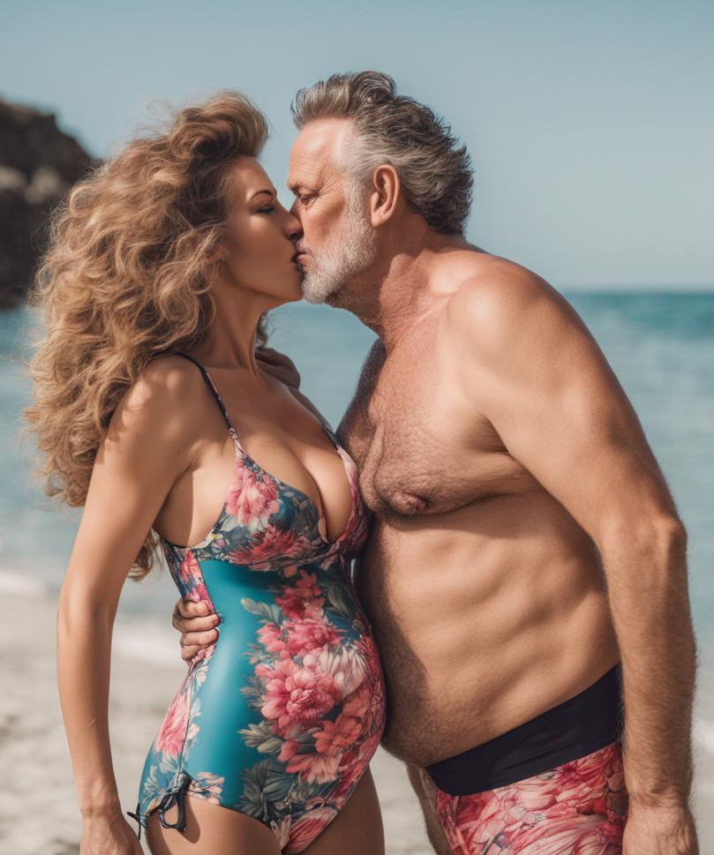  Image is by LindaSummers214

“Baby, this body of mine serves only one purpose like I said in our marriage vows – with my body I thee worship.”

“I made the same vow,” I said

“I think we had better go up to our room,” he said. “It’s a private beach but I wouldn’t want to get any sand in that expensive pussy of yours.”

The End
170

© Maryanne Peters 2025

