
"So, that"s it! Pull yourself together! Do you really want to let some kind of magic swallow you up?" — clenching her fists and squeezing her eyes shut, Teresa tried to get herself under control. — "This magic. It"s all magic. A side effect. That"s exactly why you decided to use it far away from the palace. So. So get a grip, you pathetic rag, and gather as much data as you can in these 12 hours!"
It seemed that this inner monologue gave the girl strength. On her face, for the first time since waking up in the barn, there appeared not confusion, but something else — her brows drew together, her lips pressed into a thin line, and her chin lifted slightly, as if she were once again the one who made courtiers freeze with a single glance.
"Data. Observations. Testing the boundaries of reality," Kalendor repeated to himself, straightening up and opening his eyes. At the same time, the skirt immediately reminded him of itself, wrapping around his legs with a heavy fold, the corset tightened his ribs, and his breasts, as if on purpose, swayed with the first step so much that he almost stumbled again.
— Stop it… — he hissed, as if he could give an order to his own body. To his own breasts.
"So, here"s how it is — it looks like both of them took me for some kind of peasant girl. One of them even decided I was his daughter! How disgusting!" Kalendor thought, his face twisting at that moment. — "I need to understand the scale… of this illusion."
He looked around and only now noticed that the hair on his head had grown a little, now covering his ears, though it still didn"t reach his neck.
His fingers instinctively reached up and sank into strands that shouldn"t have been there. The hair was softer, thinner than he remembered having, and — what was especially infuriating — it obediently lay between his fingers, as if it had been doing that its whole life. It really did cover his ears, lightly tickling the skin, and the sensation turned out to be so… strange that Kalendor grimaced.
— Fuck, — he growled through his teeth. — I need a mirror.
Those bold words, especially for a girl, echoed inside with a strange double wave: Kalendor"s familiar anger and an instant, almost girlish fear. He froze, as if expecting punishment from the world itself for that harshness, and automatically looked away to the side.
In the cloudy glass of the nearest window, a reflection flashed by. Blurry, distorted, and semi-transparent, yet clear enough to make his heart twitch unpleasantly. The contours of the face were recognizable: the line of the cheekbones, the shape of the nose, the stubborn cut of the mouth — all of it was his, too familiar, masculine. And at the same time, framing that face were чужие details: hair grown slightly below the ears, softly wrapping around the head, smoothing out the usual sharpness. The eyes seemed bigger? No, that was just imagination.

Kalendor frowned and leaned closer, but the reflection immediately vanished, leaving only the outlines of the room behind the window.
— Wonderful… — he breathed out through his teeth, lowering his gaze to the huge cleavage. — I need a proper mirror.
And then the realization surfaced clearly, without fuss: Elina has a mirror. That"s where I"ll look at myself.
He turned sharply and somehow too confidently toward the narrow alley and started walking.
— To Elina, — he tossed shortly into the emptiness, like an order to himself, straightening his arm forward and nodding to himself.
His steps were not the way he was used to. They were shorter, with a light sway of the hips that shifted his pelvis left, then right. He tried to walk like a man, but it was impossible. Every time he straightened up and took a step, the heavy breasts forced him to hunch slightly to keep his balance, and at that moment he forgot about his hips, which immediately started swaying again.
“Damn it all to hell,” — he hissed under his breath, lifting the hem of the skirt that tangled around his legs so he could speed up at least a little. The fabric obediently gathered in his hand, forming a tight bundle, and in that very moment Kalendor felt just how unforgivably familiar this movement was.
A chill ran down his spine from that realization.
— So this is how you work, — Kalendor whispered, still clenching the fabric in his fist. — Not just external disguise, but internal too?
He took a step, then another. His hands held the skirt in front of him, and it really did become easier to walk, so he sped up, not even noticing how he ended up on the market square. Not the central one, no, but rather a local one, where everyone knows everyone.
And Kalendor knew it. Or rather, he didn"t yet know it, but felt it with his whole body. That strange sense of recognition, as if he had lived here his entire life, even though, in truth, his eyes were seeing all of this for the first time. The square spread out before him as an uneven quadrangle paved with cracked cobblestones, with stubborn grass breaking through the gaps. The air was filled with the sweet, cloying scent of royal marzipan that caravans carried through Fleurmar to the northern lands, mixing with the smells of fresh bread, horse sweat, and smoke from braziers.
He turned his head to the left and saw Edmar"s stall with clay pots — that very stall under which Teresa used to crawl as a child, hiding from her father. Next to that stall, just like before, stood a crooked post with nails hammered into it, on which notices hung, and beneath it still lay a cracked tub, long since having lost its purpose. This was where Teresa received her first flowers as a gift.

Kalendor didn"t even notice how a light, nostalgic smile appeared on his face, as if these memories were his own. And the realization of that instantly infuriated him. The smile vanished as sharply as it had appeared; his fingers clenched the hem of the skirt, and his shoulders dropped slightly on their own, as if he really had stood here a thousand times, afraid his father would notice.
“No "a thousand times." No "as a child." I am here for the first time,” — he snapped inside his head and immediately felt the pendant respond with a warm pulse at his breasts.
He shook his head, trying to throw off this obsession, and stepped farther across the square, already knowing the route that would get him to Elina"s house the fastest. The route surfaced in his head on its own: two rows of stalls, then a turn by the bakery where it always smells of burnt honey, and a narrow passage between houses where the sun almost never reaches. Kalendor caught himself not remembering the way, but simply walking, not doubting a single step.
That was what angered him the most.
“So memory is built in too. And feelings,” — he noted to himself, trying to stay cold. — “Good. That makes the data even more valuable.”
Near the bakery, he slowed down, hearing voices coming from the open door.
— I"m telling you! Marishka is just a stupid bitch! She walked right past me yesterday and didn"t even notice! Nose in the air! — the voice was shrill, with that special kind of spite that"s born not from hurt, but from wounded pride.
— You"re the idiot! Girls always act like that when they want you to pin them behind a shed and show who the man is! — the second replied, hoarse, with teenage smugness, and both of them burst out laughing like stallions in a pasture.
— HEY! — Kalendor shouted sharply and took a couple of confident steps toward the open door. He didn"t think — he simply didn"t have time. Inside, everything was boiling with anger, mixed with something else, more personal and humiliating.
The laughter cut off.
Silence hung inside the bakery as Kalendor stepped over the threshold. His body instantly took a familiar, humiliatingly natural stance: legs slightly apart, hands clenched into fists and planted on his hips, shoulders pushed forward. The skirt settled heavily, the corset pulled tight, emphasizing his breasts, but his attention was not on his body.
There were two of them standing in front of him.
Those two… Finn and Lukas, the younger brothers of Teresa"s friends, always hanging around like puppies: either fighting, or getting into trouble, and she would scold them, bandage their scratches, feed them pies when their mothers didn"t have the time. In a way, she was like a mom to them — one who suddenly realized that the boys were no longer really boys, but starting to become men.

— What the hell do you think you"re doing, huh?! — Teresa barked, the words flying out before her mind had time to interfere. — Marishka is a good girl, and you"re saying that kind of shit about her! Girls should be respected, not… not pinned behind sheds like some fucking savages!
The boys exchanged glances. Finn, the very one who talked about the shed, flushed red to the roots of his hair and stared at the floor, while Lukas awkwardly scratched the back of his head, muttering:
— Teresa… we were just… joking…
— Joking?! — she stepped closer, jabbing a finger into the air in front of their noses. — That"s not a joke! If I hear this again, I"ll tell your father everything, and the baker too — let him stick you with the flour sacks for a whole week! And Marishka… no, she doesn"t need to know, she"d get upset. But you should be ashamed of yourselves!
At that moment, Kalendor felt like he was back in his element again, the very one where he was in charge and everyone feared him — and at the same time there was some new feeling, something that made everything tighten inside.
Those two. He didn"t want to yell at them, especially seeing how they were now shifting from foot to foot and exchanging awkward looks. They were just kids, stupid, small.
"Maybe I shouldn"t have gone at them so hard?" flashed through his mind, as the blue light of the crystal on his neck softly illuminated the room, and his hair slowly began to touch the lower part of his neck. Kalendor didn"t notice it. He completely dropped out of what was happening for a moment, catching himself on a thought that would have once seemed impossible to him.
"...maybe I shouldn"t have gone at them so hard."
He saw how Finn hunched over, as if expecting a blow, and how Lukas stopped smiling altogether, clenching his fingers in the flour until his knuckles turned white. Not cocky troublemakers. Not enemies. Just rough, noisy, not yet fully formed.
— Alright, — Teresa said more quietly now, and that single word came unexpectedly hard. — I"m not yelling at you to humiliate you. I"m yelling so you"ll think.
Finn cautiously lifted his eyes.
— We… we really didn"t mean to offend anyone.
— I know, — she answered at once. Too fast. And stopped short, inwardly wincing. — But knowing isn"t enough. You"re almost men already! Act like it.
She took her hand off her waist, feeling the tension leave her shoulders along with it. The corset reminded itself with a dull pressure, and for the first time during the whole scene Kalendor felt tired.
— Go, — she added, waving her hand. — And next time think before you let your tongues run.
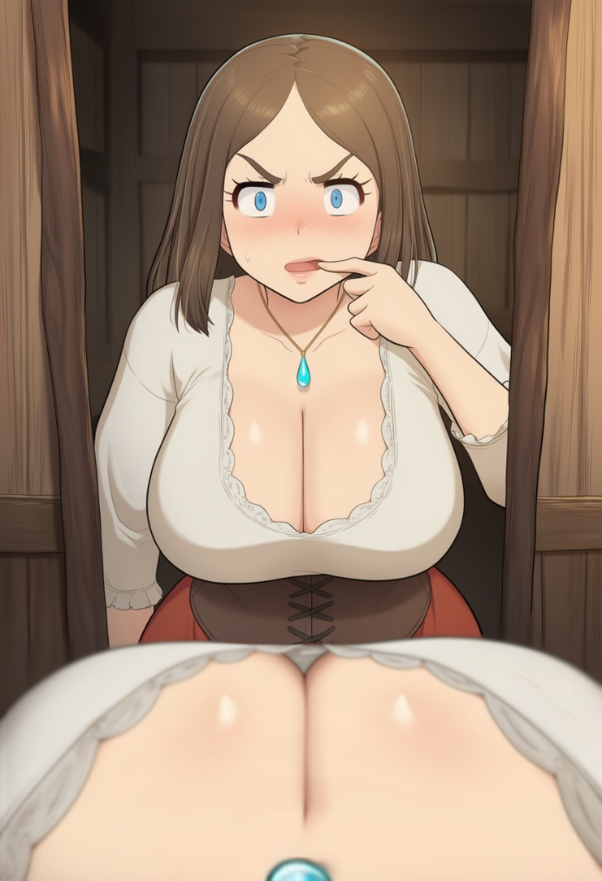
The boys nodded almost in sync and, trying not to look her in the eyes, hurried out, clipping the doorframe with a shoulder.
When Kalendor stepped out of the bakery, a warm wind stirred his hair, and he flinched, not immediately understanding why. The strands softly slid along his neck, brushed the skin, and it felt… different.
“They got longer?!” he realized, guessing that the more he acted like Teresa, the more of her he became, and immediately grabbed his face, feeling it with fingers that now seemed even thinner and more delicate. The nose under his palm felt smaller, neater, without the sharp bump the prince had; the brows — sparser, curved into an arch; and the lips… the lips were plumper, soft, as if made for something else, humiliating, but definitely not for cold orders.
Panic slammed into his breasts, making the pendant sway in the cleavage. Kalendor spun around sharply and rushed down the narrow passage toward Elina"s house — only a few buildings away now. His legs carried him forward on their own in short, quick steps, the skirt flaring up and slapping against his thighs, his breasts heavily swaying with each jolt, sending waves of tension through his back, while long hair streamed behind him, whipping against his shoulders.
The square behind him kept buzzing as before: merchants praising fresh marzipan under bright awnings, caravans leaving a sweet trail in the air.
— Teresa? Where are you flying off to like that, dear? — called some woman from a stall, but Kalendor didn"t even turn around, bursting through the open door of the herbalist"s little house.
Inside it smelled of dried herbs, honey, and hearth smoke, and countless shelves and cupboards along the walls were crammed with jars. On the walls themselves hung bundles of chamomile, mint, rosemary, and other herbs.
He slammed the door behind him harder than he meant to. The jars on the shelf rattled, and one with dark syrup let out a plaintive clink against its neighbor.
— A mirror… — he ground out, trying to breathe evenly as he took steps toward the old mirror in a darkened wooden frame hanging on the far wall, next to the shelf with headache tinctures.
The reflection… was familiar and at the same time already not the same.
The same stubborn cheekbones — but softer, as if worn down by time. The nose still held his line, but had become neater. The eyes seemed wider because of the thinner brows. And the mouth… had grown smaller, while the lips had grown fuller; even the eyelashes seemed longer. Some kind of mix of a village girl and an aristocrat was looking back at him.
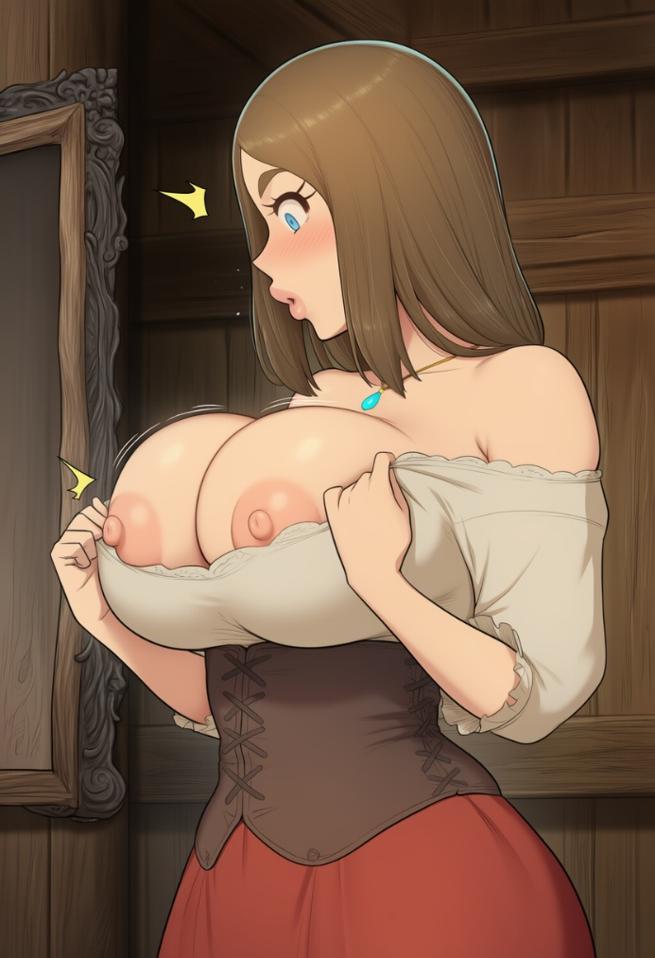
Kalendor stood so close that his breath could have fogged the glass, and he hated every new detail. The forehead lower. The chin thinner. The neck… too graceful, as if made not for commands, but for beads and laces. He raised his hand and touched his cheek — the skin was smooth, warm, and from the simple touch a strange, irritating sensitivity spread through it.
— It"s nothing… — he forced out, staring himself in the eyes. “The shape has changed — but I"m still me.”
And only now did his gaze, as if unwillingly, slide downward.
The cleavage, which before had been just a humiliating fact, looked even more humiliating in the mirror: the corset springily lifted his breasts, held by the white fabric of a simple shirt, making them look unnaturally large — two heavy, rounded masses that lived their own life even when he stood still. The white blouse was stretched along the edge so tightly that the fabric almost glowed in the window light. Between the breasts, in the hollow, lay a blue pendant on a rough cord, shimmering as if it were amusing itself.

Kalendor sharply grabbed the edge of the white blouse and yanked it down. Two soft, firm hemispheres immediately burst free, heavily swaying and bumping into each other with a quiet slap. The skin was pale, almost milky, with a faint web of bluish veins beneath the thin layer, and the nipples — large, dark pink — instantly hardened from the cool air of the room, standing out stiffly, as if accusing him of this shamelessness.
He froze, staring at them like enemies. These breasts were enormous — so big that they wouldn"t have fit fully into the prince"s palms. Heavy, full, with that softness that made them slightly spread to the sides under their own weight, yet spring back into shape. He released the fabric, feeling how the inner side of his breasts touched the cool skin of the corset. Trembling in their shapeless and at the same time clearly defined heavy mass.
His hands moved on their own, grabbing his hair and starting to braid it, while he looked with a kind of horror in the mirror at the two breasts, which were bigger than any female breasts Kalendor had ever seen. And he was a prince, and had seen plenty of naked bodies of court ladies — those who clung to him hoping for favor or simply out of boredom. But none of them possessed such… excess.
At that moment, a quiet cough sounded behind him.

— Teresa… my girl, what are you doing? — Elina"s voice was soft, but there was strong tension in it.
Kalendor flinched, spun around sharply, at the same time trying to pull the blouse back up with one hand while covering the protruding nipples with the other. It went badly — the fabric got stuck under the mass of his breasts, and they only swayed harder, making him lose his balance for a moment. He stepped back, and only then did it suddenly click — he just needed to lift them with one hand and carefully tuck the fabric in from above with the other. And yes, literally a few seconds later, the blouse was once again hugging the soft roundness, covering it with a layer of fabric exactly up to that hollow with the pendant.
Elina stood in the doorway of the inner room, arms crossed over her chest, looking at him with that patient half-smile old women give the young when they"re trying to hide the obvious.
— Well, tell me, Teresa, — she said gently, stepping closer and lowering his hands. — What exactly were you hoping to see there, and what would you have done if Erik or Stefan had walked in?
Kalendor felt the blood rush to his face, making his cheeks burn. He sharply pulled away, pressing his arms to his sides, and stepped back again, his back hitting the wall next to the mirror. The room suddenly felt cramped — the shelves with jars loomed overhead like in some giant"s world, and Elina, this gray-haired herbalist in a simple apron, towered over him, forcing him to tilt his head back.
"I'm lower than her… I"m lower than this old woman," flashed through his mind, and the humiliation made everything inside clench.
— I-I didn"t want anything! — he blurted out, trying to sound firm, but the words came out rushed, with a note of excuse. — I just… the blouse got caught, that"s all. And anyway, I"m not… not waiting for any Eriks or Stefans!
Elina only snorted softly, her wrinkled eyes sparkling with light amusement, though real concern hid beneath it. She reached out and, in a motherly way, tucked a strand of hair behind Teresa"s ear.
— Oh, my child, you"ve been overdue for marriage for a long time now, — Elina said more softly, as if it weren"t a verdict but a household truth even the gods wouldn"t argue with. — How old are you, twenty-three? And you still run around alone like a wild goat over the hills. Your Elmar has gone all gray, can"t wait for grandchildren. And suitors are circling all around you, but you keep turning your nose up.
Kalendor flared with rage inside. Marriage? Was this old woman seriously suggesting that he, the heir to the throne of Marzipania, marry some village idiot? He opened his mouth to put her in her place with an icy tone worthy of a throne room: "Have you lost your mind, old witch! Me — married?! I"ll burn you!"
But the words that came out sounded completely different — soft, with a hint of embarrassment, like a girl making excuses to an elder:

— Auntie Elina, why are you starting this again… — Teresa looked away, feeling the heat rise to her cheeks. — I"m not ready yet. And I don"t really like anyone for real right now.
Elina only smiled wider, her wrinkled fingers gently stroking Teresa"s cheek with the back of her hand. The gesture was so familiar, so warm, that something inside Kalendor clenched with disgust and at the same time with something else — cozy, something he had never had as a child at court.
— You say you don"t like him? And yet I saw you today, circling around Rodrik by the barn. Oh, your old man ruined everything again, didn"t he? — Elina shook her head, smiling with the corners of her lips, and moved toward the small hearth in the corner of the room. — Sit down, my girl, I"ll brew you some tea. With chamomile and mint, just like you like it. You"ve been running around all day, your cheeks are burning like marzipan melting in the sun.
But Teresa didn"t catch the meaning of the last phrase. In her head, that moment by the barn flared up vividly: Rodrik"s close breath, his gaze, the almost-touch of lips — and inside everything exploded with warmth; hundreds of light butterflies fluttered in her stomach, her nipples under the corset instantly hardened, digging into the fabric, and a hot wave ran along the inside of her thighs, making the skin sweat so that for a moment the skirt felt too tight and heavy.
She snapped back to reality, realizing that her fingers were still braiding her hair on their own — neatly, automatically, as if they had done it a thousand times before. Strangely, it was so calming. Strand after strand fell into a tight braid, sliding lower and lower down her back, already almost to her shoulder blades. She tried to stop, clenched her teeth, but her hands wouldn"t listen: they finished the braid, tied the end with a thin ribbon she didn"t even remember taking from anywhere. The finished braid fell heavily over her shoulder, chilling the skin through the thin blouse.
Teresa sharply dropped her hands, as if burned, and stepped a pace away from the mirror. In the reflection, no half-masculine figure looked back at her anymore, but a true village beauty: the face softer, the lips fuller, the eyes larger, and the braid — long, thick, glossy — lying on her shoulder like a heavy silk serpent. Inside, Kalendor howled with rage and helplessness, noticing that the pendant seemed to dim, as if it had been glowing just moments ago and he hadn"t even noticed.
“Again?.. Fuck, how much time has passed?” the thought flared up in his mind. The sun was still high, but already leaning west — three hours, maybe four since he had entered the barn. That meant eight left… no, nine hours. Nine hours of this humiliating farce.
She sank onto a stool by the table, the skirt softly spreading around her legs, and her breasts heavily swayed, pressing against the edge of the tabletop. The corset immediately reminded her of itself, tightening her ribs so that the breath came out short and sharp.
Elina set a clay mug in front of her, fragrant, sweetish steam rising from it. Teresa wrapped both hands around it, as if it could warm something inside her other than her palms.

— Auntie Elina… — she began, trying to speak evenly, as befits a prince, not a village girl. — That pendant… you know it, don"t you?
Elina sat down across from her, propping her chin on her hand. Her eyes, faded by time but still sharp, slid to the blue stone lying in the hollow between Teresa’s breasts.
— Oh, that blue little stone of yours, — she sighed. — Of course I know it. You’ve never parted with it since childhood. Why are you asking all of a sudden? Do you think I’m already some senile old nutcase who can’t remember your favorite trinkets?
“Good. She remembers the ‘childhood’ too. So the illusion is complete,” flashed through his mind. “But what if the stone only works within a certain radius? If I leave it somewhere and walk away, will I still be Teresa? Or will I become myself again there?”
At that moment, the idea seemed absolutely brilliant. Simple, logical, worthy of a prince who had always placed experiments above emotions. Kalendor carefully set the mug down on the table, feeling the pendant sway in the hollow, coldly touching the skin between his breasts.
He lifted the mug, pretending he was just warming his hands, while his eyes reached toward the shelves behind Elina’s back: hooks, bundles of herbs, some little pouches… you could hide anything there. Elina, he knew this for certain, was a kind and decent woman, and he was completely sure she would guard it more carefully than her herbs. Besides, for everyone here it was just a cheap trinket. For a second, he even felt relief: leave the pendant here, step outside, check.
— Auntie Elina, — Teresa began, trying to keep her tone even, though her fingers were already reaching for the cord at her neck. — Could I leave this pendant with you? For a while. It’s… getting in my way today.
Elina raised an eyebrow, taking a sip from her mug.
— Getting in your way? — she repeated, squinting. — You haven’t parted with it since you were little, Teresa.
Kalendor ground his teeth inwardly. What, was this old woman really going to argue with him?!
— It’s just… it has to be that way. I’ll explain later, — Teresa replied with a smile, taking the little stone off her neck and holding it out to Elina on her open palm. The cord slid off her skin, leaving a faint mark, and the pendant landed in the herbalist’s hand as a cold, heavy weight.
Elina took it carefully, as if it weren’t a trinket but a living thing that might bite. Her fingers, knotted from years and work with herbs, closed around the stone, and she placed her clenched fist on the table.
— Oh, — she breathed out, lifting her gaze from the hand holding the stone to Teresa. — Are you sure nothing’s wrong?

Teresa swallowed. Her fingers moved on their own to her throat, where the cord had just been, and touched bare skin. Without the pendant, breathing suddenly felt too easy. Slowly, her palm slid lower, to her breasts — to the place where just a second ago the blue stone had been chilling her skin. Now it was empty, only the warm hollow between heavy half-curves.
“So it works even when I take it off? Then I need to move farther away…”
She stood up sharply, the stool creaking on the wooden floor, the skirt heavily swaying around her legs. Elina was still standing by the hearth, not turning around, as if giving her time to gather herself.
— I’ll go now, Auntie Elina, — Teresa said quickly, trying to make her words sound steady. — I’ll be back soon. And… thank you for the tea.
The old herbalist only nodded, not looking away from the kettle.
— Go on, my dear. Is that all you came for?
Teresa froze on the threshold, her fingers already resting on the door handle. Elina’s question hung in the warm, herb-soaked air like a hook her skirt had caught on.
— Yes, — it slipped out too fast. She immediately corrected herself, feeling heat flood her cheeks: — I mean… no, Auntie Elina, — she lifted her gaze from the floor, smiling apologetically, — Father asked me to pass along that the flour will be delivered by evening. And… I’ll be going.
Elina nodded, but something like faint sadness flickered in her eyes. She clenched the pendant in her fist again, as if weighing it in her palm.
— Go on then, stubborn girl, — she sighed. — I won’t say anything to your father. Don’t worry.
Teresa blinked, feeling everything inside tighten at those words. Elina spoke so calmly, as if she knew everything — about the pendant, about the strange behavior, about what was going on in the girl’s head. Or maybe she just felt it, the way old women sometimes do.
— Thank you… — Teresa whispered, and the word came out on its own, soft, full of gratitude Kalendor hadn’t even expected from himself. She pushed the door and slipped outside before Elina could say anything else.
The street met her with warm evening light. The sun was already leaning toward the horizon, painting the roofs of Fleurmar in a soft orange, and the air was thick with the sweet smell of marzipan — a caravan had just passed through, leaving a cloying trail behind. Teresa walked fast, almost ran, lifting the hem of her skirt so as not to stumble. Her breasts bounced heavily with every step, the braid slapped against her back, and the corset bit into her ribs, reminding her of every breath.
"I need to get farther away," Kalendor thought feverishly. "If the artifact stayed with her, then here, without it on my neck, the effect should weaken. It has to!"

She reached almost the center of the city, catching the looks of passing men. Some of them seemed familiar to her as if from childhood, others not so much. One blacksmith, with a soot-stained face and muscular arms, nodded to her with a smile, and a passing caravan trader, his beard soaked with road dust, even slowed his horse. But she understood that neither of them did this because they were kind or trying to be. No. It was simply that her appearance worked in a way that made men want her… to look. Yes, to look. Just to size up her figure. Especially that last one, who slowed his horse and openly stared at how parts of her body bounced with each step.
Teresa felt her cheeks burn even hotter and quickened her pace, pressing her arms to her sides so her breasts would sway less. Yet together with the embarrassment came that same feeling she had felt with Rodrik — the one she tried to forget like a bad dream, but which kept resurfacing anyway, heating everything inside under those lustful stares.
Evening settled over Fleurmar: the sun had already disappeared behind the rooftops, leaving the sky in shades of orange and violet, and the market was closing. Merchants were taking down bright awnings, packing the remaining marzipan into baskets. Its sweet smell still lingered in the air, now mixed with smoke from dying braziers. Cart wheels creaked, horses snorted, and the last customers hurried home with their purchases.
Only now, under all those gazes she wanted to hide from, did she notice that everything had become not only familiar, but grotesquely different. Bigger, somehow. And not just everything — all the people, passersby, even some ordinary boys running past, now caught her eye. And it was completely incomparable to how she had walked here in the morning, towering over everyone and barely noticing anyone at all. Now she felt as if she were… smaller? Or… more vulnerable? Fuck, no, what stupid words are those? Prince Kalendor can’t feel like that, even in this stupid body! He needed to think about the goal. To check where the boundary of the crystal’s effect was, if its influence didn’t fade as she moved farther and farther away from it.
She tried to understand whether something was changing gradually. Or maybe everything would happen suddenly somewhere. Or…
Teresa came to an abrupt stop at the edge of the square, pressing her palm to the soft weight of her breasts to calm her heavy breathing after the fast walk. She had gone far and was tired. The corset dug into her ribs, and the braid hanging down below her ass softly swayed behind her back. It was always that long, right? Fuck, what the hell does it matter? She needed to catch her breath and move on, so she could still make it back in time if the theory didn’t work.
She looked herself over: nothing had changed. Her breasts rose and fell in rhythm with her rapid breathing, stretching the fabric of the blouse and covering almost everything below. And everything else was the same as before too… Except the absence of the pendant suddenly started to bother her.
“This… didn’t work,” flashed through her mind with cold fury. “The artifact is still working. Even without it on me.”
Inside, Kalendor ground his teeth. He looked around, his hands automatically pressing to his neck, finding only smooth, tender skin, while his elbows once again bumped into those huge cursed boulders on his chest.
He exhaled, trying to do it firmly, but it came out however it came out.
The market was almost empty. Only a few merchants were taking down their awnings, packing the remaining marzipan into baskets. The thought that it was probably time to head back appeared just as one of the merchants — an elderly man with a gray beard — noticed her and waved.
— Teresa! — he called out loudly, smiling toothlessly. — Come here, dear, take a piece for the road. Fresh, straight from the oven this morning, with almonds!
She froze, but her legs carried her forward on their own. A smile stretched her lips, even though Kalendor was boiling with anger inside.
— Thank you, Mr. Hans, — she replied softly, taking the paper-wrapped piece. The smell was so tempting that her stomach growled on its own, with the realization that she hadn’t eaten all day with all this running around. — You’re always so kind.
Hans laughed, slapping his knee.
— Of course! You’re our beauty, Teresa. All the lads keep staring at you. So when are you going to choose someone? Rodrik’s been hanging around your barn all day again.
Teresa’s cheeks flared up, and she looked away, pressing the marzipan to her breasts.
— Mr. Hans… don’t start, — she muttered, and there was no anger in her tone, only mild embarrassment. Inside, Kalendor howled: “Shut up, old man! I won’t choose any of these morons! I’m a prince, not some fucking girl!”
But Hans only winked and, looking at her kindly, said:
— Ah, Tereska! Honestly! What a beauty you are! If the king had an heir, I reckon you’d charm him for sure!
Teresa instantly shrank in on herself, her face turning as if someone had dumped all the red paint of the kingdom onto it. She lowered her head, hiding her burning cheeks behind loose strands of hair that had slipped free from the braid, and pressed the marzipan tighter to her breasts — as if that piece of sweetness could hide her from the entire world.
— Mr. Hans… — she breathed out barely audibly, and even that quiet breath sounded too gentle, too girlish. But then, like some sudden flash, it flared in her head: “An heir… would have been…”. Kalendor raised his eyes to the old man in shock, and Hans immediately, like a schoolboy caught red-handed, tore his gaze away from the cleavage.
Hans coughed awkwardly, looking down at his baskets and starting to fussily stack the remaining marzipan.
— Well… I didn’t mean anything like that, Tereska, — he muttered, scratching the back of his head. — Just a compliment. You really are… uh… a striking girl. All the lads at the market turn to look.
Teresa felt everything inside start to boil. Kalendor wanted to jump forward, grab the old man by the collar and hiss: “How dare you stare at me, you plebeian?! You’ve known me since childhood!” But he couldn’t move an inch. Instead, his shoulders hunched even more, his hands pressed the marzipan tighter to his breasts, emphasizing exactly what Hans had just been looking at, and his lips involuntarily trembled into an embarrassed smile.
— You… you shouldn’t say things like that, Mr. Hans, — she said quietly, looking away, not daring to even name his gaze. Her cheeks burned even hotter, and she felt a hot wave run down her spine. — It’s… awkward for me.
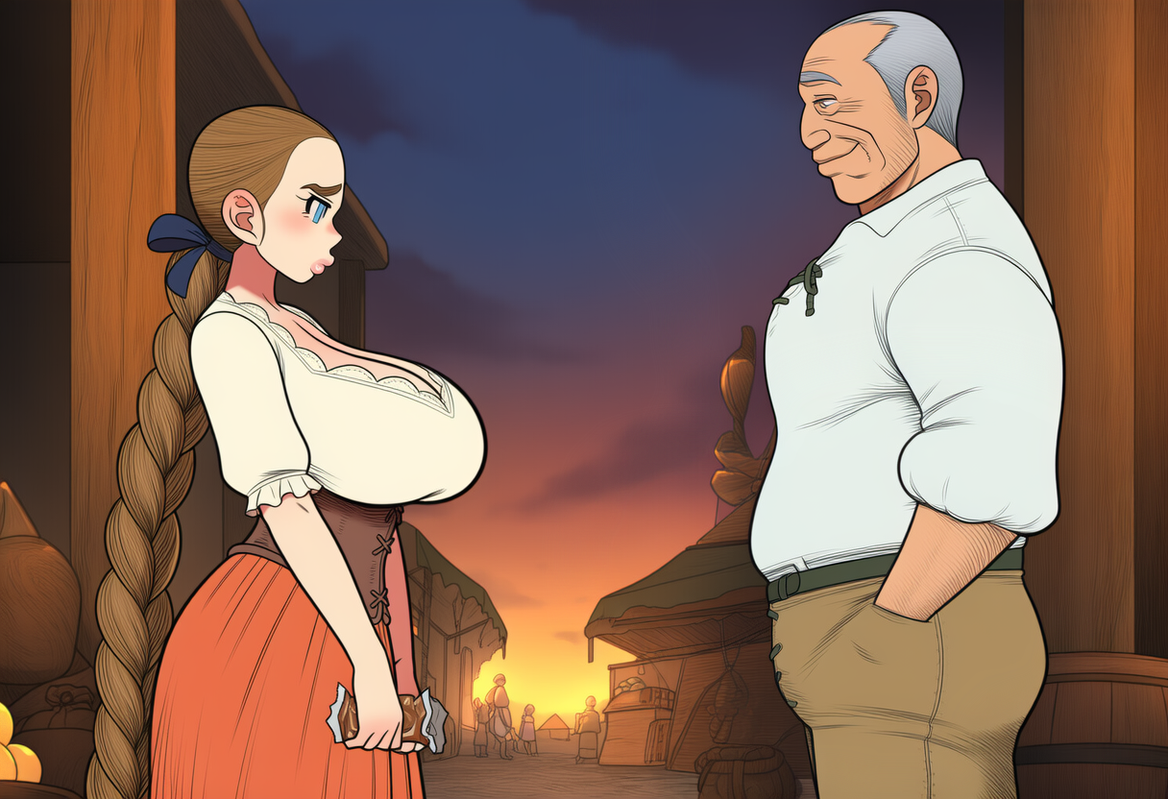
Hans snorted, still blushing himself, and waved his hand.
— Alright, don’t be mad, dear. I’m old already, I spout nonsense sometimes.
— But… the heir. Why did you say… “would have been”? The king does have an heir. Prince Kalendor Verden.
Hans blinked, then burst out laughing so hard his gray mustache shook.
— Oh, Tereska, what is it, did you sniff too much marzipan powder this morning? What Kalendor are you talking about? Our King Verden never had any children at all! His wife’s been in the grave for years, and the only son he had died as an infant. You were born that same year, by the way. Almost like on the very same day. Have you forgotten or what?
Teresa stood rooted to the spot, feeling the marzipan in her hands suddenly turn heavy, like a stone. The world around her — noisy, sweet Fleurmar with its creaking carts and fading lights on the stalls — suddenly lurched, as if someone had yanked the ground out from under her feet.
“No heir… No me…”
Everything inside Kalendor went cold. This wasn’t just a masquerade, not an illusion for the eyes. The artifact had rewritten the very fabric of the world. Prince Kalendor Verden had never existed. In his place — her. Teresa Kvoss, the miller’s daughter, a simple village girl with huge breasts and a braid down to her waist.
She swallowed, trying to find words, but her lips only trembled.
— Mr. Hans… — she began quietly, pressing the marzipan to her stomach, — are you… are you sure? Maybe rumors? In the capital, surely—
Hans shrugged, tying up a sack.
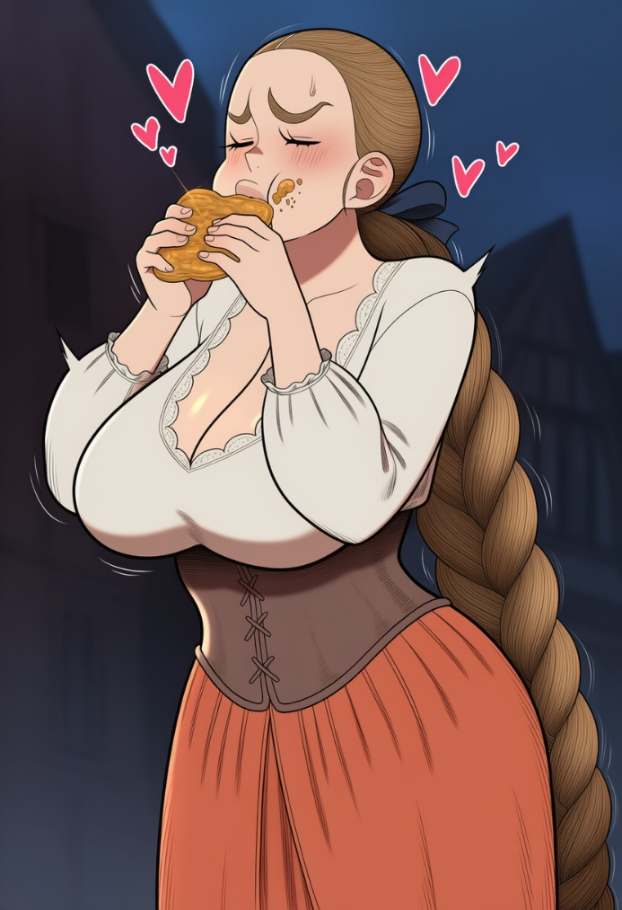
— What rumors, dear? All of Marzipania knows. The king’s old, sick, and the throne… well, who it’ll go to — only the gods know. Maybe some lord from the council. And us here in Fleurmar, we bake marzipan and see caravans off. Why do you suddenly care about that? You’ve never been interested in politics.
Teresa looked away, feeling her eyes sting with tears from rage mixed with some helpless terror. The sun had almost set, leaving the sky in warm twilight, and the market was finally emptying out. The last traders were leaving, cart wheels rumbling over the cobblestones.
“How much time has passed since the activation in the barn? Fuck. That was morning, and now it’s already evening. Have twelve hours passed or not? What even is twelve hours?”
Kalendor caught himself trying to imagine twelve hours… as if it were a sack of grain: here it is — full, here — empty. But instead of numbers, stupid village markers floated up in his head: “when the rooster crowed the second time,” “when the shadow from the well reaches the door,” “when Old Hans sells the first batch of marzipan from the stall.”
— Tch… — Teresa breathed out through her teeth and immediately flinched: a woman with a basket was passing nearby and looked at her as if she’d heard not a curse, but a childish whim.
Kalendor clenched the paper with the marzipan in his fingers, the smell instantly hitting his nose, twisting his stomach. He sharply raised the bundle closer to his face, took a deep breath, and literally the next second began hurriedly unwrapping the paper.
His fingers were trembling. Kalendor noted it with hatred right away: not from cold, not from exhaustion — from desire. At that moment, everything around stopped existing. Only Teresa and the marzipan remained, calling to her as if it were the best thing one could ever get in this life. The paper was open. No — it was torn open viciously.
The marzipan ended up in his hands — soft, warm, sticky — and in that same instant all remnants of control crumbled. Kalendor didn’t even bring it carefully to his lips — he lunged at it. Took too big a bite at once, greedily, so his cheeks puffed out and sweetness smeared toward the corners of his mouth.
He ate without thinking. A second bite — even bigger. His fingers got dirty, crumbs stuck to his skin, his tongue frantically gathered the taste as if afraid it would be taken away. A thought flashed in his head: “Stop, you’re behaving like a stablehand, or worse, a stupid illiterate girl,” but none of it seemed to matter right now.
“Like a pig. I’m eating like a pig.”
The realization didn’t come immediately, but with a delay, when he was already hastily stuffing the rest into his mouth without chewing, just to have more. His breasts heaved heavily, the corset squeezed his ribs, his stomach ached from the sweetness, but his hand still reached for the paper — to check if there was anything left.
— Hey… — a male voice sounded nearby.
Kalendor froze with his mouth full. Slowly, in horror, he lifted his eyes.
A guy was standing in front of him. A stranger. About twenty, maybe a bit older. Simple jacket, solid shoulders, sun-tanned face. He wasn’t laughing. Wasn’t even smiling. He was just looking at Teresa’s face.
And only now did Kalendor realize how he looked from the outside: a messy braid, lips shining with sweetness, sticky fingers, uneven breathing, the skirt stretched over his hips, breasts visibly rising and falling under the fabric.
The guy’s gaze slid lower and, without hiding it, lingered on the cleavage, looking at it the same way Kalendor — Teresa — had been looking at the marzipan a moment ago.
His stomach clenched now not from sweetness, but from shame.
— You… — the guy coughed, as if remembering that he was supposed to speak. — Is it good?
Kalendor swallowed. His throat tightened, his eyes stung. He jerked his gaze downward, feeling heat flood his face.
— None of your business, — Teresa forced out, but her lips trembled and her voice came out too thin.
The guy snorted, not looking away.
— I’m not saying it is. Just… — he took a step closer, and it suddenly felt too cramped. — You know, you were eating so appetizingly… and you yourself are…
Teresa stared at him, stunned.
“I’m appetizing?! What the hell are you saying, you backwoods oaf! I’ll— I’ll—”
Yet despite the screaming inside, her legs felt rooted to the cobblestones. Only now did Kalendor realize there were almost no people around.
The square had exhaled with the day. Somewhere far off a cart creaked, a shutter slammed, and all around stood a thick silence. Sudden. Too tangible right now. Too intimate for that look. For that word.
Appetizing.
It had no right to touch him. And yet something inside clicked and reacted faster than thought: her stomach twisted again, her breasts dropped heavily with a breath, her nipples swelled, and with horror he realized he was standing there with parted lips, staring at the guy’s lips.
The guy noticed.
— Come on, I’ve been here not long, but I already found a little place.
— A lit— (gulp) a little place? — Teresa said, swallowing the stuck piece of marzipan, turning her gaze aside.
Kalendor felt his cheeks burning and his heart pounding so hard it seemed audible in the silence. He stared somewhere to the side — at a dark shop window, at the stones under his feet, anywhere, just not at the guy’s face.
“What ‘little place’… I need to get out of here! I need— What?! Run?! What am I, a coward?! I’m a prince! I won’t run from anyone! I’ll smash him right now! Or… or I’ll… Or… damn it… What the hell is happening!”
The thoughts tore through Teresa’s head; she kept shifting her gaze from the guy to her cleavage and back to the side. Then her eyes fell again on his face. On his lips.
He was standing too close. Almost the same way Rodrik had this morning. But here the adrenaline seemed to amplify what she had still been able to control earlier.
“No, I’m not… I’m not…”
Her breathing quickened, her heart felt like it was about to burst out of her chest, which rose heavily, as if becoming even more noticeable.
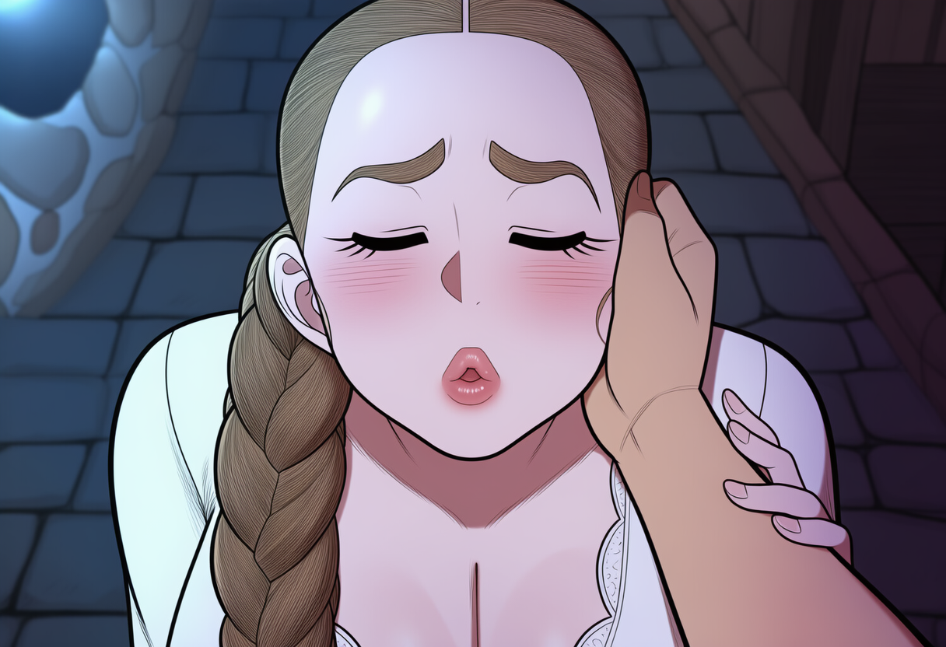
The guy’s hand moved closer. Teresa saw it, but instead of stepping back or pushing him away, she suddenly froze. Her eyelids lowered on their own, and the world narrowed to the warmth of his breath on her cheek and the light touch of fingers at her temple. The skin there flared with heat, as if from that simple touch a sweet shiver spilled through her whole body; her lips parted in silent expectation, her breasts lifted heavily, pressing into the corset, and inside everything clenched with a strange, almost painful anticipation. The guy’s fingers gently caught a loose curl, neatly tucked it behind her ear, and from that simple gesture a tremor ran down her spine, her lips quivering as if preparing for something inevitable. He leaned even closer, and a quiet, hoarse whisper brushed her skin, echoing inside as a warm wave:
— Not here…

