Devin Plays his Part
Inspired by a Captioned Image by Misogynist to Maid of Deviant Art
By Maryanne Peters
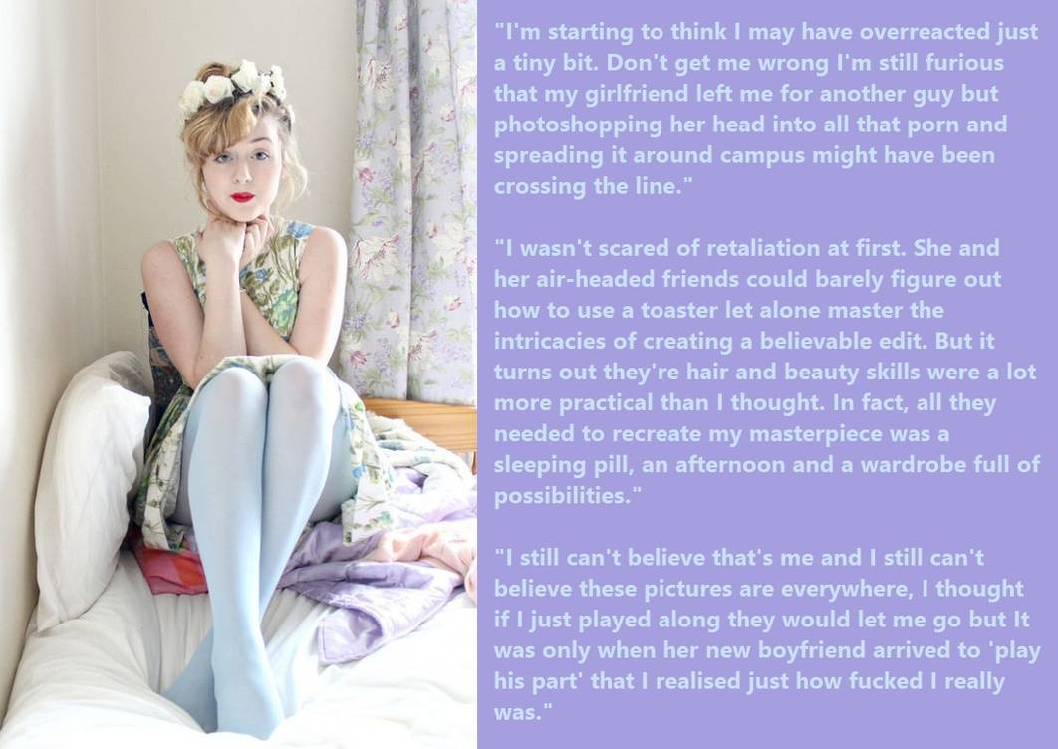

James sat on the bed looking at Devin, his ex-girlfriend’s new boyfriend. There were no other clothes to wear. He had been unable to get the flowers out of his hair or the makeup off his face. Not only had they been able to remove every hair underneath the makeup but somehow they had managed to plump up his face and lift his brow to give him a permanently vacuous look.

He was still dressed in the floral dress and the powder blue tights. More than tights, they went all the way up and over his shoulders to give a female shape to his chest and butt, and to conceal his small genitals, now tucked away with just the tip of his penis next to his butthole exposed.

“Well, this isn’t photoshop,” said Devin. “I bet you wish that she was as good at you are on that stuff. No, this is real life”. He moved towards Ivan to get a closer look.

“You may not be the prettiest thing, but there is no mistaking you for a boy, is there? He angled the mirrored door of the closet so that James could get a good look. James’ hands went up to his throat, his red painted lips pursed.

“What are you going to do to me?” James croaked.

“Well, I was just told to come in and take a few photos for circulation,” said Devin. “But I have to say, completely unexpected, but I have some circulation of my own going on.”

James’ eyes followed his hand to his crotch, and the unmistakable sight of an erection straining at the denim fabric. He gulped.

“But you’re not gay, are you Devin?”

“Hell no. But it looks to me like I am the only guy in this room.” He came closer, close enough to smell her – the smell of white roses. “If you think otherwise, you will have to tell my dick.”

In confirmation, or so it seemed, James started to whimper. He was wishing that he had never done it. He had never had a girlfriend before she showed him a little favor, and when she told him that he was not man enough for her, he was furious. In fact, she had said to him that she was not really her boyfriend at all – just a friend. That seemed to make it even worse.

Girls were so difficult. All he wanted was somebody to be a partner. Somebody to go out with. Somebody to stay in with. Somebody to snuggle up to. Somebody to love him.

Now here he was, a fragile little thing now dressed as a girl, and feeling the rough hands of one of the biggest guys in school rolling him over.

“I like your hair up at the back like that, Jamie,” said Devin. “Is there anything sexier than the back of a girl’s neck ? And what do we have here. A little hole in your underwear? A little pee hole and behind it a little rose, like the roses in your hair only pink.”

“Please don’t hurt me Devin.”

“I don’t want to do that, Sweetie. But this skin so soft and pale, and the sweet smell or flowers and fear, I am afraid it’s not me you should be talking to, it’s this.”

There was no mistaking what was pushing against his fiercely closed backdoor. James was wondering when the blow would come. If he did not yield would the first blow come to the head?

“Come on now, Baby,” said Devin. “I have a feeling that this could be something very special.”

Why did he give in? Was it fear? Or acceptance that only when it was over could he get away? Or was it something else? Perhaps understanding that as Devin said, this was beyond thought. Other organs were in charge. The limbic cortex governs this – the four F’s: Fight, Flight, Fear, Fornication. It seemed that it was time for number 4.

And when Devin was spent and lying beside James receiving kisses, it was Jamie who knew that she had been looking in the wrong place for love all along, but it had found her.

The End

Getting into Shape  Inspired by a cap from Anne Michelle’s World  By Maryanne Peters  Terry always said that the third string quarterback was just an extra cheerleader. You wait on the sideline, and you keep warmed up, but you never got called in.  I tried to give encouragement. I even said that with that healthy head of long hair Terry would make a great cheerleader. It was just a joke, but did give me a very strange look when I said it.  I told him that he would need to bulk up. The fact is that he was the lightest guy on the team. Throwing skills are great, but if you are not carrying some muscle, you will get hurt. I never wanted that for Terry.  The talk of steroids did not come from me. I would never take those drugs, but I have muscle in my genes. Terry’s father is skinnier yet, and Terry’s mother – well everybody knows her as the mother with the biggest tits.  I guess that may account for the fact that Terry’s chest turned out the way it is.  I heard tell that sometimes male hormones can cause breasts to grow. I don’t mean pectoral muscles – I mean like, mammary glands. It is some kind of reaction. Something the endo -whatever system. But a bunch of the guys are now pretty sure that this was never the mistake that Terry told the coach it was.  Like everyone says – Terry kept on taking them even after he “discovered the mistake”. Kept on taking those drugs and his tits kept on growing. Not as big as Mom’s maybe, but big enough so that people would think that Terry was Terri. | 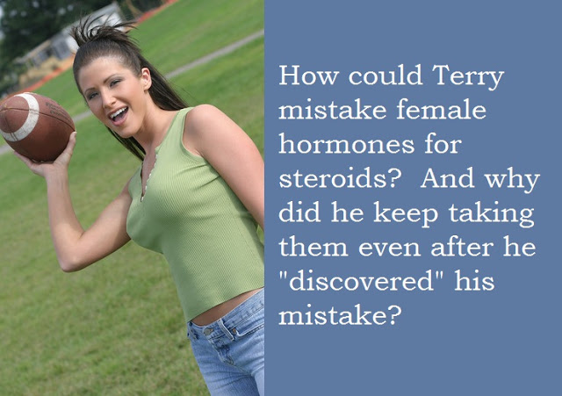

Of course, there are some on the team who say that this was no mistake at all. Some say that Terry was on the way out for not making the grade. There are people who say that only way he be with the guys was as a hanger on.

I don’t think Terri will ever make it to the cheerleaders, but that arm ain’t that bad. So if you called out - “Drop it on 10 right, in the middle of the zero”, she can still do it, if she is on the 30 yard line. Accurate, but just not the muscle for distance anymore.

But those tits! Big and soft and nice to lick. That is what I call getting into shape.

The End.

The Proposal  Inspired by a Captioned image by Think Pink  on Deviant Art  By Maryanne Peters  The dress was way over the top, but the message was simple – I AM NOT A GUY!  It showed that I have breasts and a great pair of legs. Okay the heels made me taller than him, but is one thing hormones and surgery cannot change. I still have the bones that I was born with. The breasts and the pussy are brand new.  The hair I decided to wear down. I mean I have been growing my hair for years and I am very proud of it. It goes right down my back.  So the ruffled skirts and the shocking pink color might be considered to be going too far, but I am done with hiding. He knows that. If you want me you get the whole package. I can be a little loud, and a little forward, but you will get nothing short of 100% from me – commitment and effort in bed.  You know what they say – “T-Girls try harder”. We do. We know that there are some things that we cannot give a man, so what we can give, we give more of. We give more of ourselves. We want to please our men. We want to make them proud and feed their egos.  Who was it who said it? The kind of girl who will keep her man’s belly full and his balls empty. | 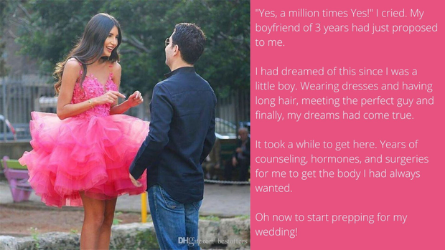

I suppose even cis girls know that there is always the chance that he might his head turned by a womb, which is something that I cannot give. But who needs that when you’ve got this? Am I right?

He thinks so. All I said when I turned up wearing this outfit was “I hope you like your girl to be girly?” And I just tittered a little as a girl should.

“Will you marry me?” He grinned.

“Yes, a million times yes!” You can never be too gushy when a man commits himself to you.

If only he really knew what this means to me. I am not a guy. Not now. Now I am going to be a bride!

The End

Guy-Wife  Inspired by a Captioned Image  This by Dontshunitfunit on DeviantArt  It just seemed like a fun thing to try. I mean I would normally consider myself to be straight, by I have always enjoyed giving anal sex, and I guess that opens you up to more choice. It opens them up too, if you get my drift. Ha ha.  I just don’t like the idea of fucking somebody hard and hairy. But they said: “Don’t worry. Our “Guy-Wives” are waxed and on hormones to make them as soft as pillows.”  Better that that, when she arrived, “she” had her hair cut in a short but very feminine bob, that shook and shimmered as I fucked her. It is longer now, and with that and the hormones I plug into her, there is now no way of mistaking her for a man.  I plug in the hormones because they are suppositories you see. Pills are bad for the liver. Up the ass those things go straight into the blood. Just poke one inside daily and ram it home with a hard cock. | 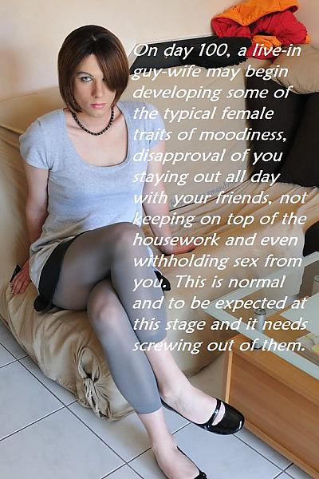

I never thought to ask whether guy-wives are willing or not. I suppose I figure that it is best not to know. They seem a bit vacant when they land on your doorstep. I like to think that they are just guys who can’t be bothered with a man’s life anymore. I mean they have to clean house and cook meals, but they get looked after and they get well fucked. Some guys want that – right?

But I was warned that around day 100 things may go a little strange. In fact I took this photo and sent it back to Guy Wives more as an observation than a complaint. There she was poking out that bottom lip and with a shitty look on her face.

She said something like – “I never wanted this” and “I don’t even understand how I got here”.

The advice that came with the package was to screw it out of her, but I decided just to let her stew for a bit. I am not a guy who forces himself on anybody. I am happy to pay for sex, or invest in a long term fuck-buddy like a Guy Wife, but I am not a rapist.

It was only a matter of time before she was back, asking me to give her what she needed.

“I guess I have kind of got used to this,” she told me. “I have kind of got used to you too.”

I feel the same. She may not be a real girl, but she rally is the next best thing and … well … I am pretty attached to her, I have to admit. In fact I can’t imagine life without her.

Thank you Guy Wives!

The End

My Cousins  Inspired by a Captioned Image from PJ’s Caption Corner  By Maryanne Peters  It seems so long ago now, but some memories say with you. I won’t say that they haunt you, because that sounds negative. The fact is that I only have fond thoughts about my cousins Jamie and Stacey.  We used to paly as three boys when I was very little, right up until their father, my Uncle Rod, died. At the time I did not know the circumstances of his death, but later we all heard how he died in the middle of having sex with his secretary. My aunt took it all very badly.  Anyway, from that day on my cousins became sissies. I think that there was resistance at the beginning, but then thy just got used to the feminine life and they both agreed that that was how they wanted to live. | 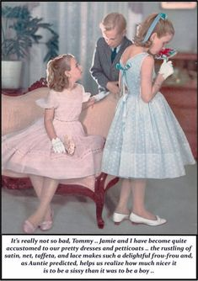

I say sissies because that was how they were at the time, but they both went on to become true women. They both had sex change surgery and both married men, adopted children and lived happy lives. They are grandmothers now, both of them. Still attractive as older women – very feminine but strong and wise.

My life has turned out to be a bit of a mess. Two wives have walked out on me and none of my children want to know me. I spent my whole life trying to prove that I was nothing like my sissy cousins – I was the big man and everybody around me had to know it. It seems like that was why I never made any friends and could never maintain a relationship.

I look back now and wonder what life would have been like if I had joined my cousins when they told me that they were committed to feminine futures. Would I have been happy?

For the last few years I have been shaving down and wearing a nightie to bed. It gives me a little comfort, but cannot soothe the sense of regret that I gave up the chance for happiness all those years ago.

The End

© Maryanne Peters 2022

