Good Neighbors
By Maryanne Peters
With Thanks to justatawickedtaste on Deviant Art for the images

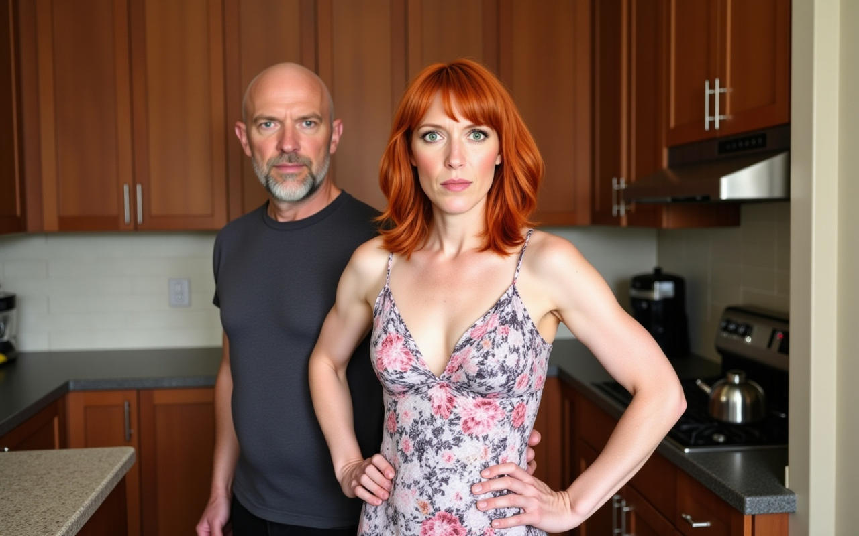

Kane next door had lost his wife to cancer only two weeks before. Hannah and I went to the funeral. His kids were grown and living in other towns, but they were with him and we left them alone with their grief. But then he was alone, and I knew that he would be suffering. It was just that I had made a ragout for dinner, and it ended up much too big for the two of us, so I decided to transfer some of it to a small casserole and drop it over before Hannah got home from work.

It was warm and I was wearing something light and short, and no bra. Hannah says that it pisses her that my new tits are so firm just as hers are starting to sag, but I figure that while you can get away with going braless, why not do it? But I do love wearing a bra – what crossdressers don’t?

I was still wearing stuffy concealing panties for the walk over to his house. I I would wear nothing down there around the house, but as far as Kane was concerned I was just one half of the lesbian couple next door. I did not want him to see anything poking out and revealing my secret, let alone ruining the line of my dress.

He was grateful and we got to talking. I just felt that a man in the grip of sadness, needs a hug. It was nothing more than that, or at least I didn’t mean it to be.

Hannah must have got home and started looking for me. The ragout was still on the stove to keep warm and the back door was open, and the gate through to Kane’s house. It seems crazy that she should be jealous. After all, she was the one who had a hand making me into the person I had become – somebody that it seemed could only be attractive to her, a lesbian with a cock.

Anyway, the next thing I know she is in Kane’ living room, looking at Kane and me in his kitchen, with Kane’s had still on my hip.

“Maybe before you go any further you should know something about Ashley,” she said, as I spun around and started at her. “Ashley is not my wife, she is my husband! My crossdressing husband!”

I was mortified. I was not simply embarrassed but I was betrayed. I was this way because of her, and because I did not want to be considered a freak. Now I was just that. I am fairly sure that I started to cry. I think it was the hormones that did that. I seem to always find myself crying when watching movies these days, for no real reason. I seem to avoid confrontation too – I have become a coward, maybe? I just ran.
It seemed as if it was just a vice – a little kinkiness that Hannah not only tolerated, but found made me a little more interesting. She said that when she discovered I liked to crossdress it fitted with the fact that she was coming to grips with lesbian tendencies. She said that it was as if our was “a match made in heaven”. We had complementary quirks.  In those days I was working and I had my naturally red hair trimmed in a man’s style. It was never short, but it was masculine. I had reddish hair on my body and sparse red whiskers, and I was reasonably well muscled without being buff. I don’t think that anybody would have mistaken me for being a woman.  But I lost my job and I was stuck at home. I was able to earn some money from freelance work which I enjoyed, so there seemed to be no great reason for me to rush back to the workforce. Plus I liked domestic chores and cooking. It was my thing. | 

It was Hannah’s idea that we try living together as two lesbians. It was just something that she wanted to try. She said that all that was needed was for me to restyle my hair, get a facial including beard removal, and get a body wax. There would be nothing permanent. I would still be a man, but I would have to present publicly as a woman. There was only supposed to be some padding in my bra and a little padding around the butt to get a more feminine shape, and I would need to change wardrobe. Since we were almost the same size a good number of her clothes would fit me.

I was not keen, but she was. In fact she was very keen. Perhaps her lesbian tendency was stronger than my desire to crossdress, or perhaps my desire was something else entirely.

Anyway, the conversation kept coming around to it so I agreed to the treatments if she arranged for them and paid for them, which she did. I guess that I was quite surprised as to how much like a woman I looked, even when just sitting on the couch with my top off.

 |  | The big change for me was the one that she really didn’t see. I only left the house wearing women’s clothes although at that time I favored pants and colorful tops. I used a little makeup but not to much, and my hairstyle remained unchanged as it grew out. I learned how to walk and behave as a woman, and I practiced a female voice until I was being assumed to be female, even over the phone.  The hormones were her idea. It still puzzles me what that was all about. She said that they would ‘soften my appearance’ and improve my skin and hair. Perhaps they did? Certainly I think that my hair became a little lighter – is that hormones at work?  But she must have known that HRT therapy which includes suppressing male hormones, would affect our sex life. It has me wondering if that was not the object of it all along. If I cannot function as a man, then she is free to function as the dominant partner in a lesbian relationship. Is that why she insisted on it?
 | I have to say that I got used to be the new me. My breasts grew and my hair grew, and I grew comfortable in this new skin. Perhaps it was the neutralization of the testosterone that made me less interested in sex than I had been. For women it is relationships and intimacy that are more important than orgasms, and I think that applies to lesbians too. Men seem to be focused on the transaction where women believe in fostering the connections between two human beings.  I also became more aware of my body. I had never had a great male body, but it now appeared that I could have a really nice female body. Hannah liked it too, or she said so. Sometimes we would go out wearing outfits that were almost indecent, like the red miniskirt and black lace top that I wore to the lesbian dance, which I liked better than she did.  Hannah said that when we were together like that, it made her feel ‘like a real lesbian’. It was just that I could never let on. I needed to keep my male bits well strapped in and give nothing away. After a while there was not much to conceal. After a while it had ceased to function.  She became the dominant partner in sex all of the time. She wore a strap on and I received a prostate orgasm if I was lucky, and I should be happy with that. |  | 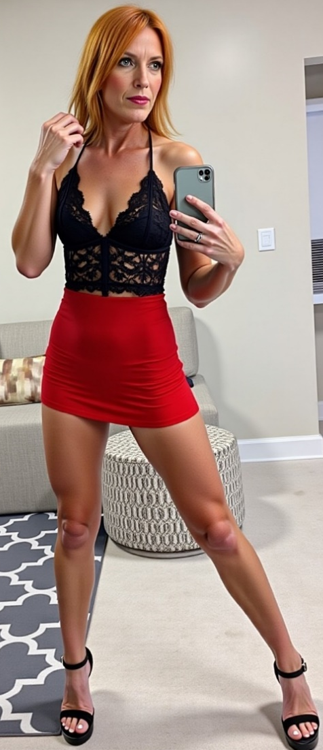

And then she outed me, in front of our neighbor, Kane. I remember that we ate that ragout in silence, but she could see I was upset. I slept in the spare room. She told me to ‘get over it’. She was so cold that she chilled me to the bone.

She left without kissing me goodbye. I decided to busy myself with some work on my PC. It was about mid-morning when there was a knock on the door. It was Kane from next door.

I was not sure if he was there to take another look at me, the husband who looks like a woman. I did. Even as I went to the door I checked myself in the hall mirror.

“I have come over to return that hug,” he said. “I had a feeling that you might be a bit down.”

Have you ever heard of such warmth in another human being? His wife was only two weeks gone and he was thinking of somebody he only vaguely knew, somebody who had been deceiving him and everybody else. I just felt those tears coming back. That damn estrogen! I just fell into his open arms and sobbed.

“I find it hard to believe, but I don’t care if it’s true – I only see you as a woman.”

If I was not a woman before, I became one there in his arms. It was not about sex or anything like that. It was discovering that I needed the kind of love that Hannah could never give me.

I made him some herbal tea and we talked, and although he did not know me before I was a full time woman, everything he said rand true.

“The real problem is that you are a better looking woman than she is … a much better looking woman. She will always be envious of you and jealous of you being with anyone,” he said.

He was right. She wanted me to be as female as possible but not to be beautiful. She hated me wearing that outfit to the club. She said I looked slutty when she wore something much more suggestive. And the scene she made the day before had no other explanation.

“I don’t know how it is with lesbians, but in a man woman relationship we are not competing for attention,” he said.

That sounds nice,” I said. “I think that I would like a relationship like that.”

The End

1700

My Wonderful Hair  A Vignette  By Maryanne Peters  I was determined not to lose my hair, so I decided to use a drug that I understood a lot of men had tried. I knew that it was a drug that blocked male hormones and that one possible side effect was gynecomastia – breast growth. I was told that if there was any sign of tenderness in my nipples I might need to consider abandoning the treatment. At the time I was ready to do that.  There was no breast growth in that first year, but there was a huge amount of hair growth, that was totally unexpected. My doctor suggested that rather than cut my hair, I should grow it so that the rate of growth could be checked and reported to the drug company.  I suppose I just got carried away. When you have great hair like what had suddenly appeared, you don’t want to have it cut off – in fact you want to show it off. | 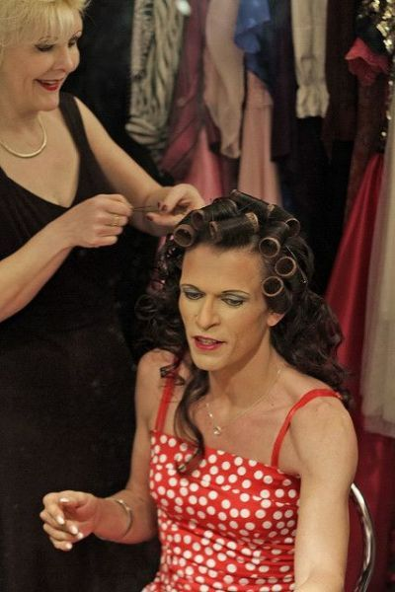

Rather than ask my doctor about the breasts or the hair, I did ask him whether it was possible that this hair retention drug might be affecting my mind, because I was wondering what was going on inside my head. I just wanted my hair to be as long as possible and pretty too, with bouncy curls and interesting accessories.

And if you have such pretty hair, you need to have outfits to match, and makeup and nail polish. It would just look silly to look like a man when you have hair as gorgeous as mine. I mean I can’t hide the square shoulder but I think that the hard angles of my face disappeared when they are framed in lovely long dark brown curls.

What do you think?

The End
Resort Fling  A Vignette  By Maryanne Peters  Him  She was not classically pretty but I thought that she was as sexy as hell. Some men might say that she looked “striking” but I am not sure what that means. She might have been a young 50 or an older 40 but she was younger than my 60. She had broad shoulders an narrow hips but a tight butt, and she had the tits of a teenager – the kind that sit up even when she was not wearing a bra under one of those robes women wear to the spa. She was hot. | 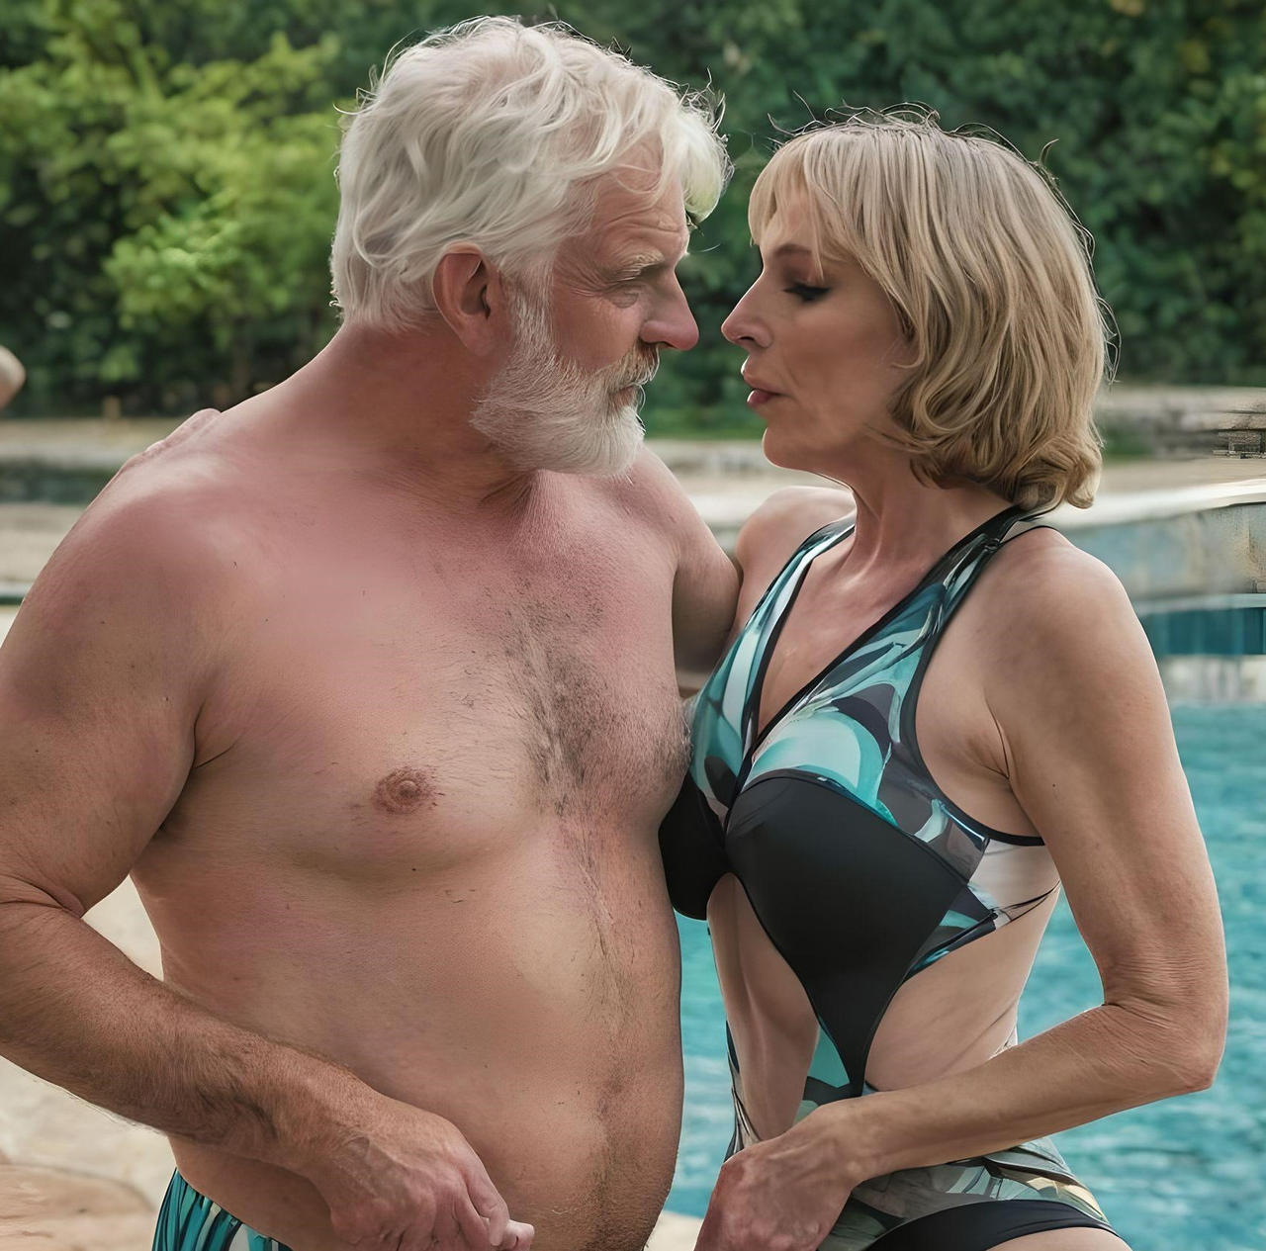

Her

I was recovering from bottom surgery in Thailand. For the first time in my life, I could wear the bathing suit I had always wanted to wear – something that could show off my new camel toe. That was something that I had recently paid good money to replace the junk that was now junked in some Thai private hospital furnace. It had taken years, but I was now complete.

I could have gone for some facial surgery too, but I was happy to look at myself in the mirror and see a real face looking back, not some plastic version of pretty. The truth is that I never had much of a chin and I did have good cheekbones. I had been living a woman for many years and I had become comfortable with the way I looked. Plus, my hair was my own and after wearing it long when I first transitioned, I had found a practical length that looked feminine.

I felt that I looked good in my swimsuit too. I was trim and working on a tan after weeks in a bed, and now I felt right. I had a woman’s body at last. I could not help myself running a hand across my crotch regularly just to check that it was flush down there, and almost giggling with joy each time.

I was not looking for sex that afternoon. I was months away from that. There was healing to be done. I was doing my regular dilation, and it was still painful, but it was a pain mixed with sheer delight. To see that significantly sizeable dildo disappear inside me was wonderful confirmation of my new capacity. I could take a man, and while I was still interested in women, I was keen to feel a hot piece of man fill up my new cavity

Him

It seemed to me that her tan was about the same state as mine – more pink – but she was lying in the sun. I asked her if she minded me taking the sun lounger next to hers, as the one I had been using was now in the shade. She said yes in a sexy husky voice that seemed to match her look perfectly. I made a little conversation and then offered to fetch her a bottle of water.

Opening with an apology for being over familiar I asked if she would mind putting some tanning oil on my back and I would return the favor. She seemed happy about the idea. Her hands were strong and they moved across my back with skill and purpose.

When my turn came I was amazed at how smooth and soft her body was, as if every hair had been removed and as if every muscle had been softened. I seemed as if I could feel a slight shudder from my contact, like stroking a captured bird. I found it unexpectedly exciting, and when I backed away that fact would have been visible through my speedos.

Her

He asked me politely, so I applied suncream to his back. I think that it was the first time I had ever run my hands over a man’s body, or rather a man’s body other than mine, when I had one. Somehow the hardness and the hairiness was now exciting, where it used to repel me. The male body was now attractive to me in a way that perhaps I more hoped than expected.

Then when he took turn to apply suncream on me, the touch of his hands thrilled me to bits. The thing is that the extent of my delight was no longer visible, but his was. He was developing an erection, and as he stepped back it was almost in my face. I smiled and thanked him. He lay down on his stomach perhaps as decorum required, given that there were others around the pool.

I felt very pleased with myself. I was a full woman and I had officially turned a man on. I could not help but smile.

We spoke a little about the resort and the country. He seemed an interesting man, but I was only thinking about his cock.

Him

After a while we decided to take a dip in the pool. We were both hot and it seemed that if the oil washed away, or sunning would be over. The day was drawing to a close and I was ready to offer to buy her a drink. We just sank into the pool up to our necks and looked at one another, and we drew closer.

She said that she found me attractive, and that I didn’t have to say what I thought, because she had seen it. We drew closer and our lips touched. There was no mistaking what it was – we had chemistry, as the film directors like to say.

I asked whether she had dinner plans, and suggested that we dine together in the hotel restaurant. She happily agreed. Even in the cooler waters of the pool my cocked swelled a little in anticipation. I had been alone for a while, and here was a definite vote in favor.

Her

I had dated plenty of men, but I always believed in telling them early that consummation was not possible unless they were happy with hand or blow job, or they enjoyed the prospect of giving anal sex, because while I considered myself a woman, in one critical respect I was not one. The thing is that now that was no longer true. I was now confirmed female in body. Now what was I supposed to say?

The fact is that my vagina was still a wound. To use it for sex would not only be painful but injurious. But at the same time, I had one. I hoped he had noticed.

I decided to wince a little and then explain that I had recently had surgery “down there”. I said that I would love to join him for dinner, and would even see matters progressing quickly from that, but that some things we “off the table for now”.

He said that the only thing that would be on the table that night was the meat and some cocktails. He was clearly a gentleman.

Him

It was not until we parted so that we could go to our respective rooms that I started to wonder about the surgery she might have had. I told myself that it did not matter what it might be – I know nothing about a woman’s internal organs. But I had a sudden thought about all of those ladyboys in Thailand, and some I knew had chosen to have sex change operations. Could this sexy goddess I had just met be transgender and in Thailand as a “medical tourist”?

I went to the hotel restaurant and I waited for her for only a little while, but I spent that time wondering how I could ask a question to find out whether I was right or wrong.

When she walked in, I decided that it didn’t matter. She looked fantastic in the gossamer kaftan that she wore with a glimpse of sexy underwear beneath,

She actually apologized for dressing in such a sexy way and said that she hadn’t intended to frustrate me.

I simply asked how long it would be before her new vagina could be put to use. I must have immediately blushed when I said it. It just slipped out. I had not intended.

She gave me an exact date, and 10 weeks following.

I suggested that whatever happened that night we should definitely make that date another date night for the both of us – no matter where she was I would go there and taker her out to dinner again.

She smiled and agreed.

The End
1408
This is another one of several “Sissy” images by lindasummers214 that sparked a story.
Lunch with the Ladies  A Vignette  By Maryanne Peters  Whenever I stayed with Grandma she always left me at home with her maid when she went out. The maid spoke only Spanish so I couldn’t talk to her, and Grandma didn’t like computers so I could only watch boring daytime TV.  Besides, she always seemed to be going somewhere special. She would always get dressed up and go to the salon. She always came back saying what a wonderful time was, and asking me what I had got up to in her absence.  “Nothing,” was always the answer. | 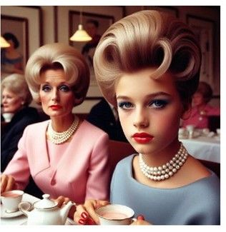  Image by k zinter

“Well, if you really do want to come out with me, you will need to look the part. I have lunch with the ladies, and I am not going to take a boy along. But a young lady – that, I will consider.”

“I’ll do anything Grandma,” I said. “Just take me out of this place next time.”

So the very next time Grandma had me dress in a blue-grey dress with a string of pearls and a pair of her shoes (that fitted me perfectly) and we both went to the hair salon on the corner of her block where she went regular to maintain her impeccable appearance.

“You have such a huge mop of fair hair I am sure that the stylist will know what to do with it,” she said. “But I have a style in mind if you will accept my guidance, And you will need makeup and the right shade of lipstick and nail polish. Why don’t you let me decide?”

I have to say that it was all such a shock that I has to agree.

I loved my lunch with the ladies. They were all excited to have a young girl join them, and they did ask me when I would be able to join them. They all seemed to have very helpful ideas about my future, some of them involving meeting their rich and handsome grandsons. I have to say that the whole experience has opened up a whole bunch of exciting opportunities!

The End

Office Amusement  A Vignette  By Maryanne Peters  I joined the firm as a junior with every ambition to rise to partner in record time. I thought that I was bright enough and my own ambition seemed boundless. I was prepared to do anything to get ahead – absolutely anything.  Tiago Talavera was senior partner, and like me, he was from South America. He was one of those men who believed in the whole idea of “machismo” and the machista culture. He believed that men were destined to dominate, and by “men” he meant men like him, rather than me. | 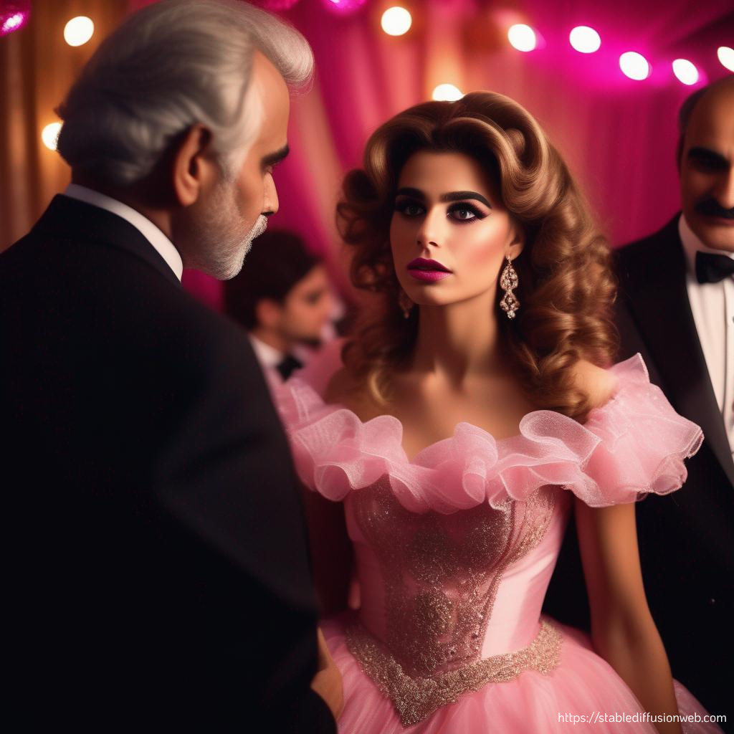  “Pink Part Sissy” by FormerlyAlice

I suppose that I was brought up differently. My mother impressed upon me the need to be gentle and sensitive, and to attend to my personal appearance. You can be those things and still be driven to succeed. By Tiago didn’t see things that way. He called me “metrosexual”. I had to admit that I met the definition, but that was before I truly understood who he was.

He simply advised me that I would be attending a function that would be attended by all the partners. He called it “a black tie gentlemen’s dinner” but he told me that as the ambitious youngster I would not be wearing a black tie but something pink.

“If you want to succeed, you will do everything that I require. I have arranged for somebody to fully prepare you for the occasion, and you will place yourself completely in their hands – do you understand? If you want to get on in the world, you need to do this. Call it the first step towards your good fortune.”

I was dressed up like a quinceanera princess, except five years too late, complete with full Brazilian wax, hair extensions and makeup. Of course, its purpose was to humiliate me and display for the amusement of the partners, but I have to say that when I saw myself in the mirror, I just loved the way I looked. I immediately fell into the character I appeared to be, although I doubt whether that was Tiago’s intention.

What he definitely did not intend was for the junior associate in the pink dress to steal his heart. I just fawned over him all night, and thanked him for allowing me the opportunity to be the only woman in a room full of macho men.

I am ambitious. So ambitious that I was prepared to let Tiago Talavera penetrate me as if I was a woman, but only him. I am not that kind of girl. So ambitious that I suddenly realized, even before he bedded me, that there is another route to wealth and power, through a different type of partnership.

The End

Author’s Note: I have touched on machista culture in a couple of my stories, but I am still searching for an idea that can be the foundation of a longer story fully exploring this theme. Check out the following:
https://zcenter.org/blog/machismo-in-latino-culture/

© Maryanne Peters 2025

